

**Gestión de Información en Dispositivos Móviles**

Práctica 1

Autor

Abdullah Taher Saadoon AL-Musawi



Escuela Técnica Superior de Ingenierías Informática y de Telecomunicación

—

Habla Español

1. **The Problem and Solution:**

There are many people have arrived The Spain or another Spanish-speaking country for tourism or study or other that without knowing the language especially for Arabic foreigners because a lot of Arabic people don’t have any idea about Spanish language form the basic Spanish such as (Hola, Adios, Buenos Dias ……. etc.), so the main idea of my project converts funny book for learning Spanish language to app works on a lot of devices work with android OS, The App allows to user communicates with anyone specks Spanish by funny way and easy, , my app will provides communication and understanding of the language in different cases and places (markets, hospitals, restaurants, trips, airports, train stations, etc.) , To be able to learn the words, phrases and expressions in a playful and interactive way.

For example:

**¿Cómo llego el estacion?**

**¿En cuanto tiempo se llega?**

**¿Me puede ayudar?**

**¿Me puede mostrar?**

**estoy perdido!!!**

**Scope and summary:**

1. "Habla Español" is intended for newcomers to Spanish-speaking countries with few or no language skills.
2. It will help you in your daily life and on trips.
3. We want it to be an electronic conversation guide.
4. Translate words, phrases and expressions from Spanish into the user's language, and vice versa.
5. It will allow you to hear the Spanish pronunciation of its content.
6. Totally free and offline.
7. It will not be a global translator or a dictionary.

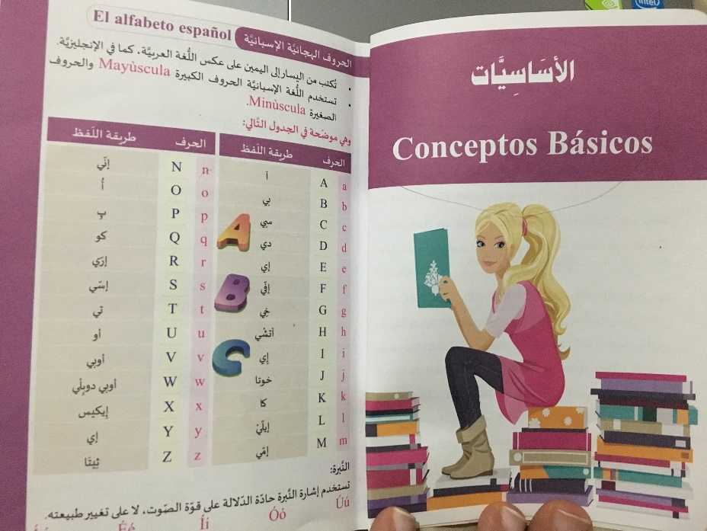

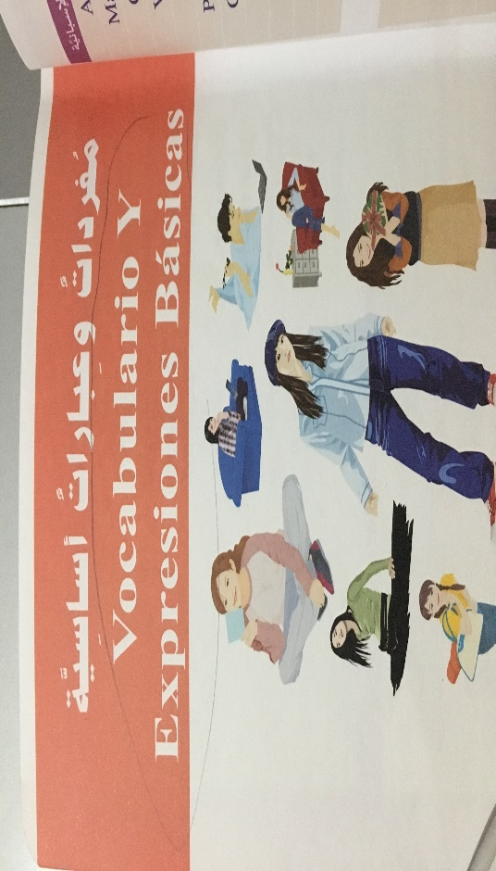

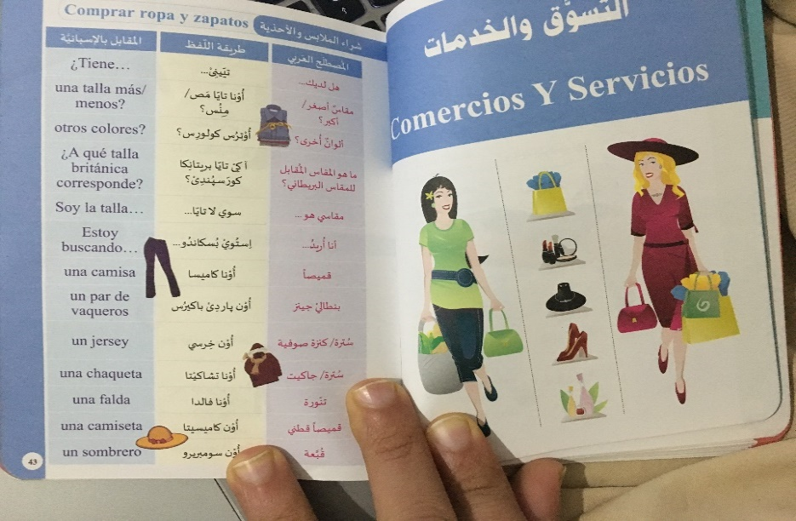

1. The Design:
2. **Home page**: the home page contains two types for learning, direct learning for example Alphabet and number don’t need more information as like statements so, when user clicks on one of elements from list just, he will hear the pronunciation of that element.

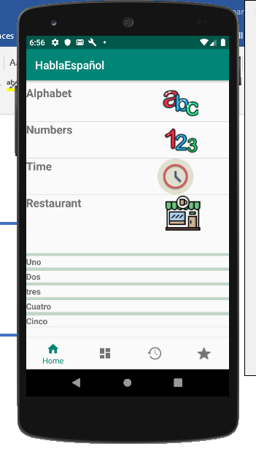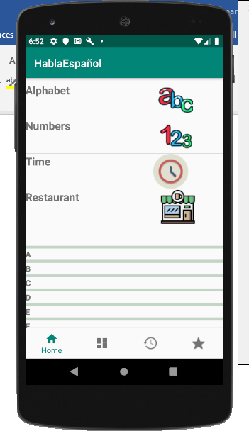



Another type indirect learning for example, there are many questions about the time like “tomorrow”, “day”,” what time is it?” So, these statements need more information for that when user select one statement from list view, he will move to another layout I called it "translate" for translating and hearing the its pronunciation and he can put it into favorite list,

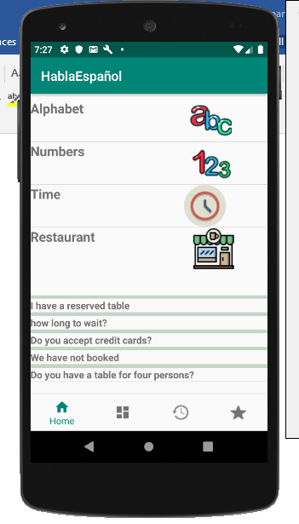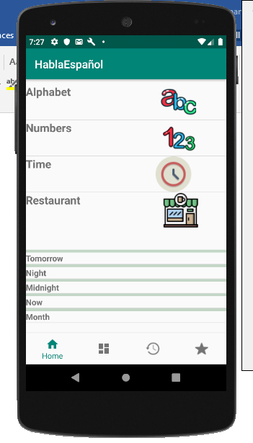

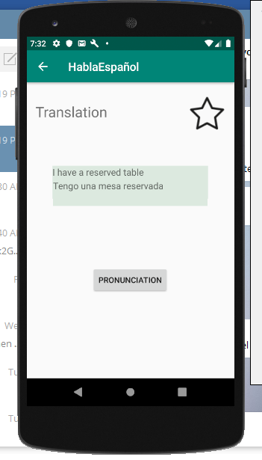



1. 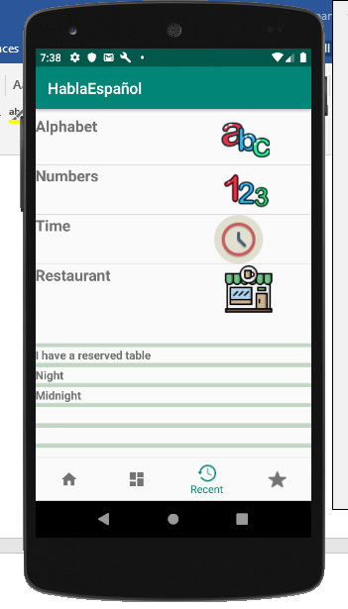Recent Page: the recent page contains last statements that a user has visited



1. Favorite page: The Favorite page contains the statements that a user has putted into list favorite when he clicked on the star icon,

