Four Barriers Corrosion Evaluation
Company: |  | SAUDI ARAMCO
Well: |  | HRDH_1702_1
Field: |  | HARADH
Country: |  | SAUDI ARABIA
Log Date: |  | 15-May-2026
Report Delivery Date: |  | 22-May-2026

Table of Contents

1. Objectives 3
2. Conclusions 3
3. Summary and Other Remarks 4
4. One Page Summary 5
5. Saudi Aramco Metal Loss Classification 6
6. ePDT processing workflow 6
7. Tabulated Joints with Highest Metal Loss 8
8. Raw Data Log Display 10
9. Processed Data Log Display 11
10. Temperature Data and GR Log Display 12
11. Well-head and Hotspots 13
12. Tabulated Joints Metal Loss 23
13. Metal Loss Pie Chart Summary 39
14. Quality Control 41
15. Well Completion Diagram 43
16. Tool String Diagram 44
17. Appendix – Findings and Observations 45

LEGAL NOTICE
This report was prepared by GOWell Energy Solutions Inc. or by its affiliates or subsidiaries (“GOWell”) at the request of {{COMPNAME}}.
This report is GOWell’s interpretation of the information provided by You and the interpretation, analysis, recommendations, advise and conclusions contained in the report are opinions based on inferences from measurements, empirical relationships, assumptions and industry practice (the “Interpretations and/or Recommendations”), which inferences, assumptions and practices are not infallible, and with respect to which professional geologists, engineers, drilling consultants, and analysts may differ and there may be a number of possible interpretations and conclusions.
Accordingly, GOWell does not warrant the accuracy, correctness, or completeness of any such Interpretations and/or Recommendations, or that Your reliance or any third party’s reliance on such Interpretations and/or Recommendations will accomplish any particular results. YOU ASSUME FULL RESPONSIBILITY FOR THE USE OF SUCH INTERPRETATIONS AND/OR RECOMMENDATIONS AND FOR ALL DECISIONS BASED THEREON (INCLUDING WITHOUT LIMITATION DECISIONS BASED ON ANY OIL AND GAS EVALUATIONS, PRODUCTION FORECASTS AND RESERVE ESTIMATES, FURNISHED BY GOWELL TO YOU HEREUNDER), AND YOU HEREBY AGREES TO RELEASE, DEFEND, INDEMNIFY AND HOLD HARMLESS GOWELL FROM ANY CLAIMS ARISING OUT OF THE USE OF SUCH INTERPRETATIONS AND/OR RECOMMENDATIONS.

{{DISC}} DISCLAIMER: The end of tubing depth could not be confirmed from the recorded data due

Objectives
- Evaluate the current completion condition of HRDH_1702_1 and assess the need for any workover maintenance.
- Locate, identify, and quantify metal loss within the 18 5/8”, 13 5/8”, 9 5/8” casing strings, 7”, 4 1/2" liner string and 4 1/2" tubing string from the specified bottom log interval at 7233ft up to the surface.
- Identify wellbore temperature anomalies.

Conclusions
- Minor metal loss detected across the 18 5/8” casing string.
- Minor metal loss detected across the 13 3/8” casing string.
- Minor metal loss detected across the 9 5/8” casing string.
- Minor metal loss detected across the 7” liner string.
- Minor metal loss detected across the 4 1/2" liner string.
- Minor metal loss detected across the 4 1/2" tubing string.
- Temperature anomaly observed across the logging interval.
- Excellent data quality & repeatability.
{{SUMMARY}} Pipe OD | Max WL | Grade of Metal Loss | Hot Spot Depth (ft)
18 5/8" CSG | 5.1% | B | 18.3
13 3/8" CSG | 5.1% | B | 18.3
9 5/8" CSG | 8.7% | B | 1345.6
7" LNR | 31.2% | D | 4180.4
4 1/2" LNR | 31.2% | D | 4180.4
4 1/2" TBG | 7.0% | B | 4180.2

Table 1 Hot Spots

Summary and Other Remarks
- Well Name: HRDH_1702_1 ARBD OIL OBSERVATION.
- Original Completion: 07-Mar-2020.
- Last workover: 07-Mar-2020 #1.
- Log Date: 07-Mar-2020
- LOG CORRELATED TO GR LOG PROVIDED BY THE CLIENT AT THE INTERVAL 6900 - 6500 ft.
- Rigless operation, logged with GOWell ePDT tool, processed with SmartLog.
- Metal loss is expressed as percentage (%) and represents average circumferential metal loss for the tubing and casing strings, surrounding the logging tool.

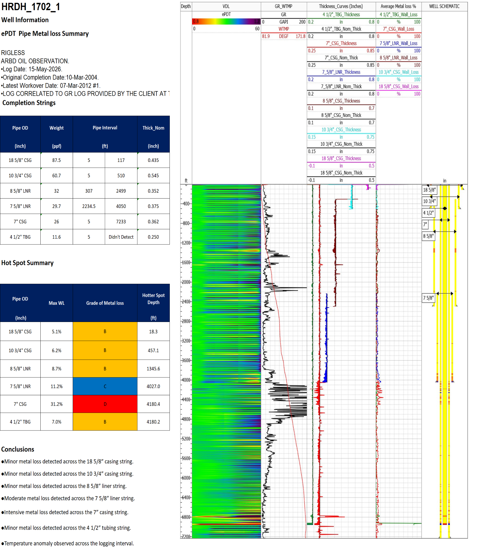
One Page Summary

Saudi Aramco Metal Loss Classification
The table below classifies metal loss categories to evaluate integrity of tubulars, as per Saudi Aramco well integrity standards.
Grade | Maximum Wall Loss | Level
A | 0-5% | Within Tool Accuracy Calculation
B | 5%-10% | Minor
C | 10%-20% | Moderate
D | >=20% | Intensive
E | <0% | Special Higher Weight Joint

Table 2 Metal Loss Classification

ePDT processing workflow
- In the table below we highlight Channels used to calculate for each pipe across one interval.
- Values of Contrast applied for each computed thickness curve aligned with the processing guidelines (K1=0.45, K2=0.55, K3=0.7 and K4 =0.9).
- Baselines shift (offset) may apply to calibrate across nominal pipe(s) intervals and values will be reported per section.
- Identify intervals with different baselines and apply zones whenever needed (additional snapshots may be added to elaborate on the anomalies seen).

Well Name | HRDH_1702_2
RIG Name | RIGLESS
Intervals | Interval 1 | Interval 2 | Interval 3
Start Depth(ft) | 5 | 117 | 307
End Depth(ft) | 117 | 307 | 510
Tubular size & weight | 4 1/2"TBG-0.250"@11.6ppf | 4 1/2"TBG-0.250"@11.6ppf | 4 1/2"TBG-0.250"@11.6ppf
 | 7"CSG-0.362"@26ppf | 7"CSG-0.362"@26ppf | 7"CSG-0.362"@26ppf
 | 10 3/4"CSG-0.545"@60.7ppf | 10 3/4"CSG-0.545"@60.7ppf | 8 5/8"LNR-0.352"@32ppf
 | 18 5/8"CSG-0.435"@87.5ppf | / | 10 3/4"CSG-0.545"@60.7ppf
Interpretation Channels | 18-35-50-56 | 18-35-50 | 18-35-50-56
Pipe channel response | 10-26-47-55 | 10-26-47 | 10-26-47-55
Offset | 0.001/-0.002/0/0.003 | 0.001/0/-0.002 | -0.001/-0.002/0.004/0.003
Intervals | Interval 4 | Interval 5 | Interval 6
Start Depth(ft) | 510 | 2234.5 | 2499
End Depth(ft) | 2234.5 | 2499 | 4050
Tubular size & weight | 4 1/2"TBG-0.250"@11.6ppf | 4 1/2"TBG-0.250"@11.6ppf | 4 1/2"TBG-0.250"@11.6ppf
 | 7"CSG-0.362"@26ppf | 7"CSG-0.362"@26ppf | 7"CSG-0.362"@26ppf
 | 8 5/8"LNR-0.352"@32ppf | 7 5/8"LNR-0.375"@29.7ppf | 7 5/8"LNR-0.375"@29.7ppf
 | / | 8 5/8"LNR-0.352"@32ppf | /
Interpretation Channels | 18-35-50 | 18-35-50-56 | 18-35-53
Pipe channel response | 10-26-47 | 10-26-47-55 | 10-26-47
Offset | 0.001/0/-0.002 | 0.001/-0.002/0/0.003 | 0.001/0/-0.002
Intervals | Interval 7 | Interval 8
Start Depth(ft) | 4050 | Not Detected
End Depth(ft) | Not Detected | 7233
Tubular size & weight | 4 1/2"TBG-0.250"@11.6ppf | 7"CSG-0.362"@26ppf
 | 7"CSG-0.362"@26ppf | /
Interpretation Channels | 26-49 | 25
Pipe channel response | 18-35 | 18
Offset | 0.006/0.005 | 0.014

Table 3 Tubulars Specification and Interpretation Channels Selection

Tabulated Joints with Highest Metal Loss
Table 4 Highest Metal Loss in 4 1/2" Tubing
{{highest_firstPipe}} | Top Body (ft) | Bottom Body (ft) | Body Length (ft) | Nom Thk (in) | Min Thk (in) | Max Loss Depth (ft) | Max Loss (%) | Grade | Damage Profile (% wall loss)
2 | 17.2 | 54.2 | 37.0 | 0.250 | 0.245 | 47.2 | 2.1 | A | ██

Table 5 Highest Metal Loss in 4 1/2" Liner
{{highest_secondPipe}} | Top Body (ft) | Bottom Body (ft) | Body Length (ft) | Nom Thk (in) | Min Thk (in) | Max Loss Depth (ft) | Max Loss (%) | Grade | Damage Profile (% wall loss)
2 | 17.2 | 54.2 | 37.0 | 0.250 | 0.245 | 47.2 | 2.1 | A | ██

Table 6 Highest Metal Loss in 7" Casing
{{highest_thirdPipe}} | Top Body (ft) | Bottom Body (ft) | Body Length (ft) | Nom Thk (in) | Min Thk (in) | Max Loss Depth (ft) | Max Loss (%) | Grade | Damage Profile (% wall loss)
2 | 17.2 | 54.2 | 37.0 | 0.250 | 0.245 | 47.2 | 2.1 | A | ██

Table 7 Highest Metal Loss in 9 5/8" Casing
{{highest_fourthPipe}} | Top Body (ft) | Bottom Body (ft) | Body Length (ft) | Nom Thk (in) | Min Thk (in) | Max Loss Depth (ft) | Max Loss (%) | Grade | Damage Profile (% wall loss)
2 | 17.2 | 54.2 | 37.0 | 0.250 | 0.245 | 47.2 | 2.1 | A | ██

Table 8 Highest Metal Loss in 13 3/8" Casing
{{highest_fifthPipe}} | Top Body (ft) | Bottom Body (ft) | Body Length (ft) | Nom Thk (in) | Min Thk (in) | Max Loss Depth (ft) | Max Loss (%) | Grade | Damage Profile (% wall loss)
2 | 17.2 | 54.2 | 37.0 | 0.250 | 0.245 | 47.2 | 2.1 | A | ██

Table 9 Highest Metal Loss in 18 5/8" Casing
{{highest_sixthPipe}} | Top Body (ft) | Bottom Body (ft) | Body Length (ft) | Nom Thk (in) | Min Thk (in) | Max Loss Depth (ft) | Max Loss (%) | Grade | Damage Profile (% wall loss)
2 | 17.2 | 54.2 | 37.0 | 0.250 | 0.245 | 47.2 | 2.1 | A | ██

Raw Data Log Display
{{raw}}
Figure 1 - Raw Data
18 5/8” Casing Shoe at 117ft

Data response possibly affected by pipe eccentricity or possible EM/grade change.

Processed Data Log Display
{{proc}}
Figure 2 - Four Barriers Metal Loss Evaluation Results

Temperature Data and GR Log Display
{{tempgr}}
Figure 3 - Expanded Temperature and GR Log

Well-head and Hotspots
{{wh}}
Figure 4 –Well-Head-section
Data response possibly affected by pipe eccentricity or possible EM/grade change.

{{damage_block_start}}
{{DMG@N_1}}
Figure 5 - Highest Metal Loss Channel Selection
Moderate metal loss in 13 3/8” CSG Max WL% is 16.9% at 76.7ft
{{DMG@N_2}}
Figure 6 - Highest Metal Loss Channel Selection
Channel 48 is used to calculate Moderate metal loss in 13 3/8” CSG Max WL% is 16.9% at 76.7ft
First Pipe Collar.
{{DMG@N_3}}
Figure 7 - Highest Metal Loss Raw Data
Response reduction in the raw curves and color intensity in VDL indicate metal loss.

{{damage_block_end}}

Tabulated Joints Metal Loss
Table 10 Joints Metal Loss in 4 1/2" Tubing
{{joints_firstPipe}} | Top Body (ft) | Bottom Body (ft) | Body Length (ft) | Nom Thk (in) | Min Thk (in) | Max Loss Depth (ft) | Max Loss (%) | Grade | Damage Profile (% wall loss)
2 | 17.2 | 54.2 | 37.0 | 0.250 | 0.245 | 47.2 | 2.1 | A | ██

Table 11 Joints Metal Loss in 4 1/2" Liner
{{joints_secondPipe}} | Top Body (ft) | Bottom Body (ft) | Body Length (ft) | Nom Thk (in) | Min Thk (in) | Max Loss Depth (ft) | Max Loss (%) | Grade | Damage Profile (% wall loss)
2 | 17.2 | 54.2 | 37.0 | 0.250 | 0.245 | 47.2 | 2.1 | A | ██

Table 12 Joints Metal Loss in 7" Liner
{{joints_thirdPipe}} | Top Body (ft) | Bottom Body (ft) | Body Length (ft) | Nom Thk (in) | Min Thk (in) | Max Loss Depth (ft) | Max Loss (%) | Grade | Damage Profile (% wall loss)
2 | 17.2 | 54.2 | 37.0 | 0.250 | 0.245 | 47.2 | 2.1 | A | ██

Table 13 Joints Metal Loss in 9 5/8" Casing
{{joints_fourthPipe}} | Top Body (ft) | Bottom Body (ft) | Body Length (ft) | Nom Thk (in) | Min Thk (in) | Max Loss Depth (ft) | Max Loss (%) | Grade | Damage Profile (% wall loss)
2 | 17.2 | 54.2 | 37.0 | 0.250 | 0.245 | 47.2 | 2.1 | A | ██

Table 14 Joints Metal Loss in 13 3/8" Casing
{{joints_fifthPipe}} | Top Body (ft) | Bottom Body (ft) | Body Length (ft) | Nom Thk (in) | Min Thk (in) | Max Loss Depth (ft) | Max Loss (%) | Grade | Damage Profile (% wall loss)
2 | 17.2 | 54.2 | 37.0 | 0.250 | 0.245 | 47.2 | 2.1 | A | ██

Table 15 Joints Metal Loss in 18 5/8" Casing
{{joints_sixthPipe}} | Top Body (ft) | Bottom Body (ft) | Body Length (ft) | Nom Thk (in) | Min Thk (in) | Max Loss Depth (ft) | Max Loss (%) | Grade | Damage Profile (% wall loss)
2 | 17.2 | 54.2 | 37.0 | 0.250 | 0.245 | 47.2 | 2.1 | A | ██

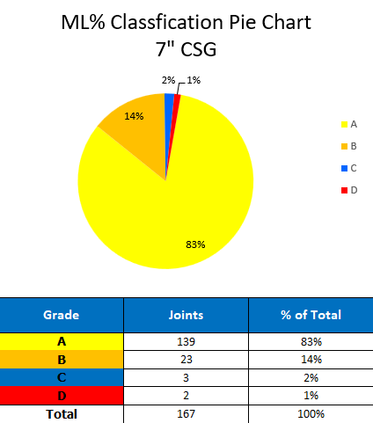
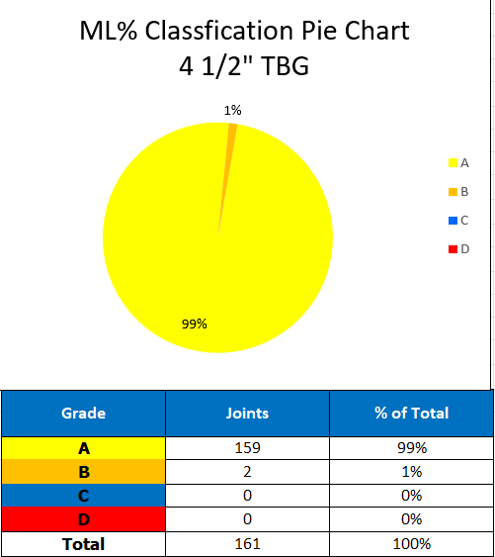
Metal Loss Pie Chart Summary
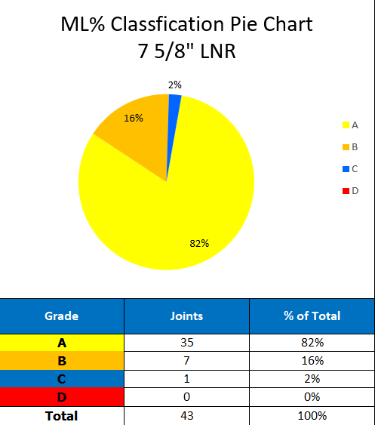
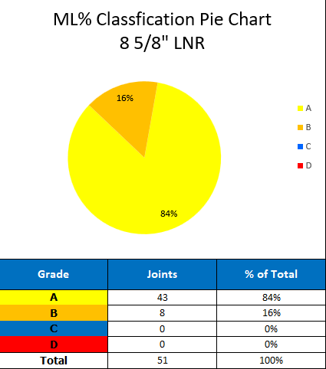




Figure 14 - Metal Loss Pie Chart Summary

Quality Control
Data quality control was applied as per standard operating procedure and Saudi Aramco guidelines, for raw data for both main and repeat passes.
Quality control curves for the IL, IM and IS (long, medium, and short spacing coils currents) are within 700 mA and 500 mA.
- S, M, L polarities alternate from 0 - 1.
- Equivalent ADEC curves, with 60 channels, are derived from combining the curves of the three long, medium, and short coils.
Figure 15 - Raw Data Repeatability
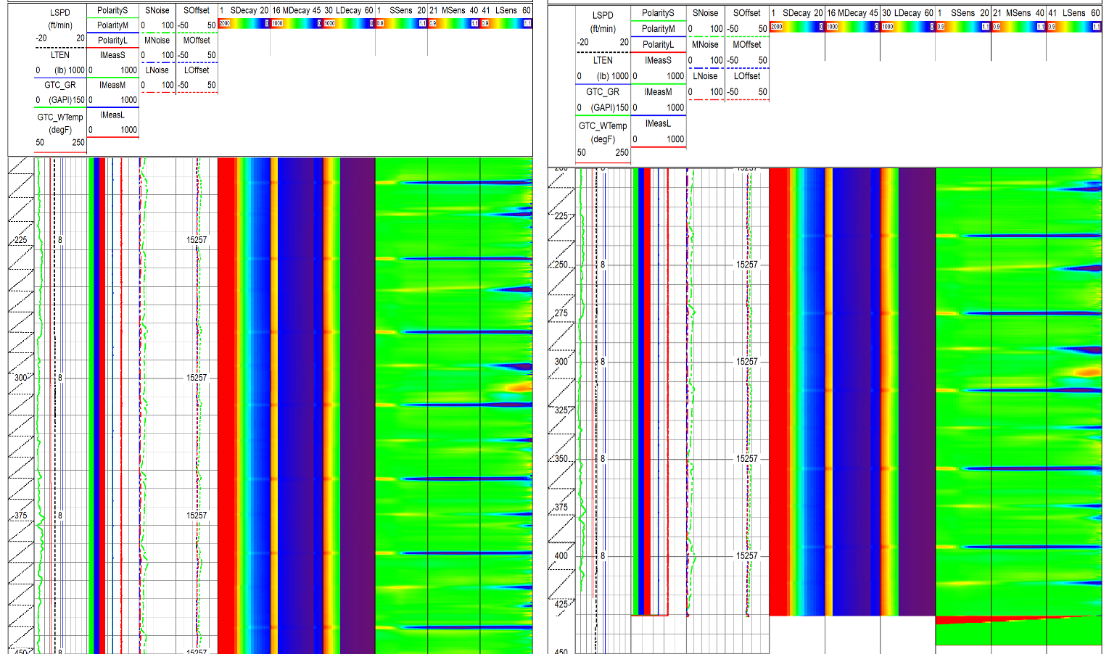
Main and repeat pass show good repeatability.

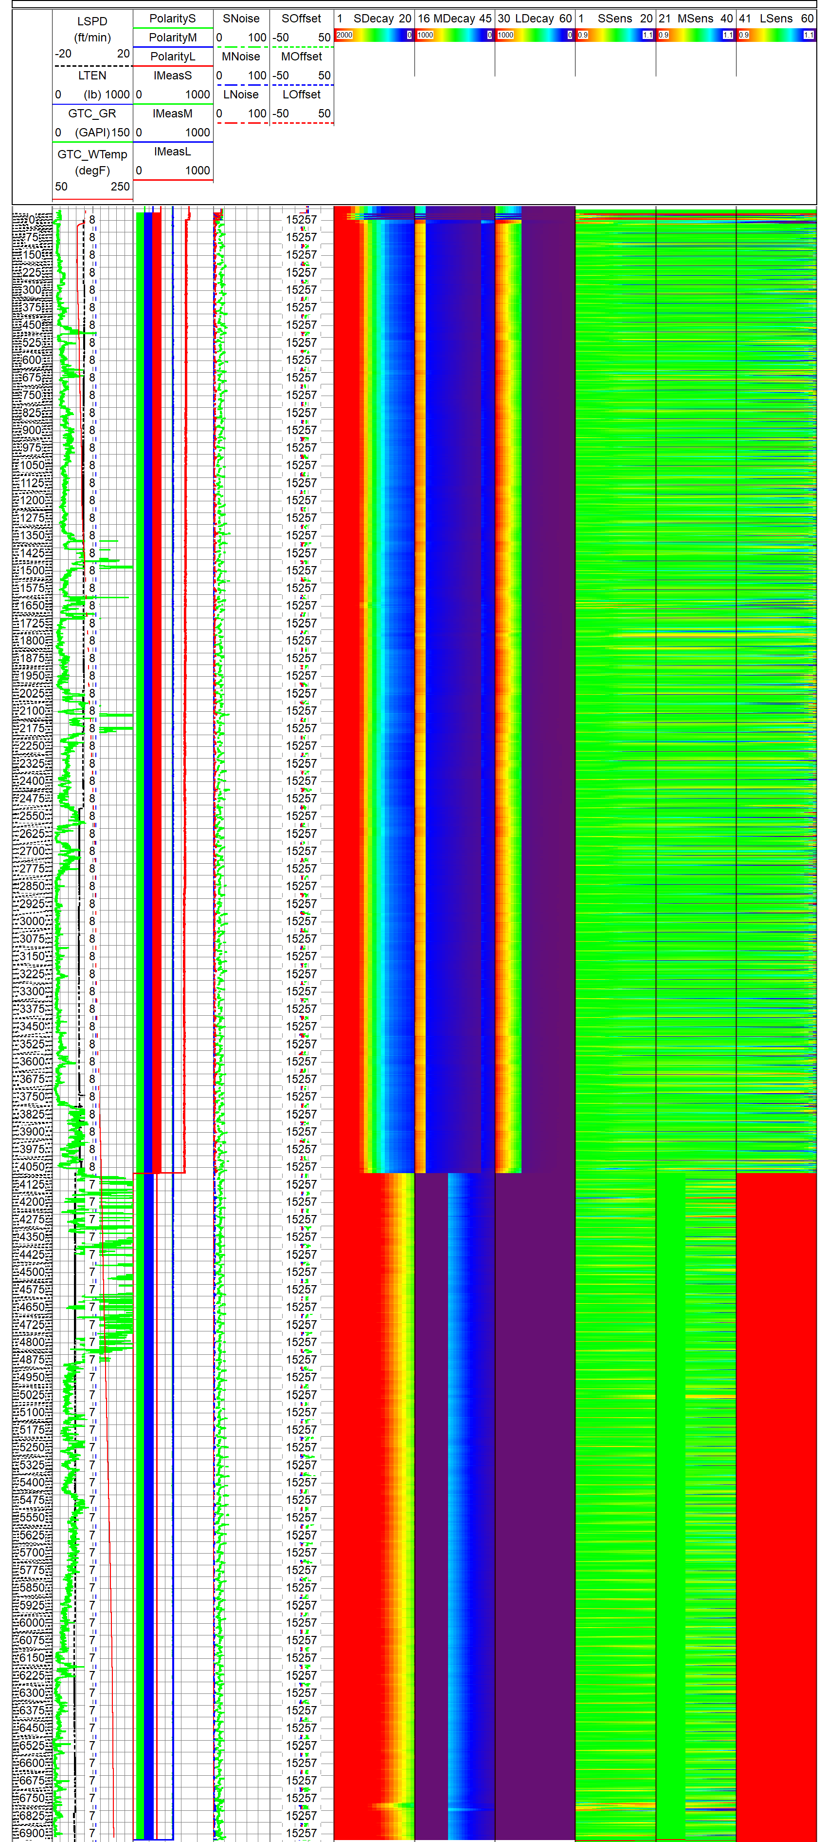
Quality control guidelines across the main pass is shown in the figure below.
Figure 16 - Main Pass Quality Control

Well Completion Diagram
{{well}}
Figure 17 - Well Cross Section Plot

Tool String Diagram
{{ts}}
Figure 18 – Tool String Diagram

