STUDENT WORKSHEET

First instruction trace
with Ripes
Lab 0 · Computer Organization · Week 1
Name: Mohammad Abdullah（祈祷） Student ID: 202322240356
Class / group: 2023/ Software engineering Date: 25/09/2026

Purpose
Connect the first week’s diagrams to a running processor model. Predict how three instructions change the program counter and registers, check the prediction in Ripes, and relate a cycle count to modeled CPU time.

Learning outcomes
By the end of the lab, you should be able to identify the PC, register file, ALU and instruction memory; step through RV32I code; record state changes; explain what the example does; and use CPU time = IC × CPI × cycle time.

Requirements and scope
Use a laptop with the instructor-approved Ripes desktop build or the experimental browser build linked from the official project. No GPU, CUDA installation or C compiler is required. RISC-V assembly syntax is introduced only as needed. [R1–R3]
Timing assumption
Two 45-minute academic periods = 90 minutes of activity, excluding the break. For two 50-minute periods, use the additional 10 minutes for setup support and the optional checks.

Time | Activity | Worksheet
0–10 min | Configure the single-cycle model | Page 2
10–30 min | Predict and trace Program A | Page 3
30–45 min | Follow the data through the CPU | Page 4
45–65 min | Run three controlled changes | Page 5
65–80 min | Connect cycles to time | Page 6
80–90 min | Reflect and prepare submission | Page 7

Student pages: 1–8. Pages 9–10 contain a detachable instructor answer key.

PART A / SETUP

Configure Ripes before running code

A1. Open an approved build
Desktop: obtain a build for your operating system from the official Ripes Releases page, or use the version supplied by your instructor. Browser: the official project currently links to https://ripes.dk/ and labels the browser deployment experimental. Internet access and JavaScript are needed for that route. Save your source locally. [R1, R3]

A2. Select the model
Use Select Processor (the processor icon). Choose the RV32 RISC-V Single Cycle Processor, not a five-stage or dual-issue model. Select Standard layout for the first trace. If ISA extension checkboxes are shown, disable C (compressed instructions). Use the base integer instruction set for this lab. [R2]
Initialize x5, x6 and x7 to zero using the processor’s register-initialization settings, then Reset. Confirm x0 reads as zero. Register aliases may be displayed: x5 = t0, x6 = t1, x7 = t2. Record the initial PC as P rather than assuming a particular starting address.
Setup item | Record / check
Ripes version or browser build | Ripes-v2.2.6-win-x86_64
Operating system / browser | Windows 11 pro
Selected model | RV32 RISC-V Single Cycle Processor
C extension disabled / not enabled | Yes
After Reset: x5, x6, x7 | 0 0 0
Initial PC = P | 0x0

A3. Learn the controls
Control / view | Use in this lab
Editor | Enter assembly. Correct code is assembled into the simulator.
Processor / Registers | Observe PC, component connections and register values.
Clock / single-step | Advance the model by one clock cycle.
Reset | Return to the program entry point and reset state.
Memory | Inspect addresses and memory contents.
Run | Do not use for the required trace: the stop label is a self-loop.

Checkpoint before continuing
Ask the instructor to verify the single-cycle model. A pipeline model will not produce the same one-clock-per-instruction trace. View labels can vary across releases; use the official introduction for your build. [R2]

PART B / PREDICT → RUN → EXPLAIN

Trace Program A
Enter this code exactly. Save it as lab0_baseline.s. The final jump keeps the PC in a safe self-loop; it is not part of the three-instruction measurement.
.text
main:
addi x5, x0, 10
addi x6, x0, 20
add x7, x5, x6
stop:
jal x0, stop

Syntax: addi destination, source, constant; add destination, source1, source2. In RV32I, x0 always reads zero. The other names identify registers. [R4]

B1. Predict before executing
After the first three instructions, predict: x5 = 10 x6 = 20 x7 = 30
Which register do you expect to change at each step? Explain in one sentence.
Ans: Clock 1 changes x5, Clock 2 changes x6, and Clock 3 changes x7, because each instruction writes its result to the register specified as its destination.
________________________________________________________________________________

B2. Record the actual state
Reset. Confirm x5–x7 are zero. In the Processor view use Clock three times, one click at a time. Record values after each clock. Use decimal values for registers and an address format for the PC. Do not count the self-loop.
After | Instruction just executed | PC | x5 | x6 | x7
Reset | None | P = 0x0 | 0 | 0 | 0
Clock 1 | addi x5, x0, 10 | 0x4 | 10 | 0 | 0
Clock 2 | addi x6, x0, 20 | 0x8 | 10 | 20 | 0
Clock 3 | add x7, x5, x6 | 0xc | 10 | 20 | 30

B3. Interpret the trace
How much did the PC increase after each of these instructions? Why?
Ans: The PC increased by 4 bytes after each instruction because each RV32I instruction used here is 32 bits, or 4 bytes, long.
________________________________________________________________________________
Stop here
Save a screenshot of the state immediately after Clock 3. Do not press Run: the last instruction intentionally jumps to itself. If you step into the self-loop, Reset and repeat the three measured clocks.

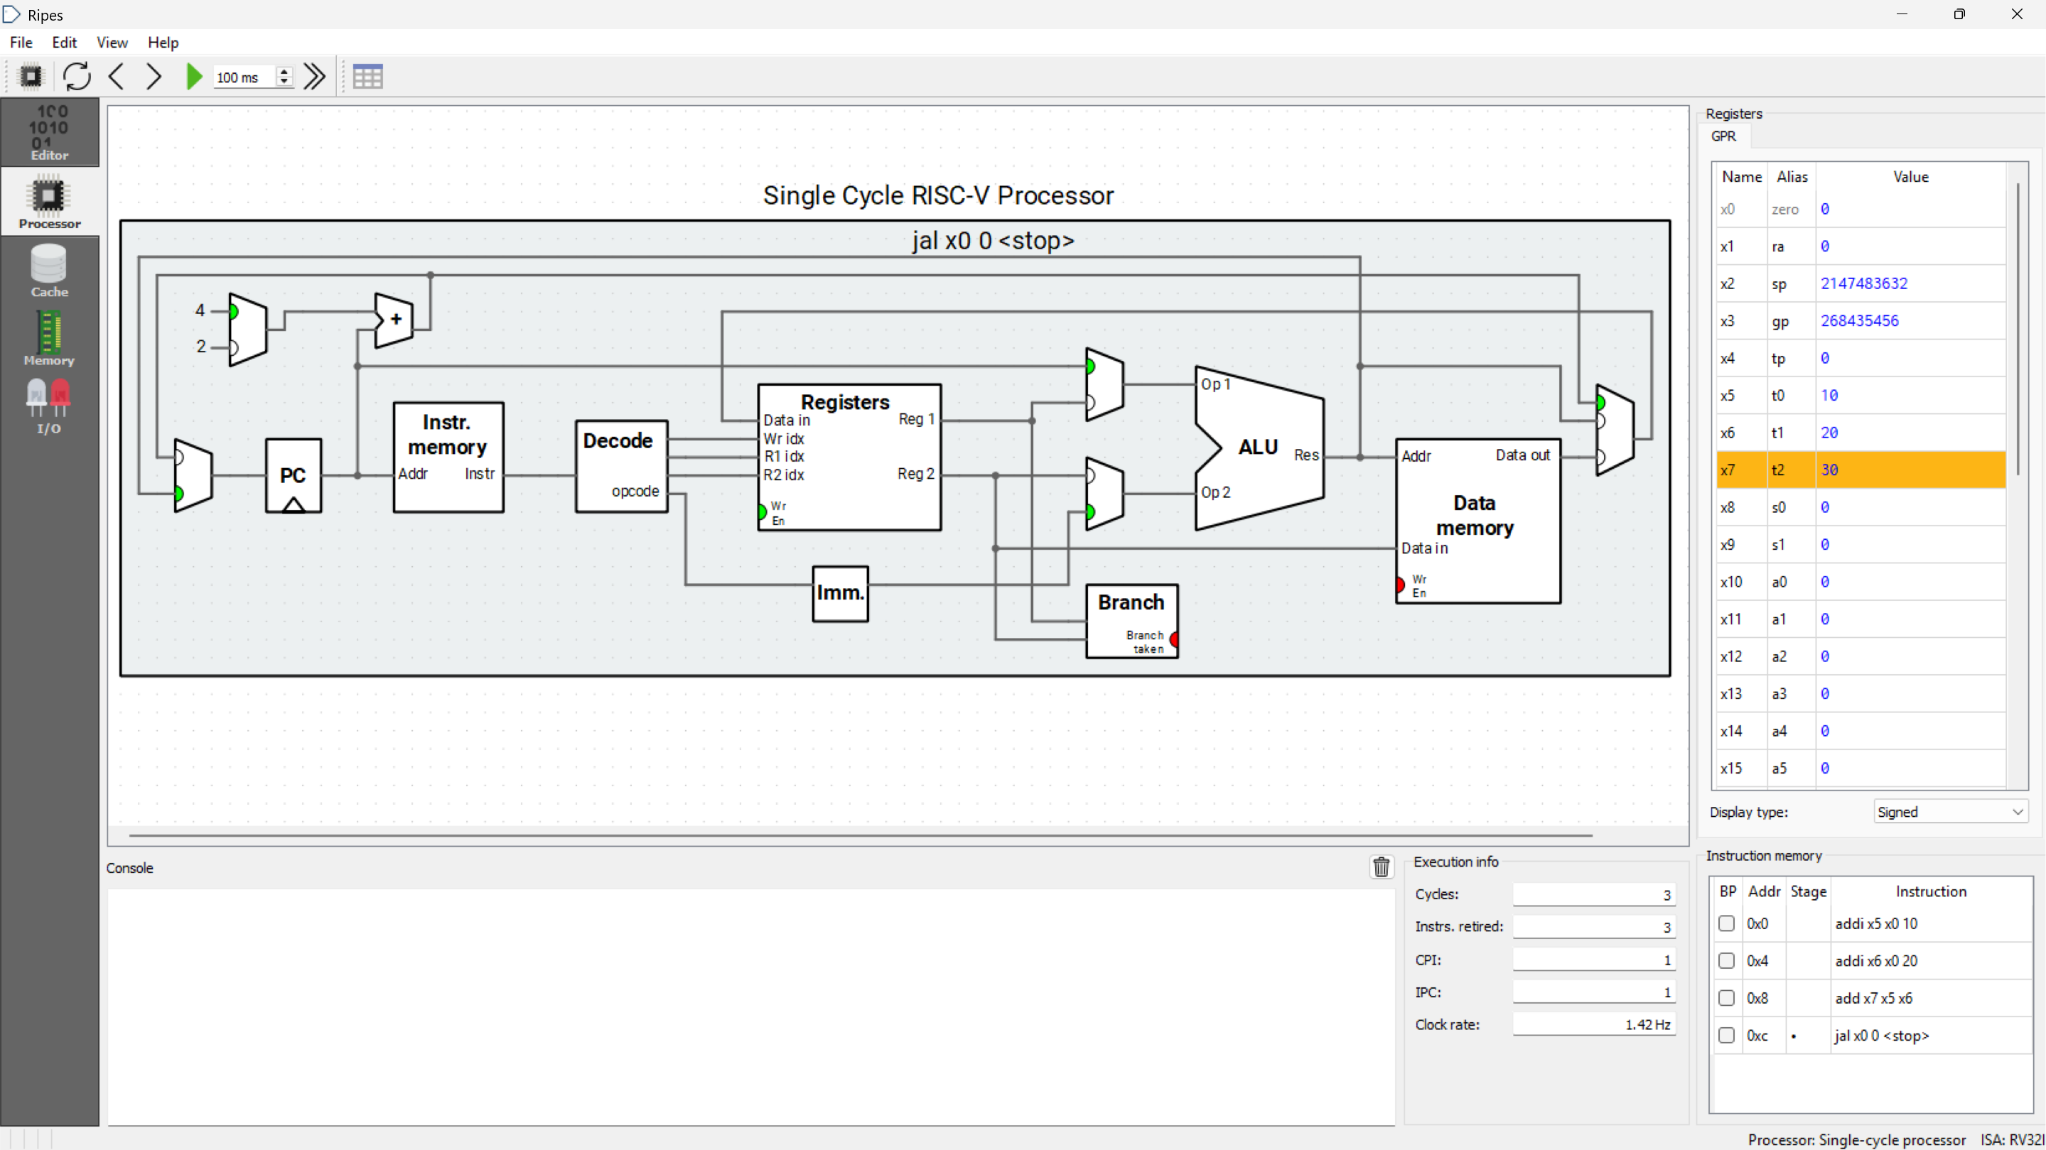
Screenshot 1: Baseline after Clock 3.

PART C / DATAPATH OBSERVATION

Follow the data for add x7, x5, x6
Reset Program A and apply two clocks. The next arithmetic instruction is add x7, x5, x6. First inspect its input values, then apply the third clock and inspect the written result. If available, switch to Extended layout only for observation; keep the same single-cycle model. [R2]

C1. Identify the component roles
Component | What to observe | Your observation
PC | Address associated with the third instruction | 0x8
Instruction memory | The instruction at that address | add x7, x5, x6
Register file | The two source-register values | x5 = 10, x6 = 20
ALU | Operation and computed result | ADD, result = 30
Destination register | Register that changes after Clock 3 | x7
Data memory | Whether this instruction loads or stores data
  Not used; no load or store

C2. Complete the data path
x5 = 10 ──┐
├── ALU operation: add ──> x7 = 30
x6 = 20 ──┘

The PC identifies an instruction address; it does not supply one of these two arithmetic operands. The register file supplies the operands for this add. Instruction fetch and data-memory access are different activities. [R4]

C3. Explain the result
1. Does add x7, x5, x6 change x5 or x6? Explain.
Ans: No. x5 and x6 do not change because they are source registers. Their values are read by the ALU, while x7 is the destination register that receives the result.

2. Does it need to load either operand from data memory? What was still fetched from instruction memory?
Ans: No. The operands are read from the register file, so data memory is not used. The instruction add x7, x5, x6 was still fetched from instruction memory.
PART D / CONTROLLED EXPERIMENTS

Change one thing at a time
Start each experiment from the original Program A, not from the previous variant. Save each variant, predict first, then Reset and use Clock. Leave the stop self-loop at the end.

D1. Change the input constant
Replace only the second arithmetic line with the following. Execute three measured instructions.
addi x6, x0, 7

D2. Change the operation
Restore the original constants 10 and 20. Replace only the third arithmetic line. Execute three measured instructions.
sub x7, x6, x5

D3. Try writing to the zero register
Restore all three original arithmetic lines. Insert this fourth line immediately before stop:. Execute four measured instructions, not three.
addi x0, x0, 99

Experiment | Prediction | Observed values | Match?
D1: after 3 clocks | x7 = 17 | x6 = 7 x7 = 17 | Yes
D2: after 3 clocks | x7 = 10 | x7 = 10 | Yes
D3: after 4 clocks | x0 = 0 | x0 = 0 x7 = 30 | Yes

Explain one observation
Choose one experiment and explain the result using “source,” “destination” and either “constant” or “zero register.”
Ans: In D3, x0 is used as both a source and the destination. The constant 99 is added to the source value 0, but because the destination is the zero register, the result is discarded and x0 remains 0.
Reproducibility rule
Reset before every run. Record exactly which instructions were included. A self-loop instruction changes the cycle count even though the visible arithmetic result does not change.

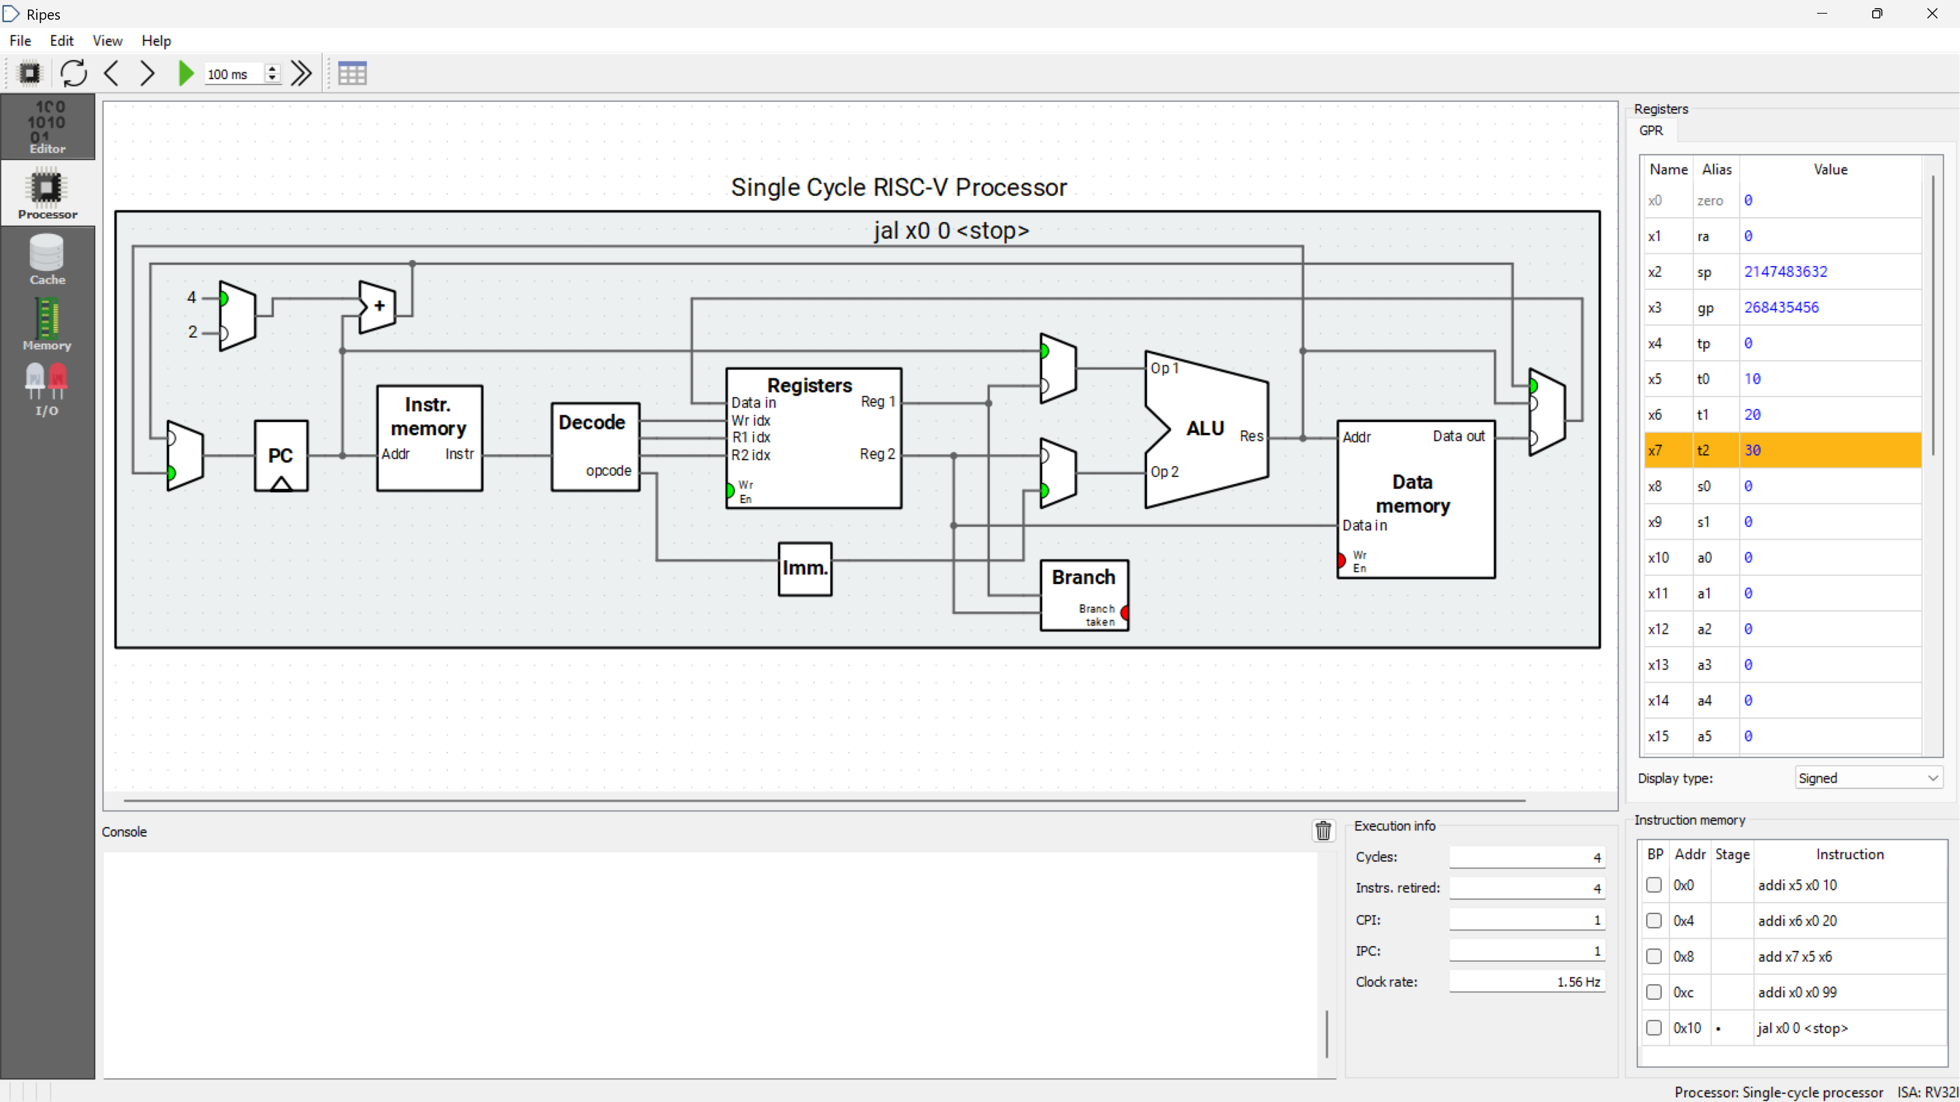
Screenshot 2: D3 controlled experiment after Clock 4. The instruction attempts to write 99 to x0, but x0 remains 0.

PART E / PERFORMANCE

From simulated cycles to modeled time
Important distinction
Ripes is running on your real laptop or browser. Its animation interval and the time you spend clicking are not the simulated processor’s hardware clock period. Use the explicitly assumed periods below; do not use a stopwatch on the interface. [R2]

For a defined instruction interval: cycles = IC × CPI; modeled CPU time = cycles × T = (IC × CPI) / f. The examples below use fixed hypothetical clock rates. [M1, I1]

E1. Your three-instruction trace
Use only the first three arithmetic instructions in baseline Program A. In the selected single-cycle model, each of these instructions completes in one cycle. Assume T = 2 ns per simulated cycle.
Quantity | Your answer
Measured instruction count, IC | 3 instructions
Modeled cycle count | 3 cycles
Average CPI | 1 cycle / instruction
Modeled CPU time | 6 ns
Clock rate equivalent to T = 2 ns | 0.5 GHz

E2. A larger hypothetical workload
A program executes 200 million instructions at average CPI = 1.5 on a processor with clock rate 2 GHz. Calculate CPU execution time in seconds. Show your units.
Ans: CPU execution time = (200 × 10^6 instructions × 1.5 cycles/instruction) / (2 × 10^9 cycles/s) = 0.15 s.

E3. Which processor is faster?
Two hypothetical processors execute the same workload with the same dynamic IC of 100 million instructions.
Processor | Clock rate | CPI | CPU time
A | 2 GHz | 1.0 | 0.05 s
B | 3 GHz | 2.0 | 0.0667 s

Faster processor: A. Speedup over the slower processor: 1.33 ×.
Can a higher clock rate alone determine the winner? Explain briefly.
Ans: No. A higher clock rate alone cannot determine the faster processor because CPU time also depends on instruction count and CPI.

PART F / REFLECT AND SUBMIT

Show evidence of understanding

F1. Evidence to submit
Submit your completed worksheet and four source files: lab0_baseline.s, lab0_D1.s, lab0_D2.s and lab0_D3.s. Include two readable screenshots as an appendix to your submission; do not shrink the register values until they are unreadable.
Screenshot | What it must show
1. Baseline after Clock 3 | Selected single-cycle model, PC and x5/x6/x7.
2. One controlled change | Variant code, register result, and a caption naming the experiment.

F2. Short reflection
- Explain the difference between the PC and the value held in x7.
Ans: The PC holds the address of the instruction being executed or fetched, while x7 is a general-purpose register that stores data or an arithmetic result.
- Which lab observation illustrates an ISA rule, rather than just a display choice?
Ans: The D3 experiment illustrates an ISA rule: x0 is the RISC-V zero register and always reads as zero, even when an instruction attempts to write another value to it.
- Why is a one-second animation interval not a one-second simulated hardware cycle?
Ans: A one-second animation interval is only the simulator’s display speed. It does not represent the processor’s hardware clock period, which is determined by the modeled cycle time.

F3. Suggested assessment rubric
Criterion | Points
Correct model selection and reproducible setup | 2
Complete baseline trace with explanation | 3
Predictions and observations for D1–D3 | 2
Performance calculations with units | 2
Readable evidence and an independent explanation | 1
Total | 10

If Lab 0 is diagnostic in your course, use this rubric for feedback rather than a grade. The instructor sets the submission platform and deadline. Work may be discussed in pairs, but each student should produce their own trace and explanation.

Appendix A - Handwritten Performance Calculations
The following handwritten pages show the calculations used for Part E (E1-E3).
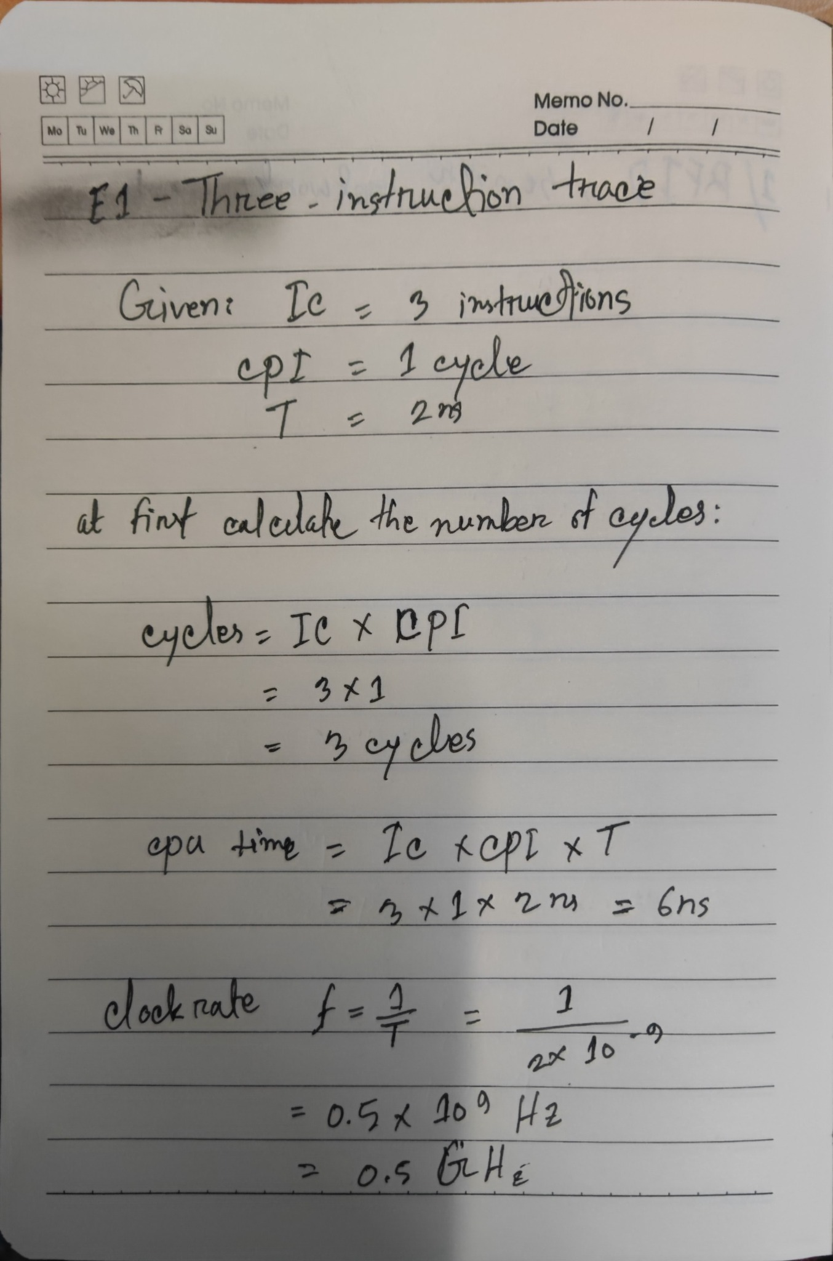
Figure A1. E1 - Three-instruction trace: cycle count, modeled CPU time, and equivalent clock rate.

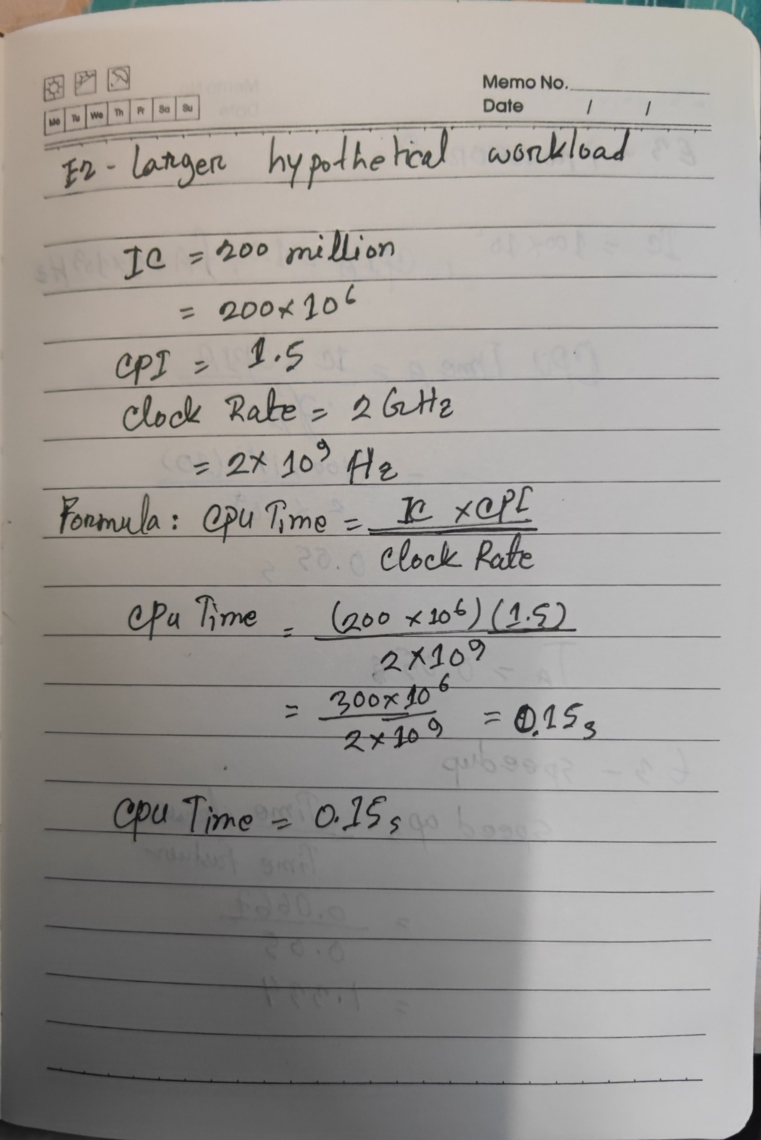
Figure A2. E2 - Larger hypothetical workload: CPU execution time calculation.

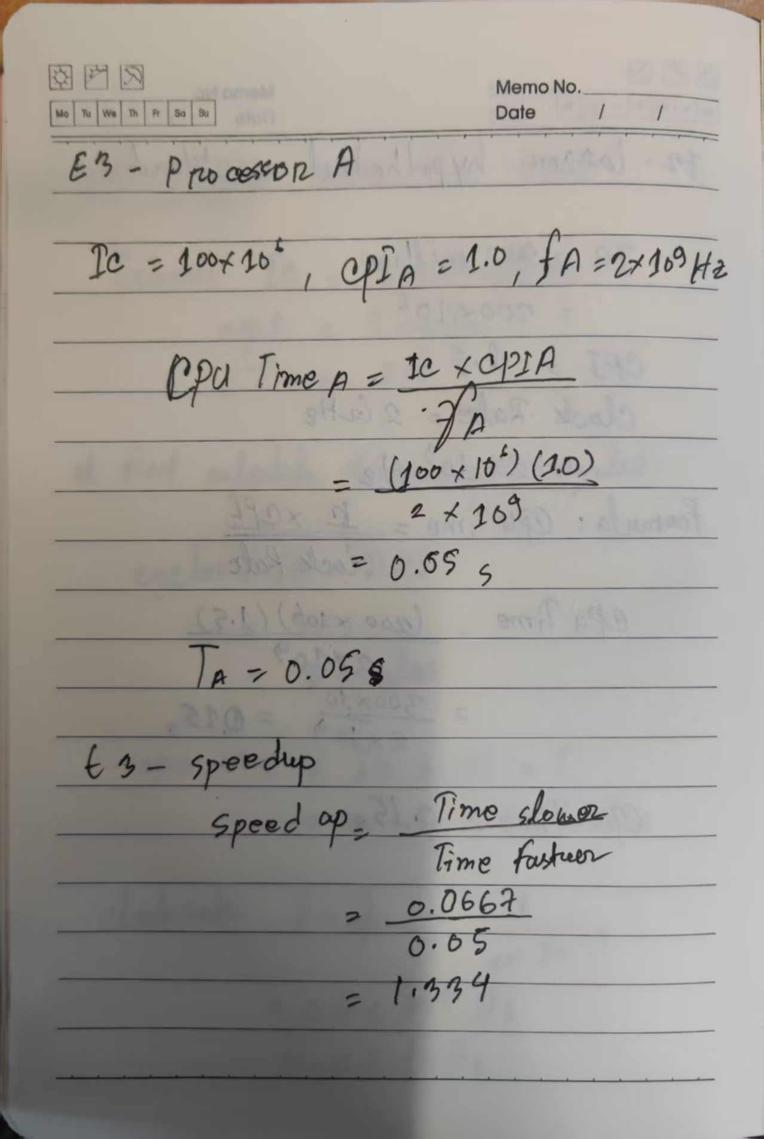
Figure A3. E3 - Processor A CPU-time calculation and speedup calculation.

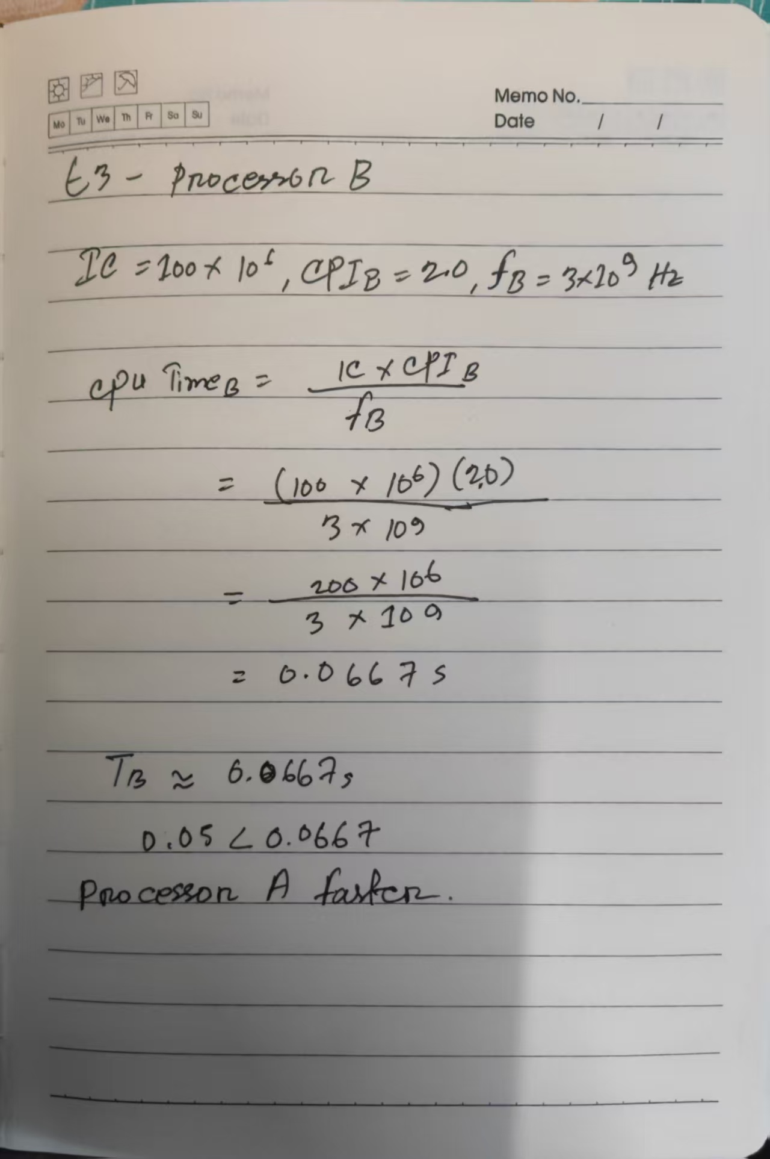
Figure A4. E3 - Processor B CPU-time calculation and comparison with Processor A.
SUPPORT / STUDENT REFERENCE

Troubleshooting and sources
Symptom | Check first
The editor reports an error | Use plain-text assembly; remove copied line numbers, smart punctuation and HTML tags such as <br/>.
Registers change later than expected | Recheck that you selected the single-cycle model, not a pipeline model. Reset and repeat.
Program keeps running | The stop label is an intentional self-loop. Stop execution, Reset, and use Clock for the measured instructions.
My PC does not start at zero | Record its starting value as P. Compare increments relative to P.
PC increments differ from +4 | Check C is disabled and inspect the assembled instruction list. Required examples use 32-bit RV32I instructions.
I see t0, t1 and t2 | These are aliases for x5, x6 and x7. Numeric and alias names refer to the same registers.
The browser build does not load | Use the official desktop release or an instructor-managed lab computer. Do not disable system security controls.
My result changes after editing | Reset after each edit and verify the original input constants for that experiment.

Official resources and lecture references
[R1] Ripes project and desktop installation: https://github.com/mortbopet/Ripes
[R2] Ripes introduction, views and controls: https://github.com/mortbopet/Ripes/blob/master/docs/introduction.md
[R3] Browser build (experimental): https://ripes.dk/
[R4] RISC-V RV32I specification: https://docs.riscv.org/reference/isa/unpriv/rv32.html
[M1] MIT 6.004, L21 Processor Performance: https://ocw.mit.edu/courses/6-004-computation-structures-spring-2017/pages/c21/c21s1/
[I1] Imperial College, CPU law (printed slides 37–40; PDF page 10): https://www.doc.ic.ac.uk/~phjk/AdvancedCompArchitecture/2003-04/Lectures/Ch01/ACA-Ch01-CurrentVersion.pdf
Sources checked 6 September 2026. Activities, code and worksheet wording are newly prepared. This introductory lab does not reproduce the later Vassar single-cycle control-signal lab. UI labels can change between Ripes builds.

