Course Hub
E-Learning Platform
Project Report

1. Overview
This project is an e-learning platform that lets students browse and purchase online courses in a simple and clear way. It is built using the Laravel framework, a popular PHP framework for web development. Students can explore different course categories, read course details, add courses to their cart, and complete their purchase through a guided checkout process.
There are two main types of users on the platform: regular users (students) and admin users. Students can search for courses, manage their accounts, and check out with the courses they want. Admins can manage the course catalog by adding, editing, or removing courses and categories. All information about courses, users, and categories is stored in a database.
The website has a clean, student-friendly interface that makes it easy to find interesting courses. Users can search, filter by category, and view course details such as pricing, descriptions, and images before deciding to buy.

2. Features for Students
Course Browsing and Search
• View all available courses in one place.
• Browse courses by category, making it easier to discover topics of interest.
• Use a search bar to find courses by title or description.
• See key course details such as price, description, and category on each course page.
Shopping Cart
• Add one or more courses to a shopping cart before checking out.
• View a list of all selected courses with their prices.
• Remove individual courses or clear the entire cart if needed.
• See the cart total calculated automatically.
Checkout Process
• Go to a secure checkout page to confirm the order.
• Enter personal details such as name, email, phone number, and address.
• View an order confirmation page after a successful checkout.
• Have the cart automatically cleared once the order is completed.
User Account Management
• Register for an account and log in securely.
• Update profile details such as name and email.
• Reset passwords using the built-in password reset flow.
• Rely on secure authentication provided by Laravel Breeze.
Contact and Support
• Visit a contact page that includes frequently asked questions (FAQs).
• Submit contact forms for additional support or questions.
• Read answers about common topics such as payments, course access, and purchasing.

3. Features for Admins
Admin Dashboard
• View an overview of total courses and categories.
• See key statistics related to active courses.
• Check a list of recently added courses.
• Display revenue-related information for better insight.
Course Management
• Create new courses with a title, description, price, and images.
• Edit course details at any time.
• Delete courses that are no longer offered.
• Set regular and discounted prices for each course.
• Assign courses to one or more categories.
• Upload course images or link to external image URLs.
• Manage course availability and stock-like status.
• Activate or deactivate courses with a simple toggle.
Category Management
• Create new categories to group related courses.
• Edit category names and descriptions.
• Delete categories that are no longer needed.
• View how many courses belong to each category.
• Activate or deactivate categories without deleting them.
Access Control
• Protect admin-only routes using authentication middleware.
• Ensure that only authorized admin users can access management tools.

4. Technical Overview
Database Structure
• Users table for managing accounts and login details.
• Categories table for grouping courses into topics.
• Products (courses) table for storing all course information.
• Defined relationships between categories and products.
Session Management
• Shopping cart data is stored in the session.
• User authentication sessions ensure secure logins.
• Sessions are handled securely to protect user data.
Image Handling
• Support for uploading course images as files.
• Support for using external image URLs.
• Images are stored in a public directory with automatically managed paths.
Technology Stack
- Backend Framework: Laravel 12
- Programming Language: PHP 8.2
- Database: SQLite
- Frontend: HTML, CSS, JavaScript, Bootstrap
- Authentication: Laravel Breeze
- Server: PHP built-in server or Apache

5. Future Improvements
The current version of the platform covers the basics of browsing and purchasing courses. However, there are many opportunities to expand the system and make it even more powerful and user-friendly:
- Integrate real payment gateways such as Stripe, PayPal, or local providers so users can pay securely online.
- Add a full order management system that stores order history, allows users to view past purchases, generates invoices, and tracks order status.
- Introduce course content delivery features like video players, lesson structures, quizzes, assignments, progress tracking, and completion certificates.
- Allow students to leave reviews and ratings for courses, and show average ratings on course pages.
- Add a wishlist feature so users can save courses for later, compare options, and receive sale notifications.
- Send email notifications for order confirmations, new courses in selected categories, course completion, and password resets.
- Offer advanced search and filters such as price range filters, sorting by price or popularity, and filtering by multiple categories.
- Create an instructor dashboard where teachers can create and manage their own courses and track their sales.
- Develop mobile apps for iOS and Android to improve learning on the go and send push notifications for updates.
- Add social features like user profiles with badges, course discussions, and sharing achievements on social media.
- Provide analytics and reporting tools for admins, including popular courses, sales reports, engagement data, and revenue trends.
- Support multiple languages and currencies so users from different regions can use the platform comfortably.

6. Conclusion
This e-learning platform demonstrates how Laravel can be used to build a practical online course marketplace. Students can search for courses, manage a cart, and complete a simple checkout, while admins can manage the course catalog and categories through a secure dashboard.
With future enhancements such as real payment processing, richer course content delivery, instructor tools, and analytics, the platform has strong potential to grow into a full-featured e-learning solution.

Screenshots
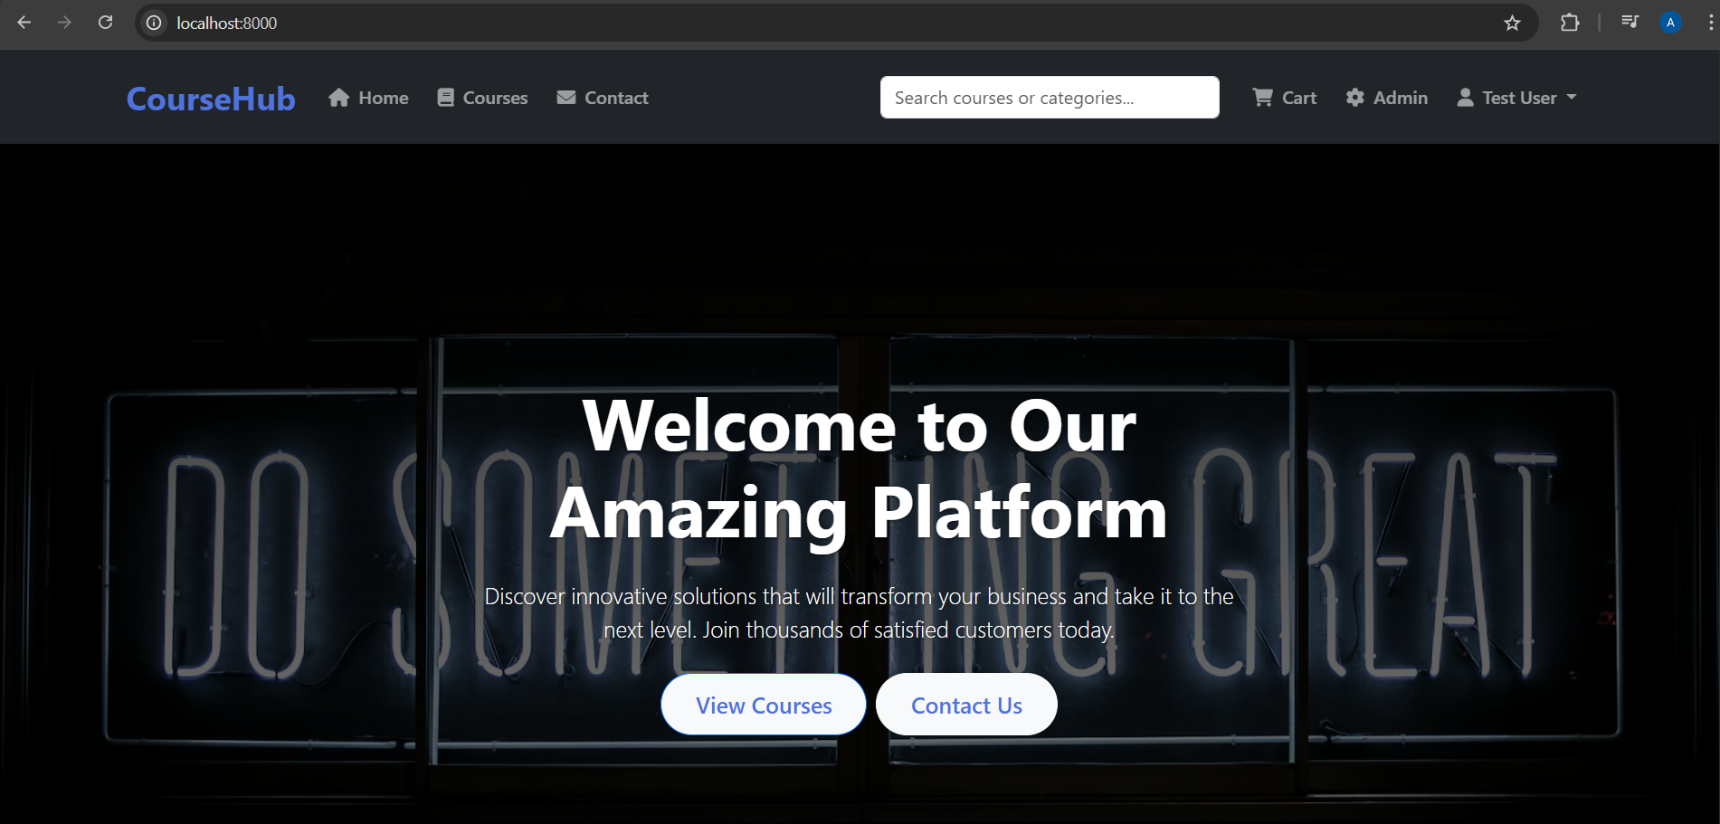
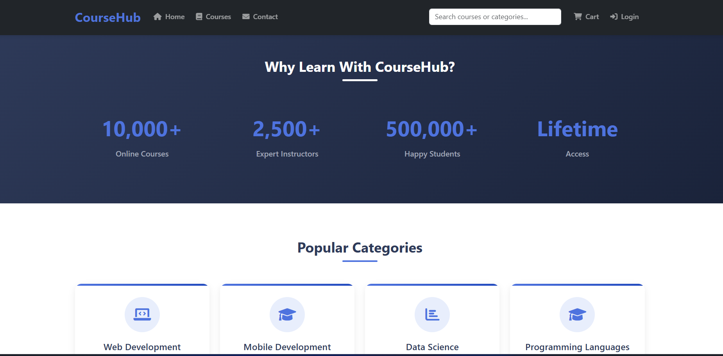
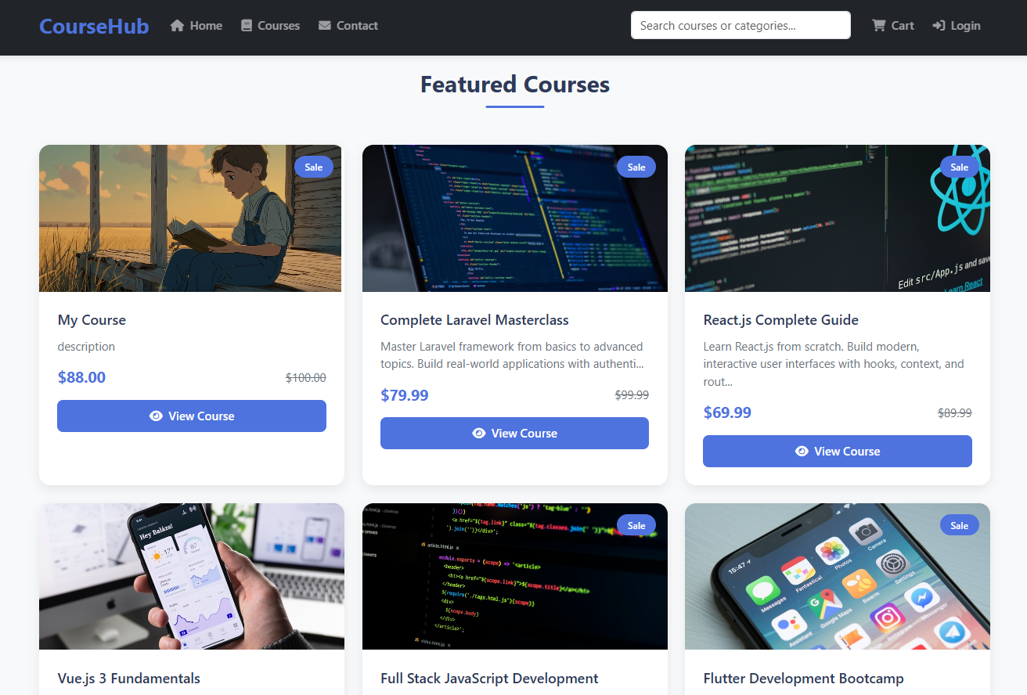
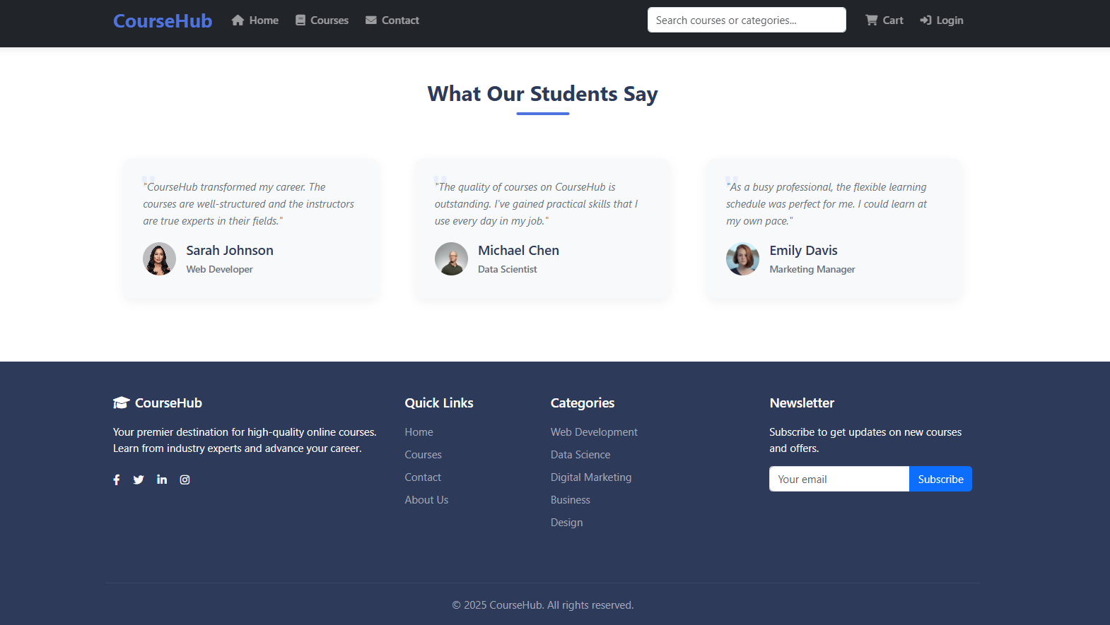
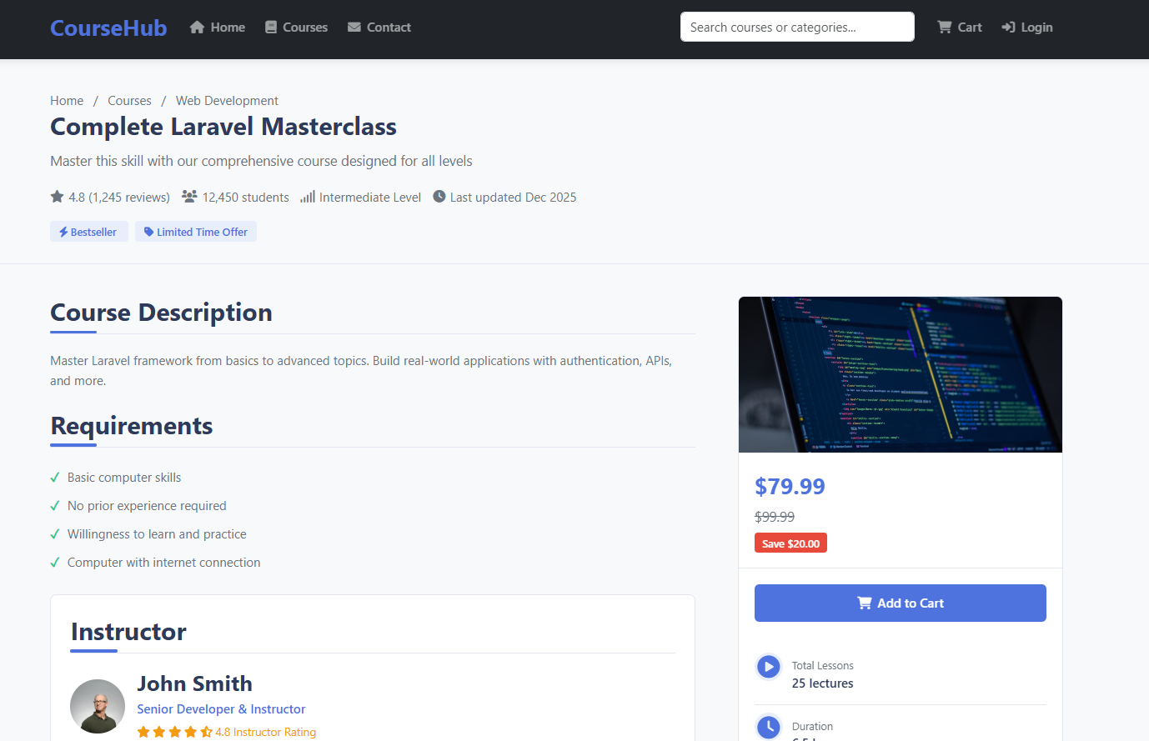

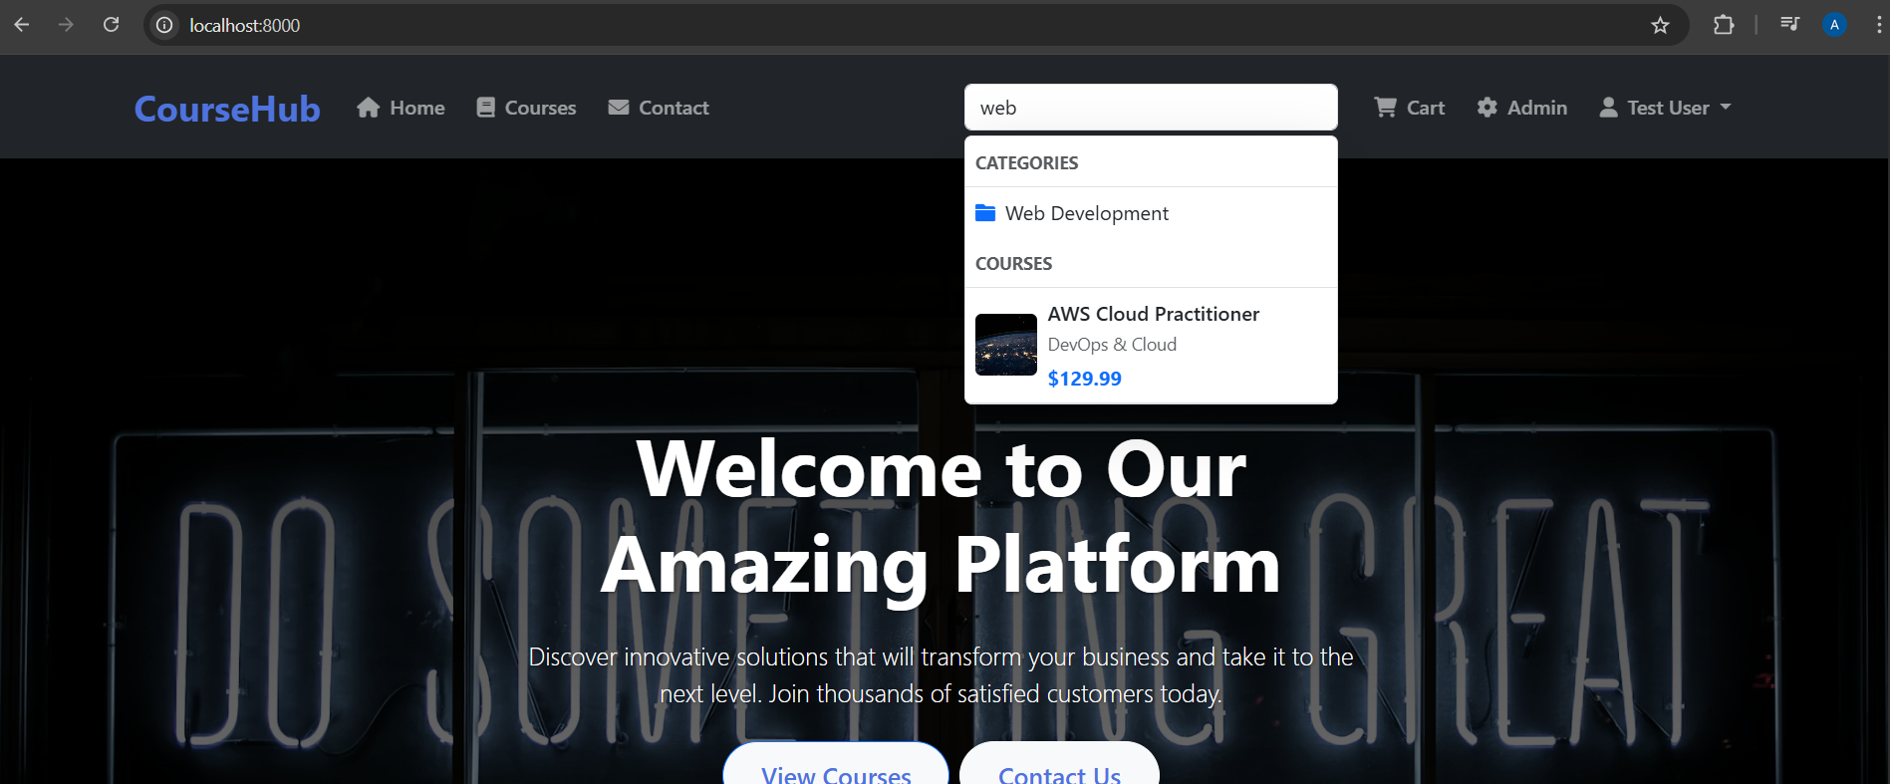
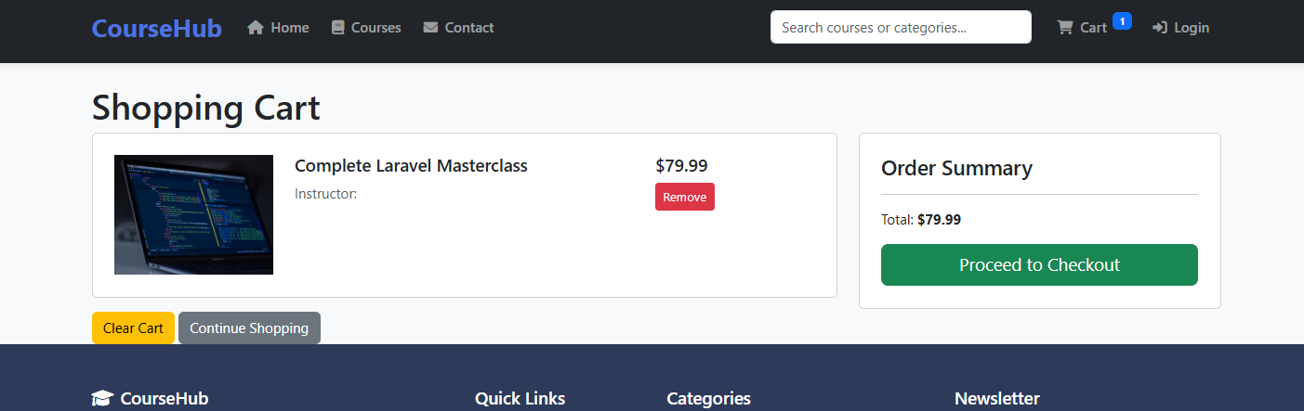
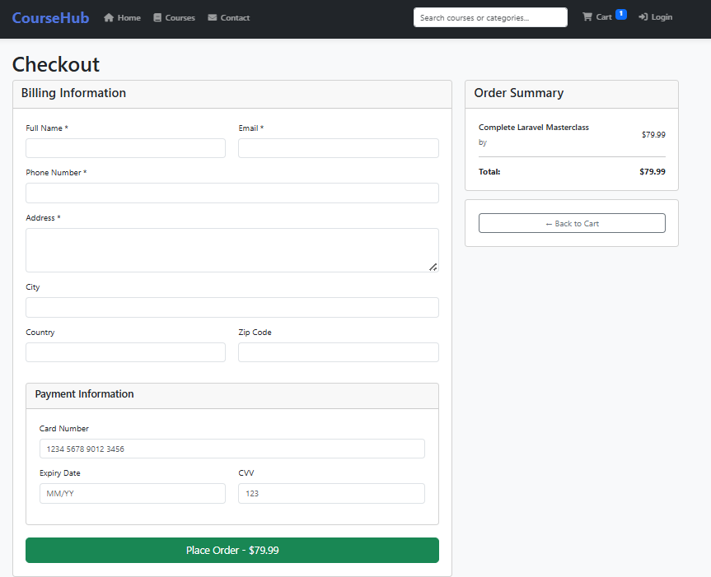
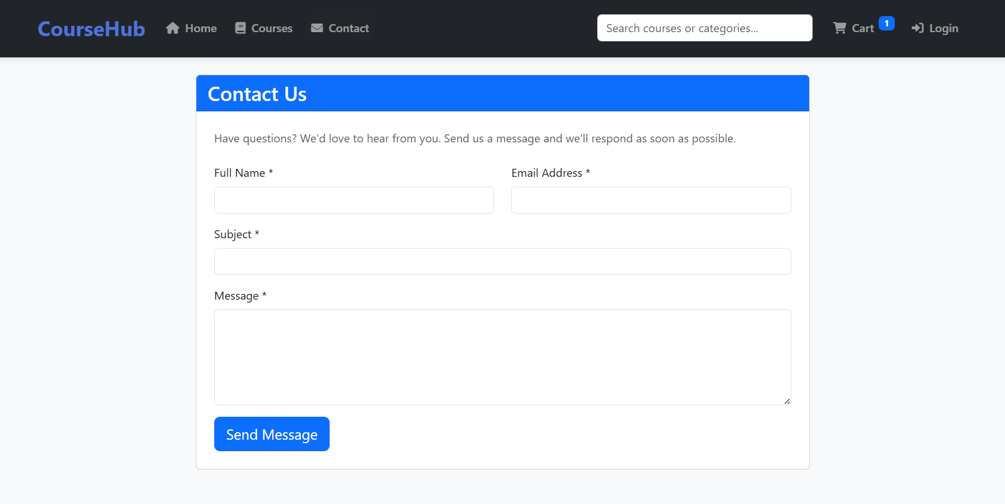
Admin Panel
