**TREE:**

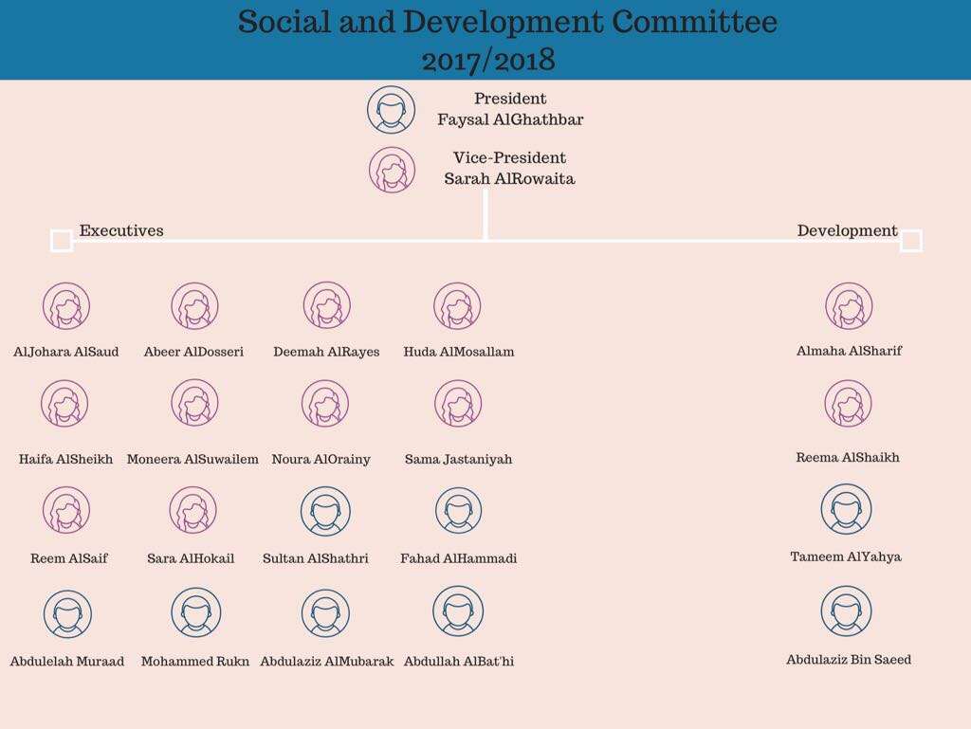

**DEPARTMENTS:**

CATERING

ENTERTAINMENT  
REGISTRATION

FINANCE

MARKETING

DECORATIONS

LOGISTICS

SPONSORSHIP