Machine-Learning-Based Near-Urban Expansion Suitability Analysis
Enugu State, Nigeria — Leakage-Free Reconstruction and Spatial Validation

Abstract
This study reconstructs a machine-learning-based near-urban expansion suitability analysis for Enugu State, Nigeria, after a methodological audit identified target leakage and a distance-driven control design in the earlier workflow. The corrected experiment asks whether seven baseline/static environmental and accessibility predictors can distinguish observed 2020–2025 expansion from stable non-built controls within the same 30–90 m near-urban support. Extra Trees was evaluated using spatially separated Train, Validation and Test blocks and benchmarked against a trivial distance-to-existing-built-up model. On the independent spatial Test set, Extra Trees achieved ROC-AUC 0.727, PR-AUC 0.332, balanced accuracy 0.661 and F1 0.337. The distance-only benchmark achieved ROC-AUC 0.707 and PR-AUC 0.190; thus Extra Trees improved discrimination by +0.020 ROC-AUC and +0.142 PR-AUC, although the baseline retained slightly higher balanced accuracy. The final probability surface uses a Validation-selected operating threshold of 0.36. High-confidence predictions at p>=0.70 cover only 37.27 km² (4.25% of the valid prediction domain), indicating that the model assigns strong confidence to a limited portion of the near-urban landscape. This sparse high-confidence result is retained explicitly rather than hidden through threshold adjustment.

1. Project Background and Research Question
Urban expansion suitability models can appear highly accurate when spatially autocorrelated samples, target-derived predictors or sampling rules inadvertently encode the outcome. The Enugu project was therefore reconstructed from the label-design stage onward. The final research question is: among comparable near-urban pixels within the observed 30–90 m proximity support to 2020 built-up land, can baseline environmental, accessibility, population and land-cover characteristics distinguish pixels that transitioned to built-up by 2025?

2. Leakage Audit and Target Reconstruction
The audit identified two major problems in the earlier experiment. First, administrative/sample-construction fields could enter the predictor set. Second, the original positive and negative samples occupied nearly disjoint distance ranges relative to 2020 built-up land, making distance almost a direct proxy for the target. The corrected design retains accepted observed expansion pixels and reconstructs stable non-built controls from the same 30–90 m near-urban distance support. Distance to 2020 built-up is excluded from the ML predictors and used only as a benchmark.

3. Data and Predictors
The final model uses seven baseline/static predictors: elevation, slope, distance to road, distance to recurring surface water, distance to drainage, 2020 population density and 2020 baseline land cover. Outcome-year variables, coordinates, raster indices, block identifiers, sample IDs and distance to 2020 built-up are excluded from the ML predictor set.
Predictor | ExtraTrees_Importance
Population_Density | 0.2862
Distance_to_Surface_Water_m | 0.1919
Elevation_m | 0.1836
Distance_to_Road_m | 0.1202
Baseline_LULC_2020 | 0.1117
Distance_to_Drainage_m | 0.0739
Slope_deg | 0.0325

4. Spatial Validation and Baseline Benchmark
Spatial blocks were used to separate Train, Validation and Test partitions. Extra Trees was trained on Train data, the decision threshold was selected using Validation only, and the Test blocks were retained for final independent evaluation. A trivial distance-to-2020-built-up benchmark was evaluated under the same prediction question.
Model | N | ROC_AUC | PR_AUC | Balanced_Accuracy | Accuracy | Precision | Recall | F1 | TN | FP | FN | TP
Extra Trees — redesigned near-urban target | 24812 | 0.7267 | 0.3319 | 0.6614 | 0.7635 | 0.2469 | 0.5293 | 0.3368 | 17453 | 4544 | 1325 | 1490
Distance-to-built-2020 — trivial baseline | 24812 | 0.7068 | 0.1903 | 0.6689 | 0.5538 | 0.1790 | 0.8178 | 0.2937 | 11438 | 10559 | 513 | 2302

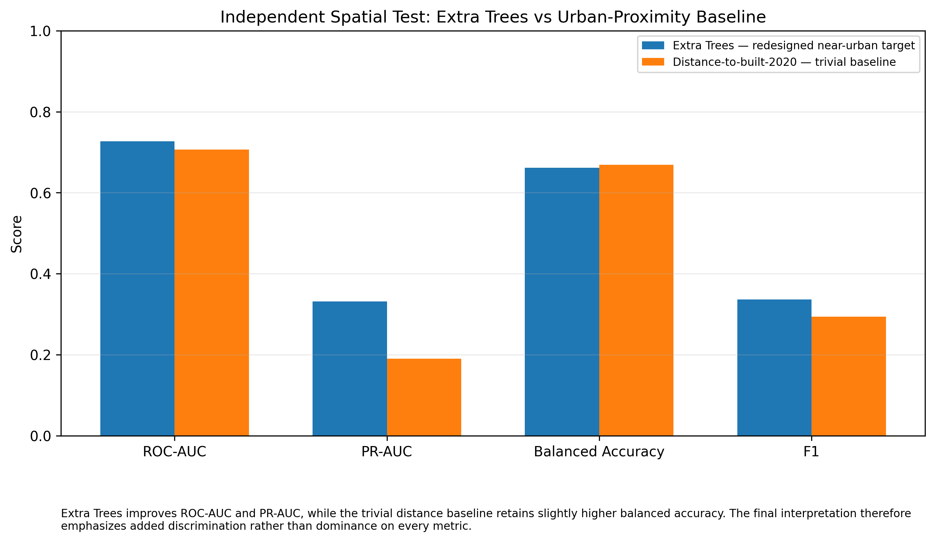
Figure 1. Independent spatial Test benchmark: Extra Trees versus distance-to-built baseline.
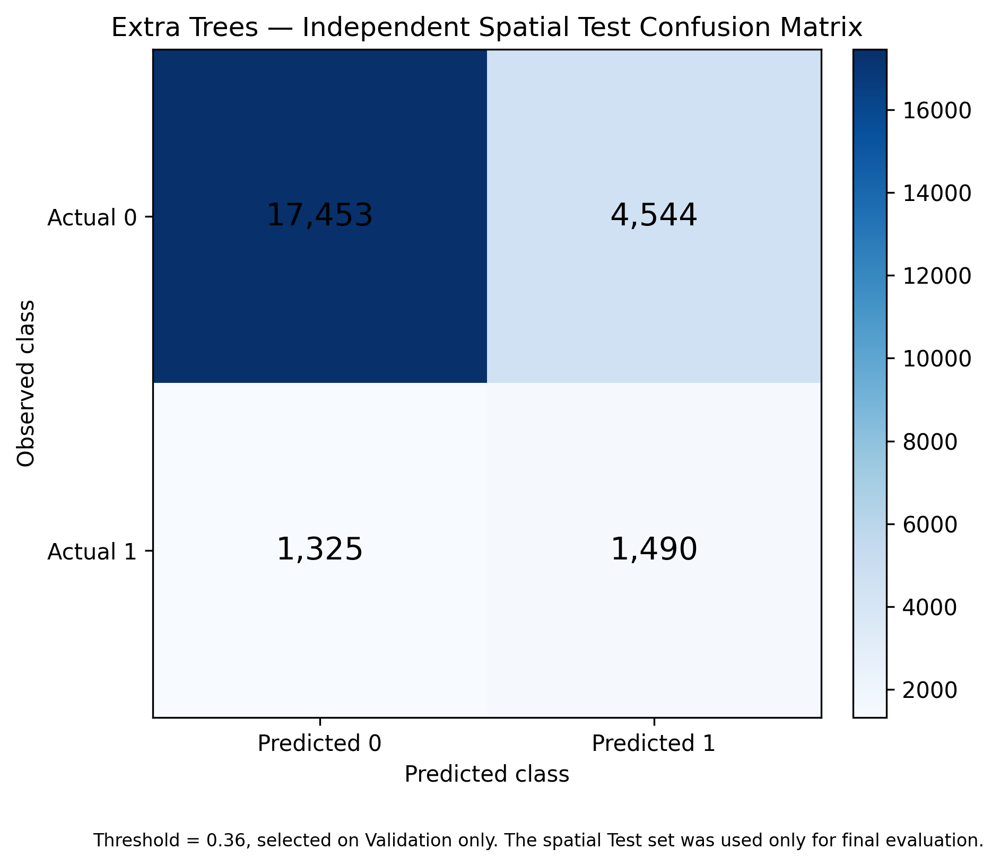
Figure 2. Extra Trees confusion matrix on the independent spatial Test set.

5. Final Probability Surface and Suitability Classes
The final probability surface was produced after refitting the locked Extra Trees design using Train + Validation only. The independent R3G Test results remain the authoritative generalization evidence. The operating threshold is 0.36. Final classes use fixed numerical probability thresholds rather than quantiles.
Class_Value | Suitability_Class | Pixels | Area_km2 | Pct_of_Valid_Prediction_Domain
1 | Low | 794587 | 715.1283 | 81.5286
2 | Moderate | 84989 | 76.4901 | 8.7203
3 | High | 53627 | 48.2643 | 5.5024
4 | Very High | 41408 | 37.2672 | 4.2487

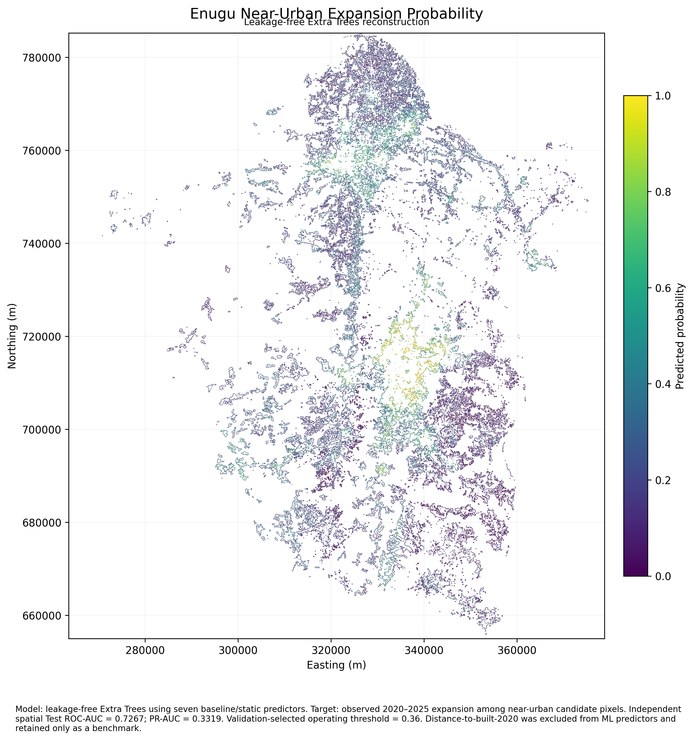
Figure 3. Final leakage-free near-urban expansion probability surface.
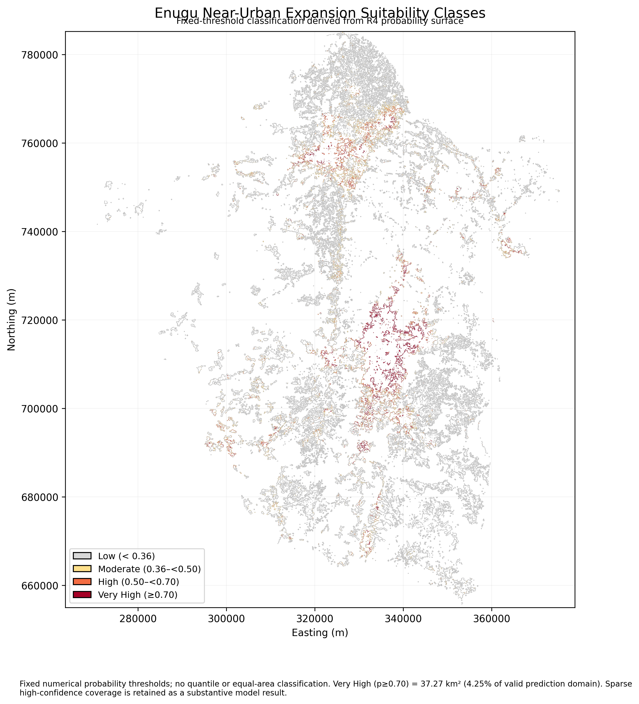
Figure 4. Final fixed-threshold near-urban suitability classes.

6. Confidence and Threshold Diagnostics
Only 37.27 km² (4.25%) of the valid prediction domain reaches p>=0.70. This is a central model result: the ensemble assigns very high confidence to a relatively small portion of the near-urban landscape.
Probability_Threshold | Pixels_at_or_above | Area_km2 | Pct_of_Valid_Prediction_Domain | Threshold_Role
0.3600 | 180024 | 162.0216 | 18.4714 | Validation-selected operating threshold
0.5000 | 95035 | 85.5315 | 9.7511 | Confidence/probability reporting threshold
0.6000 | 62225 | 56.0025 | 6.3846 | Confidence/probability reporting threshold
0.7000 | 41408 | 37.2672 | 4.2487 | Confidence/probability reporting threshold
0.8000 | 27096 | 24.3864 | 2.7802 | Confidence/probability reporting threshold
0.9000 | 15314 | 13.7826 | 1.5713 | Confidence/probability reporting threshold

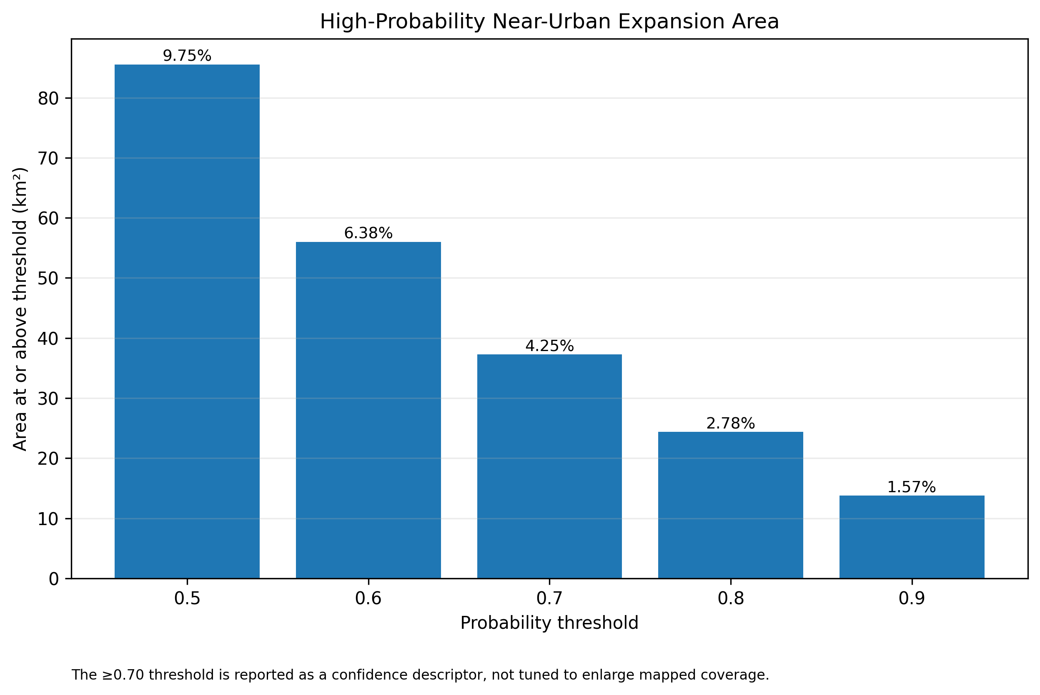
Figure 5. Area retained at increasing probability thresholds.
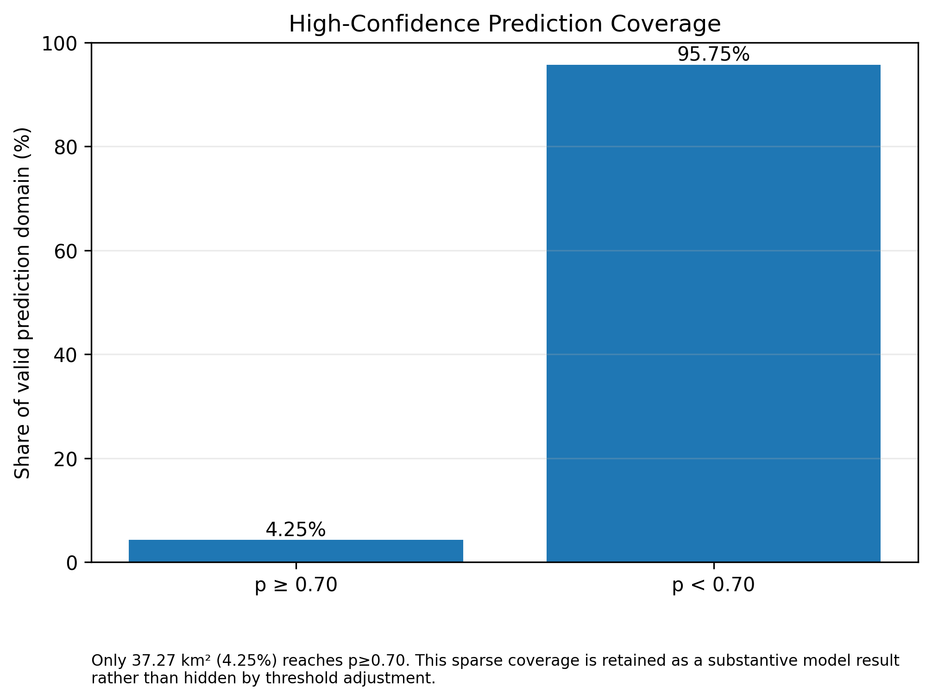
Figure 6. Spatial scarcity of p>=0.70 high-confidence predictions.

7. Predictor Importance
Population density is the strongest model predictor, followed by distance to recurring surface water and elevation. These values represent model usage and predictive association, not causal effect.
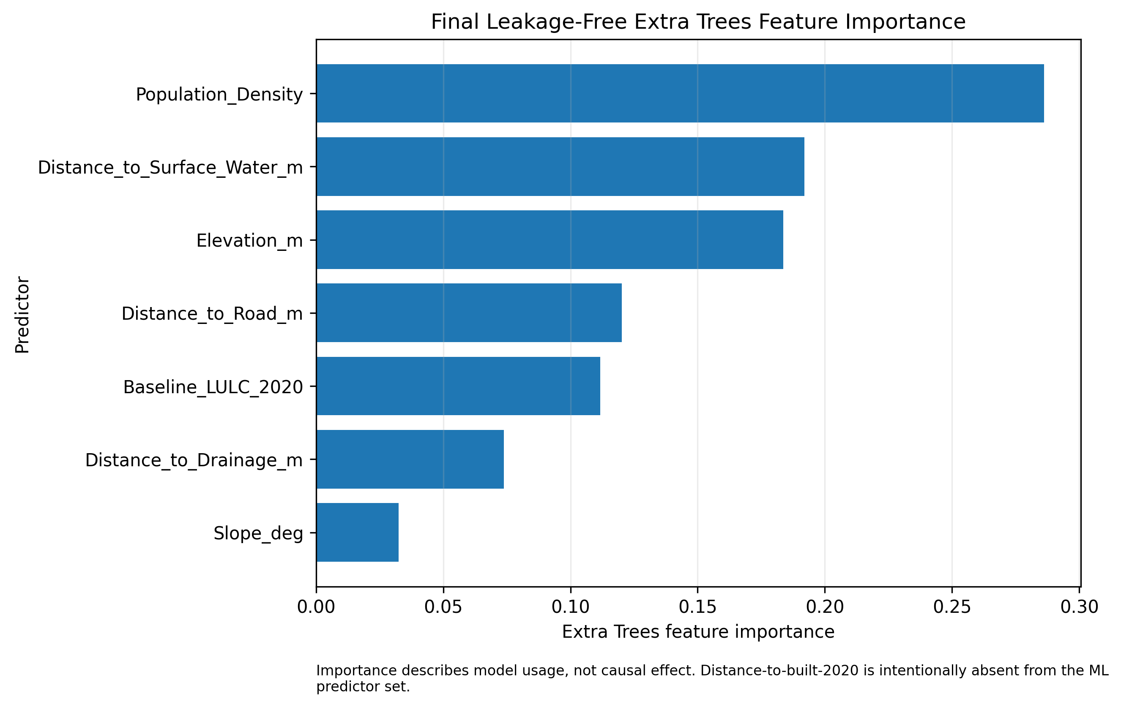
Figure 7. Final leakage-free Extra Trees feature importance.

8. Interpretation
The corrected model provides moderate spatially held-out discrimination (ROC-AUC 0.727; PR-AUC 0.332). Relative to the proximity-only baseline, Extra Trees improves ROC-AUC by +0.020 and PR-AUC by +0.142. However, the distance baseline has slightly higher balanced accuracy (0.669 vs 0.661). The appropriate conclusion is therefore that the clean ML model adds ranking/discrimination beyond simple urban proximity, not that it dominates the baseline across every metric.

9. Planning Relevance
The resulting probability and class maps can support exploratory urban-growth monitoring, prioritization of locations for further assessment, and discussion of where near-urban development pressure may be concentrated. They should be combined with statutory planning policy, infrastructure capacity, environmental constraints, tenure conditions and field verification.

10. Limitations
1. The model predicts observed near-urban expansion under the reconstructed 2020–2025 experiment; it should not be interpreted as causal probability, planning approval, or a universal land-suitability score.
2. Independent spatial Test performance is moderate rather than near-perfect: ROC-AUC 0.727, PR-AUC 0.332, and balanced accuracy 0.661.
3. Extra Trees improves discrimination relative to the distance-only benchmark, particularly PR-AUC (+0.142), but the distance baseline retains slightly higher threshold-dependent balanced accuracy (0.669 vs 0.661). Therefore the correct claim is added discrimination, not superiority on every metric.
4. The redesigned target is restricted to a 30–90 m near-urban support. Results should not be extrapolated to the entire state or to locations outside the prediction domain without further validation.
5. Feature importance measures model usage, not causality. Population density, water proximity and elevation should therefore be interpreted as predictive associations.
6. High-confidence p>=0.70 predictions remain sparse: 37.27 km² (4.25% of the valid prediction domain). This result should be reported explicitly rather than hidden by lowering the threshold.
7. The experiment is based on available 2020/2025 land-cover and environmental data; uncertainty in source data propagates into the labels and model outputs.

11. Definitive Conclusion
The reconstructed workflow replaces the earlier leakage-contaminated interpretation with a transparent spatially validated experiment. It demonstrates that a clean Extra Trees model can add useful discrimination beyond urban proximity under a carefully constrained near-urban prediction question, while also showing that uncertainty remains substantial and high-confidence predictions are spatially sparse. These limitations are part of the scientific result and are retained in the final project package.

Definitive Reconstruction Status: VALIDATED

