Spatial Healthcare Accessibility and Primary Healthcare Planning in Kano State, Nigeria
Final Validated Technical Report

Study Area: Kano State, Nigeria
Theme: Primary Healthcare Accessibility and Spatial Planning
Final scientific review completed before publication

Executive Summary
This project examined how easily people across Kano State can reach primary healthcare facilities and whether the existing distribution of facilities is balanced against population demand. The analysis used 1,584 primary healthcare facilities, 484 wards and 16,789 population-demand cells. Road-network travel time was combined with a 15-minute two-step floating catchment area (2SFCA) analysis to measure modeled spatial availability.
The baseline population-weighted 2SFCA value was 0.8438 PHCs per 10,000 people. Adding the top 20 proposed PHCs increased this to 0.8545, which is a statewide increase of only 1.26%. About 687,356 people, or 3.66% of the state population, experienced an improvement in modeled access under the top-20 scenario. This shows that new facilities can help selected underserved communities, but adding facilities alone produces only a small statewide change.
The results suggest that new PHCs should be targeted at specific underserved communities rather than treated as a complete solution to statewide healthcare access. The limited statewide improvement also shows that future planning should consider more than facility location. Information on staffing, equipment, service capacity and actual use would be needed to understand whether facilities can meet local demand.

1. Introduction

1.1 Problem
A health facility may be physically close to a community but still serve a very large surrounding population. Looking only at distance can therefore hide areas where nearby facilities face high demand. The project combined travel time, facility availability and population demand to identify places where healthcare access is weaker.

1.2 Research Question
Where are the main gaps in primary healthcare access across Kano State, and how much could carefully selected new PHC locations improve access?

2. Data and Method
The analysis first measured road-network travel time from population locations to the nearest PHC. A 15-minute 2SFCA model was then used to compare the number of PHCs available around each demand location with the population competing for those facilities. Ward-level underservice and planning-priority classes were created from the travel, supply and coverage results. Ninety-seven possible new PHC locations were assessed, after which the top 5, top 10 and top 20 options were tested as expansion scenarios. The 2SFCA results were also checked with three distance-decay approaches to see whether the main pattern depended strongly on the original 15-minute assumption.
Item | Details
Primary healthcare facilities | 1,584
Operational wards | 484
Population-demand cells | 16,789
Candidate PHC locations assessed | 97
Expansion scenarios | +5, +10 and +20 PHCs
Main accessibility model | 15-minute 2SFCA
Sensitivity checks | 3-zone E2SFCA and two Gaussian models

3. Primary Healthcare Distribution and Travel Time
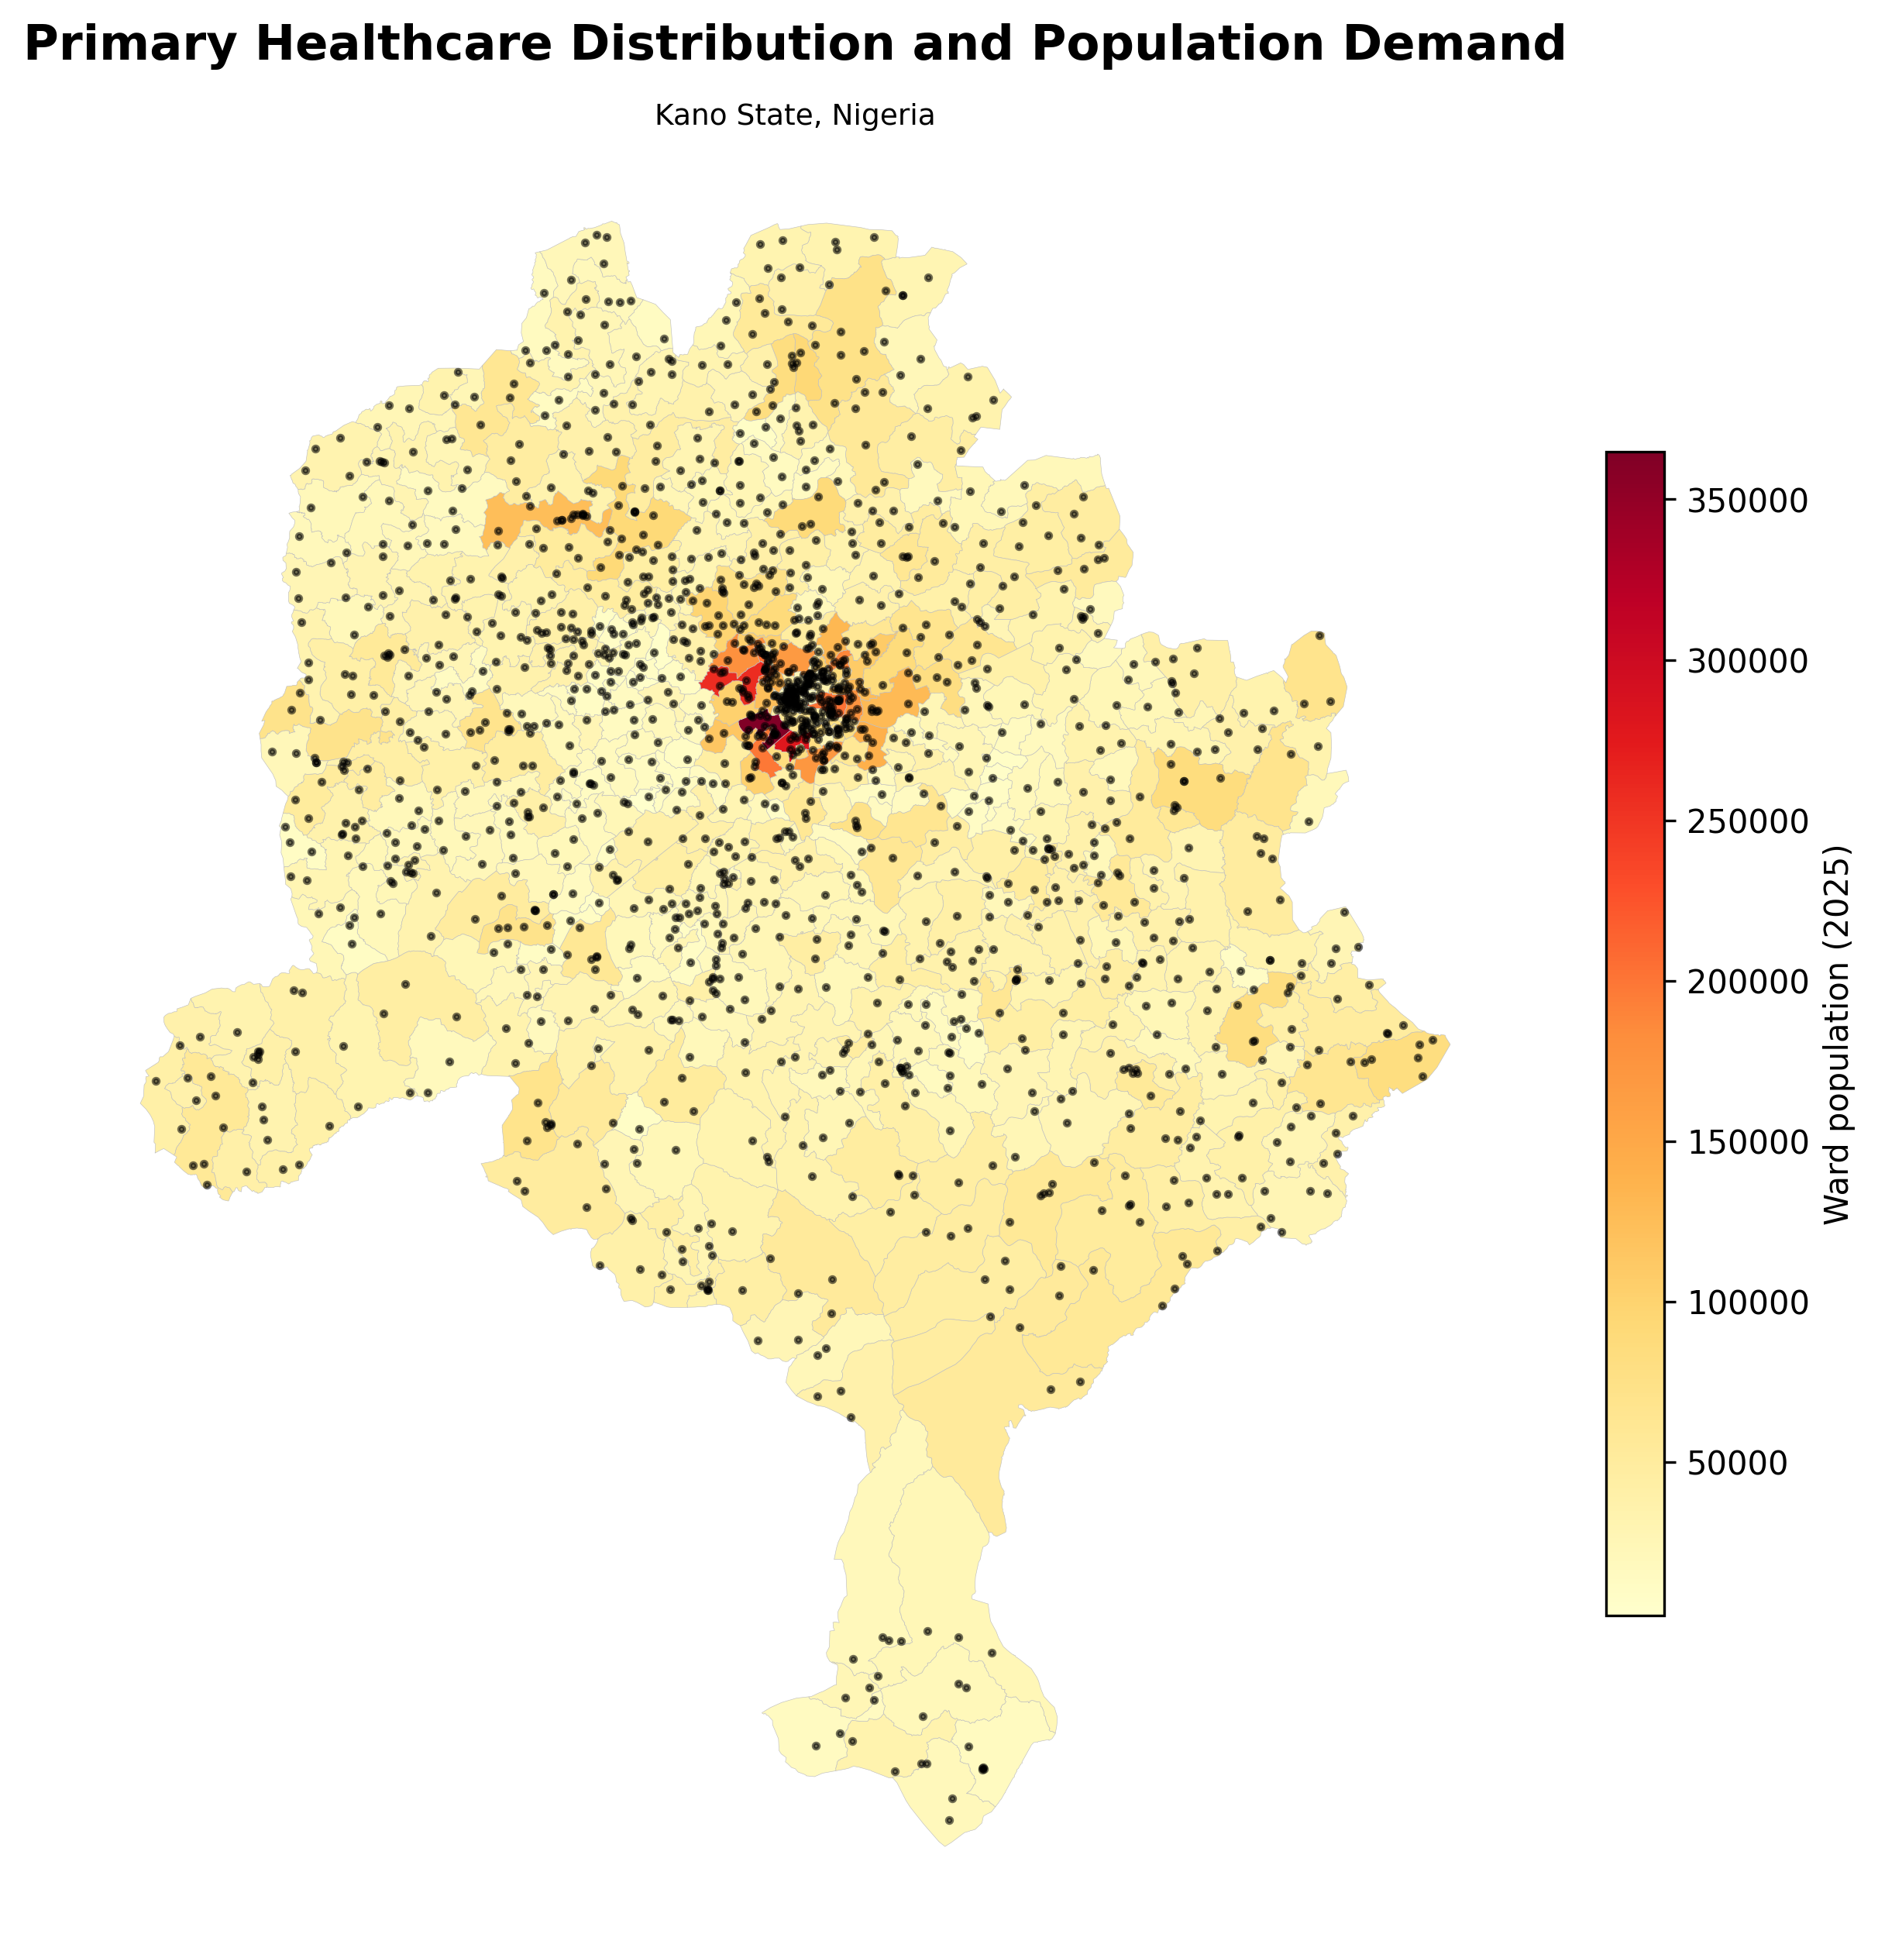
Figure 1. Distribution of primary healthcare facilities and ward population demand.
The map shows how primary healthcare facilities are distributed across Kano State alongside the population living in each ward. The pattern is uneven. Some highly populated wards have many nearby facilities, while others depend on a smaller number of facilities.
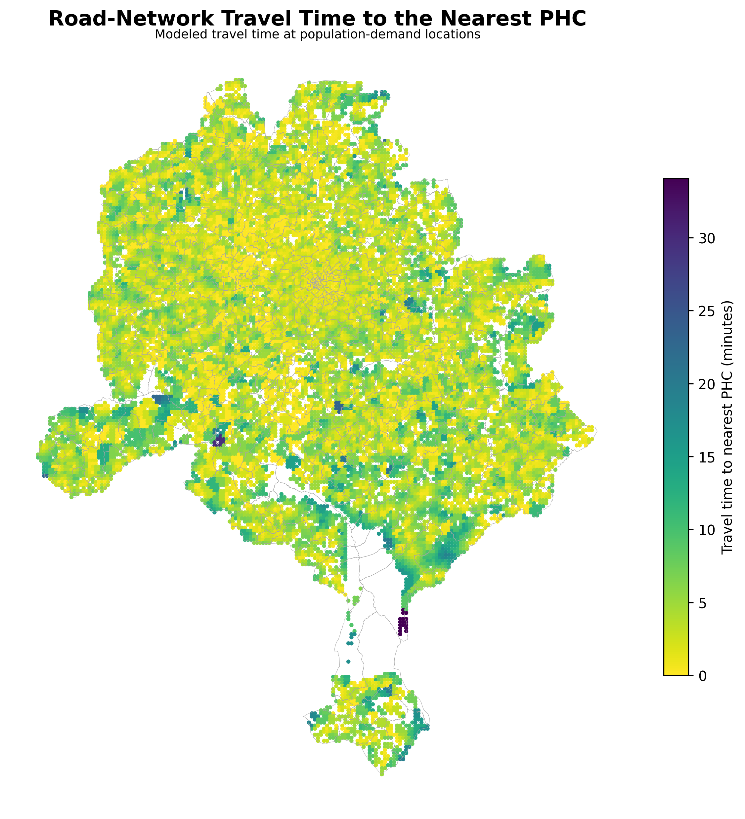
Figure 2. Road-network travel time from population locations to the nearest primary healthcare facility.
Travel time is generally low in many parts of the state, which suggests that geographical proximity to a PHC is often good. However, short travel time does not automatically mean that the available facilities are sufficient for the surrounding population.

4. Healthcare Accessibility
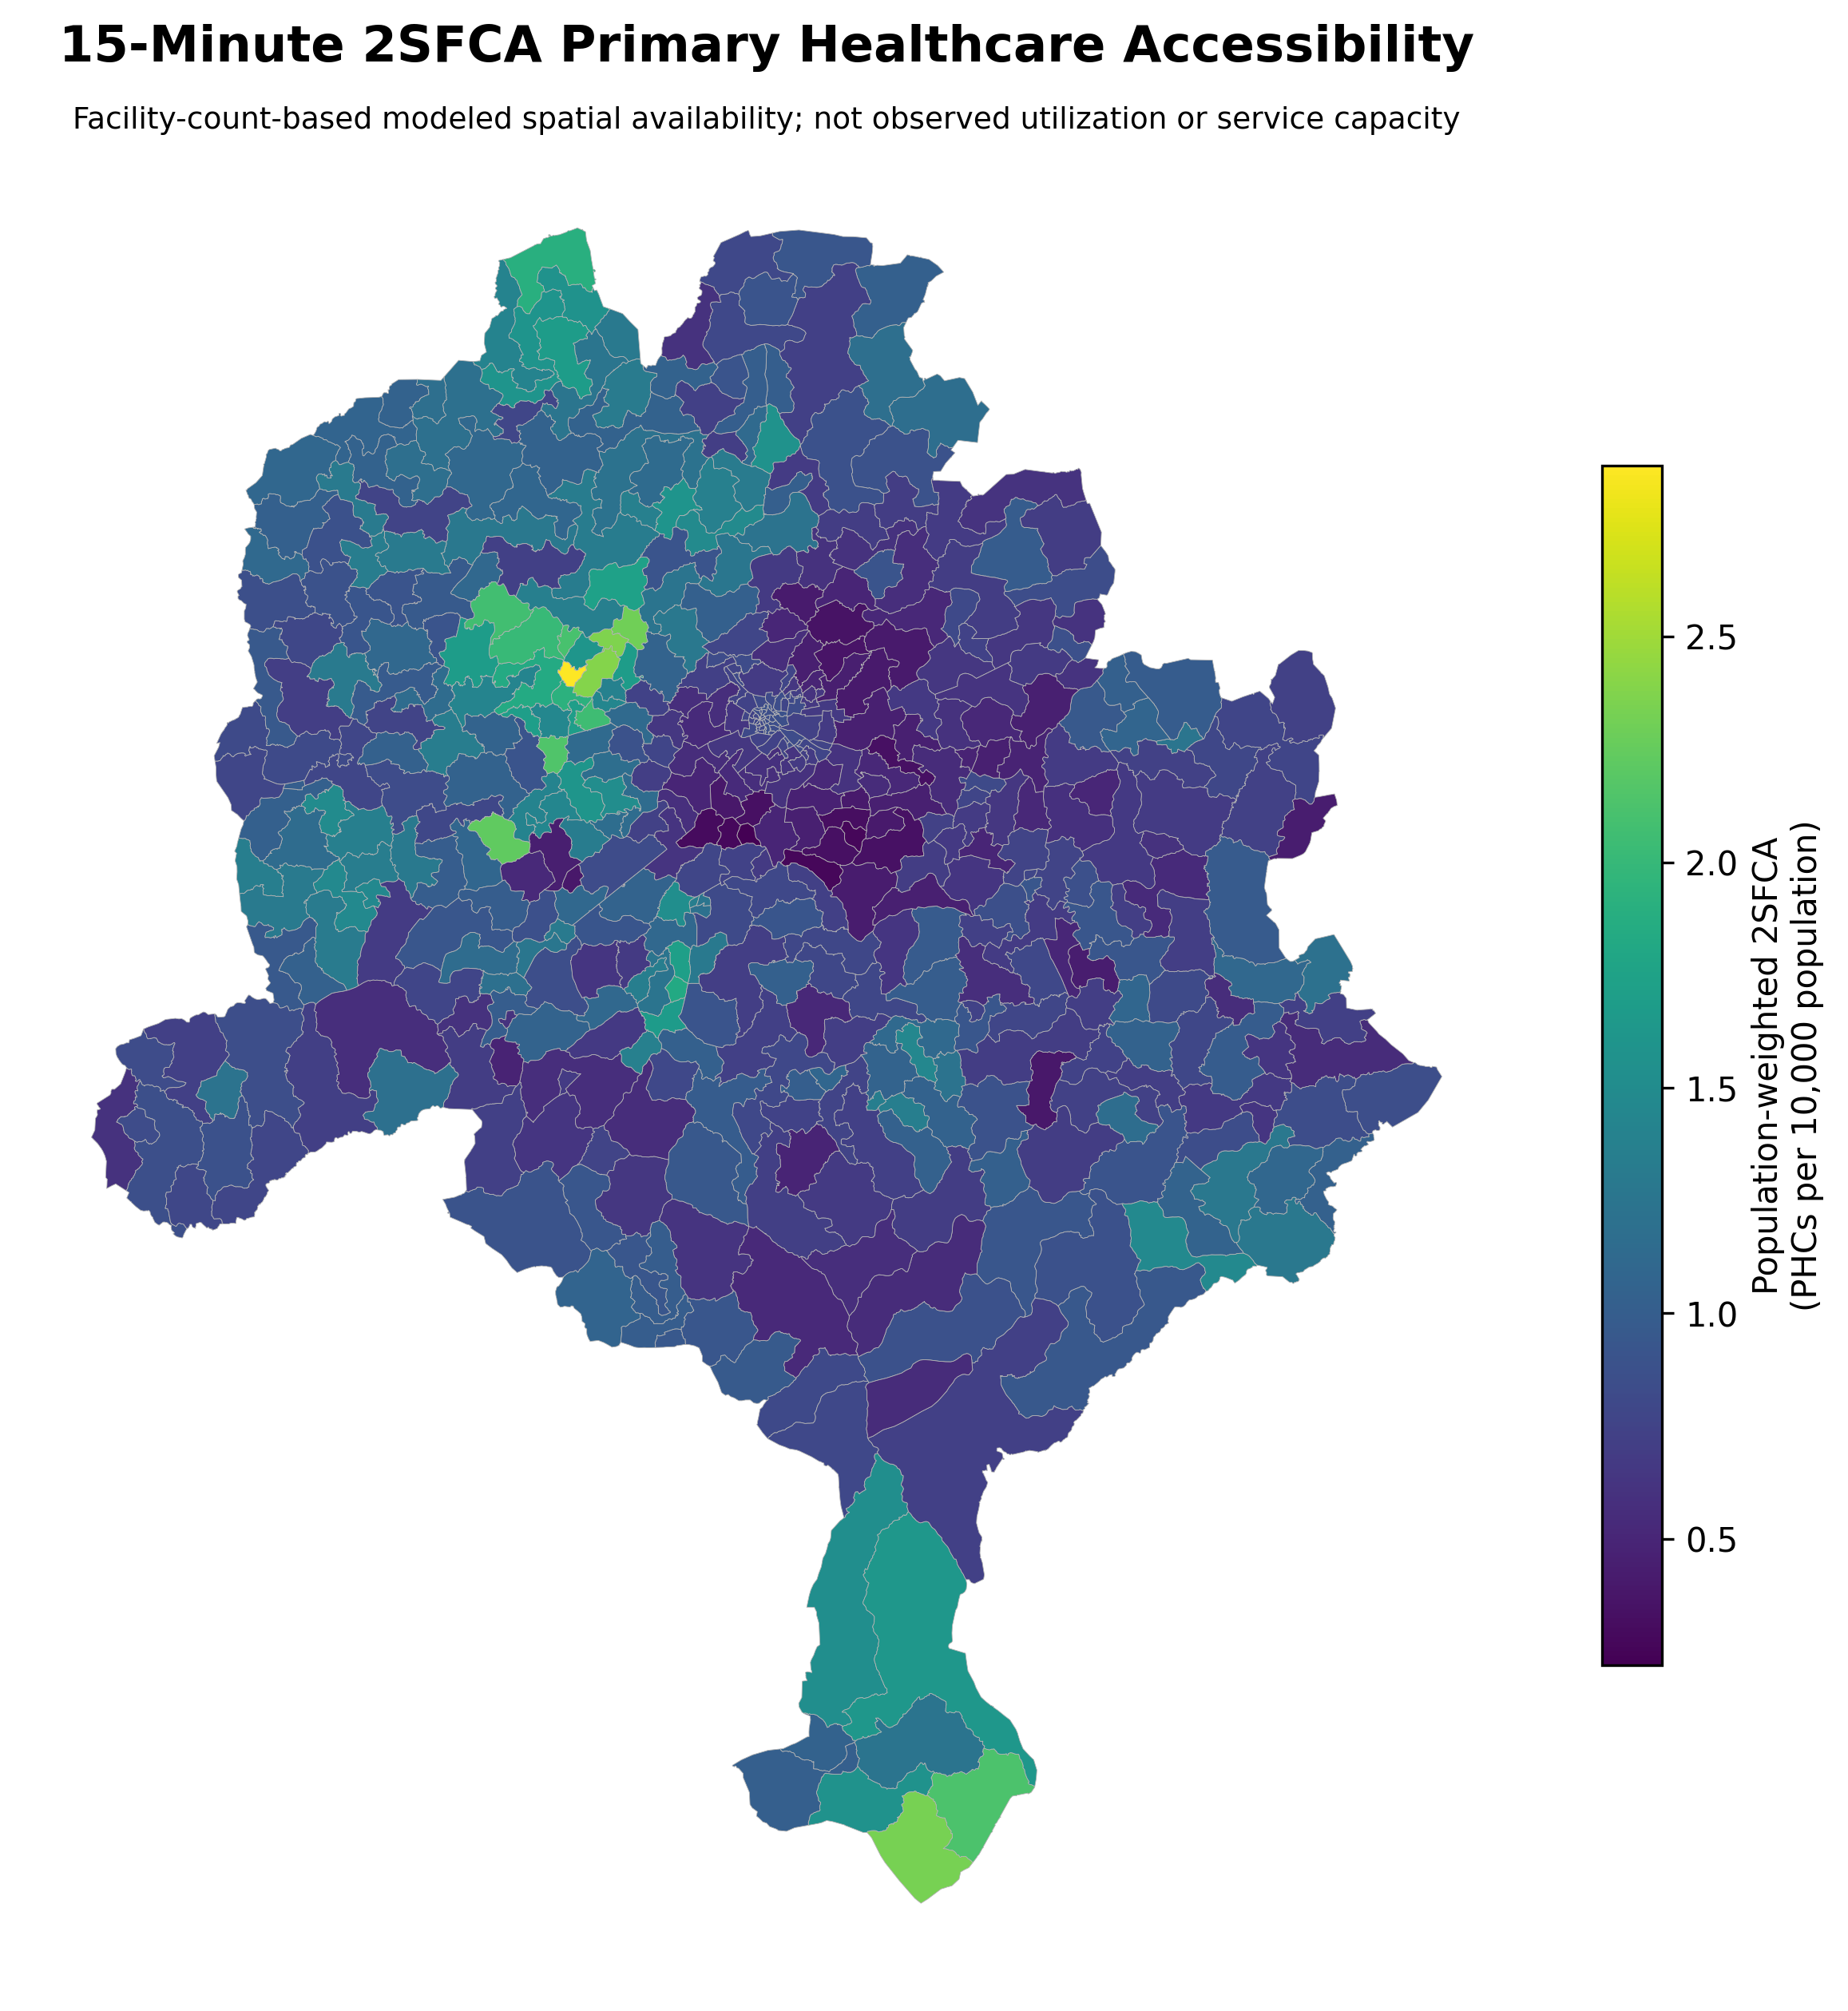
Figure 3. Validated 15-minute 2SFCA healthcare accessibility.
The 2SFCA result compares the number of available PHCs with the population competing for them. It therefore gives a different view from travel time alone. A community may be close to a facility but still have relatively low modeled access when that facility serves a large population.
The baseline population-weighted 2SFCA value is 0.8438 PHCs per 10,000 people.

5. Underserved Areas and Planning Priority
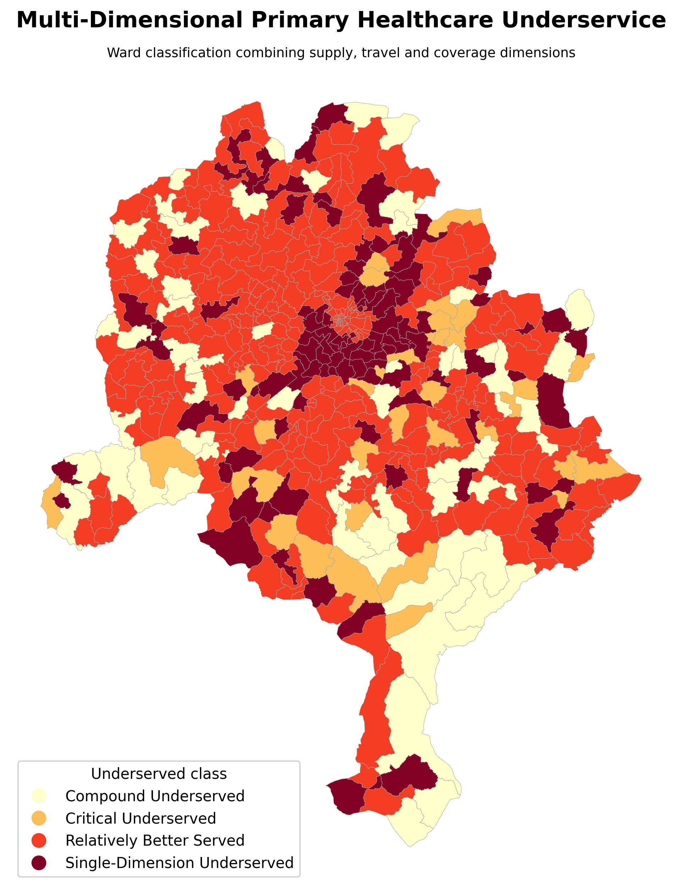
Figure 4. Ward-level healthcare underservice based on supply, travel and coverage indicators.
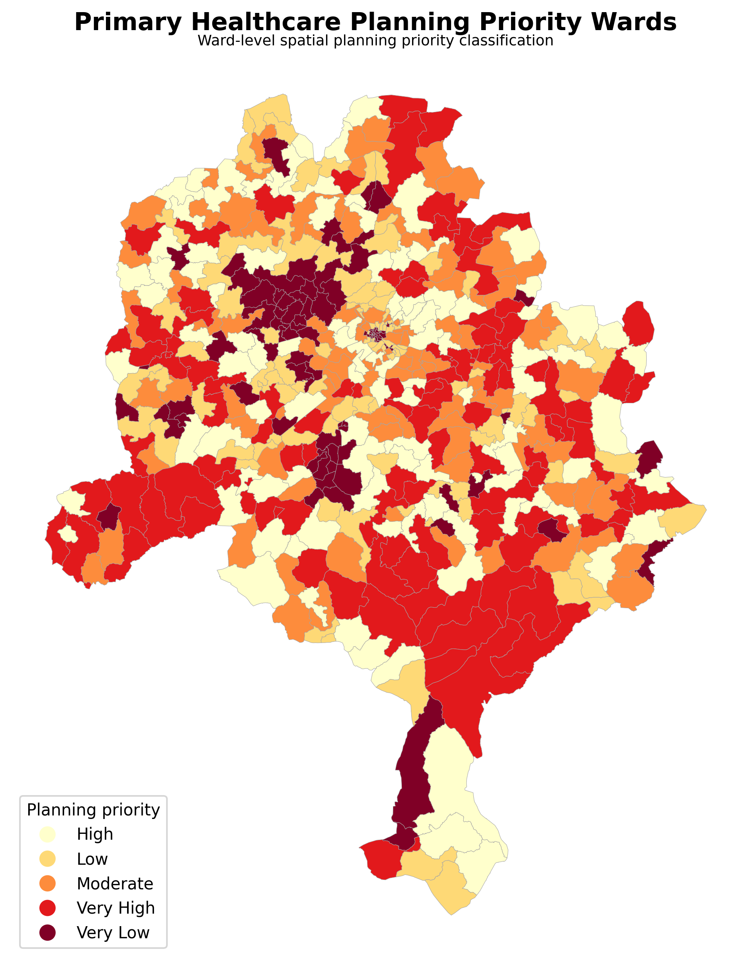
Figure 5. Ward-level primary healthcare planning priority.
The underserved and planning-priority maps identify wards where several access problems occur together. These maps are useful for deciding where further investigation or targeted intervention may be needed. They should not be read as maps of actual health outcomes.

6. PHC Expansion Scenarios
Scenario | 2SFCA | Statewide gain (%) | Population benefiting | Population benefiting (%)
Baseline | 0.8438 | 0.0000 | 0.0000 | 0.0000
+5 PHCs | 0.8465 | 0.3157 | 521,797 | 2.7798
+10 PHCs | 0.8492 | 0.6313 | 556,701 | 2.9657
+20 PHCs | 0.8545 | 1.2626 | 687,356 | 3.6618
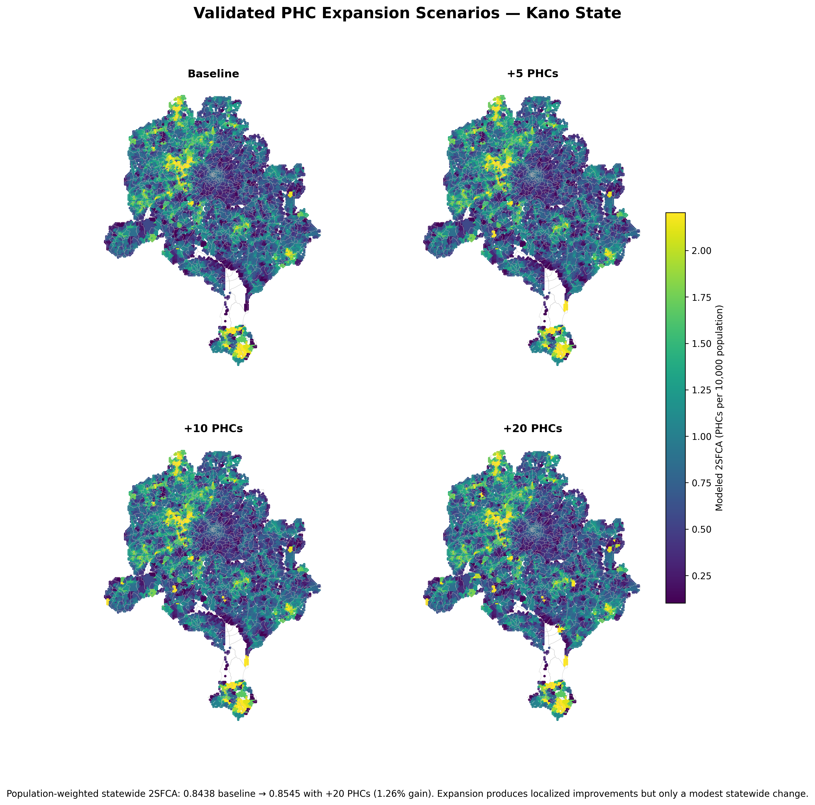
Figure 6. Baseline, +5, +10 and +20 PHC accessibility scenarios.
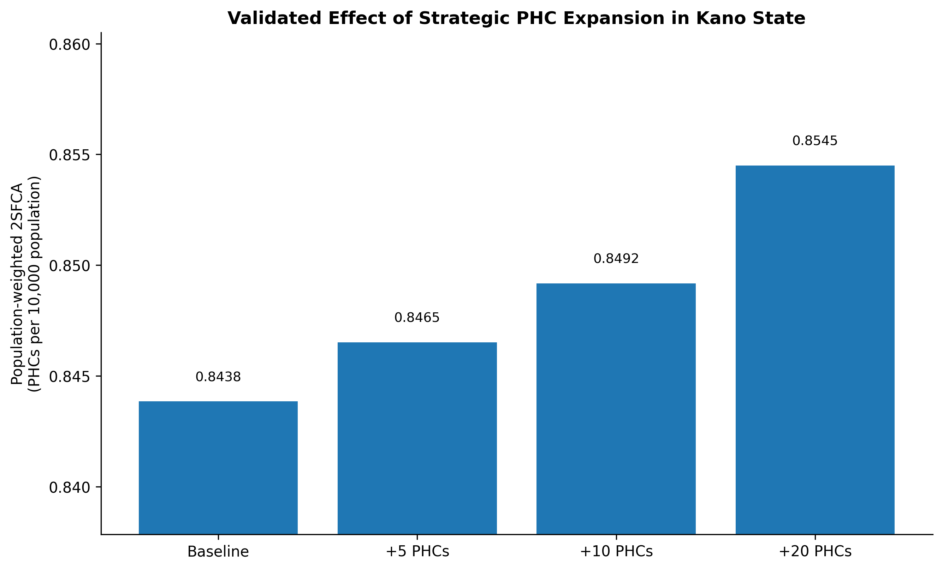
Figure 7. Population-weighted statewide 2SFCA under the four scenarios.
The baseline population-weighted 2SFCA value was 0.8438 PHCs per 10,000 people. Adding the top 20 proposed PHCs increased this to 0.8545, which is a statewide increase of only 1.26%. About 687,356 people, or 3.66% of the state population, experienced an improvement in modeled access under the top-20 scenario. This shows that new facilities can help selected underserved communities, but adding facilities alone produces only a small statewide change.
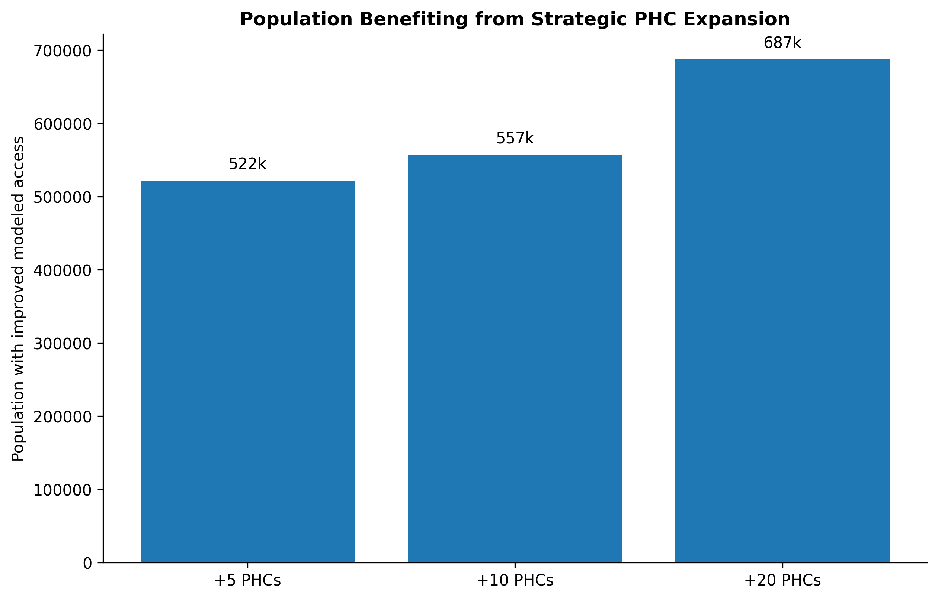
Figure 8. Population with improved modeled access under the expansion scenarios.

7. Candidate Locations for New PHCs
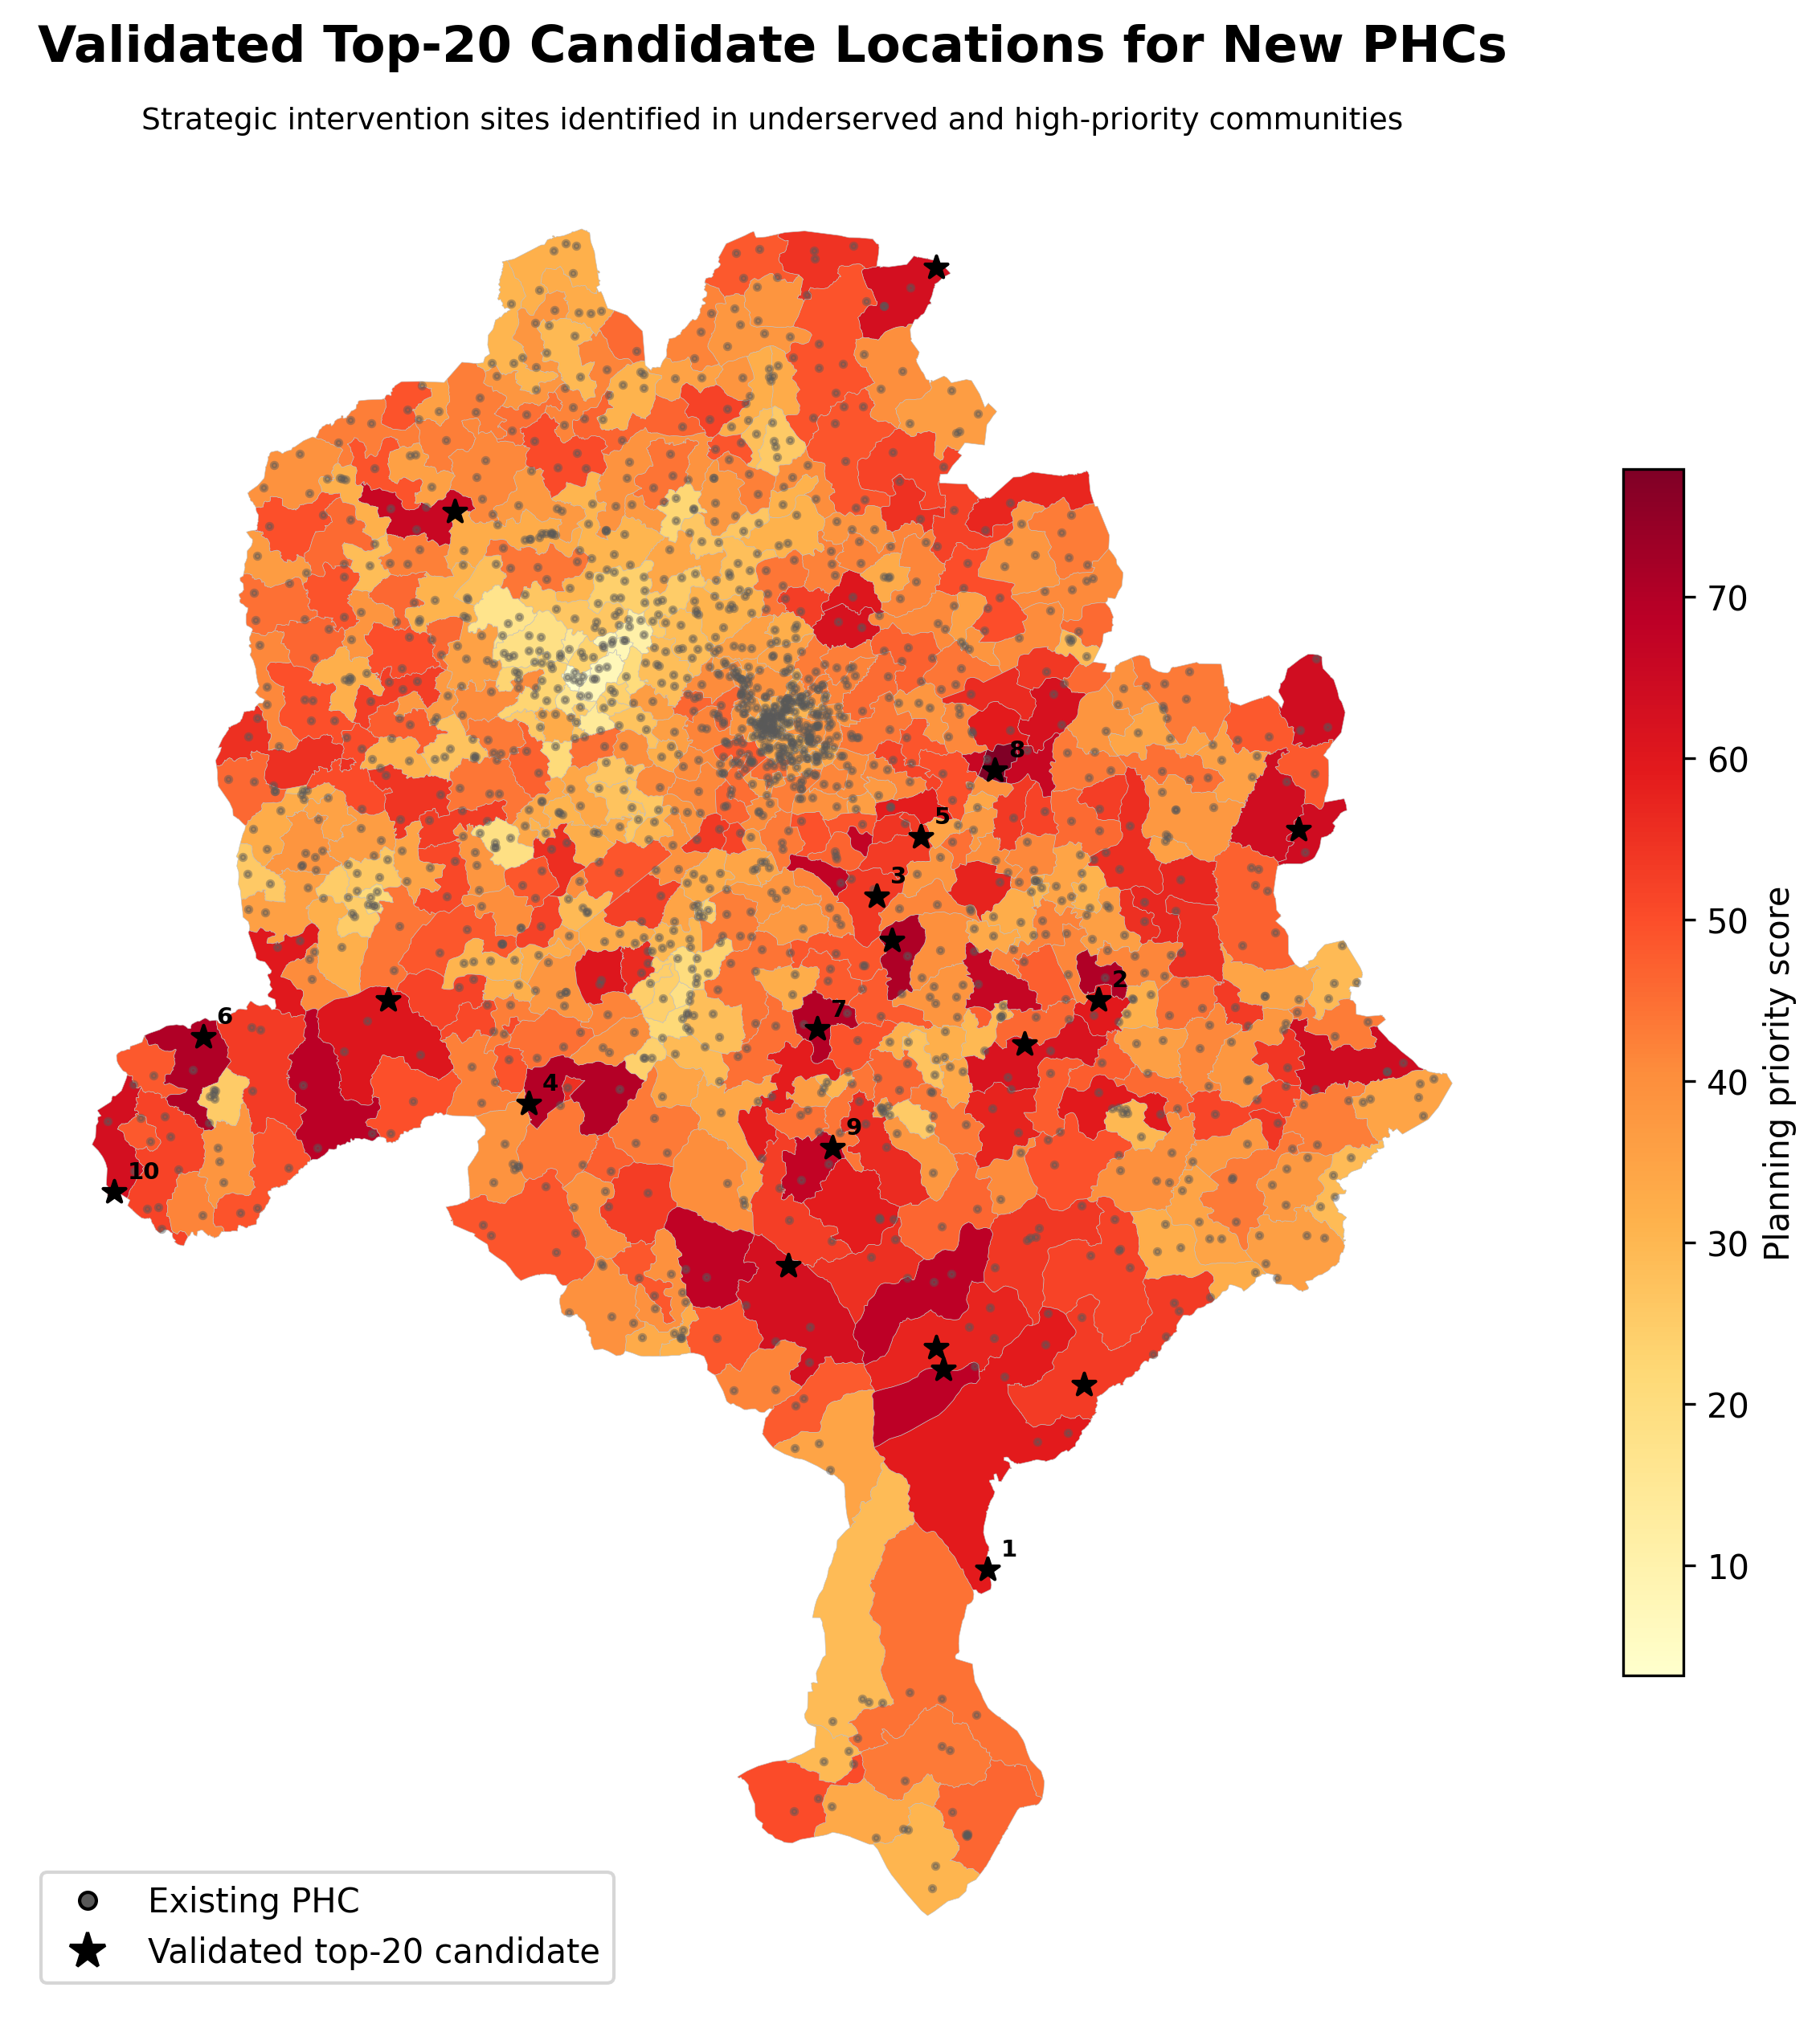
Figure 9. Validated top-20 candidate locations for new PHCs.
The top-20 sites were selected from 97 candidate locations. They are concentrated in communities where the analysis identified higher planning need. The locations are planning options rather than confirmed project sites.

8. Distance-Decay Sensitivity Check
The distance-decay tests supported the same overall conclusion. The broad accessibility pattern remained stable, although some local rankings changed when longer travel times were given less weight. The top-20 expansion scenario still produced only a small statewide improvement under all four accessibility methods.
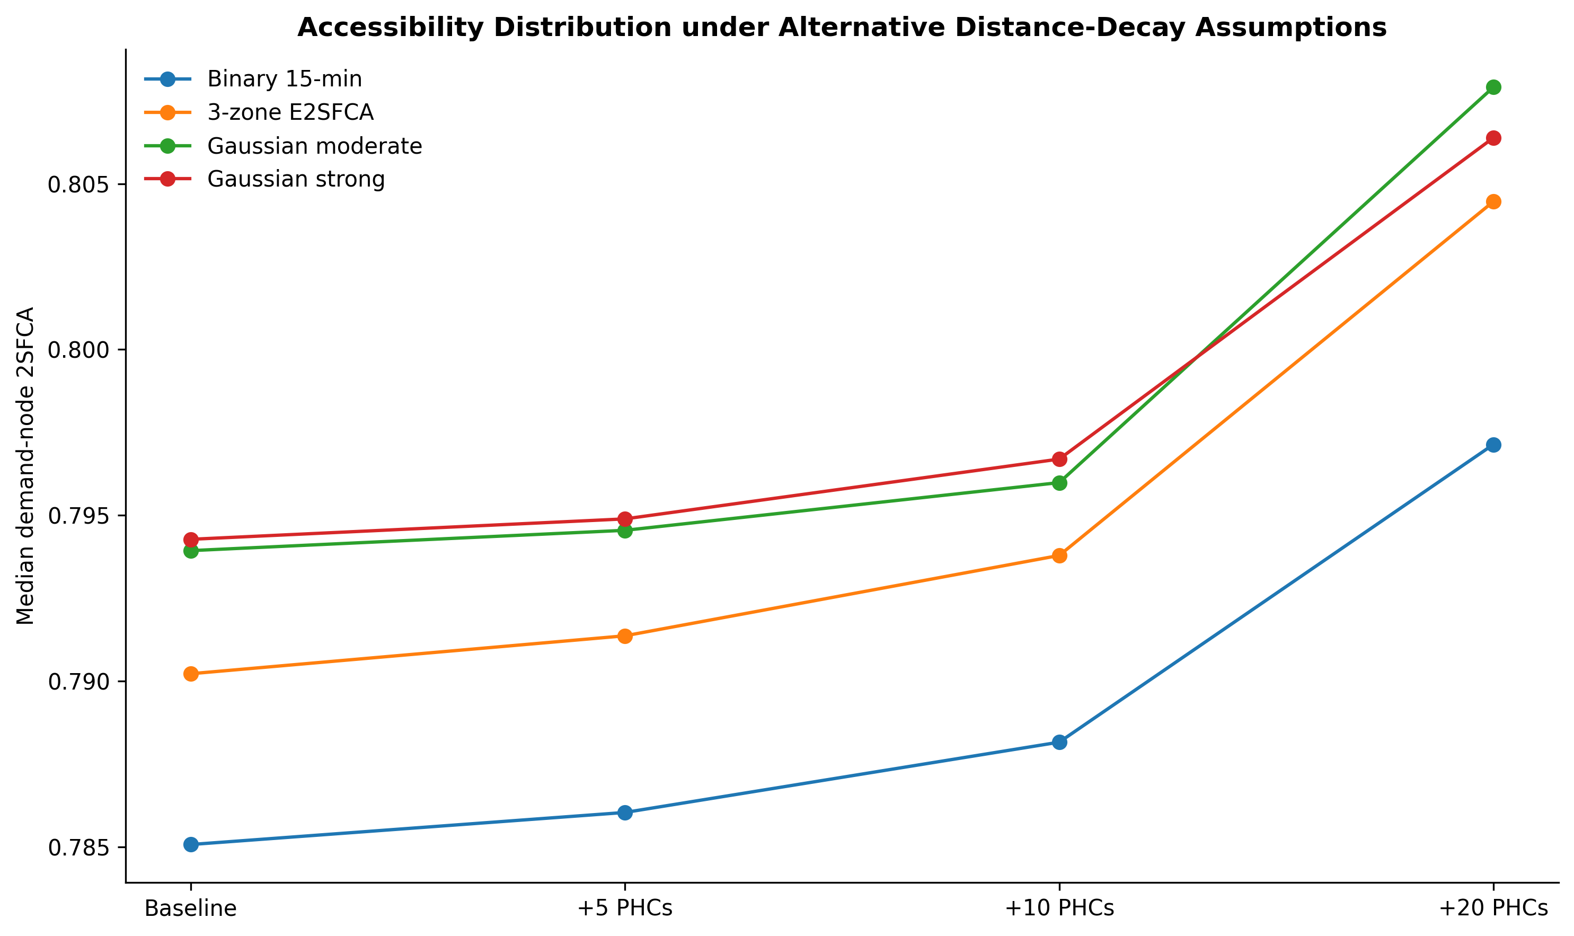
Figure 10. Median accessibility under four distance-decay assumptions.
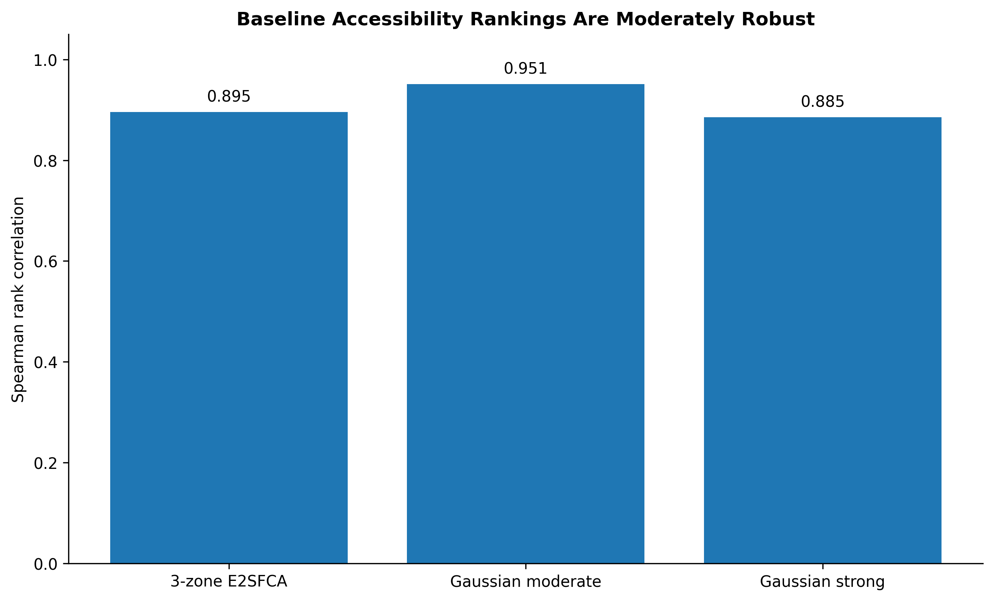
Figure 11. Rank stability between the binary model and distance-decay alternatives.
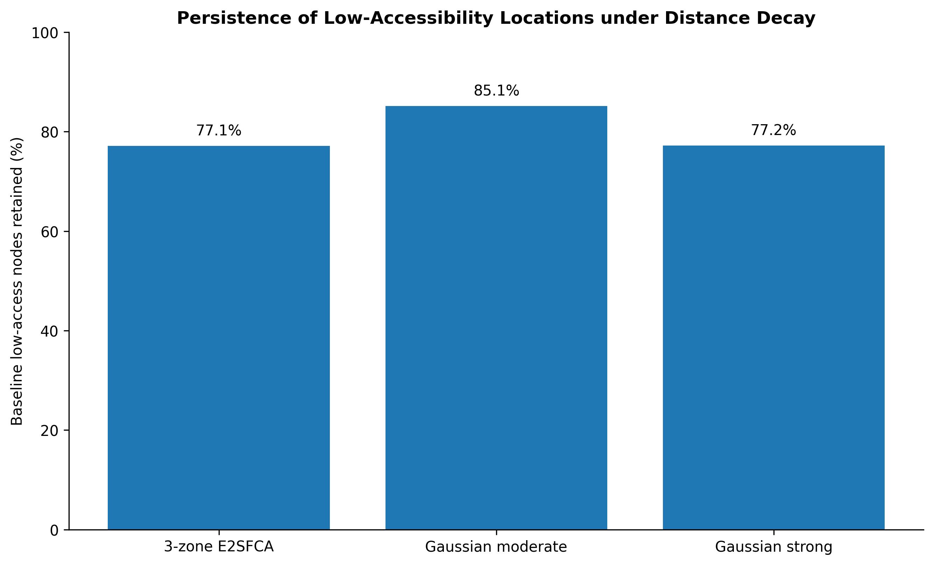
Figure 12. Stability of low-access classifications under distance decay.

9. Validation
The final review reproduced all 20 candidate-site catchments and all four binary expansion scenarios within numerical tolerance. The distance-decay analysis was then run on the same verified routing and demand structure. This final package uses only outputs that passed those checks.
Validation check | Result
Top-20 candidate catchments | 20 of 20 reproduced within numerical tolerance
Binary expansion scenarios | 4 of 4 reproduced within numerical tolerance
Distance-decay analysis | Completed using the verified routing and demand structure
External utilization validation | Not available in the current project data

10. Limitations
The project does not contain facility staffing, bed capacity, service volume, HMIS or healthcare-use data. For this reason, the 2SFCA results should be read as modeled spatial availability, not as a measure of actual service quality, facility capacity or patient use.
The analysis also depends on the road network, facility locations, population estimates and the chosen travel-time assumptions. These inputs are suitable for spatial planning analysis, but they cannot show whether a facility has enough staff, equipment or medicine to meet demand.

11. Planning Implications
The results suggest that new PHCs should be targeted at specific underserved communities rather than treated as a complete solution to statewide healthcare access. The limited statewide improvement also shows that future planning should consider more than facility location. Information on staffing, equipment, service capacity and actual use would be needed to understand whether facilities can meet local demand.

12. Conclusion
Kano State has generally good geographical proximity to PHCs, but access is not equally balanced when population demand is taken into account. Some wards remain relatively underserved even where a facility is nearby. Carefully selected new PHCs can improve access in these places, but the top-20 scenario changes the statewide 2SFCA result by only 1.26%. The main planning lesson is therefore to combine targeted facility expansion with better information on healthcare capacity and service delivery.

Appendix A. Scientific Review Actions
Priority | Status | Issue | Resolution
1 | RESOLVED | Clarify whether 2SFCA supply represents facility count or capacity-weighted healthcare supply. | Resolved. Original 2SFCA uses PHC_Count as supply. The model therefore measures modeled spatial availability, not staffing, beds, service volume or realized capacity.
2 | RESOLVED | The +20 PHC scenario produces only a small statewide 2SFCA change. | Resolved and strengthened. +20 PHCs increase statewide population-weighted 2SFCA from 0.843849 to 0.854504, a 1.263% gain. The intervention has localized value but does not materially change statewide accessibility.
3 | RESOLVED | Binary 15-minute catchment requires distance-decay sensitivity analysis. | Resolved. Binary 2SFCA was compared with three-zone E2SFCA, moderate Gaussian and strong Gaussian decay. The broad spatial pattern is moderately robust, and the +20 scenario remains a small statewide gain under all decay specifications.
4 | LIMITATION_DOCUMENTED | External utilization validation is desirable. | Closed as a documented limitation. No HMIS, utilization, staffing, capacity or service-volume dataset exists in the current project archive. Revised interpretation explicitly limits claims to modeled spatial availability.

