Flood Hazard, Vulnerability and Risk Assessment
Lokoja LGA, Kogi State, Nigeria
Validation-supported GIS Multi-Criteria Decision Analysis — Final Reconstructed Technical Report

Executive Summary
This study reconstructs and strengthens a GIS-based flood hazard, vulnerability and risk assessment for Lokoja LGA. The principal correction was to replace an earlier near-equal, quintile-like hazard classification with fixed numerical Flood Hazard Index thresholds calibrated against independent satellite-derived flood evidence from 2012, 2018 and 2022.
The authoritative model combines eight flood-conditioning factors using AHP weights that sum to 1.0000; the documented consistency ratio is 0.0093. The locked FHI thresholds are 3.20, 3.29, 3.37 and 3.83. High and Very High hazard jointly cover 1,136.71 km² of the 3,353.08 km² valid FHI domain. The High + Very High classes capture 85.08%, 86.64% and 86.36% of the mapped 2012, 2018 and 2022 historical flood evidence, respectively.
Sensitivity analysis indicates that the continuous hazard ranking is highly stable under AHP weight perturbation (minimum Spearman rho 0.99666), although categorical class agreement falls to 76.01% in the most disruptive perturbation. DEM ±10 m stress tests produce approximately 85.4–85.5% class agreement, confirming that terrain uncertainty remains material in Lokoja's low-relief confluence environment.
Physical hazard and final population-informed risk diverge substantially. In the R7B common domain, 1,125.64 km² is High or Very High physical hazard, yet only 58.54 km² of that land remains High or Very High final risk. This shows that the existing risk surface is strongly modulated by population vulnerability/exposure and should not be interpreted as a direct representation of physical flood hazard.

1. Study Context
Lokoja is located at the confluence of the Niger and Benue river systems and has experienced major flood events. The planning objective is to identify land with comparatively high physical flood susceptibility, test whether that susceptibility corresponds with observed historical inundation evidence, and distinguish physical hazard from population-informed risk.

2. Hazard Model
The continuous FHI is a weighted linear combination of eight standardized susceptibility criteria:
Distance to Drainage: 24.58%
Elevation: 20.29%
Rainfall: 15.85%
Slope: 12.18%
Drainage Density: 9.79%
LULC: 7.37%
Clay: 6.23%
NDVI: 3.71%
The AHP consistency ratio is 0.0093, indicating acceptable internal consistency of the documented weighting scheme.

3. Historical Validation and Fixed Thresholds
The continuous FHI was evaluated against independently reconstructed historical flood evidence for 2012, 2018 and 2022. Rather than dividing the study area into equal shares, fixed numerical thresholds were calibrated from cross-event validation performance.
Final classes: Very Low <3.20; Low 3.20–<3.29; Moderate 3.29–<3.37; High 3.37–<3.83; Very High ≥3.83.

4. Final Hazard Results
Very Low: 1,322.89 km² (39.45% of valid FHI domain).
Low: 444.77 km² (13.26% of valid FHI domain).
Moderate: 448.70 km² (13.38% of valid FHI domain).
High: 1,114.49 km² (33.24% of valid FHI domain).
Very High: 22.22 km² (0.66% of valid FHI domain).
High + Very High hazard totals 1,136.71 km². Historical flood capture by these two classes is 85.08% for 2012, 86.64% for 2018 and 86.36% for 2022.

Final Hazard Map
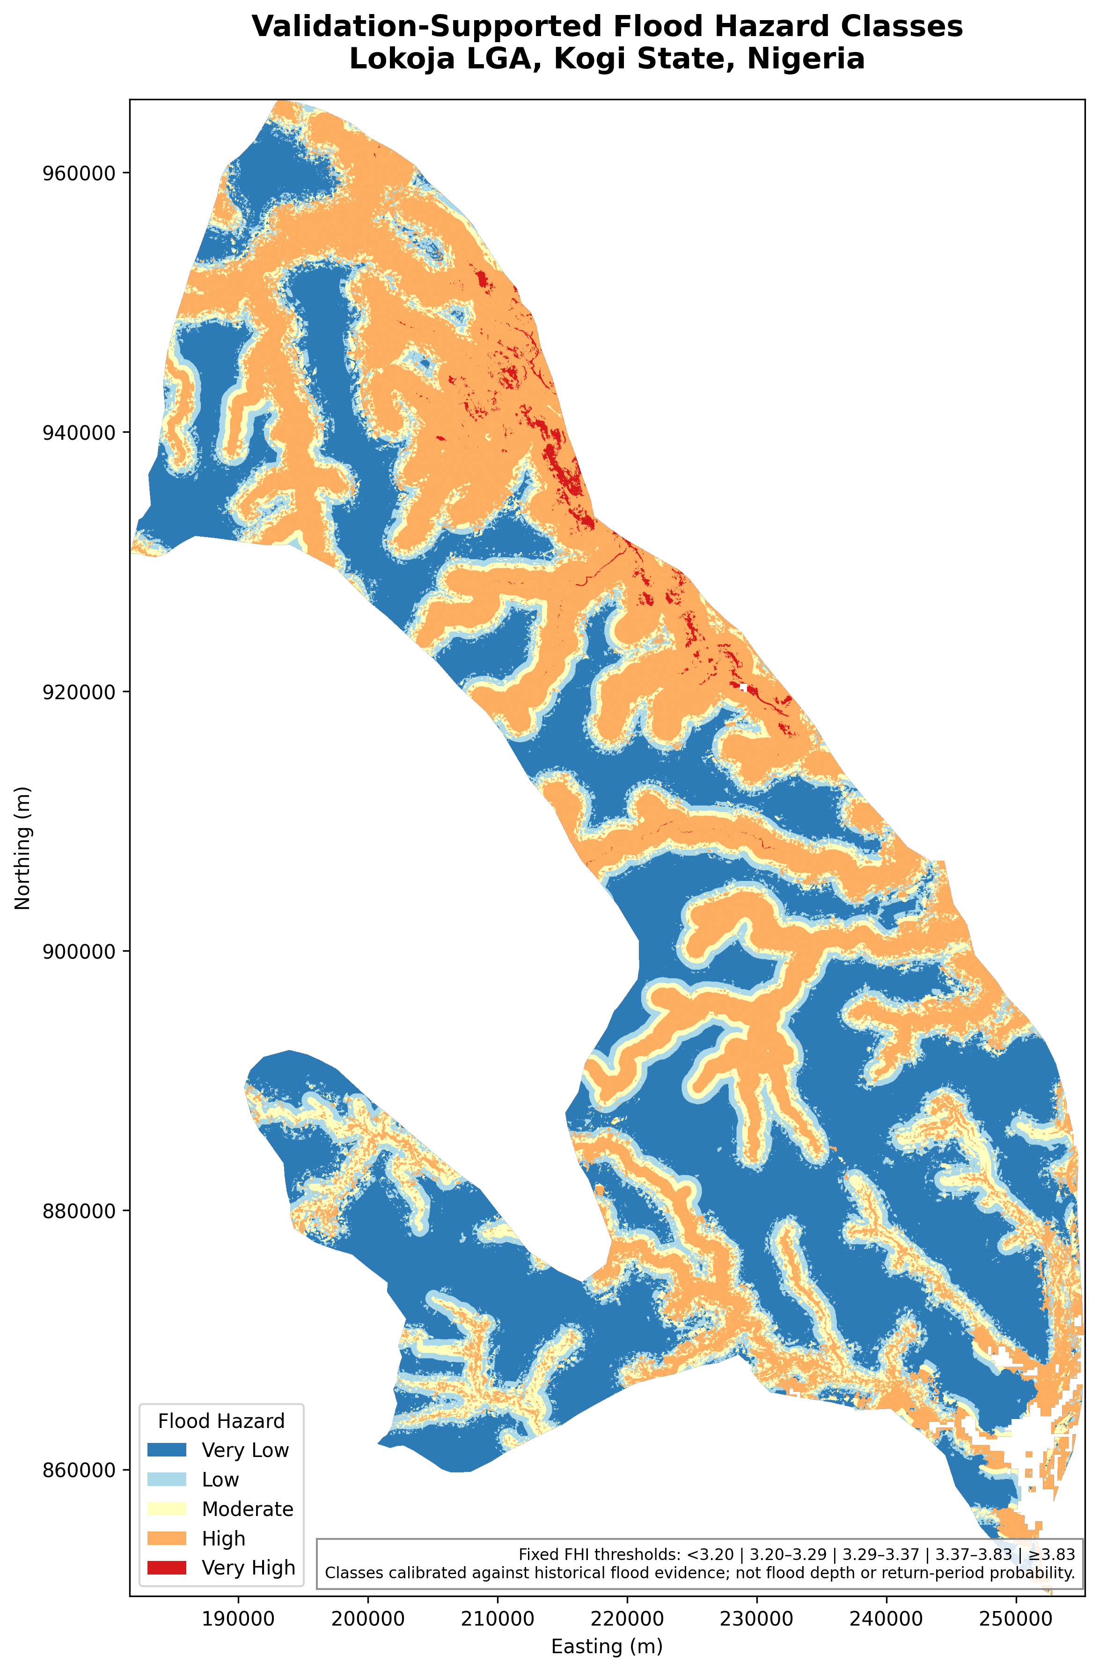

5. Sensitivity and DEM Uncertainty
Across AHP perturbation scenarios, mean categorical class agreement is 91.21%, the minimum is 76.01%, and the minimum Spearman rank correlation is 0.99666. The very high rank correlation indicates that the continuous susceptibility ordering is substantially more stable than exact class membership near fixed boundaries.
With DEM elevation offsets of -10 m and +10 m, class agreement is 85.43% and 85.48%, respectively. These are stress-test results, not a claim that the local DEM has a ±10 m measured vertical error.

6. Hazard–Risk Divergence
R7B aligned the authoritative hazard product with the existing population-vulnerability and final-risk surfaces over a 3,338.75 km² common domain. High + Very High hazard occupies 1,125.64 km² in that common domain.
Only 58.54 km² of High/Very High hazard remains High or Very High final risk. Of High/Very High hazard land, 4.79% transitions to Very Low risk, 58.05% to Low risk, 31.96% to Moderate risk, 4.67% to High risk and 0.54% to Very High risk.
The existing risk index is more strongly associated with population vulnerability (Spearman rho 0.62144) than with the FHI (rho 0.35780). A descriptive linear decomposition was calculated during R7B, but because the original risk coefficients were not recovered, those fitted coefficients are not treated as the authoritative risk equation.

7. Planning Interpretation
The final hazard map should be used to identify areas where physical flood susceptibility warrants attention irrespective of present population density. The population-informed risk product answers a different question: where physical hazard overlaps with stronger human vulnerability/exposure. For land-use control, development screening, drainage planning and emergency preparedness, the two surfaces should therefore be interpreted together rather than substituted for one another.
The validation-supported High and Very High hazard classes provide priority zones for detailed site investigation and hydraulic assessment. The map itself does not estimate flood depth, annual probability or return period.

8. Limitations
1. The product is a GIS/MCDA susceptibility assessment, not a hydraulic flood-depth, probability or return-period model.
2. Historical validation uses satellite-derived inundation/wetting evidence and is affected by sensor, timing, threshold and land-cover limitations.
3. The 2012 Landsat-derived event evidence is substantially smaller than the 2018 and 2022 Sentinel-1 evidence and should be interpreted cautiously.
4. DEM uncertainty is important in low-relief confluence terrain. The ±10 m stress test measures model sensitivity but is not a locally surveyed DEM-error estimate.
5. The original AHP pairwise matrix was unavailable; the documented weights and consistency ratio were retained, but the matrix was not recreated.
6. The original final-risk coefficients were not recovered. The R7B linear decomposition is descriptive only and must not be presented as the authoritative original risk equation.
7. Hazard and risk are distinct. A physically hazardous location can have lower population-informed risk where exposure/vulnerability is low.

9. Conclusion
The reconstruction resolves the central validity problem in the original Lokoja MCDA by replacing near-equal hazard classes with fixed FHI thresholds supported by historical flood evidence. It also documents AHP consistency, quantifies weight and DEM sensitivity, and formally explains the divergence between physical hazard and population-informed risk. The resulting product is more transparent, reproducible and defensible for portfolio, research and planning communication.

