Vegetation Browning Beyond Climatic Drought: Agro-Climatic Trend, Rainfall Decoupling and Land-Change Evidence in Northern Nigeria
Final Technical Report
Study period: 2001–2025

Abstract
Vegetation decline in dryland and sub-humid landscapes is often interpreted as evidence of climatic drought, yet vegetation response can also reflect land-use and vegetation-cover change. This study evaluates growing-season vegetation and rainfall dynamics across Northern Nigeria from 2001 to 2025 using agro-climatic strata defined by length of growing period (LGP). Temporal inference uses Sen slopes with modified Mann–Kendall testing that accounts for serial correlation, with Hamed–Rao correction as the primary method and trend-free prewhitening (TFPW) where Hamed–Rao is undefined. Benjamini–Hochberg false discovery rate correction controls multiple testing. The analysis identifies one distinctive rainfall-decoupled vegetation-decline regime: the LGP 180–239 day stratum. Normalized Difference Vegetation Index (NDVI) declines at -0.002754 per year (FDR-adjusted p=0.000096), while rainfall has no significant trend (Sen slope=0.875 mm/year; FDR-adjusted p=0.682538). Enhanced Vegetation Index (EVI) independently declines at -0.001671 per year (FDR-adjusted p=0.000849). Independent land-change evidence indicates +2.22 percentage-point cropland change, -8.88 percentage-point tree-cover change, and 1,123.1 km² of forest loss, equivalent to 28.07% of baseline forest. The integrated interpretation is retained in 77.8% of 81 robustness scenarios. The results indicate that the observed browning is more consistent with land-use and vegetation-cover change than with climatic drought alone. This is an association-based interpretation rather than causal proof; conflict attribution is deferred because a spatially representative Northern Nigeria-wide conflict dataset was not used.
Keywords: Northern Nigeria; vegetation browning; NDVI; EVI; rainfall; modified Mann–Kendall; Hamed–Rao; false discovery rate; agro-climatic zones; land-use change; forest loss; drought attribution

Key Findings
- The final analysis identifies one agro-climatic regime — LGP 180–239 days — with statistically significant vegetation decline despite no significant rainfall decline.
- Within the target LGP 180–239 day stratum, NDVI declines at -0.002754 per year (FDR-adjusted p=0.000096), while rainfall shows no significant trend (slope=0.875 mm/year; FDR-adjusted p=0.682538).
- EVI independently declines at -0.001671 per year (FDR-adjusted p=0.000849), reinforcing the NDVI signal.
- Cropland share increased by +2.22 percentage points between 2016 and 2025 in the target stratum.
- Tree-cover share declined by 8.88 percentage points between 2016 and 2025 in the target stratum.
- The target stratum experienced 1,123.1 km² of forest loss between 2001 and 2025, equivalent to 28.07% of baseline forest.
- The combined land-change interpretation was supported in 77.8% of 81 robustness scenarios.
- The evidence supports interpretation of the browning signal as more consistent with land-use and vegetation-cover change than climatic drought alone.
- The analysis identifies association rather than proof of a single causal mechanism.
- Conflict attribution remains deferred because no spatially complete Northern Nigeria-wide conflict dataset was used in the definitive analysis.
- The project therefore demonstrates that vegetation browning should not automatically be interpreted as climatic drought.

1. Introduction
Vegetation greenness is widely used to monitor drought, land degradation and ecosystem stress. A central interpretive problem, however, is that declining vegetation indices do not uniquely identify climatic drought. Vegetation may decline because of rainfall deficits, but it may also respond to cultivation, tree-cover removal, urban expansion, disturbance, management change or other human pressures. Treating every browning signal as drought can therefore misdiagnose the mechanism and lead to inappropriate planning responses.
Northern Nigeria is especially suitable for separating these processes because it spans a strong climatic and ecological gradient. Analyses based only on administrative units can obscure that gradient and are vulnerable to the modifiable areal unit problem (MAUP). This study therefore uses agro-climatic strata based on length of growing period rather than states as the primary analytical geography.
The objective is to determine where vegetation trends are statistically robust after accounting for serial correlation and multiple comparisons, whether those trends are coupled with rainfall change, and whether independent land-cover and forest-loss evidence supports a non-climatic interpretation where vegetation decline occurs without declining rainfall.

2. Study Area and Analytical Framework
The study covers Northern Nigeria and represents the region through five occupied Global Agro-Ecological Zones (GAEZ) length-of-growing-period classes: less than 60 days, 60–119 days, 120–179 days, 180–239 days and 240–299 days. These zones provide an ecologically meaningful framework that better follows the regional moisture and growing-season gradient than state boundaries.
The analysis covers 2001–2025 for the vegetation and rainfall trend assessment. Independent land-change evidence is evaluated using Dynamic World land-cover change for 2016–2025 and Hansen forest-loss information for 2001–2025. The analytical logic separates climatic co-trending from vegetation–rainfall decoupling before considering independent disturbance evidence.
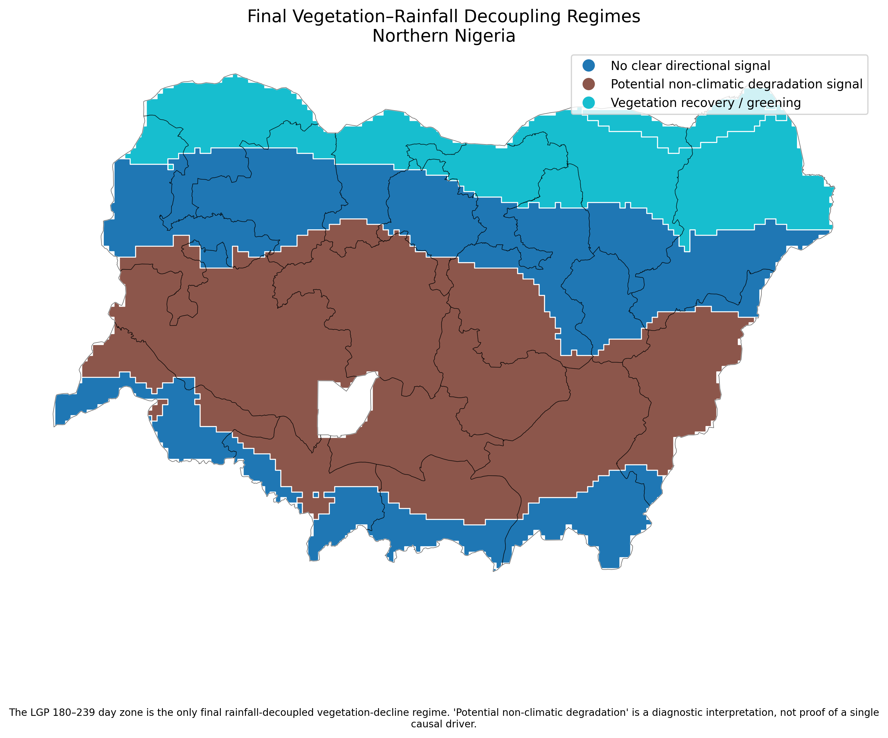
Figure 1. Final vegetation–rainfall decoupling regimes across Northern Nigeria.

3. Data and Methods
Growing-season vegetation dynamics are represented using the Normalized Difference Vegetation Index (NDVI) and Enhanced Vegetation Index (EVI), while rainfall is evaluated over the corresponding seasonal period. Annual time series are summarized for each agro-climatic stratum.
Trend magnitude is estimated using the Sen/Theil–Sen slope. Standard Mann–Kendall inference can overstate significance when environmental time series are serially correlated. The primary significance procedure is therefore the Hamed–Rao modified Mann–Kendall test. Where the Hamed–Rao calculation is mathematically undefined, trend-free prewhitening (TFPW) modified Mann–Kendall is used as a documented fallback. Because multiple vegetation and rainfall hypotheses are tested across agro-climatic strata, Benjamini–Hochberg false discovery rate (FDR) correction is applied to the selected valid p-values.
Vegetation–rainfall decoupling is then evaluated from the corrected trend results. A potential non-climatic degradation signal requires statistically significant vegetation decline without statistically significant rainfall decline. EVI is used as an independent vegetation-index robustness check.
Independent driver evidence is evaluated from Dynamic World land-cover change and Hansen forest loss. Cropland expansion, tree-cover decline and forest loss are treated as association evidence rather than direct causal attribution. A threshold sensitivity analysis tests alternative combinations of land-change thresholds and minimum evidence counts. Conflict is not used for definitive attribution because the available conflict input was not spatially representative of the full Northern Nigerian study area.

4. Results
The corrected trend analysis reveals strong ecological differentiation. The two driest LGP strata show statistically significant greening accompanied by increasing rainfall. The LGP 120–179 day zone shows no significant vegetation or rainfall trend. The LGP 240–299 day zone also lacks a statistically significant directional vegetation or rainfall trend after FDR correction.
The key exception is the LGP 180–239 day stratum. NDVI declines significantly at -0.002754 per year (FDR-adjusted p=0.000096), while rainfall remains statistically stable (Sen slope=0.875 mm/year; FDR-adjusted p=0.682538). EVI also declines significantly at -0.001671 per year (FDR-adjusted p=0.000849), strengthening confidence that the vegetation decline is not an NDVI-specific artefact.
Independent evidence shows that cropland share changed by +2.22 percentage points and tree-cover share by -8.88 percentage points between 2016 and 2025. Hansen data indicate 1,123.1 km² of forest loss between 2001 and 2025, equivalent to 28.07% of baseline forest in the target stratum.
The integrated land-change interpretation remains supported in 77.8% of 81 robustness scenarios. This means the interpretation is not dependent on one arbitrary evidence threshold, although the strictest combinations do not all pass.
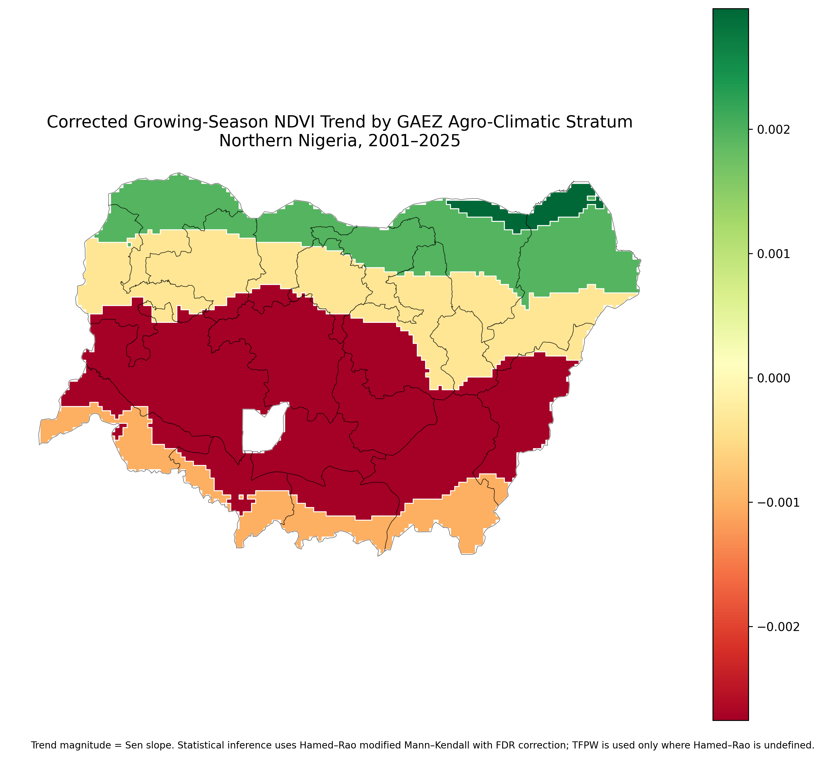
Figure 2. Corrected growing-season NDVI trend by GAEZ agro-climatic stratum, 2001–2025.
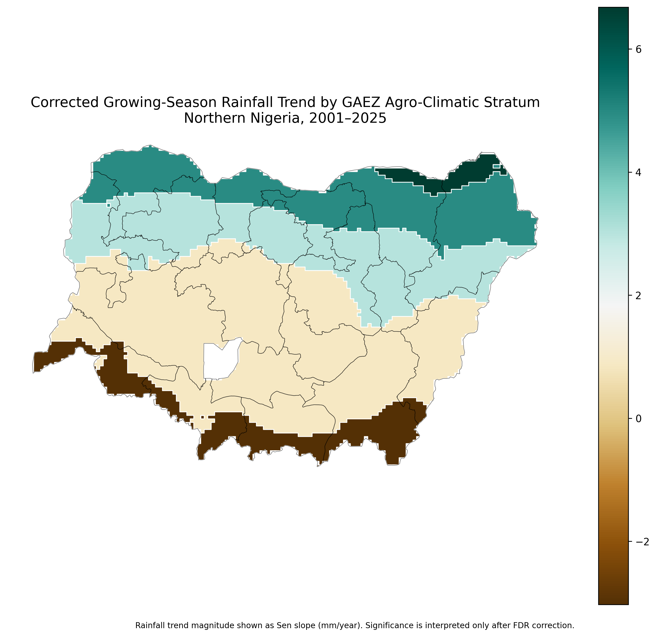
Figure 3. Corrected growing-season rainfall trend by GAEZ agro-climatic stratum, 2001–2025.

4.1 Final Agro-Climatic Trend Summary
Stratum | NDVI Slope | NDVI FDR P | Rainfall Slope | Rainfall FDR P | Regime
LGP <60 days | 0.0030 | 0.0014 | 6.6789 | 0.0035 | Vegetation recovery / greening
LGP 60–119 days | 0.0020 | 0.0188 | 4.9506 | 0.0421 | Vegetation recovery / greening
LGP 120–179 days | -0.0003 | 0.5182 | 3.0237 | 0.2571 | No clear directional signal
LGP 180–239 days | -0.0028 | 0.0001 | 0.8749 | 0.6825 | Potential non-climatic degradation signal
LGP 240–299 days | -0.0010 | 0.0826 | -3.0266 | 0.6228 | No clear directional signal
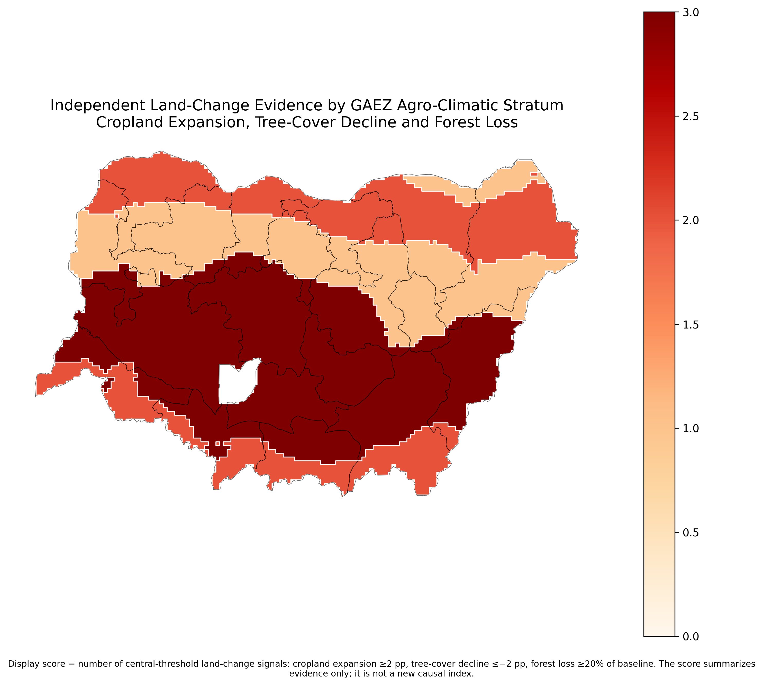
Figure 4. Independent land-change evidence summarized across GAEZ agro-climatic strata.
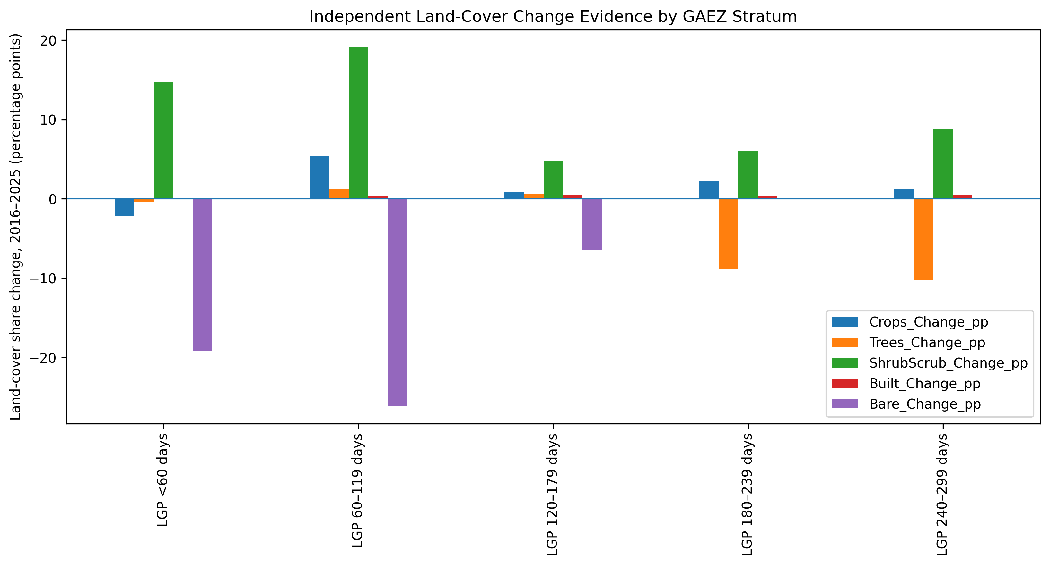
Figure 6. Land-cover share change by agro-climatic stratum.
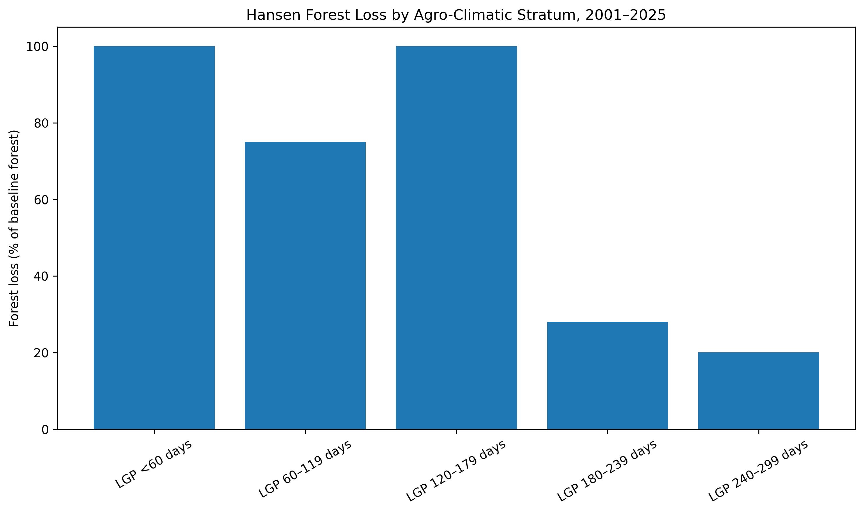
Figure 7. Forest-loss share relative to baseline forest by agro-climatic stratum.

4.2 Target-Stratum Independent Evidence
Metric | Value
NDVI Sen slope | -0.0028
NDVI FDR-adjusted p-value | 0.0001
Rainfall Sen slope (mm/year) | 0.8749
Rainfall FDR-adjusted p-value | 0.6825
EVI Sen slope | -0.0017
EVI FDR-adjusted p-value | 0.0008
Cropland change (percentage points) | 2.2158
Tree-cover change (percentage points) | -8.8810
Forest loss (km²) | 1123.1179
Forest loss (% baseline) | 28.0651
Robustness support (%) | 77.7778
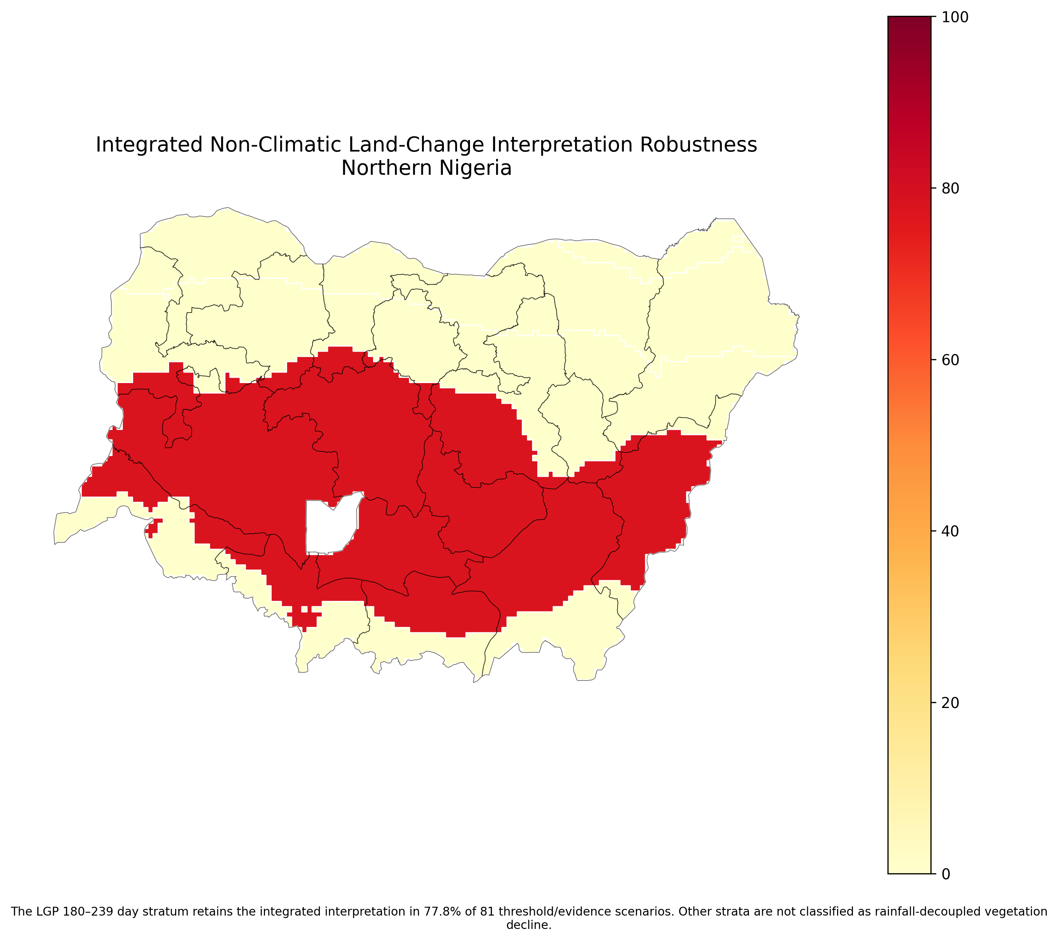
Figure 5. Robustness of the integrated non-climatic land-change interpretation.
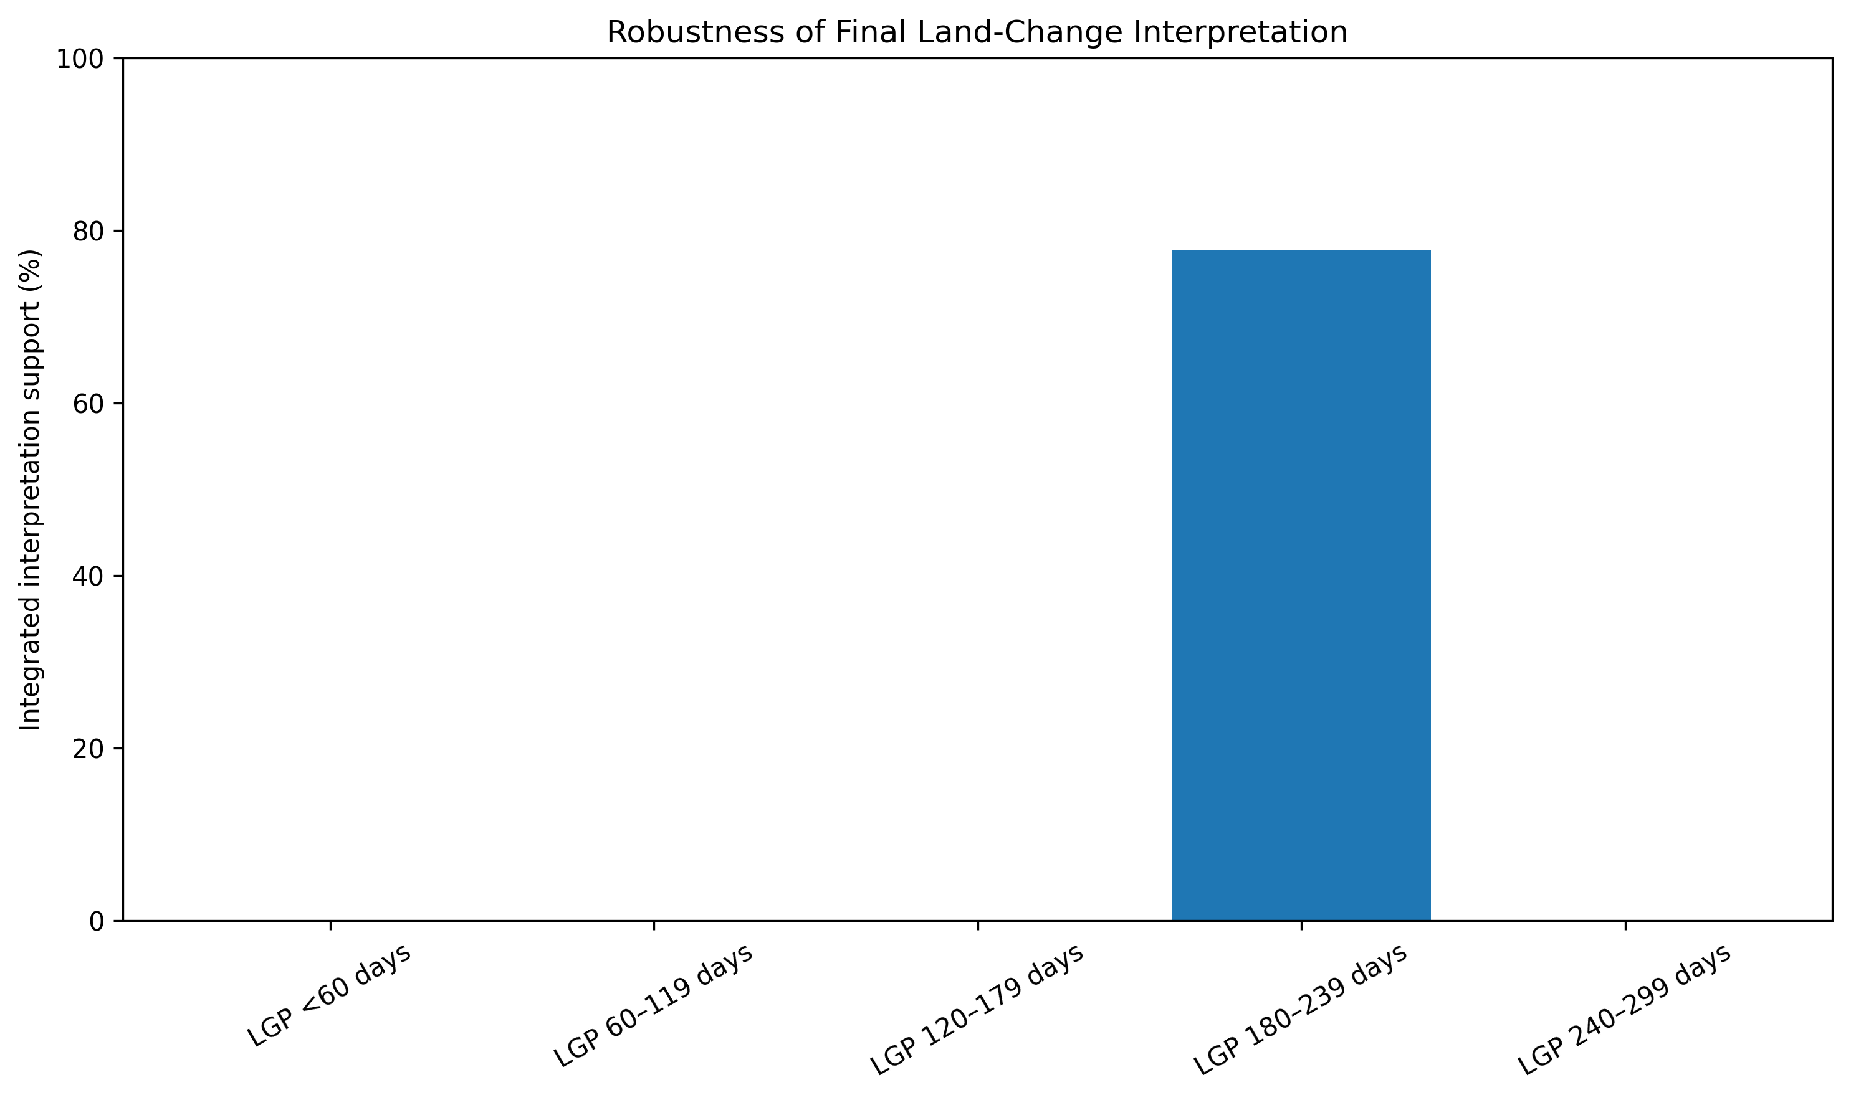
Figure 8. Integrated interpretation support across agro-climatic strata.

5. Discussion
The principal contribution is the distinction between vegetation browning and climatic drought. The LGP 180–239 day stratum exhibits statistically robust vegetation decline without statistically significant rainfall decline. That pattern is inconsistent with a simple interpretation in which rainfall deterioration alone explains the observed browning.
The accompanying cropland expansion, tree-cover decline and forest-loss evidence provides an independent basis for interpreting the vegetation signal as potentially associated with land-use and vegetation-cover change. This reframes what could otherwise appear to be an anomalous drought hotspot in central parts of Northern Nigeria. Rather than contradicting the regional climatic gradient, the result shows why vegetation-index decline should not automatically be labelled drought.
The use of agro-climatic strata is also important. State-level averages can mix different climatic regimes and create rankings that reflect administrative geometry rather than ecological processes. Length-of-growing-period zones provide a more defensible analytical geography for interpreting the north–south aridity and growing-season gradient.
The results do not establish a single causal mechanism. Cropland expansion, tree-cover decline and forest loss are associated with the target vegetation-decline regime, but the design does not isolate causal effects. Other processes may contribute. Conflict-driven land abandonment or disturbance is plausible in parts of Northern Nigeria, but conflict attribution is deliberately excluded from the definitive interpretation because the available conflict data were not regionally representative.

6. Planning and Environmental Implications
The findings have direct implications for drought monitoring and land-management policy. Vegetation-index alerts should be interpreted jointly with rainfall trends and independent land-change evidence before being classified as drought impacts. Where vegetation declines despite stable rainfall, land-management responses may be more appropriate than drought-response measures alone.
For the LGP 180–239 day zone, planning attention should include monitoring agricultural expansion, tree-cover loss, forest conversion and landscape restoration needs. The analysis supports integrated land-degradation surveillance in which remote-sensing vegetation indicators are combined with climate and land-cover diagnostics.

7. Limitations
Several limitations define the scope of inference. First, the analysis is aggregated to five agro-climatic strata; this improves ecological defensibility relative to state aggregation but still masks local heterogeneity. Second, the study identifies statistical association and spatial-temporal consistency, not causal effects. Third, Dynamic World land-cover evidence covers 2016–2025 whereas the vegetation trend covers 2001–2025, so the temporal windows are not identical. Fourth, forest-loss products capture tree-cover loss but do not independently establish the underlying cause of loss. Fifth, conflict attribution is deferred because the available conflict dataset was not spatially representative of Northern Nigeria. Finally, the robustness analysis tests plausible evidence thresholds but does not exhaust every possible model specification.

8. Conclusion
The study demonstrates that vegetation browning in Northern Nigeria cannot be treated as synonymous with climatic drought. After serial-correlation correction, false discovery rate control and agro-climatic stratification, the LGP 180–239 day zone is the only clear rainfall-decoupled vegetation-decline regime. Significant NDVI and EVI decline occurs despite statistically stable rainfall, while independent evidence shows cropland expansion, tree-cover decline and substantial forest loss. The integrated interpretation remains supported in 77.8% of 81 robustness scenarios.
The most defensible conclusion is that vegetation decline in this agro-climatic zone is more consistent with land-use and vegetation-cover change than climatic drought alone. The result is diagnostic rather than causal, but it provides a stronger basis for distinguishing climate-driven vegetation stress from land-management pressures in environmental monitoring and planning.

Author Contribution
The author developed the analytical workflow, reconstructed and quality-controlled the spatial and temporal datasets, implemented the agro-climatic stratification, trend and decoupling analyses, evaluated independent land-change evidence, performed robustness testing, produced the cartographic outputs, and interpreted the results for environmental planning.

Data and Methodological Transparency
All final numerical claims in this report are drawn from the locked authoritative R7 result tables. Building a causal attribution model was outside the scope of this analysis. Conflict attribution was explicitly deferred. The final maps and charts are interpretive products of the validated analytical workflow and do not replace the underlying tabular statistical results.

