Urban Green Infrastructure and Ecosystem Service Deficit Mapping — Tartu, Estonia
A Geospatial Assessment of Ecosystem-Service Capacity, Demand and Planning Priorities

Executive Summary
This study assessed urban green infrastructure (UGI), ecosystem-service capacity, demand, deficit and planning priority across Tartu, Estonia. I developed a geospatial planning framework that combines satellite-derived land-cover and vegetation information with population data to identify where ecological service provision is least able to meet urban demand. The final reporting area covers 38.8872 km². Built-up land occupies 21.6040 km² (55.56%), while Dense Urban Forest covers 19.48%, Healthy Green Space 16.06% and Urban Woodland 6.30%. Mean ecosystem-service capacity is 41.54/100, mean demand is 0.5768 and mean deficit is 0.4110. Built-up areas have mean capacity of 8.00/100, mean demand of 0.7339 and mean deficit of 0.6751. About 72.30% of built-up land falls within High or Very High planning priority. The results show that Tartu's main green-infrastructure planning challenge is the spatial mismatch between strong ecological assets and areas of concentrated urban demand.

1. Introduction and Study Area
Urban green infrastructure supports cooling, stormwater regulation, biodiversity, recreation and general environmental quality. For planning purposes, however, the amount of green space alone is not enough. It is also necessary to understand whether ecological capacity is located where urban demand is greatest.
The aim of this study is to assess the distribution and condition of urban green infrastructure in Tartu and identify areas where ecosystem-service provision is least able to meet demand. The analysis asks where UGI is located, where ecological capacity is strongest, where demand is concentrated, where the largest capacity-demand deficits occur, and where green-infrastructure intervention should be prioritised.
I approached the project as a geospatial planning problem. The analysis combines remote sensing, land-cover information and population data to move from environmental mapping to a practical spatial decision-support framework.
The definitive Tartu vector study boundary covers 38.887971 km². The final 10 m reporting mask contains 388,872 analytical pixels covering 38.8872 km². All final maps, charts and tables use this reporting boundary.
The final analytical chain is: UGI → Ecosystem-Service Capacity → Ecosystem-Service Demand → Ecosystem-Service Deficit → Planning Priority.
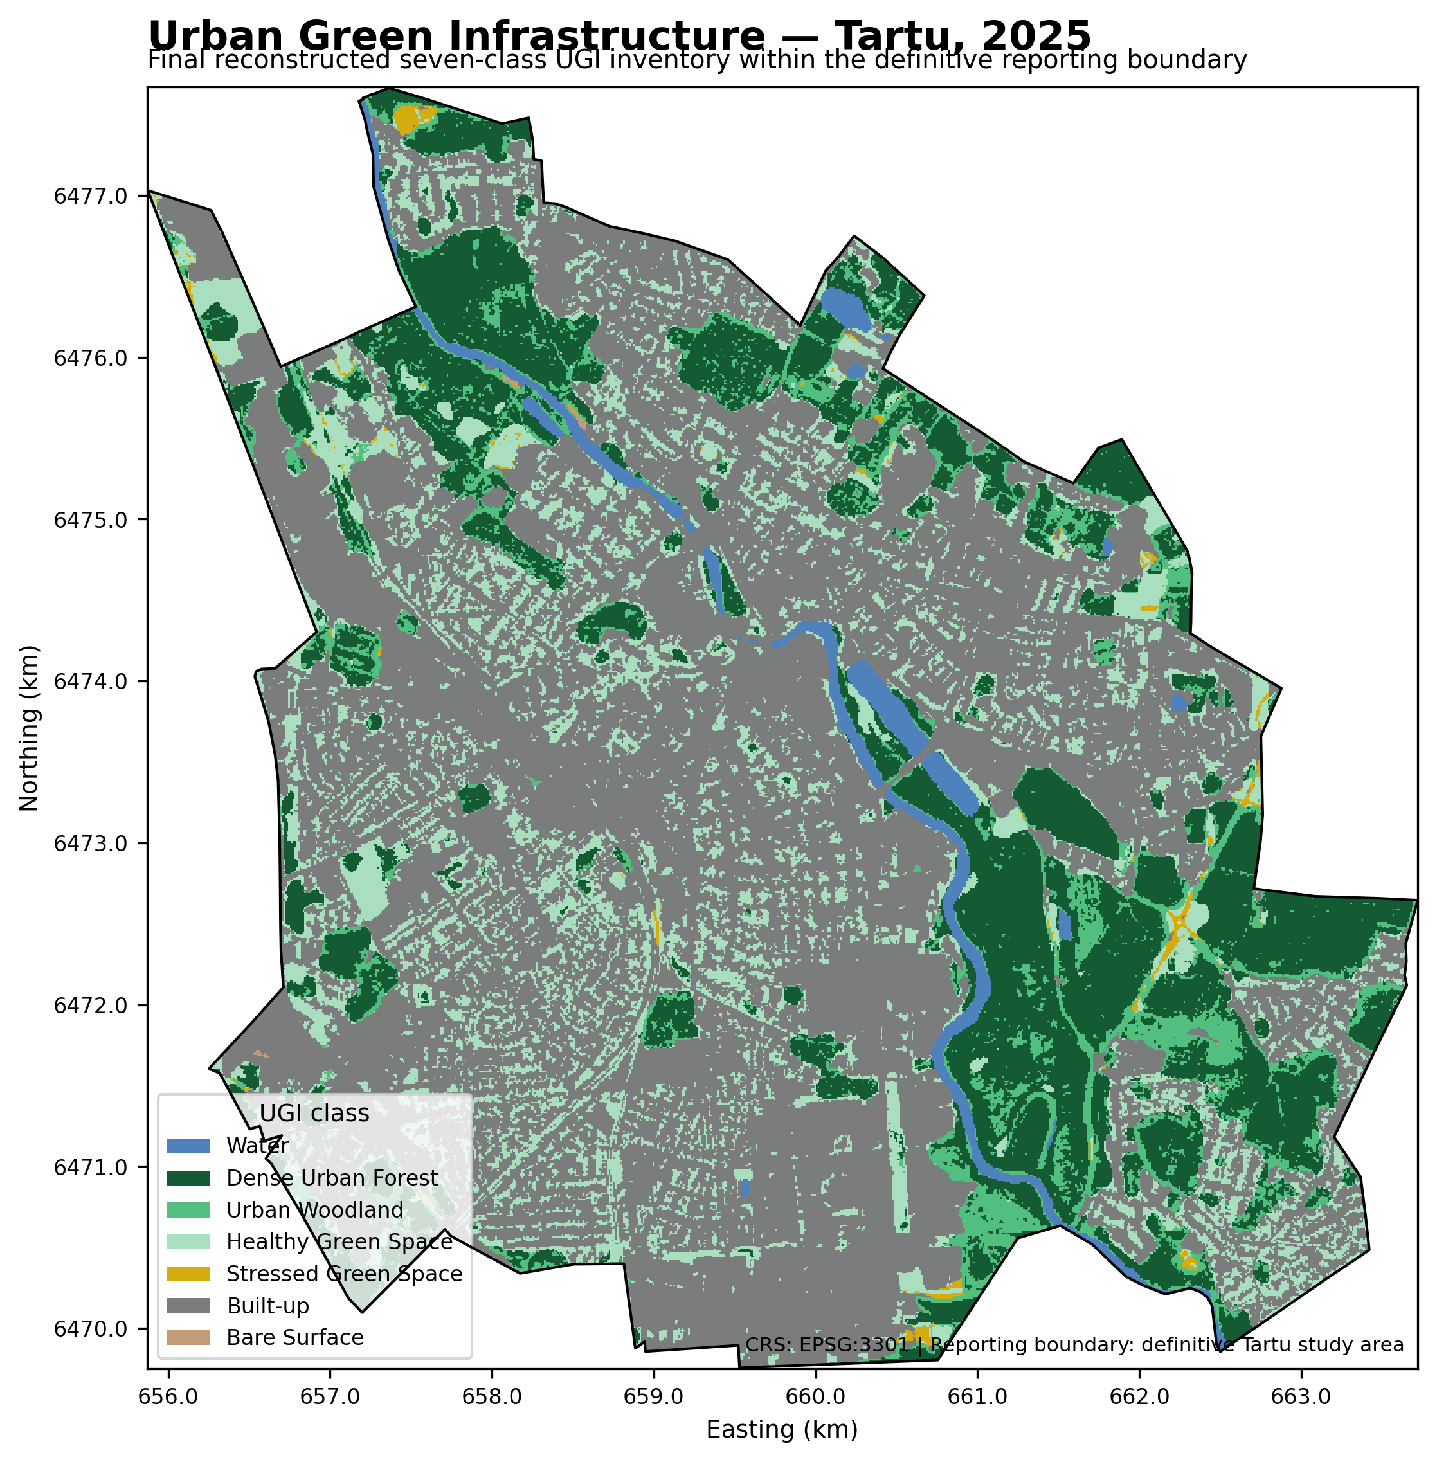
Figure 1. Final reconstructed Urban Green Infrastructure inventory for Tartu.

2. Methodology
The analytical workflow follows a sequential geospatial planning structure.
First, the environmental foundation was developed from a Sentinel-2 spectral-index stack containing NDVI, EVI, NDMI, NDBI, MNDWI, SAVI and BSI. The stack uses EPSG:3301 at 10 m resolution. Dynamic World 2025 was then re-read using raw categorical values so that class 0 (Water) was preserved rather than incorrectly treated as NoData.
Second, I developed a seven-class UGI inventory using Dynamic World land-cover information and spectral condition. The final classes are Water, Dense Urban Forest, Urban Woodland, Healthy Green Space, Stressed Green Space, Built-up and Bare Surface. Built/green ambiguity was resolved through a targeted sensitivity search that preserved ecological separation while satisfying precision, recall and area-share validation gates.
Third, ecosystem-service capacity was estimated on a 0–100 scale from UGI class baselines and continuous vegetation condition. Continuous NDVI, EVI and NDMI adjustments were applied only to vegetated classes. Built-up did not receive an additional spectral or imperviousness penalty, preventing double-counting.
Fourth, ecosystem-service demand was modelled independently of capacity. WorldPop 2020 provided the dominant population signal, while a minor Built-up context component captured urban exposure. Capacity, deficit and planning priority were excluded from demand construction.
Fifth, ecosystem-service deficit was calculated transparently as:
Deficit = Demand × (1 − Capacity/100)
This conjunctive formulation produces high deficit only where demand is high and ecosystem-service capacity is low. UGI and Built-up status were not inserted as additional deficit penalties.
Finally, the continuous deficit surface was translated into five planning-priority classes using quintile thresholds: Very Low, Low, Moderate, High and Very High. Alternative classification schemes were evaluated in sensitivity analysis, while the quintile map was retained as the reference planning product because it is transparent, balanced and reproducible.

3. Results
The final boundary-masked UGI inventory covers 38.8872 km². Built-up land accounts for 55.56% of the reporting domain. Dense Urban Forest accounts for 19.48%, Healthy Green Space for 16.06%, and Urban Woodland for 6.30%.
Ecosystem-service capacity is highest in Dense Urban Forest and Urban Woodland, and lowest in Built-up and Bare Surface. The overall mean capacity is 41.54/100. Demand is concentrated in the urbanized parts of Tartu; the overall mean demand is 0.5768, while Built-up land has a mean demand of 0.7339. Capacity and demand are negatively associated (Spearman ρ = -0.6043), reflecting the spatial contrast between ecological service provision and concentrated urban demand.
The mean deficit across the reporting area is 0.4110. Deficit is positively associated with demand (Spearman ρ = 0.8715) and negatively associated with capacity (Spearman ρ = -0.8764). Built-up areas record a substantially higher mean deficit (0.6751) than ecologically stronger UGI classes.
The final planning-priority map contains five distribution-aware classes. Approximately 72.30% of Built-up land falls in High or Very High priority. In contrast, only 0.02% of non-built land is classified High or Very High. This concentration is not produced by a direct Built-up penalty in the priority model; it is inherited from the combined spatial pattern of low service capacity and high demand in urbanized areas.

3.1 Urban Green Infrastructure composition
UGI class | Area (km²) | Share (%) | Capacity | Demand | Deficit | High/Very High (%)
Water | 0.8412 | 2.16 | 70.00 | 0.2373 | 0.0712 | 0.00
Dense Urban Forest | 7.5759 | 19.48 | 98.82 | 0.2403 | 0.0031 | 0.00
Urban Woodland | 2.4494 | 6.30 | 77.81 | 0.2684 | 0.0597 | 0.00
Healthy Green Space | 6.2446 | 16.06 | 70.43 | 0.6168 | 0.1818 | 0.00
Stressed Green Space | 0.1626 | 0.42 | 28.11 | 0.2545 | 0.1829 | 0.92
Built-up | 21.6040 | 55.56 | 8.00 | 0.7339 | 0.6751 | 72.30
Bare Surface | 0.0095 | 0.02 | 12.00 | 0.3652 | 0.3214 | 24.21
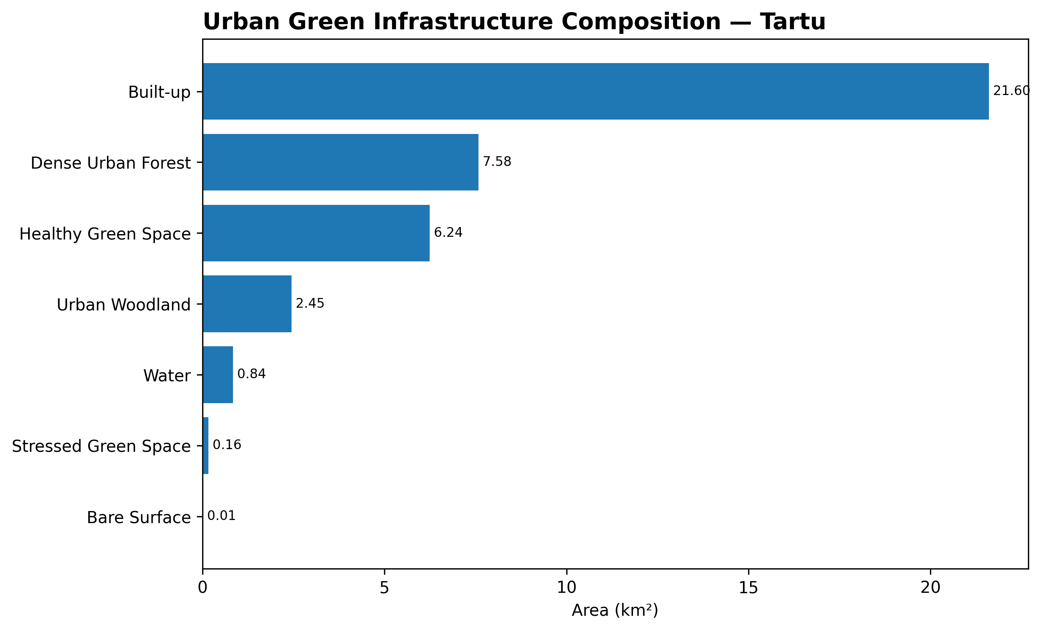
Figure 2. Final UGI area distribution.

3.2 Ecosystem-service capacity
Mean ecosystem-service capacity is 41.54/100. Built-up land has a mean capacity of 8.00/100.
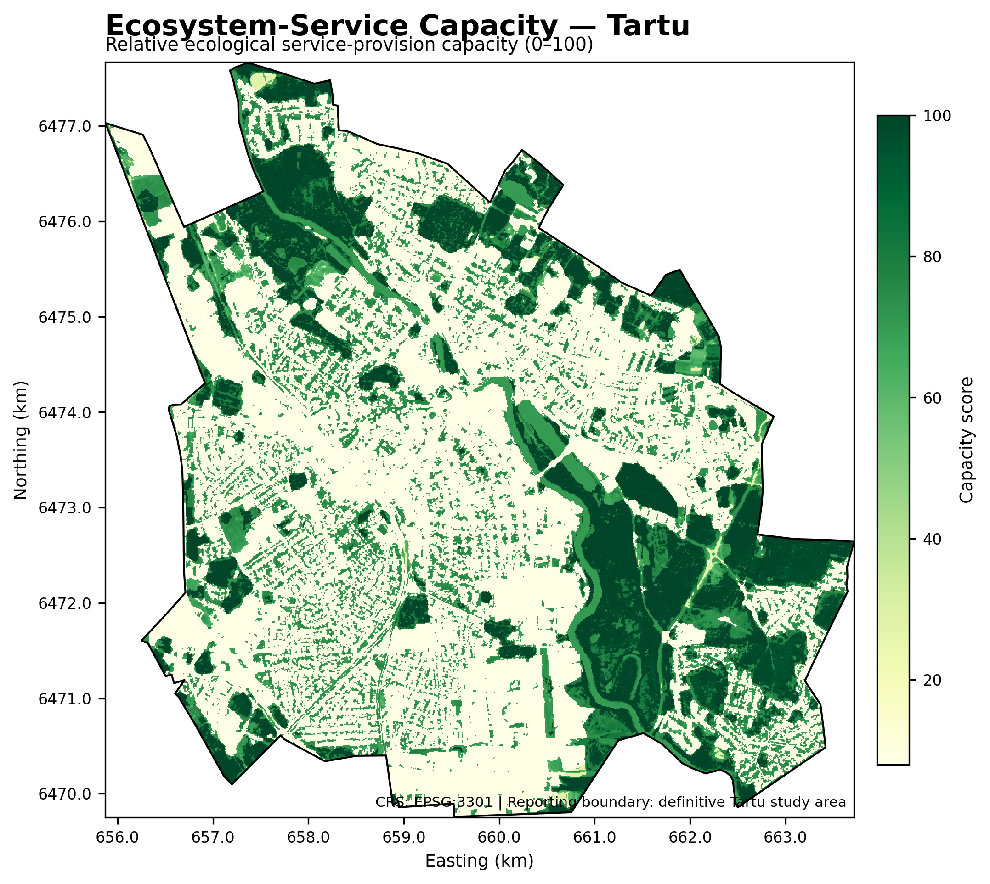
Figure 3. Final ecosystem-service capacity surface.

3.3 Ecosystem-service demand
Mean ecosystem-service demand is 0.5768. Built-up land has a mean demand of 0.7339.
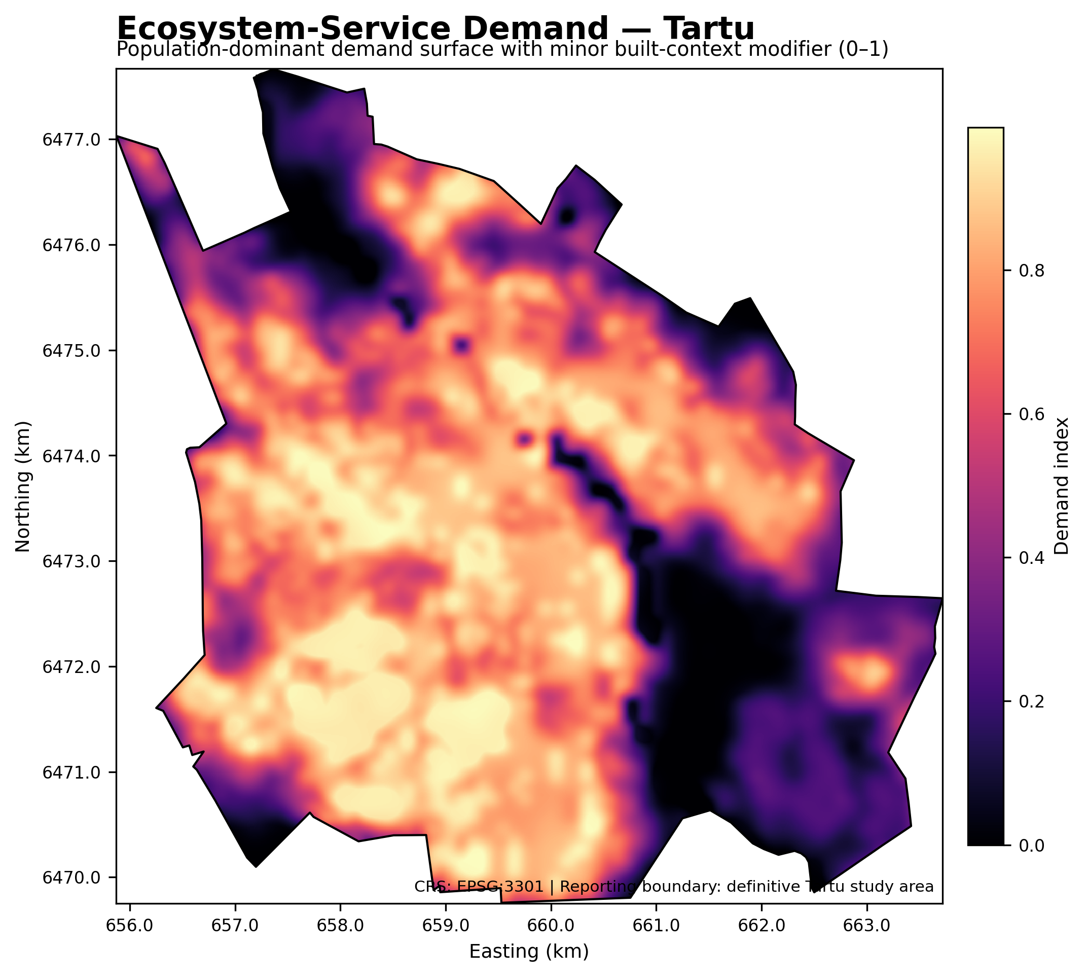
Figure 4. Final ecosystem-service demand surface.

3.4 Ecosystem-service deficit
Mean ecosystem-service deficit is 0.4110. Built-up land has a mean deficit of 0.6751. Demand and deficit are positively associated (Spearman ρ = 0.8715), while capacity and deficit are negatively associated (ρ = -0.8764).
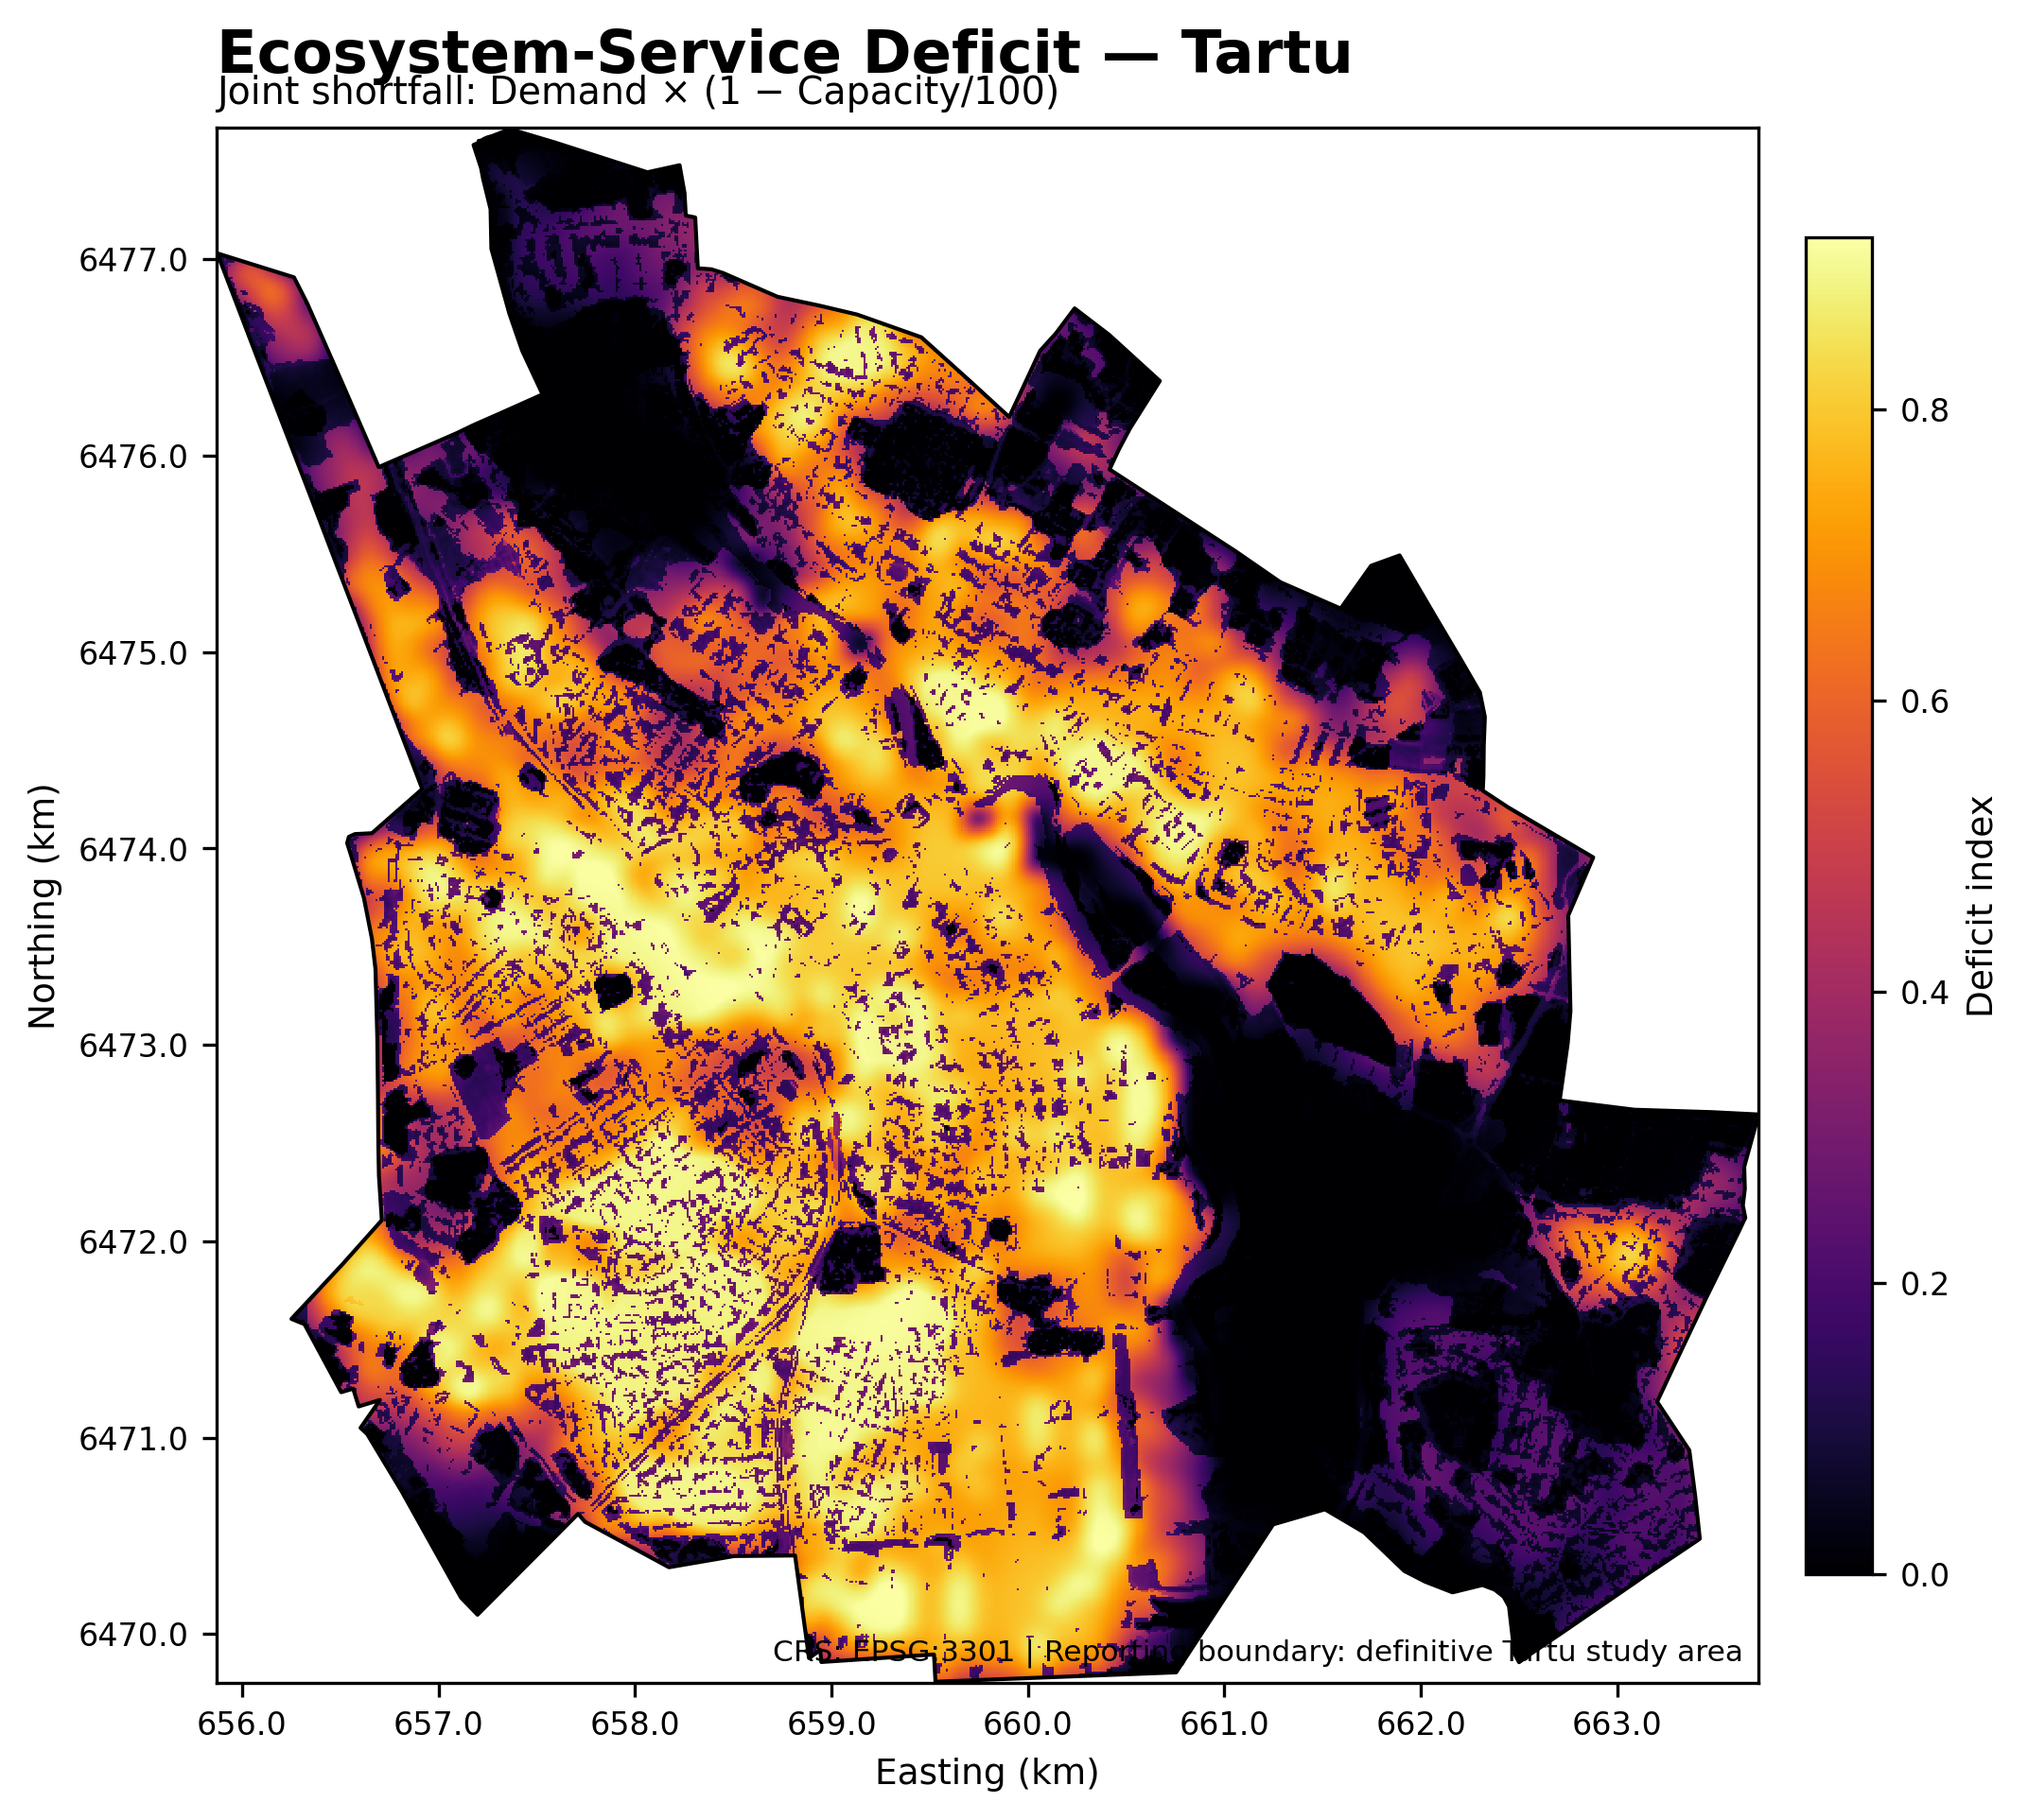
Figure 5. Final ecosystem-service deficit surface.
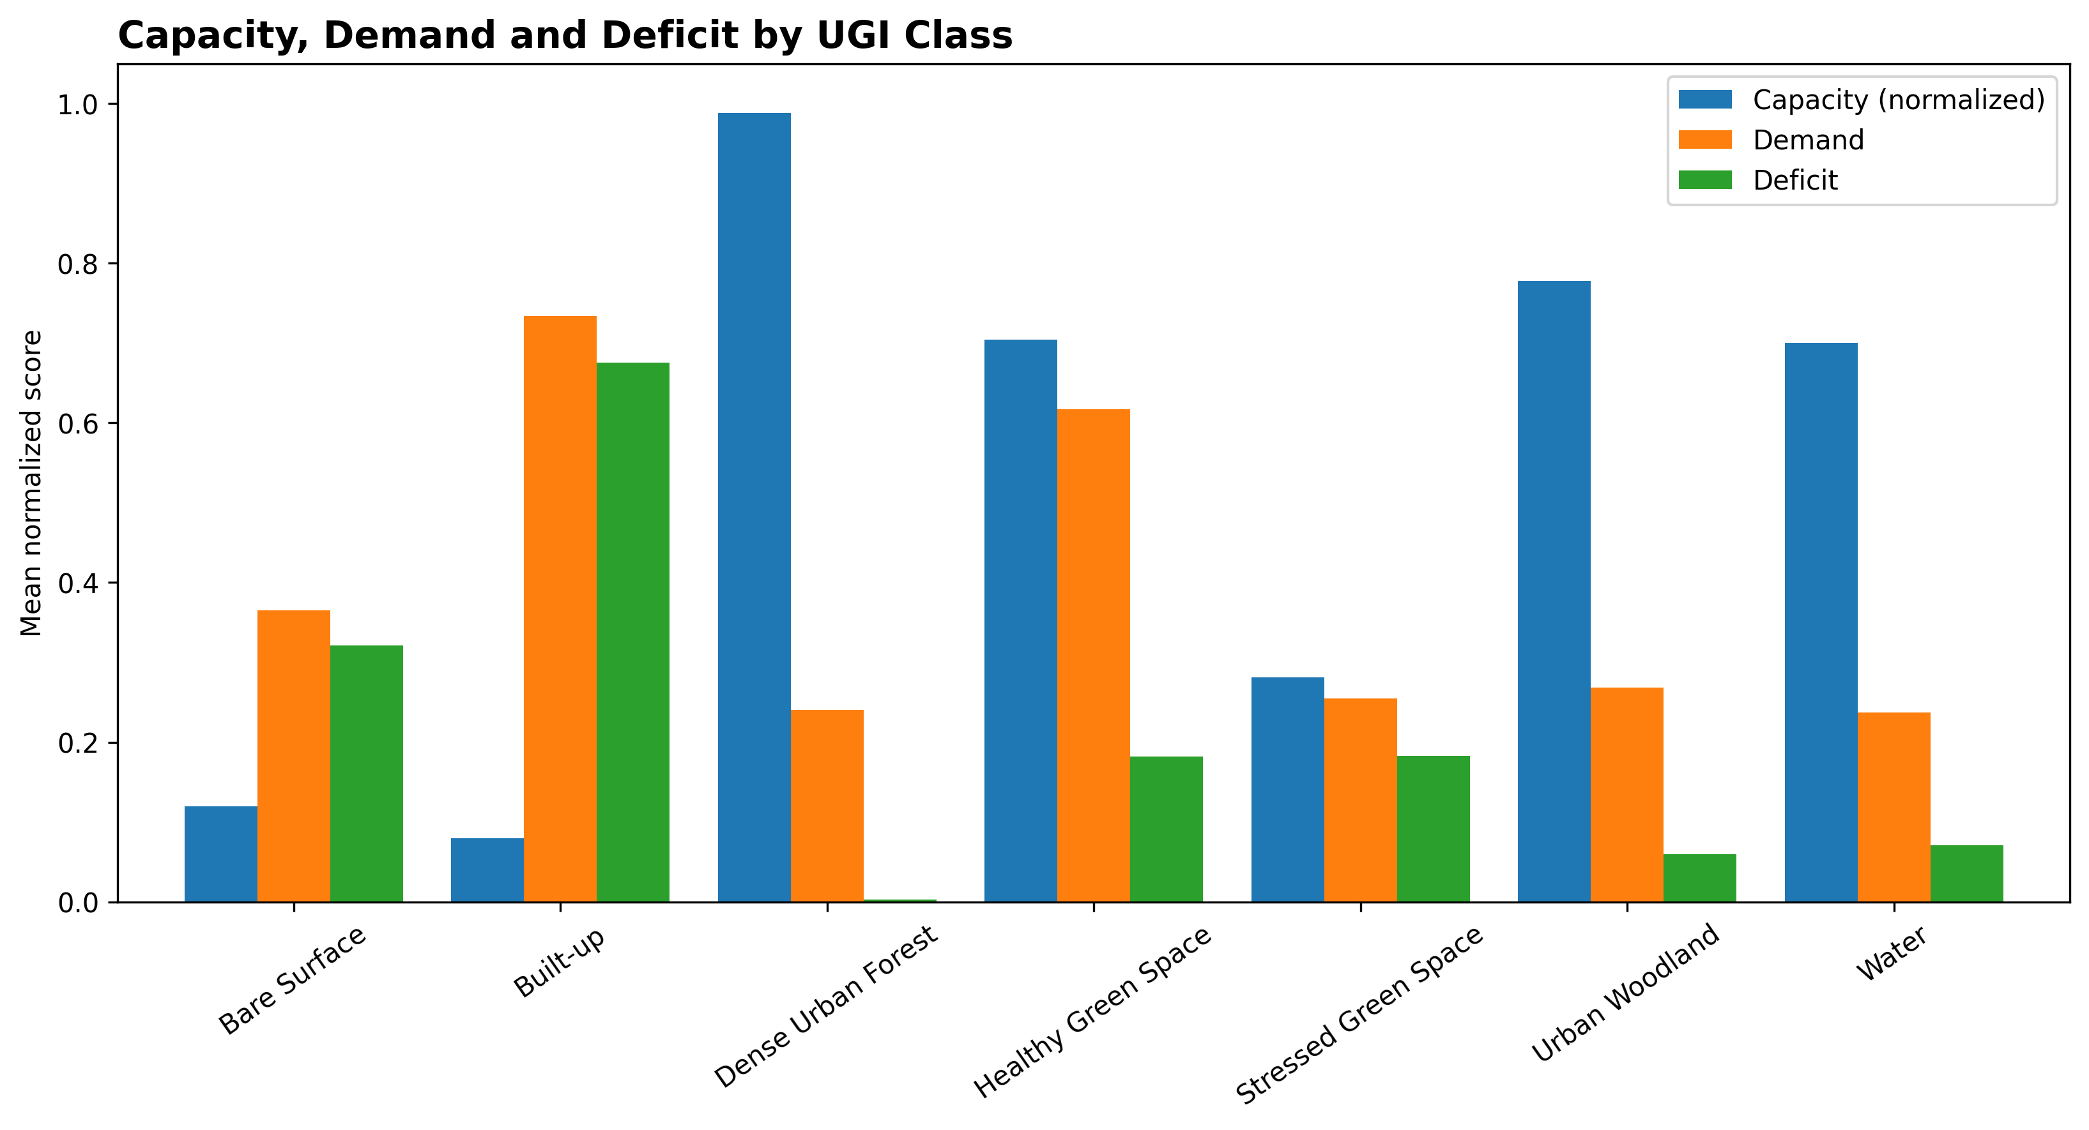
Figure 6. Mean capacity, demand and deficit by UGI class.

3.5 Planning priority
Priority class | Area (km²) | Share (%) | Mean deficit
Very Low | 7.7516 | 19.93 | 0.0018
Low | 7.7494 | 19.93 | 0.1036
Moderate | 7.7633 | 19.96 | 0.3888
High | 7.8075 | 20.08 | 0.7129
Very High | 7.8154 | 20.10 | 0.8422
Approximately 72.30% of Built-up land falls in High or Very High planning priority, compared with 0.02% of non-built land. Deficit and planning priority have Spearman ρ = 0.9802.
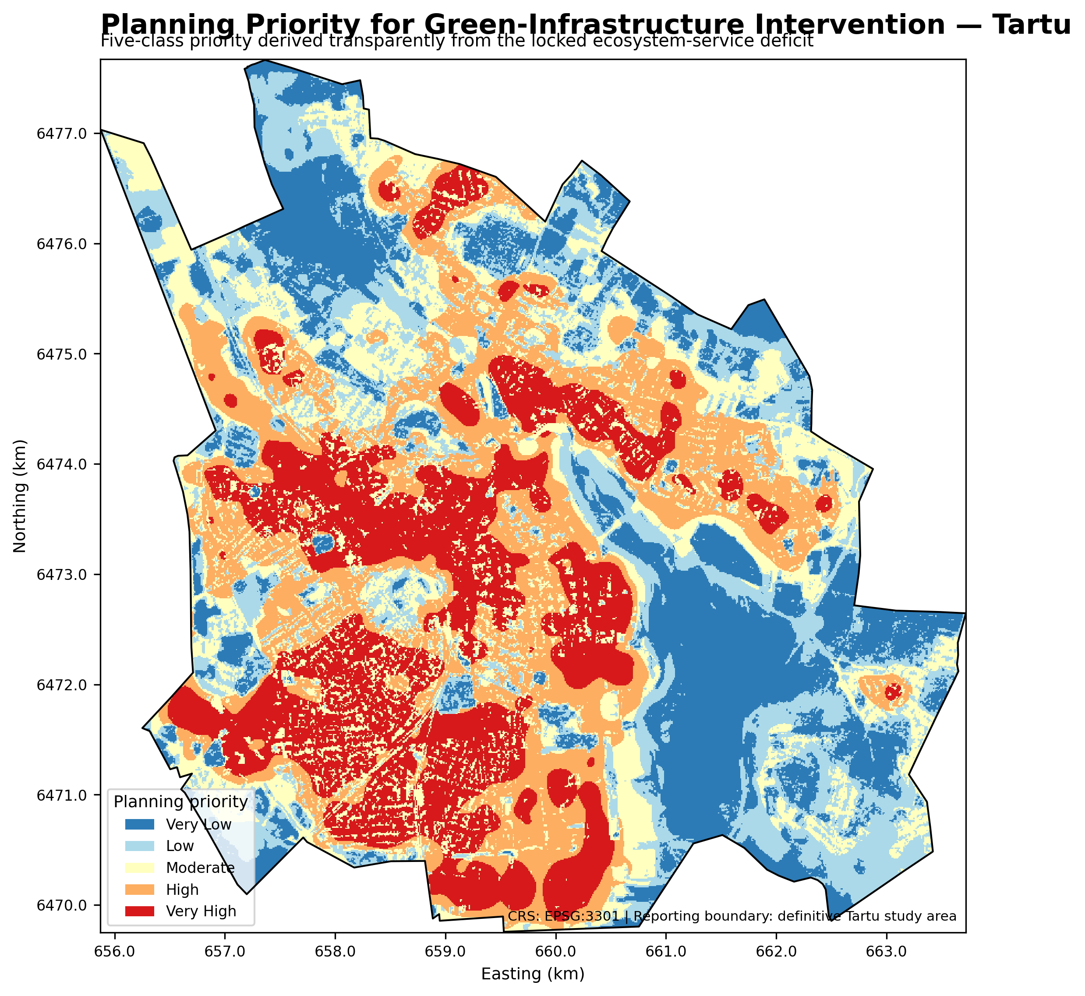
Figure 7. Final five-class planning-priority map.
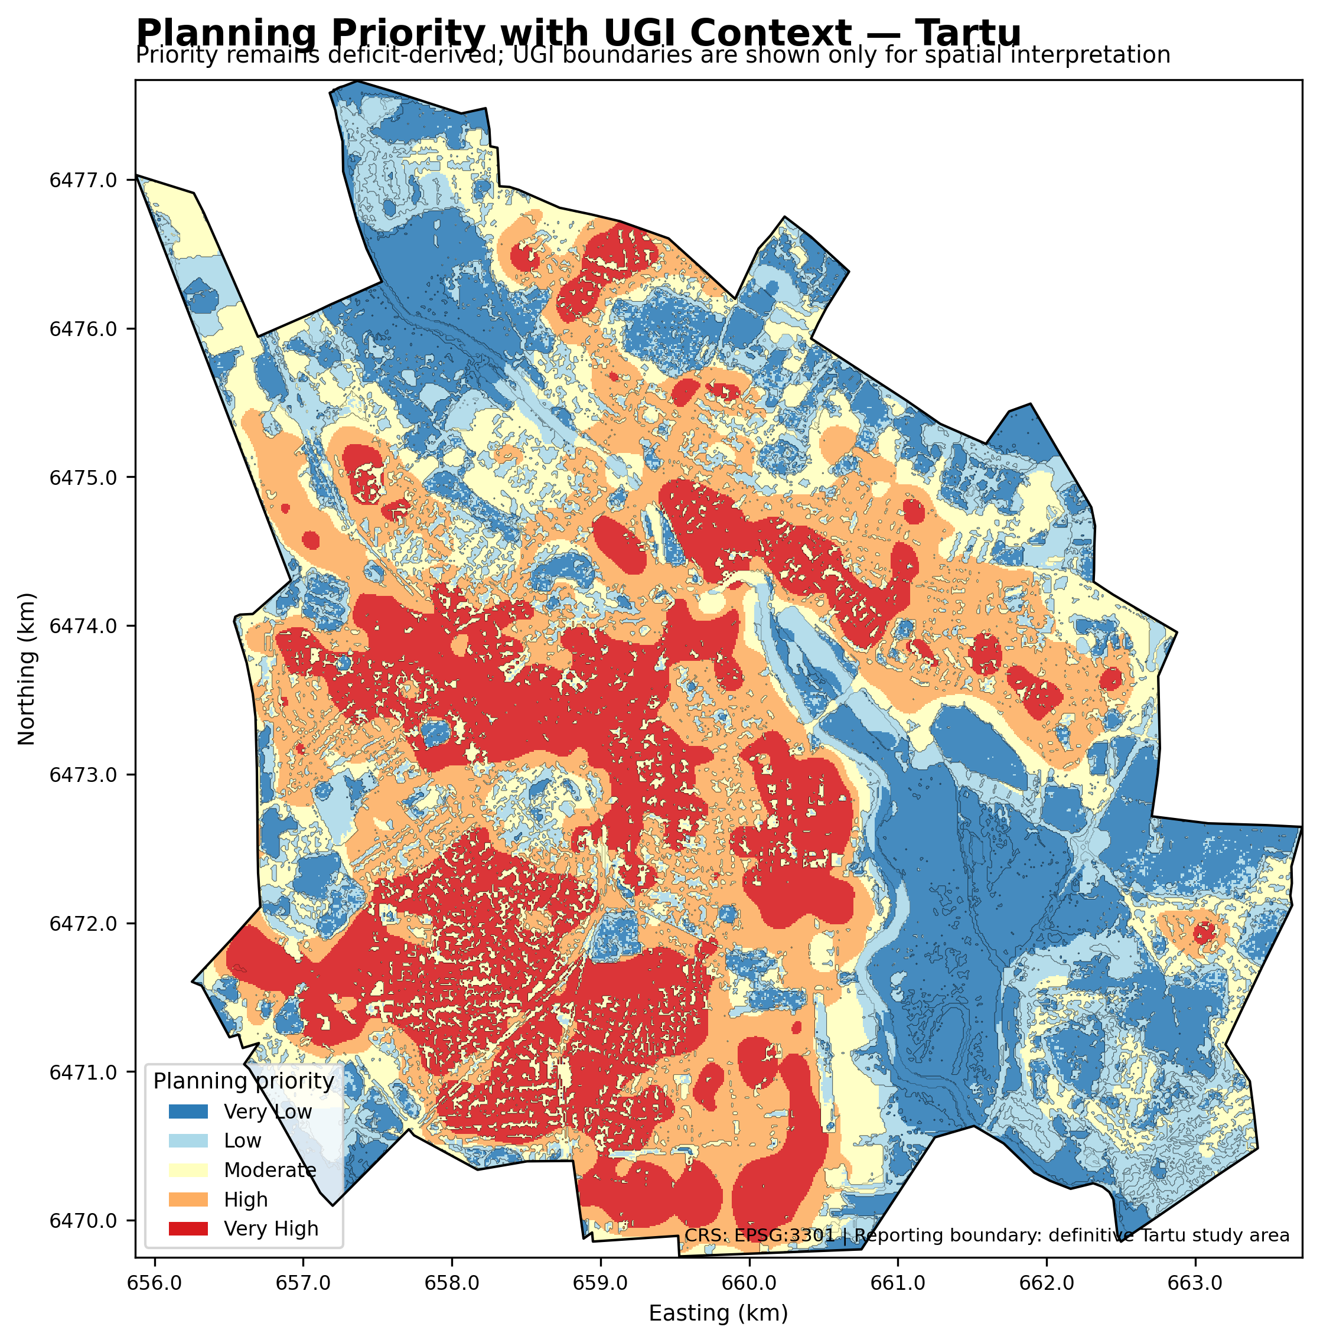
Figure 8. Planning priority with UGI context.
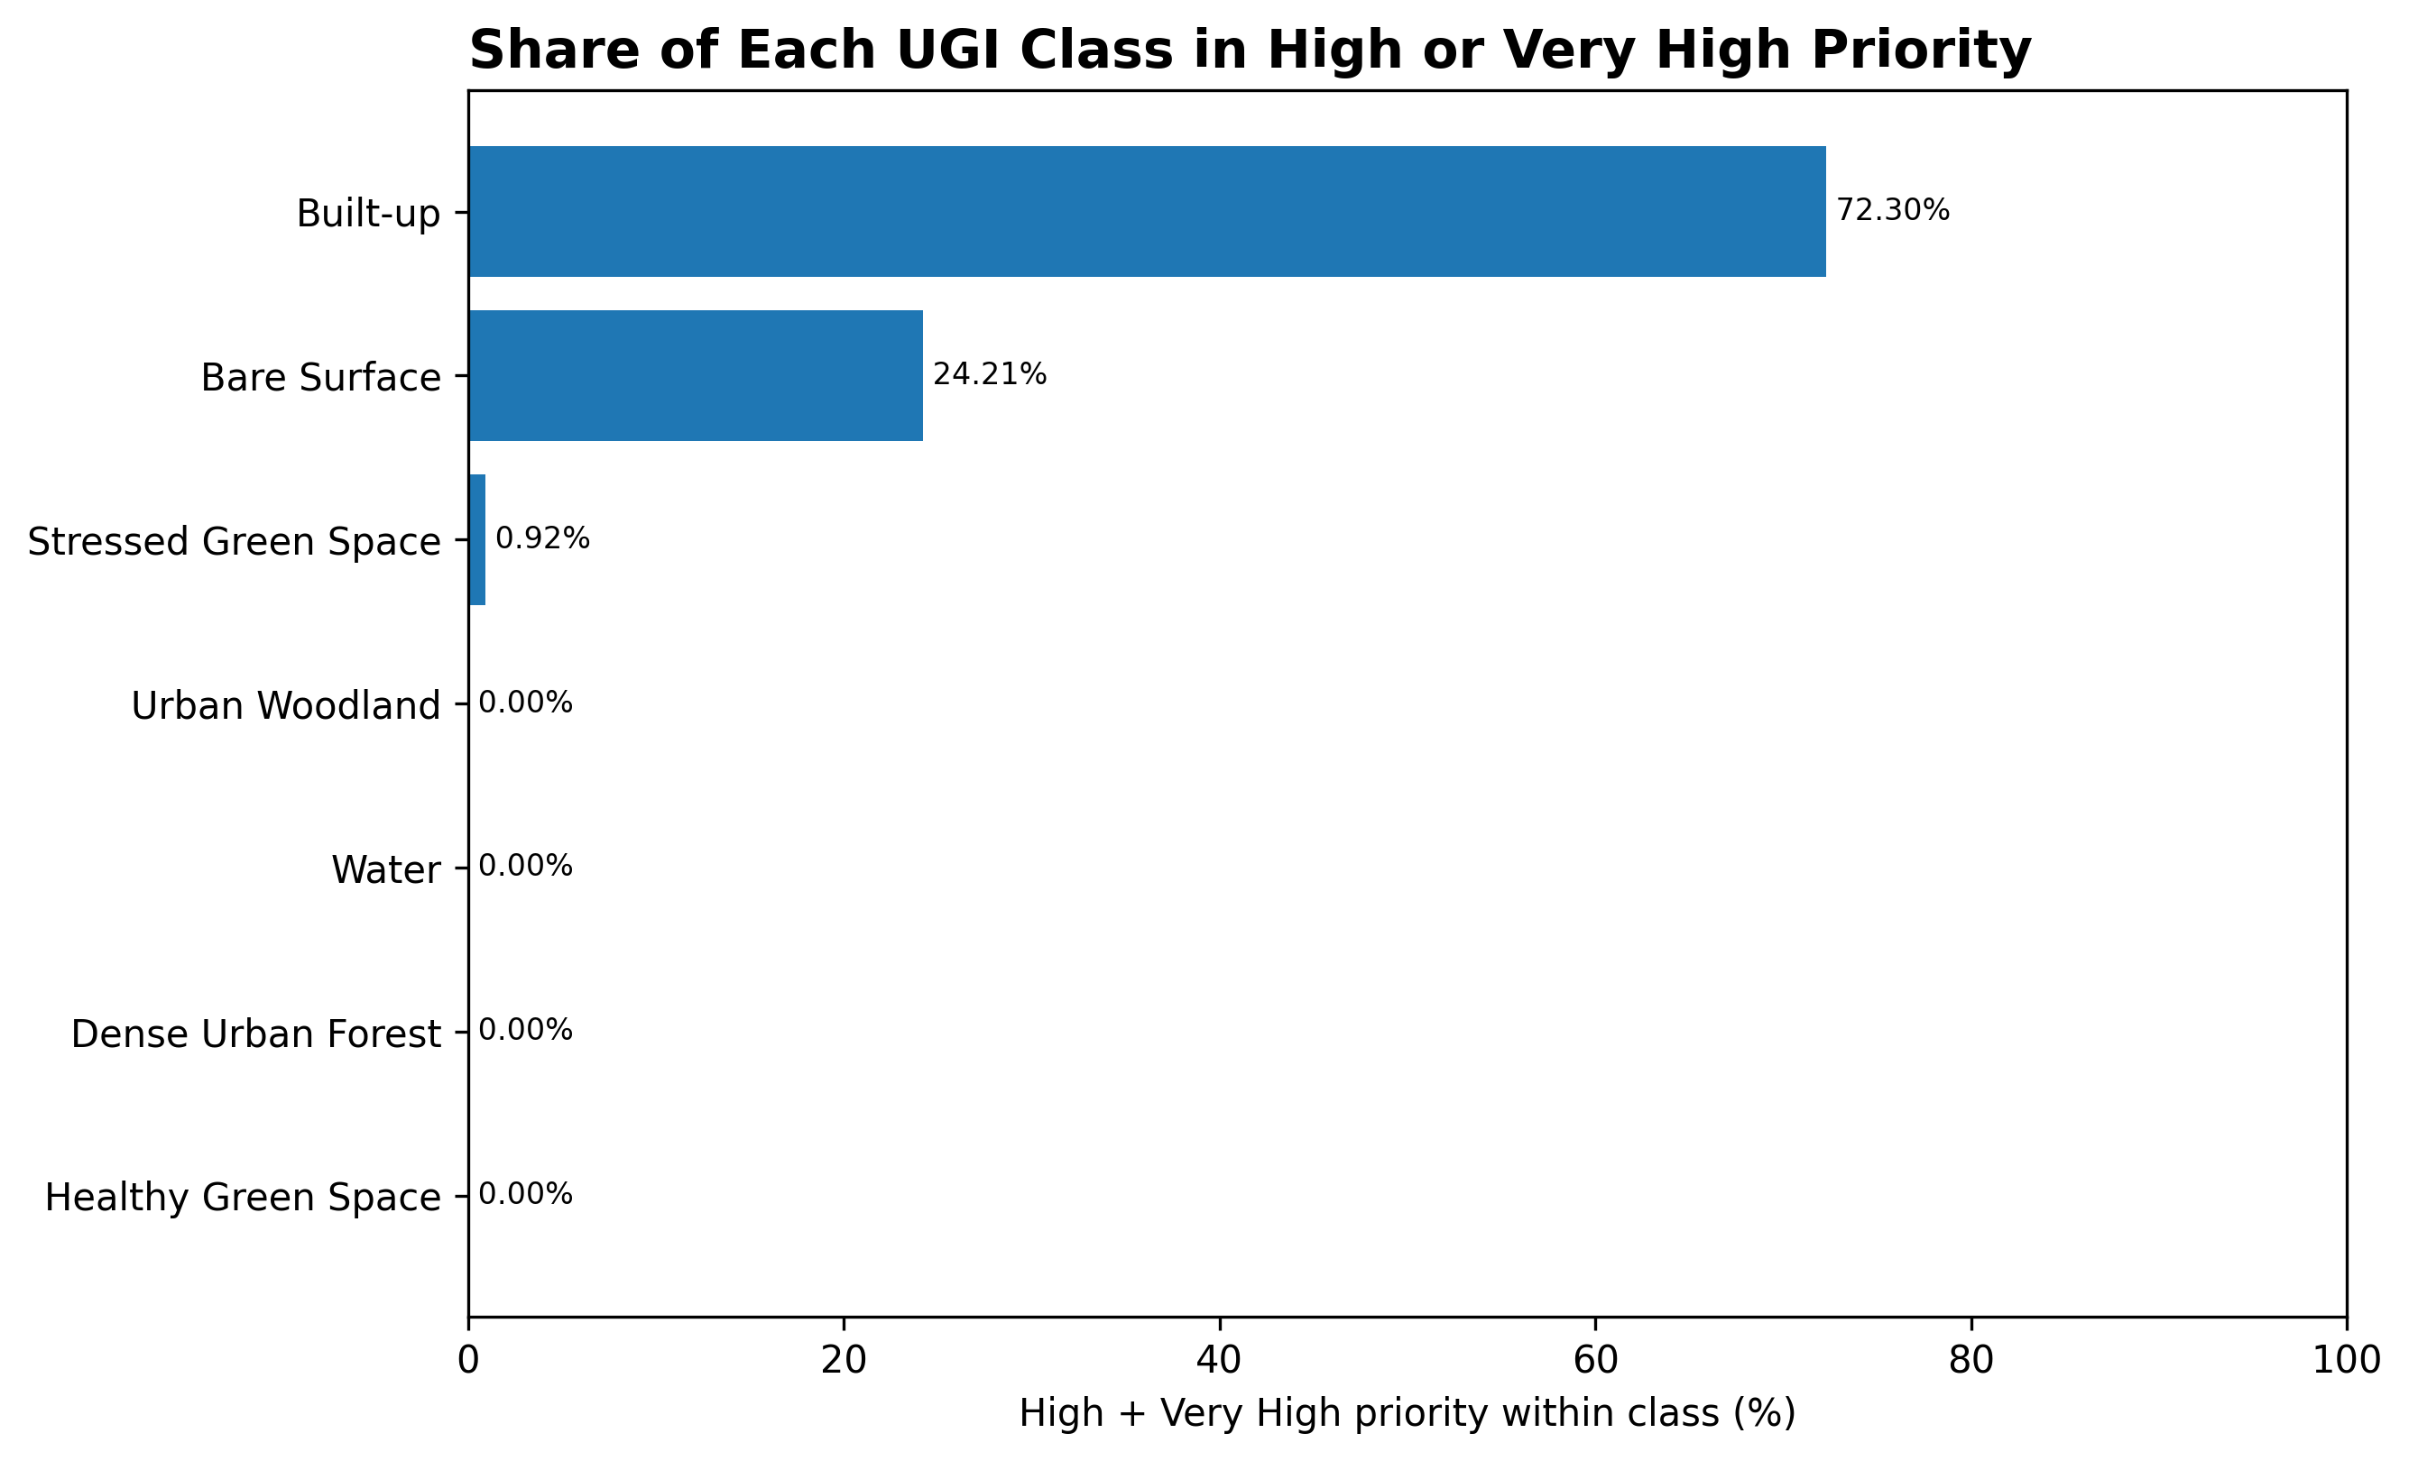
Figure 9. Share of each UGI class in High or Very High planning priority.

5. Discussion and Planning Implications
The results indicate that Tartu's planning challenge is not simply the amount of green land, but the spatial mismatch between ecological capacity and urban demand. Dense urban forest and woodland consistently exhibit high service capacity and low deficit, while the built environment concentrates demand in locations where ecological service provision is weakest.
The priority surface should therefore be interpreted as a decision-support layer for nature-based intervention rather than as a binary statement that all Built-up land is environmentally deficient. High-priority urban cells indicate locations where additional ecosystem-service provision could be most valuable. Appropriate interventions may include street-tree expansion, pocket parks, courtyard greening, green roofs and walls, permeable surfaces, stormwater-oriented green infrastructure, and stronger pedestrian connections to existing green assets.
The model does not independently prove causal relationships between land cover and human wellbeing. Instead, it provides a transparent spatial screening framework for identifying areas where ecological service capacity and demand are most imbalanced.

4.6 Model Robustness
Sensitivity testing was used to assess whether the main results depended heavily on individual modelling choices. Alternative capacity assumptions, demand parameters, deficit formulations and priority-classification schemes produced strongly similar spatial rankings and hotspot patterns.
The tests confirmed that the principal spatial relationships and planning-priority geography remain stable under reasonable alternative assumptions.

6. Limitations
Several limitations should be considered when interpreting the results.
The Sentinel-2 and Dynamic World products represent remotely sensed conditions and therefore inherit classification uncertainty, mixed-pixel effects and seasonal limitations. The UGI typology is a planning-oriented analytical classification rather than a field-validated habitat inventory.
WorldPop 2020 is the population source used to model demand. Although the demand surface is aligned to the 10 m project grid, this does not imply that the underlying population observations have a native 10 m resolution. The aligned surface should be interpreted as a spatial demand model, not a 10 m population census.
Ecosystem-service capacity is a relative index rather than a direct measurement of individual services such as cooling, runoff retention, carbon sequestration or recreation. The class baselines and vegetation-condition adjustments were explicitly documented and sensitivity-tested, but they remain modelling assumptions.
The deficit model is intentionally parsimonious. It combines demand and low capacity without additional Built-up or UGI penalties. This improves transparency and avoids double-counting, but it also means that factors such as income, age, heat exposure, public access, land ownership and intervention feasibility are not directly represented.
The five planning-priority classes are a policy translation of a continuous deficit surface. Their boundaries depend on the chosen classification method. Sensitivity testing showed that hotspot geography is robust, but class labels should still be interpreted as relative priorities within the study area.
A small raster fringe occurred along the vector boundary because of grid discretisation. Final reporting therefore uses a centre-cell boundary mask that represents 38.8872 km², closely matching the 38.887971 km² vector study area. This affects only boundary representation and not the interpretation of the internal spatial patterns.

7. Conclusion
This study demonstrates how geospatial planning can move beyond mapping green space to identify where ecological provision is least able to meet urban demand. By integrating land cover, vegetation condition, population distribution, ecosystem-service capacity and deficit, I developed a spatial decision-support framework for prioritising green-infrastructure intervention across Tartu.
The results show that built-up land covers 55.56% of the reporting area and contains the strongest concentration of ecosystem-service deficit. Mean capacity across the city is 41.54/100, mean demand is 0.5768 and mean deficit is 0.4110. About 72.30% of built-up land falls within High or Very High planning priority.
The planning implication is to combine protection of existing high-capacity ecological assets with targeted enhancement in urban areas where demand is concentrated and local ecological capacity is weak. The resulting maps provide an evidence base for directing more detailed planning, design and field assessment.

Author Contribution
I conceived and developed this project as a geospatial planning investigation rather than a stand-alone land-cover mapping exercise. I used urban-planning, GIS and remote-sensing knowledge to frame the central problem as a spatial mismatch between urban green-infrastructure capacity and the demand for ecosystem services across Tartu.
I defined the spatial planning problem, designed and implemented the analytical workflow, integrated remote-sensing indicators with land-cover and population information, developed the UGI typology and capacity-demand-deficit framework, tested model sensitivity, interpreted the spatial patterns and translated the deficit surface into planning-priority zones.
I used the geospatial evidence to move from problem identification to planning response. Areas where ecological service capacity is weak relative to concentrated urban demand were identified as locations where green-infrastructure protection, enhancement, restoration or nature-based interventions may provide the greatest planning value. Recommended measures include street-tree expansion, pocket parks, courtyard greening, green roofs and walls, permeable surfaces, stormwater-oriented green infrastructure and improved pedestrian connections to existing green assets.
External datasets and established geospatial methods remain attributable to their original providers and methodological sources. Project authorship covers the problem formulation, analytical design, geospatial implementation, sensitivity testing, spatial interpretation, cartographic communication and planning recommendations.

