The hotel management system

UNDERGRADUATE PROJECT

Submitted in partial ful_llment of the requirements of software development

project 1 for the degree of

B.Sc Engg. in CSE

By

GROUP: The Invincible

UNDER SUPERVISION OF: **Dipu Akter Shila**

Teaching Assistant

Dept. of CSE

Bangladesh University of Business and Technology



(BANGLADESH UNIVERSITY OF BUSINESS

&TECHNOLOGY(BUBT)

Dhaka-1216.

The hotel management system

GROUP MEMBER LIST

**Jubair Ibna Jaman : (19202103011)**

**……………………………………………**

**Abdullah Al Ahad Abir : (19202103031)**

**………………………………………………..**

**Farzana Yasmin Shikta : (19202103033)**

**…………………………………………….**



BANGLADESH UNIVERSITY OF BUSINESS &TECHNOLOGY(BUBT)

DEPARTMENT OF COMPUTER SCIENCE &ENGINEERING

Declaration of Authorship

………………………………..

We, **Jubair Ibna Jaman, Abdullah Al Ahad Abir, Farzana Yasmin Shikta,**

declare that this

project," The hotel management system," and the work

presented in it are our own. We con_rm that:

_ This work was done wholly or mainly while in candidature for a B.Sc Engineering in CSE

degree at this University.

_ Where any part of this software development project has previously been submitted for a

degree or any other quali_cation at this University or any other institution, this has been

clearly stated.

_ Where we have consulted the published work of others, this is always clearly attributed.

_ Where we have quoted from the work of others, the source is always given. With the

an exception of such quotations, this thesis is entirely our work.

_ We have acknowledged all primary sources of help.

_ Where the thesis is based on work done by ourselves jointly with others, We have made clear

exactly what was done by others and what we have contributed to me.

**Jubair Ibna Jaman : (19202103011)**

**Abdullah al ahad Abir : (19202103031)**

**Farzana YasminSikta : (19202103033)**

CERTIFICATE

This is to certify that the project entitled" The hotel management system" "

and submitted by **Jubair Ibna Jaman : (19202103011)**

**Abdullah al ahad Abir : (19202103031)**

**Farzana YasminSikta : (19202103033)**

in partial ful_llment of the requirements of embodies

they do the work under my supervision.

**Dipu Akter Shila**

Teaching Assistant

Bangladesh University of Business and Technology

Date: 10-03-2021

Dedication

We are dedicated to our parents for all their love and inspiration.

Abstract

The purpose of this research, computerized hotel management system with Satellite Motel Ilorin, Nigeria as the case study is to understand and make use of the computer to solve some of the problems encountered during manual operations of the hotel management. Finding accommodation or a hotel after having reached a particular destination is quite time-consuming and expensive. Here comes the importance of an online hotel booking facility. Online hotel booking is one of the latest techniques in the internet arena that allows travelers to book a hotel located anywhere globally and according to their tastes and preferences. In other words, online hotel booking is one of the excellent facilities of the internet. Booking a hotel online is not only fast as well as convenient but also very cheap. Nowadays, many of the hotel providers have their sites on the web, which allows the users to visit these sites and view the facilities and amenities offered by each of them. So, the proposed computerized online hotel management system is set to find a more convenient, well organized, faster, reliable, and accurate means

of processing the current manual system of the hotel for both near and far customer

ACKNOWLEDGEMENTS

First of all, we are thankful and expressing our gratefulness to Almighty Allah who o_ers us His

divine blessing, patient, mental and physical strength to complete this project work.

We are deeply indebted to our project supervisor Md. Ariful Islam Malik, Lecturer, Department

of Computer Science and Engineering (CSE), Bangladesh University of Business and Technology

(BUBT). His scholarly guidance, essential suggestions, work for going through our drafts and

correcting them, and generating courage from the beginning to the end of the research work has

made the completion of this thesis possible.

Special gratitude goes out to all our friends for their support and helps to implement our

works. The discussions with them have been constructive for us

to enrich our knowledge and conception regarding the outcome.

Last but not least; we are highly grateful to our parents and family members for supporting

us spiritually throughout writing this thesis and our life in general.

APPROVAL

This project "The hotel management system" " Submitted by **Jubair Ibna Jaman : (19202103011)Abdullah al Ahad Abir : (19202103031)Farzana YasminSikta : (19202103033)**

Department of Computer Science and

Engineering (CSE), Bangladesh University of Business and Technology (BUBT) under the

supervision of Dipu Akter Shila; Teaching Assistant, Department of Computer Science and

Engineering has been accepted as satisfactory for the partial ful_llment of the requirement for

the degree of Bachelor of Science (B.Sc. Engg.) in Computer Science and Engineering and

approved as to its style and contents.

Supervisor

……………

**Dipu Akter Shila**

Teaching Assistant

Department of CSE.

Bangladesh University of Business and Technology (BUBT)

Chairman:

Prof. Firoz Mridha

Professor and Chairman

Department of CSE

Bangladesh University of Business and Technology (BUBT)

#Declaration of Authorship i

#Certificate ii

#Abstract iii

#Acknowledgements iv

#Approval v

#Contents vi

#List of Figures vii

1 Introduction

* 1. Introduction.

1. Project Review

2.1 Login.

2.2 Booking.

2.3 Search.

2.4 Rent services.

2.5 Payment.

2.6Special Event Services.

3 Technologies.

3.1 Software.

3.1.1 Code::Blocks.

3.2 Programming Language.

3.2.1 C Language.

Introduction

* 1. **Introduction**

Here we have highlighted the hotel management system while explaining the various facilities in our hotel.

#### And this kind of benefit is being used to make this project structures color function array files.

#### The hotel booking system is described below :

#### First, you have to enter the hotel's name, go to the hotel page, and log in. If the customer is unknown, then he has to register again. A list of what packages are available in the hotel will come and what kind of container the customer will choose. After choosing the box, there will be a payment option where he has to pay half the booking. When the booking is completed, the booking number will be sent to the customer to understand that his hotel booking has been completed. Then there will be an exit option at the bottom where the customer will exit the page when pressed. Finally, to cancel the booking, go to the hotel page and select the cancel option. However, there will be a condition that you have to inform at least three days before your booking will be canceled.

Project Review

**Login: After a search, he will Log in Our system and book a room in our hotel.**

**Booking: With the help of a booking system, the customer can easily book his hotel or resort room**

**Search**: **Customer will search our hotel through search option and then login if he likes.**

**Rent services: Rent service is a system that helps customer book a room for 3 to 4 days in a hotel**

**Payment: The customer will pay them by money or card. Online payment No offshore was kept.**

**Special Event Services: We have a special event service in our hotel for Eid, Puja, Christmas, Valentine's Day, 31st fast night, which will be given in the hotel package.**

Technologies

Software

3.1.1 Code::Blocks

Code::Blocks is a free, open-source, cross-platform IDE that supports multiple compilers, including

GCC, Clang, and Visual C++. It is developed in C++ using wxWidgets as the GUI toolkit.

Using a plugin architecture, its capabilities and features are de_ned by the provided plugins.

Currently, Code::Blocks is oriented towards C, C++, and Fortran. It has a custom build system

and optional Make support.

Code::Blocks is being developed for Windows and Linux (the latest macOS version is 13.12

released on 12/26/2013) and has been ported to FreeBSD, OpenBSD, and Solaris.

 Code::Blocks

After releasing two release candidate versions, 1.0rc1 on July 25, 2005, and 1.0rc2 on October

25, 2005, instead of making a _nal release, the project developers started adding many new

features, with the _nal release being repeatedly postponed. Instead, there were nightly builds of

the latest SVN version made available daily.[citation needed] The _rst stable release

was on February 28, 2008, with the version number changed to 8.02. The versioning scheme

was changed to that of Ubuntu, with the major and minor numbers representing the year and

month of the release. Version 17.12 is the latest stable release; however, for the most up-to-date

performance, the user can download the relatively stable nightly build or download the source code

from SVN. Jennie Limited distributes a version of Code::Blocks customized to work with its

microcontrollers.[Wikipedia].

Programming Language

**C Language**

C (/si/, as in the letter c) is a general-purpose, imperative computer programming language,

supporting structured programming, lexical variable scope, and recursion during a static type

the system prevents many unintended operations. By design, C provides constructs that map

e_ciently to typical machine instructions, and therefore it has found lasting use in applications that had formerly been coded in assembly language, including operating systems, as well

as various application software for computers ranging from supercomputers to embedded systems.



C_ LANGUAGE.

Many later languages have borrowed directly or indirectly from C, including C, C#, Unix's

C shell, D, Go, Java, JavaScript, Limbo, LPC, Objective-C, Perl, PHP, Python, Rust, Swift,

Verilog and SystemVerilog (hardware description languages). These languages have drawn many

of their control structures and other basic features from C. Most of them (with Python being

the most dramatic exception) are also very syntactically similar to C in general. They tend

to combine the recognizable expression and statement syntax of C with underlying type systems,

data models, and semantics that can be radically di_erent.[Wikipedia.

System Analysis & Architectural

Enter for admin access

,,,,,,,,,,,,,,,,,,,,,,,,,,,,,,,,,,,,

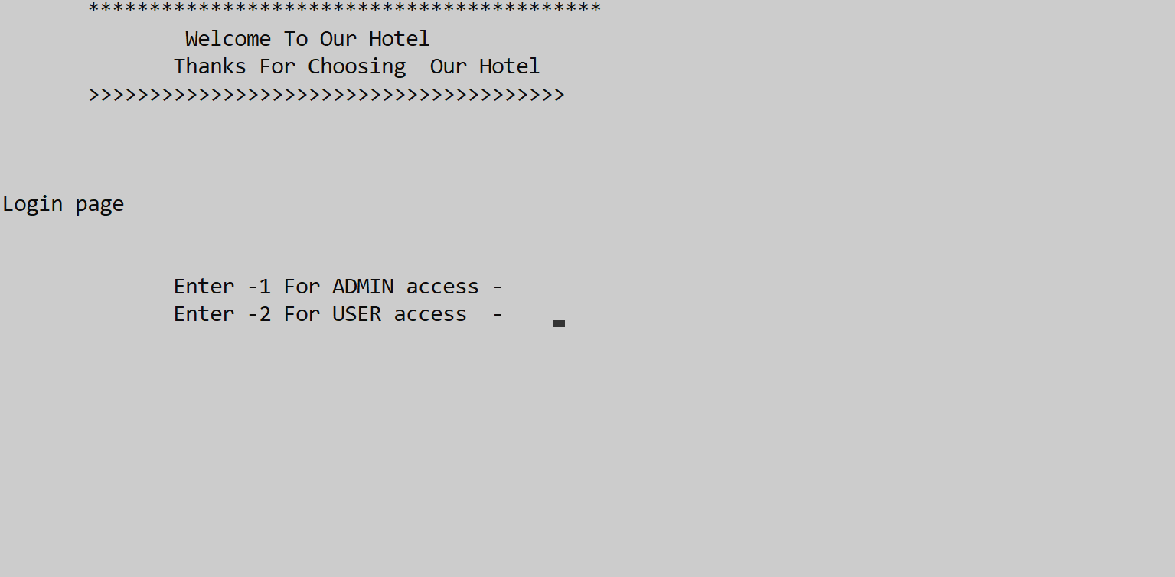Login

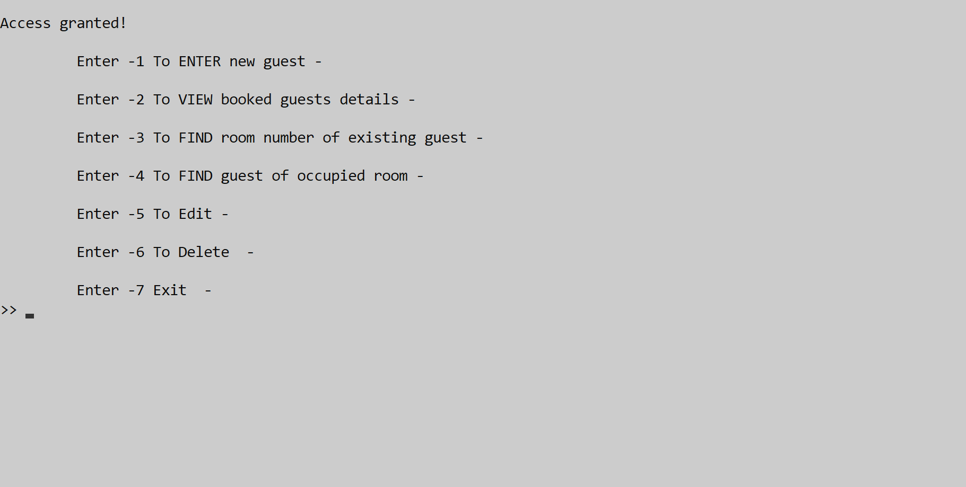Admin Panel

Booking of new Guest

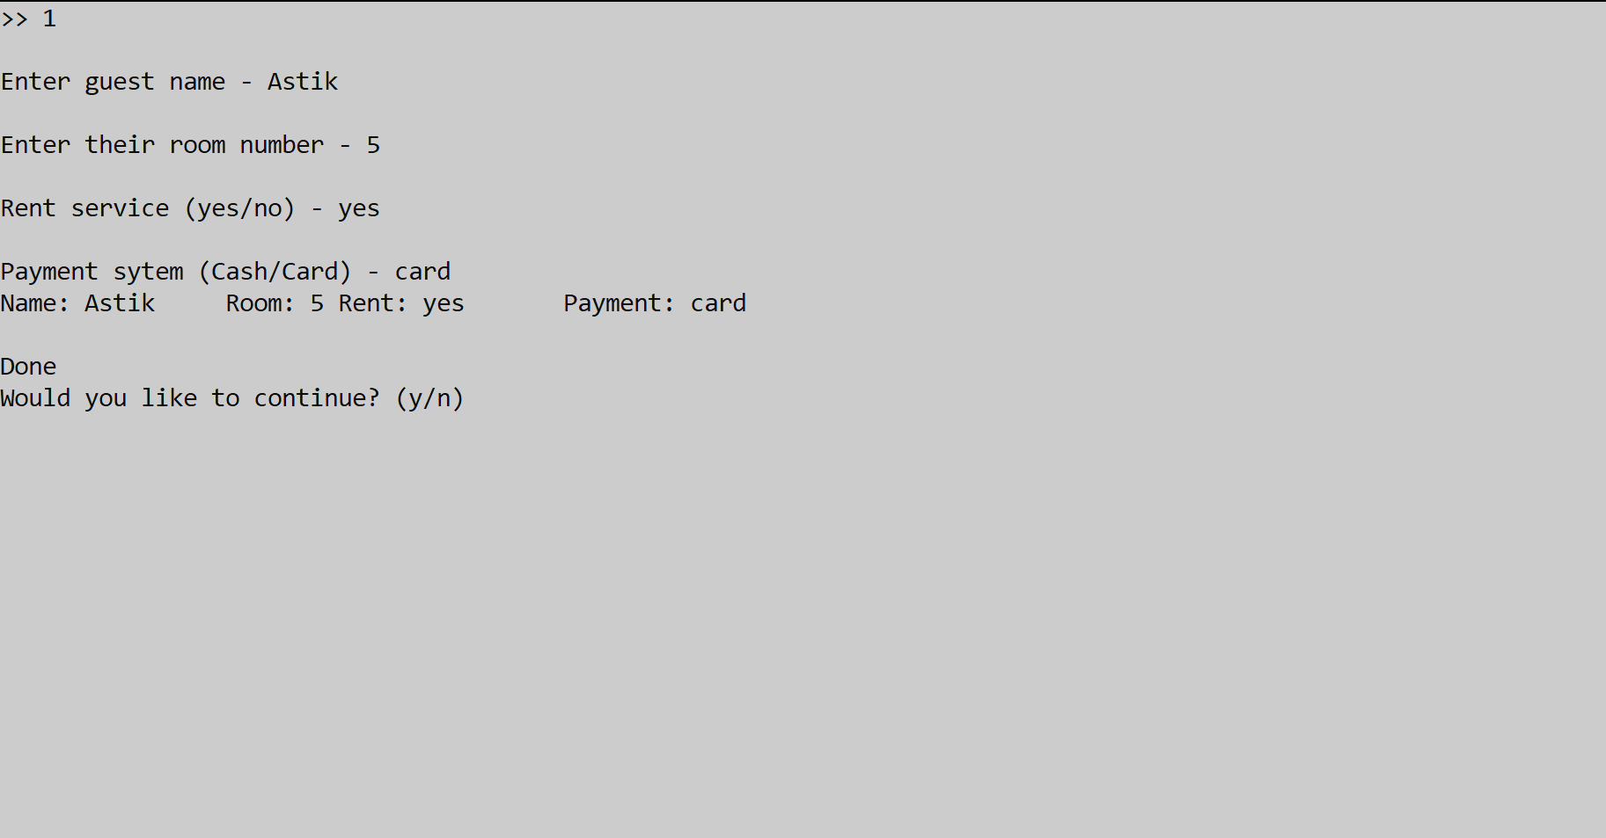

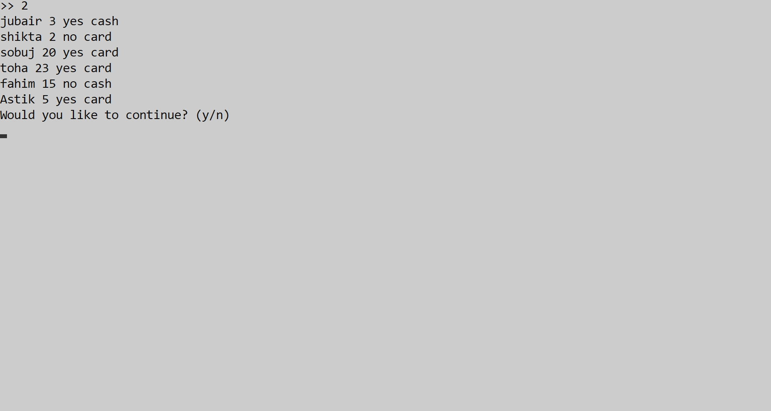Find the guest details

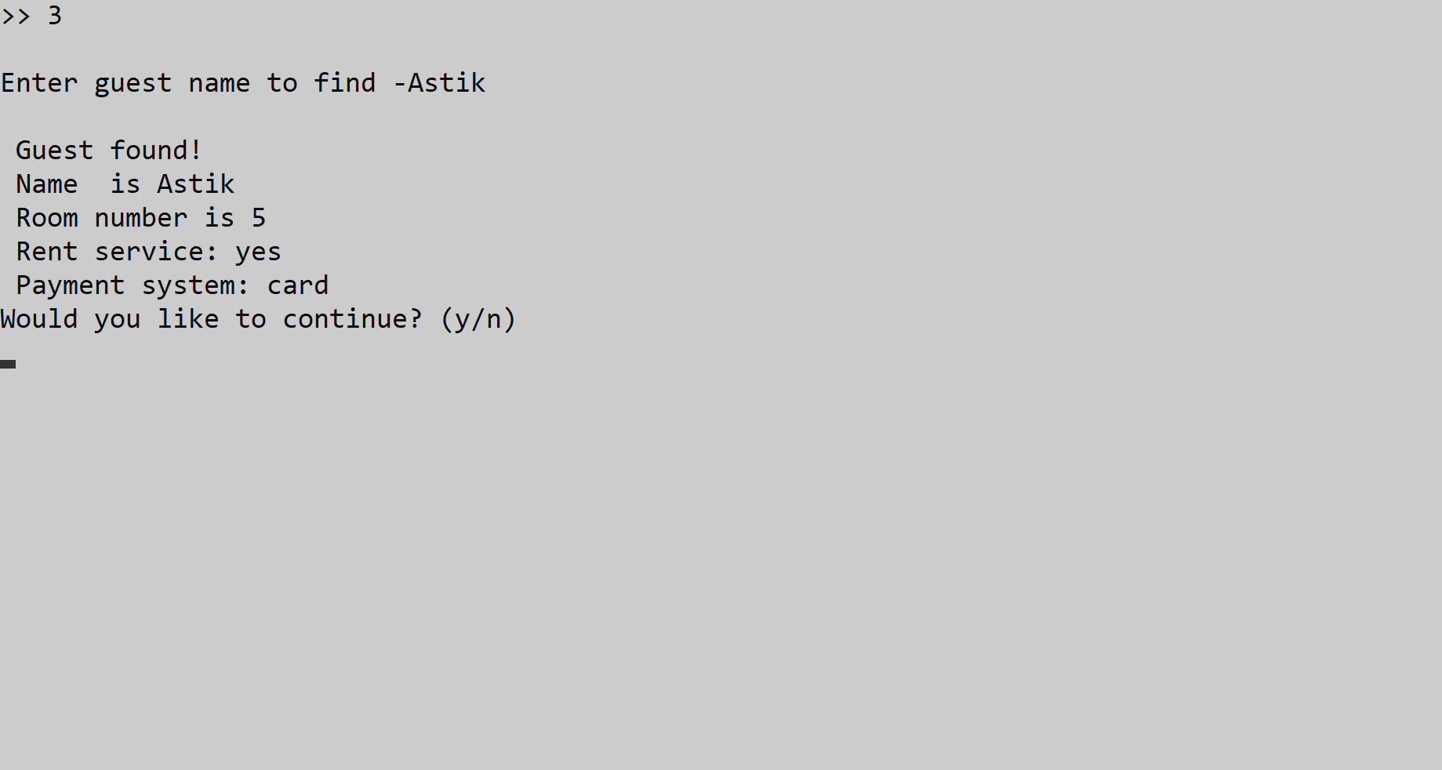Find Room Number Of Existing Guest:

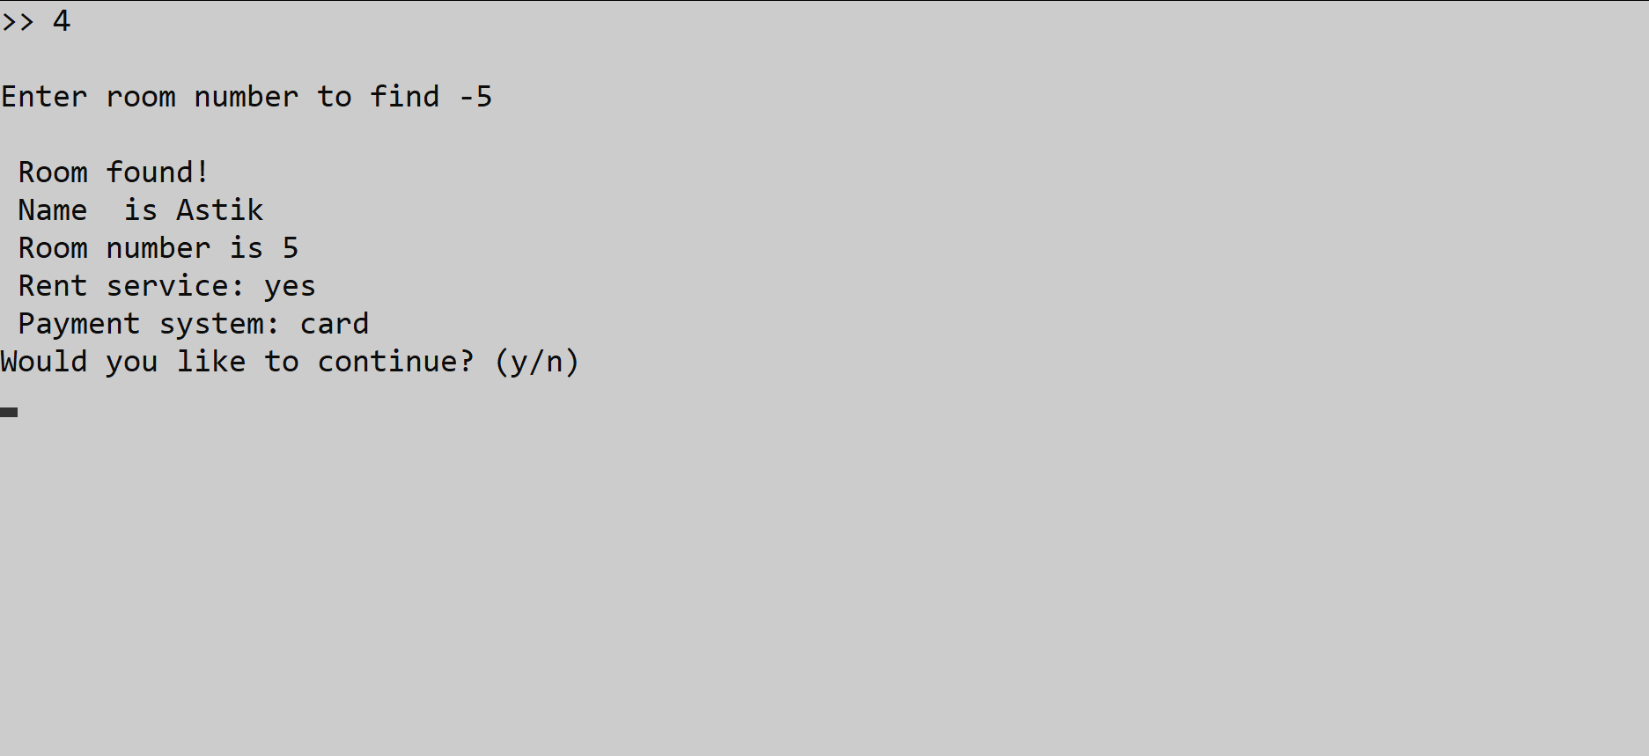Find occupied Room

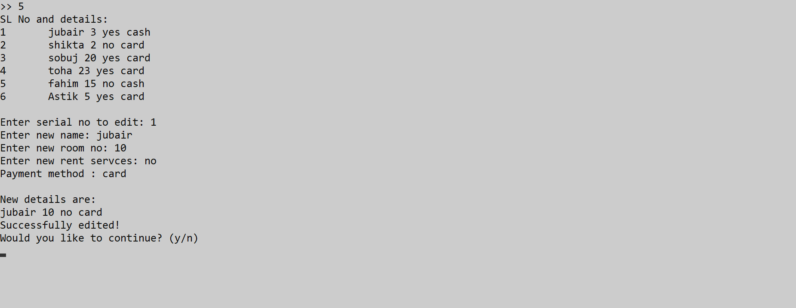Edit

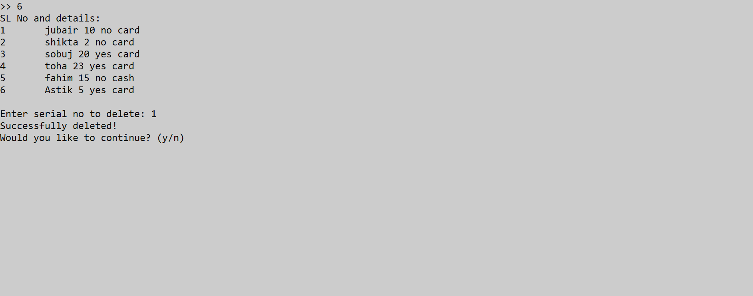 Delete

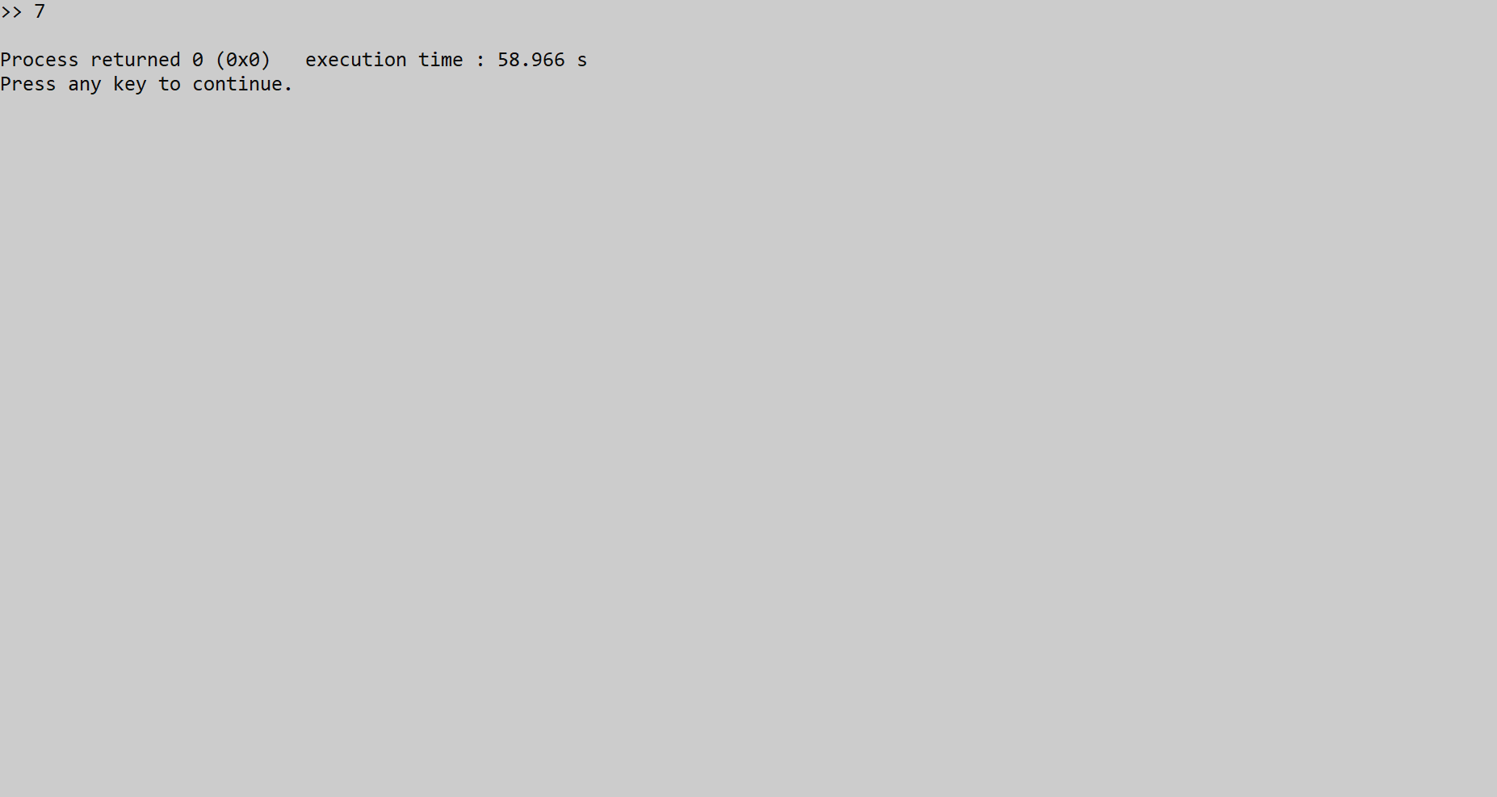Exit

Enter for user access

,,,,,,,,,,,,,,,,,,,,,,,,,,,,

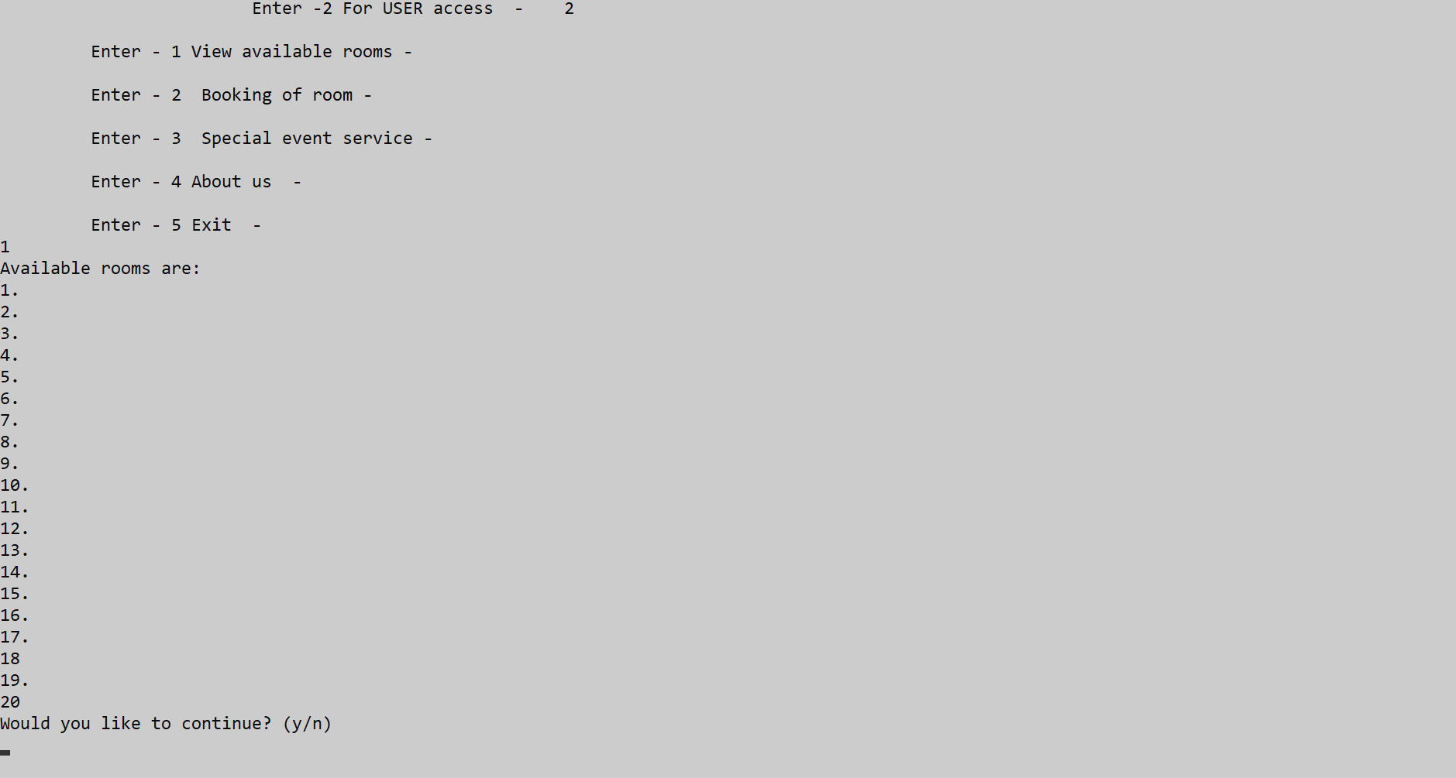Available Room

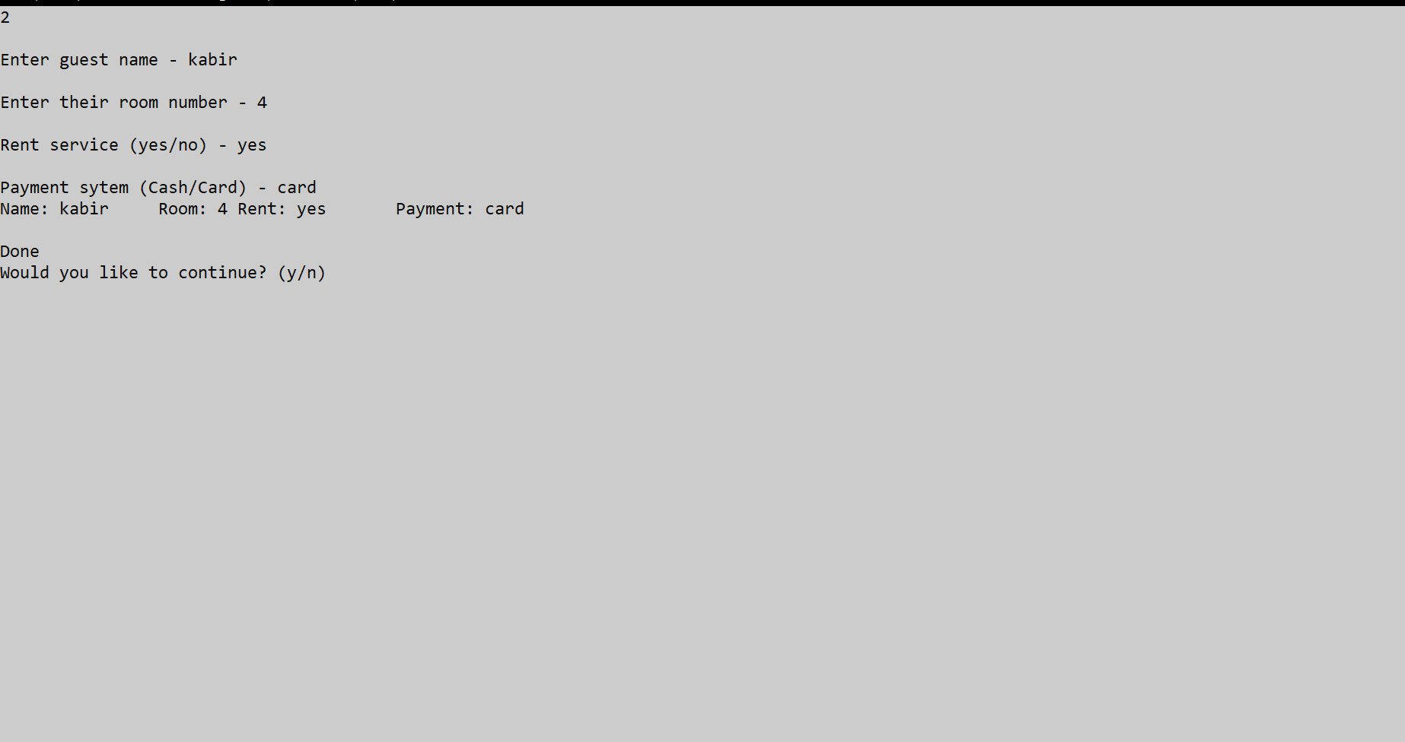Booking room of Guest

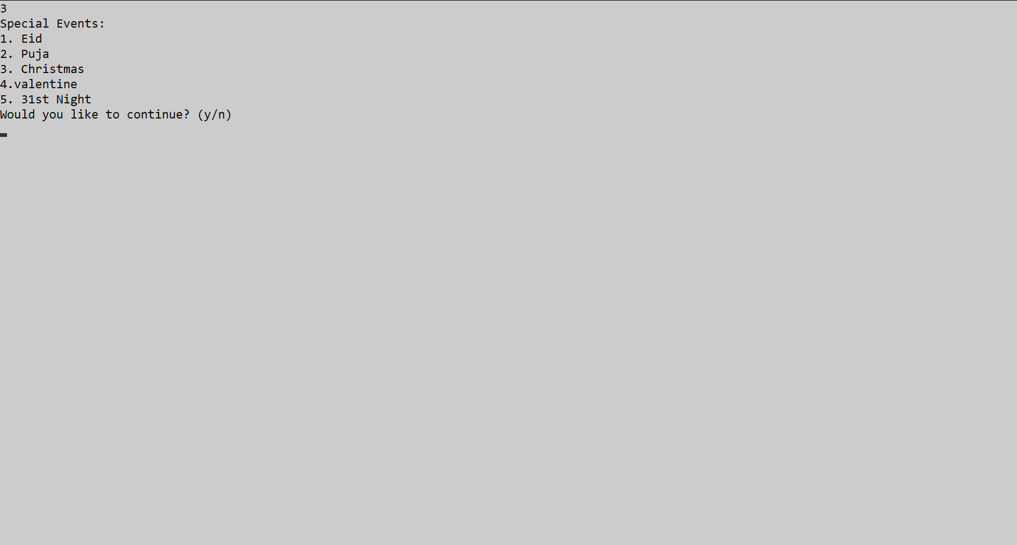Special Event

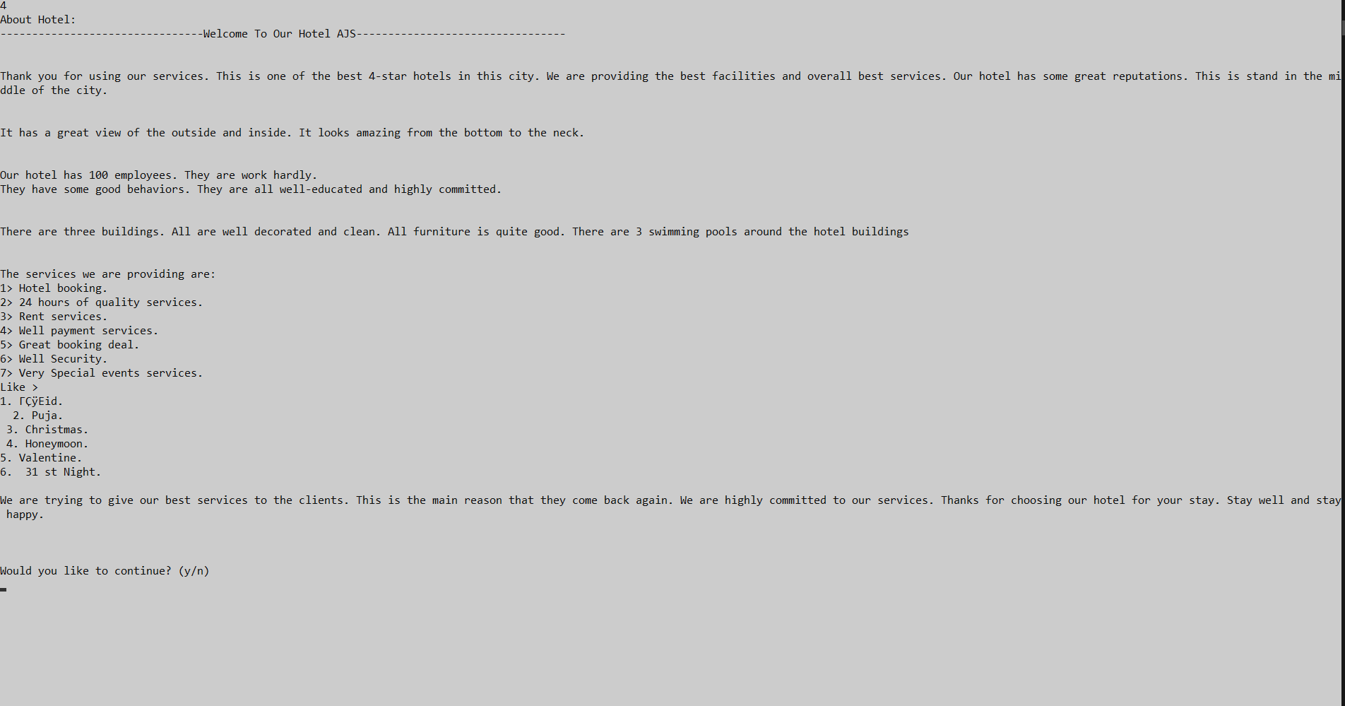About Hote

**CODE :**

#include<stdio.h>

#include<stdlib.h>

#include<string.h>

//Method Declaration

void enter_name();

void find_name();

void find_room();

void checkout_guest();

void view_bookings();

//Instance Field Declaration

FILE* view;

FILE *fp;

FILE* enter;

char admin_entry[20] = {'y'};

char user_entry[20] = {'y'};

//structure defined to store name, Room, rent service, and payment system required

struct hotel

{

char name[20];

char room[20];

char payment[5];

char rent[4];

}h;

//main method

int main(){

int a,b,c;

//Welcome screen

system("COLOR 70");

printf(" \t\t ******************************************\t\n");

printf(" \t\t\t Welcome To Our Hotel \t\t\n");

printf(" \t\t\t Thanks For Choosing Our Hotel \n");

printf(" \t\t >>>>>>>>>>>>>>>>>>>>>>>>>>>>>>>>>>>>>>>\t\n");

printf(" \t\t \n");

printf("\t\t\t\n\n Login page \n\n");

printf("\n\t\t\t Enter -1 For ADMIN access - \t");

printf("\n\t\t\t Enter -2 For USER access - \t");

scanf("%d",&a);

switch(a){

case 1:{

char pass[10];

char filepass[10];

int i;

FILE *passw;

passw = fopen("pass.txt","r");

//admins password prompt

printf("\nPlease enter the password to continue - ");

for(i=0; i<6; i++){

scanf("%s",pass);

fscanf(passw,"%s",filepass);

if (strcmp(filepass,pass) == 0) {

printf("\n\nAccess granted!\n");

fclose(passw);

break;

}

else{

printf("\nIncorrect password, please try again.");

printf("\nYou have %d trys left ",5-i-1);

printf("\n\nEnter password >> ");

}

if(i==4){

fclose(passw);

return 0;

}

}

//re-entry if

while(admin_entry[0] =='y'){

printf("\n\t Enter -1 To ENTER new guest - \t\n");

printf("\n\t Enter -2 To VIEW booked guests details - \n");

printf("\n\t Enter -3 To FIND room number of existing guest - \n");

printf("\n\t Enter -4 To FIND guest of occupied room - \n");

printf("\n\t Enter -5 To Edit - \n");

printf("\n\t Enter -6 To Delete - \n");

printf("\n\t Enter -7 Exit - \n");

printf(">> ");

scanf("%d",&b);

switch(b){

case 1:{

enter_name();

break;

}

{

case 2:

view_bookings();

break;

}

case 3:{

find_name();

break;

}

case 4:{

find_room();

break;

}

case 5:{

edit();

break;

}

case 6:{

delete();

break;

}

case 7:{

exit(0);

}

default:{

printf("\n Wrong entry!");

}

}

//enter again?

printf("Would you like to continue? (y/n)\n");

scanf("%s",admin_entry);

}

if(strcmp(admin_entry,"n") == 0){

printf("Exiting...\n");

printf("\n >Exited<\n\n");

return 0;

}

else{

printf("Wrong entry!\nExiting...\n");

return 0;

}

break;

}

case 2:{

while(user_entry[0] =='y'){

printf("\n\t Enter - 1 View available rooms - \n");

printf("\n\t Enter - 2 Booking of room - \n");

printf("\n\t Enter - 3 Special event service - \n");

printf("\n\t Enter - 4 About us - \n");

printf("\n\t Enter - 5 Exit - \n");

scanf("%d",&c);

switch(c){

case 1:{

FILE* view;

view = fopen("rooms.txt","r");

printf("Available rooms are:\n");

while(fscanf(view,"%s",h.room) != -1){

printf("%s \n",h.room);

}

fclose(view);

break;

}

case 2:{

enter_name();

break;

}

case 3:{

printf("Special Events:\n");

FILE * fp = fopen("special_events.txt", "r");

char ch;

while(fscanf(fp, "%c", &ch) != -1)

printf("%c", ch);

printf("\n");

fclose(fp);

break;

}

case 4:{

printf("About Hotel:\n");

FILE * fp = fopen("about_hotel.txt", "r");

char ch;

while(fscanf(fp, "%c", &ch) != -1)

printf("%c", ch);

printf("\n");

fclose(fp);

break;

}

case 5:{

exit(0);

}

}

printf("Would you like to continue? (y/n)\n");

scanf("%s",user_entry);

}

if(strcmp(user_entry,"n") == 0){

printf("Exiting\n");

printf("\n >Exited<\n\n");

return 0;

}

else{

printf("Wrong entry!\nExiting\n");

return 0;

}

break;

}

}

}

void delete(){

FILE * fp = fopen("hotelnew.txt", "r");

int i, j, sl_no;

if(!fp){

printf("Something went wrong!\n");

printf("Press any key to go back... ");

getch();

return;

}

struct hotel ara[1000];

i = 0;

while(fscanf(fp, "%s %s %s %s", ara[i].name, ara[i].room, ara[i].rent, ara[i].payment) != -1)

++i;

printf("SL No and details:\n");

for(int j = 0; j < i; ++j)

printf("%d\t%s %s %s %s\n", j+1, ara[j].name, ara[j].room, ara[j].rent, ara[j].payment);

printf("\nEnter serial no to delete: ");

scanf("%d", &sl_no);

fclose(fp);

fp = fopen("hotelnew.txt", "w");

for(j = 0; j < sl_no-1; ++j)

fprintf(fp, "%s %s %s %s\n", ara[j].name, ara[j].room, ara[j].rent, ara[j].payment);

for(j = sl_no; j < i; ++j)

fprintf(fp, "%s %s %s %s\n", ara[j].name, ara[j].room, ara[j].rent, ara[j].payment);

fclose(fp);

printf("Successfully deleted!\n");

return;

}

void edit(){

FILE * fp = fopen("hotelnew.txt", "r");

int i, j, sl_no;

if(!fp){

printf("Something went wrong!\n");

printf("Press any key to go back... ");

getch();

return;

}

struct hotel ara[1000];

i = 0;

while(fscanf(fp, "%s %s %s %s", ara[i].name, ara[i].room, ara[i].rent, ara[i].payment) != -1)

++i;

printf("SL No and details:\n");

for(int j = 0; j < i; ++j)

printf("%d\t%s %s %s %s\n", j+1, ara[j].name, ara[j].room, ara[j].rent, ara[j].payment);

printf("\nEnter serial no to edit: ");

scanf("%d", &sl_no);

printf("Enter new name: ");

scanf("%s", h.name);

printf("Enter new room no: ");

scanf("%s", h.room);

printf("Enter new rent servces: ");

scanf("%s", h.rent);

printf("Payment method : ");

scanf("%s", h.payment);

printf("\nNew details are:\n");

printf("%s %s %s %s\n", h.name, h.room, h.rent, h.payment);

fclose(fp);

fp = fopen("hotelnew.txt", "w");

for(j = 0; j < sl_no-1; ++j)

fprintf(fp, "%s %s %s %s\n", ara[j].name, ara[j].room, ara[j].rent, ara[j].payment);

fprintf(fp, "%s %s %s %s\n", h.name, h.room, h.rent, h.payment);

for(j = sl_no; j < i; ++j)

fprintf(fp, "%s %s %s %s\n", ara[j].name, ara[j].room, ara[j].rent, ara[j].payment);

fclose(fp);

printf("Successfully edited!\n");

return;

}

//method declare to enter name

void enter_name(){

FILE *tmp1;

FILE *tmp2;

printf("\nEnter guest name - ");

scanf("%s",h.name);

printf("\nEnter their room number - ");

scanf("%s",h.room);

printf("\nRent service (yes/no) - ");

scanf("%s",h.rent);

printf("\nPayment sytem (Cash/Card) - ");

scanf("%s",h.payment);

printf("Name: %s\tRoom: %s\tRent: %s\tPayment: %s\n", h.name, h.room, h.rent, h.payment);

//entering guests

fp = fopen("hotelnew.txt","a");

if( fp == NULL){

printf("\nFile not found");

exit(1);

}

else{

fprintf(fp,"%s %s %s %s\n",h.name,h.room,h.rent,h.payment);

printf("\nDone\n");

}

fclose(fp);

}

//method defined to find quest name

void find_name(){

char buffer[20];

char entered_name[20];

int guestFound =0;

printf("\nEnter guest name to find -");

scanf("%s",entered_name);

fp = fopen("hotelnew.txt","r");

while(fscanf(fp,"%s %s %s %s",h.name,h.room,h.rent, h.payment) != -1){

if(strcmp(h.name,entered_name) == 0){

guestFound = 1;

printf("\n Guest found!");

printf("\n Name is %s",h.name);

printf("\n Room number is %s",h.room);

printf("\n Rent service: %s",h.rent);

printf("\n Payment system: %s\n",h.payment);

}

}

if(guestFound == 0){

printf("\nGuest %s not found!\n", entered_name);

}

fclose(fp);

}

//method definition for guest checkout

void checkout_guest(){

char buffer2[20];

char checkout_name[20];

char add_room[20];

FILE *tmp;

printf("Enter guest too checkout ");

scanf("%s",checkout_name);

fp = fopen("hotelnew.txt","r");

tmp = fopen("tmp.txt","w");

if(fp == NULL){

printf("File not found");

exit(1);

}

else{

while(fscanf(fp,"%s %s %s",h.name,h.room,h.rent) != -1){

fgetc(fp);

fgets(h.payment, 20, (FILE*)fp);

if(strcmp(h.name,checkout_name) != 0){

fprintf(tmp,"%s %s %s %s",h.name,h.room,h.rent,h.payment);

}

else{

strcpy(add_room,h.room);

}

}

printf("Room checked out!");

}

fclose(fp);

fclose(tmp);

remove("hotelnew.txt");

rename("tmp.txt","hotelnew.txt");

//enter room back into available rooms list

view = fopen("rooms.txt","a");

printf(" add is %s",add_room);

fprintf(view,"%s",add_room);

fclose(view);

}

//method definition for finding rooms avalaible

void find_room(){

char buffer[20];

char entered_room[20];

int roomFound =0;

FILE *fp;

printf("\nEnter room number to find -");

scanf("%s",entered_room);

fp = fopen("hotelnew.txt","r");

while(fscanf(fp,"%s %s %s %s",h.name,h.room,h.rent, h.payment) != -1){

if(strcmp(h.room,entered_room) == 0){

roomFound = 1;

printf("\n Room found!");

printf("\n Name is %s",h.name);

printf("\n Room number is %s",h.room);

printf("\n Rent service: %s",h.rent);

printf("\n Payment system: %s\n",h.payment);

}

}

if(roomFound == 0){

printf("\nRoom %s not found!\n", entered_room);

}

fclose(fp);

}

//method defined to view bookings

void view_bookings(){

enter = fopen("hotelnew.txt","r");

while(fscanf(enter,"%s %s %s %s",h.name,h.room,h.rent,h.payment) != -1){

printf("%s %s %s %s\n",h.name,h.room,h.rent,h.payment);

}

}