CS471 – Web Technologies (Laboratory) |  | Lab 1
 |  | The Internet Protocols

Part 4: Comparing TCP and UDP by filling in the following tables. Save your work (e.g., in an MS Word document), and upload it to your online git repo.
Task 1: Fill in the following table and provide reasons.

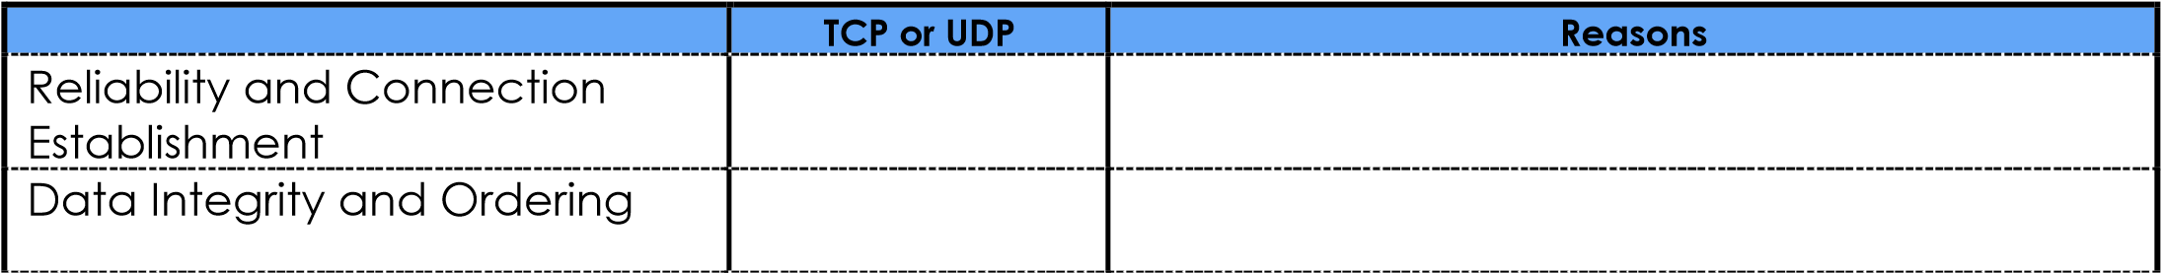
TCP
TCP
It is connection-oriented and uses a three-way handshake to guarantee delivery.
It assigns sequence numbers to packets to ensure they are reassembled in the correct order.

Task 2: Identify the use Cases and Performance of TCP and UDP.

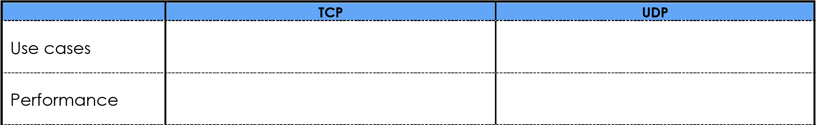
Higher (minimal overhead as it doesn't wait for acknowledgments).
Video streaming, VoIP, Online gaming, DNS.
Lower (due to error checking and retransmission overhead).
Web browsing (HTTP), Email (SMTP), File transfer (FTP).

