

Assignment 1

Advanced Software Engineering



Presented to: Dr. Islam El-Maddah

Made by:

* Abdullah Aml
* Khaled Bahaa El-Din

**# Assignment 1 statement**

A factory produces kids toys. The process of production depending on **getting a proposal** and **developing a prototype** and **finally produce the toys** and **getting feedback** from the client. A **top designer do the proposed prototype**. that usually **reviewed** by a product manager.

The business of the factory needs to be automated and also the amount of sales and feedback related to toys needs **analysis** and Business analytics.

the toy factory has:

1. Number of toy designers.
2. Product managers.
3. Customer service who interacts with client to **propose toys** and **get feedback.**

**# Assumptions**

1. The client submits a proposal design to the desired game.
2. The top designer proposes a prototype and submit it to the product manager for review. Once approved by the product manager, it is sent to the client for approval. After the client approves it, it is sent to the factory designers to implement it and track mass production degree of compliance to the main prototype.
3. Business analyst perform all business analytics needed for the mass production of the toys.

**# Use case diagram**

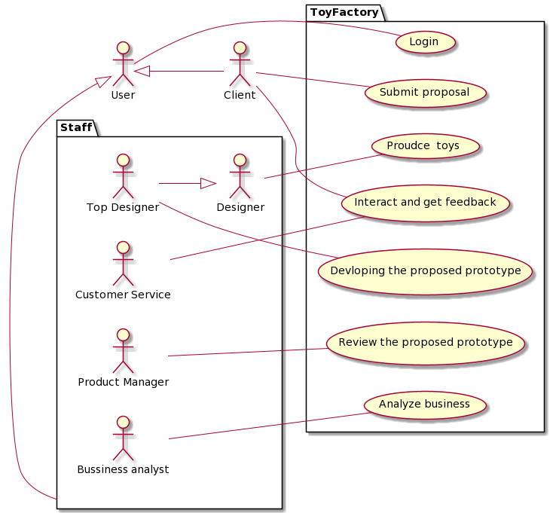

**# Use case description**

For the use case: **Interact and get feedback:**

|  |  |
| --- | --- |
| Use case | Interact and get feedback |
| Actor | **Customer service** |
| Trigger | **A toy prototype is manufactured and waiting for client’s feedback** |
| Pre-condition | **A meeting is held between customer service and the client** |
| Main success scenario | 1. The customer receives the manufactured toy prototype. 2. Customer service schedules a meeting with the client. 3. The client analyses the prototype and compares it to the proposed one. 4. Customer service provide a sheet(edits/complaints) to the client to fill. 5. The client totally accepts the proposed prototype. 6. The client writes nothing in the (edits/complaints) sheet 7. The client signs for mass production. 8. The product manager informs the top designer that the prototype is accepted. 9. The top designer meets with normal designers to organize mass production plan. 10. The product manager informs business analysts to start their analytics for mass production. |
| Post conditions | **The prototype is approved and mass production process is going on.** |
| Extensions | 3a. The client demand edits to be made to such prototype.  3b. The client totally refuses the proposed prototype.  3b1. Redesign negotiations are setup between the client and product manager.  4a. The client fills edits section in the sheet provided by customer service.  4a1. The edits are delivered to the product manager.  4a2 The product manager discusses the needed time of such edits with the top designer.  4a3. The client is informed with the time needed for such edit.  4a3a1. The client accepts.  4a3a1a1. Edits are made.  4a3a1a2. Customer service discuss the new prototype with the client.  4a3a2. The client refuses the proposed time.  3aa2a1. Prototype is refused. |

**# Final notes**

* We used <https://plantuml.com/use-case-diagram> to draw our use case diagram.
* UML diagram is made with a scripting language on [plantuml](https://plantuml.com/use-case-diagram).