1. Create a class circle class with radius as data member. Create two constructors (no argument, and two arguments) and a method to calculate Circumference.

class Circle{

private float radius;

public Circle(){

radius=2.5f;

}

public Circle(float radius){

this.radius=radius;

}

public float circumference(){

return (float) (radius\*radius\*Math.PI);

}

}

public class Main {

public static void main(String[] args) {

// write your code here

Circle c1 = new Circle();

System.out.println("Circumference of circle without parameter: "+c1.circumference());

Circle c2 = new Circle(5.2f);

System.out.println("Circumference of circle with parameter: "+c2.circumference());

}

}

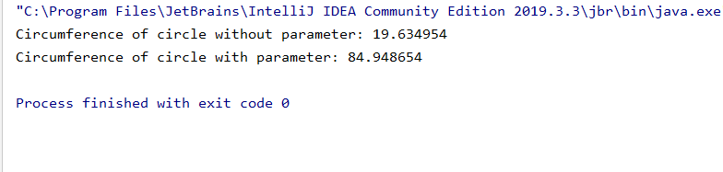

Activity 2:

1. Create a class Account class with balance as data member. Create two constructors (no argument, and one argument ) to set balance and two methods to withdraw and deposit balance.

class Account{

private int balance;

public Account(){

balance = 500;

}

public Account(int balance){

this.balance=balance;

}

public void widthdraw(){

int amount=10000;

System.out.println("Your Balance Before widthdraw :"+amount);

amount-=balance;

System.out.println("Your Balance After widthdraw :"+amount);

}

public void deposite(){

int amount=10000;

System.out.println("Your Balance Before deposite :"+amount);

amount+=balance;

System.out.println("Your Balance After deposite :"+amount);

}

}

public class Main {

public static void main(String[] args) {

// write your code here

Account a1= new Account();

a1.widthdraw();

a1.deposite();

Account a2= new Account(5000);

a2.widthdraw();

a2.deposite();

}

}

