**Interpreter Project**

**Objective:** The objective of the project was to build an interpreter according to the given syntax and semantic of a language. This program takes a Boolean expression as an input and return the value true or false to depict whether the Boolean expression is valid or not.

**Problem Statement:**

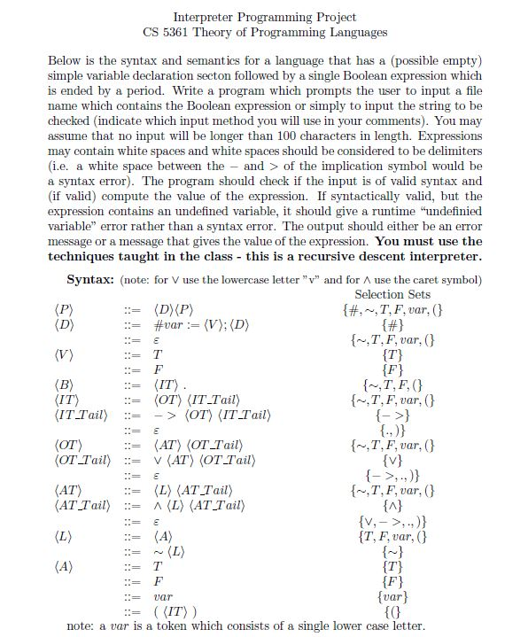

**Input File:** Input file is inside the project folder having a path

“Interpreter\src\main\resources” and the name of the input file in “input_file.txt” which looks something like this.

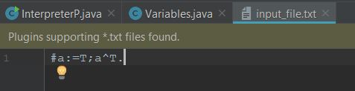

Edit the input the file with different Boolean expressions.

The program after running would give an input something like this.

