**CONVERTED TO JSON**

Wright Memorial PHC, Emmanuel Street, Shomolu 08054954593

Wright Memorial PHC, Emmanuel Street, Shomolu 07038578592

Wright Memorial PHC, Emmanuel Street, Shomolu 08020972911

Wright Memorial PHC, Emmanuel Street, Shomolu 08054954593

Ifako Mini Stadium, College Road b/side Ifako GH 08023059840

Ifako Mini Stadium, College Road b/side Ifako GH 07045947165

Ifako Mini Stadium, College Road b/side Ifako GH 08035545386

Ifako Mini Stadium, College Road b/side Ifako GH 08020542416

Ojo PHC, 1 Rest House, Ojo 08023611015

Ojo PHC, 1 Rest House, Ojo 08136100273

Ojo PHC, 1 Rest House, Ojo 08035039742

Ojo PHC, 1 Rest House, Ojo 09098700784

Ikota Primary School, LekkiEpe Expressway 0803115038

Ikota Primary School, LekkiEpe Expressway 08033227909

Ikota Primary School, LekkiEpe Expressway 07033266904

Ikota Primary School, LekkiEpe Expressway 08026930842

Ikota Primary School, LekkiEpe Expressway 08067205449

Surulere Local Council Secretariat, 24, Alhaji Masha Rd, Surulere 08029332019

Surulere Local Council Secretariat, 24, Alhaji Masha Rd, Surulere 08028537981

Surulere Local Council Secretariat, 24, Alhaji Masha Rd, Surulere 08036226419

Surulere Local Council Secretariat, 24, Alhaji Masha Rd, Surulere 08023329167

Surulere Local Council Secretariat, 24, Alhaji Masha Rd, Surulere 08025358542

Surulere Local Council Secretariat, 24, Alhaji Masha Rd, Surulere 08028859994

{"name": "Wright Memorial PHC, Emmanuel Street, Shomolu 2", "number":"07038578592"},

{"name": "Wright Memorial PHC, Emmanuel Street, Shomolu 3", "number":"08020972911"},

{"name": "Wright Memorial PHC, Emmanuel Street, Shomolu 4", "number":"08054954593"},

{"name": "Ifako Mini Stadium, College Road b/side Ifako GH 1", "number":"08023059840"},

{"name": "Ifako Mini Stadium, College Road b/side Ifako GH 2", "number":"07045947165"},

{"name": "Ifako Mini Stadium, College Road b/side Ifako GH 3", "number":"08035545386"},

{"name": "Ifako Mini Stadium, College Road b/side Ifako GH 4", "number":"08020542416"}

{"name": "Ojo PHC, 1 Rest House, Ojo", "number":"08023611015"},

{"name": "Ojo PHC, 1 Rest House, Ojo", "number":"08136100273"},

{"name": "Ojo PHC, 1 Rest House, Ojo", "number":"08035039742"},

{"name": "Ojo PHC, 1 Rest House, Ojo", "number":"09098700784"},

{"name": "Ikota Primary School, LekkiEpe Expressway ", "number":"0803115038"},

{"name": "Ikota Primary School, LekkiEpe Expressway ", "number":"08033227909"},

{"name": "Ikota Primary School, LekkiEpe Expressway ", "number":"07033266904"},

{"name": "Ikota Primary School, LekkiEpe Expressway ", "number":"08026930842"},

{"name": "Ikota Primary School, LekkiEpe Expressway ", "number":"08067205449"},

{"name": "Surulere Local Council Secretariat, 24, Alhaji Masha Rd, Surulere ", "number":"08029332019"},

{"name": "Surulere Local Council Secretariat, 24, Alhaji Masha Rd, Surulere ", "number":"08028537981"},

{"name": "Surulere Local Council Secretariat, 24, Alhaji Masha Rd, Surulere ", "number":"08036226419"},

{"name": "Surulere Local Council Secretariat, 24, Alhaji Masha Rd, Surulere ", "number":"08023329167"},

{"name": "Surulere Local Council Secretariat, 24, Alhaji Masha Rd, Surulere ", "number":"08025358542"},

{"name": "Surulere Local Council Secretariat, 24, Alhaji Masha Rd, Surulere ", "number":"08028859994"}

**NOT finished lists of test sites in LAGOS**

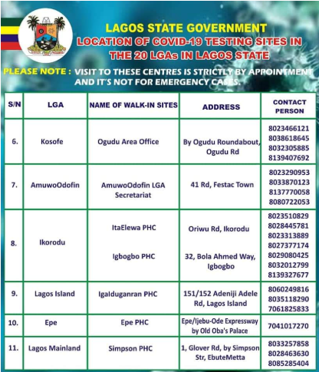

NAME OF WALK-IN SITES

ADDRESS

CONTACT

PERSON

Kosofe

Ogudu Area Office

By Ogudu Roundabout

Ogudu Rd

8023466121

8038618645

8032305885

8139407692

AmuwoOdofin

41 Rd, Festac Town

Amuwo Odofin LGA

Secretariat

8023290953

8033870123

8137770058

8080722053

ItaElewa PHC

Oriwu Rd, Ikorodu

8.

Ikorodu

8023510829

8028445781

8023313889

8027377174

8029080425

8032012799

8139327677

Igbogbo PHC

32, Bola Ahmed Way,

Igbogbo

9.

Lagos Island

lgalduganran PHC

151/152 Adeniji Adele

Road, Lagos Island

8060249816

8035118290

7061825833

10.

Ере

Epe

Ере PHC

Epe PHO

Epe/ijebu-Ode Expressway

by Old Oba's Palace

7041017270

11. Lagos Mainland

Simpson PHC

1, Glover Rd, by Simpson

Str, Ebute Metta

8033257858

8028463630

8085285404

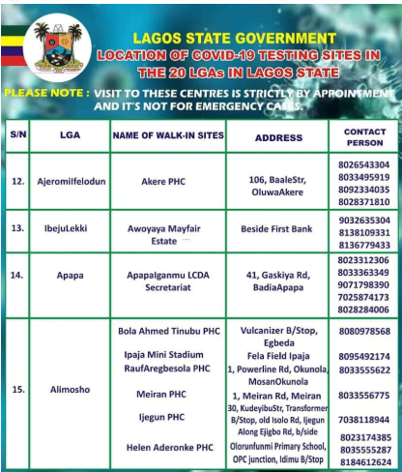

NAME OF WALK-IN SITES

ADDRESS

CONTACT

PERSON

Ajeromilfelodun

Akere PHC

106, BaaleStr,

OluwaAkere

8026543304

8033495919

8092334035

8028371810

13.

IbejuLekki

Beside First Bank

Awoyaya Mayfair

Estate

9032635304

8138109331

8136779433

8023312306

8033363349

9071798390

7025874173

8028284006

Apapa

Apapa Iganmu LCDA

Secretariat

41, Gaskiya Road,

BadiaApapa

15.

Alimosho

Bola Ahmed Tinubu PHỤ

Vulcanizer B/Stop, 8080978568

Egbeda

Ipaja Mini Stadium Fela Field Ipaja 8095492174

RaufAregbesola PHC 1, Powerline Rd, Okunolal 8033555622

MosanOkunola

Meiran PHC 1, Meiran Rd, Meiran 8033556775

30, KudeyibuStr, Transformer

Ijegun PHC

B/Stop, old Isolo Rd, ljegun 7038118944

Helen Aderonke PHC

Along Ejigbo Rd, b/side 8023174385

Olorunfunmi Primary School, 8035555287

OPC junction, Idimu B/Stop 8184612624

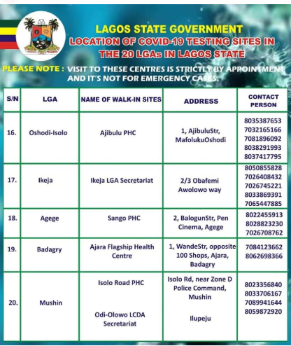

**ALL STATES**

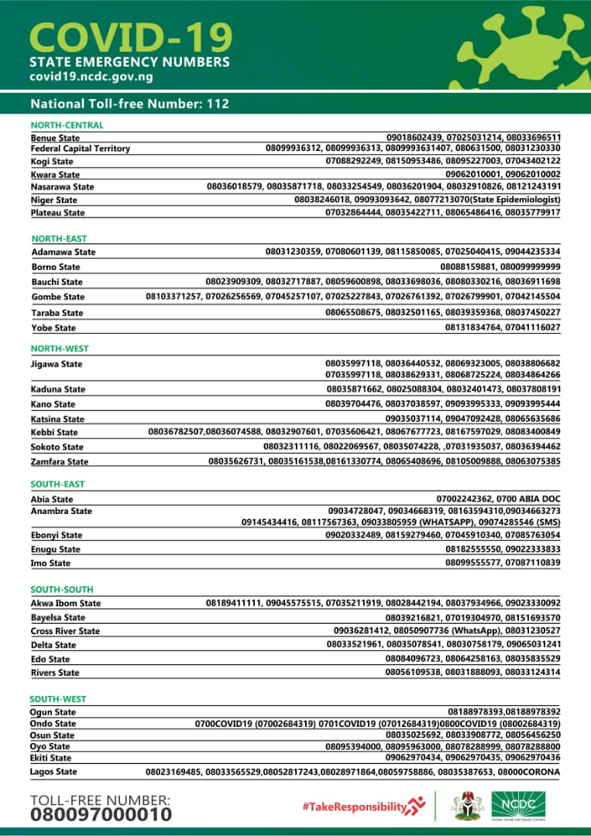

**CONVERTED TO JSON**

National Toll-free Number: 112

NORTH-CENTRAL

Benue State 09018602419

Benue State 07025031214

Benue State 08033696511

Federal Capital Territory 08099936312

Federal Capital Territory 08099936313

Federal Capital Territory 08099936314

Federal Capital Territory 07080631500

Federal Capital Territory 08031230330

Kogi State 07088292249

Kogi State 08150953486

Kogi State 08095227003

Kogi State 07043402122

Kwara State 09062010001

Kwara State 09062010002

Nasarawa State 08036018579

Nasarawa State 08035871718

Nasarawa State 08033254549

Nasarawa State 08036201904

Nasarawa State 08032910826

Nasarawa State 08121243191

Niger State 08038246018.

Niger State 09093093642

Niger State (State Epidemiologist) 08077213070

Plateau State 07032864444

Plateau State 08035422711

Plateau State 08065486416

Plateau State 08035779917

**NOT CONVERTED TO JSON**

NORTH-EAST

Adamawa State 08031230359, 07080601139, 08115850085, 07025040415, 09044235334

Borno State 08088159881, 080099999999

Bauchi State 08023909309, OB032717887, 08059600898, 08033698036, 08080330216, 08036911698

Gombe State 08103371257, 07026256569, 07045257107, 07025227843, 07026761392, 07026799901, 07042145504

Taraba State 08065508675, 08032501165, 08039359368, 08037450227

Yobe State 08131834764, 07041116027

NORTHWEST

Jigawa State 08035997118. OB036440532, 08069323005, OROBB806582

07035997118. OR038629331. 08068725224. 0803486-4266

08035871662, 08025088304, 08032401473, 08037808191

Kano State 08039704476, 08037038597, 09093995333, 09093995444

Katsina State 09035037114 09047092428, 08065635686

Kebbi State 08036782507,08036074588, 08032907601, 07035606421, 08067677723, 08167597029, 08083400849

Sokoto State 08032311116, 08022069567, 08035074228, .07031935037, 08036394462

Zamfan State 08035626731, 08035161538,08161330774, 08065408696, 08105009888, 08063075385

SOUTH-EAST

Abia State

Anambra State

Ebony State

Enugu State

Imo State

07002242362, 0700 ABIA DOC

09034728047, 09034668319, 08163594310,09034663273

09145434416, 08117567363, 09033805959 WHATSAPP)09074285546 (SMS)

09020332489, 08159279460, 07045910340, 07085763054

08182555550, 09022333833

08099555577, 07087110839

SOUTH-SOUTH

Akwa Ibom State 08189411111, 09045575515. 07035211919, 08028442194, 08037934966, 09023330092

Bayelsa State 08039216821, 07019304970, 08151593570

Cross River State 09036281412. 08050907736 (WhatsApp). 08031230527

Delta State 08033521961, 08035078541, 08030758179, 09065031241

Edo State OB0B4096723. 08064258163.00035835529

Rivers State OB056109538, 08031888091, 08013124314

SOUTH WEST

Ogun State 08188978393OR188978392

Ondo State 0700COVID19 (07002684319) 0701COVID19 (07012684319)0800COVID 19 (08002684319)

Osun State 08035025692, 08033908772, 08056456250

Oyo State 08095394000, 08095963000, 08078288999, 08078288800

Ekiti State 09062970434, 09062970435, 09062970436

Lagos State 08023169485, 08033565529,08052817243,08028971864,08059758886, 08035387653, 08000CORONA

TOLL-FREE NUMBER:

080097000010