PREMIER TUBULAR INSPECTION SERVICES (PVT.) LTD
NDT CUSTOMISED TRAINING AND CERTIFICATION PROGRAM

Certificate of Accomplishment Awarded to

Usman Waheed
For
SATISFACTORY COMPLETION OF NDT INSPECTION COURSE

DYE PENETRANT TESTING LEVEL-II
As per American Society of NDT Recommended Practice SNT TC 1A


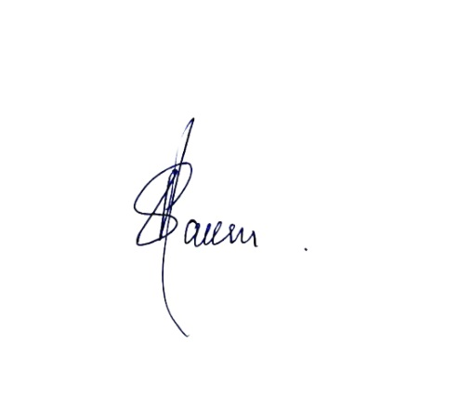

Date of Certification: 25-September-2025 Validity: 24-September-2030

Manager QHSE/Training Sponsoring Authority Examiner
NAEEM ASHRAF PTIS ASNT NDT LEVEL-III
CERTIFICATE NO: 25/PTIS/DPT/00410 DATE: 25-September-2025
E-69, BLOCK #6, P.E.C.H.S, Karachi, Pakistan. Tel: +92-21-34559070:34533739 E-mail: karachi@premiertubular.com

