PREMIER TUBULAR INSPECTION SERVICES (PVT.) LTD
NDT CUSTOMISED TRAINING AND CERTIFICATION PROGRAM

This is to certify that

Usman Waheed
For
SATISFACTORY COMPLETION OF NDT INSPECTION COURSE

DYE PENETRANT TESTING LEVEL-II
As per American Society of NDT Recommended Practice SNT TC 1A

Date of Certification: 05-August-2022 Validity: 04-August-2027

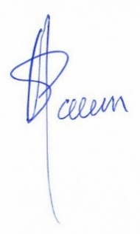

Manager QHSE/Training Sponsoring Authority Examiner
NAEEM ASHRAF PTIS ASNT NDT LEVEL-III
CERTIFICATE NO: 22/PTIS/VT/00358 DATE: 05-August-2022
58-U, BLOCK #6, P.E.C.H.S, Karachi, Pakistan. Tel: +92-21-34559070:34533739 E-mail: karachi@premiertubular.com

