PREMIER TUBULAR INSPECTION SERVICES (PVT.) LTD
NDT CUSTOMISED TRAINING AND CERTIFICATION PROGRAM

This is to certify that

Usman Waheed
Has maintained his curriculum and demonstrated his skill in accordance with our written practice No. IMS-PRO-022 which is in line with ASNT’s Recommended Practice SNT-TC-1A Edition 2020. Based on continuous experience, he has been recertified in the following NDT Method & Level.
VISUAL TESTING LEVEL-II

Date of Certification: 05-August-2022 Validity: 04-August-2027

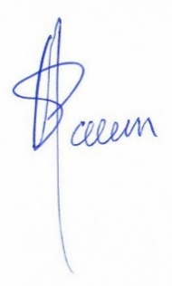

Manager QHSE/Training Sponsoring Authority Examiner
NAEEM ASHRAF PTIS ASNT NDT LEVEL-III
CERTIFICATE NO: 22/PTIS/VT/00358 DATE: 05-August-2022
58-U, BLOCK #6, P.E.C.H.S, Karachi, Pakistan. Tel: +92-21-34559070:34533739 E-mail: karachi@premiertubular.com

