**Industry Management System**



Session: 2021 – 2024

**Submitted by:**

M Abdullah

2021-CS-104

**Supervised by:**

Mam Maida Shahid

**For Fulfillment of**

**OOP**

Department of Computer Science

**University of Engineering and Technology**

**Lahore Pakistan**

**Abstraction:**

**INDUSTRY Management System** is basically helpful for admin/manager in many different ways. It help in managing employees and also their work and pay. We can add or remove employee. We also made new admin or we can also change admin or delete admin. It is also helpful to check the stations or book the seat. All information is available on it. It is much helpful for us.

**Users of Application:**

­This is two user application.

1. **Admin**

* Admin can manage every feature of management system and can create login accounts for new admin and add staff information.

1. **User**

* User can be able to check the movies and the detail of the movie

For Example: he/she can check the release date of the movie or drama, he/she can also watch the director, producer, writer and actors;.

**Functional Requirements:**

1. **Admin**

* Edit Director.
* Edit Writer.
* Edit Producer.
* Edit Actor.
* Edit Employee.
* View Dramas.
* Exit

1. **Applicant**

* View Profile.
* View Pay.
* View Dramas.
* Exit

**Wireframes:**

* **Graphical user interface, application

  Description automatically generatedMain page**
* **SIGN IN**

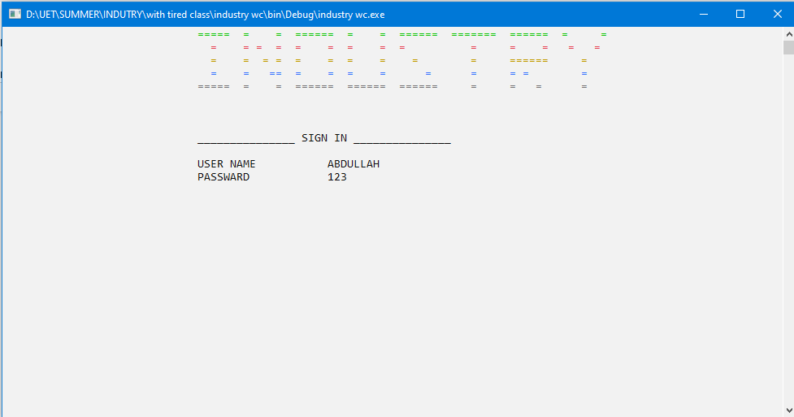

* **ADMIN**

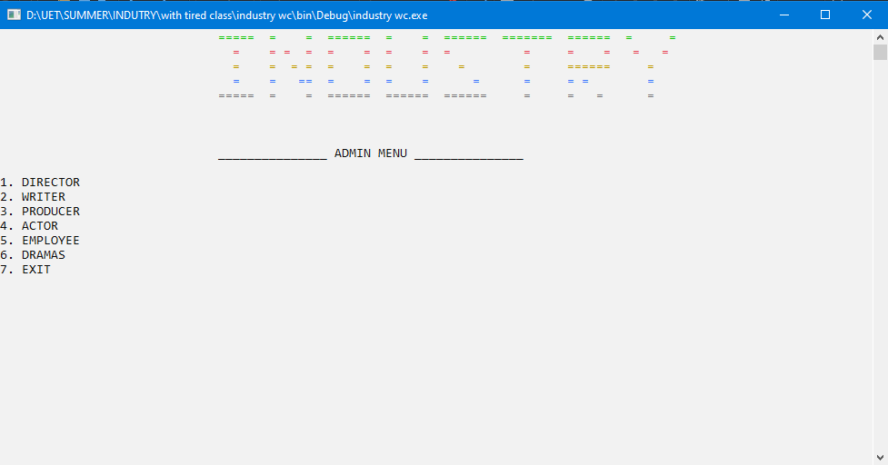

* **ADD CHARACTER**

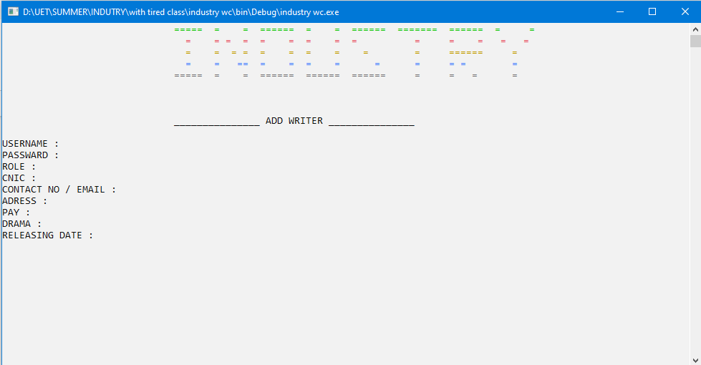

* **UPDATE EMPLOYEE INFO**

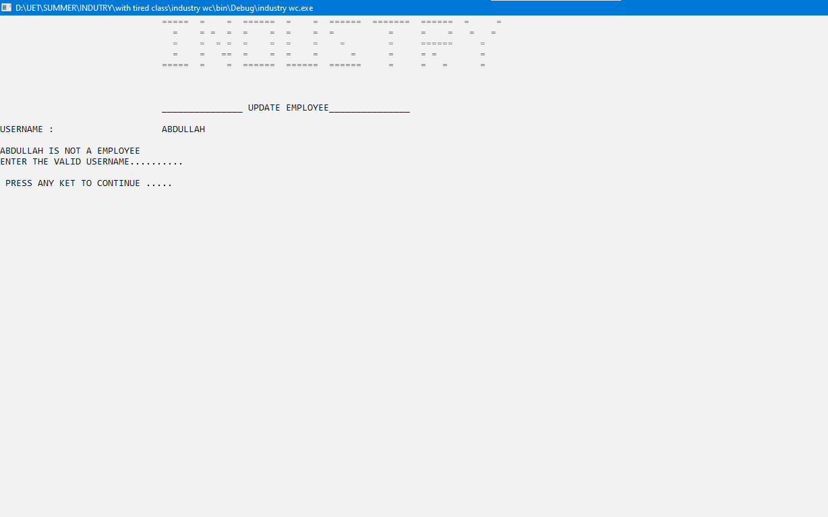

* **VIEW ALL EMPLOYEE**

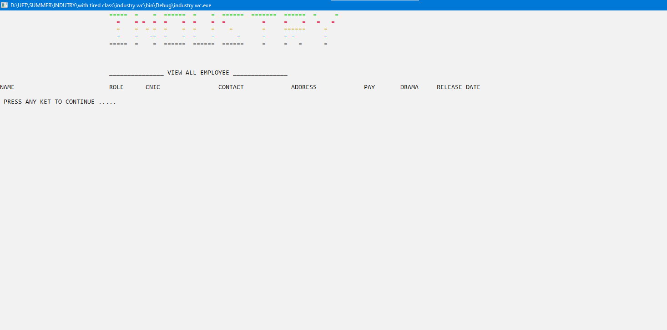

* **VIEW ALL**



* **VIEW DRAMA**

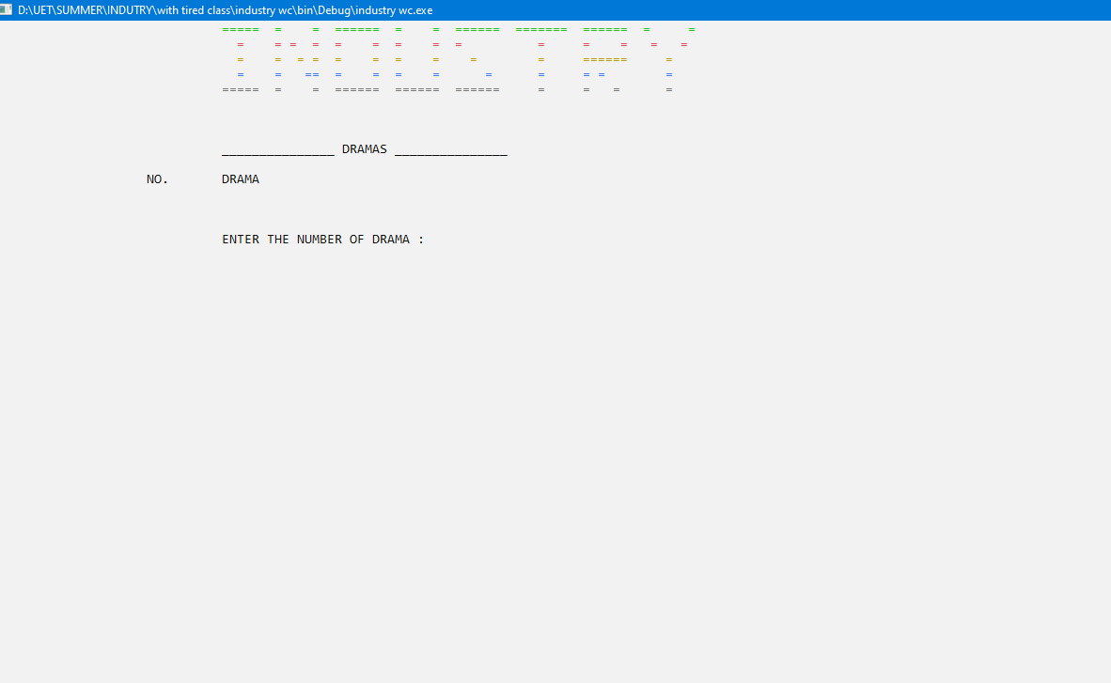

* **USER MENU**

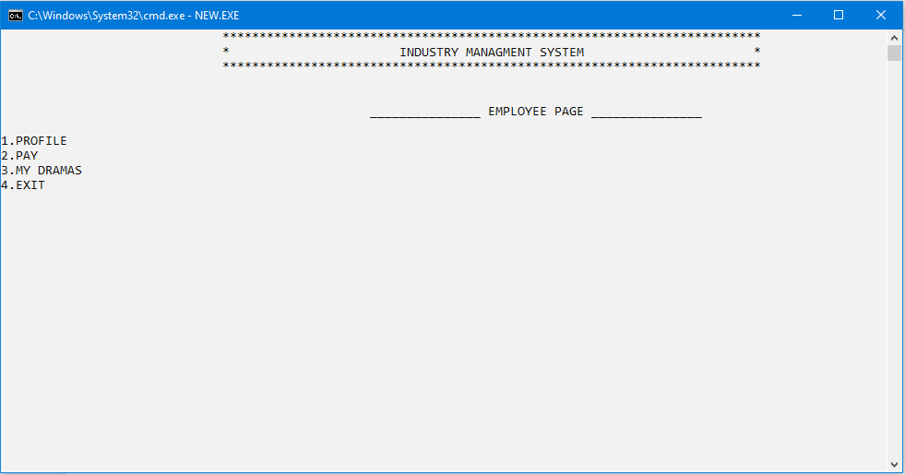

* **VIEW DRAMAS**



**CLASS DIAGRAM:**

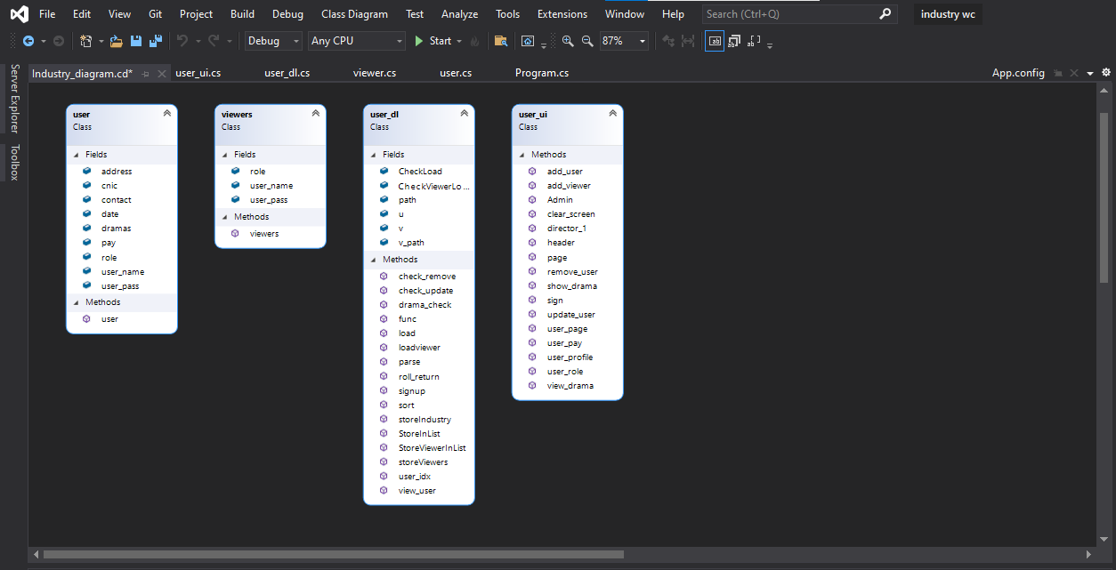

**MAIN:**

using System;

using System.Collections.Generic;

using System.Linq;

using System.Text;

using System.Threading.Tasks;

using System.IO;

using industry_wc.BL;

using industry_wc.DL;

using industry_wc.UI;

namespace industry_wc

{

class Program

{

static void Main(string[] args)

{

string path = "industry.txt";

string v_path = "viewers.txt";

const int min = 100;

string[] serial = new string[min], sdate = new string[min];

string main;

bool CheckLoad = user_dl.load(path);

bool CheckViewerLoad = user_dl.loadviewer(v_path);

user_dl.sort();

int dcount = user_dl.drama_check(serial, sdate);

String option = "1";

bool check = false;

while (check != true)

{

string rol;

option = user_ui.sign();

if (option == "1")

{

main = user_ui.page();

if (main == "DIRECTOR")

{

string op = "1";

while (op != "7")

{

op = user_ui.Admin();

if (op == "1")

{

string op1 = "2";

while (op1 != "5")

{

rol = "DIRECTOR";

op1 = user_ui.director_1(rol);

if (op1 == "1")

{

user_ui.add_user( rol);

}

else if (op1 == "2")

{

user_ui.remove_user(rol);

}

else if (op1 == "3")

{

user_ui.update_user(rol);

}

else if (op1 == "4")

{

user_dl.sort();

user_dl.view_user(rol);

}

else if (op1 != "5")

{

Console.WriteLine("ENTER THE VALID OPTION");

user_ui.clear_screen();

}

user_dl.storeViewers(v_path);

user_dl.storeIndustry(path);

dcount = user_dl.drama_check( serial, sdate);

}

}

else if (op == "2")

{

string op1 = "1";

while (op1 != "5")

{

rol = "WRITER";

op1 = user_ui.director_1(rol);

if (op1 == "1")

{

user_ui.add_user( rol);

}

else if (op1 == "2")

{

user_ui.remove_user(rol);

}

else if (op1 == "3")

{

user_ui.update_user( rol);

}

else if (op1 == "4")

{

user_dl.sort();

user_dl.view_user( rol);

}

else if (op1 != "5")

{

Console.WriteLine("ENTER THE VALID OPTION");

user_ui.clear_screen();

}

user_dl.storeViewers(v_path);

user_dl.storeIndustry(path);

dcount = user_dl.drama_check(serial, sdate);

}

}

else if (op == "3")

{

string op1 = "2";

while (op1 != "5")

{

rol = "PRODUCER";

op1 = user_ui.director_1(rol);

if (op1 == "1")

{

user_ui.add_user( rol);

}

else if (op1 == "2")

{

user_ui.remove_user( rol);

}

else if (op1 == "3")

{

user_ui.update_user( rol);

}

else if (op1 == "4")

{

user_dl.sort();

user_dl.view_user( rol);

}

else if (op1 != "5")

{

Console.WriteLine("ENTER THE VALID OPTION");

user_ui.clear_screen();

}

user_dl.storeViewers(v_path);

user_dl.storeIndustry(path);

dcount = user_dl.drama_check( serial, sdate);

}

}

else if (op == "4")

{

string op1 = "2";

while (op1 != "5")

{

rol = "ACTOR";

op1 = user_ui.director_1(rol);

if (op1 == "1")

{

user_ui.add_user( rol);

}

else if (op1 == "2")

{

user_ui.remove_user( rol);

}

else if (op1 == "3")

{

user_ui.update_user( rol);

}

else if (op1 == "4")

{

user_dl.sort();

user_dl.view_user( rol);

}

else if (op1 != "5")

{

Console.WriteLine("ENTER THE VALID OPTION");

user_ui.clear_screen();

}

user_dl.storeViewers(v_path);

user_dl.storeIndustry(path);

dcount = user_dl.drama_check(serial, sdate);

}

}

else if (op == "5")

{

string op1 = "2";

while (op1 != "5")

{

rol = "EMPLOYEE";

op1 = user_ui.director_1(rol);

if (op1 == "1")

{

user_ui.add_user( rol);

}

else if (op1 == "2")

{

user_ui.remove_user(rol);

}

else if (op1 == "3")

{

user_ui.update_user( rol);

}

else if (op1 == "4")

{

user_dl.sort();

user_dl.view_user( rol);

}

else if (op1 != "5")

{

Console.WriteLine("ENTER THE VALID OPTION");

user_ui.clear_screen();

}

user_dl.storeViewers(v_path);

user_dl.storeIndustry(path);

dcount = user_dl.drama_check(serial, sdate);

}

}

else if (op == "6")

{

user_dl.sort();

int opt = user_ui.show_drama(serial, sdate, dcount);

for (int x = 0; x < dcount; x++)

{

if (serial[opt - 1] == user_dl.u[x].dramas && sdate[opt - 1] == user_dl.u[x].date)

{

user_ui.view_drama(serial, sdate, x);

}

}

}

}

}

else if (main == "WRITER" || main == "PRODUCER" || main == "ACTOR" || main == "EMPLOYEE")

{

user_dl.sort();

rol = main;

string op2 = "1";

while (op2 != "4")

{

op2 = user_ui.user_page(rol);

if (op2 == "1")

{

user_ui.user_profile(rol);

}

else if (op2 == "2")

{

user_ui.user_pay(rol );

}

else if (op2 == "3")

{

user_ui.user_role(rol);

}

else if (op2 != "4")

{

Console.WriteLine("ENTER THE VALID OPTION");

user_ui.clear_screen();

}

}

}

else if (main == "USER")

{

user_dl.sort();

int opt = user_ui.show_drama(serial, sdate, dcount);

for (int x = 0; x < dcount; x++)

{

if (serial[opt - 1] == user_dl.u[x].dramas && sdate[opt - 1] == user_dl.u[x].date)

{

user_ui.view_drama(serial, sdate, x);

}

}

}

}

else if (option == "2")

{

rol = "user";

user_dl.signup( );

user_dl.storeViewers(v_path);

user_dl.storeIndustry(path);

}

else if (option == "3")

{

break;

}

}

}

}

}

**CLASSES**

class user

{

//==================================== > OBJECTS

public string user_name;

public string user_pass;

public string role;

public string cnic;

public string contact;

public string address;

public string dramas;

public string date;

public int pay;

//==================================== > CONSTRUCTORS

public user()

{

}

}

class viewers

{

public string user_name;

public string user_pass;

public string role;

public viewers()

{

}

}

class user_dl

{

static public List<user> u = new List<user>();

static public List<viewers> v = new List<viewers>();

static public bool load(string path)

{

user u = new user();

if (File.Exists(path))

{

StreamReader file = new StreamReader(path);

string record;

while ((record = file.ReadLine()) != null)

{

u.user_name = parse(record, 1);

u.user_pass = parse(record, 2);

u.role = parse(record, 3);

u.cnic = parse(record, 4);

u.contact = parse(record, 5);

u.address = parse(record, 6);

u.pay = int.Parse(parse(record, 7));

u.dramas = parse(record, 8);

u.date = parse(record, 9);

StoreInList(u);

}

file.Close();

return true;

}

else

{

return false;

}

}

static public bool loadviewer(string v_path)

{

if (File.Exists(v_path))

{

StreamReader file = new StreamReader(v_path);

string record;

while ((record = file.ReadLine()) != null)

{

viewers v = new viewers();

v.user_name = parse(record, 1);

v.user_pass = parse(record, 2);

v.role = parse(record, 3);

StoreViewerInList(v);

}

file.Close();

return true;

}

else

{

return false;

}

}

static public void sort()

{

int position = 0;

for (int i = 0; i < u.Count; i++)

{

position = i;

int large = func(position);

int temp = u[i].pay;

u[i].pay = u[large].pay;

u[large].pay = temp;

string temp_1;

temp_1 = u[i].user_name;

u[i].user_name = u[large].user_name;

u[large].user_name = temp_1;

temp_1 = u[i].role;

u[i].role = u[large].role;

u[large].role = temp_1;

temp_1 = u[i].cnic;

u[i].cnic = u[large].cnic;

u[large].cnic = temp_1;

temp_1 = u[i].contact;

u[i].contact = u[large].contact;

u[large].contact = temp_1;

temp_1 = u[i].address;

u[i].address = u[large].address;

u[large].address = temp_1;

temp_1 = u[i].dramas;

u[i].dramas = u[large].dramas;

u[large].dramas = temp_1;

temp_1 = u[i].date;

u[i].date = u[large].date;

u[large].date = temp_1;

}

}

static public int func(int position)

{

int largest = u[position].pay;

int idx = position;

for (int i = position; i < u.Count; i++)

{

if (largest <= u[i].pay)

{

largest = u[i].pay;

idx = i;

}

}

return idx;

}

static public void StoreInList(user f)

{

u.Add(f);

}

static public void StoreViewerInList(viewers f)

{

v.Add(f);

}

static public string parse(string record, int field)

{

string term = "";

int comma = 1;

for (int i = 0; i < record.Length; i++)

{

if (record[i] == ',')

{

comma++;

}

else if (comma == field)

{

term = term + record[i];

}

}

return term;

}

static public void signup( )

{

string rol="USER";

user_ui.add_viewer(rol);

}

static public bool check_user(string name, string pass)

{

int count = 0;

foreach(user i in u)

{

if(i.user_name==name && i.user_pass==pass)

{

count++;

}

}

foreach (viewers i in v)

{

if (i.user_name == name && i.user_pass == pass)

{

count++;

}

}

if (count>0)

{

return false;

}

return true;

}

static public string roll_return(string user, string pass)

{

for (int x = 0; x < u.Count; x++)

{

if (user == u[x].user_name && pass == u[x].user_pass)

{

return u[x].role;

}

}

for (int x = 0; x < v.Count; x++)

{

if (user == v[x].user_name && pass == v[x].user_pass)

{

return v[x].role;

}

}

return "not include";

}

static public void storeIndustry(string path)

{

path = "industry.txt";

if (File.Exists(path))

{

StreamWriter file = new StreamWriter(path);

for (int i = 0; i < u.Count; i++)

{

file.WriteLine(u[i].user_name + "," + u[i].user_pass + "," + u[i].role + "," + u[i].cnic + "," + u[i].contact + "," + u[i].address + "," + u[i].pay + "," + u[i].dramas + "," + u[i].date);

}

file.Flush();

file.Close();

}

else

{

Console.WriteLine("file not exist");

Console.ReadKey();

}

}

static public void storeViewers(string v_path)

{

if (File.Exists(v_path))

{

StreamWriter file = new StreamWriter(v_path);

for (int i = 0; i < v.Count; i++)

{

file.WriteLine(v[i].user_name + "," + v[i].user_pass + "," + v[i].role);

}

file.Flush();

file.Close();

}

else

{

Console.WriteLine("file not exist");

Console.ReadKey();

}

}

static public int user_idx(string rol)

{

int idx = 0;

for (int x = 0; x < u.Count; x++)

{

if (rol == u[x].role)

{

return x;

}

}

return idx;

}

static public int drama_check(string[] serial, string[] sdate)

{

int idx = 0;

for (int i = 0; i < u.Count; i++)

{

int count = 0;

for (int x = 0; x < serial.Length ; x++)

{

if (u[i].dramas == serial[x])

{

count++;

}

if (count > 0)

{

break;

}

}

if (count == 0)

{

serial[idx] = u[i].dramas;

sdate[idx] = u[i].date;

idx++;

}

}

Console.WriteLine(idx);

Console.ReadKey();

return idx;

}

static public bool check_remove(string nam, string rol)

{

char y = ' ';

for (int x = 0; x < u.Count; x++)

{

if (nam == u[x].user_name && u[x].role == rol)

{

Console.SetCursorPosition(15, 12);

Console.WriteLine("PRESS Y TO DELETE THIS USER ");

y = char.Parse(Console.ReadLine());

if (y == 'Y')

{

u.RemoveAt(x);

}

return true;

}

}

return false;

}

static public int check_update(string nam, string rol)

{

for (int x = 0; x < u.Count; x++)

{

if (nam == u[x].user_name && u[x].role == rol)

{

return x;

}

}

return 100000;

}

static public void view_user(string rol)

{

user_ui.header();

Console.SetCursorPosition(30, 8);

Console.WriteLine("_______________ VIEW ALL " + rol + " _______________");

Console.SetCursorPosition(0, 10);

Console.WriteLine("NAME ");

Console.SetCursorPosition(30, 10);

Console.WriteLine("ROLE ");

Console.SetCursorPosition(40, 10);

Console.WriteLine("CNIC ");

Console.SetCursorPosition(60, 10);

Console.WriteLine("CONTACT ");

Console.SetCursorPosition(80, 10);

Console.WriteLine("ADDRESS ");

Console.SetCursorPosition(100, 10);

Console.WriteLine("PAY ");

Console.SetCursorPosition(110, 10);

Console.WriteLine("DRAMA ");

Console.SetCursorPosition(120, 10);

Console.WriteLine("RELEASE DATE ");

int y = 11;

for (int x = 0; x < u.Count; x++)

{

if (u[x].role == rol)

{

Console.SetCursorPosition(0, y);

Console.WriteLine(u[x].user_name);

Console.SetCursorPosition(30, y);

Console.WriteLine(u[x].role);

Console.SetCursorPosition(40, y);

Console.WriteLine(u[x].cnic);

Console.SetCursorPosition(60, y);

Console.WriteLine(u[x].contact);

Console.SetCursorPosition(80, y);

Console.WriteLine(u[x].address);

Console.SetCursorPosition(100, y);

Console.WriteLine(u[x].pay);

Console.SetCursorPosition(110, y);

Console.WriteLine(u[x].dramas);

Console.SetCursorPosition(120, y);

Console.WriteLine(u[x].date);

y++;

}

}

user_ui.clear_screen();

}

}

class user_ui

{

static public string page()

{

string name;

string pass;

bool flag = false;

while (flag == false)

{

header();

Console.SetCursorPosition(30, 8);

Console.WriteLine("_______________ SIGN IN _______________");

Console.SetCursorPosition(30, 10);

Console.WriteLine("USER NAME ");

Console.SetCursorPosition(30, 11);

Console.WriteLine("PASSWARD");

Console.SetCursorPosition(50, 10);

name = Console.ReadLine();

Console.SetCursorPosition(50, 11);

pass = Console.ReadLine();

string check = user_dl.roll_return(name, pass);

if (check== "not include")

{

header();

Console.SetCursorPosition(40, 8);

Console.WriteLine("ENTER THE VALID USERNAME OR PASSWARD");

Console.WriteLine("");

clear_screen();

}

else

{

flag = true;

return check;

}

}

return "1";

}

static public string Admin()

{

string op = "0";

header();

Console.SetCursorPosition(30, 8);

Console.WriteLine("_______________ ADMIN MENU _______________");

Console.WriteLine("");

Console.WriteLine("1. DIRECTOR ");

Console.WriteLine("2. WRITER ");

Console.WriteLine("3. PRODUCER ");

Console.WriteLine("4. ACTOR ");

Console.WriteLine("5. EMPLOYEE ");

Console.WriteLine("6. DRAMAS ");

Console.WriteLine("7. EXIT ");

op = Console.ReadLine();

return op;

}

static public string director_1(string rol)

{

header();

string op1 = "0";

Console.SetCursorPosition(30, 8);

Console.WriteLine("_______________" + rol + "_______________");

Console.WriteLine("");

Console.WriteLine("1. ADD ", rol);

Console.WriteLine("2. REMOVE ", rol);

Console.WriteLine("3. UPDATE ", rol);

Console.WriteLine("4. VIEW ALL ", rol);

Console.WriteLine("5. EXIT ");

op1 = Console.ReadLine();

return op1;

}

static public void add_user(string rol)

{

user u = new user();

header();

Console.SetCursorPosition(30, 8);

Console.WriteLine("_______________ ADD " + rol + " _______________");

Console.WriteLine("");

Console.SetCursorPosition(0, 10);

Console.WriteLine("USERNAME :");

Console.SetCursorPosition(0, 11);

Console.WriteLine("PASSWARD :");

Console.SetCursorPosition(0, 12);

Console.WriteLine("ROLE :");

u.role = rol;

Console.SetCursorPosition(0, 13);

Console.WriteLine("CNIC :");

Console.SetCursorPosition(0, 14);

Console.WriteLine("CONTACT NO / EMAIL :");

Console.SetCursorPosition(0, 15);

Console.WriteLine("ADRESS :");

Console.SetCursorPosition(0, 16);

Console.WriteLine("PAY :");

Console.SetCursorPosition(0, 17);

Console.WriteLine("DRAMA :");

Console.SetCursorPosition(0, 18);

Console.WriteLine("RELEASING DATE :");

Console.SetCursorPosition(30, 10);

u.user_name = Console.ReadLine();

Console.SetCursorPosition(30, 11);

u.user_pass = Console.ReadLine();

u.role = rol;

Console.SetCursorPosition(30, 12);

Console.WriteLine(u.role);

Console.SetCursorPosition(30, 13);

u.cnic = Console.ReadLine();

Console.SetCursorPosition(30, 14);

u.contact = Console.ReadLine();

Console.SetCursorPosition(30, 15);

u.address = Console.ReadLine();

Console.SetCursorPosition(30, 16);

u.pay = int.Parse(Console.ReadLine());

Console.SetCursorPosition(30, 17);

u.dramas = Console.ReadLine();

Console.SetCursorPosition(30, 18);

u.date = Console.ReadLine();

Console.SetCursorPosition(20, 24);

Console.WriteLine(u.role + " IS ADDED");

Console.WriteLine("");

user_dl.StoreInList(u);

clear_screen();

}

static public void add_viewer(string rol)

{

viewers u = new viewers();

bool check =false;

while (check != true)

{

header();

Console.SetCursorPosition(30, 8);

Console.WriteLine("_______________ ADD " + rol + " _______________");

Console.WriteLine("");

Console.SetCursorPosition(0, 10);

Console.WriteLine("USERNAME :");

Console.SetCursorPosition(0, 11);

Console.WriteLine("PASSWARD :");

Console.SetCursorPosition(0, 12);

Console.WriteLine("ROLE :");

u.role = rol;

string name, pass;

Console.SetCursorPosition(30, 10);

name = Console.ReadLine();

Console.SetCursorPosition(30, 11);

pass = Console.ReadLine();

if (user_dl.check_user(name,pass) == true)

{

u.user_name = name;

u.user_pass = pass;

check = true;

}

else

{

Console.SetCursorPosition(0, 14);

Console.WriteLine("THIS USER NAME ALREADY EXIST");

Console.SetCursorPosition(0, 15);

Console.WriteLine("USE ANOTHER USERNAME OR PASSWARD");

Console.WriteLine();

Console.SetCursorPosition(0, 17);

clear_screen();

check =false;

}

}

u.role = rol;

Console.SetCursorPosition(30, 12);

Console.WriteLine(u.role);

Console.SetCursorPosition(20, 24);

Console.WriteLine(u.role + " IS ADDED");

Console.WriteLine("");

user_dl.StoreViewerInList(u);

clear_screen();

}

static public void remove_user( string rol)

{

string nam;

header();

Console.SetCursorPosition(30, 8);

Console.WriteLine("_______________ REMOVE " + rol + " _______________");

Console.WriteLine("");

Console.SetCursorPosition(0, 10);

Console.WriteLine("USERNAME :");

Console.SetCursorPosition(30, 10);

nam = Console.ReadLine();

bool check = user_dl.check_remove(nam, rol);

if(check==true)

{

Console.SetCursorPosition(0, 12);

Console.WriteLine(nam + " IS REMOVED.......");

}

else

{

Console.SetCursorPosition(0, 12);

Console.WriteLine(nam + " IS NOT A " + rol);

Console.WriteLine("");

Console.WriteLine("ENTER THE VALID USERNAME.......... ");

}

clear_screen();

}

static public void update_user(string rol)

{

string nam;

header();

Console.SetCursorPosition(30, 8);

Console.WriteLine("_______________ UPDATE " + rol + "_______________");

Console.SetCursorPosition(0, 10);

Console.WriteLine("USERNAME :");

Console.SetCursorPosition(30, 10);

nam = Console.ReadLine();

char y = ' ';

int x = user_dl.check_update(nam, rol);

if (x != 100000)

{

header();

Console.SetCursorPosition(30, 8);

Console.WriteLine("_______________ UPDATE ", rol, " _______________");

Console.SetCursorPosition(0, 10);

Console.WriteLine("UPDATE USERNAME :");

Console.SetCursorPosition(0, 11);

Console.WriteLine("UPDATE PASSWARD :");

Console.SetCursorPosition(0, 12);

Console.WriteLine("UPDATE ROLE :");

Console.SetCursorPosition(0, 13);

Console.WriteLine("UPDATE CNIC :");

Console.SetCursorPosition(0, 14);

Console.WriteLine("UPDATE CONTACT NO / EMAIL :");

Console.SetCursorPosition(0, 15);

Console.WriteLine("UPDATE ADRESS :");

Console.SetCursorPosition(0, 16);

Console.WriteLine("UPDATE PAY :");

Console.SetCursorPosition(0, 17);

Console.WriteLine("UPDATE DRAMA :");

Console.SetCursorPosition(0, 18);

Console.WriteLine("UPDATE RELEASING DATE :");

Console.SetCursorPosition(30, 10);

user_dl.u[x].user_name = Console.ReadLine();

Console.SetCursorPosition(30, 11);

user_dl.u[x].user_pass = Console.ReadLine();

Console.SetCursorPosition(30, 12);

user_dl.u[x].role = Console.ReadLine();

Console.SetCursorPosition(30, 13);

user_dl.u[x].cnic = Console.ReadLine();

Console.SetCursorPosition(30, 14);

user_dl.u[x].contact = Console.ReadLine();

Console.SetCursorPosition(30, 15);

user_dl.u[x].address = Console.ReadLine();

Console.SetCursorPosition(30, 16);

user_dl.u[x].pay = int.Parse(Console.ReadLine());

Console.SetCursorPosition(30, 17);

user_dl.u[x].dramas = Console.ReadLine();

Console.SetCursorPosition(30, 18);

user_dl.u[x].date = Console.ReadLine();

y = 'Y';

}

else

{

Console.SetCursorPosition(0, 12);

Console.WriteLine(nam + " IS NOT A " + rol);

Console.WriteLine("ENTER THE VALID USERNAME.......... ");

}

if (y == 'y')

{

Console.SetCursorPosition(0, 12);

Console.WriteLine(nam + " IS UPDATED.......");

}

clear_screen();

}

static public void header()

{

Console.Clear();

ConsoleColor color = ConsoleColor.Green;

Console.ForegroundColor = color;

Console.SetCursorPosition(30, 0);

Console.WriteLine("===== = = ====== = = ====== ======= ====== = =");

color = ConsoleColor.Red;

Console.ForegroundColor = color;

Console.SetCursorPosition(30, 1);

Console.WriteLine(" = = = = = = = = = = = = = =");

color = ConsoleColor.DarkYellow;

Console.ForegroundColor = color;

Console.SetCursorPosition(30, 2);

Console.WriteLine(" = = = = = = = = = = ====== =");

color = ConsoleColor.Blue;

Console.ForegroundColor = color;

Console.SetCursorPosition(30, 3);

Console.WriteLine(" = = == = = = = = = = = =");

color = ConsoleColor.DarkGray;

Console.ForegroundColor = color;

Console.SetCursorPosition(30, 4);

Console.WriteLine("===== = = ====== ====== ====== = = = =");

color = ConsoleColor.Black;

Console.ForegroundColor = color;

}

static public void clear_screen()

{

Console.WriteLine("");

Console.WriteLine(" PRESS ANY KET TO CONTINUE ..... ");

Console.ReadLine();

Console.Clear();

}

static public string sign()

{

string op = "0";

while (op != "3")

{

header();

Console.SetCursorPosition(30, 8);

Console.WriteLine("_______________ SIGN UP / SIGN IN_______________");

Console.SetCursorPosition(30, 10);

Console.WriteLine("1.SIGN IN ");

Console.SetCursorPosition(30, 11);

Console.WriteLine("2 SIGN UP ");

Console.SetCursorPosition(30, 12);

Console.WriteLine("3.EXIT ");

Console.WriteLine("");

Console.SetCursorPosition(30, 13);

Console.WriteLine("ENTER THE OPTION");

Console.SetCursorPosition(60, 13);

op = Console.ReadLine();

if (op != "1" && op != "2" && op != "3")

{

header();

Console.SetCursorPosition(30, 8);

Console.WriteLine("_______________ SIGN UP / SIGN IN_______________");

Console.SetCursorPosition(30, 10);

Console.WriteLine("ENTER THE RIGHT OPTION");

Console.SetCursorPosition(30, 11);

Console.WriteLine("PRESS ANY KEY TO CONTINUE");

Console.ReadKey();

}

else

{

return op;

}

}

return "3";

}

static public void user_role(string rol)

{

header();

Console.SetCursorPosition(30, 8);

int y = 10;

Console.WriteLine("_______________ " + rol + " ROLE _______________");

Console.SetCursorPosition(0, y);

Console.WriteLine("NAME ");

Console.SetCursorPosition(20, y);

Console.WriteLine("ROLE ");

Console.SetCursorPosition(40, y);

Console.WriteLine("DRAMA ");

Console.SetCursorPosition(60, y);

int n = 12;

int x = user_dl.user_idx(rol);

Console.SetCursorPosition(0, n);

Console.WriteLine(user_dl.u[x].user_name);

Console.SetCursorPosition(20, n);

Console.WriteLine(user_dl.u[x].role);

Console.SetCursorPosition(40, n);

Console.WriteLine(user_dl.u[x].dramas);

Console.SetCursorPosition(60, n);

clear_screen();

}

static public void user_pay(string rol)

{

header();

Console.SetCursorPosition(30, 8);

Console.WriteLine("_______________ " + rol + " PAY _______________");

Console.WriteLine("");

Console.SetCursorPosition(0, 10);

Console.WriteLine("NAME ");

Console.SetCursorPosition(20, 10);

Console.WriteLine("ROLE ");

Console.SetCursorPosition(40, 10);

Console.WriteLine("PAY ");

Console.SetCursorPosition(60, 10);

int x = user_dl.user_idx(rol);

Console.SetCursorPosition(0, 12);

Console.WriteLine(user_dl.u[x].user_name);

Console.SetCursorPosition(20, 12);

Console.WriteLine(user_dl.u[x].role);

Console.SetCursorPosition(40, 12);

Console.WriteLine(user_dl.u[x].pay);

Console.SetCursorPosition(60, 12);

clear_screen();

}

static public void user_profile(string rol )

{

header();

Console.SetCursorPosition(30, 8);

Console.WriteLine("_______________ " + rol + " PROFILE _______________");

Console.WriteLine("");

Console.SetCursorPosition(0, 10);

Console.WriteLine("NAME ");

Console.SetCursorPosition(20, 10);

Console.WriteLine("PASSWARD ");

Console.SetCursorPosition(30, 10);

Console.WriteLine("ROLE ");

Console.SetCursorPosition(40, 10);

Console.WriteLine("CNIC ");

Console.SetCursorPosition(60, 10);

Console.WriteLine("CONTACT ");

Console.SetCursorPosition(80, 10);

Console.WriteLine("ADDRESS ");

Console.SetCursorPosition(100, 10);

Console.WriteLine("PAY ");

Console.SetCursorPosition(110, 10);

Console.WriteLine("DRAMA ");

Console.SetCursorPosition(120, 10);

Console.WriteLine("RELEASE DATE ");

int y = 12;

int x = user_dl.user_idx(rol);

Console.SetCursorPosition(0, y);

Console.WriteLine(user_dl.u[x].user_name);

Console.SetCursorPosition(20, y);

Console.WriteLine(user_dl.u[x].user_pass);

Console.SetCursorPosition(30, y);

Console.WriteLine(user_dl.u[x].role);

Console.SetCursorPosition(40, y);

Console.WriteLine(user_dl.u[x].cnic);

Console.SetCursorPosition(60, y);

Console.WriteLine(user_dl.u[x].contact);

Console.SetCursorPosition(80, y);

Console.WriteLine(user_dl.u[x].address);

Console.SetCursorPosition(100, y);

Console.WriteLine(user_dl.u[x].pay);

Console.SetCursorPosition(110, y);

Console.WriteLine(user_dl.u[x].dramas);

Console.SetCursorPosition(120, y);

Console.WriteLine(user_dl.u[x].date);

y++;

clear_screen();

}

static public void view_drama(string[] serial, string[] sdate, int idx)

{

header();

Console.SetCursorPosition(30, 8);

Console.WriteLine("_______________ DRAMA DETAILS_______________");

Console.WriteLine("");

Console.SetCursorPosition(30, 10);

Console.WriteLine("DRAMA :");

Console.SetCursorPosition(30, 11);

Console.WriteLine("RELEASE DATE :");

for (int i = 0; i < user_dl.u.Count; i++)

{

Console.SetCursorPosition(60, 10);

Console.WriteLine(serial[idx]);

Console.SetCursorPosition(60, 11);

Console.WriteLine(sdate[idx]);

int d = 0, p = 0, w = 0, a = 0;

for (int x = 0; x < user_dl.u.Count; x++)

{

if (user_dl.u[x].dramas == serial[idx] && user_dl.u[x].date == sdate[idx])

{

Console.SetCursorPosition(35, 13);

Console.WriteLine("DIRECTOR");

if (user_dl.u[x].role == "DIRECTOR")

{

Console.SetCursorPosition(45, 13);

Console.WriteLine(user_dl.u[x].user_name);

d++;

}

Console.SetCursorPosition(35, 14);

Console.WriteLine("WRITER");

if (user_dl.u[x].role == "WRITER")

{

Console.SetCursorPosition(45, 14);

Console.WriteLine(user_dl.u[x].user_name);

w++;

}

Console.SetCursorPosition(35, 15);

Console.WriteLine("PRODUCER");

if (user_dl.u[x].role == "PRODUCER")

{

Console.SetCursorPosition(45, 15);

Console.WriteLine(user_dl.u[x].user_name);

p++;

}

Console.SetCursorPosition(35, 16);

Console.WriteLine("ACTOR");

if (user_dl.u[x].role == "ACTOR")

{

Console.SetCursorPosition(45, 16);

Console.WriteLine(user_dl.u[x].user_name);

a++;

}

}

}

if (d == 0)

{

Console.SetCursorPosition(45, 13);

Console.WriteLine("NEED DIRECTOR");

}

if (w == 0)

{

Console.SetCursorPosition(45, 14);

Console.WriteLine("NEED WRITER");

}

if (p == 0)

{

Console.SetCursorPosition(45, 15);

Console.WriteLine("NEED PRODUCER");

}

if (a == 0)

{

Console.SetCursorPosition(45, 16);

Console.WriteLine("NEED ACTORS");

}

}

clear_screen();

}

static public string user_page(string rol)

{

header();

string op = "0";

Console.SetCursorPosition(30, 8);

Console.WriteLine("_______________ " + rol + " PAGE _______________");

Console.SetCursorPosition(0, 10);

Console.WriteLine("1.PROFILE ");

Console.SetCursorPosition(0, 11);

Console.WriteLine("2.PAY");

Console.SetCursorPosition(0, 12);

Console.WriteLine("3.MY DRAMAS");

Console.SetCursorPosition(0, 13);

Console.WriteLine("4.EXIT");

Console.SetCursorPosition(0, 14);

op = Console.ReadLine();

return op;

}

static public int show_drama(string[] serial, string[] sdate, int dcount)

{

header();

Console.SetCursorPosition(30, 8);

Console.WriteLine("_______________ DRAMAS _______________");

Console.WriteLine("");

Console.SetCursorPosition(20, 10);

Console.WriteLine("NO.");

Console.SetCursorPosition(30, 10);

Console.WriteLine("DRAMA ");

int y = 12;

int x = 1;

for (int i = 0; i < dcount; i++)

{

Console.SetCursorPosition(20, y);

Console.WriteLine(x);

Console.SetCursorPosition(30, y);

Console.WriteLine(serial[i]);

y++;

x++;

}

int point;

y++;

y++;

Console.SetCursorPosition(30, y);

Console.WriteLine("ENTER THE NUMBER OF DRAMA : ");

Console.SetCursorPosition(60, y);

point = int.Parse(Console.ReadLine());

return point;

}

}