
Department of Computer Science
Institute of Business Administration, Karachi

Lab #1: Logic Gates implementation and IC mechanism understanding

Digital Logic Design

Objective:

The objectives of this experiment are:
- Understanding basic structure of integrated circuits (ICs).
- To understand different gates mechanism and their implementations.
- Logical input output using AND OR XOR NOT gates.
- To integrate two gates ICs to make third logic.

Introduction:

Logic gates are fundamental building blocks of digital circuits, responsible for performing logical operations on binary inputs (0s and 1s) to produce binary outputs. These gates are implemented using various integrated circuit (IC) technologies. There are several types of logic gates, each with a specific function:
- AND Gate: The AND gate produces an output of 1 only when all its inputs are set to 1. It follows the logical multiplication operation. In IC form, it is commonly represented using transistors, where two or more inputs are connected to the gate terminals of transistors, and the output is taken from the drain terminal.
- OR Gate: The OR gate yields an output of 1 if at least one input is set to 1. This corresponds to logical addition. OR gates are realized in ICs by connecting input signals to transistor gates and combining their outputs.
- NOT Gate: The NOT gate, also known as an inverter, inverts the input signal. If the input is 0, the output is 1, and vice versa. Its IC implementation typically involves a single transistor where the input is connected to the gate and the output is taken from the transistor's drain.
- NAND Gate: A NAND gate acts as a combination of an AND gate followed by a NOT gate. It produces an output of 0 only when all inputs are 1. NAND gates are formed by connecting inputs to transistors and taking the output from the transistor's drain terminal.
- NOR Gate: Like
- ‘a NAND gate, a NOR gate combines an OR gate with a NOT gate. It generates an output of 1 when all inputs are 0. The IC structure involves connecting input signals to transistors and obtaining the output from the transistors' drain terminals.
- XOR Gate: The XOR gate, or exclusive OR gate, yields an output of 1 when the number of input values set to 1 is odd. This gate's IC representation includes interconnected transistors to realize the logic behind XOR operations.
- XNOR Gate: The XNOR gate, or exclusive NOR gate, produces an output of 1 when the number of input values set to 1 is even. It is built using transistor arrangements in ICs to achieve this logical function.

These logic gates find extensive use in digital electronics and computer systems. Their structures in integrated circuits involve configuring transistors to mimic the desired logical operations, forming the basis for complex digital circuits and computations.

here's an overview of some common IC families and the quantity of gates they typically include for various logic gates:

- 74 Series ICs (TTL Logic): The 74 series is a popular family of Transistor-Transistor Logic (TTL) integrated circuits. It includes various logic gates with different gate counts per IC. For example:
  - 7400: Quad 2-Input NAND Gate (4 NAND gates per IC)
  - 7402: Quad 2-Input NOR Gate (4 NOR gates per IC)
  - 7404: Hex Inverter (6 NOT gates per IC)
  - 7408: Quad 2-Input AND Gate (4 AND gates per IC)
  - 7432: Quad 2-Input OR Gate (4 OR gates per IC)
- 4000 Series ICs (CMOS Logic): The 4000 series is a family of Complementary Metal-Oxide-Semiconductor (CMOS) integrated circuits. Like the 74 series, it includes various logic gates with different gate counts per IC. For instance:

  - 4001: Quad 2-Input NOR Gate (4 NOR gates per IC)
  - 4011: Quad 2-Input NAND Gate (4 NAND gates per IC)
  - 4013: Dual D-Type Flip-Flop (2 flip-flops per IC, not a pure logic gate)
  - 4071: Quad 2-Input OR Gate (4 OR gates per IC)
- CD4000 Series ICs (CMOS Logic): Another subset of CMOS ICs, the CD4000 series, offers various logic functions:

  - CD4011: Quad 2-Input NAND Gate (4 NAND gates per IC)
  - CD4013: Dual D-Type Flip-Flop (2 flip-flops per IC, not a pure logic gate)
  - CD4017: Decade Counter (1 counter per IC, not a pure logic gate)
  - CD4071: Quad 2-Input OR Gate (4 OR gates per IC)
These are just a few examples of the many IC families available. The quantities of gates per IC can vary, but it's common to find integrated circuits containing multiple gates to provide more compact and efficient implementations of logic functions. Always refer to the datasheets of specific ICs for accurate information on gate counts and other details.

Background Theory:

Here are step-by-step explanations for constructing AND, OR, and NOT gates using transistors:
1. AND Gate:
An AND gate produces an output only when both of its inputs are high (1).
Components Needed:
- Two NPN transistors (Q1 and Q2)
- Resistors (R1, R2, R3)

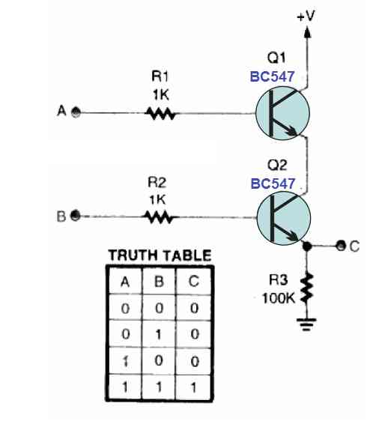
Steps:
- Connect the emitters of Q2 to the output and ground (GND) rail through resistor R3.
- Connect the base of Q1 to input A through resistor R1.
- Connect the base of Q2 to input B through resistor R2.
- Connect the collector of Q1 to supply and emitter to collector of Q2
When both inputs (A and B) are high (1), current flows through the base-emitter junction of both transistors, turning them on. This allows current to flow from the collectors to the emitters, resulting in an output.

2. OR Gate:
An OR gate produces an output when at least one of its inputs is high (1).
Components Needed:
- Two NPN transistors (Q1 and Q2)
- Resistors (R1, R2, R3)

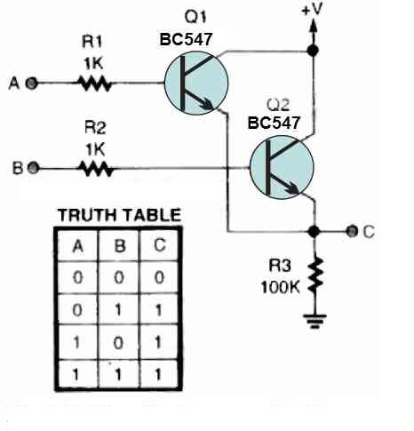
Steps:
- Connect the emitters of Q1 and Q2 to the output and ground (GND) rail through resistor R3.
- Connect the collectors of Q1 and Q2 to the supply.
- Connect the base of Q1 to input A through resistor R1.
- Connect the base of Q2 to input B through resistor R2.
When either input A or input B (or both) is high (1), current flows through the base-emitter junction of at least one transistor, turning it on. This allows current to flow from the collector of the active transistor to the output, resulting in an output.

3. NOT Gate (Inverter):
A NOT gate (inverter) produces an output that's the opposite of its input.
Components Needed:
- One NPN transistor (Q1)
- Two Resistor (R1, R2)

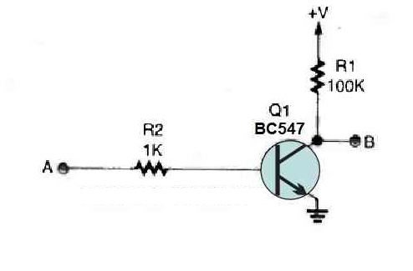

Steps:
- Connect the emitter of Q1 to the ground (GND) rail.
- Connect the collector of Q1 to the output of the NOT gate with supply through resistor.
- Connect the base of Q1 to the input through resistor R2.
When the input is low (0), no current flows through the base-emitter junction of the transistor, keeping it off. When the input is high (1), current flows through the base-emitter junction, turning the transistor on. This allows current to flow from the collector to the emitter, resulting in a low output when the input is high and vice versa.
Keep in mind that these descriptions provide simplified explanations of how basic logic gates can be constructed using transistors. In practical integrated circuits, more advanced designs and multiple transistors are used for reliability and efficiency.

Tasks for the Lab
Component:
- 74LS08 X l
- 74LS32 X l
- 74LS86 X l
- 74LS04 X l

Tools:
- ETS 7000A Trainer or IDL 400 Logic Trainer
- Cutter.
- Single Core Wire.
- Tweezer.
- Pair of Pliers.

Diagram
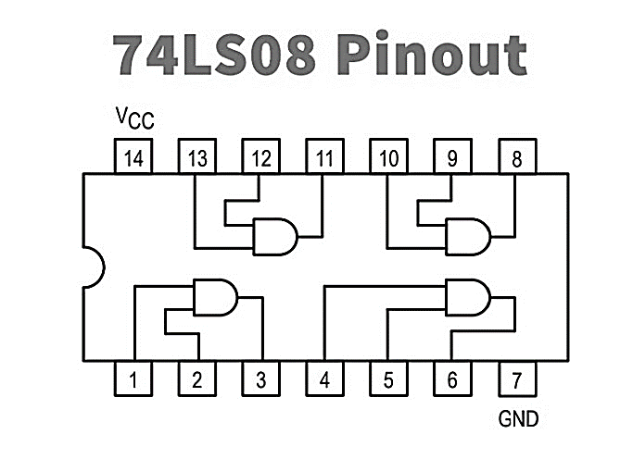

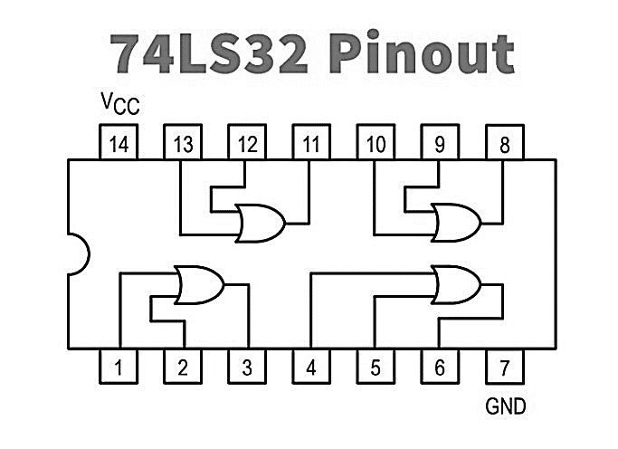

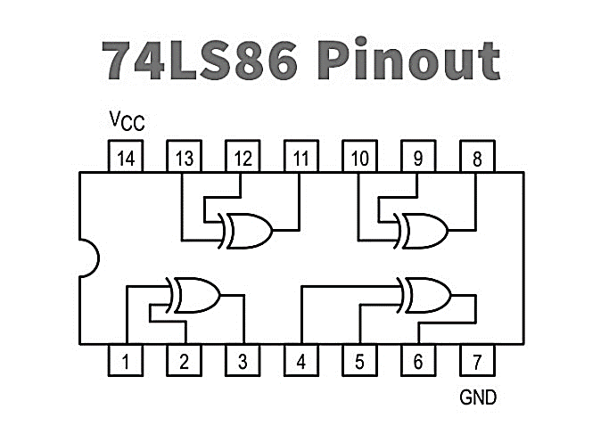

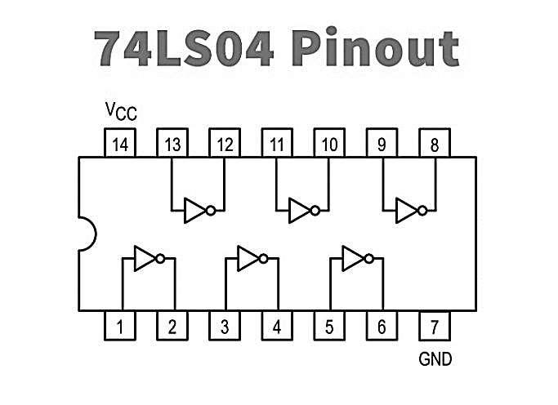

Task:

- Connect all the above four ICs and produce output using any single gate and fill the truth table below.

Table # 1: Truth Table for AND, OR, XOR, NOT gates

Inputs |  | Outputs
A | B | AND | OR | XOR | NOT
0 | 0 | 0 | 0 | 1 | 1 (considering A)
0 | 1 | 0 | 1 | 0 | 1
1 | 0 | 0 | 1 | 0 | 0
1 | 1 | 1 | 1 | 1 | 0

- Using NOT gates with AND, OR, and XOR gates develop NAND, NOR, XNOR Gates with the help of diagram below and solve the following truth table as well.

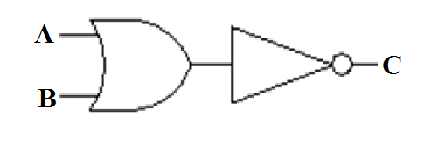

A | B | A+B | $$\overline{A+B}$$
0 | 0 | 0 | 1
0 | 1 | 1 | 0
1 | 0 | 1 | 0
1 | 1 | 1 | 0

A | B | A.B | $$\overline{A.B}$$
0 | 0 | 0 | 0
0 | 1 | 0 | 1
1 | 0 | 0 | 1
1 | 1 | 1 | 1

A | B | A⊕B | $$\overline{A⊕B}$$
0 | 0 | 0 | 1
0 | 1 | 1 | 0
1 | 0 | 1 | 0
1 | 1 | 0 | 1

