
Department of Computer Science
Institute of Business Administration, Karachi

Lab #10: Sequential Logic Design and Counter Implementation

Digital Logic Design

Objective:

The objective of this lab is to:
- Design and implement an 8-bit counter using Verilog.
- Create a state-machine-based special counter in Logisim.
- Implement the special counter in Verilog based on the designed state machine.

Introduction:

Counters are fundamental components in digital systems, used for counting events, generating timing sequences, and more. This lab focuses on understanding counter design, from basic increment logic to custom state-machine-based counters. By completing the tasks, students will gain hands-on experience in designing counters, creating state diagrams, using simulation tools like Logisim, and implementing logic in Verilog.
In the below provided code here you see the example of a 4 bit counter with reset here is link of code as well: https://edaplayground.com/x/UN5Z
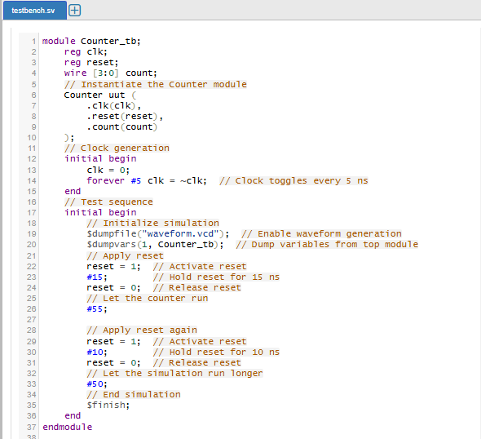
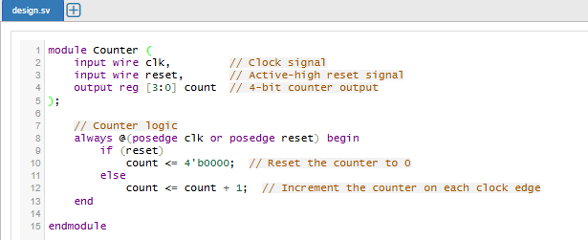

Tasks for the Lab

Task 1: Designing and Simulating an 8-bit Counter in Verilog
Objective:
Design an 8-bit counter that increments on every positive clock edge and resets to 0 when the reset signal is active.
Instructions:
- Extend the provided 4-bit counter code to an 8-bit counter.
- Update the count output to be 8 bits wide ([7:0]).
- Simulate the 8-bit counter using EDA Playground or another simulation tool.
- Observe and verify the waveform for clk, reset, and count.
Expected Deliverable:
- Verilog code for the 8-bit counter.
- Waveform output showing correct incrementing behavior and reset functionality.

Task 2: Designing a 3-bit Special Counter in Logisim
Objective:
Design a 3-bit special counter that follows the sequence: 1 → 3 → 5 → 7 → 0 → 2 → 4 → 6.
Instructions:
- State Diagram and State Table:
  - Draw the state diagram representing the counter transitions.
  - Create a state table showing the current state and next state in binary form.
- Circuit Design in Logisim:
  - Use the state table to design a circuit in Logisim using D-Flip flops.
  - Use combinational logic for state transitions and sequential logic (flip-flops) to store the current state.
Expected Deliverable:
- A clear state diagram and state table.
- A screenshot of the functional counter circuit designed in Logisim.

Task 3: Implementing the 3-bit Special Counter in Verilog
Objective:
Translate the 3-bit special counter logic into Verilog code and simulate it.
Instructions:
- Use the state table from Task 2 to implement the state machine in Verilog.
- Utilize a case statement for state transitions in Verilog as we did in previous lab.
- Simulate the design using EDA Playground or another Verilog simulator.
- Observe the waveform for clk, reset, and count to ensure the sequence is correct.

