
Department of Computer Science
Institute of Business Administration, Karachi

Lab #2: Universal gate implementation and Boolean expression implementation

Digital Logic Design

Objective:

The objectives of this experiment are:
- Understanding basic phenomena of universal gate implementation
- Integrating multiple ICs on hardware
- Analyzing Boolean expression and design on hardware
- Cost calculation and analysis of Boolean expressions and hardware implementations

Introduction:

Universal logic gates are fundamental components in digital electronics and computer science. They are special types of logic gates that can be used to create any other logic gate or perform any logical operation. Two of the most well-known universal logic gates are the NOR gate and the NAND gate.

- NOR Gate:
  - Symbol: The NOR gate is represented by the symbol ⊼ (or sometimes by a standard OR gate with a NOT symbol at its output).

  - Truth Table:
A | B | Output
0 | 0 | 1
0 | 1 | 0
1 | 0 | 0
1 | 1 | 0

  - Functionality: The NOR gate performs the logical NOR operation. It produces a high output (1) only when both of its inputs are low (0). In all other cases, it produces a low output (0).

- NAND Gate:
  - Symbol: The NAND gate is represented by the symbol ⋁ (or sometimes by a standard AND gate with a NOT symbol at its output).

  - Truth Table:
A | B | Output
0 | 0 | 1
0 | 1 | 1
1 | 0 | 1
1 | 1 | 0

  - Functionality: The NAND gate performs the logical NAND operation. It produces a low output (0) only when both of its inputs are high (1). In all other cases, it produces a high output (1).
Now, here's why NOR and NAND gates are considered universal:
Universal Property:
- Both NOR and NAND gates are universal because you can use them to create any other logic gate or perform any logical operation. This property is based on De Morgan's theorem.
For example:
- By connecting NOR gates in a specific way, you can create AND, OR, and NOT gates.
- By connecting NAND gates in a specific way, you can also create AND, OR, and NOT gates.
This versatility makes NOR and NAND gates essential in digital circuit design because they can be used as building blocks to construct complex digital systems.
In summary, universal logic gates, such as the NOR and NAND gates, are fundamental components in digital electronics due to their ability to perform any logical operation and create other logic gates. Their simplicity and versatility make them invaluable tools in designing digital circuits and computers.

Implementation of XOR using NAND

You can create an XOR (exclusive OR) gate using NAND gates. An XOR gate produces a high output (1) when there is an odd number of high inputs (1) among its two inputs. Here's how you can construct an XOR gate using NAND gates:

To create an XOR gate, you can follow these steps:
- Use NAND gates to create a basic AND gate:
  - Connect two NAND gates in series (one after the other) with the same input A and B.
  - The output of the first NAND gate is the NAND of A and B, which is essentially NOT (A AND B).
  - The output of the second NAND gate is the NAND of the result from the first NAND gate and its own input.
  - This effectively creates an AND gate because you are negating the result of A AND B and then NAND-ing it with its own input.

- Use NAND gates to create a basic OR gate:
  - Connect two NAND gates in parallel (side by side) with the same input A and B.
  - The output of the first NAND gate is the NAND of A and A, which is NOT A.
  - The output of the second NAND gate is the NAND of B and B, which is NOT B.
  - This effectively creates an OR gate because you are negating both A and B individually and then NAND-ing them together.

- Combine the AND and OR gates:
  - Take the outputs of the AND and OR gates from the previous steps and feed them into another NAND gate.
  - The output of this final NAND gate will be your XOR gate.

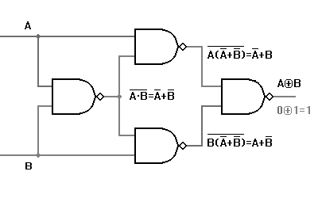

Tasks for the Lab
Component:
- 74LS00 X l
- 74LS32 X l
- 74LS86 X l
- 74LS08 X l

Tools:
- ETS 7000 Trainer or IDL 400 logic trainer.
- Cutter.
- Single Core Wire.
- Tweezer.
- Pair of Pliers.

Diagram

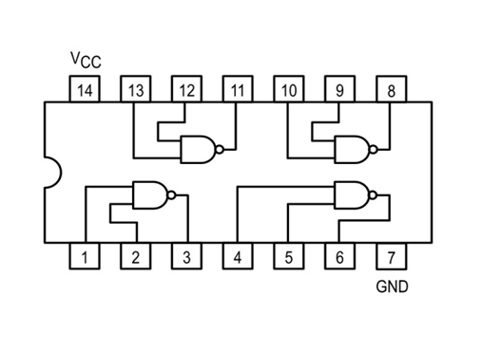
Task:

- Implement the functionality of XOR gate using NAND gate as described above.

- Implement the following Boolean expression and draw its truth table.

$$X=\left(A+B\right).\overline{C}$$

A | B | C | X
0 | 0 | 0 | 0
0 | 0 | 1 | 0
0 | 1 | 0 | 1
0 | 1 | 1 | 0
1 | 0 | 0 | 1
1 | 0 | 1 | 0
1 | 1 | 0 | 1
1 | 1 | 1 | 0

