
Department of Computer Science
Institute of Business Administration, Karachi

Lab #3: Seven Segment display operation with BCD to Seven Segment Decoder

Digital Logic Design

Objective:

The objectives of this experiment are:
- Understanding basic phenomena of function of Boolean algebra
- To check the operation of common anode 7 -segment display.
- To check the operation of common anode BCD to 7-Segment decoder using IC 74LS47.

Introduction:
Seven-segment displays are widely used electronic components that provide a simple and efficient way to display numerical and alphanumeric characters. They are commonly found in various electronic devices, from digital clocks and calculators to industrial control panels and consumer appliances. This versatile display technology consists of seven individual LED or LCD segments arranged in a specific pattern, allowing the representation of numbers, letters, and some special characters.

Types of Seven-Segments Displays:

Common Cathode (CC) Seven-Segment Display:
In a common cathode seven-segment display, all the cathodes of the seven segments are connected and share a common ground connection. To light up a particular segment, you apply a positive voltage to the corresponding anode pin.

Common Anode (CA) Seven-Segment Display:
Conversely, in a common anode seven-segment display, all the anodes are connected and share a common positive voltage connection. To illuminate a specific segment, you ground the corresponding cathode pin.

BCD to Seven-Segment Decoder ICs:

To interface seven-segment displays with digital logic circuits or microcontrollers, BCD (Binary Coded Decimal) to seven-segment decoder ICs is commonly used. These ICs take a 4-bit BCD input and convert it into the appropriate signals to drive the seven segments of the display. Here are the correct types of BCD to seven-segment decoder ICs.

7447 Series:
The 7447 series of ICs are BCD to seven-segment decoder/driver ICs designed for common anode seven-segment displays. They provide a 4-bit BCD input and generate the necessary signals to drive a common anode seven-segment display.

Here in the image below the 7447A is an connected to an LED seven segment display. Notice the current limiting resistors, required to prevent overdriving the LED display.
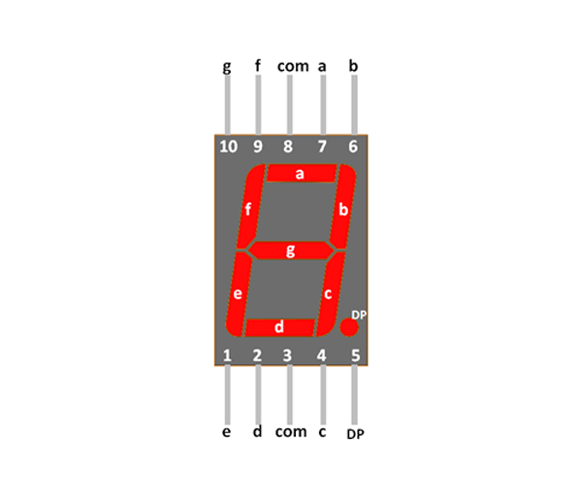

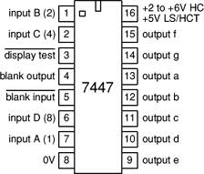

7448 Series:

The 7448 series is like the 7447 series but designed for common cathode seven-segment displays.

BCD to Seven-Segment Latch/Decoder/Driver:
These ICs integrate not only the decoder functionality but also latches to store and hold the BCD input, making it easy to display static numbers without continuous input.

BCD to Seven-Segment Multiplexers:
Some ICs incorporate multiplexing functionality alongside BCD decoding, allowing for the control of multiple seven-segment displays.

In summary, seven-segment displays are invaluable components for visualizing numerical and alphanumeric data in a wide range of applications. BCD to seven-segment decoder ICs facilitate their use by simplifying the interface with digital circuits, making it easier to create digital readouts and displays. The choice between common cathode or common anode displays and the appropriate decoder IC depends on the specific requirements of your project.

Tasks for the Lab

Component:
• Common Anode seven segment display
• Resistors
• 74LS47

Tools:
• ETS 7000 Trainer or IDL 400 logic trainer.
• Cutter.
• Single Core Wire.
• Tweezer.
• Pair of Pliers.

Diagram:

Task:

- Using the seven-segment provided to you display digits one to nine using 7 inputs of your trainer and fill the provided below truth table.
Inputs |  |  |  |  |  |  | Output
a | b | c | d | e | f | g | Decimal
0 | 0 | 0 | 0 | 0 | 0 | 1 | 0
1 | 0 | 0 | 1 | 1 | 1 | 1 | 1
0 | 0 | 1 | 0 | 0 | 1 | 0 | 2
0 | 0 | 0 | 0 | 1 | 1 | 0 | 3
1 | 0 | 0 | 1 | 1 | 0 | 0 | 4
0 | 1 | 0 | 0 | 0 | 1 | 0 | 5
0 | 1 | 0 | 0 | 0 | 0 | 0 | 6
0 | 0 | 0 | 1 | 1 | 1 | 1 | 7
0 | 0 | 0 | 0 | 0 | 0 | 0 | 8
0 | 0 | 0 | 0 | 1 | 0 | 0 | 9

- With the help of decoder ic provided to you now design a circuit which will display all seven outputs but used only four inputs and fill the following truth table

Inputs |  |  |  | Output
D | C | B | A | a | b | c | d | e | f | g
0 | 0 | 0 | 0
0 | 0 | 0 | 1
0 | 0 | 1 | 0
0 | 0 | 1 | 1
0 | 1 | 0 | 0
0 | 1 | 0 | 1
0 | 1 | 1 | 0
0 | 1 | 1 | 1
1 | 0 | 0 | 0
1 | 0 | 0 | 1

