
Department of Computer Science
Institute of Business Administration, Karachi

Lab #4: Half Adder, Full adder, and Parallel adder

Digital Logic Design

Objective:

The objectives of this experiment are:
- Understanding basic phenomena of function of Boolean algebra
- Understanding arithmetic of Boolean algebra and arithmetic circuit
- To check the operation of half, full and parallel adder.
- Designing full adder and using parallel adder ic.

Introduction:
Introduction:
Digital Logic Design is a fundamental aspect of modern electronics, serving as the foundation for designing complex digital systems. Within this domain, the concepts of addition and arithmetic operations are critical. Half adders, full adders, and parallel adders are essential building blocks for performing binary addition, and they find applications in various digital systems, from simple calculators to advanced microprocessors.
In this review, we will explore the circuitry, truth tables, and commonly used integrated circuits (ICs) associated with half adders, full adders, and parallel adders.

Half Adder:
A half adder is the simplest form of an adder circuit. It can add two binary digits (0 or 1) and produce two outputs: the sum (S) and the carry (C). The circuit consists of two inputs, A and B, and two outputs, S and C. The sum output (S) represents the least significant bit of the addition result, while the carry output (C) indicates if there's a carry to the next higher bit position.
Circuitry: A half adder can be implemented using two basic logic gates: an XOR gate and an AND gate. The XOR gate computes the sum (S), while the AND gate computes the carry (C).

Truth Table:
A | B | S | C
0 | 0 | 0 | 0
0 | 1 | 1 | 0
1 | 0 | 1 | 0
1 | 1 | 0 | 1
Common ICs:
- The 74LS83 is a common IC used to implement a 4-bit binary adder, which can be composed of four half adders.

Full Adder:
A full adder is an extension of the half adder, capable of adding three binary digits: A, B, and a carry-in (Cin). It produces two outputs, the sum (S), and the carry-out (Cout), which is carried over to the next higher bit position.
Circuitry: A full adder can be constructed using XOR, AND, and OR gates. It considers the carry from the previous bit position, making it suitable for multi-bit addition.

Truth Table:
A | B | Cin | S | Cout
0 | 0 | 0 | 0 | 0
0 | 0 | 1 | 1 | 0
0 | 1 | 0 | 1 | 0
0 | 1 | 1 | 0 | 1
1 | 0 | 0 | 1 | 0
1 | 0 | 1 | 0 | 1
1 | 1 | 0 | 0 | 1
1 | 1 | 1 | 1 | 1

Common ICs:
- The 74LS83 is a popular IC for constructing 4-bit binary adders using full adders.

Parallel Adder:
A parallel adder is used for adding multi-bit binary numbers in parallel, combining multiple full adders. It can add two n-bit binary numbers, producing an n+1 bit sum and a carry-out (Cout).
Circuitry: A parallel adder consists of n full adders, where each full adder adds corresponding bits of the two input numbers and considers the carry from the previous stage.

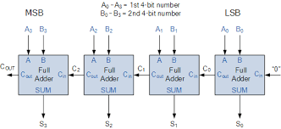

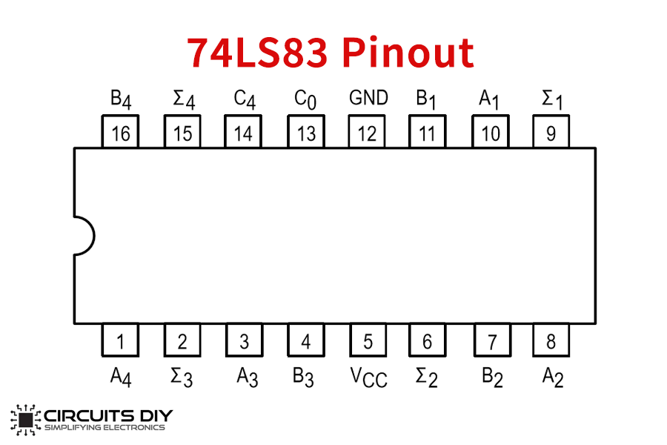

Tasks for the Lab

Component:
• Logic Gates
• 74LS83
• 74LS08

Tools:
• ETS 7000 Trainer or IDL 400 logic trainer.
• Cutter.
• Single Core Wire.
• Tweezer.
• Pair of Pliers.

Task:

- Design a circuitry to perform function of half adder and full adder. Kindly show your working what expression you are designing for half adder and full adder.

- Using parallel adder(74LS83) design a circuitry that can add two inputs of two bits.

- Using parallel adder (or Half adder, Full adder) and AND gate design a circuitry that can multiply two inputs of two bits each. Also draw its truth table.

