Name: Abdullah

Roll: 1802016

(ERD)

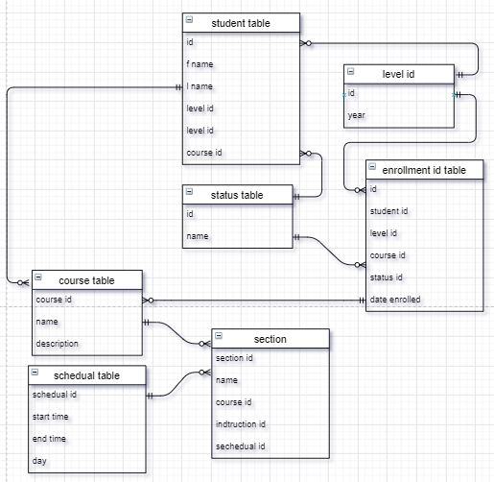

(Queries)

1.SELECT student.student_id, student.first_name, student.course_id, course.course_id, course.name, course.description

FROM student

FULL OUTER JOIN course ON course.course_id=student.course_id

ORDER BY student.course_id;

2. SELECT * FROM student s, course c, enrollment e

where s.course_id=c.course_id and s.course_id=e.course_id;

3. SELECT count(first_name), course_id from student where course_id IN(select course_id from student) GROUP BY course_id;

4. SELECT * FROM enrollment WHERE date > '2019-3-29’ ;

5. select * from student where course_id = (select course_id from course

where course_name = 'BSIT')

6. SELECT a.name as "Name", c.course_name, s.schedule_id from section a, schedule s, course c where a.course_id= 24 and a.schedule_id = s.schedule_id and c.course_id=a.course_id