**Activity # 1:**

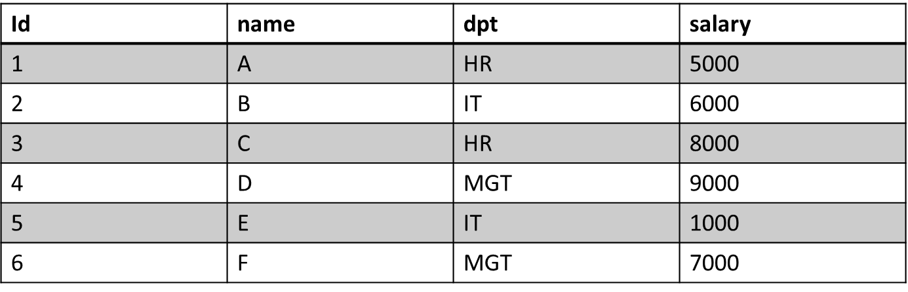

1. Select name from employee where dpt = (select dpt from employee where name=’C’ ) and name <> ‘C’ ;
2. Select name from employee where salary > (select MAX(salary) from employee);
3. SELECT name From employee where salary=(select MAX(salary) From employee where salary <

(Select Max (salary) from employee));

**ACTIVITY # 2:**

1. select count(minimum_bricks_needed) from colours ;
2. select colours.colour_name,colours.MINIMUM_BRICKS_NEEDED from colours left join bricks on colours.colour_name=bricks.colour;

or

select * from colours left join bricks on colours.colour_name=bricks.colour;

1. select colour_name from colours where colour_name = ANY (select colour from bricks where brick_id < 5) and minimum_bricks_needed > 1;
2. select * from colours where colour_name NOT IN (Select colour from bricks where colour IS NOT NULL );