1. **Change OR to XOR in a guard condition  
   Status:** Completed and verified.  
   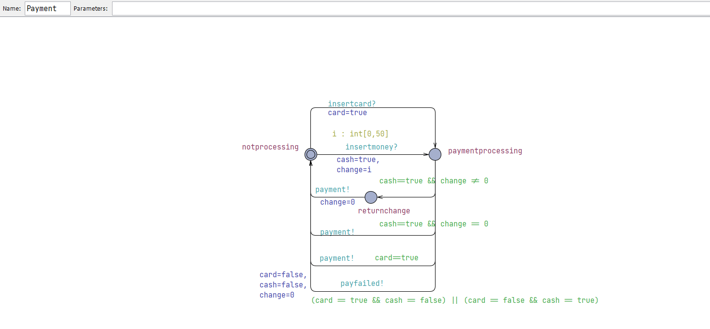  
   Here, as you can see, we have implemented XOR in the last transition.  
   Here it is verified in verifier that these simultaneously can not be true

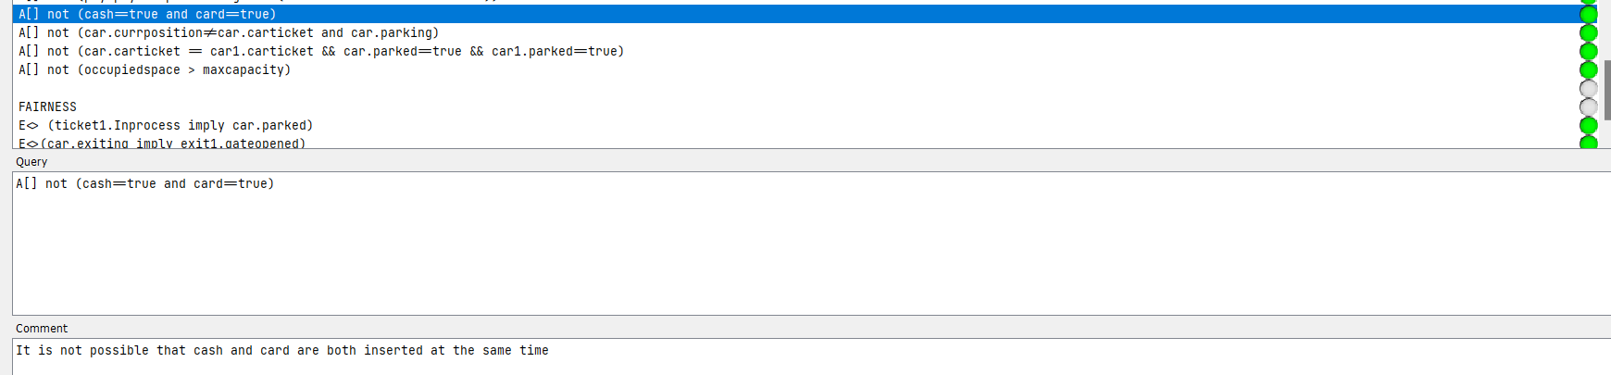

1. **Idle state at the start and the car to send a signal when it comes at the parking and then the availability is checked**  
   **Status:** Completed.  
   **Description:** We have implemented an idle state in both the car and the ticket automata. The car is initially in idle state, if a car wants to enter the parking, it sends a check? signal which the getTicket automata receives and moves to the checkAvalibility state. It must be kept in mind that we have only kept one ticketing booth so at a time only one car can be in the ticketing process.  
   **Screenshots for proof:**

1. **Cater multiple cars coming simultaneously:  
   Status:** Catered and verified  
   **Description:** We have made array channels to accommodate this feature. Basically how the system works is that there are two parking slots right now so each slot has an entry and exit gate along with a fine module. When a car gets a ticket, they get assigned a spot and we have maintained an array of spots in which that spot turns to true and the number of occupied spaces is improved. So, if another car comes into the ticketing booth, they can not get that parking spot ticket, and this is ensured by guard conditions. Each car can simultaneously park and unpark in their allocated spot regardless of what the other cars are doing, provided that there was enough space to accommodate all the cars. If a car comes when all spots are occupied, they have to wait until a car leaves and occupiedspace is decremented and that car's assigned spot is turned to false in the parking array.  
   **Screenshots for proof:**  
   A screenshot of a computer

   Description automatically generatedA screenshot of a computer

   Description automatically generatedA screenshot of a computer

   Description automatically generated  
   **Variables for car:**  
   A screenshot of a computer program

   Description automatically generated  
   **Global Declarations including the new array channels to accommodate simultaneous behavior and the car spots array for active tracking:**  
     
   A screenshot of a computer code

   Description automatically generated

Apart from this, We have also attached a file with all possible paths a car can  take during its process such as payment accepted and failed, a car parked and unparked within a time limit of 60 minutes or a car parked beyond the time and fined accordingly. The simulation has 2 cars where one car is fined and 1 is not and both are accessing the parking simultaneously.  
Finally, as requested, we have also updated assignment 2, 3 and the final report with our changes so that our marks can be updated accordingly.