

**LAGOS STATE UNIVERSITY**

**FACULTY OF ENGINEERING**

**EPE CAMPUS**

**NAME:** Abdullateef Ojugbele

**MATRIC NO: 220211197**

**DEPARTMENT: Electronics and computer engineering**

**COURSE CODE:** MEE 203

**COURSE TITLE:** WORKSHOP PRACTICE I

**PROJECT TITLE**: FITTING BENCH WORK

MALE & FEMALE PRODUCTION

**LECTURER-IN-CHARGE**: ENGR. ATETEDAYE

**DATE: 19TH APRIL, 2024.**



**LAGOS STATE UNIVERSITY**

**FACULTY OF ENGINEERING**

**EPE CAMPUS**

**NAME:** Korede Amusa

**MATRIC NO: 220211074**

**DEPARTMENT: Electronics and computer engineering**

**COURSE CODE:** MEE 203

**COURSE TITLE:** WORKSHOP PRACTICE I

**PROJECT TITLE**: FITTING BENCH WORK

MALE & FEMALE PRODUCTION

**LECTURER-IN-CHARGE**: ENGR. ATETEDAYE

**DATE: 19TH APRIL, 2024.**

**MEASUREMENT AND MARKING OUT OF THE GIVEN COMPONENT'S DIMENSION**

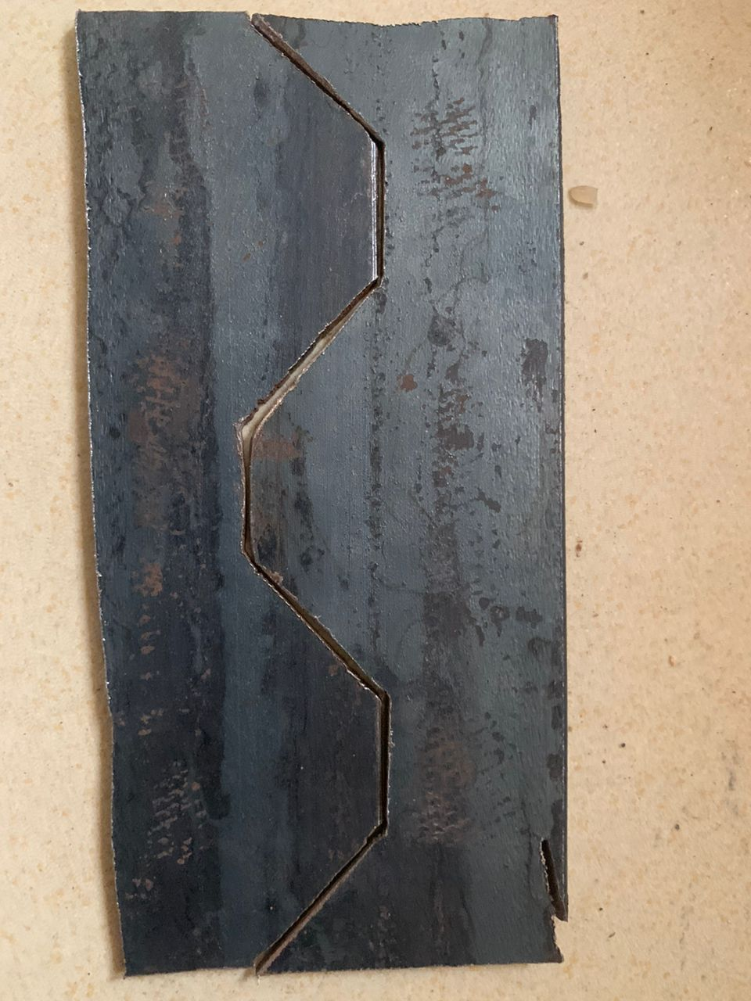

**TOOLS AND MACHINE USED**

**·Bench-vice**: This is the tool used to hold your work piece firmly.

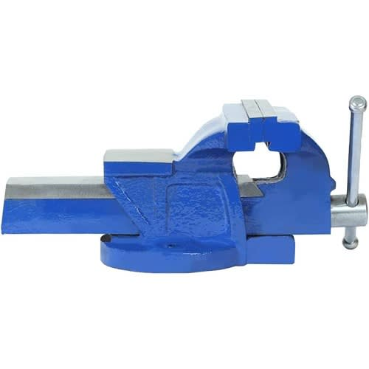

**Hack saw**: This is a tool with a blade used for cutting metals.

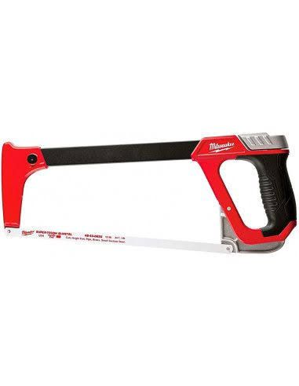

**Scriber**: this a tool used for marking out lines on metal works.

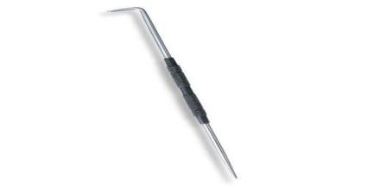

**Steel rule**: It is used for measurement on the work piece.

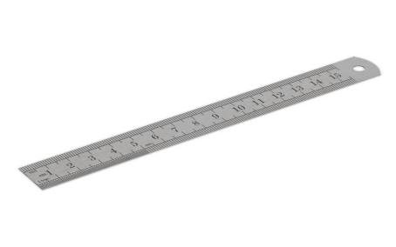

**Work bench**: It is the surfacc where all activitics in the workshop are carried out.

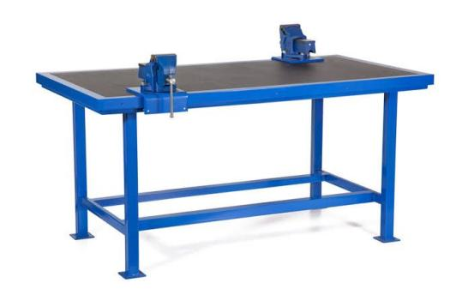

·Flat metal (work piece exraction).

· **Chalk:** This is used to for rubbing the surface of metals to make markings made by scriber visible.



**PROCEDURES/METHODS INVOLVED**

1.Cutting and measurement of workpiece:

· Take measurement of 110mm on the metal sheet using a metre rule.

·Use the chalk to shade the metal sheet.

·Use the scriber to mark the measured length on the shaded surface.

· Cut out the marked area using a hack saw.

2.Filing reference side to sureness :

·File the cut-off edge to get a smooth side.

3. Marking out the required pattern:

· Tools used: Chalk, Dot punch, Scriber, Steel rule, Try square.

·The metal is a bent metal sheet, so we divide and cut out the metal sheet into two and use one for Male and the other for the Female.

For the Male;

Take measurement of 100mm on the metal sheet and divide into 5 parts each of length 20mm.

Use the scriber to mark out the measurement.

Use a try square to get a perpendicular side.

Divide the second and fourth part of the 5 divided parts into 2 measuring 10mm from each other

Connect the end of the last divided part to the centre of the fourth.A“V”shape will be formed.

Take the measurement of 10mm from the 2 divided parts.

· Mark it out with a scriber and connect it with a try square to the end of the mctal, the line drawn that intercepts is the centre of the hole to be punched.

**For the Female;**

Measure 100mm and divide it into 5. Ench will have a width of 20mm.

Mark out the measured points with a scriber.

Measure 20mm from the shorter side and mark it out with a scriber.

Connect it with the other end using a try square.

Divide the second and fourth side into two equal parts. Each of them having a width of 10mm. mark the points with a scriber and connect it to the other end.

From the second side of the fourth side that was divided. Draw a line to the centre of the fourth part. Then connect it to the other end of the fourth part to get a“V-shaped” pattern.

·Measure 10mm from the base of the female. Mark it out with a scriber and connect it to the other side.

·The point of intersection of the centre point of the divided part 2 and part 4and the 10mm line is the centre of the hole to be punched.

4. **Drilling of the hole:**

For both the Male and Female:

·Use the drilling machine to drill holes at the points of intersection on the metal sheet.

5. **Cutting out the patter**n :

For the Male:

·Lock the metal in the vice in a position that the 20mm can be viewed.

·Cut out the horizontal 20mm from the first divided part to the second part. It is advisable not to get to the second point exactly before stopping for higher level of accuracy.

After that, remove the metal from the vice and position it in a way that the second divided part is a vertical.

· Cut it out with a hack saw it should intercept with te cutting started in the previous step.

Remove the metal from the vice and change its position.

· From the other side of the second division, cut out measured 20mm mark.

·Change the position of the metal and cut carefully the V shapc.

·Change the position of the metal and cut out the last part.

·Use the hammer to remove the part that has both of its ends cut out.

For the female:

·In the second divided part of the metal. Fasten the metal to the vice and cut vertically the ends of both of the second division.

Change the position of the metal piece in the vice. In the fourth divided part.Cut out the “V" shape carefully.

·Use the hammer to remove the second divided part of the metal that has both of its end cut by hitting.

6. Filing to size

·File out the sides that were cut to the original size using a file.

· The rough edges should be filed also.

7.Finishing file the surface of the metal piece. To get a smooth surface.

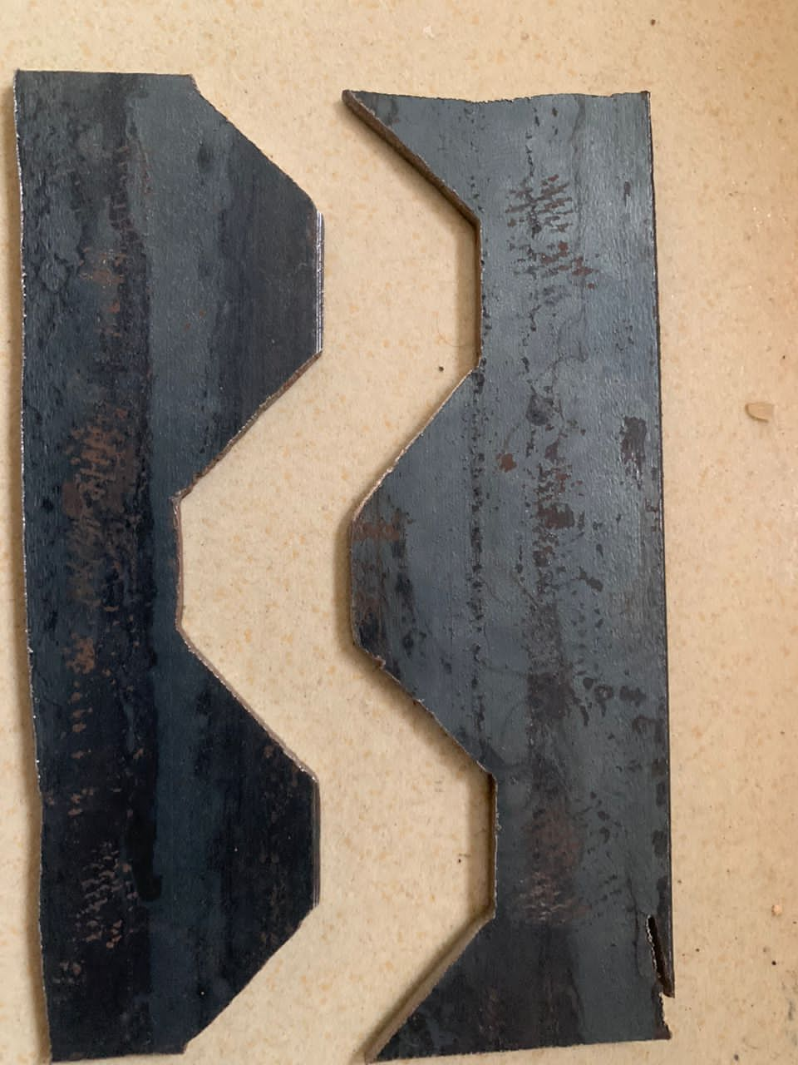

**MALE AND FEMALE WORK PIECE**

**SAFETY PRECAUTIONS**

**MEASURING AND MARKING OUT**

1. I ensured that each measurement was taken properly

2. I checked if the try square had smooth edges

3. I placed my workpiece properly while measuring to ensure accuracy.

4. I ensured drew lines drawn by the try square were perpendicular.

5. I ensured the drawn were straight.

**DRILLING AND CUTTING**

1. I ensured to pour coolant on the surface of the workpiece to soften the surface to aid easy penetration.

2. I ensured the work piece was tightened firmly on the vice while cutting.

3. I ensured I cut through the lines that were marked to avoid inaccurate cut.

4. I positioned my hands well while using the hack saw to avoid injury.

5. I ensured the baked if the hack saw was sharp to aid accurate cutting

6. I ensured my workbench was firm while cutting.

7. I ensured I carefully shaped out the pattern using the hammer.

**FILING:**

1. I ensured I did not file beyond the measured area.

2. I ensured my workbench was firm while filing.

3. I ensured my workpiece was firmly held by the vice while filing.

4. I positioned my hands well while filing to avoid injury.

