Laboratory work 4. Learning functionality of Figma environment as for the work with alignment, shapes primitives, and export of graphical images as the elements of user interface
The purpose of the work is to get familiar with the purpose and use of different alignments, shapes primitives and export of graphical images for creating elements of the user interface within Figma environment.
The progress of the work
1. Learn theoretical information by performing exercises.
2. Do a practical task (see below).
3. Prepare a report on the performance of laboratory work (Theme, practical task formulation, steps, ready-made .fig file(s)).

Theoretical information and exercises

https://frusia.pro/p/13
Aligning an object relatively to another one
Alignment can also be done manually, but Figma provides special tools to increase speed.
Exercise 1. To align objects you need:
• Select both layers with objects. Note that a smaller object will always be aligned relative to a larger one (which is logical);
• In the right pane, click one of the alignment types. They are at the top of the properties bar just below the Design tab. Consider each type of alignment and hotkeys:
o Align Left - align the left edge of a larger object. Option + A in macOs. Alt + A in Windows;
o Align Horizontal Centers - align horizontally in the center of a larger object. Option + H in macOs. Alt + H in Windows;
o Align Right - align the right edge of a larger object. Option + D in macOs. Alt + D in Windows;
o Align Top - align the top edge of a larger object. Option + W in macOs. Alt + W in Windows;
o Align Vertical Centers - align the top edge of a larger object. Option + W in macOs. Alt + W in Windows;
o Align Bottom - align the bottom edge of a larger object. Option + S in macOs. Alt + S in Windows.
• Note that the side alignment hotkeys are set in the same order as the arrow buttons. Another analogy for gamers is that the alignment hotkeys are similar to moving to Counter-Strike (AWSD).
• Immediately after the click, the objects will be instantly moved to a new location, the coordinates will change. You can continue clicking on other types of alignment, watching how the position changes: https://frusia.pro/files/2020-10/0013-01-v2.mp4
Align several objects relatively to each other
Exercise 2.
Here the sequence of actions is the same as in the previous case, but you need to select more than two objects. Alignment will occur relative to the largest object: https://frusia.pro/files/2020-10/0013-02-v3.mp4
• Note that objects that are aligned change their position relative to each other (because they are different sizes). To avoid this, it is enough to pre-group the objects, as shown in the next section.
• Align a group of objects relative to another while maintaining a position
• We recommend watching how it happens: https://frusia.pro/files/2020-10/0013-03-v3.mp4
As you can see, the preliminary grouping allows you to save the relative positions of the aligned layers, which is sometimes extremely convenient. Otherwise, without a group, when applying multiple alignments, all objects can be mixed into a pile, as happened in the video.
Aligning individual objects
If the selected objects are located separately (without a large object that overlaps the rest, as in the previous examples), then the alignment will occur relative to the boundaries of all selected objects. In practice it looks so (after each alignment cancellation of the last action of Cmd + Z is applied): https://frusia.pro/files/2020-10/0013-04-v2.mp4
As you can see, the preliminary grouping allows you to save the relative positions of the aligned layers, which is sometimes extremely convenient. Otherwise, without a group, when applying multiple alignments, all objects can be mixed into a pile, as happened in the video.
Aligning a single object within a frame
If you select only one object inside the frame, it will be aligned along the boundaries of the latter: https://frusia.pro/files/2020-10/0013-05-v2.mp4
As you can see, the alignment tool works differently depending on the context. Make sure you understand how objects will be aligned depending on the situation. Train yourself to use hot keys.

Even distribution
Even distribution (allocation) is another extremely useful tool for arranging objects.
Exercise 3. Imagine a situation: you have several objects (buttons), but the distances between them are different and you need to set the same indents. Of course, you can arrange everything yourself, but the Tidy Up tool will do everything for you. To do this, select all objects and press Ctrl + Alt + T in macOs or Ctrl + Alt + Shift + T in Windows. Click on the field that appears and use the arrow keys (up and down) to select the appropriate distance between the elements or enter the value immediately and press Enter: https://frusia.pro/files/2020-10/0013-06-v2.mp4
There are two more similar tools - Distribute Vertical Spacing (Ctrl + Alt + V in macOs and Ctrl + Alt + Shift + V in Windows) and Distribute Horizontal Spacing (Ctrl + Alt + H in macOs and Ctrl + Alt + Shift + H in Windows ). They have two key differences:
1. They distribute the selected objects within their boundaries, in other words, after the redistribution of objects, they will occupy the same space as before the operation. The Tidy Up tool, on the other hand, doesn't care how much space objects in the new positions will take up in the end;
2. You need to explicitly specify in which direction to distribute the objects (horizontally or vertically). Tidy Up does this automatically.
Let us look in practice: https://frusia.pro/files/2020-10/0013-07-v2.mp4
Do not forget that the distribution (allocation) can be used allong with the alignment. This allows you to organize quickly a large number of inaccurately placed objects.
New shapes primitives
We still have a few unfamiliar primitives left in the toolbar. Let's find out how to use them if you haven't already. I'm sure you had no idea that an ellipse has so many capabilities.
Ellipse
Creating an ellipse is elementary. Just use the O hot key (or select the appropriate item in the tool drop-down menu) and then do everything exactly as with the rectangle. Then the transformation process begins: https://frusia.pro/files/2020-10/0013-08-v2.mp4
Exercise 4.
• If you hover the cursor over the circle you just created, you will notice that a white circle appears on the right (if you hover over it, the Arc prompt will appear), which you can drag. If this is done, the circle will turn into an arc;
• Immediately after the conversion, three circles will appear: Start - the starting point, Sweep - the scope (determines the length of the arc), Ratio - the ratio of the inner radius of the arc to the outer (determines the thickness of the arc).
• The corresponding parameters will appear in the properties panel, where you can set the exact values;
• A rounding radius may be helpful to soften the ends. Located in the same place on the right panel as the rectangle.
Polygon
Allows you to create polygons: from a triangle to a polygon with an unlimited number of vertices (usually up to 10). There is no hot key, so you have to use the drop-down menu. As in the case of an ellipse, after creating and hovering, two circles will appear with the following parameters:
• Count - the number of vertices;
• Radius - radius of rounding of vertices: https://frusia.pro/files/2020-11/0013-09-v2.mp4
Star
This shape also does not have a hot key. The limits of its application are quite limited, but not entirely trivial. The video shows how you can use it to make a gear and even a sea urchin.
Exercise 5. Let's get acquainted with circles-parameters:
• Count - the number of star rays;
• Ratio - the ratio between the recesses and protrusions of the beam (the smaller the value, the longer the beam);
• Radius - rounding radius: https://frusia.pro/files/2020-11/0013-10-v4.mp4
Export of design
At work, you will often need to transform the design inside Figma into an image that can be sent as a file. There are different file formats for different purposes. Here are some situations when this may be needed:
• Send several screens in Png files without loss of quality to the customer by e-mail;
• Send icons in vector format Svg to the developer;
• Provide photos of goods in Jpg files.
The process of converting a design element in Figma to an image file is called exporting. You can export any layer or frame either individually or all items marked for export in one go. Let's see how this happens.
How to mark a layer for export and save it to a file
Exercise 6. The sequence of actions is as follows: https://frusia.pro/files/2020-11/0013-11-v6.mp4
1. Select a frame, group or layer to export;
2. In the properties panel on the right, press + (plus) opposite the inscription Export;
3. The settings for export will appear;
4. The rightmost drop-down menu indicates in which format the file will be saved. Make sure that the selected PNG is a format without loss of quality;
5. Click the Export button the name of the selected layer, which is under the settings (the inscription on the button will correspond to the name of the selected layer);
6. A window will appear in which we indicate where and under what name to save the graphic file. By default, the file name is taken from the name of the selected layer, but you can change it. Do not change the file format at this stage (three characters after the period) - it's too late. If necessary, click Cancel and change the format in the rightmost drop-down list;
7. Click the Save button. The file selection window will disappear. Done! The image is saved in the specified location in the specified file.
Png format
PNG (Portable Network Graphics) - raster format without loss of quality. Allows you to accurately capture every pixel of the original image. In other words, the recipient will see it without distortion. Always export the design in Png format to the client (if for some reason he can't see it directly in Figma) and in all other cases.
Jpg format
Jpg (Jpeg, Joint Photographic Experts Group) - raster format for photos with loss of quality. Slightly distorts the original image using the features of human perception. Allows you to save significantly on file size. Never use Jpg to export your design.
Svg format
Svg (Scalable Vector Graphics) is a vector graphic format. Supports both static and animated images. Figma still exports only statically, although it supports animations. Takes up very little space. It is widely used for export of icons and illustrations with a small amount of colors (infographics, diagrams, tables with non-trivial layout). Note that the introductory picture in each lesson was exported in this format. To make sure of this, it is enough to increase the scale of the page - quality loss will never happen (you will not see a pixel ladder).
Pdf format
Pdf (Portable Document Format) - electronic document format. Allows you to save the design in vector form, but this is not its direct purpose. More commonly used to save presentations for investors or reports. Unfortunately, Figma generates extremely heavy files in this format. Never use Pdf to export a design.
Each format has its own features of use and special features (for example, Png allows you to specify where the image is transparent, and Jpg can not).

Practical task of laboratory work
When performing the task, it is recommended to use theoretical material of laboratory works 3-4 as well as the results of practical tasks.
!Create a new file in Figma. Create a separate page for each task!
Practical task 1.
Repeat the drawing (Fig. 1) below, reproducing all the figures in separate frames and using all the primitives known to you.
Export each figure with a caption to a separate png file using frames of the same size.
Then import the newly created png files back into Figma.
Arrange the newly imported shapes in a separate frame as shown in the original image.
In total, you should have three top-down frames on the page:
1) With the original image;
2) With drawn figures;
3) With drawn figures in raster format (which you imported at the end).
All three frames should be as similar as possible.

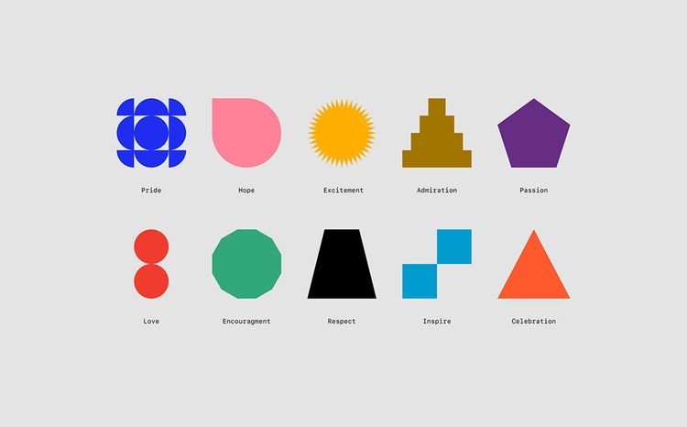
Fig. 1. The shapes in separate frames with the use of all the primitives
Practical Task 2.
Select any object from Task 1 and draw in a separate frame what the Figma properties panel looks like at the moment (this panel is on the right). Change the colors to match the dark gamut of the Figma interface (Figure 2).
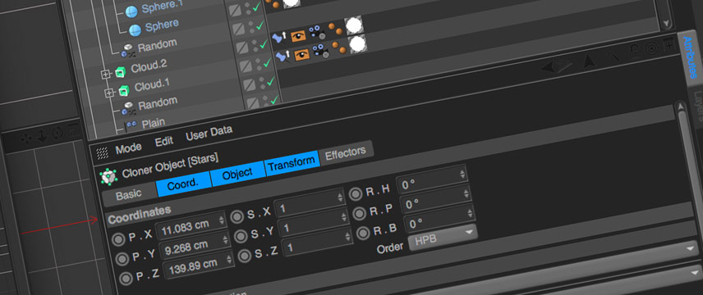
Fig. 2.

Practical Task 3 (creative one).
Check out the popular behance designer platform and gallery at https://www.behance.net/search?sort=recommended&time=week&field=Web%20Design
Choose designs for two sites. Create new designs using structures from one site and colors and illustrations from another.

WARNING! We remind you that each task must be performed on a separate page of the file Lab.Work 4.fig!

Include in the report of the Lab. Work 4:
1) a link to your chosen site with the image of the drawn screens,
2) screenshots of your results,
3) Your file Lab.work4.fig and a link to it with the ability to make changes.
WARNING!!!! Make sure that you select Can edit option next to Anyone with the link. Then click on the Copy link and include this link in the report.

