Лабораторна робота №13

Паралельне виконання. Багатопоточність

Мета: Ознайомлення з моделлю потоків Java. Організація паралельного виконання декількох частин програми.
- ВИМОГИ
  - Використовуючи програми рішень попередніх задач, продемонструвати можливість паралельної обробки елементів контейнера: створити не менше трьох додаткових потоків, на яких викликати відповідні методи обробки контейнера.
  - Забезпечити можливість встановлення користувачем максимального часу виконання (таймаута) при закінченні якого обробка повинна припинятися незалежно від того знайдений кінцевий результат чи ні.
  - Для паралельної обробки використовувати алгоритми, що не змінюють початкову колекцію.
  - Кількість елементів контейнера повинна бути досить велика, складність алгоритмів обробки колекції повинна бути зіставна, а час виконання приблизно однаковий, наприклад:
- пошук мінімуму або максимуму;
- обчислення середнього значення або суми;
- підрахунок елементів, що задовольняють деякій умові;
- відбір за заданим критерієм;
- власний варіант, що відповідає обраній прикладної області.
Розробник
- П.І.Б: Абдуллін О. Р.
- Группа: КІТ-119а
- Варіант: 1
- ОПИС ПРОГРАМИ
  - Засоби ООП:
Scanner inInt, inStr = new Scanner(System.in) – для введення обраних опцій користувачем з клавіатури;
XMLEncoder encoder = new XMLEncoder(new BufferedOutputStream(new FileOutputStream("filename"));
encoder.writeObject(recuitingAgency); – нестандартна серіалізація;
XMLDecoder decoder = new XMLDecoder(new BufferedInputStream(new FileInputStream("filename")));
container = (MyContainer<Challanger>) decoder.readObject(); – нестандартна десеріалізація;
oos.writeObject(container);
container = (MyContainer<Challanger>) ois.readObject(); – стандартна десеріалізація;
Pattern pattern = Pattern.compile() – компілює регулярний вираз у шаблон;
Matcher matcher = pattern.matcher(information); – створює matcher, який буде відповідати даному вводу для цього шаблону.
  - Ієрархія та структура класів
Було створено класи Main (головний клас програми), Challanger (клас, що містить всі поля та методи прикладної області «Кадрове агенство»), MyConatainer (клас-контейнер), Node (клас-покажчик на елемент) та 3 класи, що реалізують інтерфейс Comparator для сортування за певними критеріями. Клас MyThread (реалізує інтерфейс Runnable для роботи з потоками).
2.3 Важливі фрагменти програми
Class Main
package ua.khpi.oop.abdullin13;

import java.beans.XMLDecoder;
import java.beans.XMLEncoder;
import java.io.BufferedInputStream;
import java.io.BufferedOutputStream;
import java.io.File;
import java.io.FileInputStream;
import java.io.FileNotFoundException;
import java.io.FileOutputStream;
import java.io.ObjectInputStream;
import java.io.ObjectOutputStream;
import java.util.Scanner;
import java.util.regex.Matcher;
import java.util.regex.Pattern;

import ua.khpi.oop.abdullin07.Challanger;
import ua.khpi.oop.abdullin07.DemandsToWork;
import ua.khpi.oop.abdullin07.WorkExperience;
import ua.khpi.oop.abdullin10.MyContainer;

public class Main {

public static void main(String[] args) {
MyContainer<Challanger> recruitingAgency = new MyContainer<Challanger>();

for (String str : args) {
if(str.equals("-a") || str.equals("-auto")) {
recruitingAgency = auto(recruitingAgency);
return;
}
}
recruitingAgency = menu(recruitingAgency);
}

private static MyContainer<Challanger> auto(MyContainer<Challanger> recruitingAgency) {
System.out.println("Adding elements...");

File file = new File("recruitingAgency11.txt");

try {
String education;
int day;
int month;
int year;
String specializationPrevious;
int experience;
String specializationNext;
int minSalary;
String conditions;
Scanner reader = new Scanner(file);
while(reader.hasNextLine()) {
String data = reader.nextLine();
Pattern pattern = Pattern.compile("((\\w+(|\\s))*,\\s([1-9]|[12]\\d|3[01])\\.([1-9]|1[012])\\.((19|20)\\d{2}),\\s" +
"(\\w+.)+,\\s([0-9]|[1-6][0-9]),\\s(\\w+.)+,\\s([1-9]\\d{3,}),\\s(\\w+(\\.|\\s)(\\s|))+)");
Matcher matcher = pattern.matcher(data);
if(matcher.matches()) {
String[] information = data.split(",\\s");
education = information[0];
specializationPrevious = information[2];
experience = Integer.parseInt(information[3]);
specializationNext = information[4];
minSalary = Integer.parseInt(information[5]);
conditions = information[6];
String[] date = information[1].split("\\.");
day = Integer.parseInt(date[0]);
month = Integer.parseInt(date[1]);
year = Integer.parseInt(date[2]);

int id = recruitingAgency.getSize();

WorkExperience workExperienceAdd = new WorkExperience(specializationPrevious, experience);
DemandsToWork demandsToWorkAdd = new DemandsToWork(specializationNext,minSalary,conditions);
Challanger challangerAdd = new Challanger(id++,education,day,month,year,workExperienceAdd,demandsToWorkAdd);
recruitingAgency.add(challangerAdd);
}
}
reader.close();
System.out.println("Adding was end.\n");
} catch (FileNotFoundException e){
e.printStackTrace();
}

System.out.println("List in Recruiting Agency:\n");
if(recruitingAgency.getSize() > 0) {
for(var element : recruitingAgency) {
element.print();
}
}
else {
System.out.println("The recruiting agency is empty!\n");
}

task(recruitingAgency);

int orderSort = 1;

recruitingAgency.sort(new workExperienceComparator(), orderSort);
System.out.println("Data sorted by work experience");

System.out.println("List in Recruiting Agency:\n");
if(recruitingAgency.getSize() > 0) {
for(var element : recruitingAgency) {
element.print();
}
}

return recruitingAgency;
}

private static MyContainer<Challanger> menu(MyContainer<Challanger> recruitingAgency) {
boolean endprog = false;
Scanner inInt = new Scanner(System.in);
Scanner inStr = new Scanner(System.in);
int menu;
int menuSort;
int orderSort;
int menuSerialization;
int menuDeserialization;

while(!endprog)
{
System.out.println("1. Show all challanger");
System.out.println("2. Add challanger");
System.out.println("3. Delete chellanger");
System.out.println("4. Clear list");
System.out.println("5. Is empty recruiting agency?");
System.out.println("6. Sort data");
System.out.println("7. Serialize data");
System.out.println("8. Deserialize data");
System.out.println("9. Task");
System.out.println("10. Thread task");
System.out.println("0. Exit");
System.out.print("Enter option: ");
try
{
menu = inInt.nextInt();
}
catch(java.util.InputMismatchException e)
{
System.out.println("Error! Ошибка ввода.");
endprog = true;
menu = 0;
}
System.out.println();
switch(menu)
{
case 1:
if(recruitingAgency.getSize() > 0) {
for(var element : recruitingAgency) {
element.print();
}
}
else {
System.out.println("The recruiting agency is empty!\n");
}
break;
case 2:
String education;
int day;
int month;
int year;
String specializationPrevious;
int experience;
String specializationNext;
int minSalary;
String conditions;

Pattern patternEducation = Pattern.compile("(\\w+.)+");
Pattern patternDay = Pattern.compile("([1-9]|[12]\\d|3[01])");
Pattern patternMonth = Pattern.compile("([1-9]|1[012])");
Pattern patternYear = Pattern.compile("(19|20)\\d{2}");
Pattern patternSpeсialization = Pattern.compile("(\\w+.)+");
Pattern patternExperience = Pattern.compile("[0-9]|[1-6][0-9]");
Pattern patternMinSalary = Pattern.compile("(^[1-9]\\d{3,})");
Pattern patternConditions = Pattern.compile("(\\w+(\\.|\\s)(\\s|))+");

System.out.println("Enter education of challanger: ");
try {
education = inStr.nextLine();
education = stringRegexCheck(education, patternEducation);
}catch(java.util.InputMismatchException e) {
System.out.println("Error! Incorect input!");
break;
}

System.out.println("Enter day of dismissal: ");
try {
day = inInt.nextInt();
day = intRegexCheck(day, patternDay);
} catch(java.util.InputMismatchException e) {
System.out.println("Error! Incorect input!");
break;
}

System.out.println("Enter month of dismissal: ");
try {
month = inInt.nextInt();
month = intRegexCheck(month, patternMonth);
} catch(java.util.InputMismatchException e) {
System.out.println("Error! Incorect input!");
break;
}

System.out.println("Enter year of dismissal: ");
try {
year = inInt.nextInt();
year = intRegexCheck(year, patternYear);
} catch(java.util.InputMismatchException e) {
System.out.println("Error! Incorect input!");
break;
}

System.out.println("Enter pervious job: ");
try {
specializationPrevious = inStr.nextLine();
specializationPrevious = stringRegexCheck(specializationPrevious, patternSpeсialization);
} catch(java.util.InputMismatchException e) {
System.out.println("Error! Incorect input!");
break;
}

System.out.println("Enter experience of working: ");
try {
experience = inInt.nextInt();
experience = intRegexCheck(experience, patternExperience);
} catch(java.util.InputMismatchException e){
System.out.println("Error! Incorect input!");
break;
}

System.out.println("Enter next job: ");
try {
specializationNext = inStr.nextLine();
specializationNext = stringRegexCheck(specializationNext, patternSpeсialization);
} catch(java.util.InputMismatchException e) {
System.out.println("Error! Incorect input!");
break;
}

System.out.println("Enter min salary: ");
try {
minSalary = inInt.nextInt();
minSalary = intRegexCheck(minSalary, patternMinSalary);
}catch (java.util.InputMismatchException e) {
System.out.println("Error! Incorect input!");
break;
}

System.out.println("Enter whishes to the next job: ");
try {
conditions = inStr.nextLine();
conditions = stringRegexCheck(conditions, patternConditions);
} catch(java.util.InputMismatchException e){
System.out.println("Error! Incorect input!");
break;
}
int id = recruitingAgency.getSize();

WorkExperience workExperienceAdd = new WorkExperience(specializationPrevious, experience);
DemandsToWork demandsToWorkAdd = new DemandsToWork(specializationNext,minSalary,conditions);
Challanger challangerAdd = new Challanger(id++,education,day,month,year,workExperienceAdd,demandsToWorkAdd);
recruitingAgency.add(challangerAdd);
break;
case 3:
System.out.println("Enter ID to delete: ");
int delete = inInt.nextInt();
boolean isExist = false;
if(recruitingAgency.getSize() > 0) {
for(var element : recruitingAgency) {
if(element.getRegistrationNum() == delete) {
isExist = true;
}
}
if(isExist) {
if(recruitingAgency.delete(delete))
System.out.println("Challanger was deleted successfully.");
else
System.out.println("Error! Wrong ID.");
}
else
System.out.println("Error! Wrong ID.");
}
break;
case 4:
recruitingAgency.clear();
System.out.println("RecruitingAgency is empty now.\n");
break;
case 5:
if(recruitingAgency.isEmpty())
System.out.println("Recruiting agency is empty.\n");
else
System.out.println("Recruiting agency is not empty.");
break;
case 6:
System.out.println("1. Sort by Registration Number");
System.out.println("2. Sort by work experience");
System.out.println("3. Sort by demand to min salary");
System.out.println("4. Return to menu");
System.out.println("Enter option: ");
try
{
menuSort = inInt.nextInt();
}
catch(java.util.InputMismatchException e)
{
System.out.println("Error! Ошибка ввода.");
break;
}
System.out.println();
System.out.println("How to sort data?");
System.out.println("1. Asc");
System.out.println("2. Desc");
System.out.println("Enter option: ");
try
{
orderSort = inInt.nextInt();
}
catch(java.util.InputMismatchException e)
{
System.out.println("Error! Ошибка ввода.");
break;
}
switch(menuSort) {
case 1:
recruitingAgency.sort(new idComparator(), orderSort);
System.out.println("Data sorted by Registration Number\n");
break;
case 2:
recruitingAgency.sort(new workExperienceComparator(), orderSort);
System.out.println("Data sorted by work experience\n");
break;
case 3:
recruitingAgency.sort(new minSalazyComparator(), orderSort);
System.out.println("Data sorted by demand to min salary");
break;
case 4:

break;
default:
System.out.println("Error! Wrong num in Sort menu.");
break;
}
break;
case 7:
String filenameSerialization;
String filenameXML;

System.out.println("1. Serialization");
System.out.println("2. XML serialization");
System.out.println("0. Exit serialization");
try
{
menuSerialization = inInt.nextInt();
}
catch(java.util.InputMismatchException e)
{
System.out.println("Error! Ошибка ввода.");
menuSerialization = 0;
}
switch(menuSerialization)
{
case 1:
System.out.println("\nEnter file name: ");
filenameSerialization = inStr.nextLine();
if (filenameSerialization.indexOf(".ser") == -1) {
filenameSerialization += ".ser";
}
try(ObjectOutputStream oos = new ObjectOutputStream(new BufferedOutputStream(new FileOutputStream (filenameSerialization)))){
oos.writeObject(recruitingAgency);
System.out.println("Serialization successful.");
} catch (Exception e){
System.out.println(e.getMessage());
}
break;
case 2:
System.out.print("Enter XML filename: ");
filenameXML = inStr.nextLine();
if (filenameXML.indexOf(".xml") == -1)
filenameXML += ".xml";
try(XMLEncoder encoder = new XMLEncoder(new BufferedOutputStream(new FileOutputStream (filenameXML)))){
encoder.writeObject(recruitingAgency);
System.out.println("Serialization successful.");
} catch (Exception e){
System.out.println(e.getMessage());
}
break;
case 0:
break;
default:
System.out.println("Error! Wrong num in menu.");
break;
}
break;
case 8:
String filenameDeserialization;

System.out.println("1. Deserialization");
System.out.println("2. XML deserialization");
System.out.println("0. Exit deserialization");
try
{
menuDeserialization = inInt.nextInt();
}
catch(java.util.InputMismatchException e)
{
System.out.println("Error! Ошибка ввода.");
menuDeserialization = 0;
}
switch(menuDeserialization)
{
case 1:
System.out.println("\nEnter file name: ");
filenameDeserialization = inStr.nextLine();
if (filenameDeserialization.indexOf(".ser") == -1) {
filenameDeserialization += ".ser";
}
try(ObjectInputStream ois = new ObjectInputStream(new BufferedInputStream(new FileInputStream (filenameDeserialization)))){
recruitingAgency.clear();
recruitingAgency = (MyContainer<Challanger>) ois.readObject();
System.out.println("Deserialization successful.");
} catch (Exception e){
System.out.println(e.getMessage());
}
break;
case 2:
System.out.print("Enter XML filename: ");
filenameDeserialization = inStr.nextLine();
if (filenameDeserialization.indexOf(".xml") == -1)
filenameDeserialization += ".xml";
try(XMLDecoder decoder = new XMLDecoder(new BufferedInputStream(new FileInputStream (filenameDeserialization)))){
recruitingAgency.clear();
recruitingAgency = (MyContainer<Challanger>) decoder.readObject();
System.out.println("Deserialization successful.");
} catch (Exception e){
System.out.println(e.getMessage());
}
break;
case 0:
break;
default:
System.out.println("Error! Wrong num in menu.");
break;
}
break;
case 9:
task(recruitingAgency);
break;
case 10:
int time = -1;
int timeSet = 0;
MyThread[] thread = new MyThread[4];
System.out.println("Adding elements...");
MyContainer<Challanger> container = new MyContainer<Challanger>();

File file = new File("recruitingAgency11.txt");
String education1 = null;
int day1 = 0;
int month1 = 0;
int year1 = 0;
String specializationPrevious1 = null;
int experience1 = 0;
String specializationNext1 = null;
int minSalary1 = 0;
String conditions1 = null;
int id1 = 0;
String education2 = null;
int day2 = 0;
int month2 = 0;
int year2 = 0;
String specializationPrevious2 = null;
int experience2 = 0;
String specializationNext2 = null;
int minSalary2 = 0;
String conditions2 = null;
int id2 =0;
try {
Scanner reader = new Scanner(file);
while(reader.hasNextLine()) {
String data = reader.nextLine();
String data1 = reader.nextLine();
Pattern pattern = Pattern.compile("((\\w+(|\\s))*,\\s([1-9]|[12]\\d|3[01])\\.([1-9]|1[012])\\.((19|20)\\d{2}),\\s" +
"(\\w+.)+,\\s([0-9]|[1-6][0-9]),\\s(\\w+.)+,\\s([1-9]\\d{3,}),\\s(\\w+(\\.|\\s)(\\s|))+)");
Matcher matcher = pattern.matcher(data);
if(matcher.matches()) {
String[] information = data.split(",\\s");
education1 = information[0];
specializationPrevious1 = information[2];
experience1 = Integer.parseInt(information[3]);
specializationNext1 = information[4];
minSalary1 = Integer.parseInt(information[5]);
conditions1 = information[6];
String[] date1 = information[1].split("\\.");
day1 = Integer.parseInt(date1[0]);
month1 = Integer.parseInt(date1[1]);
year1 = Integer.parseInt(date1[2]);
}
Matcher matcher1 = pattern.matcher(data1);
if(matcher1.matches()) {
String[] information1 = data1.split(",\\s");
education2 = information1[0];
specializationPrevious2 = information1[2];
experience2 = Integer.parseInt(information1[3]);
specializationNext2 = information1[4];
minSalary2 = Integer.parseInt(information1[5]);
conditions2 = information1[6];
String[] date2 = information1[1].split("\\.");
day2 = Integer.parseInt(date2[0]);
month2 = Integer.parseInt(date2[1]);
year2 = Integer.parseInt(date2[2]);
}
}
reader.close();
System.out.println("Adding was end.\n");
} catch (FileNotFoundException e){
e.printStackTrace();
}
for(int i = 0; 20000 > i; i++) {
id1 = container.getSize();
WorkExperience workExperienceAdd1 = new WorkExperience(specializationPrevious1, experience1);
DemandsToWork demandsToWorkAdd1 = new DemandsToWork(specializationNext1,minSalary1,conditions1);
Challanger challangerAdd1 = new Challanger(id1++,education1,day1,month1,year1,workExperienceAdd1,demandsToWorkAdd1);
container.add(challangerAdd1);
id2 = container.getSize();
WorkExperience workExperienceAdd2 = new WorkExperience(specializationPrevious2, experience2);
DemandsToWork demandsToWorkAdd2 = new DemandsToWork(specializationNext2,minSalary2,conditions2);
Challanger challangerAdd2 = new Challanger(id2++,education2,day2,month2,year2,workExperienceAdd2,demandsToWorkAdd2);
container.add(challangerAdd2);
}
System.out.println("Adding was end.");

System.out.println("Want to set a maximum lead time?");
System.out.println("1. Yes");
System.out.println("2. No");
System.out.print("Enter option: ");
timeSet = inInt.nextInt();
if(timeSet == 1)
{
System.out.print("Enter the time in milliseconds: ");
time = inInt.nextInt();
}
try
{
for(int i = 0; 4 > i; i++)
{
thread[i] = new MyThread(container, "Thread " + i );
thread[i].thread.start();
}
if(time > 0)
{
Thread.currentThread().sleep(time);
for(int i = 0; 4 > i; i++)
thread[i].disable();
}
for(int i = 0; 4 > i; i++)
thread[i].thread.join();
}
catch(InterruptedException ex)
{
System.out.println("Thread has been interrupted.");
}

container.clear();
time = -1;
System.out.println();
break;
case 0:
endprog = true;
inInt.close();
inStr.close();
break;
default:
System.out.println("Error! Wrong num in menu.");
break;
}
}
return recruitingAgency;
}
public static int intRegexCheck(int value, Pattern pattern)
{
Matcher matcher;
Scanner in = new Scanner(System.in);
boolean ready = false;
do
{
matcher = pattern.matcher(Integer.toString(value));
if(!matcher.matches())
{
System.out.println("You've entered the wrong data. Try again:");
value = in.nextInt();
}
else
ready = true;
}
while(!ready);
return value;
}

public static String stringRegexCheck(String value, Pattern pattern)
{
Matcher matcher;
Scanner in = new Scanner(System.in);
boolean ready = false;
do
{
matcher = pattern.matcher(value);
if(!matcher.matches())
{
System.out.println("You've entered the wrong data. Try again:");
value = in.nextLine();
}
else
ready = true;
}
while(!ready);
return value;
}

public static void task(MyContainer<Challanger> recruitingAgency) {
String conditions;
String prevJob;
Pattern patternManager = Pattern.compile(".*(M|m)anager.*");
Pattern patternNot = Pattern.compile(".*(N|n)ot.*");
Pattern patternBuisnessTrip = Pattern.compile(".*(B|b)uisness trip.*");
MyContainer<Challanger> task = new MyContainer<Challanger>();

if(recruitingAgency.getSize() > 0) {
for(var element : recruitingAgency) {
conditions = element.getDemandsToWork().getConditions();
prevJob = element.getWorkExperience().getSpecialization();
Matcher matcher = patternManager.matcher(prevJob);
if(matcher.matches()) {
Matcher matcherNot = patternNot.matcher(conditions);
if(matcherNot.matches()) {
Matcher matcherBuisnessTrip = patternBuisnessTrip.matcher(conditions);
if(matcherBuisnessTrip.matches()) {
task.add(element);
}
}
}
}
}
if(task.getSize() > 0) {
System.out.println("\nChallangers with wishes to dose not have a buiness trip:\n");
for(var challanger : task) {
challanger.print();
}
System.out.println();
}
else {
System.out.println("\nChallangers without wishes to dose not have a buisness trip.\n");
}
}
}
Class MyContainer
package ua.khpi.oop.abdullin13;

import java.io.Serializable;
import java.util.Comparator;
import java.util.Iterator;
import java.util.NoSuchElementException;

import ua.khpi.oop.abdullin07.Challanger;
import ua.khpi.oop.abdullin10.Node;

public class MyContainer<T> implements Iterable<T>, Serializable {
private static final long serialVersionUID = 1487028470983100792L;

public Node<T> head;
private int size;

public MyContainer() {
super();
}

public int getSize() {
return size;
}
public void setSize(int size) {
this.size = size;
}

public T getElement(int id) {
if(id < 0 || id > size) {
System.out.println("Error! Wrong ID.");
return null;
}
Node<T> temp = head;
for(int i = 0; id > i; i++) {
temp = temp.next;
}
return temp.element;
}

public void add(T element) {
Node<T> tmp = new Node<T>();

if(head == null) {
head = new Node<T>(element);
}
else {
tmp = head;
while(tmp.next != null) {
tmp = tmp.next;
}
tmp.next = new Node<T>(element);
}
size++;
}

public boolean delete(int id) {
Node<T> tmp = head;

if(head != null) {
if(id == 0) {
head = head.next;
}
else {
for(int i = 0; id-1 > i; i++) {
tmp= tmp.next;
}
if(tmp.next != null) {
tmp.next = tmp.next.next;
}
else
tmp.next = null;
size--;
}
return true;
}
else {
System.out.println("Container is empty!");
return false;
}
}

public void clear() {
head = null;
size = 0;
}

public Object[] toArray() {
Object[] array = new Object[size];
for(int i = 0; size > i; i++) {
array[i] = getElement(i);
}
return array;
}

public String toString() {
StringBuilder str = new StringBuilder();
for(T element : this) {
str.append(element + "\n");
}
return str.toString();
}

public boolean isEmpty() {
if(size == 0)
return true;
else
return false;
}
public Iterator<T> iterator() {
return new Iterator<T>(){
int index = 0;
boolean check = false;
@Override
public boolean hasNext() {
return size > index;
}
@Override
public T next() {
if(index != size) {
check = true;
return getElement(index++);
}
else
throw new NoSuchElementException();
}

@Override
public void remove() {
if(check) {
MyContainer.this.delete(index - 1);
check = false;
}
}

};
}
public void sort (Comparator<T> comp, int order) {
Object[] array = this.toArray();
Object temp;
boolean check;

if (order == 1) {
do {
check = false;
for(int i = 0; size - 1 > i; i++) {
if(comp.compare((T)array[i],(T)array[i+1]) == 1) {
temp = array[i];
array[i] = array[i + 1];
array[i + 1] = temp;
check = true;
}
}
} while (check == true);
}
else {
do {
check = false;
for(int i = 0; size - 1 > i; i++) {
if(comp.compare((T)array[i],(T)array[i+1]) == -1) {
temp = array[i+1];
array[i+1] = array[i];
array[i] = temp;
check = true;
}
}
} while (check == true);
}

this.clear();
for(Object obj : array) {
this.add((T)obj);
}
}
}
class idComparator implements Comparator<Challanger>{
@Override
public int compare(Challanger o1, Challanger o2) {
if(o1.getRegistrationNum() > o2.getRegistrationNum())
return 1;
else if (o1.getRegistrationNum() < o2.getRegistrationNum())
return -1;
else
return 0;
}
}
class workExperienceComparator implements Comparator<Challanger>{
@Override
public int compare(Challanger o1, Challanger o2) {
if(o1.getWorkExperience().getExperience() > o2.getWorkExperience().getExperience())
return 1;
else if (o1.getWorkExperience().getExperience() < o2.getWorkExperience().getExperience())
return -1;
else
return 0;
}
}
class minSalazyComparator implements Comparator<Challanger>{
@Override
public int compare(Challanger o1, Challanger o2) {
if(o1.getDemandsToWork().getMinSalary() > o2.getDemandsToWork().getMinSalary())
return 1;
else if (o1.getDemandsToWork().getMinSalary() < o2.getDemandsToWork().getMinSalary())
return -1;
else
return 0;
}

}
Class MyThread
package ua.khpi.oop.abdullin13;

import ua.khpi.oop.abdullin07.Challanger;
import ua.khpi.oop.abdullin10.MyContainer;

public class MyThread implements Runnable {
private MyContainer<Challanger> container;
private boolean isActive;
Thread thread;

MyThread(MyContainer<Challanger> container2, String name){
container = container2;
isActive = true;
thread = new Thread(this, name);
}

void disable() {
isActive = false;
}

@Override
public void run() {
int count = 0;
int minSalary = 0;

for(Challanger i : container) {
if(isActive) {
minSalary = i.getDemandsToWork().getMinSalary();
if(minSalary > 10000) {
count++;
}
}
else {
break;
}
}
System.out.println(Thread.currentThread().getName() + ": " + count);
System.out.println(Thread.currentThread().getName() + " finished");
}
}
- Результат роботи програми
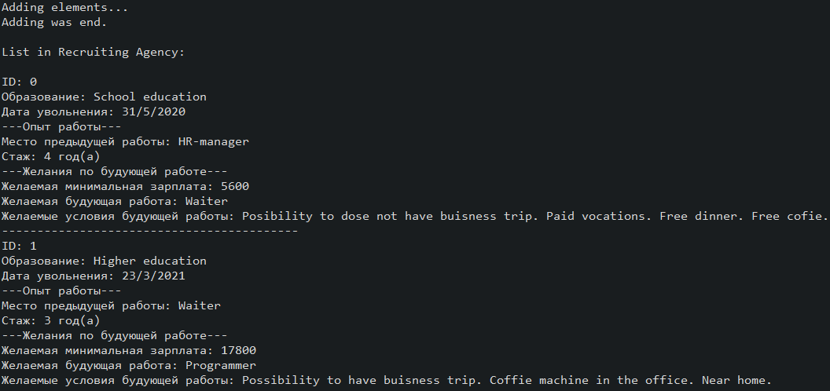
Рисунок 13.1 – Результат роботи програми у автоматичкому режимі
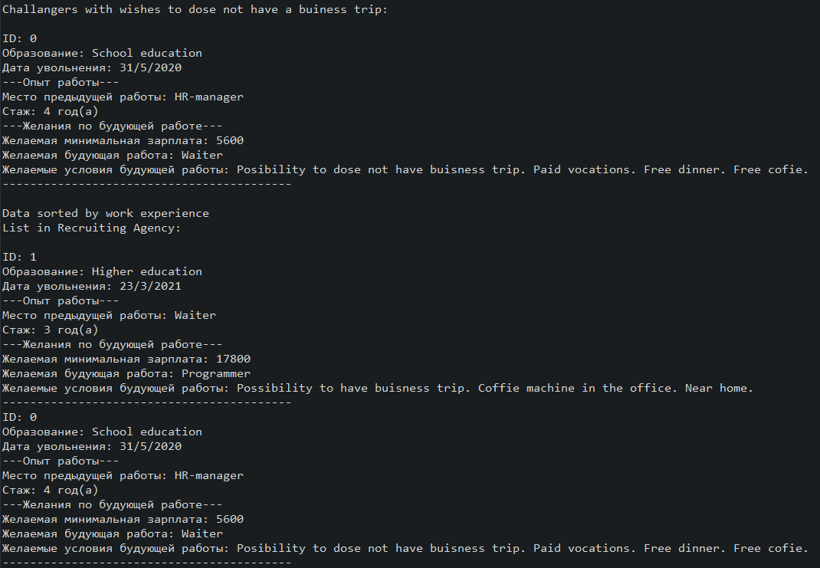
Рисунок 13.2 – Результат роботи програми у автоматичкому режимі
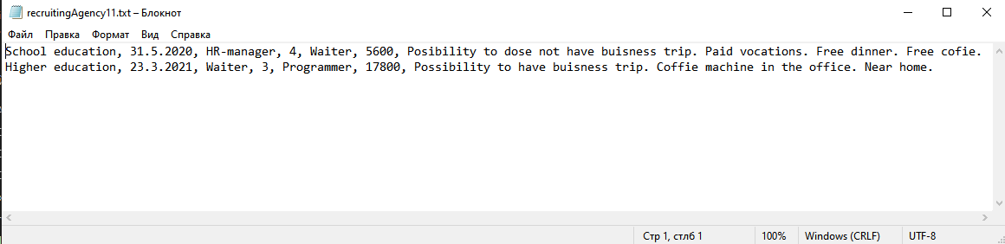
Рисунок 13.3 – Текстовий файл з претендентами
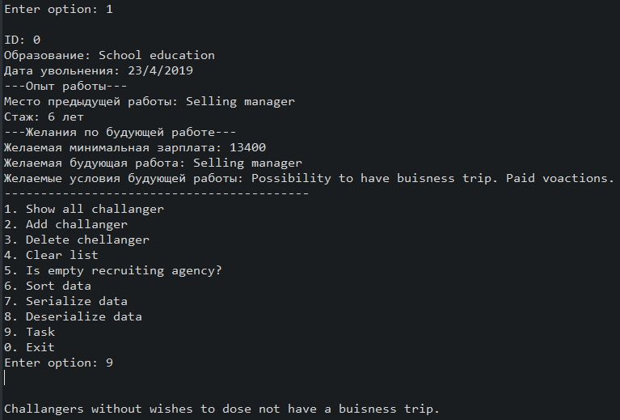
Рисунок 13.4 – Тестування пошуку претендента, котрий не бажає їздити у відрядження
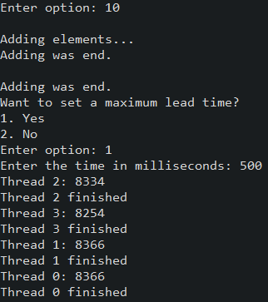
Рисунок 13.5 – Тестування потоків з прериванням

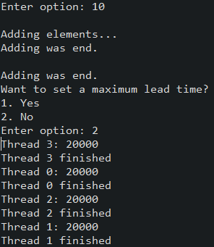
Рисунок 13.6 – Тестування потоків без преривання
Висновок
Під час виконання лабораторної роботи було набуто навички роботи з паралельною обробкою та багатопоточністю в середовищі Eclipse IDE.

