Лабораторна робота №15

Колекції в Java

Мета: Ознайомлення з бібліотекою колекцій Java SE. Використання колекцій для розміщення об'єктів розроблених класів.

- ВИМОГИ
- Розробити консольну програму для реалізації завдання обробки даних згідно прикладної області.
- Для розміщення та обробки даних використовувати контейнери (колекції) і алгоритми з Java Collections Framework.
- Забезпечити обробку колекції об'єктів: додавання, видалення, пошук, сортування згідно розділу Прикладні задачі л.р. №10.
- Передбачити можливість довготривалого зберігання даних: 1) за допомогою стандартної серіалізації; 2) не використовуючи протокол серіалізації.
- Продемонструвати розроблену функціональність в діалоговому та автоматичному режимах за результатом обробки параметрів командного рядка.
  - Розробник
- П.І.Б: Абдуллін О. Р.
- Группа: КІТ-119а
- Варіант: 1
- ОПИС ПРОГРАМИ
2.1 Засоби ООП:
Scanner inInt, inStr = new Scanner(System.in) – для введення обраних опцій користувачем з клавіатури;
XMLEncoder encoder = new XMLEncoder(new BufferedOutputStream(new FileOutputStream(filename));
encoder.writeObject(container); – нестандартна серіалізація;
XMLDecoder decoder = new XMLDecoder(new BufferedInputStream(new FileInputStream(filename)));
container = (ArrayList<Challanger>) decoder.readObject(); – нестандартна десеріалізація;
ObjectOutputStream oos = new ObjectOutputStream(new BufferedOutputStream(newFileOutputStream(filename)));
oos.writeObject(container);
oos.flush(); – стандартна серіалізація;
ObjectInputStream ois = new ObjectInputStream(new BufferedOutputStream(new FileInputStream(filename)));
container = (ArrayList<Challanger>) ois.readObject(); – стандартна десеріалізація;
Pattern pattern = Pattern.compile() – компілює регулярний вираз у шаблон;
Matcher matcher = pattern.matcher(data); – створює matcher, який буде відповідати даному вводу для цього шаблону.
  - Ієрархія та структура класів
Було створено класи Main (головний клас програми), Challanger (містить всі поля та методи предметної області «Кадрове агентство»), 3 класи, що реалізують інтерфейс Comparator для сортування за певними критеріями, а також підключено класи з попередньої роботи: DemandsToWork та WorkExperience.
2.3 Важливі фрагменти програми
Клас Main
package ua.khpi.oop.abdullin15;

import java.beans.XMLDecoder;
import java.beans.XMLEncoder;
import java.io.BufferedInputStream;
import java.io.BufferedOutputStream;
import java.io.File;
import java.io.FileInputStream;
import java.io.FileNotFoundException;
import java.io.FileOutputStream;
import java.io.ObjectInputStream;
import java.io.ObjectOutputStream;
import java.util.ArrayList;
import java.util.Collections;
import java.util.Comparator;
import java.util.List;
import java.util.Scanner;
import java.util.regex.Matcher;
import java.util.regex.Pattern;

import ua.khpi.oop.abdullin07.DemandsToWork;
import ua.khpi.oop.abdullin07.WorkExperience;

public class Main {

public static void main(String[] args) {
ArrayList<Challanger> recruitingAgency = new ArrayList<Challanger>();

for (String str : args) {
if(str.equals("-a") || str.equals("-auto")) {
recruitingAgency = auto(recruitingAgency);
return;
}
}
recruitingAgency = menu(recruitingAgency);
}

private static ArrayList<Challanger> auto(ArrayList<Challanger> recruitingAgency) {
System.out.println("Adding elements...");

File file = new File("recruitingAgency11.txt");

try {
String education;
int day;
int month;
int year;
String specializationPrevious;
int experience;
String specializationNext;
int minSalary;
String conditions;
Scanner reader = new Scanner(file);
while(reader.hasNextLine()) {
String data = reader.nextLine();
Pattern pattern = Pattern.compile("((\\w+(|\\s))*,\\s([1-9]|[12]\\d|3[01])\\.([1-9]|1[012])\\.((19|20)\\d{2}),\\s" +
"(\\w+.)+,\\s([0-9]|[1-6][0-9]),\\s(\\w+.)+,\\s([1-9]\\d{3,}),\\s(\\w+(\\.|\\s)(\\s|))+)");
Matcher matcher = pattern.matcher(data);
if(matcher.matches()) {
String[] information = data.split(",\\s");
education = information[0];
specializationPrevious = information[2];
experience = Integer.parseInt(information[3]);
specializationNext = information[4];
minSalary = Integer.parseInt(information[5]);
conditions = information[6];
String[] date = information[1].split("\\.");
day = Integer.parseInt(date[0]);
month = Integer.parseInt(date[1]);
year = Integer.parseInt(date[2]);

int id = recruitingAgency.size();

WorkExperience workExperienceAdd = new WorkExperience(specializationPrevious, experience);
DemandsToWork demandsToWorkAdd = new DemandsToWork(specializationNext,minSalary,conditions);
Challanger challangerAdd = new Challanger(id++,education,day,month,year,workExperienceAdd,demandsToWorkAdd);
recruitingAgency.add(challangerAdd);
}
}
reader.close();
System.out.println("Adding was end.\n");
} catch (FileNotFoundException e){
e.printStackTrace();
}

System.out.println("List in Recruiting Agency:\n");
if(recruitingAgency.size() > 0) {
for(var element : recruitingAgency) {
element.print();
}
}
else {
System.out.println("The recruiting agency is empty!\n");
}

task(recruitingAgency);

Comparator comp = new workExperienceComparator();
Collections.sort(recruitingAgency, comp);

System.out.println("Data sorted by work experience");

System.out.println("List in Recruiting Agency:\n");
if(recruitingAgency.size() > 0) {
for(var element : recruitingAgency) {
element.print();
}
}

return recruitingAgency;
}

private static ArrayList<Challanger> menu(ArrayList<Challanger> recruitingAgency) {
boolean endprog = false;
Scanner inInt = new Scanner(System.in);
Scanner inStr = new Scanner(System.in);
int menu;
int menuSort;
int menuSerialization;
int menuDeserialization;

while(!endprog)
{
System.out.println("1. Show all challanger");
System.out.println("2. Add challanger");
System.out.println("3. Delete chellanger");
System.out.println("4. Clear list");
System.out.println("5. Is empty recruiting agency?");
System.out.println("6. Sort data");
System.out.println("7. Serialize data");
System.out.println("8. Deserialize data");
System.out.println("9. Task");
System.out.println("0. Exit");
System.out.print("Enter option: ");
try
{
menu = inInt.nextInt();
}
catch(java.util.InputMismatchException e)
{
System.out.println("Error! Ошибка ввода.");
endprog = true;
menu = 0;
}
System.out.println();
switch(menu)
{
case 1:
if(recruitingAgency.size() > 0) {
for(var element : recruitingAgency) {
element.print();
}
}
else {
System.out.println("The recruiting agency is empty!\n");
}
break;
case 2:
String education;
int day;
int month;
int year;
String specializationPrevious;
int experience;
String specializationNext;
int minSalary;
String conditions;

Pattern patternEducation = Pattern.compile("(\\w+.)+");
Pattern patternDay = Pattern.compile("([1-9]|[12]\\d|3[01])");
Pattern patternMonth = Pattern.compile("([1-9]|1[012])");
Pattern patternYear = Pattern.compile("(19|20)\\d{2}");
Pattern patternSpeсialization = Pattern.compile("(\\w+.)+");
Pattern patternExperience = Pattern.compile("[0-9]|[1-6][0-9]");
Pattern patternMinSalary = Pattern.compile("(^[1-9]\\d{3,})");
Pattern patternConditions = Pattern.compile("(\\w+(\\.|\\s)(\\s|))+");

System.out.println("Enter education of challanger: ");
try {
education = inStr.nextLine();
education = stringRegexCheck(education, patternEducation);
}catch(java.util.InputMismatchException e) {
System.out.println("Error! Incorect input!");
break;
}

System.out.println("Enter day of dismissal: ");
try {
day = inInt.nextInt();
day = intRegexCheck(day, patternDay);
} catch(java.util.InputMismatchException e) {
System.out.println("Error! Incorect input!");
break;
}

System.out.println("Enter month of dismissal: ");
try {
month = inInt.nextInt();
month = intRegexCheck(month, patternMonth);
} catch(java.util.InputMismatchException e) {
System.out.println("Error! Incorect input!");
break;
}

System.out.println("Enter year of dismissal: ");
try {
year = inInt.nextInt();
year = intRegexCheck(year, patternYear);
} catch(java.util.InputMismatchException e) {
System.out.println("Error! Incorect input!");
break;
}

System.out.println("Enter pervious job: ");
try {
specializationPrevious = inStr.nextLine();
specializationPrevious = stringRegexCheck(specializationPrevious, patternSpeсialization);
} catch(java.util.InputMismatchException e) {
System.out.println("Error! Incorect input!");
break;
}

System.out.println("Enter experience of working: ");
try {
experience = inInt.nextInt();
experience = intRegexCheck(experience, patternExperience);
} catch(java.util.InputMismatchException e){
System.out.println("Error! Incorect input!");
break;
}

System.out.println("Enter next job: ");
try {
specializationNext = inStr.nextLine();
specializationNext = stringRegexCheck(specializationNext, patternSpeсialization);
} catch(java.util.InputMismatchException e) {
System.out.println("Error! Incorect input!");
break;
}

System.out.println("Enter min salary: ");
try {
minSalary = inInt.nextInt();
minSalary = intRegexCheck(minSalary, patternMinSalary);
}catch (java.util.InputMismatchException e) {
System.out.println("Error! Incorect input!");
break;
}

System.out.println("Enter whishes to the next job: ");
try {
conditions = inStr.nextLine();
conditions = stringRegexCheck(conditions, patternConditions);
} catch(java.util.InputMismatchException e){
System.out.println("Error! Incorect input!");
break;
}
int id = recruitingAgency.size();

WorkExperience workExperienceAdd = new WorkExperience(specializationPrevious, experience);
DemandsToWork demandsToWorkAdd = new DemandsToWork(specializationNext,minSalary,conditions);
Challanger challangerAdd = new Challanger(id++,education,day,month,year,workExperienceAdd,demandsToWorkAdd);
recruitingAgency.add(challangerAdd);
break;
case 3:
System.out.println("Enter ID to delete: ");
int id_to_remove = 0;
int delete = inInt.nextInt();
boolean isExist = false;
if(recruitingAgency.size() > 0) {
for(var element : recruitingAgency) {
if(element.getRegistrationNum() == delete) {
isExist = true;
break;
}
id_to_remove++;
}
if(isExist) {
recruitingAgency.remove(id_to_remove);
}
else
System.out.println("Error! Wrong ID.");
}
break;
case 4:
recruitingAgency.clear();
System.out.println("RecruitingAgency is empty now.\n");
break;
case 5:
if(recruitingAgency.isEmpty())
System.out.println("Recruiting agency is empty.\n");
else
System.out.println("Recruiting agency is not empty.");
break;
case 6:
System.out.println("1. Sort by Registration Number");
System.out.println("2. Sort by work experience");
System.out.println("3. Sort by demand to min salary");
System.out.println("4. Return to menu");
System.out.println("Enter option: ");
try
{
menuSort = inInt.nextInt();
}
catch(java.util.InputMismatchException e)
{
System.out.println("Error! Ошибка ввода.");
break;
}
switch(menuSort) {
case 1:
Comparator comp_id = new idComparator();
Collections.sort(recruitingAgency, comp_id);
System.out.println("Data sorted by Registration Number\n");
break;
case 2:
Comparator comp_work = new workExperienceComparator();
Collections.sort(recruitingAgency, comp_work);
System.out.println("Data sorted by work experience\n");
break;
case 3:
Comparator comp_min = new minSalazyComparator();
Collections.sort(recruitingAgency, comp_min);
System.out.println("Data sorted by demand to min salary");
break;
case 4:

break;
default:
System.out.println("Error! Wrong num in Sort menu.");
break;
}
break;
case 7:
String filenameSerialization;
String filenameXML;

System.out.println("1. Serialization");
System.out.println("2. XML serialization");
System.out.println("0. Exit serialization");
try
{
menuSerialization = inInt.nextInt();
}
catch(java.util.InputMismatchException e)
{
System.out.println("Error! Ошибка ввода.");
menuSerialization = 0;
}
switch(menuSerialization)
{
case 1:
System.out.println("\nEnter file name: ");
filenameSerialization = inStr.nextLine();
if (filenameSerialization.indexOf(".ser") == -1) {
filenameSerialization += ".ser";
}
try(ObjectOutputStream oos = new ObjectOutputStream(new BufferedOutputStream(new FileOutputStream (filenameSerialization)))){
oos.writeObject(recruitingAgency);
System.out.println("Serialization successful.");
} catch (Exception e){
System.out.println(e.getMessage());
}
break;
case 2:
System.out.print("Enter XML filename: ");
filenameXML = inStr.nextLine();
if (filenameXML.indexOf(".xml") == -1)
filenameXML += ".xml";
try(XMLEncoder encoder = new XMLEncoder(new BufferedOutputStream(new FileOutputStream (filenameXML)))){
encoder.writeObject(recruitingAgency);
System.out.println("Serialization successful.");
} catch (Exception e){
System.out.println(e.getMessage());
}
break;
case 0:
break;
default:
System.out.println("Error! Wrong num in menu.");
break;
}
break;
case 8:
String filenameDeserialization;

System.out.println("1. Deserialization");
System.out.println("2. XML deserialization");
System.out.println("0. Exit deserialization");
try
{
menuDeserialization = inInt.nextInt();
}
catch(java.util.InputMismatchException e)
{
System.out.println("Error! Ошибка ввода.");
menuDeserialization = 0;
}
switch(menuDeserialization)
{
case 1:
System.out.println("\nEnter file name: ");
filenameDeserialization = inStr.nextLine();
if (filenameDeserialization.indexOf(".ser") == -1) {
filenameDeserialization += ".ser";
}
try(ObjectInputStream ois = new ObjectInputStream(new BufferedInputStream(new FileInputStream (filenameDeserialization)))){
recruitingAgency.clear();
recruitingAgency = (ArrayList<Challanger>) ois.readObject();
System.out.println("Deserialization successful.");
} catch (Exception e){
System.out.println(e.getMessage());
}
break;
case 2:
System.out.print("Enter XML filename: ");
filenameDeserialization = inStr.nextLine();
if (filenameDeserialization.indexOf(".xml") == -1)
filenameDeserialization += ".xml";
try(XMLDecoder decoder = new XMLDecoder(new BufferedInputStream(new FileInputStream (filenameDeserialization)))){
recruitingAgency.clear();
recruitingAgency = (ArrayList<Challanger>) decoder.readObject();
System.out.println("Deserialization successful.");
} catch (Exception e){
System.out.println(e.getMessage());
}
break;
case 0:
break;
default:
System.out.println("Error! Wrong num in menu.");
break;
}
break;
case 9:
task(recruitingAgency);
break;
case 0:
endprog = true;
recruitingAgency.clear();
inInt.close();
inStr.close();
break;
default:
System.out.println("Error! Wrong num in menu.");
break;
}
}
return recruitingAgency;
}
public static int intRegexCheck(int value, Pattern pattern)
{
Matcher matcher;
Scanner in = new Scanner(System.in);
boolean ready = false;
do
{
matcher = pattern.matcher(Integer.toString(value));
if(!matcher.matches())
{
System.out.println("You've entered the wrong data. Try again:");
value = in.nextInt();
}
else
ready = true;
}
while(!ready);
return value;
}

public static String stringRegexCheck(String value, Pattern pattern)
{
Matcher matcher;
Scanner in = new Scanner(System.in);
boolean ready = false;
do
{
matcher = pattern.matcher(value);
if(!matcher.matches())
{
System.out.println("You've entered the wrong data. Try again:");
value = in.nextLine();
}
else
ready = true;
}
while(!ready);
return value;
}
public static void task(List<Challanger> recruitingAgency) {
String conditions;
String prevJob;
Pattern patternManager = Pattern.compile(".*(M|m)anager.*");
Pattern patternNot = Pattern.compile(".*(N|n)ot.*");
Pattern patternBuisnessTrip = Pattern.compile(".*(B|b)uisness trip.*");
ArrayList<Challanger> task = new ArrayList<Challanger>();

if(recruitingAgency.size() > 0) {
for(var element : recruitingAgency) {
conditions = element.getDemandsToWork().getConditions();
prevJob = element.getWorkExperience().getSpecialization();
Matcher matcher = patternManager.matcher(prevJob);
if(matcher.matches()) {
Matcher matcherNot = patternNot.matcher(conditions);
if(matcherNot.matches()) {
Matcher matcherBuisnessTrip = patternBuisnessTrip.matcher(conditions);
if(matcherBuisnessTrip.matches()) {
task.add(element);
}
}
}
}
}
if(task.size() > 0) {
System.out.println("\nChallangers with wishes to dose not have a buiness trip:\n");
for(var challanger : task) {
challanger.print();
}
System.out.println();
}
else {
System.out.println("\nChallangers without wishes to dose not have a buisness trip.\n");
}
}
}

Класс Challanger
package ua.khpi.oop.abdullin15;

import java.io.Serializable;
import java.util.Comparator;
import java.util.Comparator;

import ua.khpi.oop.abdullin07.DemandsToWork;
import ua.khpi.oop.abdullin07.WorkExperience;

public class Challanger implements Serializable {
private static final long serialVersionUID = -5616690429713031285L;

private int registrationNum;
private String education;
private int dismissalDay;
private int dismissalMonth;
private int dismissalYear;
private DemandsToWork demandsToWork;
private WorkExperience workExperience;

/**
* Конструктор
* @param registrationNum ID претндента
* @param education образование претендента
* @param dismissalDay день увольнения претендента
* @param dismissalMonth месяц увольнения претендента
* @param dismissalYear год увольнения претендента
* @param workExperience опыт работы претендента
* @param demandsToWork пожелания к будующей работе
*/
public Challanger(int registrationNum, String education, int dismissalDay, int dismissalMonth, int dismissalYear, WorkExperience workExperience, DemandsToWork demandsToWork ) {
this.registrationNum = registrationNum;
this.education = education;
this.dismissalDay = dismissalDay;
this.dismissalMonth = dismissalMonth;
this.dismissalYear = dismissalYear;
this.workExperience = workExperience;
this.demandsToWork = demandsToWork;
}
public Challanger()
{
super();
}
/**
* Геттер ID претендента
* @return ID претендента
*/
public int getRegistrationNum() {
return registrationNum;
}
/**
* Сеттер ID претендента
* @param registrationNum ID претендента
*/
public void setRegistrationNum(int registrationNum) {
this.registrationNum = registrationNum;
}
/**
* Геттер образования претендента
* @return образование претендента
*/
public String getEducation() {
return education;
}
/**
* Сеттер образования претендента
* @param education Образование претендента
*/
public void setEducation(String education) {
this.education = education;
}
/**
* Геттер дня увольнения
* @return день увольнения
*/
public int getDismissalDay() {
return dismissalDay;
}
/**
* Сеттер дня увольнеия
* @param dismissalDay день увольнения
*/
public void setDismissalDay(int dismissalDay) {
this.dismissalDay = dismissalDay;
}
/**
* Геттер месяца увольнеия
* @return месяц увоьнения
*/
public int getDismissalMonth() {
return dismissalMonth;
}
/**
* Сеттер месяца увольнения
* @param dismissalMonth месяц увольнения
*/
public void setDismissalMonth(int dismissalMonth) {
this.dismissalMonth = dismissalMonth;
}
/**
* Геттер года увольнения претендента
* @return год увольнения
*/
public int getDismissalYear() {
return dismissalYear;
}
/**
* Сеттер года увольнения претендента
* @param dismissalYear год увольнения
*/
public void setDismissalYear(int dismissalYear) {
this.dismissalYear = dismissalYear;
}
/**
* Геттер опыта работы претендента
* @return
*/

/**
* Геттер требований к будующей работе
* @return
*/
public DemandsToWork getDemandsToWork() {
return demandsToWork;
}
public WorkExperience getWorkExperience() {
return workExperience;
}
public void setWorkExperience(WorkExperience workExperience) {
this.workExperience = workExperience;
}
/**
* Сеттер требований к будующей работе
* @param demandsToWork
*/
public void setDemandsToWork(DemandsToWork demandsToWork) {
this.demandsToWork = demandsToWork;
}

public void print() {
System.out.println("ID: " + getRegistrationNum());
System.out.println("Образование: " + getEducation());
System.out.println("Дата увольнения: " + getDismissalDay()+"/" + getDismissalMonth()+"/"+getDismissalYear());
System.out.println("---Опыт работы---");
System.out.println("Место предыдущей работы: " + getWorkExperience().getSpecialization());
if(getWorkExperience().getExperience() <= 4)
System.out.println("Стаж: " + getWorkExperience().getExperience() + " год(а)");
else
System.out.println("Стаж: " + getWorkExperience().getExperience() + " лет");
System.out.println("---Желания по будующей работе---" );
if(getDemandsToWork().getMinSalary() == 0 && getDemandsToWork().getSpecialization() == null && getDemandsToWork().getConditions() == null)
System.out.println("Предендет не имеет никаких желаний по будующей работе");
else {
if(getDemandsToWork().getMinSalary() != 0)
System.out.println("Желаемая минимальная зарплата: " + getDemandsToWork().getMinSalary());
else
System.out.println("Желаемая минимальная зарплата: Претендент не имеет пожеланий к этому пунку " );
if(getDemandsToWork().getSpecialization() != null)
System.out.println("Желаемая будующая работа: " + getDemandsToWork().getSpecialization());
else
System.out.println("Желаемая будующая работа: Претендент не имеет пожеланий к этому пунку");
if(getDemandsToWork().getConditions() != null)
System.out.println("Желаемые условия будующей работы: " + getDemandsToWork().getConditions());
else
System.out.println("Желаемые условия будующей работы: Претендент не имеет пожеланий к этому пунку");
}
System.out.println("------------------------------------------");

}
}

class idComparator implements Comparator<Challanger>{
@Override
public int compare(Challanger o1, Challanger o2) {
if(o1.getRegistrationNum() > o2.getRegistrationNum())
return 1;
else if (o1.getRegistrationNum() < o2.getRegistrationNum())
return -1;
else
return 0;
}
}

class workExperienceComparator implements Comparator<Challanger>{
public int compare(Challanger o1, Challanger o2) {
if(o1.getWorkExperience().getExperience() > o2.getWorkExperience().getExperience())
return 1;
else if (o1.getWorkExperience().getExperience() < o2.getWorkExperience().getExperience())
return -1;
else
return 0;
}
}

class minSalazyComparator implements Comparator<Challanger>{
@Override
public int compare(Challanger o1, Challanger o2) {
if(o1.getDemandsToWork().getMinSalary() > o2.getDemandsToWork().getMinSalary())
return 1;
else if (o1.getDemandsToWork().getMinSalary() < o2.getDemandsToWork().getMinSalary())
return -1;
else
return 0;
}

}

3 Результати роботи програми
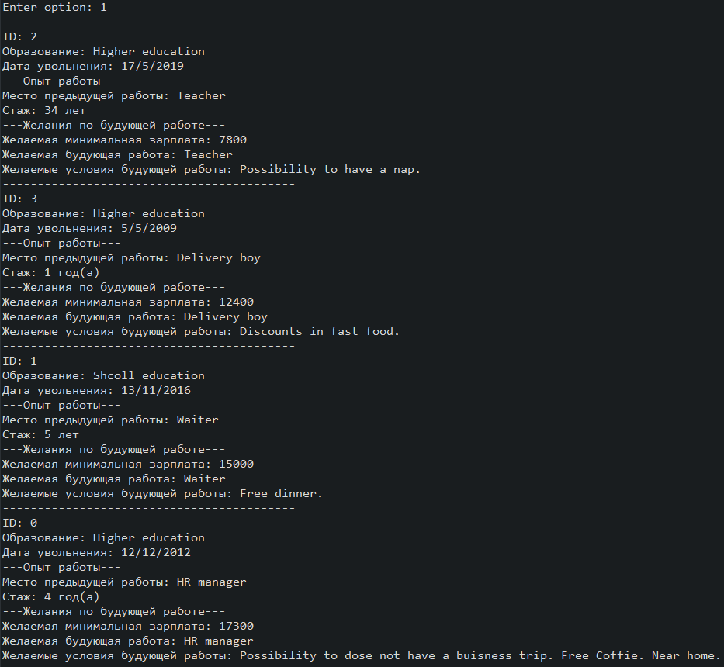
Рисунок 15.1 – Результат виводу
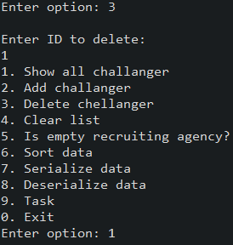
Рисунок 15.2 – Операція видалення елемента
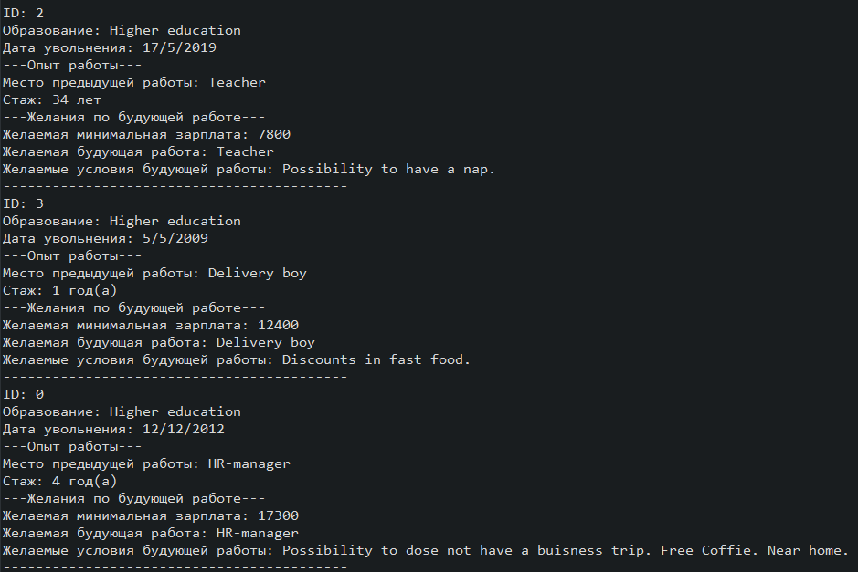
Рисунок 15.3 – Результат видалення
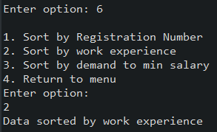
Рисунок 15.4 – Операція сортування за досвідом роботи
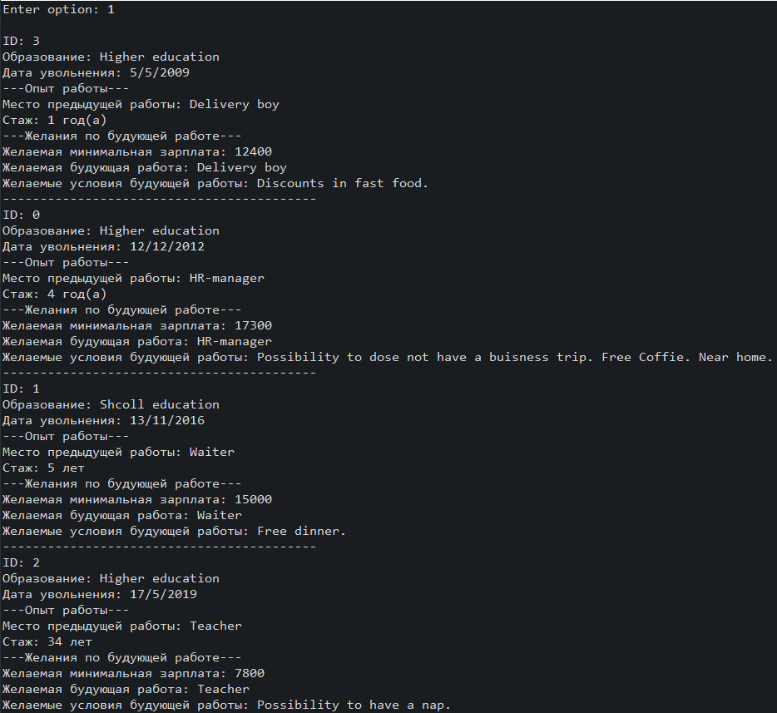
Рисунок 15.4 – Результат сортування за досвідом роботи
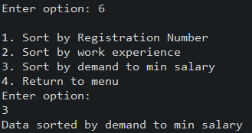
Рисунок 15.5 – Операція сортування за мінімальною зарплатнею
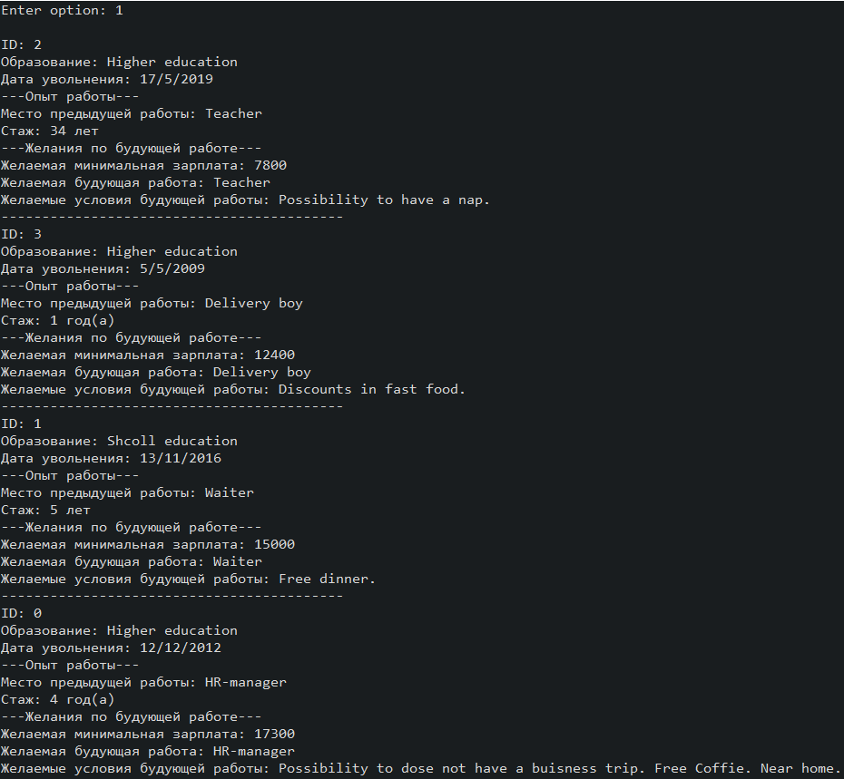
Рисунок 15.6 – Результат сортування за мінімальною заралатнею
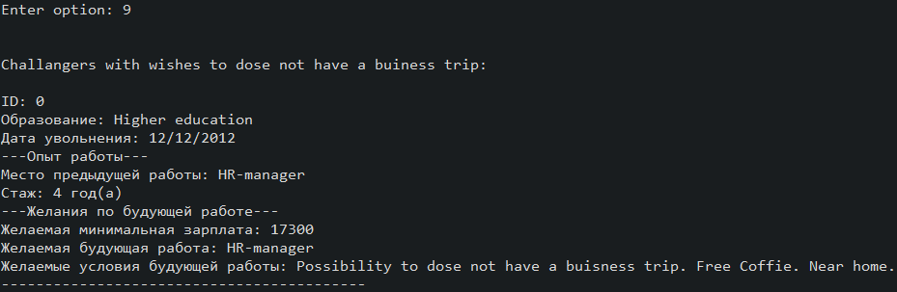
Рисунок 15.7 – Результат виконання завдання з 12 Лабораторної роботит
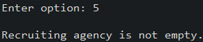
Рисунок 15.8 – Результат перевірки контейнера на наявність елементів
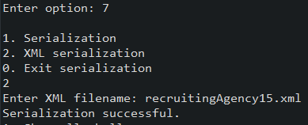
Рисунок 15.9 – Результат виконання серіалізації
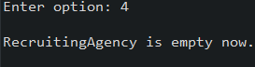
Рисунок 15.10 – Результат очищення контейнера
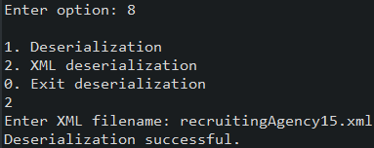
Рисунок 15.11 – Виконання десеріалізації

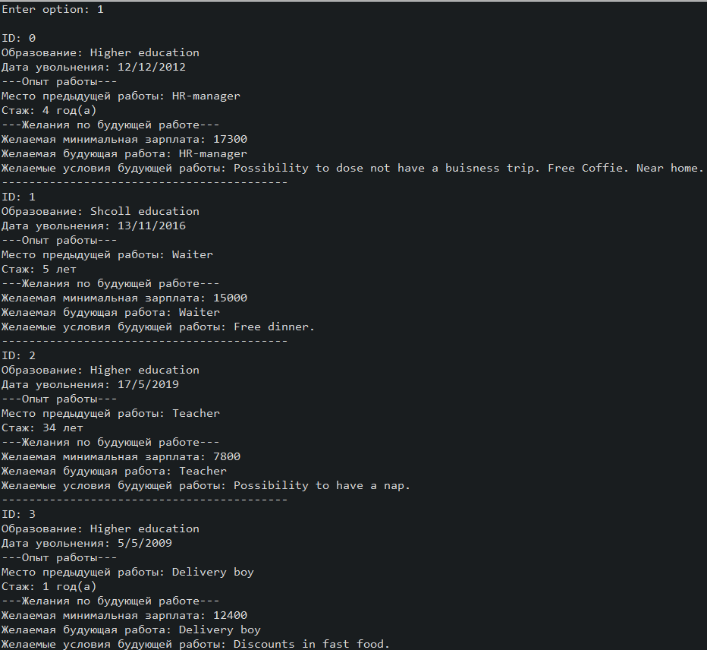
Рисунок 15.12 – Результат виконання десеріалізації
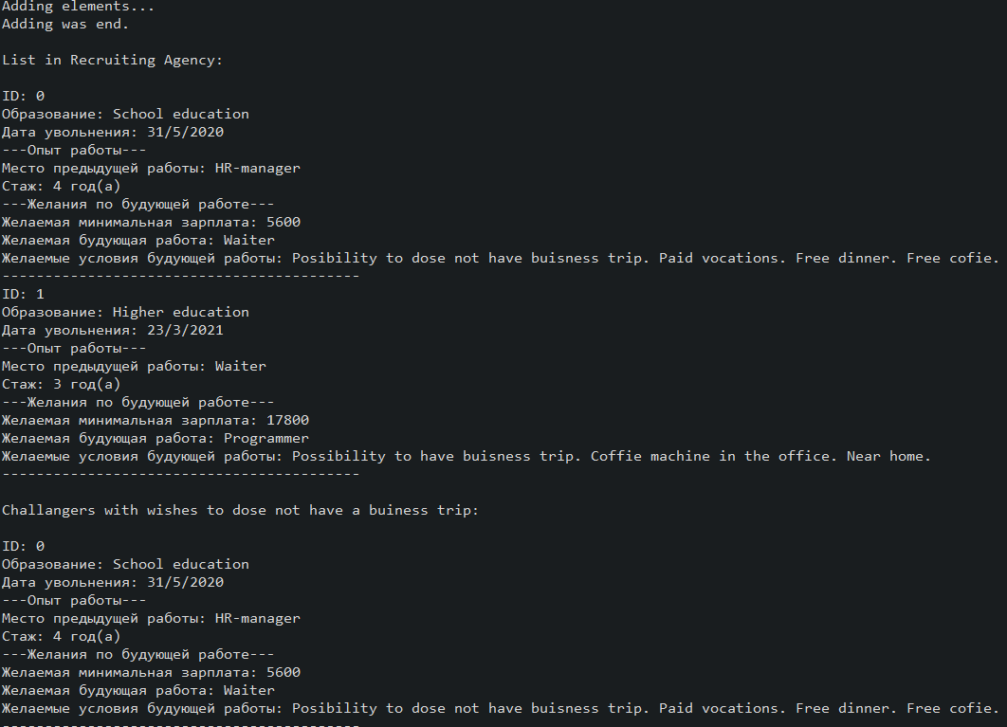
Рисунок 15.14 – Виконання програми у автоматичному режимі
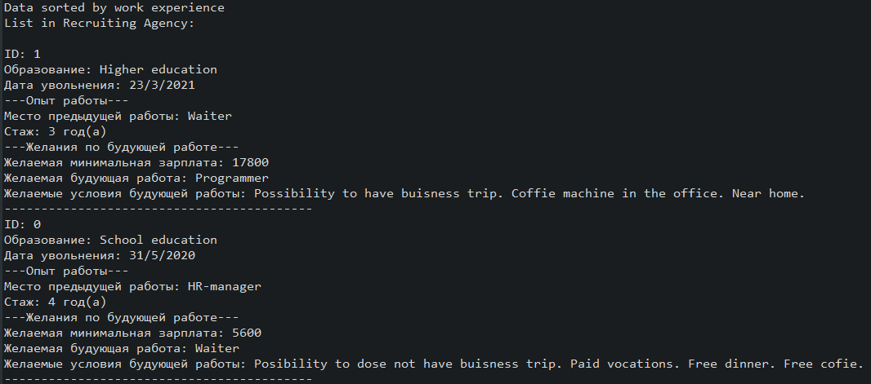
Рисунок 15.15 – Результат виконання програми у автоматичному режимі
Висновок
Під час виконання лабораторної роботи було набуто навички роботи з колекціями та їх обробкою в середовищі Eclipse IDE.

