Advanced Web Application Security Labs

CIP-B101 Basic Computer Skills For Digital Forensics

Lab1A Digital Forensics Fundamentals

Abdulmalik Isah Gaya

C11/26/FCDF/17171

VM hostname: Kali

November 4, 2026

A1. Capture basic system specification
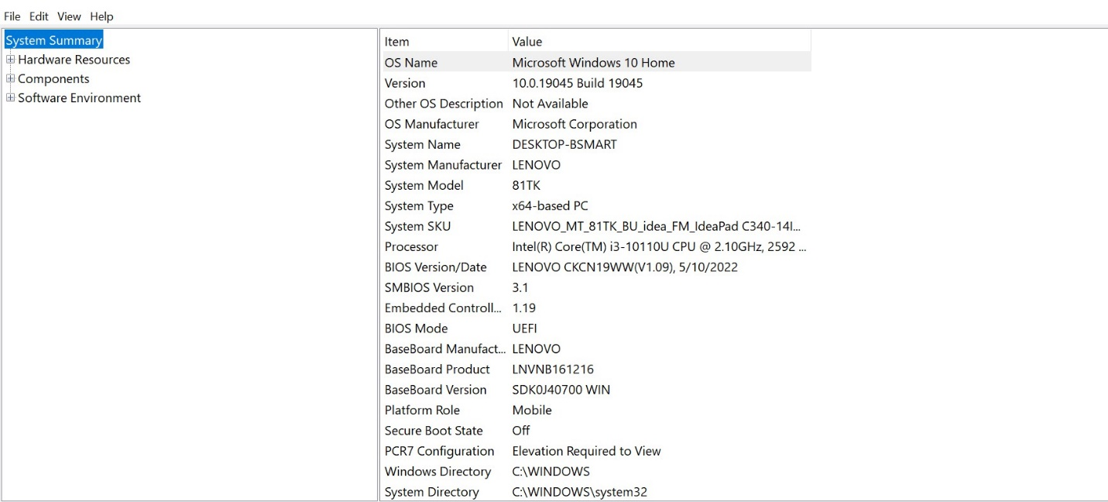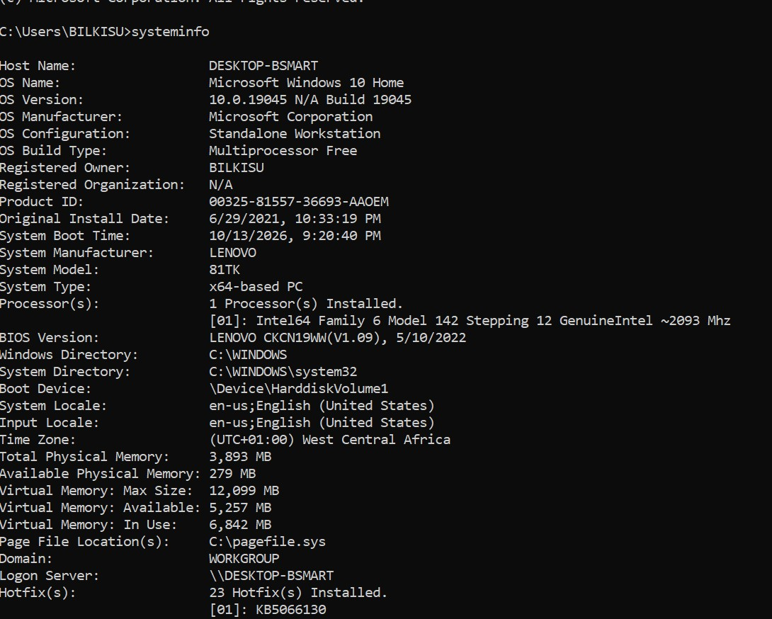
After typing window +R I used the command msinfo32 to check the basics information and I also typed systeminfo in the command line to check the info.
A2. Capture storage information
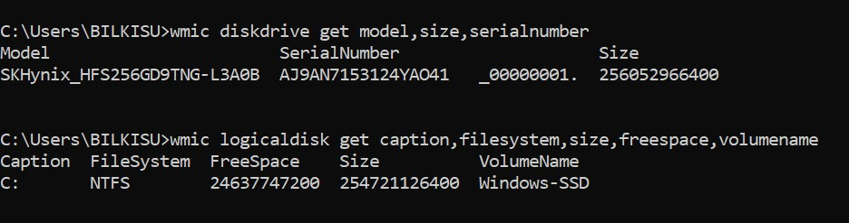
I check the storage model,size,partition,and filesystem.
A3. Map evidence sources to system layers
Layer / Source | Example Evidence | Where It May Be Found | Why It Matters
User layer | Opened files, searched terms, typed usernames | Recent files, browser history, shell history | Links user action to system activity
Application layer | Office document metadata, browser cache, chat logs | Application folders and databases | Shows what software created or used evidence
OS layer | Event logs, installed programs, user profiles | Windows logs, registry, Linux /var/log | Shows system events and account activity
Disk layer | Deleted files, file fragments, partitions | File system and unallocated space | Supports recovery and timeline analysis
Memory/process layer | Running malware, PIDs, network connections | RAM capture, process list | Shows live system behavior
Evedence exists in more than one action triggers many systems at once. When a user opens a file the application saves metadata , the OS writes an event log and updates the registry and recent files, the disk stores the file contents, and memory holds the running process.

Part B - Program, Process and Thread Investigation
This section links the slide concept of program, process, and thread to forensic observation.
B1. Observe running processes
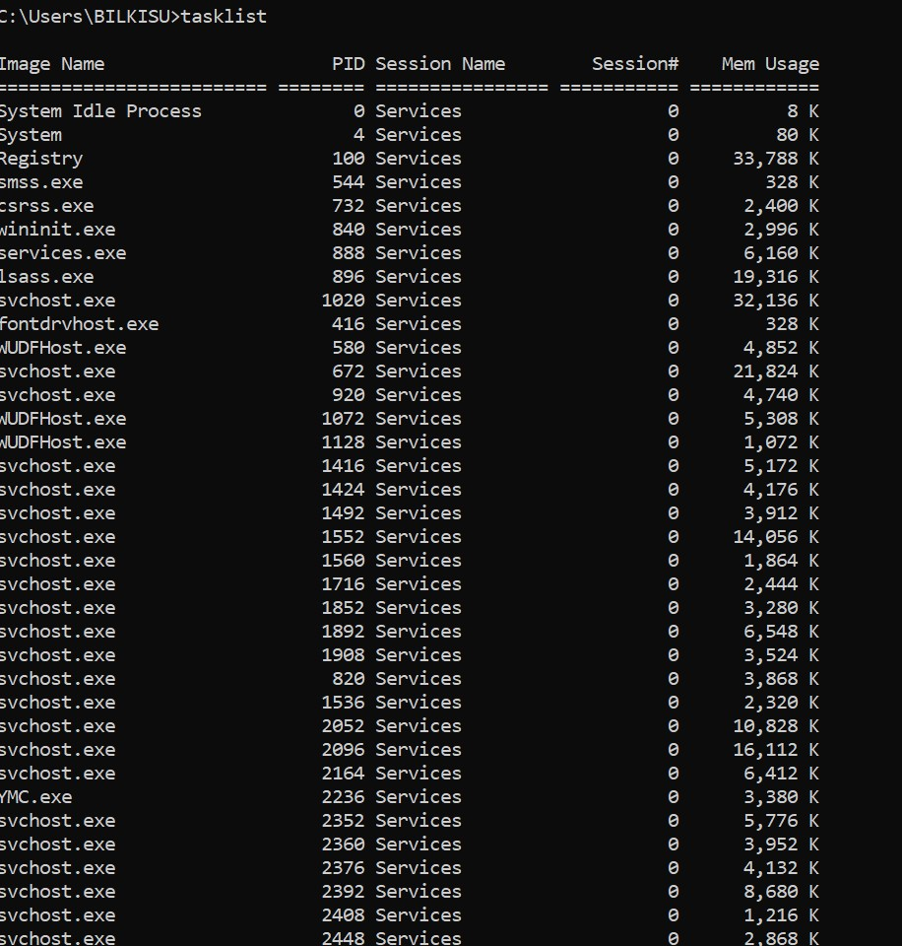
I used windows command prompt to to view the list of process running.
These are the 3 process and there PIDs:
Names PID
Services.exe 888
Registry 100
Smss.exe 544

B2. Explain the difference
1.A program is just file sitting on the disk doing nothing. And A process is a program that’s currently running. While Thread is a small worker inside a process.one process can have many threads doing different jobs at the same time.
2.Process information is useful because malware must run to do harm, when it runs it becomes a process and leaves live evidence that is not on disk.

Part C - Disk Sector and Disk Size Calculation
C1. Reproduce the slide calculation
Item | Formula / Value | Answer
Total sectors | 400 x 12 x 17000 | 81,600,000 sectors
Total bytes | 81,600,000 x 512 | 41,779,200,000 bytes
Kilobytes | 41,779,200,000 / 1024 | 40,800,000 KB
Megabytes | 40,800,000 / 1024 | 39,843.75 MB
Gigabytes | 39,843.75 / 1024 | 38.91 GB
1.Total sectors = 400 x 12 = 4800, then 4800 x 17000 = 81,600,000
2.Total bytes = 81,600,000 x 512 = 41,779,200,000
3.KB = 41,799,200,000 / 1024 = 40,800,000
4.MB = 40,800,000 / 1024 = 39,843.75
5.GB = 39,843.75 / 1024 = 39.91GB

C2. Calculate your own disk or partition size
Partition 1: /dev/sda1 start sector: 2048 end sector:167968749 number of sector:167966702 sector size512 file system: ext4(linux,id83)

Calculations for /dev/sda1
1.Total sectors = 167,966,702 x 512 = 85,998,951,424 bytes
2.Kilobytes = 85,998,951,424 /1024 = 83,983,351KB
3.Megabytes = 83,983,351 /1024 = 82,014.99 MB
4.Gigabytes = 82,014.99 /1024 = 80.09GB

Part D - Safe Partition Table Inspection
Choose either Windows or Linux. You may do both for extra practice. You must not modify the disk.
D1. Windows method - Disk Management, PowerShell and DiskPart

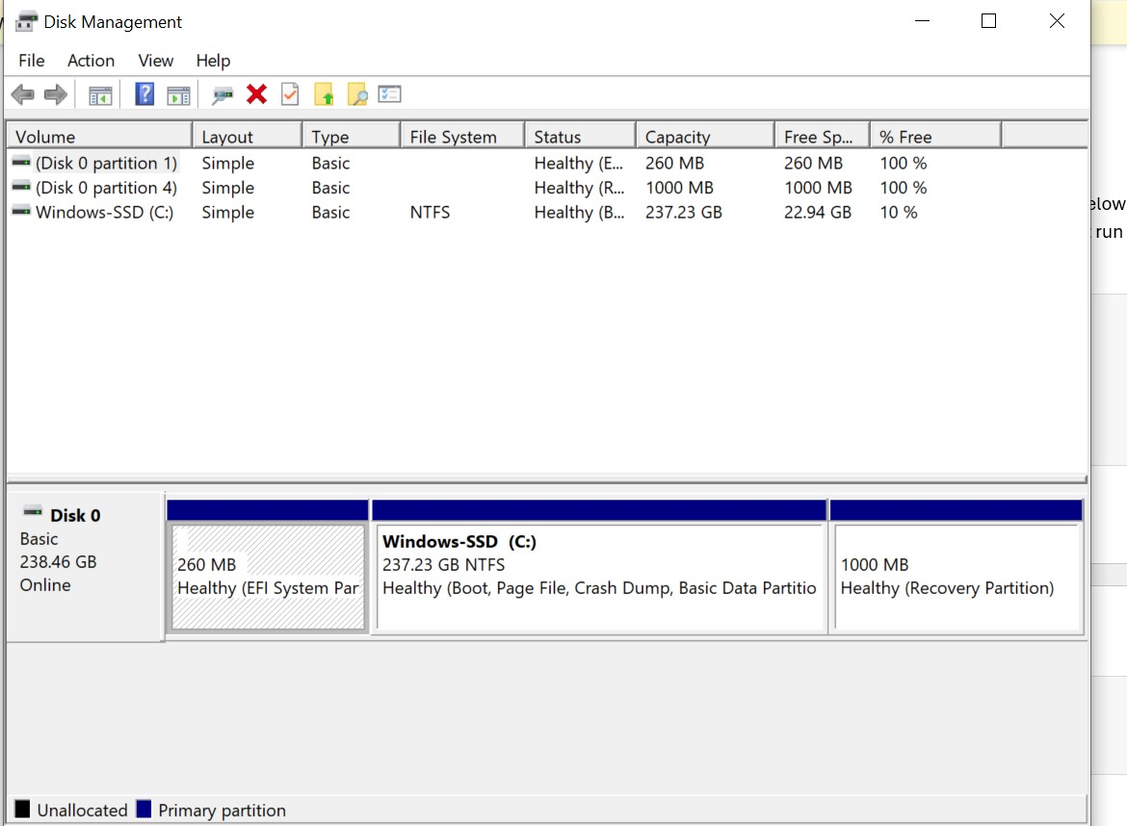
I typed this command diskmgmt.msc to view the layout and visible partitions.
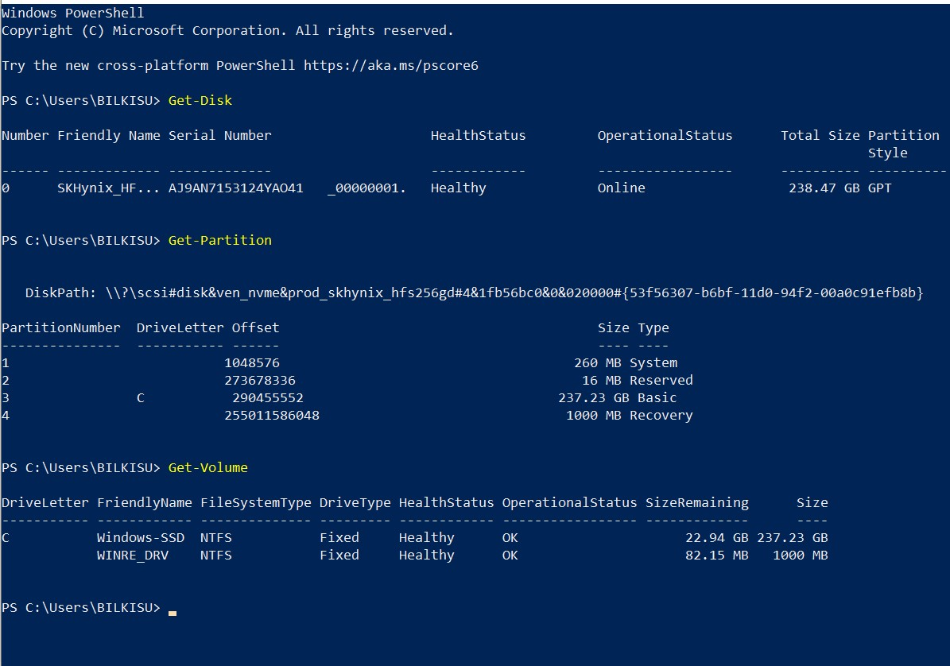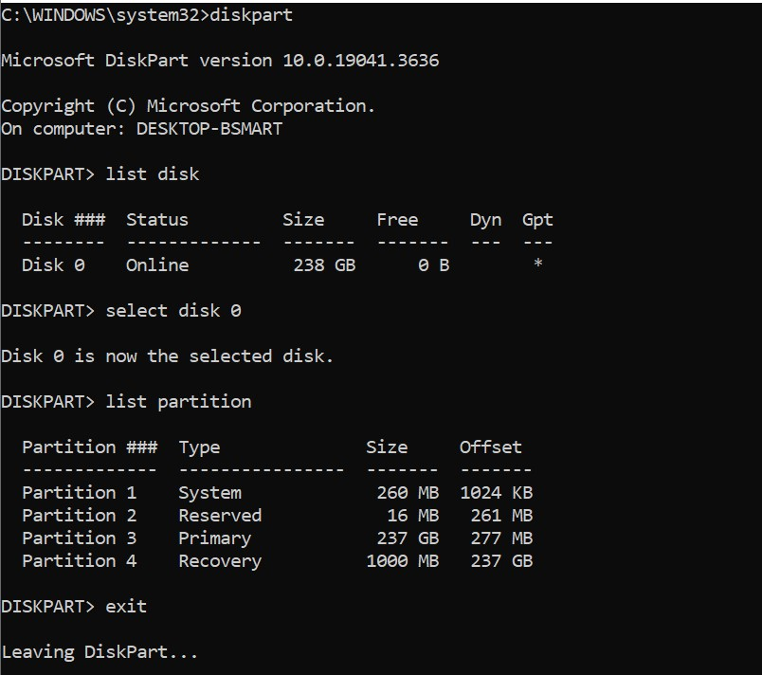

D2. Linux/Kali method - read-only inspection
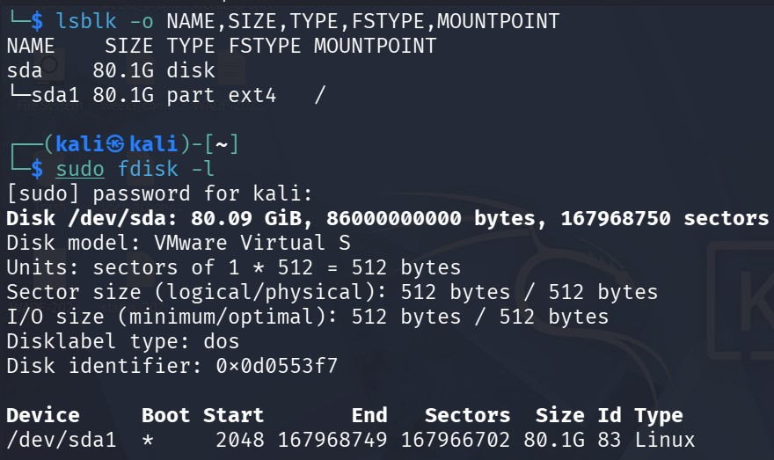
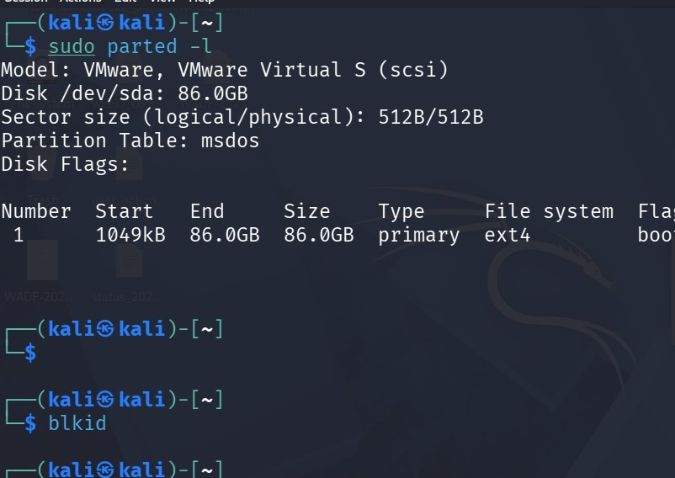
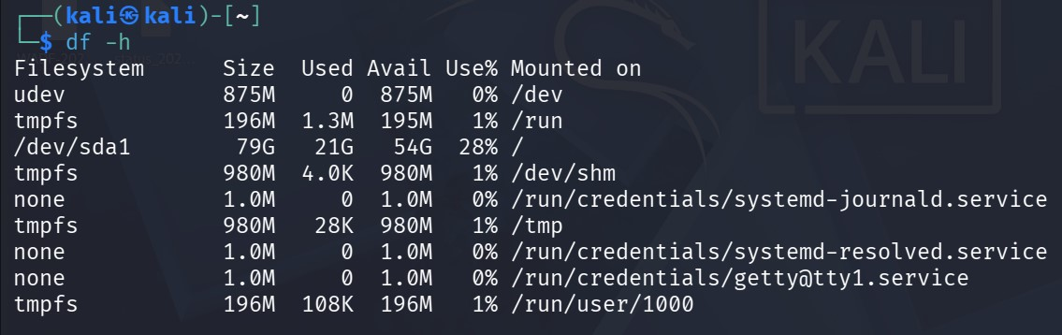

Part E - MBR, GPT and Boot Process Explanation
E1. Explain the boot process
Create a simple flow diagram or numbered list explaining how a PC boots.
Your explanation must include power-on, POST, BIOS/UEFI, CMOS/firmware settings, MBR/GPT or EFI boot records, boot loader/manager, kernel loading, and operating system control.
State whether your own system uses BIOS/Legacy or UEFI based on system information evidence.
Stage | What Happens | Forensic Relevance
Power-on and POST | Hardware is initialized and checked. | Hardware failure or tampering may affect evidence access.
BIOS/UEFI firmware | Boot device order and firmware settings are applied. | Boot mode can explain partition style and boot artifacts.
MBR/GPT or EFI boot | System locates bootable partition or EFI boot entry. | Boot records may contain evidence of boot configuration.
Boot loader/manager | OS selection and pre-kernel loading occurs. | May show multi-boot or hidden OS behavior.
Kernel and OS control | Operating system fully starts. | Logs and user activity begin to accumulate.
My System Evidence:
*Disk label type: dos
* Disk: /dev/sda: 80.90 Gib
*Device /dev/sda1_ Boot
My system uses BIOS/Legacy+MBR
The dos = MBR partition table. While UEFI systems use gpt disklabel. And my disk also has a Boot flag on /dev/sda1, which is MBR boot style.

Boot Process – Flow Diagram
- Power-on
- POST(Power-On Self Test)
- BIOS / UEFI Firmware + CMOS Settings
- MBR / GPT or EFI Boot Record us read
- Boot Loader / Boot Manager (GRUB)
- Kernel Loading
- Operating System Control
1.Power-on and POST
When power button is pressed, CPU starts. Post checks hardware – RAM,CPU,Keyboard,disk. If hardware fails,it beeps and stops. No OS yet.
2. BIOS/UEFI Firmware + CMOS:
BIOS or UEFI firmware runs from motherboard chip. It reads CMOS settings boot device order, date/time, secure boot. My system uses BIOS/Legacy.
3. MBR/GPT or EFI Boot Records:
BIOS looks at first sector of disk - Sector 0. For my system, this is MBR (Master Boot Record, 512 bytes). It contains partition table + boot code. It finds which partition is bootable - my /dev/sda1 with flag. UEFI systems instead look for EFI System Partition and GPT.

4. Boot Loader / Manager:
MBR loads the Boot Loader - on Kali Linux this is GRUB. GRUB shows OS selection menu and allows multi-boot. It loads pre-kernel files.

5. Kernel Loading:
GRUB loads the Linux Kernel (vmlinuz) into memory. Kernel takes control of CPU, memory, drivers.

6. Operating System Control:
Kernel starts systemd, mounts / partition (/dev/sda1 ext4), starts services, login screen appears. From now, logs and user activity begin to accumulate.
E2. Compare MBR and GPT

Age / Design Older partitioning system from the 1980s Modern partitioning
system used with UEFI systems
Size Limitation Commonly limited to about 2 TB Supports very large disks,
slides note up to about 9.4 ZB
Partition Information Partition table is stored in the first sector with
boot code Uses primary and backup GPT headers and partition entries
Forensic Issue Critical information in sector 0; damage can affect
partition interpretation Backup structures may help recovery and validation.
My Interpretation:
MBR keeps everything in Sector 0 only, so if Sector 0 is wiped, we lose
the partition map. GPT keeps a primary header at the start AND a backup
header at the end, so even if one is damaged, the other can recover the
layout.
Part F - File System Identification and Interpretation
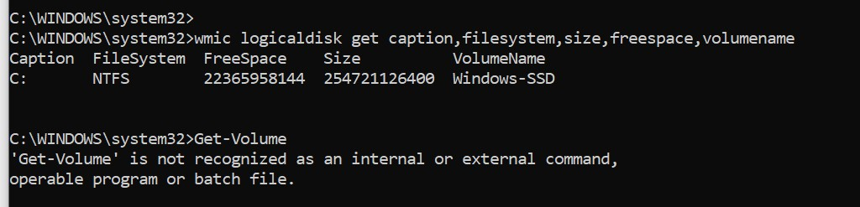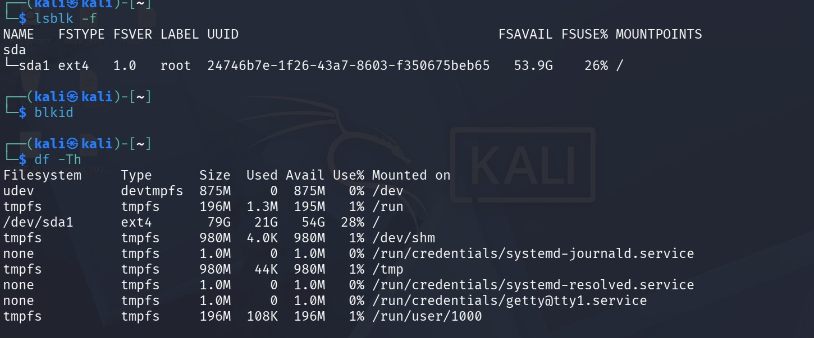
File System Reference Table:
File System Common OS / Usage Forensic Importance
FAT/FAT32 Removable media and older systems Simple structure; often used on
USB drives
NTFS Modern Windows systems Includes metadata such as MFT entries,
timestamps, permissions, and journals
ext family Linux systems Uses inode based metadata and supports forensic
timeline analysis
XFS/JFS/btrfs Linux/Unix-like systems Advanced features may affect recovery
and metadata interpretation
HFS+ Older macOS systems Important in Mac forensic investigations; slide
notes date support limitations
My Real Evidence:
Volume / Partition File System Size (OS Reported) Free Space Volume Name /
Mount Evidence Screenshot
Partition 1 - Windows C: NTFS 254,721,126,400 bytes 22,365,958,144
Partition 2 - Linux /dev/sda1 ext4 79G (in df -Th) / 80.1G (in
fdisk -l) 53.9G avail / 54G avail / (root), LABEL=3Droot
Partition 2b - Linux tmpfs tmpfs 980M / 196M RAM-based /run,
/tmp, /dev/shm df -Th output
Linux Details from my screenshot:
lsblk -f: sda1 ext4 1.0 root UUID 24746b7e-1f26-43a7-8603-f350675beb65
FSAVAIL 53.9G FSUSE% 26% MOUNTPOINT /
df -Th: /dev/sda1 ext4 79G 21G 54G 28% /

Windows Note: Get-Volume gave error in CMD because it is a PowerShell
command, not CMD. wmic worked and is the valid evidence.

Why File System is Important in Digital Forensics (copy this):
File system is important because it decides how files are stored, how
metadata is kept, how deletion works, and how recovery is possible. NTFS
keeps MFT entries, timestamps, permissions and a journal, so even deleted
files leave MFT traces. ext4 keeps inode based metadata and a journal, so
we can do timeline analysis and recover deleted inodes. FAT32 has no
journal and no permissions, so timestamps are less reliable. If I don't
know the file system, I will use the wrong tool and misinterpret
timestamps, deleted files, and hidden data. That is why I must identify the
file system first before imaging or analysis.

Part G - Final Practical Assignment
Formula used:
Size in GB = Sectors x 512 / 1024 / 1024 / 1024

---

Partition 1 - Windows C: (NTFS)
Task Required Evidence Student Notes / Answer
Identify partition 1 Screenshot of partition table and command output wmic logical disk get caption, filesystem, size, free space, volume name - Screenshot: Win_file_identification.jpg - Shows `C: NTFS 254721126400 bytes, Volume Name Windows-SSD
Record partition 1 sector count Start sector, end sector or sector count Size from wmic = 254,721,126,400 bytes. Sector count = 254,721,126,400 / 512 = 497,500,246 sectors, Sector size = 512 bytes
Calculate partition 1 size Formula and result in GB 254,721,126,400 / 1024 / 1024 / 1024 = 237.23 GiB = 254.72 GB (decimal)

Partition 2 - Linux /dev/sda1 (ext4)
Task Required Evidence Student Notes / Answer
Identify partition 2 Screenshot of partition table and command output sudo fdisk -l + lsblk -f + df -Th - Screenshot: Linux_file_identification.jpg - Shows /dev/sda1 ext4 /
Record partition 2 sector count Start sector, end sector or sector count Start = 2048, End = 167968749, Sector count = 167966702, Sector size = 512 bytes
Calculate partition 2 size Formula and result in GB 167,966,702 x 512 = 85,998,951,424 bytes
85,998,951,424 / 1024 / 1024 / 1024 = 80.09 GiB = 85.99 GB (decimal)
Compare with OS-reported size Disk Management, Get Volume, lsblk, or df output Partition 1: wmic = 254.72 GB = Matches calculation exactly.
Partition 2: fdisk -l = 80.09 GiB, lsblk = 80.1G, df -Th = 79G = Matches calculation
Explain difference if any Short explanation of rounding, reserved space, file system overhead, or GiB/GB differences Small difference is not an error. 1) GiB vs GB: 80.09 GiB = 85.99 GB because GiB uses 1024, GB uses 1000. 2) Rounding: df rounds to 79G because it shows usable space. 3) Reserved space: ext4 reserves 5% for root + journal, and 2048 sectors (1 MB) before partition are reserved for bootloader. Calculation matches OS, so partition table is verified, no hidden partition.
SS

