Advanced Web Application Security Labs

CIP-B101Lab1C Basic Computer Skills For Digital Forensics

Lab1A Digital Forensics Fundamentals

Abdulmalik Isah Gaya

C11/26/FCDF/17171

VM hostname: Kali

November 4, 2026

5. Before You Start: Create Your Evidence Folder
Open Command Prompt and create a dedicated lab workspace. Replace FIRSTNAME_LASTNAME with your real name or registration name.
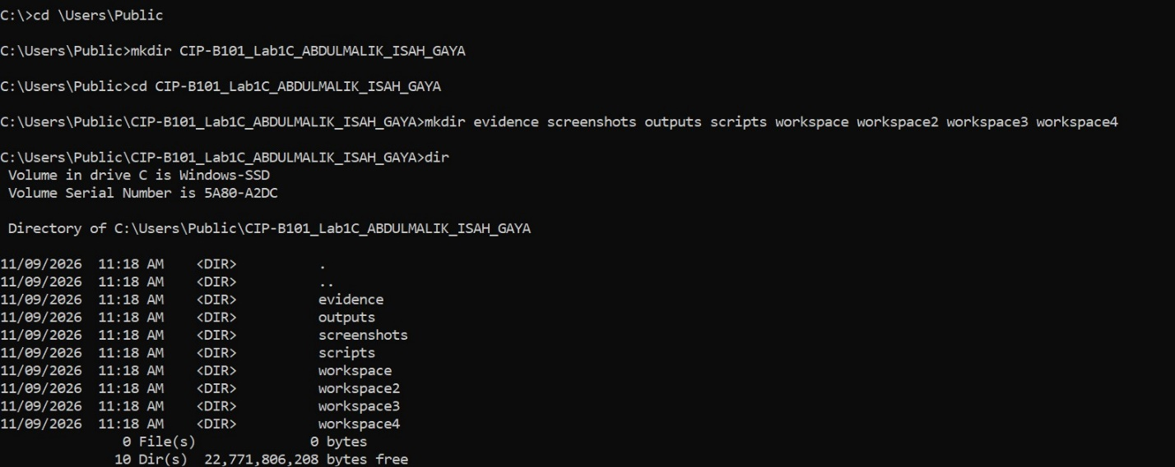
I moved into two directories user,and public which I created another directory named CIP-B101_Lab1C_ABDULMALIK_ISAH_GAYA I also moved inside the directory which I created some sub folders and I listed them all.

Task 1: Understand Windows Paths and Navigation
In this task, you will practice absolute paths, relative paths, root directories, and parent-directory navigation. This is important because forensic analysts must correctly identify where evidence is located.
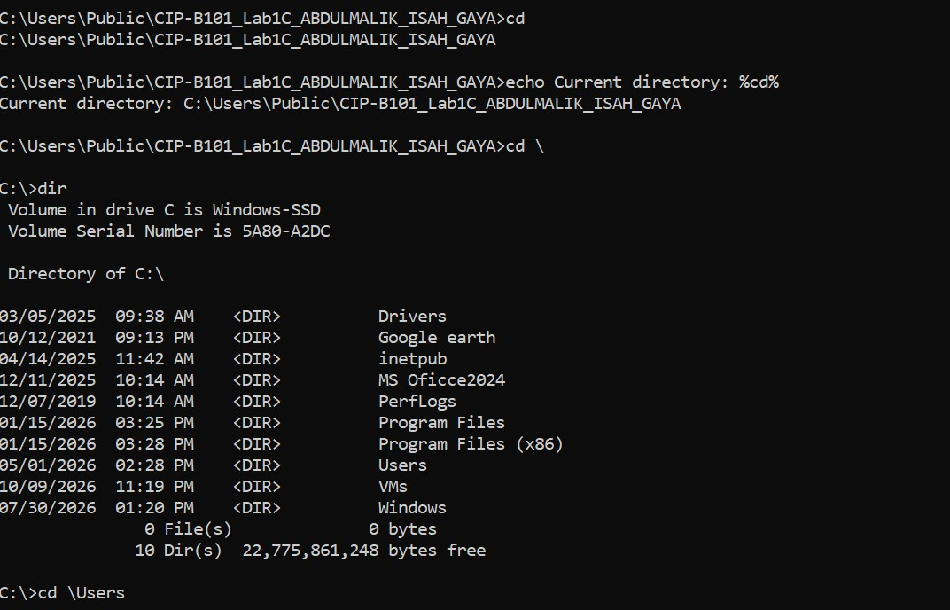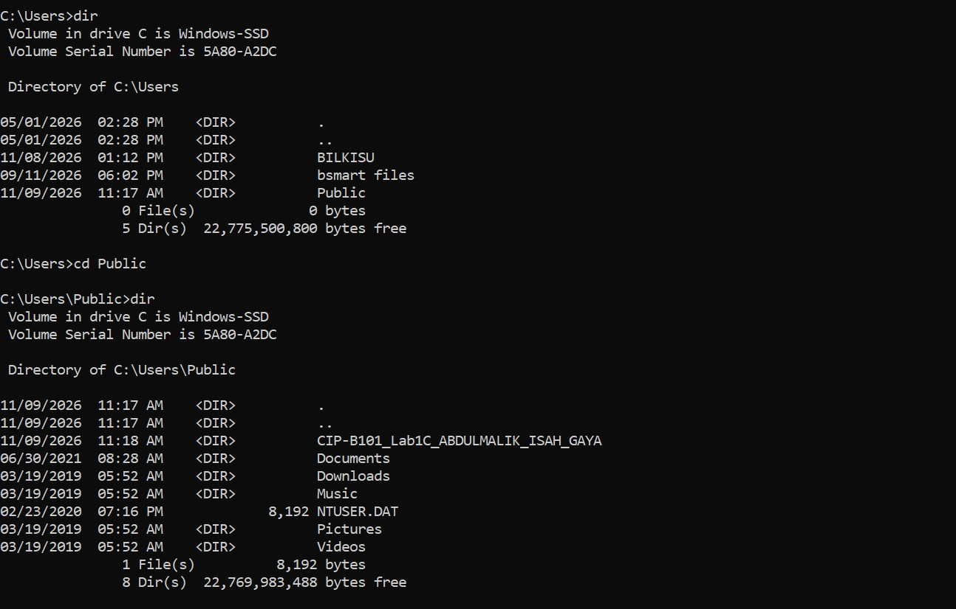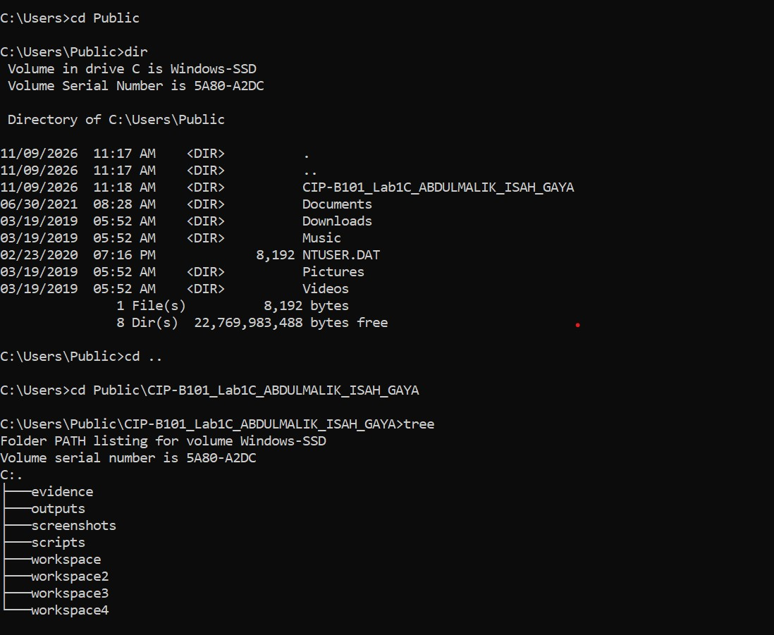
The absolute path: this is the full address of a file or folder starting from the root of drive.
The relative path: this is the short address that depends on where I am currently and it does not start from root.

Task 2: Basic File and Folder Creation
This task teaches basic command-line file creation and verification. You will create a text file that represents a simple evidence note.
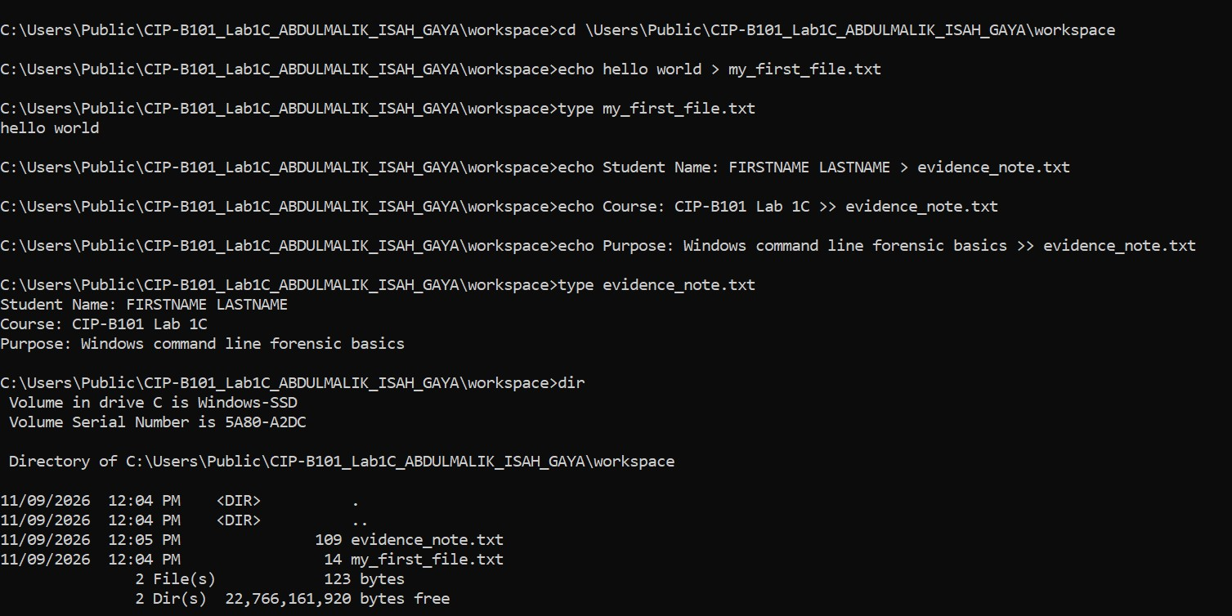
The difference between > means single redirection it creates a new file or delete everything inside the file.
>> this is called double redirection which keeps the old content and add new content to the end of the.

Task 3: Copy, Duplicate, Rename, and Delete Files Safely
Forensic work requires careful handling of files. In this exercise, you will copy files and verify that the copies exist before deleting test files.
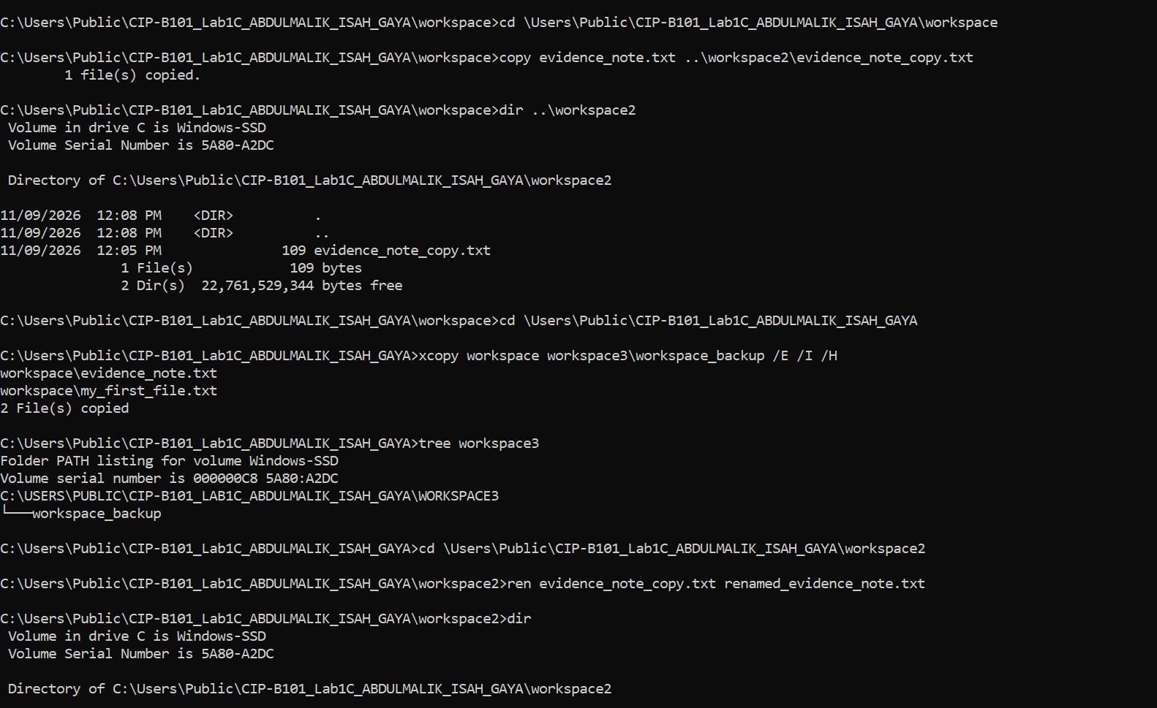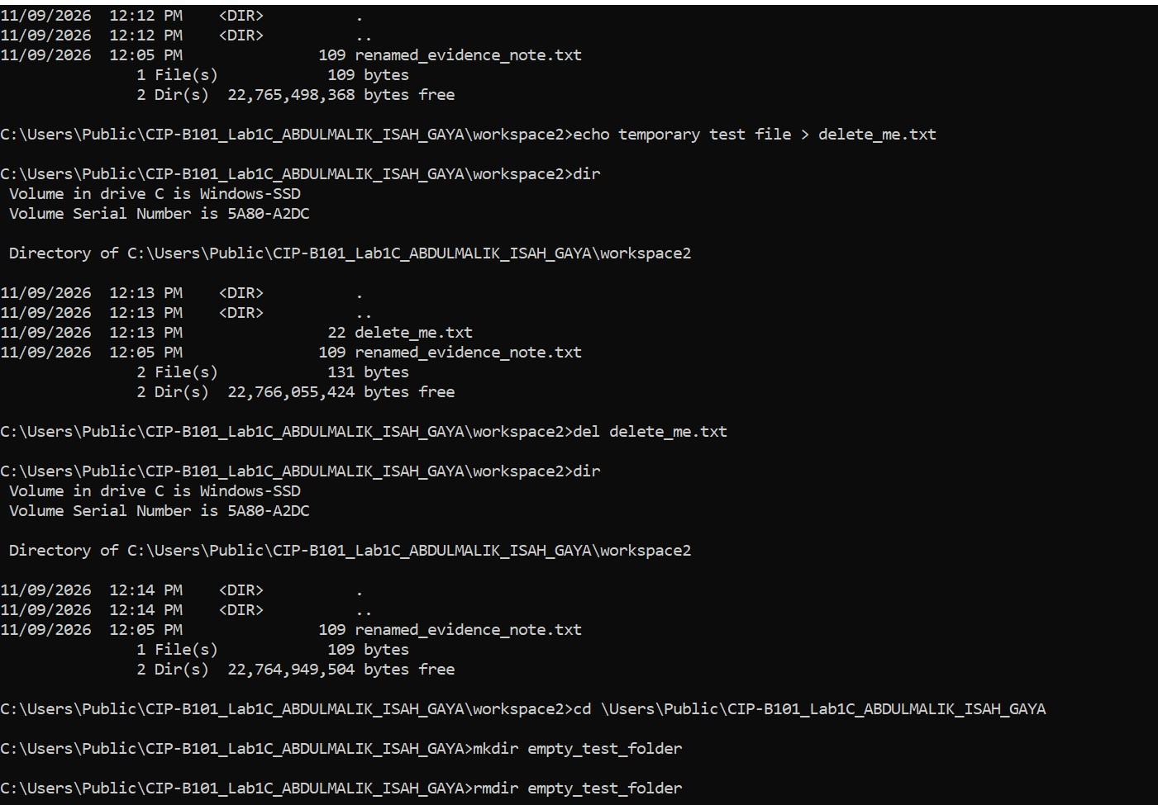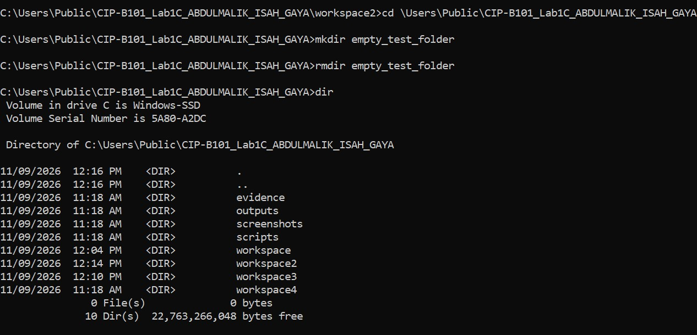

Task 4: Understand How Windows Finds Applications
Windows searches executable files using defined paths. This is important because attackers and malware may abuse PATH or place malicious executables in searchable directories.
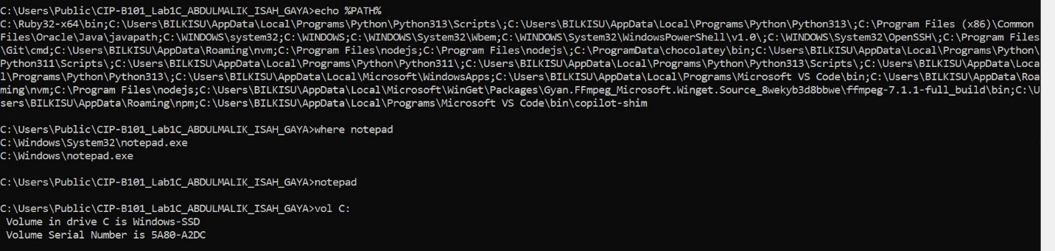
PATH is important in forensics because windows uses it to decide which executable to run when I only type a anme like notepad without the full path.an attacker can abuse it in two ways like: PATH Hijacking or Planting.

Task 5: Collect Windows System Information
This task collects host details that are commonly included in a basic forensic triage note.

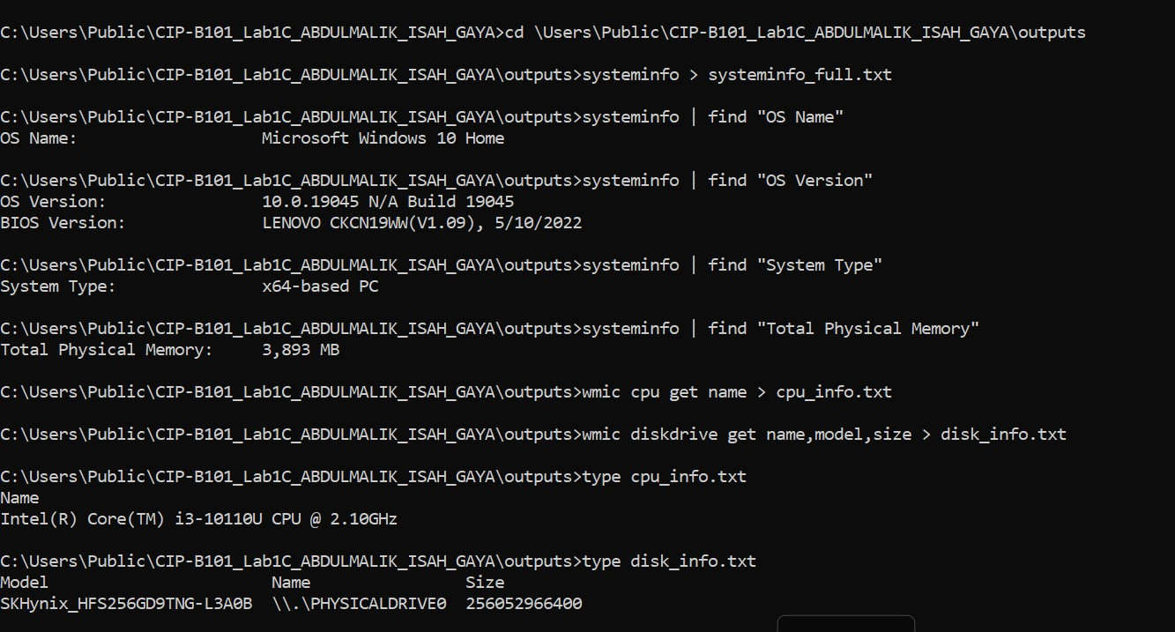

Task 6: Collect Basic Network Information
This task records IP configuration, default gateway information, MAC address information, and basic connectivity checks.
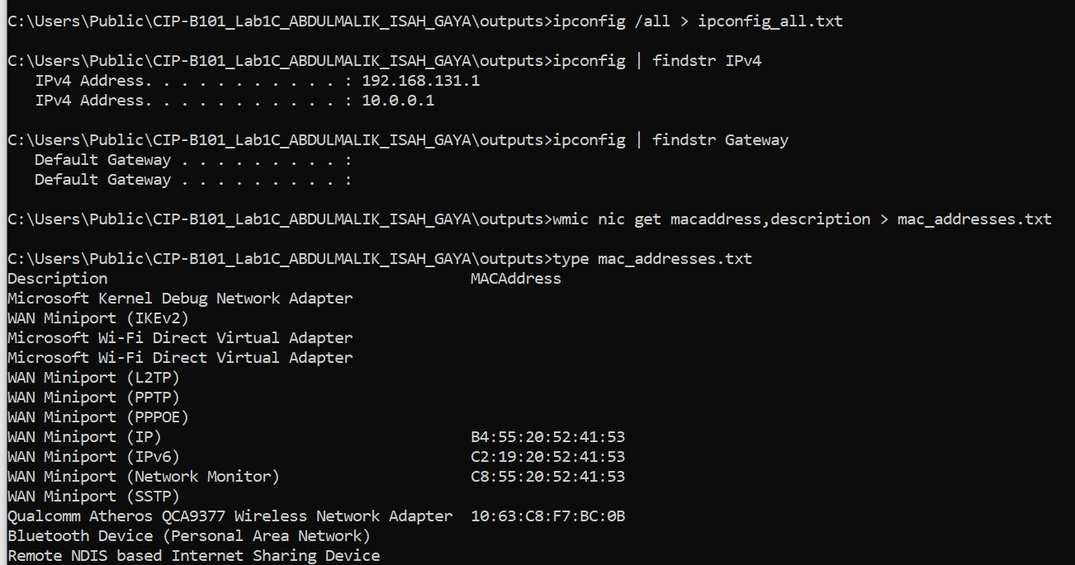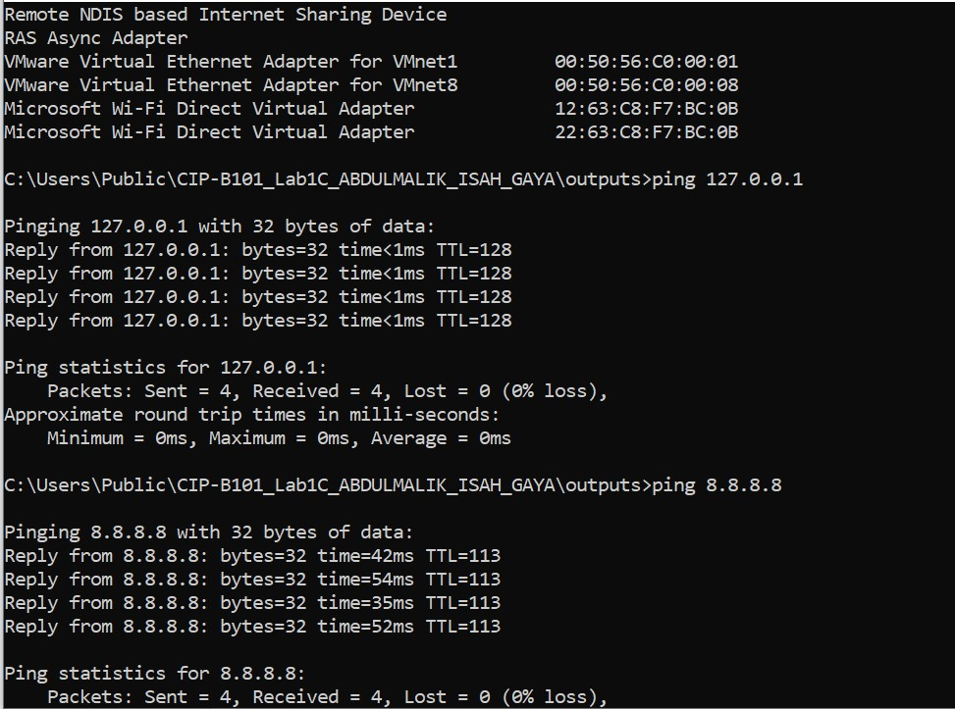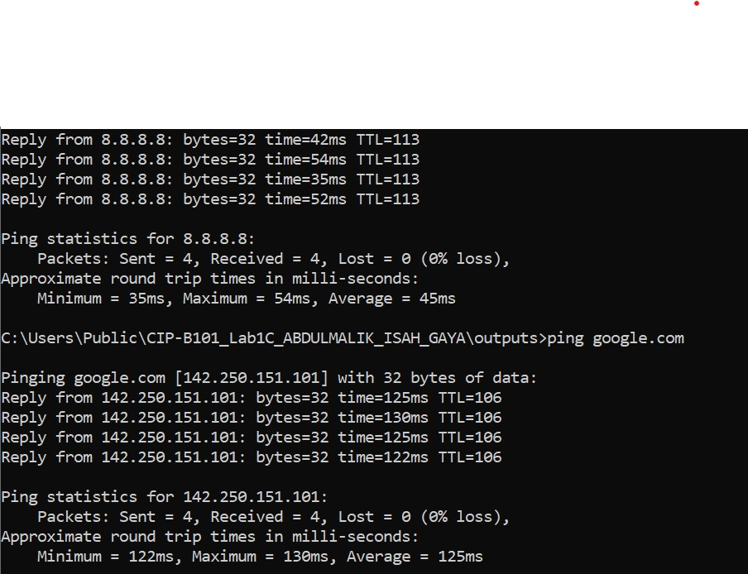

Task 7: Search for Evidence Text in Files
You will create a small text evidence file and then search it using Windows command-line search tools. This prepares you for later file-content searching in forensic work.
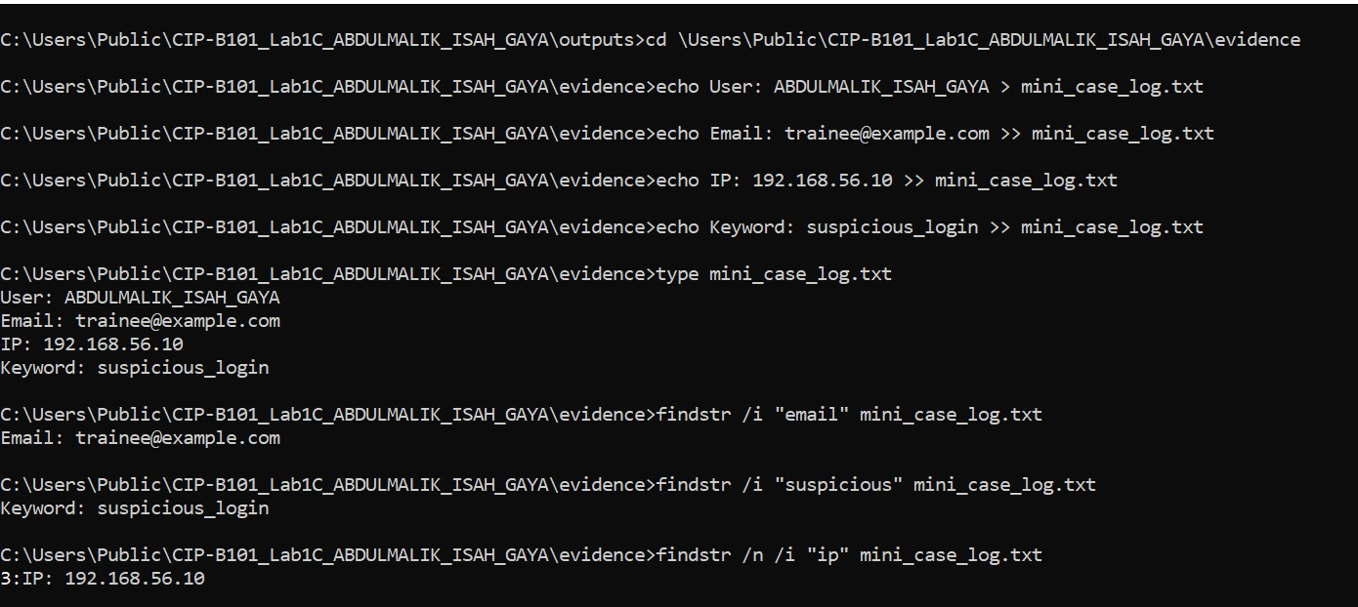
The function of /i in findstr it makes the search case insensitive it tells the findstr to ignore upper and lower case.
And for /n it makes findstr print the line number before each matching line.

Task 8: Check File Owner and Directory Information
The slide introduces file ownership review. In forensic documentation, ownership and access context can be useful when reviewing a local system.
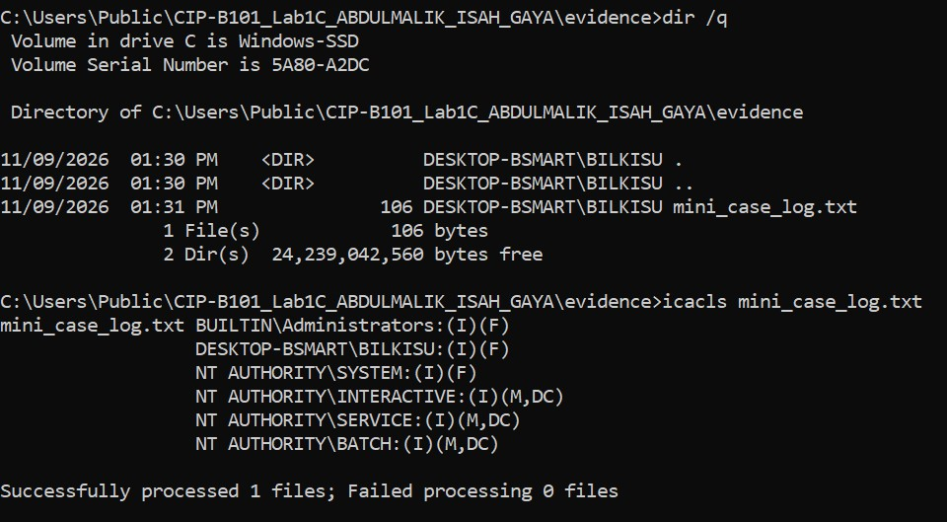
The file mini_case_log.txt on my system is owned by : DESKTOP-BSMART\BILKISU

Task 9: List Processes and Identify Browser Processes
Processes are running instances of programs. During basic incident triage, analysts often collect process information to identify suspicious or unusual activity.
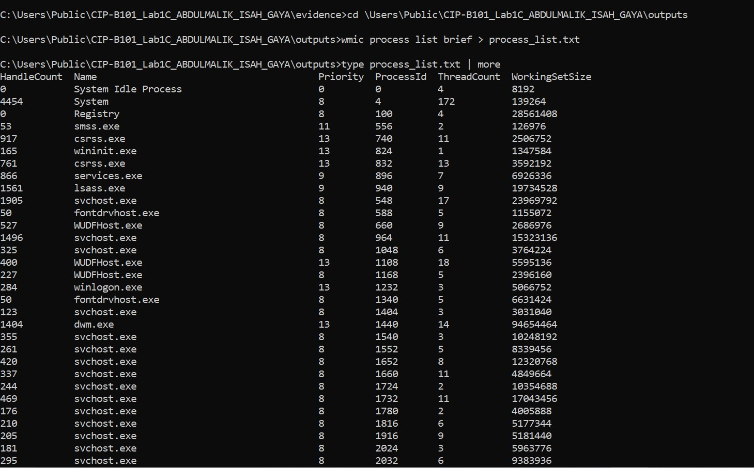
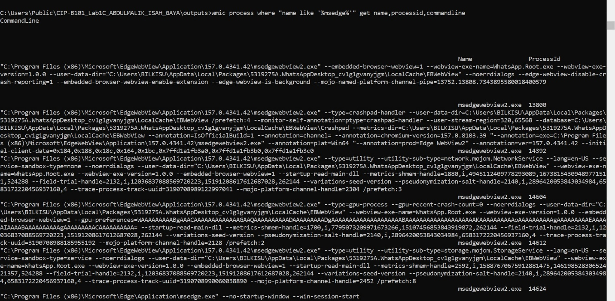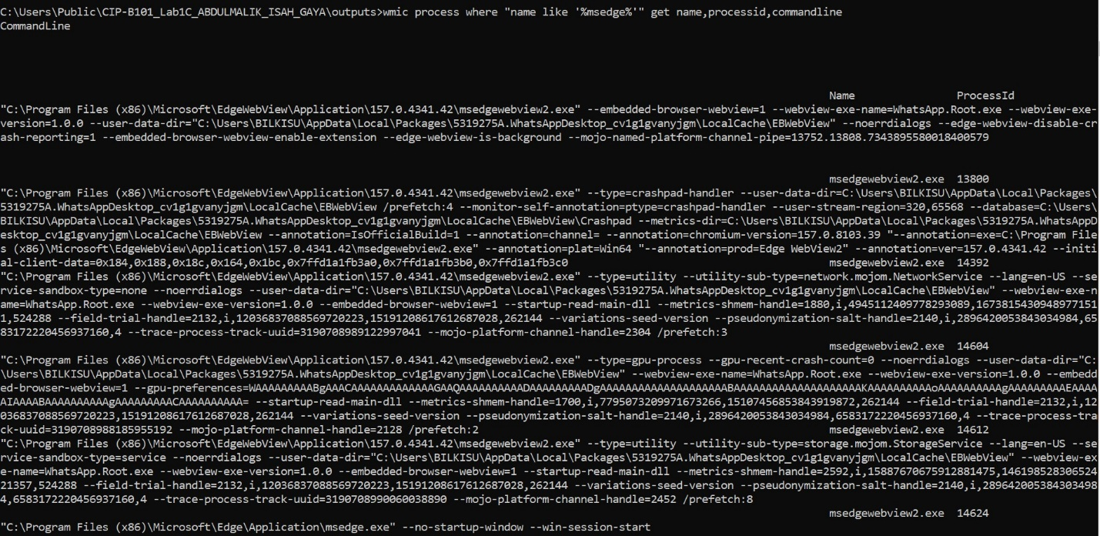

Task 10: Create and Execute a Batch File
Batch files allow analysts to run repeatable commands. In this task, you will create a simple Hello World batch file and a forensic-style system-information batch file.
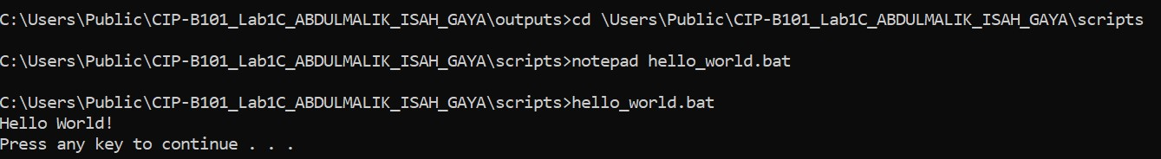

10.2 Create sys_info.bat
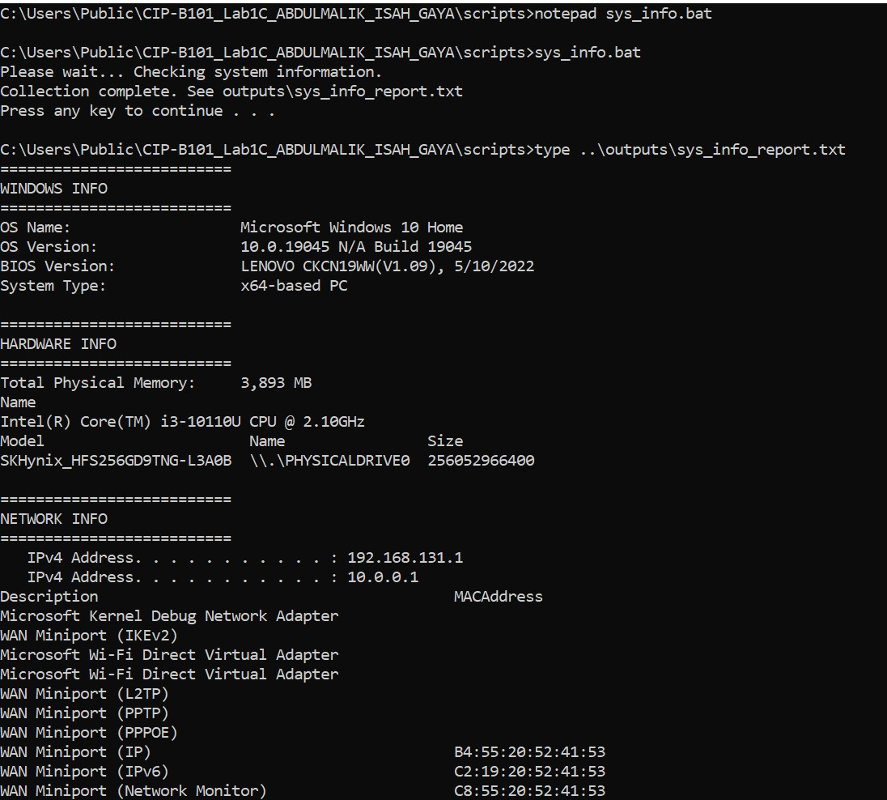

Task 11: Make sys_info.bat Callable from Any Folder
The original slide assignment asks students to make sys_info.bat callable from any folder. This means Windows must be able to locate the batch file through PATH.
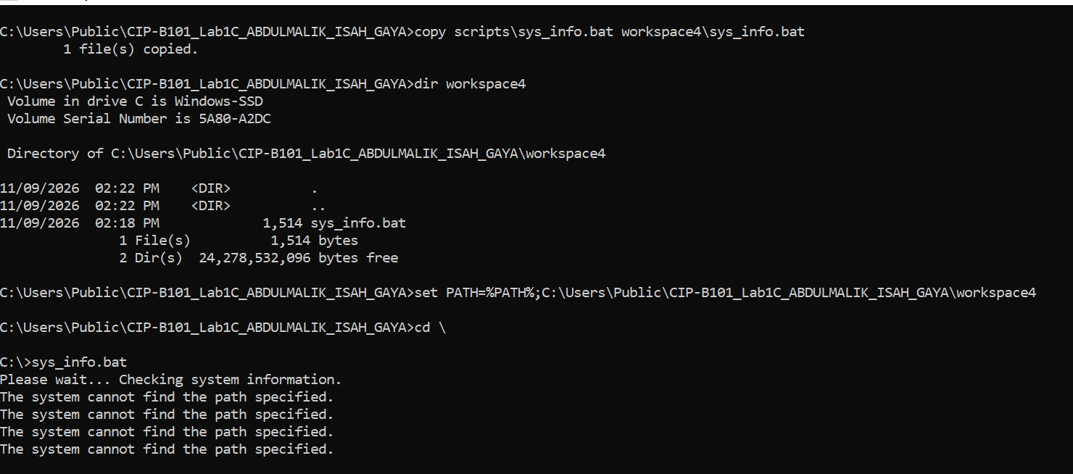
I used temporary update

Task 12: Mini Forensic Interpretation Questions
- The difference between absolute and relative path, the absolute path: full address starting from the root e.g C:\User\Public\CIP-B101_Lab1C_ABDULMALIK_ISAH_GAYA\evidence. And relative path: short address that depends on where you are now C:\Users I typed cd Public instead of the full path.
- The reason why analysts should create separate lab/evidence before running commands is to avoid contaminating the original evidence and to keep work organized.
- The command that showed an ip address an mac address are:ip address is ipconfig and for the mac address is ipconfig /all.
- The reason why batch file is useful in forensic triage is a batch file .bat runs many commands automatically in order, without typing each one.
- The reason why analysts documented failed commands or failed pings instead of hiding them is because a failed ping does not mean no result but it can mean the host is down, blocked by firewall, no internet or the ip is wrong .
- The risk that can occur if a suspicious executable is placed in a directory listed in PATH the windows searches PATH from left to right and runs the first match.

