Advanced Web Application Security Labs

CIP-B101 Basic Computer Skills For Digital Forensics

Lab1A Digital Forensics Fundamentals

Abdulmalik Isah Gaya

C11/26/FCDF/17171

VM hostname: Kali

November 4, 2026

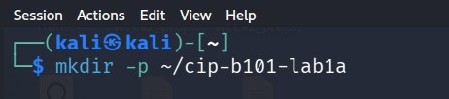
I created student working folder.
Task A Number System Manuall Conversion.
2.2 Practical Conversion Exercises
1.Convert 101010₂ to decimal manually. Show the weight of each bit from right to left.
101010₂
0 x 2⁰ = 0
1 x 2¹ = 2
0 x 2² = 0
1 x 2³ = 8
0 x 2⁴ = 0
1 x 2⁵ = 32
42₁₀

Convert AB2₁₆ to decimal manually. Remember that A = 10 and B = 11.
AB2₁₆
2 x 16⁰ = 2 x 1 = 2
B x 16¹ = 11 x 16 = 176
A x 16² = 10 x 256 = 2560
2738₁₀

Convert 126₁₀ to binary manually by division by 2.

2 | 126
2 | 63 0
2 | 31 1
2 | 15 1
2 | 7 1
2 | 3 1
2 | 1 1
- 1
126₁₀ = 1111110₂
Convert 2738₁₀ to hexadecimal manually by division by 16.
16 | 2738
16 | 171 2
16 | 10 11 = B
0 10 = A
Convert 101010110010₂ to hexadecimal by grouping bits in fours from the right.
1010 1011 0010
10 11 2
A B 2
101010110010₂ AB2₁₆
2.3 Validate With Linux Shell and Python
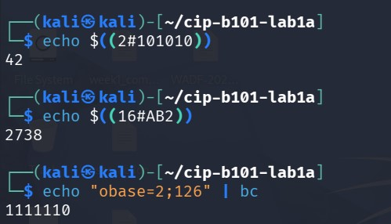
I convert the binary to decimal using shell.
I also convert hexadecimal to decimal using shell.
I convert decimal to binary using basic calculator.
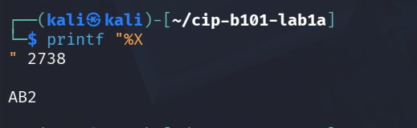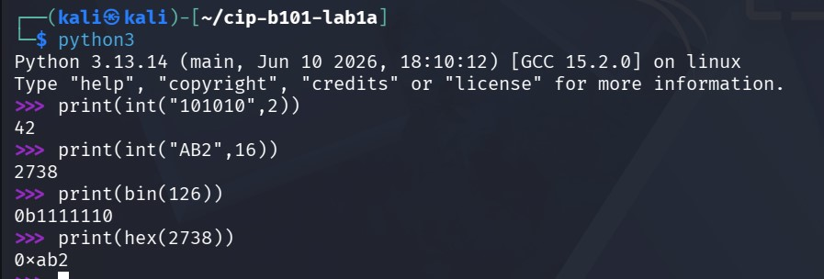
I converted binary to decimal,hexadecimal to decimal, 126 to binary, and also 2738 to hexadecimal.
3. Task B - ASCII, UTF-8 and Hex Evidence Strings
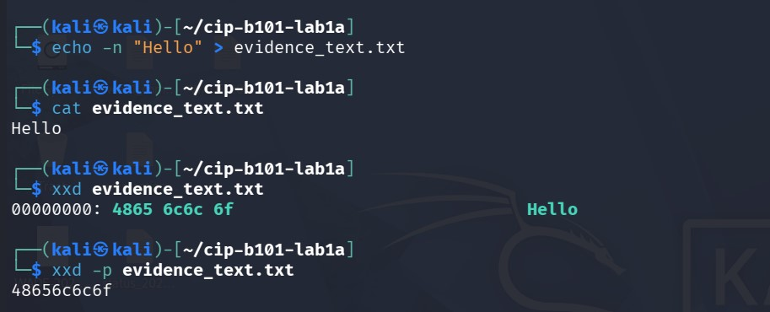
I used echo to create evidence with exact bytes, and also view the content of the file using cat and I used xxd command to show the hex with an argument -p to showed the plain hex.
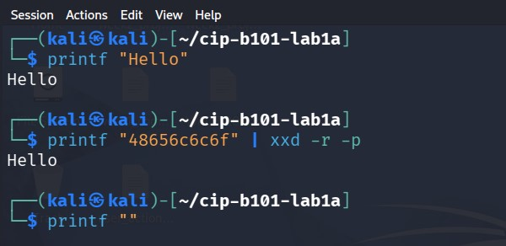
I used printf function to print out hello . I also print out the hex back to the plain text using the command xxd -r -p .
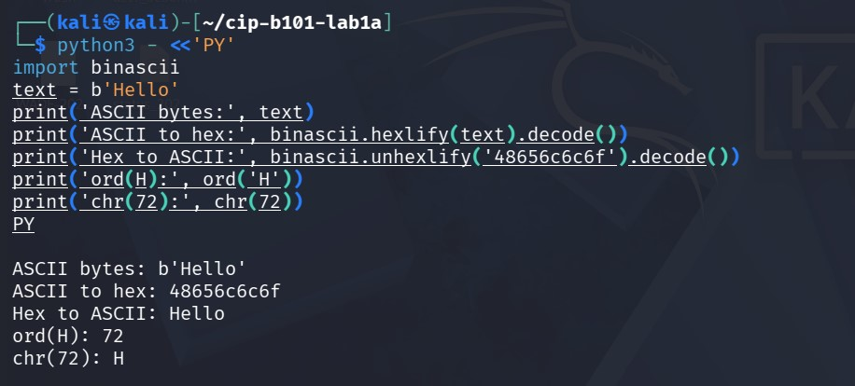
I used binascii hexlify to change hello to hex and to unchanged it back to hello.
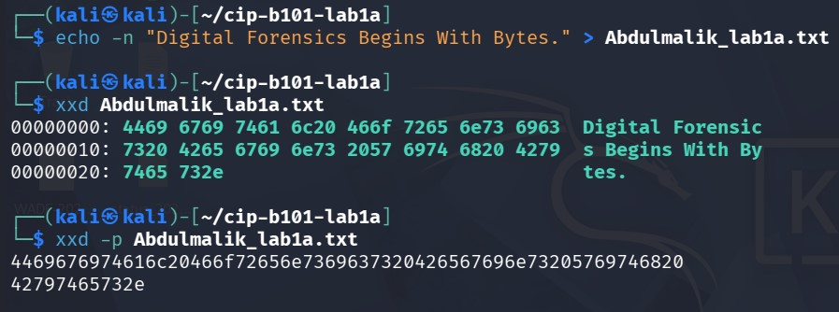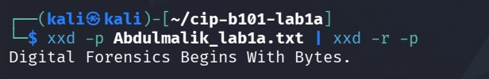
I created a file called Abdulmalik_lab1a.txt and I inserted some content in it, which I used xxd to show its hex and with an optrion -p to showed plain hex, which I also reversed it back to the readable text.
And the reason why0A appears at the end if you did not put -n that’s to adds a newline at the end.
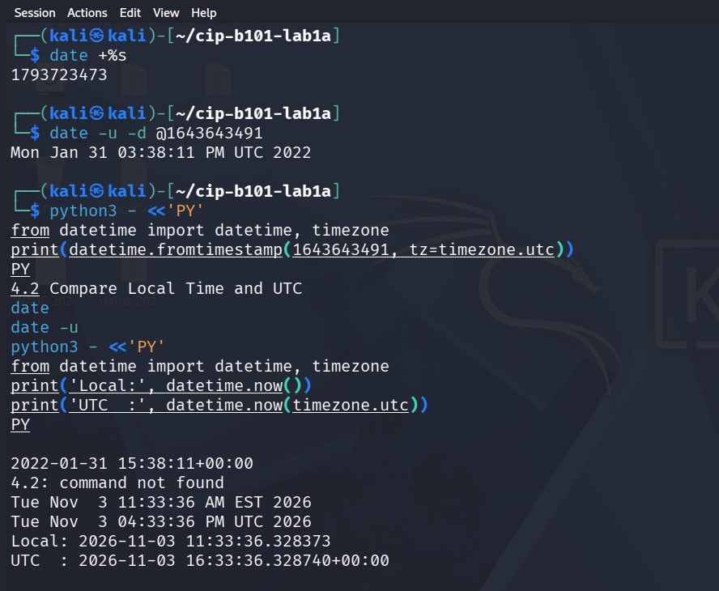
Date +%s gives the current time as seconds. While the date -u -d converts a known timestamp to readable UTC time.
4.2 Compare Local Time and UTC
The python shows local time while the timezone shows UTC time the difference is 1 hour.
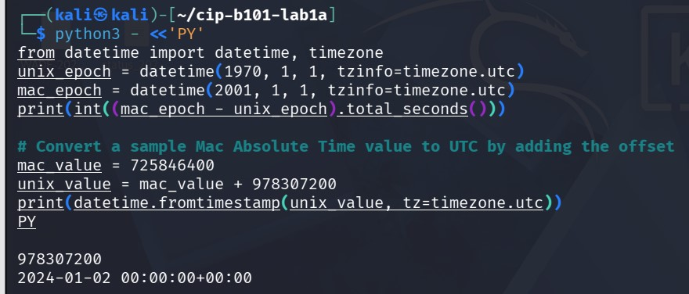
Mac does not count from 1970 it counts from 2001-01-01 00:00:00 UTC
5. Task D - Hashing and the Newline Problem
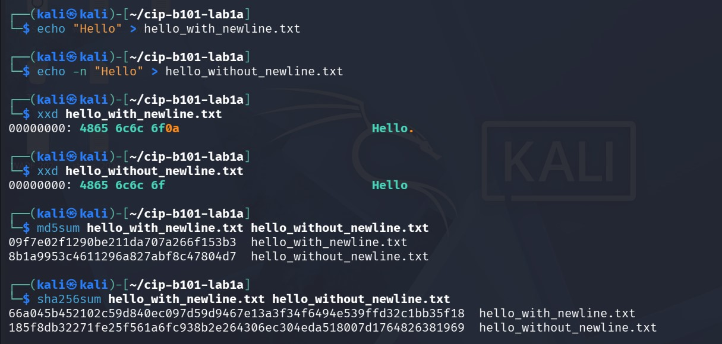
First echo I inserted hello with newline in a file while the second echo I inserted echo without newline which I used xxd to compare both file the look both same when you cat them but the bytes are different.
Both files have different MD5 and SHA256sum values even though they both look like hello.
5.3 Student Exercise

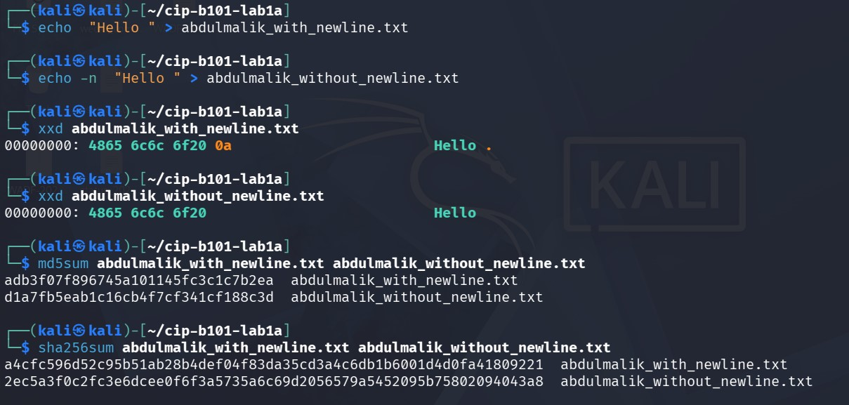
I created a file Abdulmalik_with_newline.txt which I inserted hello with newline and also a file Abdulmalik_without_newline.txt whi I inserted hello without newline and I used the xxd to compare both file to see the result,and also the hashes to compare the calculated bytes.
6.2 Interpret the Same Bytes in Two Ways
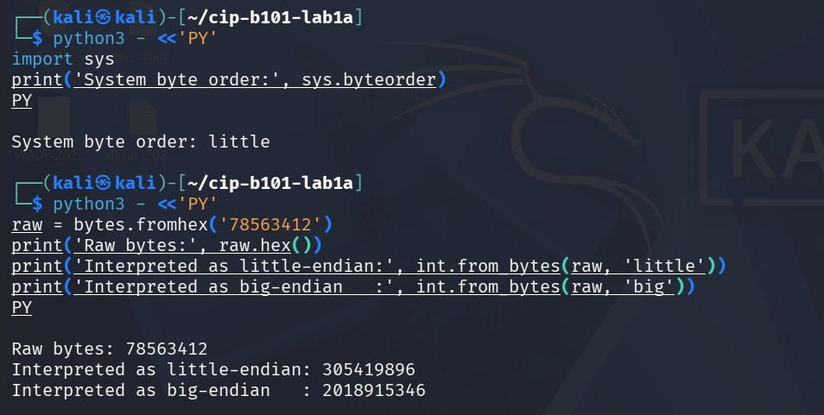
The endianness is the order bytes are stored in memory but the same two numbers can mean two different numbers depending on how you read them.
6.3 Student Exercise
Raw Hex Bytes | Little-Endian Decimal | Big-Endian Decimal | Command Used | Explanation
01000000 | 1 | 16777216 | Int.from_bytes(rwa,little,big) | Little reads backwards,01 is first=1.big reads forward=16million.
FF000000 | 255 | 4278190080 | Int.from_bytes(raw,little,big) | Little=255, big=FF in highest position=4.2 billion.
00000100 | 65536 | 256 | Int.from_bytes(raw,little,big) | Same bytes,different position of 01 changes value
78563412 | 305419896 | 2018915346 | Int.from_bytes(raw,little,big) | Little=12345678 hex,big=78563412 hex.

7. Task F - Mini Forensic Interpretation Case
Evidence Item | Value | Student Interpretation | Command/Screenshot Ref.
EVID-001 | 48656c6c6f204943444641 | Hello FORENSICS- Hexto ASCII text | Bytes.from hex(48656c).decode()/xxd -r -p
EVID-002 | 01001000 01101001 | Hi-Binary to ASCII. 01001000=H,01101001 | Chr(int(01001000,2))
EVID-003 | 1675008832 | 2023-01-29 16:13:52 UTC -unix timestamp(seconds since 1970) | Datetime.fromtimestamp(1675008832,tz=timezone.utc)
EVID-004 | 725846400 (Mac Absolute Time) | 2024-01-02 00:00:00 UTC-Mac time. 725846400+978307200=1704153600 | Datetime.fromtimestamp(725846400+978307200,tz=timezone.utc)
EVID-005 | 78563412 as little-endian and big-endian | Little=305419896,Big2018915346-Same bytes,different value | Int.from_bytes(raw,little,big)

7.1 Required Case Narrative
EVID-001 is text evidence
EVID-001 is text evidence. Hex 48656c6c6f20464f52454e53494353 decodes to Hello FORENSICS. Method used: hex to ASCII with bytes.fromhex().decode() and xxd -r -p. This is content evidence - it shows a message.

EVID-002 is binary text evidence. Binary 01001000 01101001 decodes to Hi. Method used: binary to decimal to character with chr(int('01001000',2)). 01001000 = H (72), 01101001 = i (105). This is also content evidence.

EVID-003 is a timestamp. Unix timestamp 1675008832 = 2023-01-29 16:13:52 UTC. Method used: datetime.fromtimestamp(1675008832, tz=timezone.utc). Unix counts seconds from 1970-01-01. This is timeline evidence.

EVID-004 is a timestamp with different epoch. Mac Absolute Time 725846400 = 2024-01-02 00:00:00 UTC. Method used: Add Mac-to-Unix offset 978307200. So 725846400 + 978307200 = 1704153600, then convert to UTC. If we forget the offset, date will be 31 years wrong. This is timeline evidence.

EVID-005 is byte-order evidence. Raw bytes 78563412 give two values:
As little-endian: 305419896
As big-endian: 2018915346
Method used: int.from_bytes(raw, 'little') and int.from_bytes(raw, 'big'). They differ because little-endian reads the bytes backwards (12 34 56 78) and big-endian reads them forwards (78 56 34 12).

