Advanced Web Application Security Labs

CIP-B101Lab2B Basic Computer Skills For Digital Forensics

Lab1A Digital Forensics Fundamentals

Abdulmalik Isah Gaya

C11/26/FCDF/17171

VM hostname: Kali

November 11, 2026

5. Practical Tasks

Task 1: Prepare Your Evidence Workspace
Create a structured workspace that will hold all commands, outputs, screenshots, and final evidence artifacts. Replace FIRSTNAME_LASTNAME with your real name.
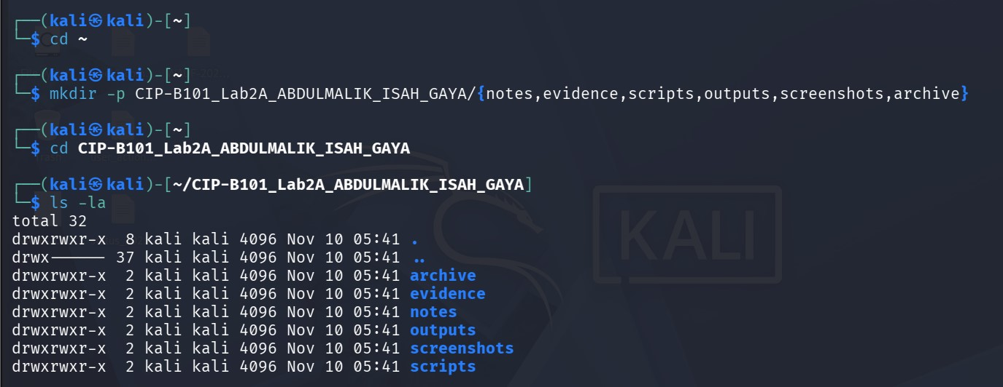
This is my working directory which I created a folder with the lab number and my name together with subfolders and I listed the directories to be verified.

Task 2: Inspect Linux Filesystem and OS Information
Use the commands below to observe Linux filesystem hierarchy, operating system information, and basic system structure.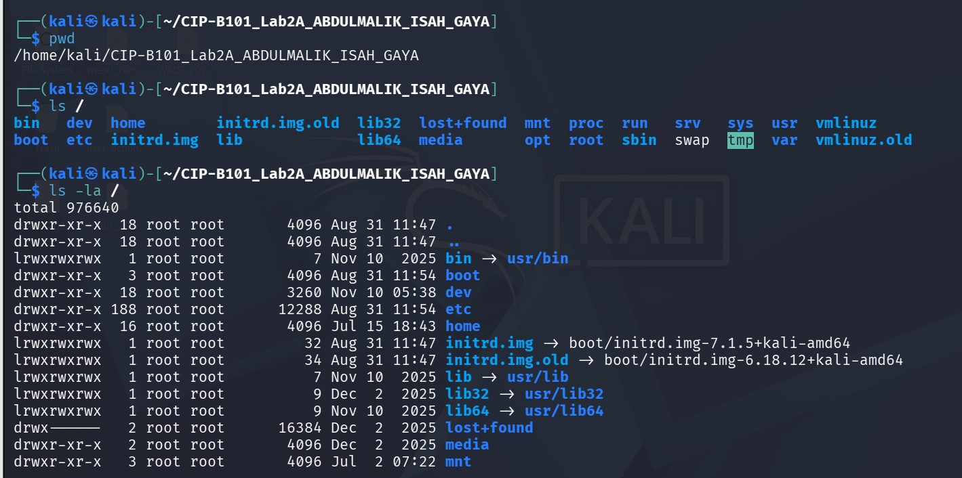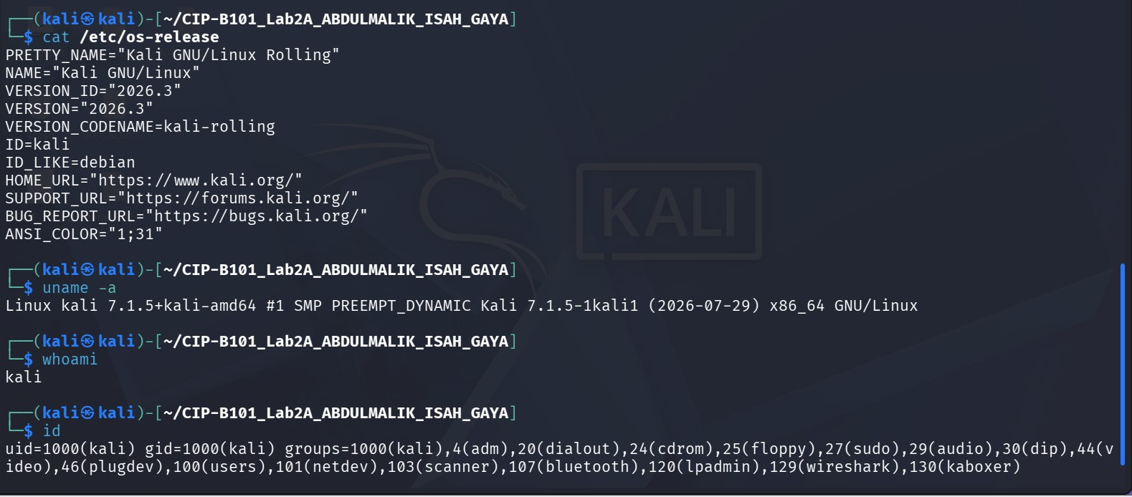/home: This personal files for normal users each user has their own folder here.
/etc: System configuration files settings for the whole system,users,passwords,network.
/proc: Fake folder for running processes it does not exist on disk,it is created by the kernel in memory and it shows info about running programs and CPU.
/sys: Fake folder for hardware and kernel like /proc but for devices,drivers,and kernel settings.
/dev: Devices everything is a file here hard disk, USB, mouse,terminal.
/bin: Basic commands everyone can use essential programs needed to boot and use the system.
/tmp: Temporary files any user can write here but files are deleted on reboot.

Task 3: Understand Inodes and Disk Information
Create a test evidence file and inspect its inode and disk information. This shows that Linux tracks files using metadata structures, not only file names.
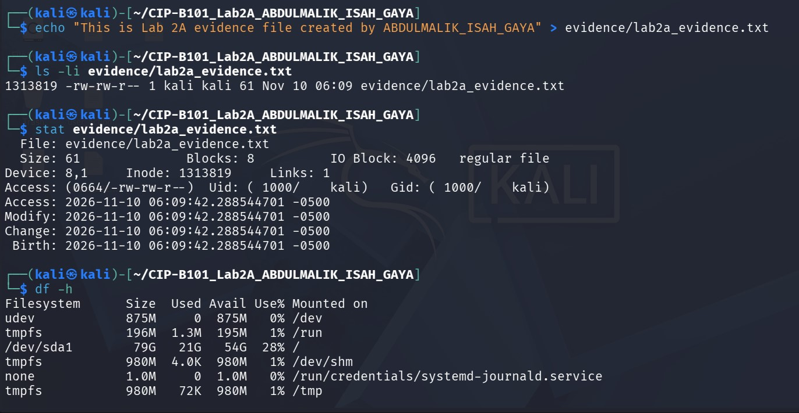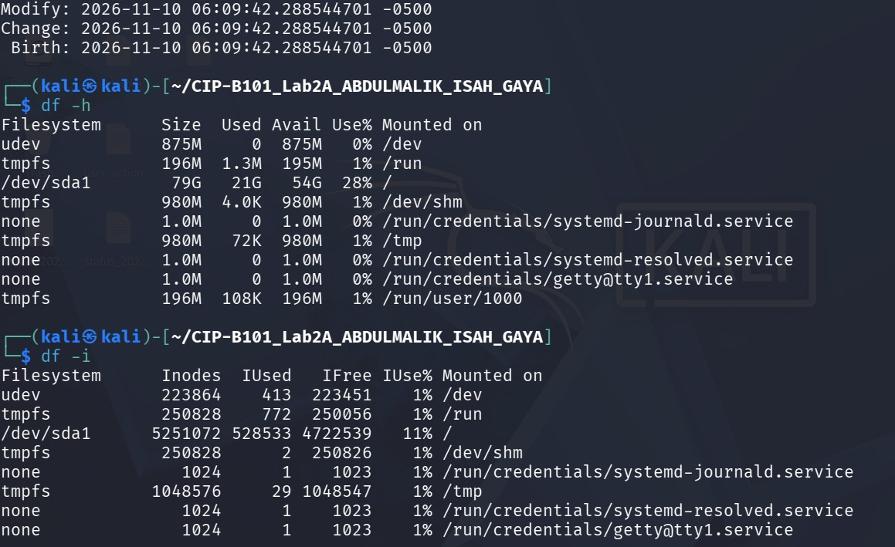
An inode is a data structure in linux filesystem that stores all the information about a file except it’s a name and its actual content. And the reason why inode information matters in digital forensics is because the inode is the true identity of a file and a file can be changed, hidden, or deleted but inode number stays the same until file is overwritten.

Task 4: Absolute and Relative Paths
Demonstrate that you understand absolute and relative paths by navigating between folders without relying only on the graphical interface.
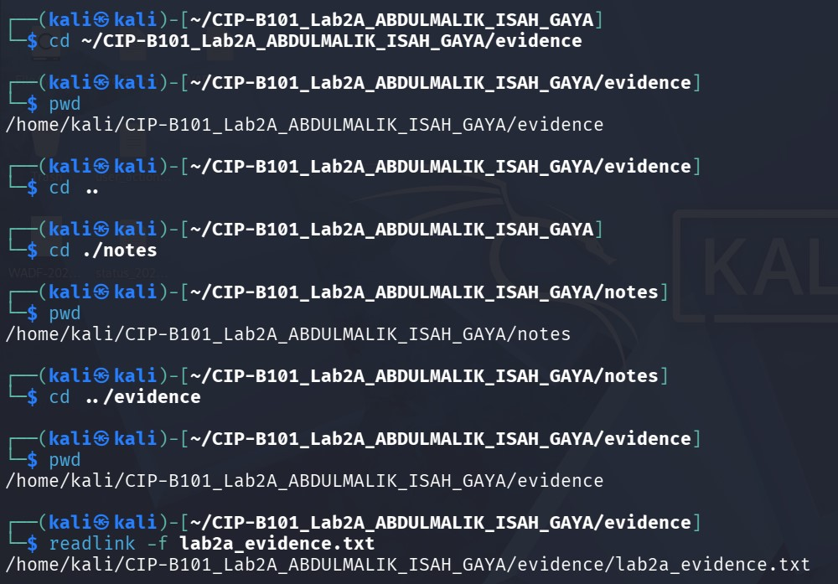
Absolute path to the evidence file: /home/kali/CIP-B101_Lab2A_ABDULMALIK_ISAH_GAYA/evidence.txt. this absolute because it start from the root and it shows every folder from the beginning.
Relative path to the same evidence file: ../evidence/lab2a_evidence.txt. this is the relative because it does not start from root it start from my current directory.

Task 5: Create, View, Copy, Rename and Remove Files
Perform basic file management operations that forensic analysts use when organizing working copies and extracted evidence.
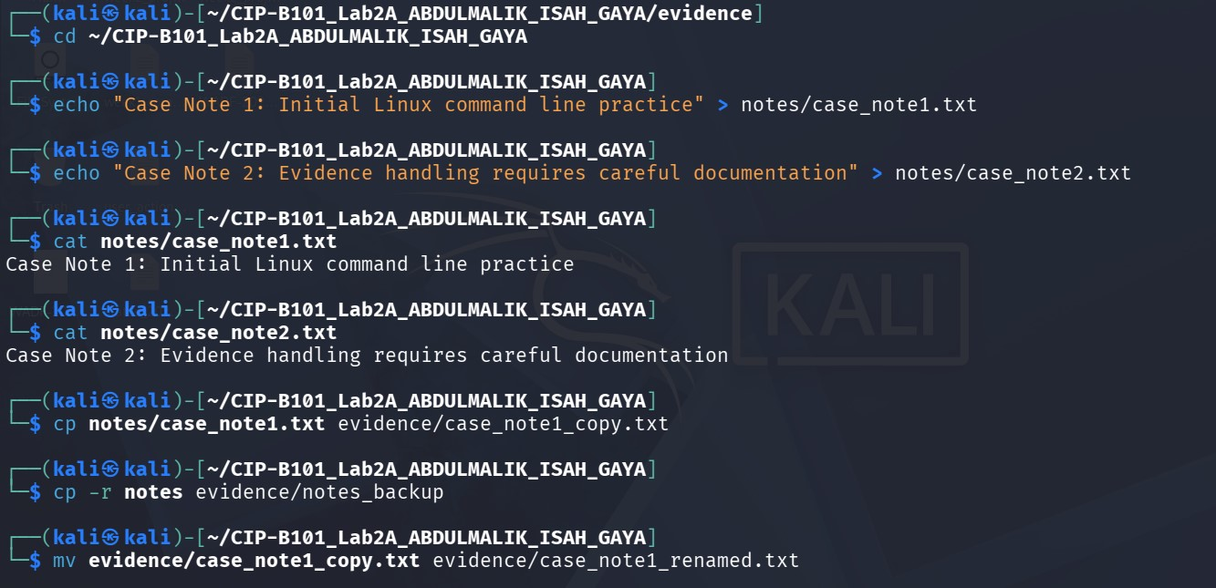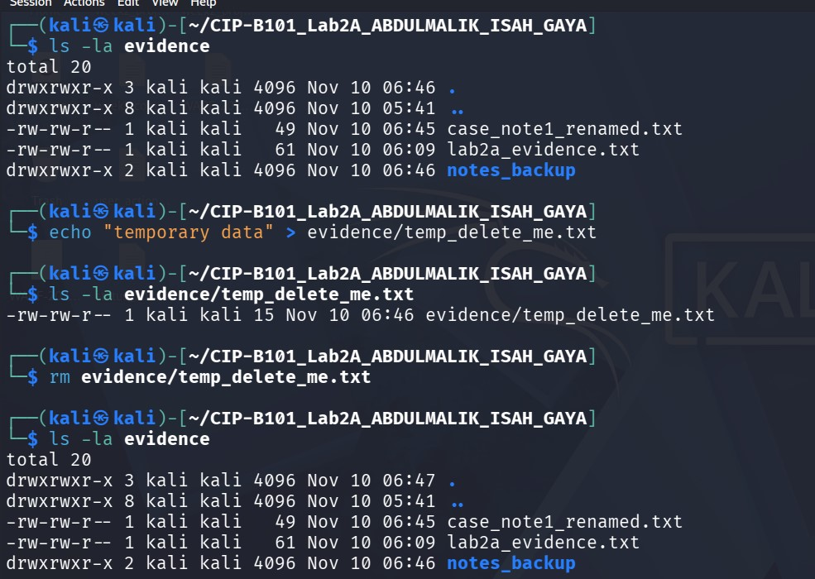

Task 6: Search Evidence Content with grep
Create a small evidence log and search it using grep. This introduces content searching, a key forensic skill.
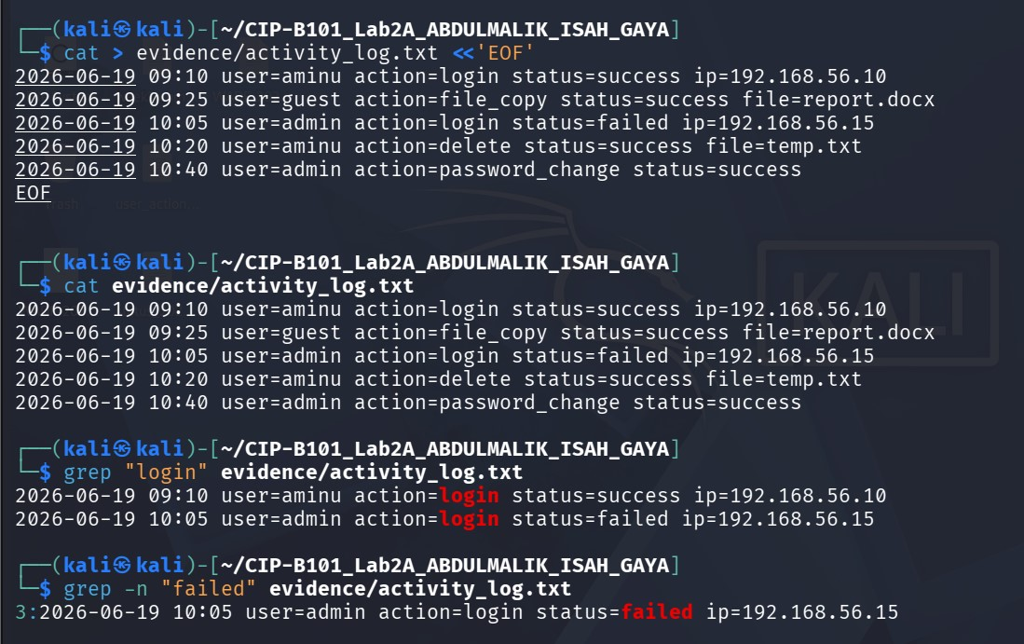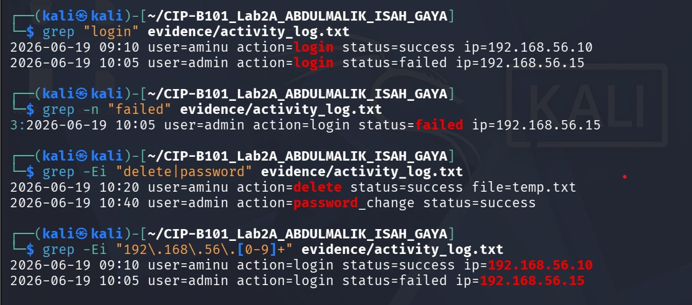
The command that shows failed login evidence is grep -n "failed" evidence/activity_log.txt
And the command that shows suspicious activity is grep -Ei "delete|password" evidence/activity_log.txt

Task 7: Search File Names and Display Directory Tree
Use tree and find to understand the evidence folder layout and locate files by name pattern.
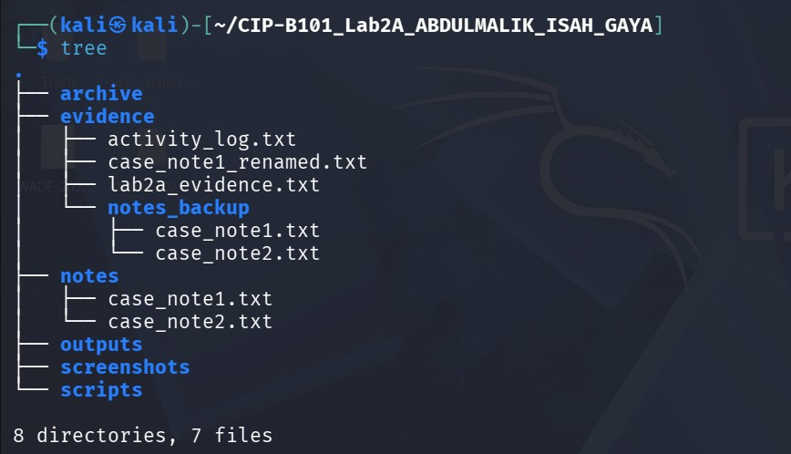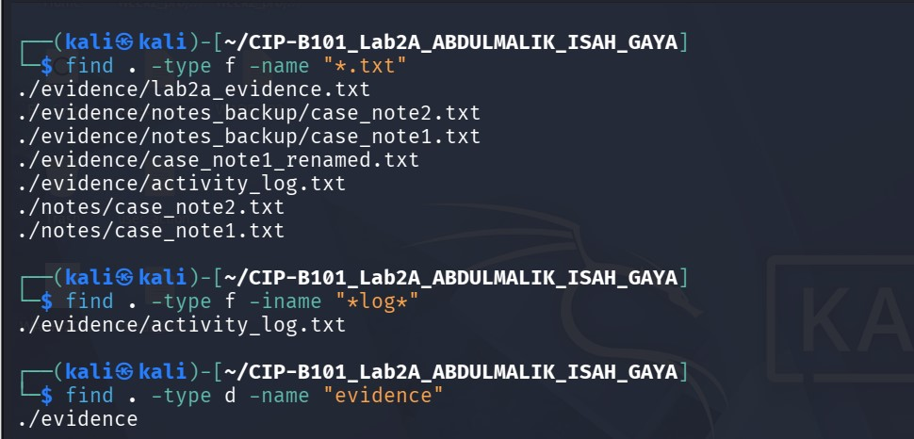

Task 8: Check Network Information Safely
Check your own system network settings and test local or approved connectivity only. Do not scan external networks.

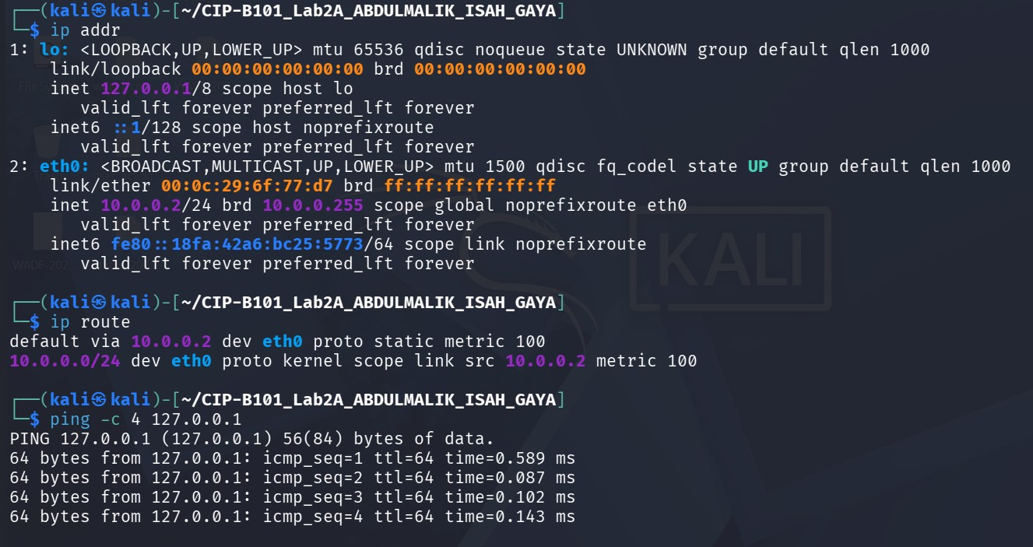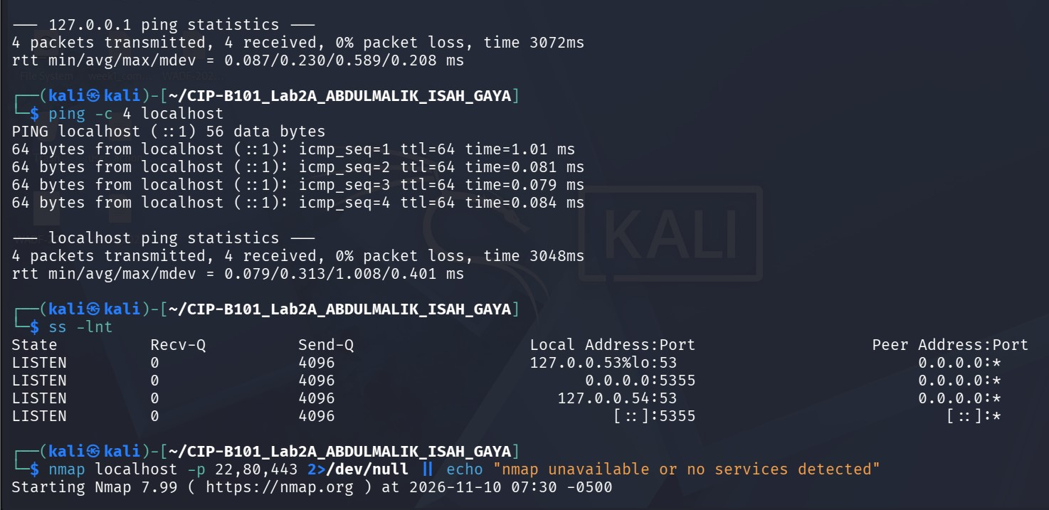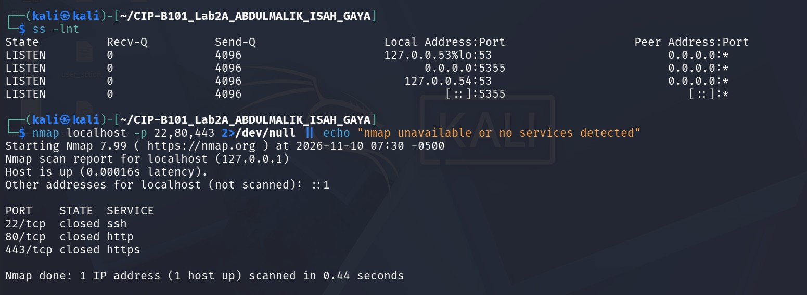
My loopback Address is ipv4:127.0.0.1, ipv6: : : 1 , hostname: localhost.
Why localhost testing is safer because it stays inside my own computer . no permission needed, no harm, no legal risk. we can only test what we own that’s why I scanned localhost, not any unknown ip.

Task 9: Create and Execute a Simple Forensic Script
Create a shell script that records basic system and evidence-folder information into a text report.
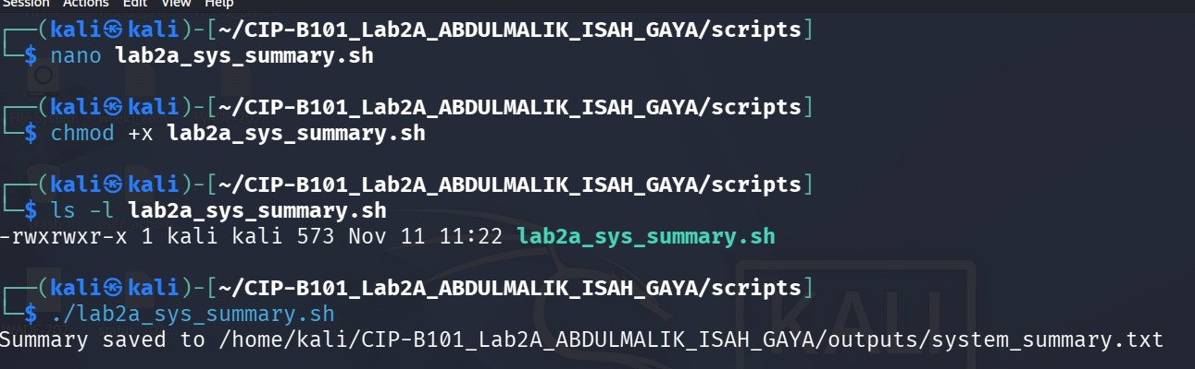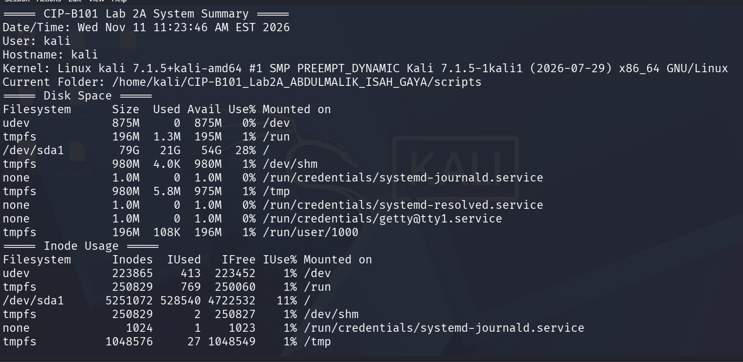

Task 10: Make the Script Callable from Another Folder Using PATH
Temporarily add the script folder to PATH and run the script from a different directory.
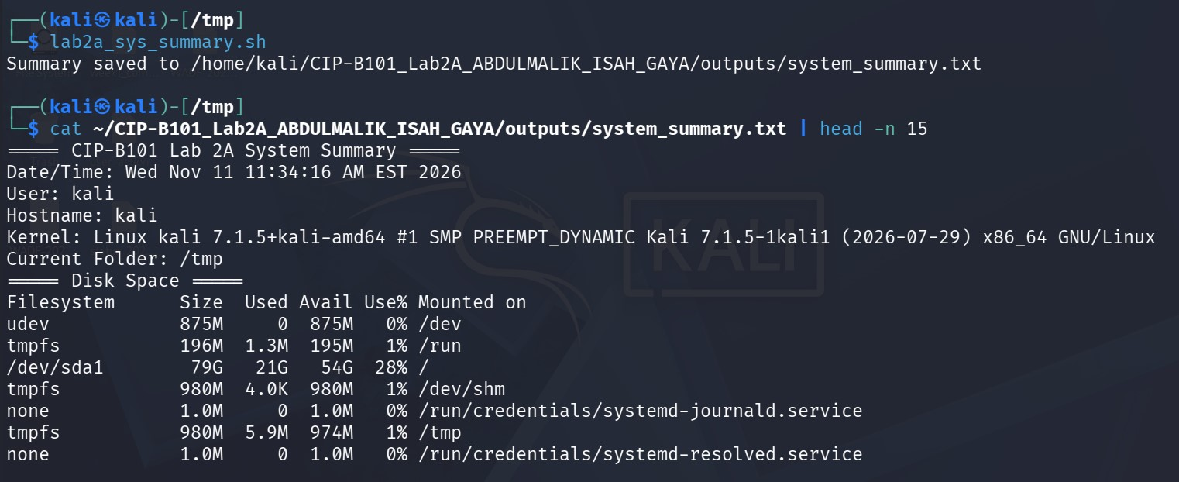
The PATH tells linux where to look for commands. I added my scripts folder to PATH temporarily, made the script executable with +x then ran it from /tmp by name only it worked because linux found it in PATH just like ls in /bin.

Task 11: Compress the Evidence Workspace
Compress your lab workspace for submission. You may use zip or tar.gz. Submit the compressed file along with your PDF report.


