Advanced Web Application Security Labs
Abdulmalik Isah Gaya
C11/26/FCDF/17171
Linux distribution/version: 6.18.12+kali-amd64
VM hostname: Kali
Octoberr 04, 2026

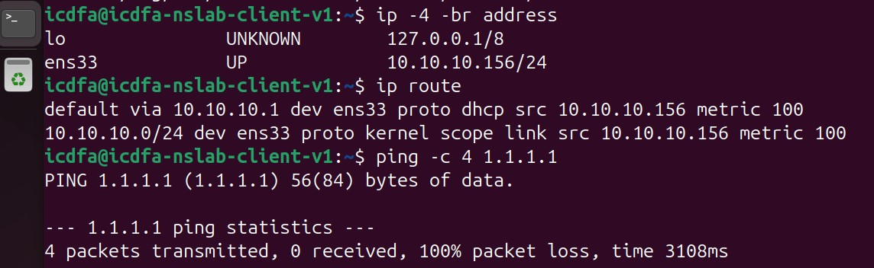
Ip -4 -br address check if you’re the pc got ip, and ip route to check your pc knows where to send internet traffic.
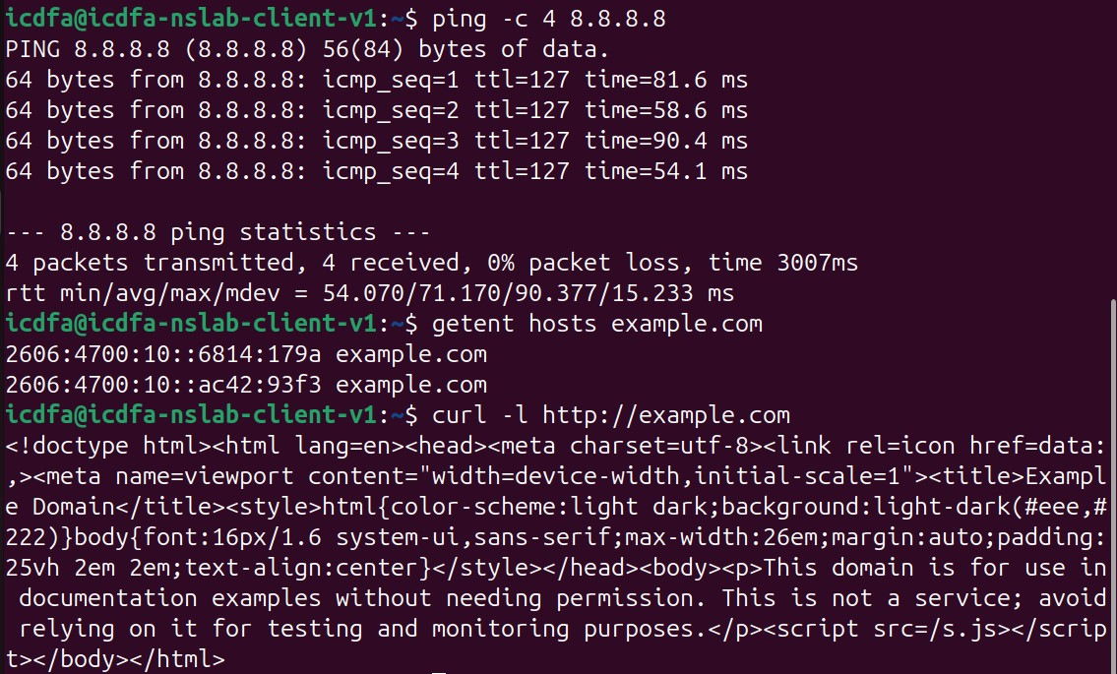
Ping -c 4 8.8.8.8 test if internet is reachable. And getent hosts example.com to test DNS toc convert name to ip. And the
