Advanced Web Application Security Labs
Abdulmalik Isah Gaya
C11/26/FCDF/17171
Linux distribution/version: 6.18.12+kali-amd64
VM hostname: Kali
Octoberr 04, 2026

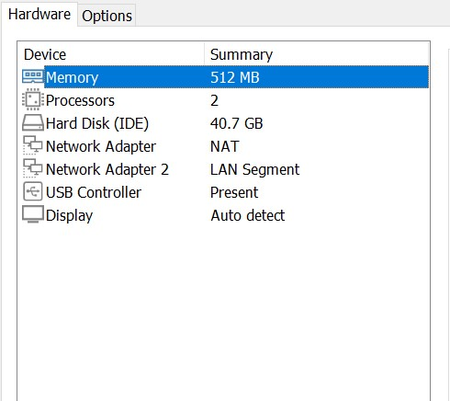
The icdfa-nslab-client and icdfa-nslab-firewall are completely shut down.
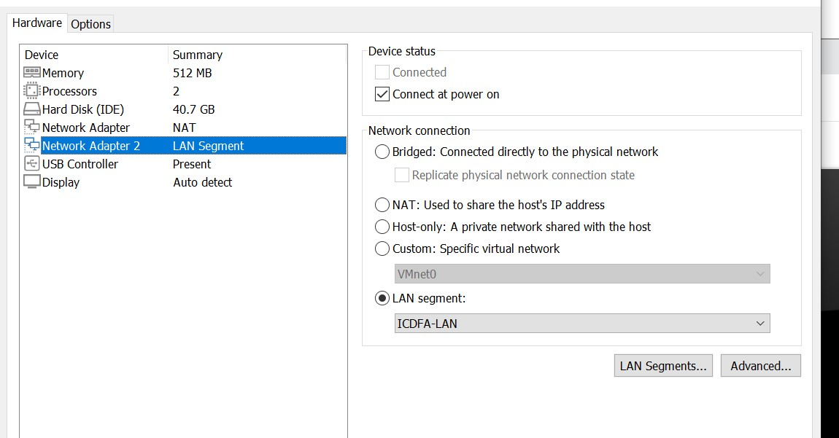
I select icdfa-nslab-firewall which i open Settings, and choose Network for the Adapter 1 and Adapter 2 and I also comfirmed the cable connected is selected.
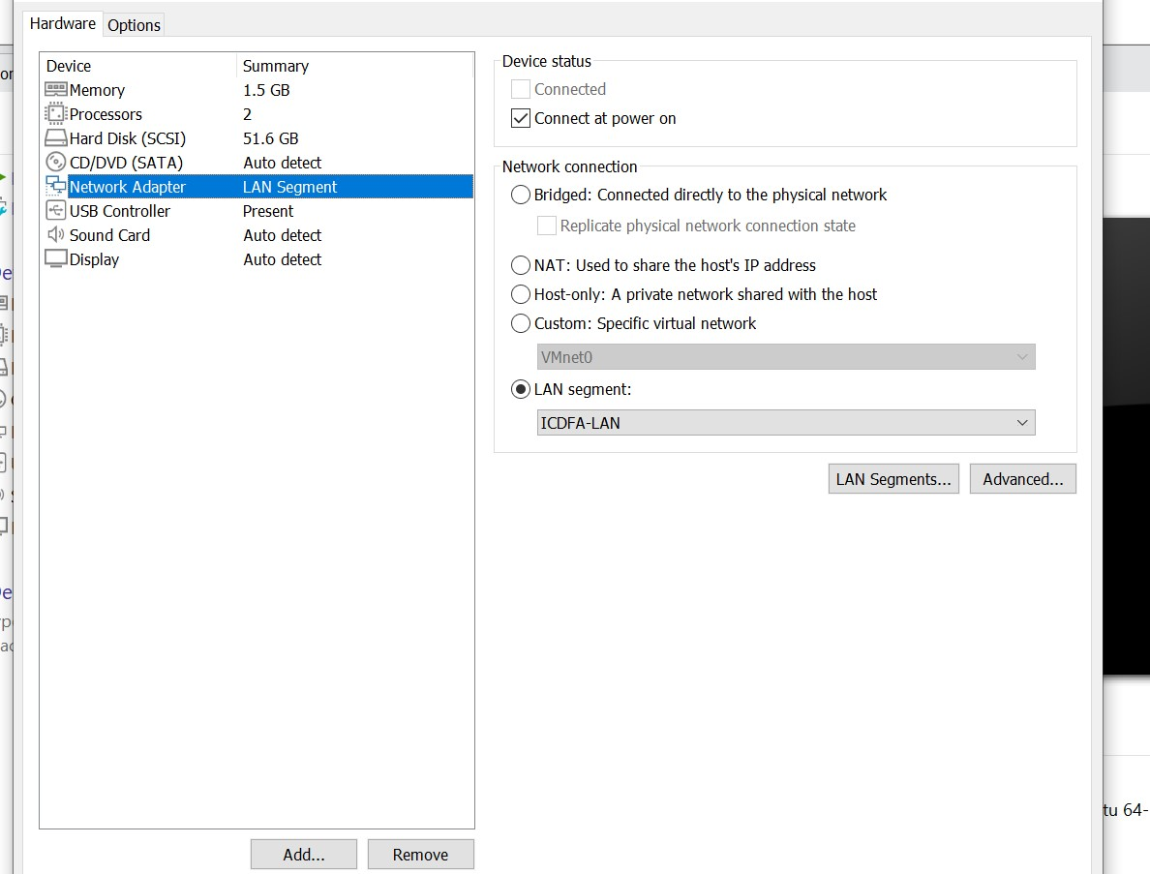
I selected the nslab-client and I opened the settings to change the network Adapter 1 which I select the internal network ICDFA-LAN and I confirmed the cable connected is selected.

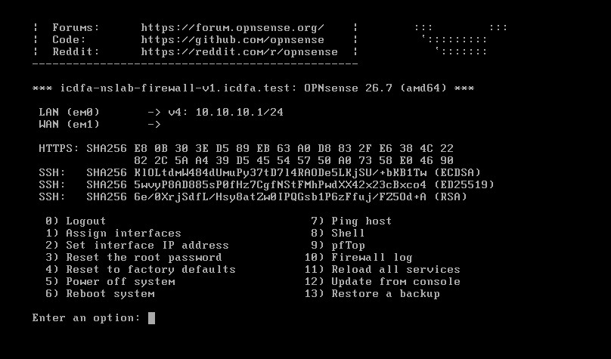
I started the icdfa-nslab-firewall and waited for the OPNsense console menu which I confirmed the LAN interface was marked and for the WAN interface is not marked.

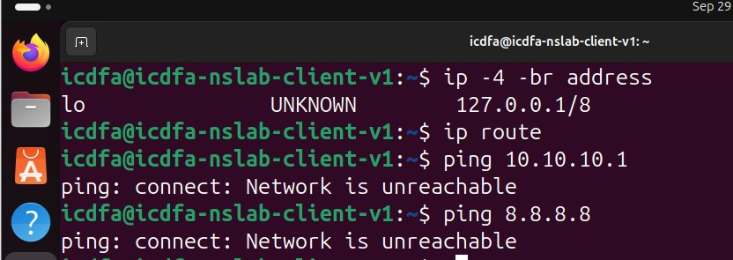
I used the command ip -4 -br address which only show a loopback no ens33 which means the vmware is not connected to ICDFA-LAN, which I powered off the vmware to select the LAN segment which is ICDFA-LAN Adapter 1 to be NAT and Adapter 2 to be LAN segment and I haved fixed it.
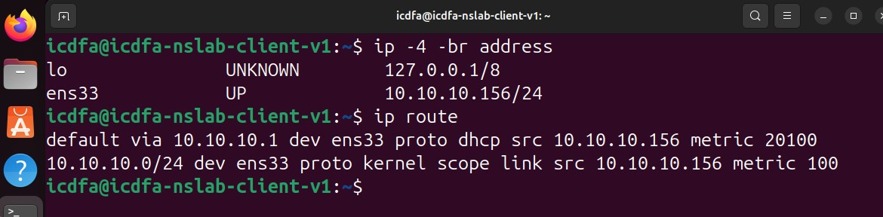
Here is the fixed one which shows the ens33 is UP and the ens33 is 10.10.10.156/24 and for the lo is 127.0.0.1/8
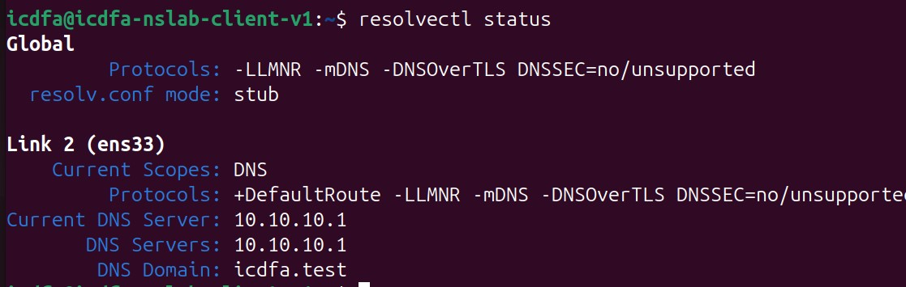

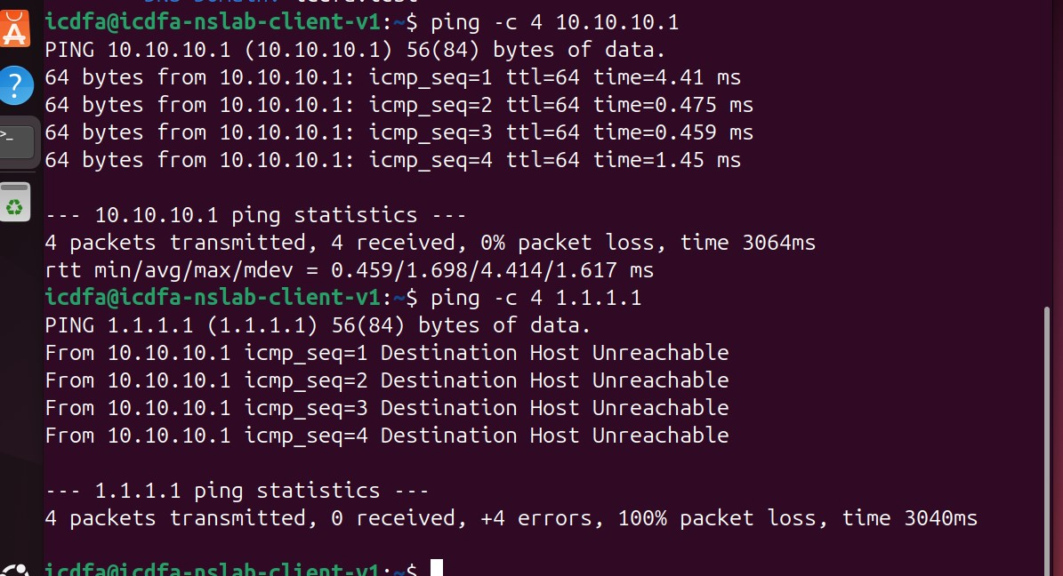
I used the ping -c 4 10.10.10.1 to test wether the network is reachable to the LAN which it proves that the ubuntu can reach the firewall LAN . and the second test failed is shows destination unreachable.
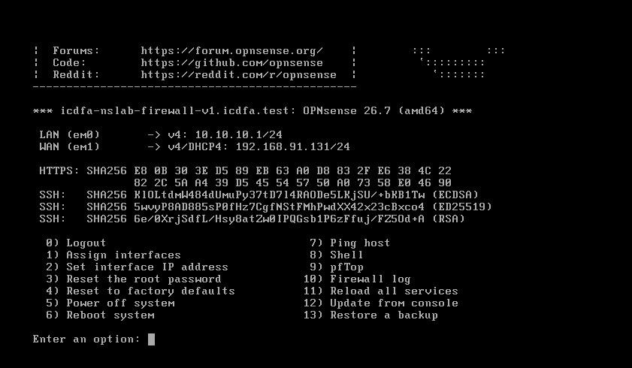
Here is the fixed one which shows both the WAN and LAN are there.
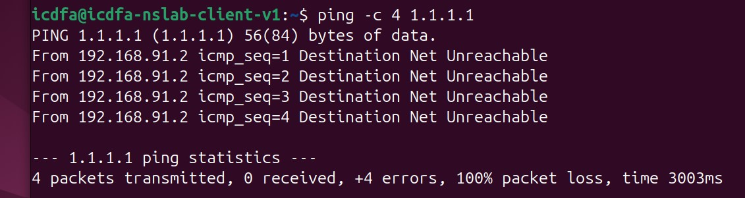
I still ping it to test the connection but it shows me that firewall has the WAN but not routing client traffic that’s the firewall blocked it. I also tried to test it in the firewall console which still cant be reach.

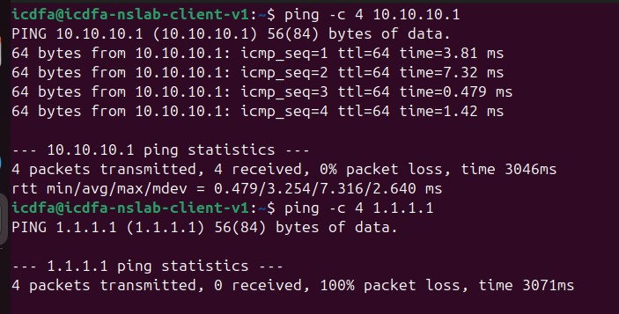
I went to the client VM I used this command ip addr add 10.10.10.10/24 dev ens33, to add the ip address after that I open the opnsense in firefox but the internet is working when I ping 8.8.8.8 but my phone hostspot is blocking from accessing the internet.

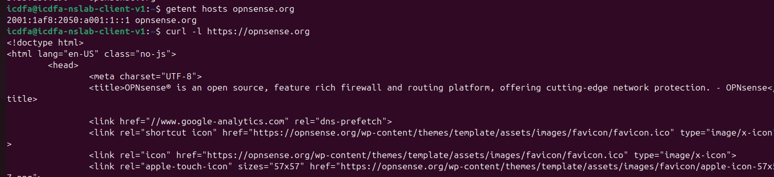
I used the command getent hosts opensense.org to test wether the DNS resolution is working.
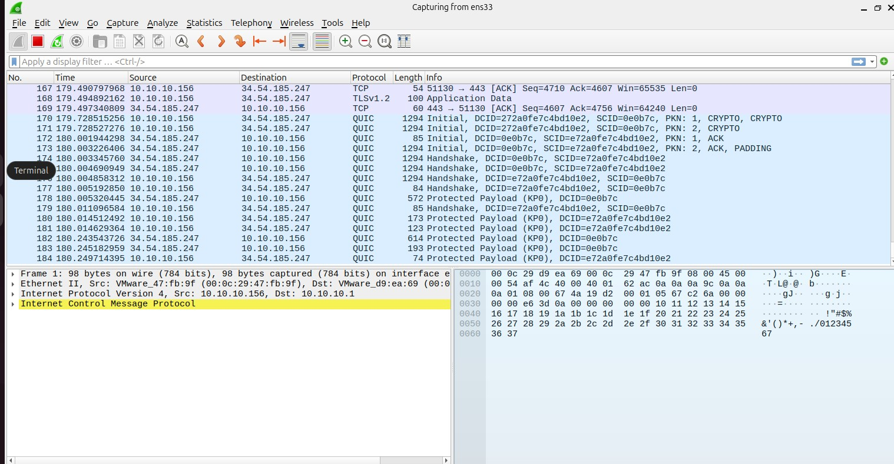
This shows icmp packets between client and host.

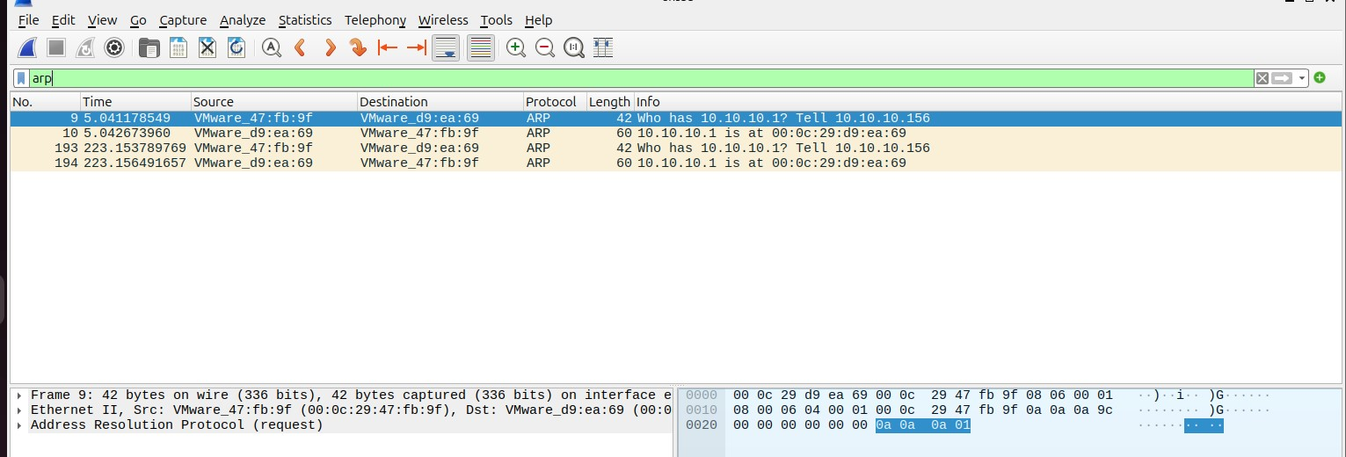
ARP is asking who the 10.10.10.1 address and it tells that its 10.10.10.156 this is how pc finds the MAC address of OPNsense firewall.

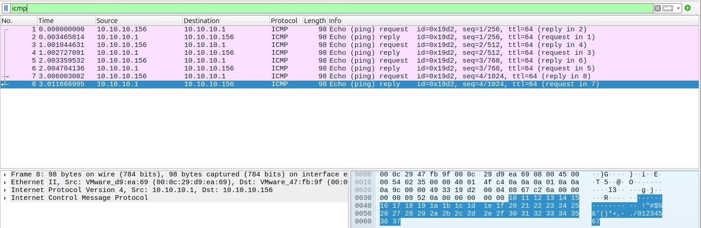
ICMP this is the actual ping test, it shows the request going out and reply coming back.
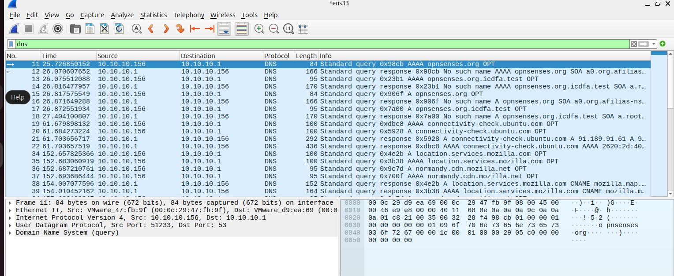
DNS is for dns resolutions the client 10.10.10.156 is asking the firewall 10.10.10.1 to resolve domain names .

