SHMtrace V2 – for Alberto review
22 October 2026
SHMtrace calls somatic hypermutation and other AID-driven mutation with a measured false-discovery rate
Abdulmateen Aderinto^{1,3}, Philip Barbulescu^{1,4} and Alberto Martin^{1,2,*}
¹Department of Immunology, University of Toronto, Toronto, ON M5S 1A8, Canada
²Lead contact
³Technical contact
⁴Present address: Structural Genomics Consortium, Toronto, ON M5G 1L7, Canada
*Correspondence: alberto.martin@utoronto.ca
Summary
Cloned-amplicon Sanger sequencing provides accurate but low-throughput measurements of somatic hypermutation (SHM). We developed SHMtrace to quantify substitutions and indels against background measured in matched activation-induced cytidine deaminase (AID)-deficient controls and compare mutation profiles across biological replicates. A Sanger workflow quantifies substitutions and reports control-derived background separately. Evaluation included planted mutations, recalled at observed false-discovery proportions of 0.050 and 0.045, simulated lineages, and twelve loci from eleven laboratories across four sequencing platforms. Across five nanopore assays, SHMtrace reduced substitution calls in AID-null controls by 64–90% relative to the uncorrected Geneious rule. In four assays, AID-active and AID-null libraries showed 66–141-fold separation in unique-variant density under the stated zero-call convention. Nanopore reads preserved mutation linkage across the amplicon and yielded substitution spectra similar to Sanger sequencing of the same mice. Further datasets extended analysis to engineered diversification and class-switch junctions. SHMtrace provides a reproducible framework for control-informed analysis of AID-associated diversification.
Keywords
somatic hypermutation, activation-induced cytidine deaminase, nanopore sequencing, variant calling, negative controls, false-discovery rate, pseudoreplication, immunoglobulin, mutation trees, Sanger sequencing
Introduction
Somatic hypermutation (SHM) diversifies immunoglobulin (Ig) genes in germinal-center B cells. It is initiated by activation-induced cytidine deaminase (AID), which deaminates cytosines in Ig DNA. Replication over the resulting uracils, together with uracil excision and mismatch repair, generates substitutions at G:C and A:T base pairs^{1–3}. Because each repair pathway leaves its own footprint, the frequency, position and spectrum of mutations are key readouts of AID activity and broader lesion processing^{4–7}. Relatedly, the mouse J_{H}4 downstream intron is widely used as a genomic reporter because it undergoes SHM without directly contributing to antigen binding^{8,9}.
AID activity read out from J_{H}4 amplicons can be measured on various sequencing platforms, each reporting a different kind of evidence. Cloned-amplicon Sanger sequencing reads one molecule at a time at high per-base confidence, though it yields only tens of sequences per animal¹⁰. Short reads typical of Illumina sequencers give depth but may not span the complete region¹¹. Long reads from ONT and PacBio span the J_{H}4, so mutations stay linked across the amplicon, and nanopore accuracy now reaches modal values above 99% with R10.4.1 flow cells^{12–14}; nanopore sequencing has also been used to sequence Ig genes, where consensus sequencing can absorb errors^{15,16}. What all platforms, however, share is the need to separate AID-driven mutation from their own error. A wild-type J_{H}4 intron carries roughly one mutation per 100 bases, whereas the residual error of a single filtered read, especially with nanopore, is within one or two orders of magnitude of that rate and is concentrated at particular positions and sequence contexts¹⁷.
Two common analysis practices make this problem worse. First, general-purpose low-frequency variant callers judge each base by its own quality score¹⁸, and the simple rules used in commercial software test candidates one at a time without correcting for the number of tests¹⁹. In the configurations evaluated here, neither measures the errors a particular library makes, so mismatches that recur at one position, from PCR, sequence context or a co-amplified paralog, can be counted as SHM mutations. Second, treating reads from the same animal as independent replicates overstates statistical certainty because multiple reads can derive from the same B-cell clone or PCR-amplified molecule²⁰. Matched AID-null libraries address technical background, whereas group comparisons must account for biological replication by using one summary value per animal. Existing SHM software summarises previously identified mutations^{21–23} but does not use matched AID-null controls to distinguish candidate variants from technical background.
Here we describe SHMtrace, which integrates variant calling calibrated against matched AID-null controls from the same sequencing run with mutation profiling and group comparisons across independent biological replicates, starting from delivered reads or Sanger chromatograms. We validated it with planted mutations, simulated lineages, twelve loci from eleven laboratories across four platforms, Sanger sequencing of the same mice, and deposited clones from three published Sanger studies, and compared it against LoFreq¹⁸, the long-read somatic callers ClairS²⁴ and DeepSomatic²⁵, the germline callers Clair3²⁶ and DeepVariant²⁷, and the uncorrected Geneious test¹⁹.
Results
SHMtrace calibrates substitutions against AID-null controls
SHMtrace starts from the files that a sequencing provider or core facility returns (Figures 1 and S1). Nanopore and Illumina reads are first filtered by length and expected error²⁸ and then aligned with minimap2²⁹ against the target together with competing references. Sanger chromatograms, by contrast, are assigned to animals through a sample sheet and trimmed to their high-quality core, and UMI-tagged reads can be collapsed to one consensus per molecule (STAR Methods).
The central step is the variant test (Figures 1A and 1C). For each substitution type, strand and base quality, SHMtrace measures how often the AID-null libraries of the same run show that change, and then asks whether a candidate is supported by more reads than this background explains. Because quality scores overstate certainty at the highest qualities (Figure S2), the control rates are multiplied by a margin chosen by leaving one control out at a time. The held-out controls then serve as decoys, in an approach inspired by target–decoy analysis³⁰, and SHMtrace keeps the most permissive cutoff at which estimated false calls are at most 5% of calls. This is an empirical estimate rather than a guarantee, since it relies on a few controls representing the samples' background. Finally, alleles carried by at least half the reads are set aside as likely germline or parental differences; because a mutation shared by a dominant lineage can cross the same threshold, this is a heuristic, and every excluded site is reported.
Because it weighs read support against measured background, the read-library test can retain a candidate supported by a single read; repeated sequencing of the same original molecule is not required. Sanger clones instead take a separate counting route (Figure 1C): every substitution at base quality ≥ 20 is counted, and the AID-null clones' mismatch rate gives the expected background, reported beside the counts rather than subtracted. The germline filter, window, automatic checks and animal-level comparisons are shared. The Sanger results below therefore test trace reading, counting, bookkeeping and group comparisons, not the control-calibrated test.
Two C-to-T candidates in an external wild-type Sμ library (WT3) illustrate how matched controls separate mutations from recurrent background (Figure 2). Both had support on both strands and similar base qualities. However, no control supported the substitution at position 165, within a WRC hotspot, at Q≥20, whereas the substitution at position 97 recurred in the controls. SHMtrace therefore retained position 165 (p = 5 × 10⁻¹⁹) and rejected position 97 (p = 1). Across WT3, 88 of 743 candidates met the threshold (p ≤ 0.009).
Downstream, SHMtrace compares groups using one summary value per biological replicate, with Welch tests on log-transformed rates, bootstrapped negative-binomial tests and permutation tests (Figure 1D). It also describes spectra, hotspot use, S5F targeting²³ and clustering, estimates uncalled single-read mutations in aggregate, groups reads into junction-defined clones and reconstructs read-level trees (Figure S3). The desktop and command-line interfaces share one analysis engine.
Planted mutations and simulated lineages quantify recall and false calls
We planted 60 AID-weighted substitutions into each held-out control library, preserving base qualities and assigning 1–20 supporting reads per site, with three repetitions per control (Figure 3). On J_{H}4, SHMtrace recalled 81% overall and 95% among events supported by at least three reads, with 2.6 false calls per library (observed false-discovery proportion, FDP, 0.050). In contrast, Geneious recalled more single-read mutations (60% versus 31%) but produced 4.9 false calls per library (FDP 0.083). Default LoFreq recalled none; disabling its short-read-oriented base-alignment quality correction yielded 34% recall, restricted to mutations with at least five supporting reads. Permissive settings increased recall to 56% with 4.4 false calls per library (Figures 3A and 3D).
We also gave the long-read somatic callers ClairS²⁴ and DeepSomatic²⁵ the other AID-null libraries as matched normals. Neither recovered planted mutations at default settings, and even with permissive settings ClairS recovered none of 2,160 substitutions, while DeepSomatic recalled 19%, 18%, 5% and 3% on J_{H}4, N114 V_{H}, Sμ and Pim1, respectively. Their recall improved at higher allele fractions (Figure 3C), but real SHM mostly lies below that range: 53% of 1,197 retained SHMtrace calls occurred in <1% of reads (Figures 2E and 3C). The germline callers Clair3 and DeepVariant recovered none, consistent with their intended use (Table S1).
On N114 V_{H}, SHMtrace recalled 90% of planted substitutions, including 58% supported by one read, with 2.6 false calls per library (FDP 0.045; Figure 3B). Here Geneious performed similarly, recalling 88% with 2.8 false calls (FDP 0.050), whereas LoFreq without base-alignment quality recalled 34%. On external Sμ and Pim1 controls at 2,000 reads, SHMtrace recalled 63% and 72% at FDP 0.055 and 0.035, compared with 59% and 64% for Geneious at FDP 0.114 and 0.050; LoFreq recalled 0–26%, with permissive FDP 0.27–0.52 (Figure 3D). To isolate what the controls contribute, two ablations used the same libraries. Without controls, a read-quality test made 5.7–46.6 false calls per library; testing each site against its control error rate instead made 1.3–2.8, but recalled only 27–64%, against SHMtrace's 63–90% (Table S1). Measured background therefore removes most false calls, and the calibrated test recovers the sensitivity a simple per-site comparison loses.
We then called the same libraries at targets from 1% to 30% to test whether the threshold delivers the rate it targets. At the default 5%, the pooled false-discovery proportion was 3.5–5.5% across the four loci, and looser targets stayed at or below their stated rate except J_{H}4 at 10% (13.8%) (Figure S4A). Targets below 5%, however, did not deliver their stated rate on J_{H}4, Sμ or Pim1 (2.0–6.1% at a 1% target; N114 V_{H}, 0.5%): false calls per library levelled off while recall fell, from 81% to 17% on J_{H}4 (Figures S4B and S4C).
Because everything rests on the controls, we next varied them through the whole procedure on J_{H}4 (Figure S5). One control leaves no decoys, so the threshold falls back to Benjamini–Hochberg; it recalled 68% of planted lineage mutations, against 93% with two controls and 95% with three or four, with false-discovery proportions of 2.8–3.1% for the two- to four-control designs. All-null libraries yielded no calls with any number of controls (40 runs), and one control carrying recurrent artifacts changed false calls little, with or without the noisy-control rule. On Sμ, AID-null controls from a second experiment performed like the matched controls (66–68% versus 63% recall), and pooling all five lowered false calls from 2.2 to 0.8 per library.
Planted mutations lack the clonality and clustering of real SHM, so we also diluted real hypermutated reads into AID-null reads (Figure S6). On N114 V_{H}, mutation frequency was 0.87–0.97 of the expected value at 25–50% donor reads, and calls were made from 1–5% donor reads. On J_{H}4, in contrast, detection was all-or-nothing and depended on the donor: calls began at 2% donor reads for Wt3 and at 50% for Wt2, with no call below that.
Indels were validated in the same way, with ten planted insertions or deletions of 1–40 bp per library, supported by 1–20 reads, eight draws per control and error models fitted to the other controls. Among events supported by at least three reads, recall was 72% on J_{H}4 and 91% on N114 V_{H}, with 0.33 and zero false calls per library; events supported by one or two reads fall below the three-read requirement. Single-base homopolymer deletions in J_{H}4 were the least reliably recovered (19%), whereas recall was 100% for 2-bp insertions and 89% for deletions ≥10 bp (Figure S7).
We next simulated approximately 40 B-cell clones per J_{H}4 library, with clone sizes following a power-law distribution (Figure S8A). SHMtrace recalled 83% of single-read mutations versus 57% for Geneious, with FDP 0.037 versus 0.012 and 13.7 versus 4.0 false calls per library. In null libraries, false calls averaged 0.7 versus 4.3. When an unmutated clone contributed 60% of reads, read-weighted frequency was 6.2 versus a true 6.0 per 10³ bp, while the majority-rule clone-weighted measure recovered 94% of its corresponding true burden (14.6 versus 15.5; Figure S8B).
Because that dominant clone was unmutated, it could not trigger the ≥50% allele filter. When we repeated the simulation with a mutated dominant clone, nothing was lost at 40% abundance, but all mutations crossing the threshold at 60% or 80% were removed, and read-weighted and clone-weighted estimates fell by as much as 62% and 34%, respectively (STAR Methods). Excluded sites are therefore reported for inspection.
At 500 reads per library, read-weighted mutation frequencies were within 2% of the simulated values (Figure S8C). Unique-variant density was less consistently recovered, because it counts each distinct substitution once: as depth increases, additional reads carry mutations already counted, enlarging the denominator without adding variants. Adding the aggregate estimate of uncalled single-read mutations restored 96–100% of the true density (Figures S8C and S8D). Comparisons of unique-variant density therefore require matched sequencing depth.
Finally, we asked whether the group tests hold their stated error rate. In 300 simulations per condition, with a between-animal coefficient of variation of 1, pooled-read tests returned p < 0.05 in 91% of 3-versus-3 and 94% of 5-versus-5 experiments without a true difference (Figure S8E), whereas negative-binomial rejection rates were 5.0% and 5.7%. With three animals per group, however, that test detected two-fold and four-fold changes in only 12% and 30% of simulations, illustrating the limited power at this sample size.
Matched controls set the background in real libraries
We next compared callers on real libraries with matched AID-null controls (Table S2; Figure 4). These included our J_{H}4 intron libraries from germinal-center B cells of three wild-type (Wt) and three Aicda^{−/−} mice, N114 hybridoma subclones transduced with AID or empty vector, and two loci in three assay contexts from an independent laboratory's public nanopore dataset: the Sμ switch region in LPS-activated B cells and in CH12 cells, and the AID off-target gene Pim1. Every caller analysed exactly the same reads (Table S3).
Across these assays, SHMtrace retained 1–4 calls in the three controls, compared with 5–20 for Geneious (Figures 4A–4E and 4G). As a result, geometric-mean unique-density separation, with zero-call controls assigned one-event values, reached 141-, 85-, 66- and 94-fold for J_{H}4, N114 V_{H}, primary-cell Sμ and CH12 Sμ, respectively, compared with 16–62-fold for Geneious and 2–40-fold for LoFreq configurations (Figure 4F). At 500 reads, J_{H}4 and N114 V_{H} had reached 90% and 59% of the most each library yielded at any depth, without establishing saturation (Figures S9 and S10). Background mismatches were position-dependent, yet separable from the abundant clone-shared calls of Wt libraries (Figure S11).
Repertoire tools meet the same background from the other side. When the same N114 V_{H} reads were analyzed by IgBLAST³¹ and SHazaM²², which count every mismatch to the germline (Figure S12), the AID libraries were only 2-fold above the empty-vector libraries with the IMGT germline, because the parental line differs from it (99.3% identity) and sequencing errors count as mutations. Using the parental V as germline raised this to 6-fold, and masking bases below Q20 to 32-fold, compared with 188-fold for SHMtrace.
Not every locus separated so clearly. At Pim1, mutation calls in AID-competent libraries remained close to the AID-null background: at 2,000 reads per library, SHMtrace yielded 1.8-fold separation, with four calls across the controls, compared with 1.6-fold and eleven control calls for Geneious. Increasing depth to all available reads (3,238–3,447 per library) did not clearly resolve the signal, with SHMtrace detecting 3–10 variants per AID-competent library and 0–3 per AID-null library, and Geneious 5–7 and 0–4, respectively (Table S1).
Two CH12 AID off-target loci, off-target 1 and off-target 2, then tested a genetic perturbation expected to reduce AID targeting³². Off-target 1 Wt libraries carried 69, 50, and 55 calls versus 0, 2, and 0 in Aicda^{−/−} controls, with densities of 3.07 versus 0.04 per 10⁵ bases (Welch p = 9.7 × 10⁻⁴ on log density). Off-target 2 counts were 42, 28, and 23 versus 2, 0, and 0, with densities of 1.68 versus 0.04 (p = 5.5 × 10⁻⁴), and G:C substitutions accounted for 97% of calls at both loci. MLLT1/MLLT3 double knockout reduced counts to 2, 0, and 2 at off-target 1 (0.07 per 10⁵ bases) and 1, 0, and 0 at off-target 2 (0.02), with no detected difference from Aicda^{−/−} controls (p = 0.51 and 0.43). We report no fold here, because a zero-count convention would determine its magnitude.
These results depend on the error margin chosen from the controls. Without it, 5.4% of J_{H}4 and 9.6% of N114 V_{H} held-out control tests fell below p < 0.01; margins of five for the shared J_{H}4 window and ten for full-length J_{H}4 and N114 V_{H} reduced these to 1.0%, 0.7% and 0.5%, respectively (Figure 4H). The margin calibrates the error model, whereas the separate decoy threshold estimates the false-discovery proportion.
SHMtrace-generated nanopore and Sanger profiles agree in matched mice
SHMtrace processed 182 Sanger chromatograms from the six nanopore-sequenced mice, retaining 134 clones after alignment and sequence-quality filtering for comparison across the shared 529-bp window (Figures 5 and S13). SHMtrace-derived mutation profiles distinguished Wt from Aicda^{−/−} mice on both platforms: Sanger showed 38-fold separation (p = 8.8 × 10⁻⁴), and nanopore showed 141-fold separation when zero-call controls were assigned one event (p = 0.0027; Welch tests on log densities, n = 3 mice per group). Pooled substitution spectra were similar across the twelve substitution types (descriptive Pearson r = 0.92; slope = 0.97), as were positional profiles in 25-bp bins (r = 0.94). Among G:C mutations, 58% of Sanger and 54% of nanopore calls occurred at WRC/GYW hotspots, which accounted for 20% of eligible sites in the window. Among A:T mutations, 70% and 69%, respectively, occurred at WA/TW motifs, compared with 50% of eligible sites. No platform-by-substitution-type interaction was detected (p = 0.62), although this does not establish equivalence with three mice per group. Both densities count distinct variants but are not directly comparable: Sanger counts every Q≥20 change in 26–40 single clones, nanopore counts control-calibrated calls among 500 reads that resample expanded clones.
Sanger reanalysis recovers published comparisons and identifies discrepancies
We next re-analysed published Sanger data. A J_{H}4 study had compared four Wt and four Maea^{fl/fl}Mb1^{cre} mice with Aicda^{−/−} controls using SHMTool^{21,33}. From its chromatograms, SHMtrace recovered a 4.6-fold frequency reduction, against 4.4-fold in the publication (one-tailed p = 2.3 × 10⁻⁴ and 0.0143; Figure S14). Spectra correlated at r = 0.99, and denominator-harmonized frequencies averaged 1.0-fold the published values. Shared trace assignments and identical mutated-clone pairs were retained as filed and flagged; the detailed discrepancies are in Table S4 and STAR Methods.
A second study from the same laboratory agreed on frequency but less closely on the knockout spectrum. Reanalysis of its 402 Mkln1-study chromatograms³⁴ found an 8.0-fold frequency reduction versus the published 7.8-fold (p = 0.0038 and 0.014), and G:C transversions increased from 15% to 29%, against 16% to 27% in the published tables (p = 0.0078 and 0.0040). Spectrum correlations were r = 0.97 for Wt and 0.62 for knockout (Figure S15; Table S4).
Because both of those studies come from the laboratory that produced our libraries, we also re-analysed a Sanger study from an unrelated laboratory at a different locus. Thientosapol et al. hypermutated a SW_{HEL} V_{H}10 knock-in V region in germinal-centre B cells and deposited 1,795 sequences across five arms³⁵ (Figure S16). From these records alone, SHMtrace counted 2,804 of the 2,809 mutations the study tabulates (r > 0.9999 across 60 spectrum cells), and mutations per sequence agreed to two decimal places in every arm. The four substitution classes the study tested moved as reported, and total mutation decreased in both analyses, although significance differed under the different tests used. Reassuringly, the Msh2^{−/−} arm, which SHMtrace was not told was a repair mutant, showed the expected collapse of A:T mutations. Because this study deposits sequences rather than chromatograms, it tests counting, spectra and group statistics but not trace reading.
Long reads retain whole-amplicon profiles and within-lineage linkage
Nanopore sequencing extended SHMtrace analysis of the J_{H}4 intron from the shared 529-bp Sanger window to a 1,141-bp interval spanning positions 90–1,230 (Figure 6A). Across this longer interval, Wt unique-variant density was 229-fold above controls. Approximately 69% of mutations occurred within the first 450 bp, with a seven-fold decline between the first and last 250 bp, consistent with the reported decline downstream of V(D)J⁹. Substitution spectra across the full interval closely matched those within the Sanger window (Pearson r = 0.989; Figure S17).
Wt mutations preferentially occurred at positions predicted to undergo SHM by the S5F model, which assigns mutability according to the surrounding five-base sequence. The targeting index, defined as mean predicted mutability at mutated positions divided by the mean across the analysis window, ranged from 1.22 to 1.36, indicating 22–36% enrichment over the window average (permutation p ≤ 0.015). Calls per position were also 4.1-fold higher in the highest-mutability quintile than in the lowest (Figure 6B). In contrast, Aicda^{−/−} mismatch positions showed no enrichment (index = 1.00; p = 0.50). Because S5F mutability is not used in the variant-calling test, this analysis provides a separate check that the detected mutations follow an SHM-associated targeting pattern.
Long reads also keep each molecule's junction, which groups reads into B-cell lineages (Figure 6C). In Wt2, one largely unmutated lineage accounted for 81% of junction-assigned reads, so the read-weighted frequency of 2.8 per 10³ bp rose to 16.3 when each lineage's majority-rule mutation profile was counted once. Wt3 and Wt4 changed less (22.5 to 24.9 and 4.9 to 5.3). The largest Wt3 lineage comprised 69 reads and four founder mutations, with five inferred sublineages extending to 17 mutations (Figure 6D). Without UMIs, however, PCR recombination and residual errors remain possible, so these are read-level reconstructions rather than proven cellular lineages.
Public datasets test transfer across platforms and experimental designs
To test transfer beyond nanopore, we analysed three public Illumina studies of different biological contexts (Figure 7). At J_{H}4 positions 53–122, Wt mice showed 56-fold greater mutation frequency than AID-null mice (log-rate Welch p = 0.005; n = 7 and 4), whereas Ldha deletion showed no detectable difference from Wt (Mann–Whitney p = 0.75), consistent with the original study³⁶ (Figure 7A).
In Aicda^{−/−}Ung^{−/−}Msh2^{−/−} CH12F3 cells, ectopic AID increased frequency 40-fold over empty vector (p = 0.00781; n = 4 each), with one control call in 20,000 reads³⁷. All AID calls were C→T/G→A, consistent with loss of uracil excision and mismatch repair; R50E yielded none (Figure 7B). R174E/R178E appeared more active but gave only 17% transitions, a 56% cluster within positions 164–172 and targeting index 0.73 versus 2.46 for AID. These features suggest a library-specific artifact absent from controls (Figure 7C). Establishing its source would require additional sequencing provenance or independent material.
HMCES-deficient Ramos clones³⁸ carried 3.8-fold more deletions and 2.5-fold more insertions than Wt clones (deletions, p = 1.0 × 10⁻⁴; n = 6 per group; Figure 7D). Substitution calling in this deposit, however, depended strongly on one noisy AID-null library. After inspecting this dataset, we developed a rule that excluded it from threshold selection while retaining it for model fitting and reporting the exclusion. With this adjustment, Wt and HMCES-deficient clones yielded 52–99 substitution calls each, whereas treating the noisy library as a sample instead yielded 277–413. Control assignment thus materially affects the inferred substitution burden here (STAR Methods), and the same rule also acted in the mOrange analysis.
A published mOrange reporter study compared active and catalytically inactive AID in cells carrying an empty vector, Ugi or UNG³⁹. Using the inactive-AID libraries to calibrate calling, SHMtrace retained 115 substitutions, all at G:C and 75–100% at WRC/GYW hotspots (Figure 7E). Separation between active and inactive AID was 20-fold with empty vector, 1,002-fold with Ugi and 103-fold with UNG, with Ugi zeros assigned one event. Among retained substitutions, the transition share fell from 95% with Ugi to 4% with UNG, whereas uncorrected inactive-AID backgrounds contained 43–66% transitions. The paired mean difference was 92 percentage points (95% CI 74–110; paired t, p = 0.0021), although few calls per library limit precision.
Two engineered-diversification datasets extended the evaluation to mutations measured relative to experimental starting constructs (Figure S18). In a study using a common GFP substrate⁴⁰, no-editor libraries yielded at most one call in 20,000 reads. AID substitutions were more frequently located at WRC/GYW hotspots than APOBEC3A substitutions, both in Wt cells (56% versus 14%; p = 0.0040) and in UNG/MSH2-deficient cells (37% versus 20%; p = 9.0 × 10⁻⁴). In the repair-deficient background, however, their transition shares were similar (78% versus 76%; p = 0.74), showing that transition enrichment alone could not distinguish the two enzymes.
The second engineered dataset, a CRISPR-X antibody-evolution study, diversified an antibody V_{H} and published the mutations it found in each selected cluster⁴¹. Comparing the two lists position by position, SHMtrace recovered 150 of the 150 published mutations and called none the authors did not, across all 42 cluster entries (Figure S18B). Because the comparator is an independently curated list rather than another run of the same software, this is the sharpest available test of variant identity on this route.
Two further datasets tested transfer to another laboratory's switch-region libraries and to a fourth platform, and showed where a deposit limits what can be asked. Sμ libraries under PI3Kδ inhibition⁴² confound genotype with library layout: six of nine wild-type libraries are single-end whereas every Aicda^{−/−} library is paired, and the mates do not overlap, so only the twelve paired libraries reach the switch repeats where AID acts (Figure S19). Analysed over those repeats, the nine Aicda^{−/−} libraries returned one call between them against 81–172 per wild-type library (p = 0.0021), and the wild-type calls carried the AID signature: targeting index 1.52–1.67 and 31–35% C→T or G→A. The calibration therefore transfers to an independent laboratory, platform and perturbation. The drug comparison does not follow from this deposit, because only one wild-type replicate per treatment reaches the repeats.
Finally, PacBio Sμ–Sγ1 reads⁴³ carry the donor, the join and the acceptor on one molecule, so we applied the junction module to a class-switch phenotype it was not tuned for (Figure S20). Mean microhomology was 1.01 nt in wild type and unchanged in Shld1^{−/−} (1.02 nt), but rose without XLF (1.69 nt) and in double mutants (1.59 nt), which also showed more ≥4-nt microhomology and fewer blunt junctions; Shld1^{−/−} junctions instead carried more insertions. This is the shift toward microhomology-mediated end joining expected when classical non-homologous end joining is impaired.
Discussion
Measuring somatic hypermutation has long meant choosing between reading molecules accurately and reading enough of them. Our results suggest that this choice is no longer necessary, provided the background is measured rather than assumed. SHMtrace takes whatever a platform delivers, reads or chromatograms, and replaces the two assumptions that make low-frequency calling from single reads unreliable for SHM. First, rather than relying on quality scores alone, it estimates the background in the AID-null libraries that SHM studies already include, at the level of substitution type, strand and base quality, and checks that calibration by holding out each control in turn. Second, instead of treating reads as replicates, it tests independent biological samples. Both replacements held: 81% of planted J_{H}4 mutations and 90% on N114 V_{H} were recovered at false-discovery proportions near the default target, while a quality-based caller either missed most true mutations or, made permissive, called as much background as the uncorrected rule, and pooling reads produced false positives in more than 90% of simulated experiments without a true difference.
The gap this fills is specific, and it sits between two mature bodies of software. Repertoire toolkits identify and summarise mutations well: IgBLAST assigns germlines³¹, Change-O and SHazaM quantify load²², SHMTool compares datasets²¹, and S5F models targeting²³. They begin, however, from mismatches already taken to be real, which is why counting every mismatch on the same N114 reads separated AID from empty-vector libraries by 2- to 32-fold, depending on germline and masking, where SHMtrace separated them by 188-fold. General-purpose variant callers do the opposite: they decide what is real, but from error models fitted to data of a different kind. LoFreq reads base qualities¹⁸, while ClairS and DeepSomatic were developed for tumour–normal sequencing, with different training data and calling assumptions^{24,25}. As configured here, neither class measures what a particular SHM library does wrong. SHMtrace closes that circuit by making the AID-null control, where available, the source of the error model, and by carrying the measurement through to the animal-level comparison that the biology requires²⁰. Its distinctive contribution is therefore to connect control-informed mutation detection with interpretable profiles and comparisons across biological replicates in one reproducible workflow.
Seen this way, comparator performance is a matter of operating range rather than quality. LoFreq was designed for deep short-read data with calibrated qualities; its base-alignment correction suppressed nearly all nanopore calls here, and disabling it still limited recovery of low-support variants. That is not a defect on its intended data; rather, as configured here, it did not capture this assay's library-specific background as well as matched-control calibration did. The measurements suggest why. Above Q40, control error stopped decreasing and differed across the evaluated datasets (1–9 × 10⁻⁵; Figure S2), so the quality score runs out of information exactly where SHM calling needs it. ClairS and DeepSomatic, similarly, recovered clean variants at higher allele fractions but few real SHM calls, and chemistry and model mismatches further qualify the external-data comparisons. Geneious, in turn, provided greater single-read recall on J_{H}4 and Pim1 but more false calls on each amplicon. These are choices a study can make deliberately: sensitive mode raises the empirical target to 0.20 and recovers 72% of single-read mutations on J_{H}4 and 87% on N114 V_{H} at observed FDP 0.18 and 0.16, while events unresolved individually can still be estimated in aggregate.
Because the background is measured rather than modelled, one framework serves all four platforms, each through the analysis its data support. A Sanger clone is one molecule read once, so there is no read support to weigh against a background; the workflow therefore counts quality-filtered substitutions directly and reports the control-derived background beside them. Nanopore and Illumina libraries, by contrast, carry matched AID-null arms, so each candidate is tested against the errors those controls make. Nanopore spans the whole amplicon, which made the 3′ decline visible without tiling, identified clones from the V(D)J junction and ordered their mutations into trees; Illumina gives depth without that linkage. PacBio combines length with per-base accuracy, and reading the donor, the join and the acceptor on one molecule recovered a known end-joining phenotype from a deposit with no AID-null arm, using junction shape in place of calibrated calls. Figure S21 sets out what each measured. Agreement between platforms is itself evidence: nanopore and Sanger reads from the same six mice gave substitution spectra correlated at r = 0.92 and separated the genotypes in the same direction, supporting the use of cloning-free long reads to recover established SHM patterns while adding whole-amplicon linkage.
Applying the same engine to other laboratories' data turned out to be a harder test than any internal benchmark. Published sequence collections support reproducible reanalysis when clones are linked to animals and genotypes: SHMtrace recovered the principal J_{H}4 frequency and G:C comparisons, matched SW_{HEL} counts across five arms and twelve substitution types (2,804 of 2,809 tabulated mutations; r > 0.9999), and recovered 150 of 150 mutations an antibody-evolution study curated by hand, calling none its authors did not. Agreement was not complete, and the exceptions are as informative: Wt frequencies differed after denominator harmonisation, the published Mkln1 A:T decrease was not significant in the reanalysis, and the SW_{HEL} total-mutation inference differed under a different test (Tables S4 and S5; Figures S14–S16). The Sanger re-analysis also surfaced bookkeeping problems, which SHMtrace now checks and reports rather than silently resolving.
What this enables in practice is a short experiment-to-answer path that keeps its own evidence: read accounting, fixed-seed sampling and one engine behind the desktop and command-line interfaces, with every exclusion, threshold and flagged site written out for inspection. The power analysis sets the honest expectation. How many animals a study needs depends on the difference it seeks: under variation estimated from three Wt J_{H}4 mice, the AID-competent against AID-null contrasts made here separate at three animals per group, whereas a two-fold difference between two AID-proficient groups would require about 24, and more if three mice underestimate the variation (Figure S8F). Sequencing depth cannot substitute for independent biological samples, and no analysis can recover a comparison the design did not support. Within that boundary, however, the framework extends readily. It needs only a target, matched AID-null libraries and a sample sheet, which is why it could be applied to off-target loci, switch regions, engineered diversification and base-editor substrates across twelve loci from eleven laboratories. Further validation on independently prepared runs and UMI-tagged SHM libraries will establish how far it extends. More broadly, SHMtrace offers a practical foundation for studying how AID targeting and DNA repair shape antibody diversification.
Limitations of the study
SHMtrace relies on representative AID-null controls prepared and sequenced alongside the samples. Error profiles can vary between runs and basecalling configurations, and calibration using controls from a different run was not evaluated. With one nanopore run per assay, the present results do not establish performance across independent runs.
The reported variants remain subject to technical uncertainty. Without UMIs, early PCR errors, recombination and repeated sequencing of PCR-derived molecules cannot be reliably distinguished from genuine mutations or expanded biological lineages. Mutation trees therefore describe relationships among reads rather than independently established cellular lineages. The default ≥50% allele-frequency filter can also remove genuine mutations shared by a dominant lineage. Excluded sites are reported for review, and experiments with a known starting sequence can use an optional reference policy that retains high-frequency differences. Single-read mutations that cannot be called individually are estimated only in aggregate, and unique-variant densities require comparison at matched sequencing depth.
The empirical false-discovery estimate depends on the available controls and can exceed its nominal target when background differs between libraries. Noisy-control exclusion requires at least three controls, and its effect should be reviewed. Sample-specific artifacts absent from the controls may still pass the test; spectrum and clustering flags can identify unusual patterns but require interpretation. At weakly mutated targets such as Pim1, signal remained close to background.
The core validation used three animals per group for J_{H}4 and one locus per cell system. Settings were developed using these libraries and applied to public datasets without dataset-specific retuning, although the noisy-control exclusion rule was introduced after inspection of the Ramos results. Evaluation on an independent sequencing run with new biological samples would provide a stronger test of generalizability. Indel validation comprised nanopore spike-ins and one Illumina biological phenotype, while UMI validation used rRNA rather than SHM data. These experiments do not establish performance on biological nanopore indels or UMI-tagged SHM libraries; molecule-level consensus remains preferable when available. Two Sanger studies originated from the authors’ laboratory, while the independent Sanger study provided sequences without chromatograms or AID-null controls. Together, these datasets evaluate distinct parts of the workflow, with different limits on the conclusions each can support.
Resource availability
Lead contact
Requests for further information and resources should be directed to and will be fulfilled by the lead contact, Alberto Martin (alberto.martin@utoronto.ca).
Materials availability
This study did not generate new unique reagents.
Data and code availability
Nanopore reads of the J_{H}4 and N114 V_{H} libraries, the Sanger chromatograms and clone records, SHMtrace project files, per-library read accounting and all benchmark outputs will be deposited at [data deposit DOI] and will be publicly available as of the date of publication; accession numbers are listed in the key resources table. The public datasets analyzed are listed in Table S2 and the key resources table. SHMtrace (v0.2.2), including the desktop application, and all analysis and figure code will be deposited at [SHMtrace Zenodo DOI] and will be publicly available as of the date of publication. The deposit carries a file manifest with SHA-256 checksums, the sample sheets, the per-library read accounting, and the intermediate tables each figure reads. It also carries a record of the environment the analyses were run in (interpreter, package and external-tool versions, and the commit the manuscript was built from) and a table giving, for every figure, table and quoted number, the command that produced it with its inputs and outputs, so that each displayed value can be traced to one file without reading the prose. Alignment uses the mappy bindings; the LoFreq comparison uses the standalone minimap2 executable, and the key resources table gives both versions. Any additional information required to reanalyze the data reported in this paper is available from the lead contact upon request.
Acknowledgments
We thank the University of Toronto flow cytometry facility and members of the Martin laboratory for discussions. Long-read sequencing was performed by Plasmidsaurus, and cloned-amplicon Sanger sequencing by The Centre for Applied Genomics (SickKids, Toronto). This work was supported by the Canadian Institutes of Health Research (PJT-180269).
Author contributions
Conceptualization, A.A. and A.M.; methodology, A.A.; software, A.A.; validation, A.A.; formal analysis, A.A.; investigation, A.A. and P.B.; data curation, A.A.; writing – original draft, A.A.; writing – review & editing, A.A. and A.M.; visualization, A.A.; supervision, A.M.; funding acquisition, A.M.
Declaration of interests
The authors declare no competing interests.
Declaration of generative AI and AI-assisted technologies in the manuscript preparation process
During the preparation of this work, the authors used Anthropic Claude and OpenAI Codex to assist with drafting the analysis and figure code, language editing and figure layout. After using these tools, the authors reviewed and edited the content as needed and take full responsibility for the content of the published article.
Supplemental information
Document S1. Figures S1–S24 and Tables S2–S7
Table S1. Caller comparison: the five calling settings on real libraries in Figure 4, and planted-mutation results for all tested callers and two SHMtrace ablations (Excel)
Data S1. Benchmark outputs (JSON) and SHMtrace project files for every analysis
Figure titles and legends
Figure 1. SHMtrace tests read-library variants against controls and counts Sanger substitutions separately. (A) Quality-based and control-calibrated decisions, drawn schematically. (B) Inputs and read preparation. (C) Read libraries are tested against a control-fitted error model with an empirical, decoy-based threshold, and single-read support is allowed. Sanger Q≥20 substitutions are counted, with expected background reported beside them rather than subtracted. Both routes share the window, quality checks and the heuristic ≥50% allele exclusion. (D) Outputs, with comparisons across biological replicates. PacBio reads are analysed for junction structure only.
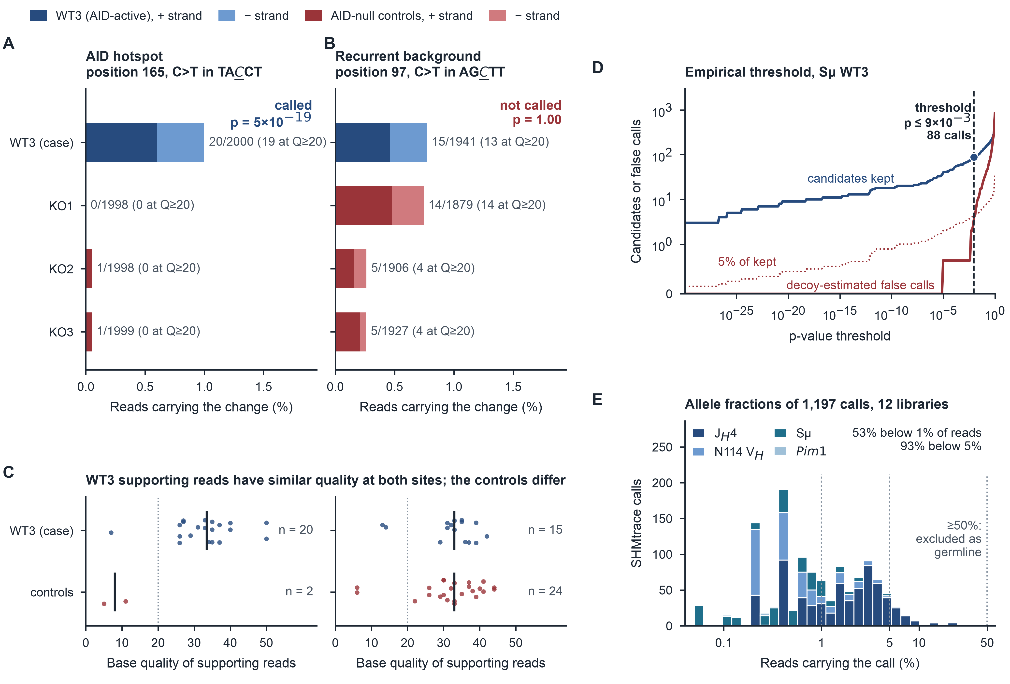
Figure 2. Matched controls distinguish candidate substitutions from recurrent background. (A, B) Support for two C-to-T candidates, at a hotspot (A) and a recurrent-background position (B), in Sμ WT3 and its three AID-null controls (PRJNA1481264; 2,000 reads per library). Counts include all qualities, with Q≥20 subsets in parentheses; p, SHMtrace's test. (C) Base qualities of the supporting reads; bars, medians. (D) Candidates kept and decoy-estimated false calls across p-value thresholds; the threshold is the largest at which the estimate stays within 5% of the candidates kept, an empirical estimate rather than a guaranteed FDR. (E) Allele fractions of 1,197 retained calls in 12 AID-active libraries. See Figures 3C and S2.
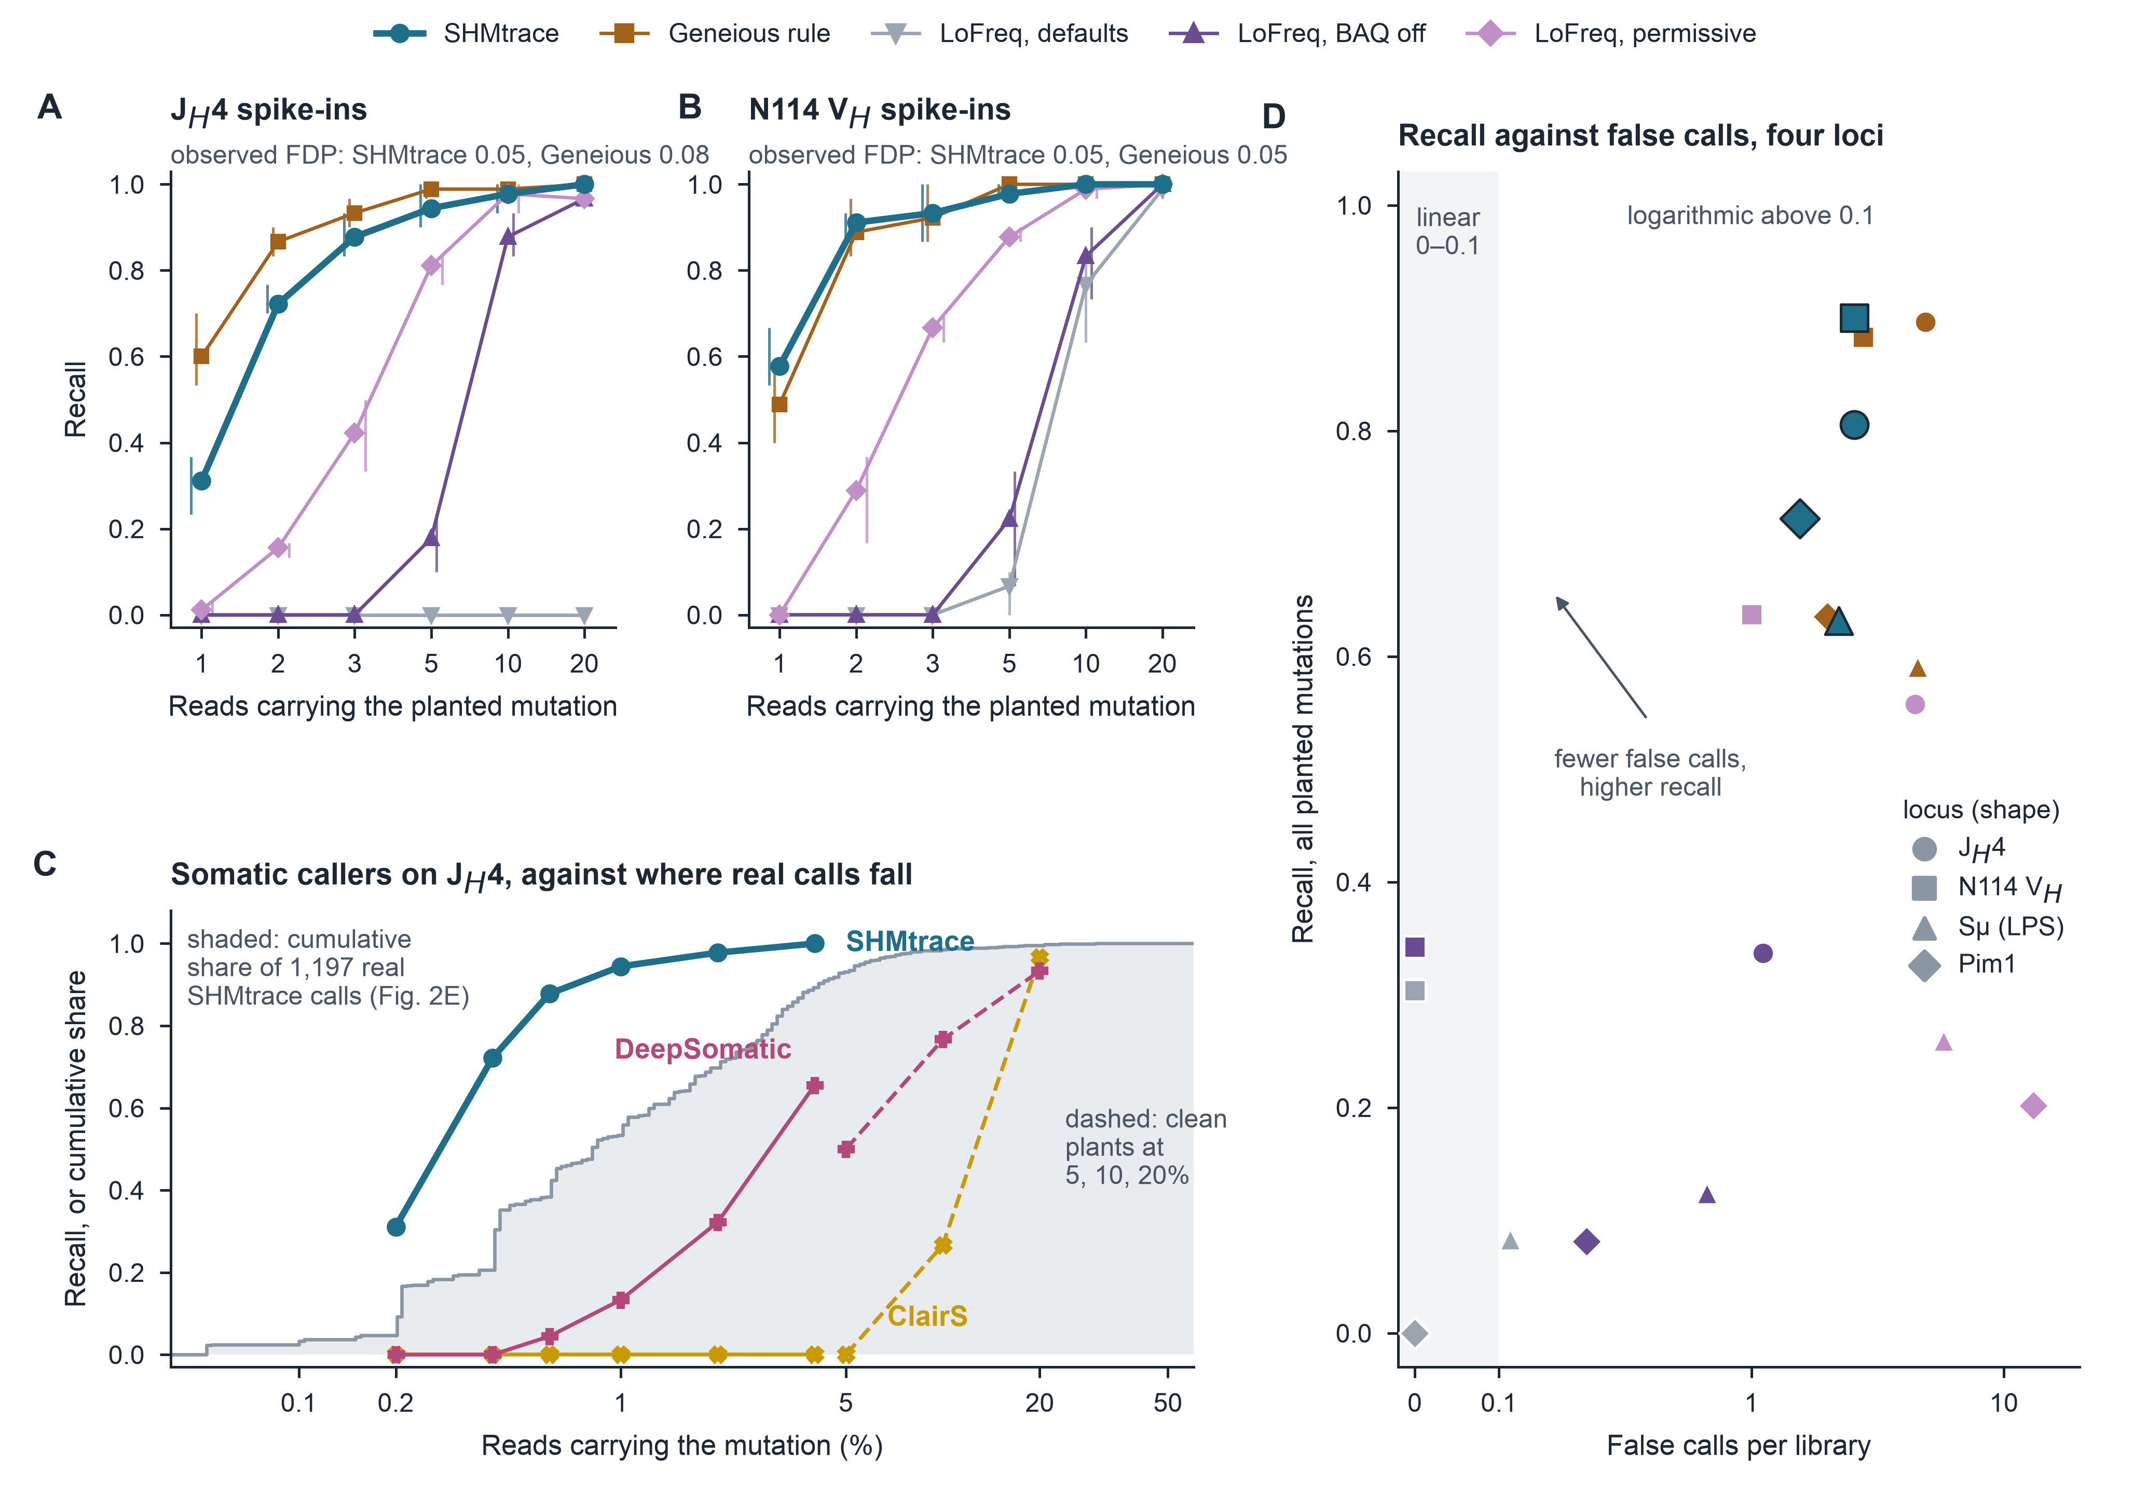
Figure 3. Planted mutations quantify recall and false calls. (A, B) Recall of planted substitutions by supporting reads: 60 sites × 3 draws × 3 held-out controls per locus; vertical lines, range over controls; FDP, pooled false over all calls. (C) Permissive somatic callers on J_{H}4, given peer controls as matched normals: solid, the spike-ins of A; dashed, clean plants at 5–20% of reads. Grey, cumulative share of the real SHMtrace calls in Figure 2E. (D) Recall against false calls per library for every caller at four loci. BAQ, base-alignment quality. See Figures S4–S8 and S24; Tables S1 and S6.
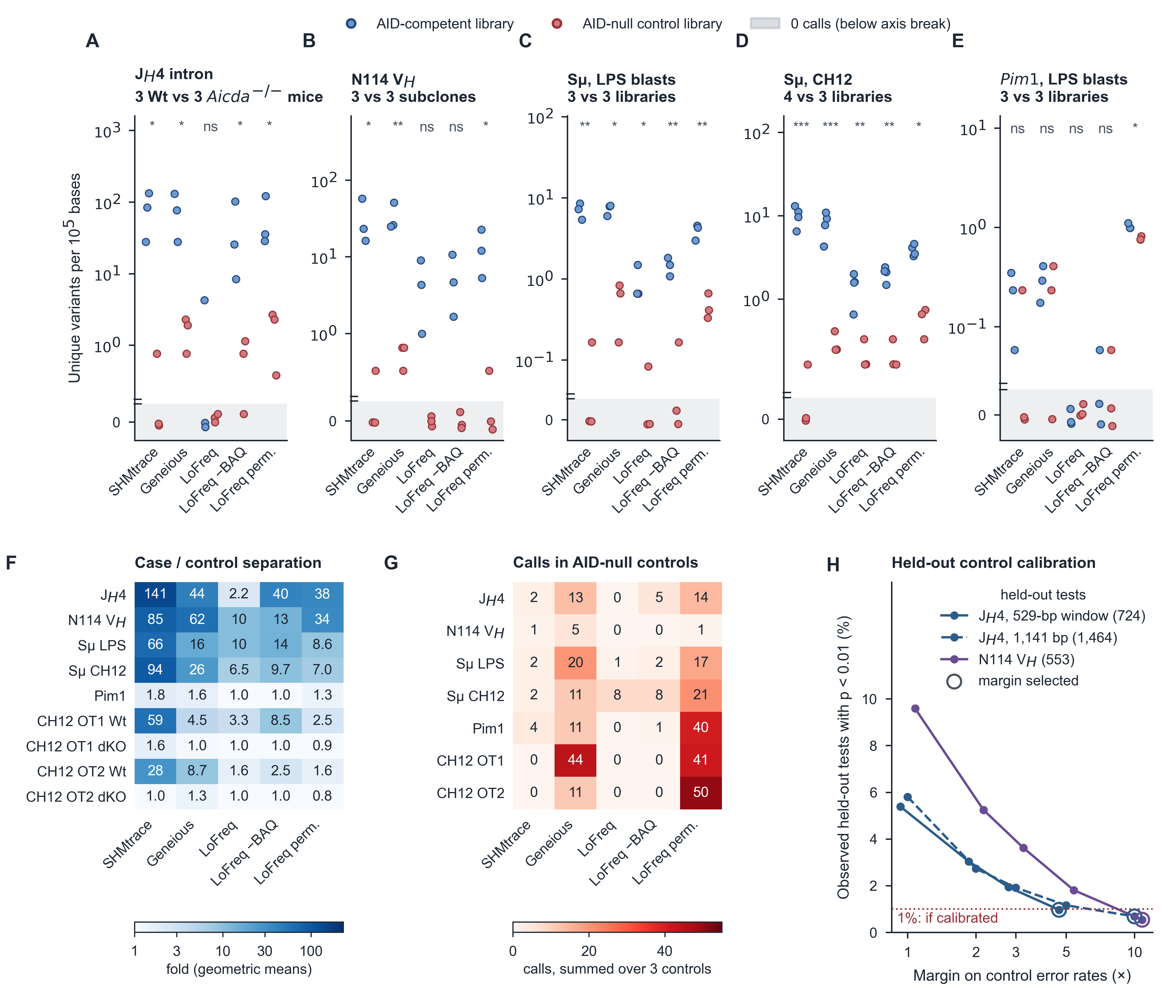
Figure 4. Matched controls reduce apparent substitution background in real libraries. (A–E) Unique variants per 10⁵ analyzed bases for each caller: blue, AID-competent libraries; red, AID-null; shaded strip below the axis break, libraries with no call. Welch tests on log density, Holm-adjusted across callers, with zero-call libraries at one event; ns, not significant, which with three libraries per group does not show that a caller fails; *p<0.05; **p<0.01; ***p<0.001. (F) Geometric-mean case/control separation, same zero convention; CH12 OT1/OT2, AID off-target loci in CH12 cells. (G) Calls summed over three controls. (H) Held-out control tests with p<0.01 by error margin; dotted line, 1% expected if calibrated; rings, selected margin. See Figures S9–S11; Tables S1 and S3.
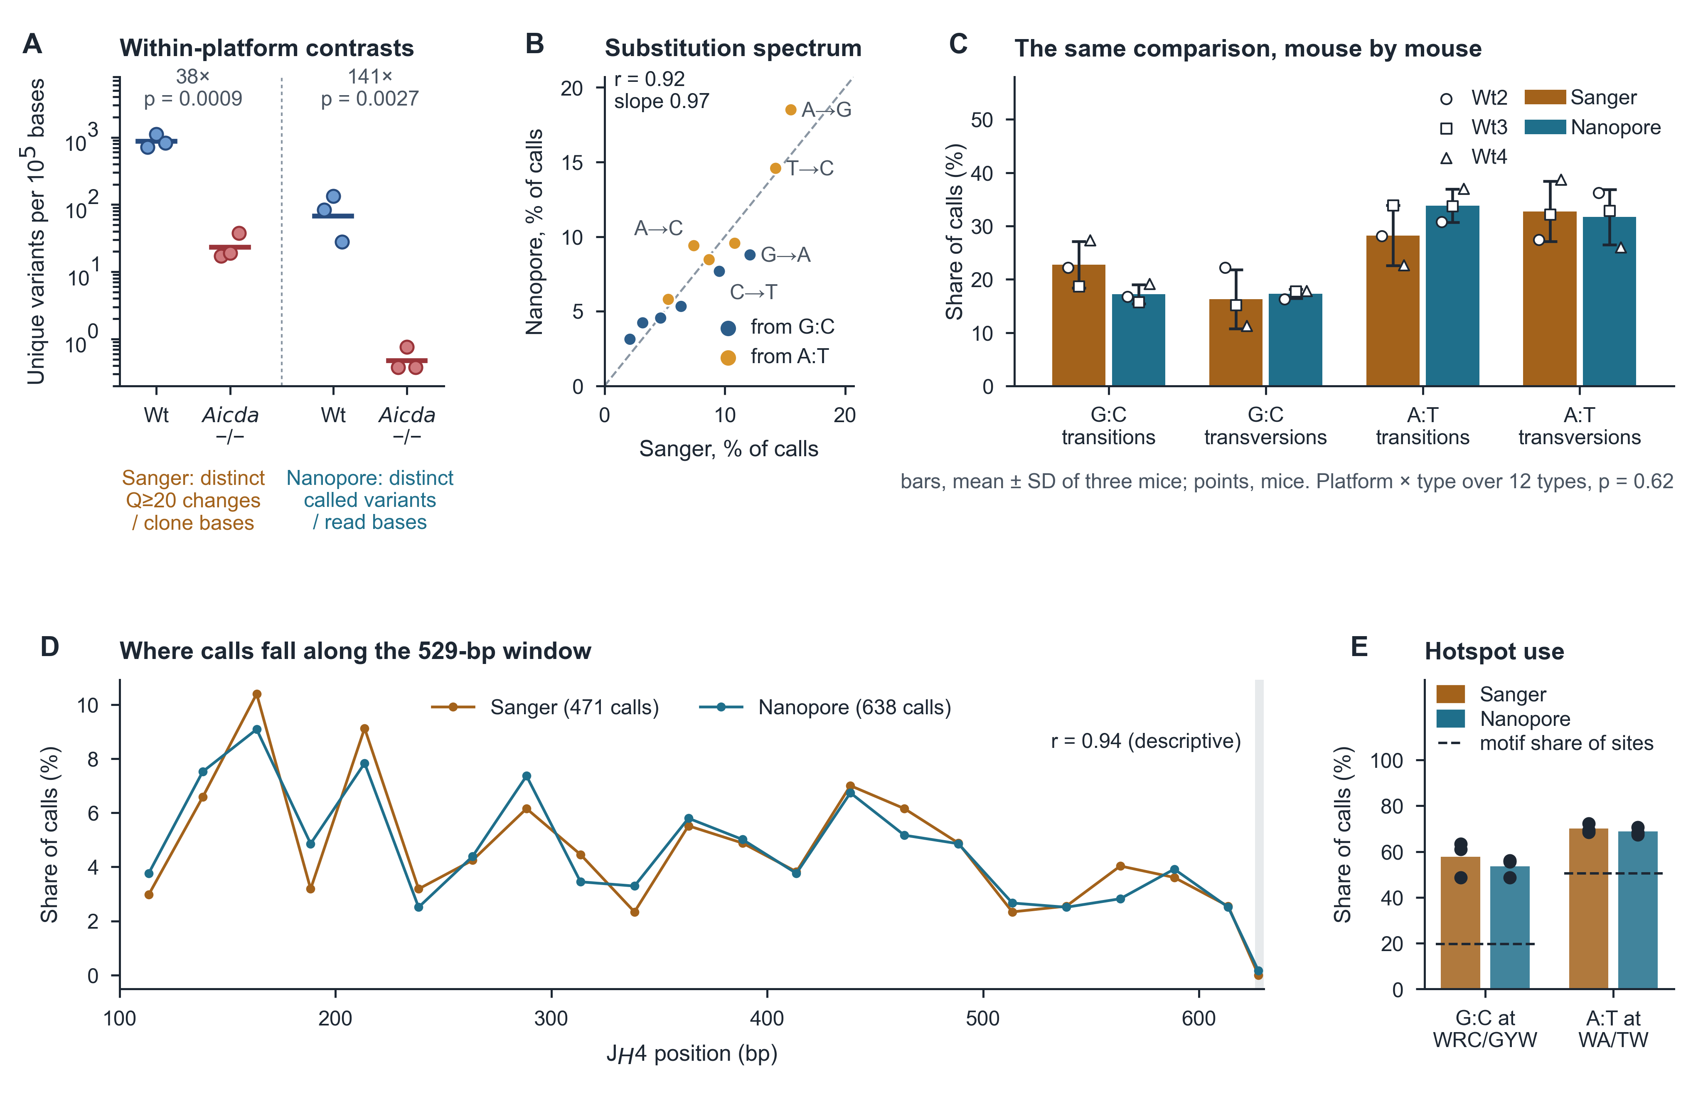
Figure 5. Matched Sanger and nanopore libraries yield similar mutation profiles. Matched 529-bp data from three Wt and three Aicda^{−/−} mice³⁴. (A) Unique-variant densities within each platform: distinct Q≥20 changes among 26–40 clones per Wt mouse (Sanger) and control-calibrated calls among 500 reads (nanopore). Bars, geometric means; p, log-Welch; nanopore zeros at one event. (B) Pooled shares of the twelve substitution types; dashed line, identity. The correlation describes similarity of pattern, not interchangeable values. (C) Four classes by mouse. (D) Positional shares in 25-bp bins; the final shaded bin is 4 bp. (E) Hotspot use; bars, mouse means; dashed lines, share of eligible positions in each motif. See Figures S13–S16; Tables S4 and S5.
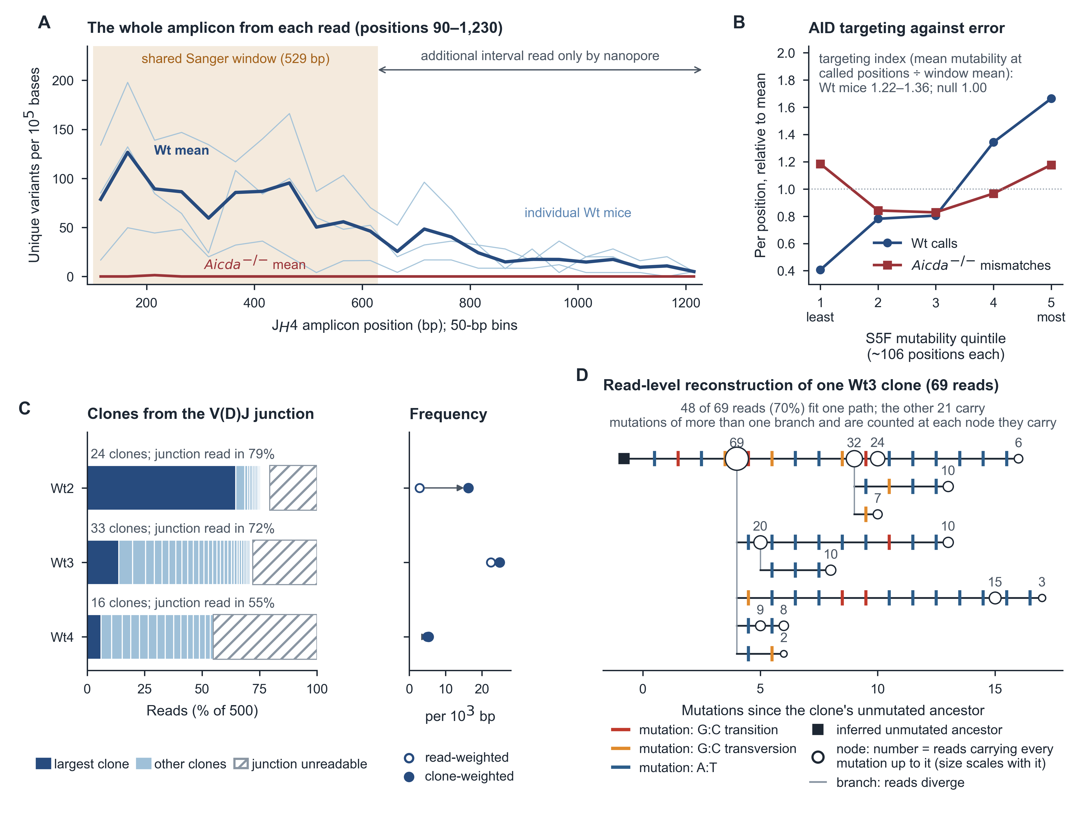
Figure 6. Long reads retain positional profiles and linked mutation patterns. Libraries as in Figure 5. (A) J_{H}4 variants per 10⁵ bases in 50-bp bins across positions 90–1,230. (B) Calls per position by S5F mutability quintile, relative to each series' mean, for Wt calls and germline-excluded null mismatches. (C) Junction-defined clones among 500 reads per mouse, with read- and clone-weighted frequency alongside. (D) The largest Wt3 clone. Of 69 reads, 48 fit one path and 21 carry mutations of two branches. See Figure S17.
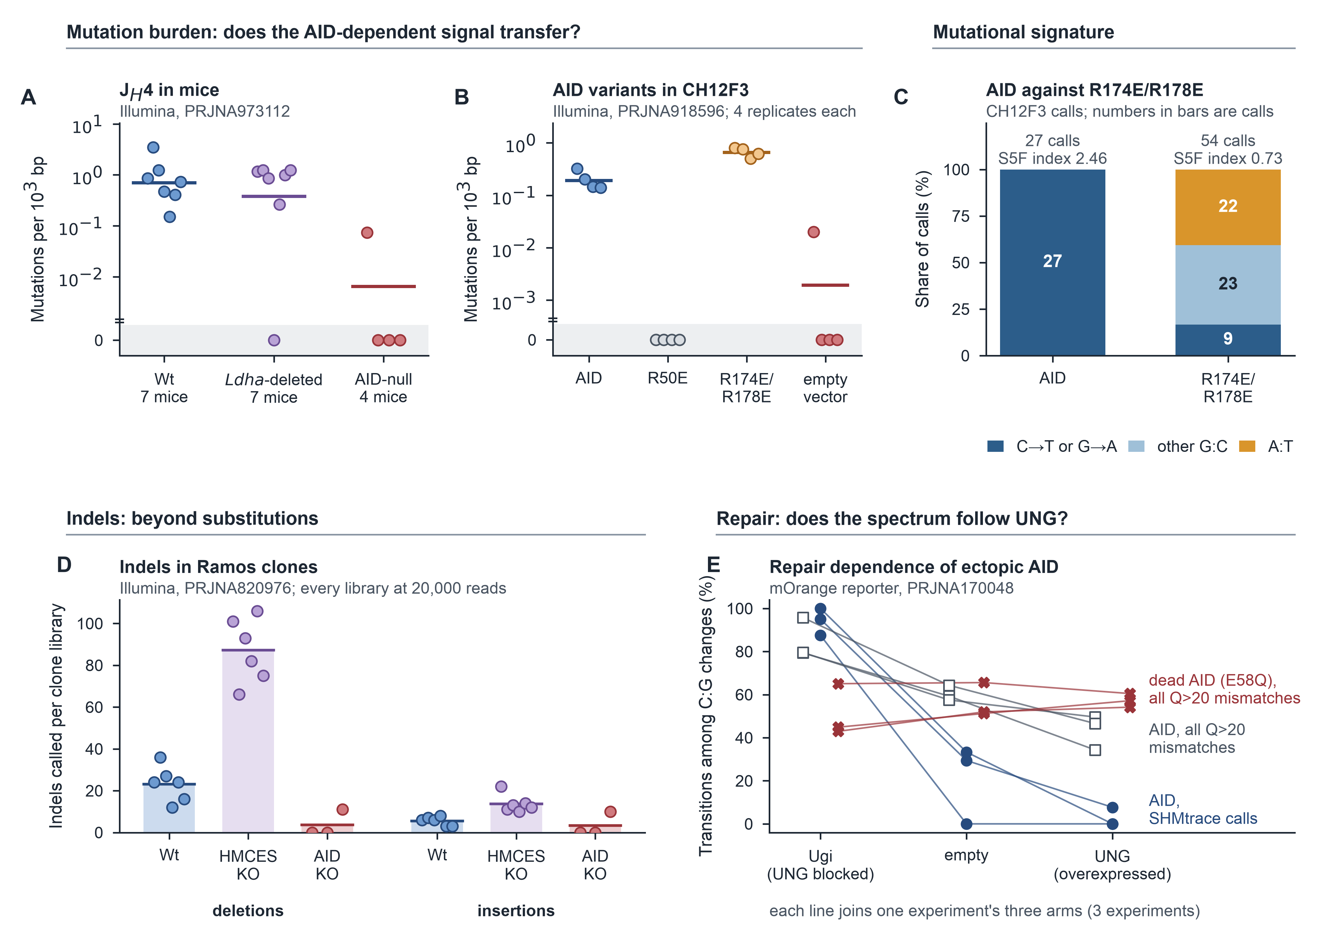
Figure 7. Public Illumina datasets test analysis across biological contexts. (A) J_{H}4 mutation frequency in Illumina data (PRJNA973112); points, mice; strip below the break, no call; bars, geometric means with zeros at one event. Tests: log-Welch versus AID-null; Mann–Whitney for Ldha versus Wt. (B) Aicda^{−/−}Ung^{−/−}Msh2^{−/−} CH12F3 cells expressing AID variants or empty vector (PRJNA918596; n = 4 per arm). (C) Substitution classes of each arm's pooled calls. (D) Ramos indels per clone at 20,000 reads (PRJNA820976); bars, means. (E) mOrange repair arms (PRJNA170048). See Table S1.
STAR★Methods
Key resources table
REAGENT or RESOURCE | SOURCE | IDENTIFIER
Antibodies
Anti-mouse B220 (CD45R)–FITC, clone RA3-6B2 | SouthernBiotech | Cat# 1665-02; RRID: AB_2795114
Anti-mouse GL7–eFluor 660, clone GL7 | Thermo Fisher Scientific (eBioscience) | Cat# 50-5902-82; RRID: [to confirm]
Anti-mouse Fas (CD95)–BV421, clone Jo2 | BD Biosciences | Cat# 562633; RRID: AB_2737690
Chemicals, peptides, and recombinant proteins
Platinum SuperFi II PCR Master Mix | Thermo Fisher Scientific | 12368010
Proteinase K | Invitrogen (Thermo Fisher Scientific) | [proteinase K Cat#]
Critical commercial assays
Monarch PCR & DNA Cleanup Kit | New England Biolabs | [Monarch kit Cat#]
Premium PCR (full-length amplicon) sequencing, R10.4.1, Kit 14 | Plasmidsaurus | https://www.plasmidsaurus.com
Deposited data
J_{H}4 and N114 V_{H} nanopore reads, Sanger chromatograms and SHMtrace outputs | This paper | [SRA BioProject]; [data deposit DOI]
J_{H}4 Sanger chromatograms, Maea^{fl/fl}Mb1^{cre} study (cohort 2) | Barbulescu et al.³³; this paper | [data deposit DOI]
Nanopore amplicons, Sμ and Pim1, AID-competent and Aicda^{−/−} | NCBI SRA | BioProject PRJNA1481264
Illumina J_{H}4, Ldha study | Sharma et al.³⁶ | BioProject PRJNA973112; GEO GSE232658
Illumina CH12F3 VDJ, ectopic AID | Wang et al.³⁷ | BioProject PRJNA918596
Illumina Ramos IGH VDJ, HMCES | Wu et al.³⁸ | BioProject PRJNA820976
Illumina mOrange reporter, ectopic AID in NIH-3T3 cells | Pérez-Durán et al.³⁹ | BioProject PRJNA170048; GEO GSE39108
R10 nanopore reads with dual UMIs, ZymoBIOMICS operons | Karst et al.⁴⁴ | github.com/SorenKarst/longread_umi
PacBio Sμ–Sγ1 class-switch products, Shld1 and Xlf mice | Vincendeau et al.⁴³ | BioProject PRJNA831666
Illumina Sμ mutation libraries, PI3Kδ inhibitors | Compagno et al.⁴² | BioProject PRJNA311552; GEO GSE77788
Illumina GFP reporter, diversifying base editors | Liu et al.⁴⁰ | SRA SRP159221
Anti-HLA-A2 antibody clone sequences | Devilder et al.⁴¹ | the study's Additional file 1
Experimental models: Cell lines
N114 hybridoma (V_{H}, J558/IGHV1 family) | Martin et al.⁴⁵ | N/A
Experimental models: Organisms/strains
Mouse: C57BL/6N wild type | Bred in house (wild-type littermates) | N/A (bred in house)
Mouse: Aicda^{−/−} (C57BL/6 background) | Muramatsu et al.¹ | [Aicda-/- RRID (MGI)]
Oligonucleotides
J_{H}4 intron primers | Jolly et al.⁸ | forward 5′-GGAATTCGCCTGACATCTGAGGACTCTGC-3′, reverse 5′-GACTAGTCCTCTCCAGTTTCGGCTGAATCC-3′
N114 V-region primers | Martin et al.⁴⁵ | forward 5′-TTACCTGGGTCTATGGCAGT-3′, reverse 5′-TGAAGGCTCAGAATCCCCC-3′
Recombinant DNA
pMX-Aicda and pMX empty vector (GFP, puromycin resistance) | Martin laboratory⁴⁶ | N/A
Software and algorithms
SHMtrace v0.2.2 (command line and desktop application) | This paper | [SHMtrace Zenodo DOI]; https://github.com/AbdulmateenAderinto/SHMtrace
minimap2 2.30 (mappy 2.31) | Li²⁹ | https://github.com/lh3/minimap2
LoFreq 2.1.5 | Wilm et al.¹⁸ | https://github.com/CSB5/lofreq
ClairS 0.5.1 and Clair3 2.0.3 (Docker image hkubal/clairs) | Zheng et al.^{24,26} | https://github.com/HKU-BAL/ClairS
DeepVariant 1.9.0 and DeepSomatic 1.9.0 (Docker images google/deepvariant, google/deepsomatic) | Poplin et al.²⁷; Park et al.²⁵ | https://github.com/google/deepvariant
SAMtools 1.24 | Danecek et al.⁴⁷ | https://github.com/samtools/samtools
SHazaM 1.2.0 (HH_S5F model) | Gupta et al.²²; Yaari et al.²³ | https://immcantation.readthedocs.io
IgBLAST 1.22.0 | Ye et al.³¹ | https://ncbi.github.io/igblast
Python 3.13, NumPy 2.5, SciPy 1.18 | Virtanen et al.⁴⁸ | https://scipy.org
SRA Toolkit 3.4.1 | NCBI | https://github.com/ncbi/sra-tools
Geneious Prime 2026.1.2 (comparison only) | Kearse et al.¹⁹ | https://www.geneious.com
Other
R10.4.1 flow cells, Ligation Sequencing Kit V14 (via provider) | Oxford Nanopore Technologies | N/A
Experimental model and study participant details
Mice
Four-month-old Wt and Aicda^{−/−} mice were maintained on a predominantly C57BL/6 background. Both sexes were included (n = 3 per genotype; [sex of each of the 6 J_{H}4 mice (e.g. Wt2 M, Wt3 F, ...)]), but sex-specific effects were not evaluated. The J_{H}4 comparison used the same mice previously analyzed by cloned-amplicon Sanger sequencing³⁴ to permit paired platform assessment. Procedures were approved by the University of Toronto Animal Care Committee (protocol 20011472).
Cell lines
N114 authentication: [how the N114 hybridoma was authenticated, or 'not authenticated']. Mycoplasma status: [N114 mycoplasma testing result and date, or 'not tested']. Cells^{45,49} were retrovirally transduced with pMX-Aicda or matched empty vector, both encoding GFP and puromycin resistance. GFP-high cells were selected and subcloned by limiting dilution; three puromycin-resistant subclones per vector were maintained for 1 month before DNA collection. One library per subclone was analyzed. When repeat sequencing was available (C1 and D3 from stocks frozen on different dates; two C3 libraries), the library with the most usable reads was selected. The alternative C3 library was retained for sensitivity analysis.
Method details
Germinal-center B cell isolation and DNA extraction
Peyer's patches were harvested post-mortem into cold FACS buffer ([FACS buffer composition, e.g. PBS with 2% fetal bovine serum]) and dissociated into single-cell suspensions by pressing them through a 70-µm strainer, then washed once. Cells were stained for 20–30 min on ice with anti-B220–FITC (RA3-6B2, 1:400), GL7–eFluor 660 (GL7, 1:100), and anti-Fas–BV421 (Jo2, 1:200), with anti-CD16/32 Fc block (clone 93, 1:100) and Fixable Viability Dye eFluor 506 (1:1,000) and washed twice. Germinal-center B cells (B220⁺GL7⁺Fas⁺) were isolated by fluorescence-activated cell sorting on a BD FACSymphony S6 SE or FACSAria II, collecting approximately 10,000 cells per mouse; wild-type and Aicda^{−/−} mice were processed on the same day with the same reagents, so that genotype is not confounded with handling. Genomic DNA was released from the sorted cells, or from 5 × 10⁶ hybridoma cells, by proteinase K digestion (55 °C overnight, then 95 °C for 15 min; [lysis buffer and volume to confirm]), and lysate quality was checked by A260/280 and A260/230 ratios.
Amplification and sequencing
The N114 line carries a fixed, rearranged heavy-chain V region of the J558/IGHV1 family: IgBLAST assigns it to IGHV1-47-36 with IGHD1-1 and IGHJ3, and germline sequence of that V gene matches it over the whole V segment, so the assignment does not rest on this analysis. Relative to that germline the line carries two changes in CDR2, in frame and confirmed by the reads: the first replaces the germline glycine with an opal stop (TGA) and the second changes the following glycine to valine, giving W-I-Y-P-stop-N-V-N-T-K in place of W-I-Y-P-G-N-G-N-T-K. The stop is the point of the line: it prevents antibody production, and the original study scored its reversion as hypermutation⁴⁵. Sequencing supersedes that readout: the analysis here measures mutation across the whole V region rather than reversion at one codon, and is made against the line's own reference throughout, which carries the stop; the V region is called N114 V_{H} rather than by an allele. The 1,230-bp J_{H}4 intron amplicon^{8,33} and the 655-bp N114 V-region amplicon⁴⁵ were amplified with Platinum SuperFi II high-fidelity DNA polymerase. Each 50-µL reaction held 1× SuperFi II master mix, 0.5 µM of each primer and [lysate volume per PCR] of lysate, with a no-template control in every setup; wild-type and AID-null samples were amplified together. The J_{H}4 primers were forward 5′-GGAATTCGCCTGACATCTGAGGACTCTGC-3′, reverse 5′-GACTAGTCCTCTCCAGTTTCGGCTGAATCC-3′, and the N114 primers forward 5′-TTACCTGGGTCTATGGCAGT-3′, reverse 5′-TGAAGGCTCAGAATCCCCC-3′. Cycling was 98 °C for 5 min; 35 cycles of 98 °C for 30 s, 68.8 °C for 30 s, and 72 °C for 1 min; and a final 72 °C for 5 min. Products were checked on a 1% agarose gel for a single band of the expected size, then column-purified and submitted as separate, individually barcoded samples for full-length amplicon sequencing (Plasmidsaurus Premium PCR service), which uses ligation library preparation, R10.4.1 flow cells, Kit 14 chemistry, and super-accuracy basecalling (dna_r10.4.1_e8.2_400bps_sup@v5.2.0). Between 2,336 and 5,000 reads were delivered per library. For the Sanger benchmark, J_{H}4 amplicons from separate PCRs of the same DNA had been cloned and sequenced³⁴. Of the 447 chromatograms in that archive, which also covers other mice of that study, 184 were filed to the six mice sequenced here and re-analyzed; 134 returned analyzable clones (Figure S13).
Read preparation
SHMtrace reads FASTQ files, which may be gzipped or, for Illumina data, paired files that are merged on their overlap. Reads are then processed in the following order. First, reads longer than a locus-specific limit (2,000 bp for J_{H}4 and 900 bp for N114 V_{H}) are removed, as are reads with a mean expected error above 0.01 per base, calculated from Phred qualities²⁸. Second, reads are aligned with minimap2 (map-ont preset, or sr for Illumina) against an index containing the target and any competing references, and each read is assigned to the sequence it aligns to best. Unmapped reads, reads assigned to a competing reference, reads with a supplementary alignment (chimeras), and reads aligned over less than a minimum length (800 bp for J_{H}4 and 400 bp for N114 V_{H}) are removed. For J_{H}4, the competing references were a J_{H}4-like paralog (the consensus of Agouti-type clones, approximately 12% divergent) and a recurrent contaminant haplotype. Because a full-length paralog read can align better to the longer target, reads carrying 10 or more bases specific to a competing reference, at sites where fewer than 20% of the sample's reads carry them, are also removed. Genuine J_{H}4 reads carry 0–7 such bases, whereas paralog reads and chimeras carry 11–62. The fate of every read is recorded. Usable reads were then downsampled at random with a fixed seed (Python random, seed 0) to the analysis depth: 500 reads for J_{H}4 and N114 V_{H} and 2,000 reads for the IRCM loci. The analysis windows were positions 101–629 (529 bp, the window shared with Sanger) or 90–1,230 (full length) of the J_{H}4 reference and positions 21–635 of the N114 V_{H} reference. For loci whose window is not set by a preset, it runs from position 21 to 20 bases before the reference's end: Sμ 21–631 (611 bp), Pim1 21–882 (862 bp), off-target 1 21–988 (968 bp) and off-target 2 21–962 (942 bp). Reads that align better to a paralog, are chimeric or carry paralog-specific bases are removed, and the same number of usable reads is then drawn from every library. Read preparation removed 67% of delivered J_{H}4 reads overall (Figure S1E), and competitive alignment alone was not enough: without an additional paralog-base filter, simulated paralog reads produced 35–54 false variants per library.
Control-calibrated variant calling
Each observed single-nucleotide difference within the window is a candidate, including substitutions supported by one read. Control error rates are estimated by substitution type, strand and quality threshold, combining a pooled rate with position-specific counts. For a candidate with k supporting reads ranked q₁ ≥ q₂ ≥ …, the test evaluates, for each j ≤ k, the probability of at least j errors with quality ≥qj, using strand-specific depth and control rates multiplied by margin c. The reported p value is the smallest tail probability multiplied by k.
The margin c is chosen by leaving one control out at a time. It is an empirical calibration factor: it does not imply that sequencing errors are five or ten times the fitted rate, and it does not by itself set the false-discovery level, which the decoy threshold addresses separately. Because the same few controls choose the margin and supply the decoys, the false-discovery estimate is conditional on how well they represent the samples' background; it is not a guarantee. Each control is tested against an error model built from the other controls, and c is the smallest value in the grid 1, 2, 3, 5, 10, 20, and 50 at which no more than 1% of candidate tests pooled across held-out controls reach p < 0.01. In the analyses reported here, c was 5× on J_{H}4, 10× on the full length, and 10× on N114 V_{H}. The same held-out tests, made at the samples' analysis depth, are then used to set the significance threshold. Each held-out control is kept as a decoy, defined by its sorted p values and the number of bases it tested. For a sample and a candidate threshold t, the expected number of false calls is the mean, across decoys, of the number of decoy p values ≤ t, scaled by the ratio of the sample's tested bases to the decoy's when that ratio exceeds 1. Decoys are never scaled down to a shallower library, whose coarser p values they would otherwise underestimate. SHMtrace keeps the largest t at which the expected number of false calls is at most 0.05 times the number of sample p values ≤ t, an empirical false-discovery estimate inspired by target–decoy analysis³⁰. A control is never used as its own decoy: when a control is tested, only the other controls serve as decoys. Each sample is judged against the controls of its own sequencing run when that run has at least two (one, for a control), and against all controls otherwise, with the report naming any sample whose run has no control; every J_{H}4 and N114 V_{H} sample shared its controls' run, while the public deposits do not record runs, so their samples were judged against all of their study's controls. A control whose held-out candidates at p ≤ 0.01 per base exceed five times the median of the other controls, and number at least five, is left out of the decoys (unless no decoy would remain) and named in the report; it still contributes to the error model, and is never removed from the analysis. The comparison needs a majority to judge against, so it is made only when at least two other controls remain, that is with three or more controls; with exactly two, the more variable library is named in the report but not left out, because which of the two is unusual cannot be established. The rule was written for one public dataset, the Ramos clones of Figure 7D, in which a single Aicda^{−/−} clone suppressed every call; it was then applied to the other datasets and was already fixed when the off-target libraries were analyzed, where it excluded no control; it excluded one in the mOrange analysis. It is therefore a rule derived from data rather than a pre-registered one, and it is reported here so that its effect can be judged. With fewer than two controls, or for indels, the Benjamini–Hochberg procedure⁵⁰ across positions and alternative alleles is used instead. The number of controls therefore selects between four modes, and the output records which was used in its multiple_testing field, so a reader never has to infer it. With no control the background is not measured at all: every candidate is judged from base qualities, the correction is Benjamini–Hochberg, indels are not called, and the run carries a note saying so. With one control that library supplies the error model, but the margin cannot be fitted by leaving a control out and the default of 10, measured on J_{H}4, is used; a control cannot be its own decoy, so there is no decoy set and the correction is again Benjamini–Hochberg; the noisy-control rule cannot act, since it needs two others to compare against. With two each is the other's decoy, the margin is fitted but can reach the top of its grid, and a disagreement between the pair is reported without acting on it, because with two there is no majority to say which is wrong. With three or more the margin is fitted by leave-one-out, the decoys are the peers, and a far noisier control is set aside automatically. A single control is enough to run but not to calibrate: the model fitted to that one library can absorb the signal, so results from it should be reported as mismatch rates without an FDR claim. Benjamini–Hochberg is not avoided because the p values are discrete: it controls the false-discovery rate for valid discrete p values, conservatively. It is avoided because of how candidates arise. A position enters the test only when at least one read already differs from the reference there, so the tested set is chosen by the same data that supply the evidence, and the null distribution of a candidate's p value is conditioned on that selection rather than superuniform on (0, 1]. The control-based threshold applies the same candidate-selection rule to samples and held-out controls, so it measures the corresponding background empirically. This does not establish formal FDR control: the decoys are few, their fitted nulls differ from the sample null, and their exchangeability with samples is an assumption. Figure S24 tests selected consequences of these limitations, and Figure S4 compares the target with the realised proportion on planted truth: the default was met when pooled, and targets below it were not; Figure S5 varies the number and source of the controls. Because the threshold targets a proportion, a library with many true mutations admits more false calls in absolute terms: in simulated polyclonal lineages, 13.7 per library, in exchange for recalling 83% of single-read mutations. Table S7 compares the default with a target of 0.01 and with the noisiest control's decoy count in place of the mean. At 0.01, false calls in those lineages fell to 3.0 per library but single-read recall fell to 38%; on the planted J_{H}4 controls, recall fell from 81% to 17% without a lower false-discovery proportion (0.061), whereas N114 V_{H} kept 76% recall at 0.005. With three controls, the decoy counts are too coarse to resolve a 1% target reliably. In the J_{H}4 and N114 V_{H} projects, both stricter settings removed calls only from mutation-bearing libraries; the group differences remained 71–138-fold (p ≤ 0.0078). The default was kept. Alternative alleles carried by at least 50% of covering reads are removed as germline or parental differences; other alleles at the same position remain eligible. Without controls, recommended mode uses a Poisson approximation to read-quality error probabilities; the separate pbinom mode implements the exact Poisson-binomial calculation.
Per-sample summaries report G:C share, transition share, G:C substitutions at WRC/GYW and A:T substitutions at WA/TW, with the corresponding motif opportunities in the analysis window. These describe spectrum and context, not uniquely identifiable repair-pathway contributions: uracil excision, mismatch repair and replication over uracil produce overlapping outcomes. Repair interpretations in Ung^{−/−}Msh2^{−/−} cells and Ugi/UNG fibroblasts are therefore grounded in the experimental perturbations rather than inferred from spectra alone.
At Sμ WT3, position 165 (TACCT) had 20 of 2,000 supporting reads, median Q34; position 97 (AGCTT) had 15 of 1,941, median Q33. Both had support on both strands. KO1 carried the latter in 14 of 1,879 reads at median Q33. Geneious called it in two controls and all three cases. These examples distinguish control-supported calling decisions, without independent truth validation of each native candidate.
Testing the calling procedure as a whole
End-to-end assessment used partitions and planted mutations from three existing Aicda^{−/−} J_{H}4 libraries (crm/fdr_validation.py). Cases used KO1 reads. Two-control analyses used one partition each from KO2/KO3; three-control analyses used two KO2 partitions and one KO3 partition. Case/control sets shared no read records, but without UMIs this does not establish original-molecule independence. Partitions are technical resamples rather than independent biological controls. Each run_project analysis reselected its margin, threshold and exclusions. Conditions were unmodified background, one noisy control, case-only artifact and shared case/control artifact. Artifacts occupied six positions at nominal 6% support; shared artifacts used identical alternate alleles, and case artifacts avoided planted biological sites. Control number (two/three), depth (250/500/1,000) and mutation burden (none/approximately 400 true recovered calls) were varied. Exclusion-on/off analyses used identical inputs (Figure S24). These stress tests assess behavior conditional on existing libraries, not transfer to a new run.
Under unmodified all-null background, discoveries occurred in 1/25 exclusion-on and 0/25 exclusion-off resamples; with one noisy control, both were 0/25. Clopper–Pearson 95% upper bounds of 20% and 14% for the unmodified condition do not establish a 5% bound. Shared-artifact resamples yielded 0/5 discoveries in both settings, each with a 52% upper bound. Case-only artifacts yielded discoveries in 5/5 under both settings, averaging 6.0 false calls. With biological mutations and exclusion enabled, mean per-library FDP was 3.8%, 3.0%, 3.7% and 5.1% for unmodified, noisy-control, shared-artifact and case-only conditions, respectively (five resamples each). Per-library FDP, pooled false/(true+false), and the all-null probability of any discovery are reported separately. These small conditional experiments do not establish general error control.
The noisy control was excluded in 25/25 all-null rule-on resamples. With biological mutations, exclusion-on/off analyses averaged 396.0/394.2 true calls and 12.2/11.2 false calls across five paired resamples. At least three controls are required to assess an outlier against peers. When the peer median is zero, ≥5 held-out candidates at p≤0.01 trigger exclusion; an unmodified control was consequently excluded in 3/25 all-null resamples. Every exclusion is recorded and warrants review, including sensitivity to retaining that control.
The default mean-decoy estimator was compared with control_decoy_estimate="max", which requires the threshold to satisfy the noisiest retained decoy (crm/fdr_estimator.py). On unmodified mutation-bearing inputs, mean FDP was 3.8% versus 2.5%, with 403.0 versus 389.0 true calls. For case-only artifacts, FDP was 5.1% versus 4.1%. Five paired resamples per condition used identical inputs. This compares implemented estimators; it is neither independent validation nor proof that the maximum guarantees FDR control.
Reported runtimes are wall-clock seconds for one run_project call on an Apple M2 Pro (12 cores, 32 GB; macOS), from prepared input to written results. They include file reading, mappy alignment, calling and sample summaries, but exclude reference construction and external benchmark containers. Sanger projects contain a few hundred chromatograms; nanopore projects contain six libraries analyzed at 500–2,000 reads. Input recovery and curation, including reconstruction of clone assignments from historical projects, took substantially longer and are excluded from compute times.
The Geneious rule was reproduced as an uncorrected approximate p ≤ 0.05 per candidate, which matched Geneious exports site by site (Jaccard index 0.97–0.98 on Wt J_{H}4).
What each mutation measure counts
Three measures are reported per library, and they answer different questions; group tests then use one value per animal. A unique variant is a position and substituted base counted once per library, however many reads carry it; unique means distinct within that library and does not imply an independent mutational origin, since one lineage's trunk mutation is one unique variant. Unique-variant density is D / B × 10⁵, where D is the number of unique variants and B the base observations at callable positions (inside the analysis window and the end trims), counted exactly as the read depth summed over those positions, not the number of reference positions. Because B grows with depth while D saturates, this density falls as depth rises even at a constant mutation rate, so it is compared only between libraries analyzed at the same depth (Figure S10). Read-weighted mutation frequency is Σ m_{i} / (N × L) × 10³, where m_{i} is the number of called sites read i carries at or above the configured minimum base quality (0 for these read-library analyses), N the reads analyzed and L the window length; a mutation shared by many reads is counted once in each of them, so an expanded clone raises it. This fixed-window frequency credits every read with the whole window; an observed-base frequency, which counts only the bases each read covers, is reported beside it and agrees when reads span the window, as they did in the J_{H}4 and N114 V_{H} projects to within 2.4%. Clone-weighted frequency groups reads by their V(D)J junction, keeps a mutation when at least half the reads of its clone carry it (any read of a single-read clone), and is Σ c_{k} / (K × L) × 10³ over the K clones, so each clone counts once whatever its size. For wild-type J_{H}4 library Wt2 at 500 reads over the 529-bp window these give 221 unique variants over 263,886 base observations (83.8 × 10⁻⁵), 747 read-level mutations over 264,500 bases (2.82 × 10⁻³), and 207 clonal mutations over 24 clones (16.3 × 10⁻³); the clone-weighted value is the largest because one clone holds 81% of the reads. For Sanger clones, where each clone is one molecule read once, the frequency denominator is the clones analyzed times L, with L the 529-bp window; the published studies used their own full consensus length and counted every filed clone, which is the convention Table S4 reports separately.
Two implementation details of the error model. The rate used at a site is the pooled rate for that substitution, strand and quality over all window positions, used as a floor, with that position's own control count shrunk toward it by m = 500 pseudo-observations, so a position the controls show erring often keeps its high rate while a position that happened to show none does not look error-free. A substitution class the controls never showed is given half a pseudo-count over the control bases observed, which keeps the quality tail above zero rather than allowing a p value of exactly zero. Indels are called separately, because nanopore indel errors are systematic rather than quality-driven: each exact indel is tested against the rate of its class (insertion or deletion, length up to 4, homopolymer run up to 5), counted per read spanning each position of the analysis window and used as a floor, with that site's own control rate shrunk toward it and inflated by a margin fitted as the substitution margin is; candidates are corrected by Benjamini–Hochberg; indels are counted only at quality ≥ 30 at the inserted bases or the bases flanking a deletion, and those carried by fewer than three reads are not called. UMI consensus groups reads by their tags, allowing up to 3 edits per tag end, greedily from the most abundant tag and merging a neighbor only when it is at most half as abundant; groups of fewer than 3 reads are dropped, and each remaining group becomes one quality-weighted consensus read. The single-read estimate divides the excess of single-read substitutions at quality ≥ 35 over the controls' rate by the share of that sample's correctly read bases reaching that quality, so that the estimate does not depend on the cutoff; that it does not between Q30 and Q40 is the check reported for J_{H}4.
Single-read estimate, clones, mutation trees, and quality checks
Single-read mutations not called individually are estimated in aggregate. SHMtrace counts Q≥35 single-read substitutions outside the accepted call set, subtracts the control expectation scaled to sample bases, and divides by the fraction of correctly read bases reaching that quality. Control events are counted only at positions and alleles where the sample could show a single-read event, so neither its per-site calls nor alleles it carries in two or more reads add to the background. The 95% interval inverts a profile likelihood in which the sample count is Poisson in signal plus background and the control count Poisson in background, scaled by the between-control overdispersion; it stays nonzero when neither sample nor controls show an event. In simulation it covered the true count in 92.5–98.8% of experiments with Poisson background, and in 87–90% when three heterogeneous controls carried several background events, because three controls estimate the overdispersion imprecisely. The combined density's interval holds the per-site calls fixed.
Two different things are called a clone in this field, and this paper keeps them apart. A Sanger clone is one bacterial colony, that is one PCR product carried by one transformant and sequenced once: a unit of sequencing, which says nothing about which B cell the molecule came from, and two Sanger clones of one animal may well come from the same B cell lineage. A B cell clone is a lineage, defined here by a shared V(D)J junction, which is what the clone-weighted frequency and the mutation trees use. The two coincide only by accident. Where the text says a measure counts each clone once, it means the B cell clone; the Sanger denominator is clones analyzed × 529 bp, where those clones are the sequencing units. Sanger amplicons of the J_{H}4 intron do not span the junction, so B cell clones cannot be identified in them, and clone-weighted frequencies are reported only for the nanopore libraries.
Junction grouping uses the twenty bases immediately upstream of alignment starts occurring within 18 bp of J_{H}4. Sequences are clustered greedily around abundance-ranked centroids with edit distance ≤3 and a free 5′ end. Each lineage's majority profile retains calls supported by at least half its reads. Tree nodes merge mutations supported by ≥2 lineage reads with Jaccard overlap ≥0.9; each node's parent is the smallest node containing ≥90% of its supporting reads. A read fits when its nodes occupy one ancestral path. The four-gamete test requires each of the four presence/absence combinations for a mutation pair in at least two reads. Overall, 70% of mutated reads fitted one tree, and 7/1,128 mutation pairs failed the four-gamete test.
The targeting index is mean S5F mutability²³ at mutated positions divided by the window mean. A one-sided permutation test uses 2,000 random position sets; the model was exported from SHazaM 1.2.0. Positional-clustering flags identify 10-base windows with more calls than expected under a Poisson distribution, with Bonferroni correction across windows (p < 10⁻³). Figure S22 summarizes the workflow; Figure S23 illustrates the analytical rules using J_{H}4 libraries. Sanger traces are assigned through a sample sheet and trimmed to their longest reliably aligned Q≥20 segment. All Q≥20 substitutions are counted after germline filtering. Quality-control flags identify copied files, unexpectedly shared clones between animals (Poisson test weighted by mutation frequency across animals), excess mutations in controls, label mismatches and mutation-load outliers. Flags are reported for review without automatic exclusion. These flags were tested on forty simulated projects, each carrying one instance of every bookkeeping error: a changed label was detectable only where the affected clones shared mutations with another animal's clones, because a label alone leaves no trace in the sequence, and no correctly assigned clone was flagged in error among the 6,018 tested (crm/sanger_validation_summary.json).
The Sanger route counts Q≥20 substitutions without per-call significance testing. AID-null clones provide the observed Q≥20 mismatch rate after their own germline differences are excluded, stratified by quality and position. Applying these rates to each sample's bases gives the expected background count, reported beside observations without subtraction. Sites mismatched in more than one control clone are annotated on corresponding sample calls. This background estimate contextualizes Sanger counts but does not determine acceptance of individual substitutions.
For the Maea Sanger study³³, chromatograms from four 96-well plates and the pilot plate of cohort two were downloaded from the sequencing facility portal. Mouse assignments were reconstructed from the original project folders using screen recordings. Four traces filed under two mice were retained under both assignments. Published per-mouse values came from Source Data: Figure 2h for mutation frequencies, including Aicda^{−/−} mice; Figure 2i for G:C transitions and transversions; and Figure 2g for clone distributions. Twelve-type counts were transcribed from Supplementary Figure 9b, using printed cell values where they conflicted with printed totals. Wt and Maea-deficient groups were compared using the original one-tailed unpaired t test; comparisons with Aicda^{−/−} used Welch tests on log frequencies. Data S1 contains the sample sheet and transcribed tables.
For the Mkln1 study³⁴, mouse assignments were reconstructed from original project folders using a screen recording. A separate folder contained 58 later-run Mkln1^{−/−} traces named for the same three mice. These were included under their named mice because the published substitution counts exceed the earlier preprint by eight mutations, matching the number and types of SHMtrace calls in this batch. The files do not establish which later clones entered the published tables or how the three knockout folders map to published mice #1–#3; comparisons therefore use groups rather than matched mice. Each later clone carries at most two mutations and cannot be placed using the matched nanopore libraries, because assignment requires a read carrying at least three of its mutations.
A sensitivity analysis used an evidence-based Mkln1 clone set with rules fixed before analysis and independent of published values. Paralog amplicons and trace copies were set aside as in the primary analysis. Lineages filed under two mice, identified by duplicate-clone and shared-mutation checks, were sought in matched J_{H}4 nanopore libraries after excluding positions mismatched in >0.5% of Aicda^{−/−} reads. A read supported a lineage when it carried more than half its shared mutations and at least three. Lineages supported by at least three reads in exactly one mouse library were reassigned to that mouse; other multiply filed lineages were set aside. AID-null clones flagged for more mutations than predicted by their base qualities would also have been excluded; none met this criterion. Clones without an original mouse assignment remained excluded, as in the primary analysis.
For the SW_{HEL} study³⁵, all 1,795 GenBank clones (MH198782–MH200576) were downloaded and treated as Sanger sequences; the sample sheet records each accession, host and well. GenBank provides no base qualities, so Q30 was assigned as a processing convention rather than measured quality. The majority-consensus reference converged in two iterations. The analysis window covered the interval represented in ≥99% of clones (558 bp of the 576-bp consensus). Host and genotype assignments followed deposited records, with the UGI group kept separate. No Aicda^{−/−} group was available for background estimation. Published per-group counts were transcribed from the source study's Table 1, which counts each sequence independently. SHMtrace totals were compared using this convention; unique-mutation counts are lower, as expected. The publication lists 1,796 sequences versus 1,795 deposited, owing to one fewer Msh2^{−/−} record (445 versus 446); no deposited record was excluded. The Wt deposit names twelve hosts versus thirteen reported, and AT40 contains 88 clones, approximately twice the other collections, suggesting that two animals may share this label. Pooled counts are unaffected. Animal-level tests use deposited host names and were repeated without AT40; clones were not arbitrarily split between inferred animals. Excluding AT40 gave p = 1.6 × 10⁻¹⁰, 8.5 × 10⁻⁶, 5.0 × 10⁻¹⁰, and 0.18 for the four substitution classes and 2.6 × 10⁻⁴ for total mutation, versus 9.7 × 10⁻¹¹, 7.7 × 10⁻⁶, 1.2 × 10⁻¹⁰, 0.14 and 3.8 × 10⁻⁴ with all hosts.
The high-allele-fraction rule removes any change carried by at least 50% of the reads covering it, as a germline or parental difference. Because a mutation shared by a dominant lineage reaches the same frequency, we measured what the rule costs by simulating lineages whose dominant clone is itself mutated. Libraries were built on the J_{H}4 AID-null reads as for Figure S8A, with the dominant clone holding 40%, 60% or 80% of the reads and carrying its own trunk mutations (mean 6, as the other clones), 3 libraries per abundance, each planted library called with the other two controls as its null. A planted mutation was counted as exposed to the rule when the reads carrying it reached the threshold at its position. At 40% none did. At 60% and 80%, 0–4 and 0–4 per library did, and none of them was called: a mutation at or above the threshold is removed before any test. Across libraries the read-weighted frequency fell to as much as 40% and 62% below the truth and the clone-weighted frequency to 26% and 34%, while libraries in which nothing crossed the threshold were unaffected. Each sample's report now lists every site the rule removed with its read count, depth and frequency, so a library with a large mutated clone can be recognized and its sites inspected.
For the matched-platform comparison, 184 traces were assigned to the six mice, 2 excluded in the sample sheet and 182 processed; 48 failed analysis and 134 were retained (Figure S13). This distinguishes the complete 447-trace archive from the matched comparison.
In matched mice, G:C hotspot shares were 58% for Sanger and 54% for nanopore versus 20% of eligible positions; A:T shares were 70% and 69% versus 50%. No equivalence conclusion follows from the non-significant interaction at n=3. In the independent SW_{HEL} comparison, the analysis window was 558 bp; per-class p-values were 9.7 × 10⁻¹¹, 7.7 × 10⁻⁶, 1.2 × 10⁻¹⁰ and 0.14. The published total-mutation p=0.07 used one-way ANOVA; the reanalysis p=3.8 × 10⁻⁴ used per-animal log-rate Welch. The deposit's 12 hosts differ from the reported 13; the potentially pooled host was retained and excluded in sensitivity analysis. A:T mutation shares fell from 56% in Wt to 5% in Msh2 mutants.
SHMtrace processed 293 chromatograms in 16 s after manual assignment curation. G:C transitions fell from 19% to 11% (same published shares; p=2.9 × 10⁻⁴ versus 0.0028 published), while transversions rose from 15% to 21% versus 14% to 20% published (p=0.025 versus 0.0285). Mouse rankings correlated at ρ=0.95. Controls had two mutations in 19 clones (p=3.0 × 10⁻⁴ versus Wt and 0.0039 versus knockout). Shared trace assignments and 134 identical mutated-clone pairs remained as filed and were flagged.
Benchmark against other callers
Figure 4 and Table S1 are built by crm/benchmark_real.py, which drives the calling stage directly so that every caller sees exactly the same reads; the product itself runs run_project. Because those are two code paths, they were compared library by library (crm/route_check.py). On the J_{H}4 and N114 V_{H} libraries of this study the two agree exactly, all twelve giving identical calls. On the four public nanopore datasets they do not, because the leave-one-control-out margin is fitted over a different set: the benchmark route fits it from the two peers of each held-out control, run_project across all three together, so the thresholds differ. Counts then move in both directions, for instance 88 against 101 calls in one Sμ wild-type library and 6 against 1 in one Pim1 wild type. The separations are unchanged in direction and in order of magnitude under either route (J_{H}4 141 against 141, N114 V_{H} 85 against 84, Sμ LPS 66 against 84, Sμ CH12 94 against 171, off-target 1 53 against 46, off-target 2 28 against 24), and Pim1 stays below separation either way, at 1.8 against 0.8. Figure 4 therefore reports the benchmark route throughout, for comparability between callers, and Table S3 reports run_project, where the two coincide.
For each library, the reads analyzed by SHMtrace were written out, aligned with minimap2 using the same preset with secondary alignments turned off, and sorted and indexed with SAMtools. They were then called with LoFreq 2.1.5 call, restricted to the analysis window, at three settings: default settings (base-alignment quality on, Bonferroni correction, default filters); -B (base-alignment quality off); and -B -a 0.05 -b 1 --no-default-filter (uncorrected p ≤ 0.05, filters off). Substitutions at an allele frequency below 0.5 were kept, matching SHMtrace's germline filter, and all callers used the same density denominator for each library. In the spike-in tests, 60 sites per replicate were chosen with WRC/GYW motifs weighted 4-fold and WA/TW motifs 2-fold, and each substitution was written into 1, 2, 3, 5, 10, or 20 reads covering that site while keeping each read's own base quality. Three replicates were performed for each held-out control. Two ablations used the same planted libraries (crm/spikein.py --profiles ctlnull_bh,qualonly_pbinom --tag _ablation; Table S1): ctlnull_bh tests each site against its per-position error rate in the other controls with Benjamini–Hochberg correction, without quality calibration or the decoy threshold, and qualonly_pbinom applies the exact Poisson-binomial test to read qualities with no control null. In these runs the recommended mode reproduced the original spike-in results exactly. For Figure S4 the same libraries were called at target false-discovery rates of 0.01, 0.02, 0.05, 0.10, 0.20 and 0.30 (fdr_alpha), every other setting at its default; the realised proportion is false calls over all calls, pooled over a locus's libraries. For Figure S5 (crm/controls_design.py), the validation libraries of Figure S24 (KO1 carrying planted polyclonal lineages, or none, against halves of KO2 and KO3) were run through run_project with one to four controls, and with one control carrying recurrent artifacts, 10 repeats per setting; the third and fourth controls are halves of the same two animals. Each Sμ LPS AID-null library, with 60 planted substitutions and three draws, was called against its experiment's other two controls, two or three CH12 AID-null controls, or all five. The SRA reads carry no run identifiers, so this compares experiments, not verified sequencing runs. For the dilution series (crm/titration.py), 500 usable reads were drawn with a fraction f from an AID-active library and the rest from one AID-null library (J_{H}4 KO1; N114 D1), 3 draws per fraction, and called by run_project against the other two AID-null libraries; expected mutation frequency is f times the donor at f = 1 plus (1 − f) times the diluent. N114 V_{H} used ancestral_reference, because its reference is the parental construct: with the default 50% rule, mutations fixed within a subclone are removed at f = 1 but counted once diluted, and D3 then read 1.84 per 10³ bp at f = 0.5 and 0.63 at f = 1. For Figure S12 (crm/immcantation_compare.py), the 500 reads SHMtrace analyzed from each N114 V_{H} library were passed to IgBLAST 1.22.0 (AIRR output) against the IMGT mouse IGH germlines, or with the parental V segment (294 bp) as the only V germline, with and without bases below Q20 replaced by N first (the rule of pRESTO's quality masking). SHazaM observedMutations counted substitutions between v_sequence_alignment and v_germline_alignment; a library's value is the mean over reads. SHMtrace's value is the supporting reads of its calls in the same segment over analyzed reads times its length. MiXCR was not run. The IRCM runs (PRJNA1481264) were downloaded with the SRA Toolkit, validated with vdb-validate, and subsampled to 6,000 reads (seed 0). The reference for each locus was the majority consensus of its first Aicda^{−/−} library, built with minimap2 and SAMtools consensus and iterated to convergence. The two off-targets of the same BioProject were added later and analyzed the same way, at 2,000 reads, with references built by the same consensus procedure (1,008 and 982 bp, converged in two iterations). Other loci of that BioProject were set aside: Cd83 and Ly6e yielded no calls in any library, including at 30,000 reads, and the remaining cell contexts provide two libraries per group or a single Aicda^{−/−} library, which is below what the control-based test and the animal-level comparison need.
Two somatic callers that compare a case library with a matched normal, ClairS 0.5.1²⁴ and DeepSomatic 1.9.0²⁵, and two germline callers, Clair3 2.0.3²⁶ and DeepVariant 1.9.0²⁷, were run from their official Docker images on the same planted mutations, using the same alignments as LoFreq and restricted to the analysis window. For the somatic callers, the normal was the pooled usable reads of the other two AID-null libraries, the libraries from which SHMtrace's null is fitted. Each caller was run at its defaults for R10.4.1 nanopore reads (ClairS ont_r10_dorado_sup_5khz; Clair3 r1041_e82_400bps_sup_v520; DeepVariant ONT_R104; DeepSomatic ONT) and at the lowest allele fraction it accepts (ClairS --snv_min_af 0.005 --min_coverage 4; Clair3 --snp_min_af 0.01 --min_coverage 4; DeepVariant and DeepSomatic candidate thresholds of 1% and 0.5% of reads, with two supporting reads). PRJNA1481264 reports PromethION sequencing without the chemistry, so the same R10.4.1 models were used for Sμ and Pim1; those models assume a flow-cell and basecaller combination those libraries may not match, and a mismatch would count against the caller for reasons unrelated to SHM. This qualifies the somatic and germline callers on the public reads as LoFreq's design qualifies it on nanopore reads: comparators run outside the conditions they were built for, not evidence of general superiority either way. Substitutions with FILTER PASS below 0.5 allele fraction were kept, as for the other callers. To find the allele fraction at which the somatic callers begin to work, 30 substitutions were also planted into 25, 50, and 100 of 500 reads (5%, 10%, and 20%) of each held-out J_{H}4 control, which otherwise carries few mutations. ClairS and DeepSomatic were also run on the real AID-active libraries: the wild-type J_{H}4 libraries against the pooled Aicda^{−/−} reads, and the pMX-Aicda N114 V_{H} subclones against the pooled empty-vector reads (500 reads each, seed 0).
On real J_{H}4 libraries, ClairS reported one mutation and DeepSomatic at most 13, compared with 221, 344 and 73 SHMtrace calls; N114 totals were one, at most 14, and 70, 49 and 173, respectively. ClairS rejected both Wt3 candidates supported by ≥20% of reads. Among 1,197 retained calls, 53% were in <1%, 93% in <5% and 99.5% in <20% of reads. These results describe the tested settings and datasets rather than universal caller limits.
Figure 4's unique-density separation ranged 16–62-fold for Geneious and 2–40-fold across LoFreq settings. J_{H}4 Wt calls were 221, 344 and 73 versus 0, 2 and 0 in nulls; Geneious gave 203, 337 and 73 versus 2, 6 and 5. Default LoFreq gave 0, 11 and 0; BAQ-off gave 22 in Wt2. External Sμ Wt counts were 65–157 for SHMtrace and 52–131 for Geneious, with 0–2 versus 2–10 per null. The displayed Wt/null raster libraries had 34/35 other Q≥20 mismatches after germline exclusion; Wt added 5,643 mismatches at called sites. These are individual mismatch observations, distinct from unique variant counts.
Across the four planted datasets, permissive DeepSomatic produced at most 0.4 false calls per library under the evaluated settings.
Simulations
Lineage simulations partitioned one null library into approximately forty power-law-sized clones. Each received a random 20-bp junction, J trimming from −3 to +12 bp, and S5F-weighted trunk, branch, subbranch and private mutations with gamma-distributed loads. In the expanded-clone scenario, one unmutated clone supplied 60% of reads. Each control was held out against the other two. Quantification was assessed at 125, 250, 500 and 1,000 reads on JH4/N114 V_{H} (168 libraries). Group simulations used log-normal animal rates (coefficient of variation 1), negative-binomial counts and 262,913 base observations per animal, across 300 experiments per condition. This represents approximately 526 covered bases per read at 500 reads, rather than complete coverage of the 529-bp window; observed per-read coverage ranged from 516 to 528 bases. Forty Sanger projects included realistic trace qualities, unusable traces and one of each planted tracking error. Junction clustering recovered clone assignments with adjusted Rand indices⁵¹ of 0.94–0.98.
Public Illumina and UMI datasets
PRJNA973112 (J_{H}4, positions 53–122, 5,000 merged read pairs per mouse), PRJNA918596 (CH12F3 VDJ, positions 21–249, 5,000 reads per replicate), and PRJNA820976 (Ramos VDJ, positions 26–446, 20,000 reads per clone, with indel calling) were analyzed with the same analysis engine and Illumina settings, using the AID-null groups as controls and the S5F model. PRJNA170048 (mOrange reporter, positions 75–693 of the study's own numbering, which is positions 31–649 of the 679-bp reference rebuilt here: that reference begins at position 45 of the study's numbering, so the two differ by a constant offset of 44. 200,000 of the first 600,000 reads per library, about 10,600 reads per position) was analyzed the same way, with the catalytically dead AID-E58Q-ER libraries of the empty-vector arm as controls and the dead-AID libraries of the other two arms left as samples; its reference was rebuilt from the position and reference-nucleotide columns of the study's own supplementary table, and the same table's per-position counts were used for the comparison with every-mismatch counting. The CH12F3 and Ramos references were the majority consensus of the control reads. Because these libraries are sequenced far beyond one read per molecule, mutation frequency rather than unique-variant density was compared. Read pairs were merged on an overlap of at least 20 bp with at most 10% mismatches (Figure S21). The PRJNA973112 and PRJNA918596 files as distributed carry a flat Q30 on every base, so for them the error model has a single quality level; PRJNA820976 keeps binned qualities. UMI consensus was evaluated on 4,259 R10 reads of rRNA operons carrying 18-nt UMIs at both ends⁴⁴. Reads were grouped by UMI (allowing up to three edits per end, with directional merging of rare UMIs), and each group of three or more reads was collapsed into one quality-weighted consensus, which was scored against the 43 known operon sequences of the mock community. On these dual-UMI R10 rRNA-operon reads⁴⁴, consensus reduced error 57-fold (95% CI 35–99) to 0.17%, with residual errors concentrated in homopolymer indels; at ≥10 reads per family, substitution error approached one per 10,000 bases (Figure S8H). This is a technical consensus benchmark rather than an SHM experiment.
The noisy null library carried 36 substitutions, 61% at G:C, while the other two had none. Retaining it as a decoy suppressed all sample substitution calls. Excluding it from decoys, while retaining it in model fitting, yielded 86–97% G:C calls; treating it as a sample instead yielded 71–84%. The rule was developed from this dataset, so this is a sensitivity analysis rather than independent validation of that rule.
The source study's Q>20 every-mismatch counts gave inactive-AID background of 0.31–0.72 per 10³ bases, approximately two-fold active/inactive separation in the empty arm, and 43–66% G:C transitions in inactive backgrounds. SHMtrace's inactive Ugi and UNG arms retained 0 and 2 calls, respectively. Calling across contexts used inactive-AID empty-arm controls. The paired effect and interval use one transition-share value per experiment; the pooled 95%/4% shares have a different weighting and need not subtract to the paired mean difference.
Public PacBio class-switch junctions
PRJNA831666⁴³ holds Sμ–Sγ1 switch products from wild-type, Shld1^{−/−}, Xlf^{−/−} and Shld1^{−/−}Xlf^{−/−} primary B cells, three mice per genotype, one PacBio run per mouse. Although the archive names the files as subreads, the reads are of high-accuracy quality: aligned to the bundled Sμ fragment over 600 bp or more, their median identity is 99.8%, so the map-hifi preset was used in place of the module's map-ont default. Donor and acceptor references were cut from the GRCm39 IgH locus (chromosome 12, minus-strand orientation): Sμ with the forward primer site, chr12:113,386,000–113,392,500, and Sγ1 through Cγ1 to the reverse primer site, chr12:113,290,000–113,304,000, the windows being fixed by where the reads themselves start and stop (crm/build_switch_reference.py, which refuses to write unless the project's own J_{H}4 reference and the bundled Sμ fragment both align inside the fetched locus). Junctions were called with shmtrace.switch (crm/switch_pacbio.py): reads were oriented to the donor, the donor and acceptor parts taken as the two best forward alignments, and junctions whose breakpoints agreed within 3 bp on both sides counted once as a unique junction. Each library also carries a large population of short off-target molecules, median about 350 bp against about 1.3 kb for the reads that yield junctions, so read accounting is reported per sample. Genotypes were compared with one value per mouse, by Welch test and by permutation; with three mice per genotype the permutation p cannot fall below 0.1, so both are reported. The fifteen comparisons there, five features against three genotypes, are reported unadjusted, with each group mean beside its p value so the size of the difference is visible and not only its significance. Adjusting them together by Benjamini–Hochberg changes nothing: nine reach 0.05 before and nine after. The engineered-diversification contrast of Figure S18A is a single pre-specified comparison, AID against APOBEC3A in each genotype, so no adjustment arises there. Acceptor-breakpoint ambiguity was measured directly, by re-aligning each junction's first 60 acceptor bases on their own with the short-read preset and counting placements within five matched bases of the best, because the module's own flag depends on secondary alignments that minimap2 does not report for these reads. What that ambiguity costs the comparisons was then measured rather than assumed (crm/switch_ambiguity_sensitivity.py): dropping every junction whose acceptor segment has more than one near-equal placement removes 2–21% of a sample's junctions, and 13 of the 15 genotype comparisons stay on the same side of 0.05. Two do not, in opposite directions: microhomology of four bases or more in Shld1^{−/−} strengthens from p = 0.065 to 0.005, and insertions in Xlf^{−/−} weaken from p = 0.016 to 0.060. Those two should be read as provisional. Because reads per unique junction vary between samples, counts reflect PCR recovery rather than switching efficiency, and 19–47% of unique junctions place equally well at more than one acceptor position.
Mean-microhomology comparisons against Wt gave p=0.92 for Shld1, 0.0092 for Xlf and 9.3 × 10⁻⁵ for the double mutant. The ≥4-nt share rose from 7% to 18% (p=0.0053), and blunt junctions fell from 21% to 7% (p=0.0028). Shld1 insertion-bearing junctions were 48% versus 31% in Wt (p=0.0074). Reads per unique junction ranged 1.1–23.3; inferred structures do not measure switching efficiency.
Public engineered-diversification datasets
Two datasets in which a deaminase is directed deliberately were analysed against the construct each experiment began with, which is what ancestral_reference is for: there the reference is a known ancestor, so a change that selection drove high is the result and not germline. The option is off by default and leaves the physiological presets unchanged (crm/germline_policy_demo.py shows what it does and does not alter). SRP159221⁴⁰ edits one 238-bp EGFP amplicon with a panel of editors delivered alike, three replicates per arm; pairs merge on a 97.8% overlap, the reference is the consensus of the no-editor arm, and the prespecified contrast was DBE-AIDmono against DBE-humanA3a in wild-type and UNG/MSH2-null 293T, at 20,000 reads per library (crm/liu_mutators.py). Motif and spectrum shares are descriptive: they are computed from whatever was called and never used to decide what to call. The anti-HLA-A2 clones⁴¹ were taken from the study's Additional file 1, which publishes each selected cluster's nucleotide sequence together with the authors' own list of its mutations; each cluster is kept separate and nothing is collapsed to a consensus (crm/devilder_clones.py). Comparing the two lists position by position, SHMtrace recovers every one of the 150 mutations the authors report across the 42 selected clusters, and calls nothing they do not report: 17 clusters and 31 mutations in the first round, 25 clusters and 119 in the second, with no cluster differing in either direction. That is the sharpest available test of variant identity on this route, because the comparator is an independently curated list rather than another run of the same software. The Devilder records are selected cluster sequences, not a sampled population, so they are used to compare variant identities and no population frequency, unselected distribution or technical error rate is computed from them.
Public Illumina Sμ mutation libraries
GSE77788⁴² comprises Sμ libraries from Wt/Aicda−/− primary B cells under DMSO, idelalisib or duvelisib, three replicates per genotype/treatment. All nine null libraries are paired, whereas six Wt libraries are 300-bp single-end. Against the bundled 651-bp reference, R1 covers 401–650, single reads 351–650 and R2 1–250. Most pairs do not overlap; merging retains only 9–21%, preferentially short products. Analyses therefore use R1 alone or the single-end file over shared positions 410–625, excluding primer/end sequence. Each treatment is analyzed separately against its own null controls at 20,000 reads per library. The repeat interval, positions 1–327, is reached by R2; a second analysis uses positions 20–240 in the twelve paired libraries. Its three Wt libraries represent one per treatment, so the pooled genotype contrast is descriptive rather than a balanced treatment-adjusted design (crm/public_smu_pi3k.py).
Quantification and statistical analysis
Groups were compared with one value per library, each library being one animal, subclone, clone, culture or experiment as Table S2 states; reads were never treated as replicates. The Welch test on log₁₀ rates is the primary test throughout, chosen before the analyses reported here; the negative-binomial and permutation tests are reported alongside it as sensitivity analyses, and Figure S8E compares all three. The negative-binomial test models each library's mutation count k with mean n·r, where n is that library's bases and r its group's rate, and variance n·r + φ(n·r)² with one dispersion φ shared by both groups and fitted by maximum likelihood under the full model. No moderation or shrinkage across features is applied, since there is one endpoint. The statistic is the likelihood ratio against a common rate, and its null distribution comes from 499 parametric bootstrap samples drawn under that common rate with the fitted φ, because two to ten libraries per group are too few for the asymptotic χ². A group with no calls keeps rate zero rather than being floored. The permutation test is exact when the number of allocations allows, which sets a floor on the p value it can return: with three libraries per group there are only 20 allocations, so the smallest two-sided p is 0.10 and the test cannot reach 0.05 whatever the difference. Its apparent power of zero at n = 3 in Figure S8E is therefore arithmetic, not a property of the data, and it is why the Welch test is primary at these group sizes. Each cell of Figure S8E is 300 simulated experiments, so a reported share carries a Monte Carlo 95% interval no wider than ±5.6 percentage points (Wilson); under the null at n = 3 the Welch test rejected in 3.7% (95% CI 2.1–6.4) and the negative-binomial test in 5.0% (3.1–8.1), while pooling reads rejected in 91.3% (87.6–94.0). The Welch test uses log₁₀ rates, with libraries without calls placed at their one-event density; a fold against such libraries therefore depends on that convention and is not a confidence bound. The same rule, one event on the library's own exposure, is used for every log-scale test, fold and plotted geometric mean; the software also reports each test with half an event and with a third of the smallest observed rate, as labelled sensitivity analyses, never as the primary result. The permutation test is exact. Folds are ratios of geometric means. Spectra were compared by pooled Pearson correlation across the 12 substitution types with a Fisher interval, by a repeated-measures test of the platform-by-substitution-type interaction with mouse as the matching factor, and by paired Šídák-adjusted t tests. Sample sizes, statistical tests, and dispersion measures are given in each figure legend. Analyses used Python 3.13 with NumPy and SciPy⁴⁸. For the two CH12 off-target loci, Welch tests on mutation frequency gave p = 0.024 (off-target 1) and 0.030 (off-target 2).
Document S1. Supplemental figures and tables
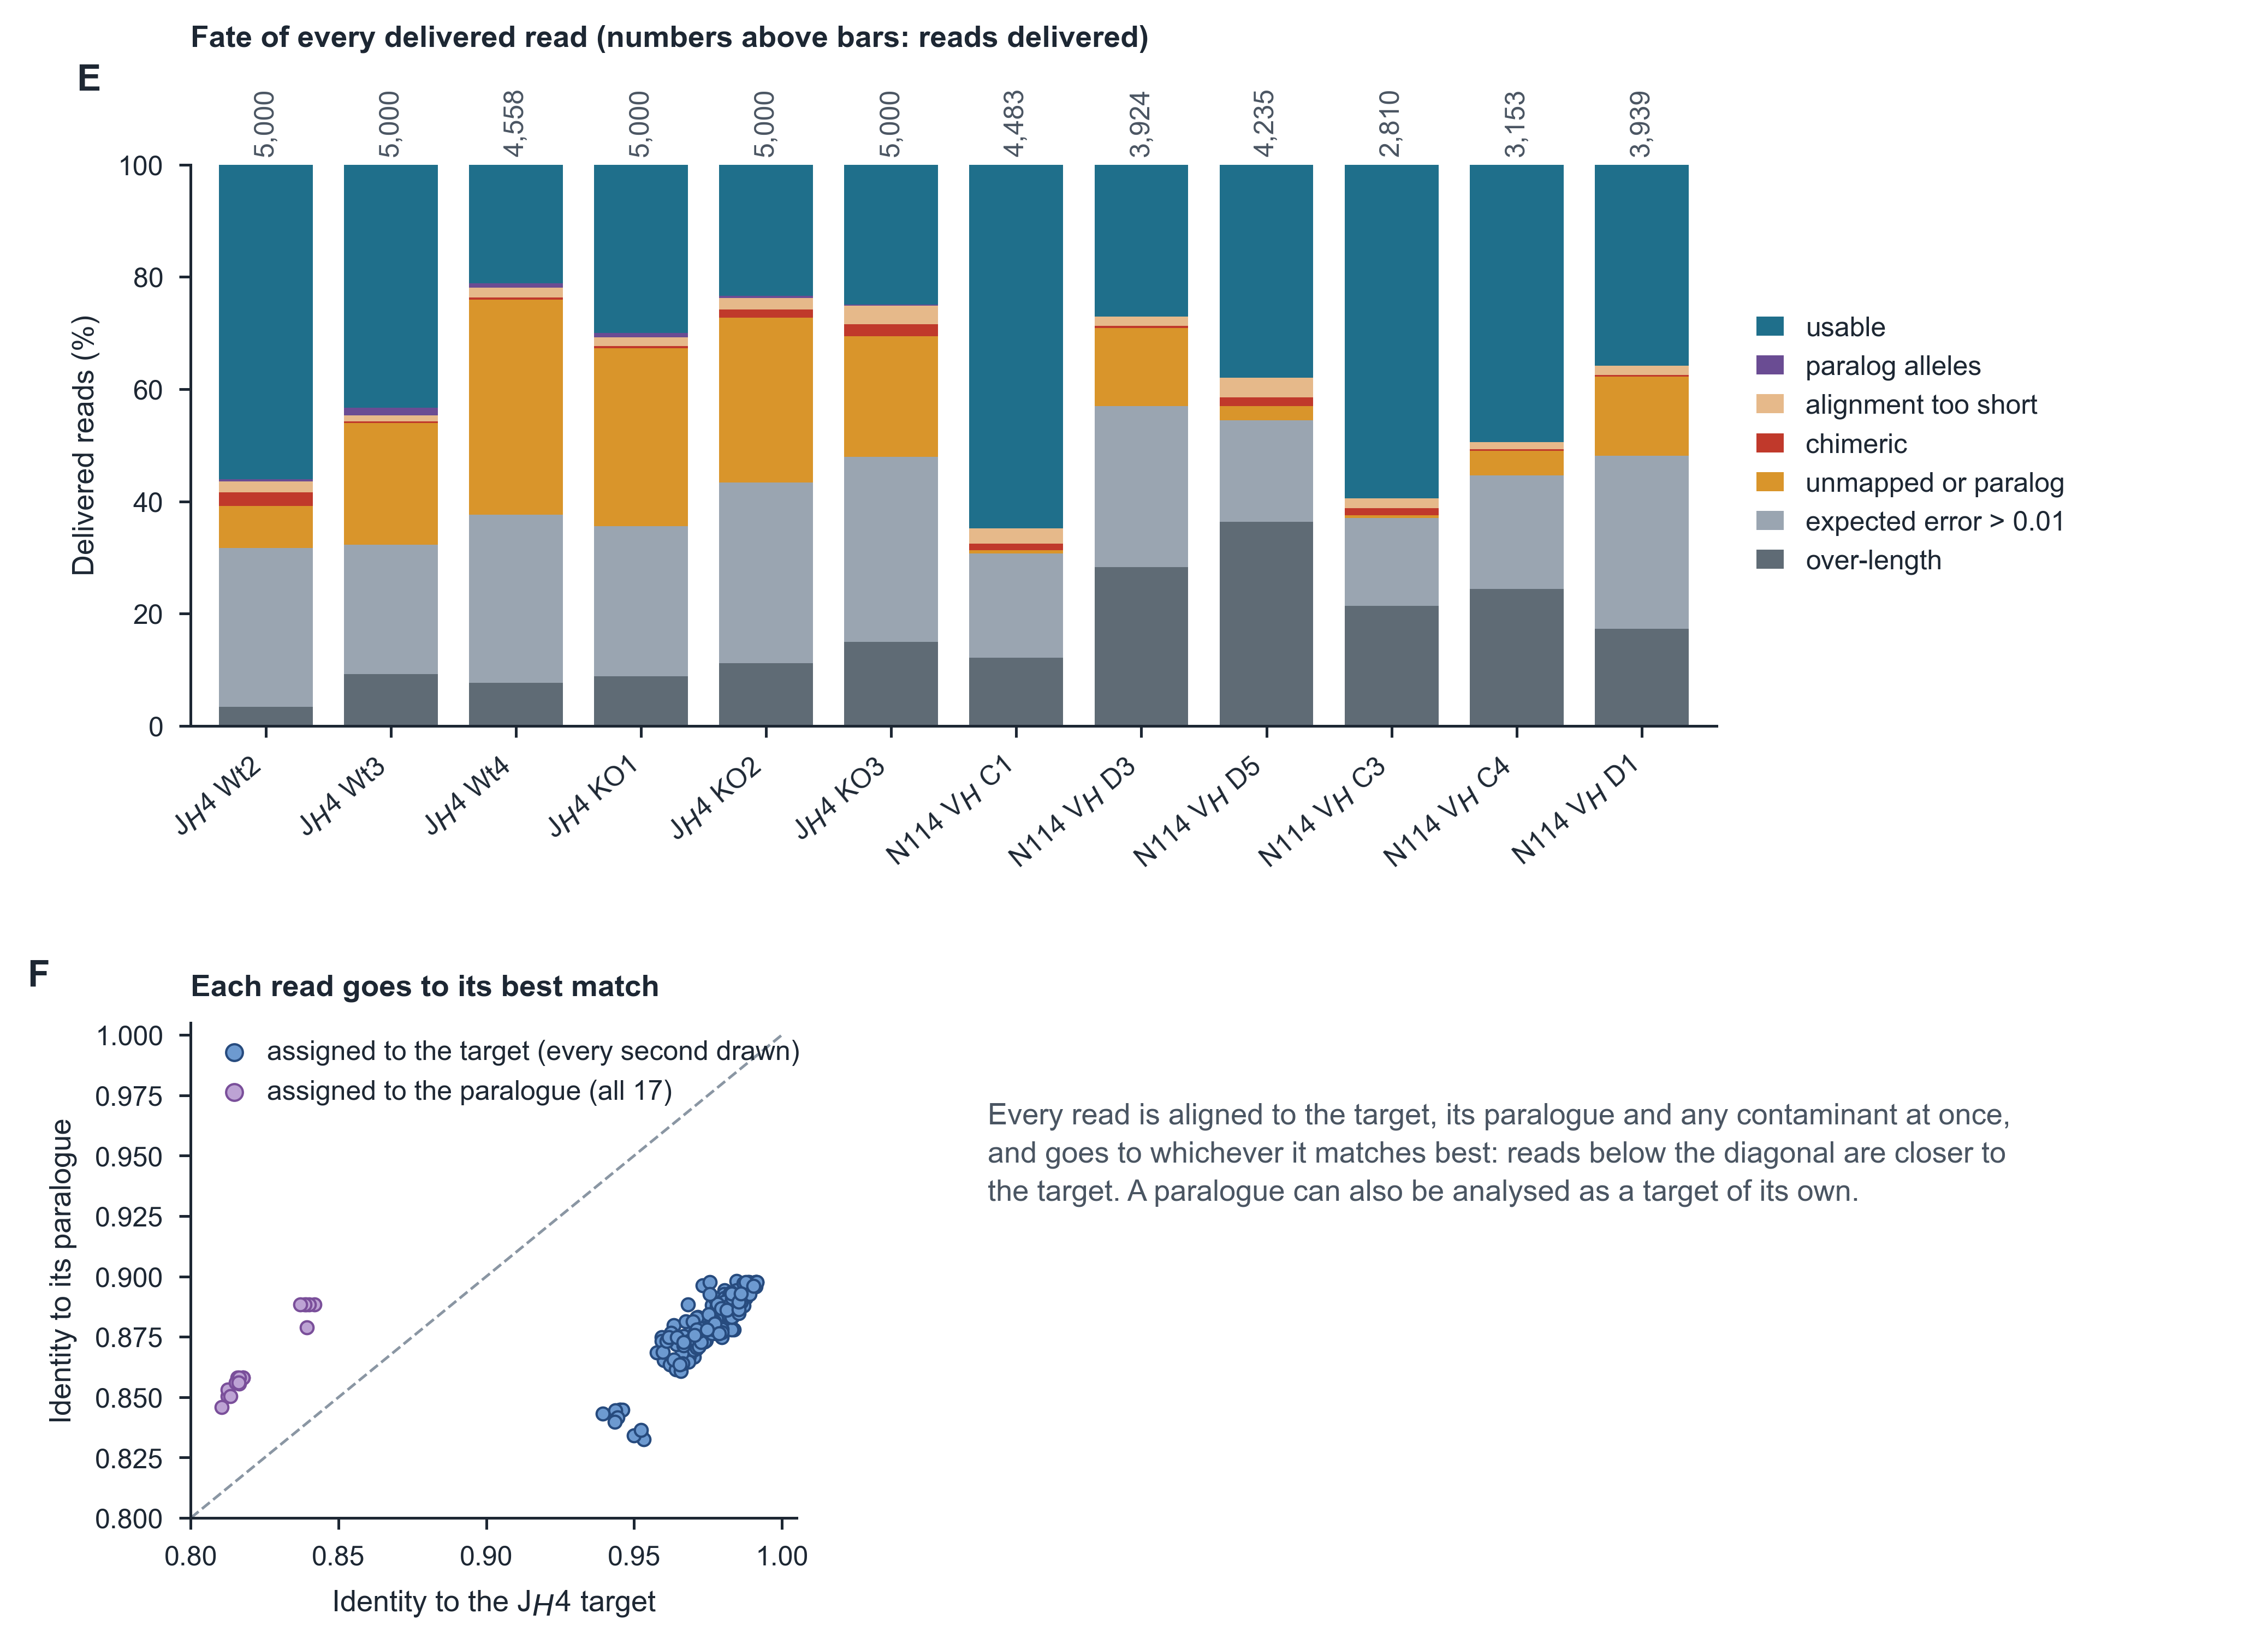
Figure S1. Detailed workflow, related to Figure 1. The workflow of Figure 1 in full, from the design of the two experiments to the counting of a Sanger clone. (A) Experimental design for the J_{H}4 and N114 V_{H} libraries. (B, C) Read preparation and variant calling from the delivered sequence files, which is the read-library route of Figure 1C. By default, an allele carried by 50% or more of the reads is excluded as a likely germline difference; because a mutation driven to that frequency within a dominant clone is removed with it, this is a heuristic and not a test (STAR Methods). (D) The Sanger route counts every substitution at base quality ≥20 across the analysed clones and the 529-bp window. The mismatch rate measured in the AID-null clones is reported beside those counts rather than subtracted from them, because it estimates the background of the whole set and not of any one call. A sequencing clone is one PCR-derived molecule sequenced once, so it says nothing about which B cell the molecule came from. (E) Fate of every delivered read of the J_{H}4 and N114 V_{H} libraries through SHMtrace's read preparation, as a share of delivered reads; numbers above bars, reads delivered. (F) Identity to the J_{H}4 target and to its paralog after competitive alignment, for the first 400 reads of the bundled Wt3 example library (every second target-assigned read drawn); each read is assigned to whichever it matches better. Experimental details: as in Figure 5 for J_{H}4 and Figure 4 for N114 V_{H}.
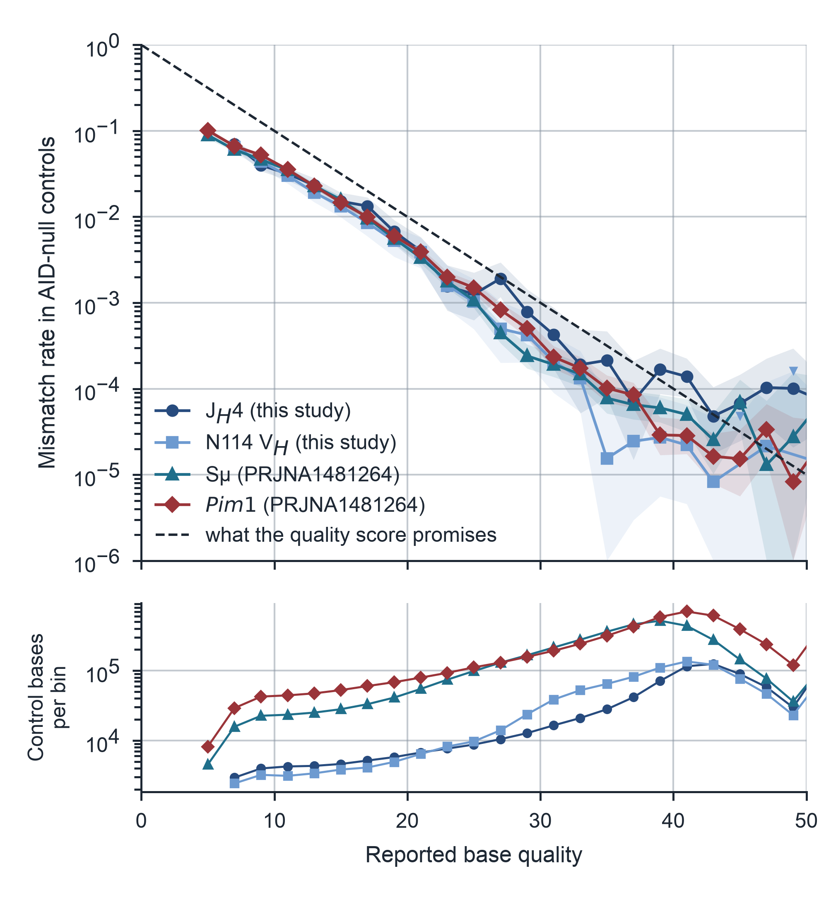
Figure S2. Reported base qualities and observed control mismatch rates, related to Figure 2. A reported base quality is a prediction, and this is how far it holds at each of the four nanopore loci. Top, the mismatch rate measured in the AID-null controls, grouped into two-quality-score bins holding at least 2,000 bases after germline positions are excluded. Shading, 95% Clopper–Pearson intervals; downward triangles, bins with no mismatch, drawn at the upper confidence bound because a rate of zero cannot be placed on a logarithmic axis; dashed line, the error probability the quality score nominally implies, 10^{−Q/10}. Bottom, the number of control bases in each bin. Observations thin out above Q40, so the uncertainty grows there. This is why each locus is calibrated against its own controls rather than against the reported qualities. Experimental details: the J_{H}4 libraries were sequenced under order DHJGKB and the N114 V_{H} libraries under order 75K3B3; for Sμ and Pim1 (PRJNA1481264) the deposited records do not establish which libraries shared a flow cell.
Figure S3. What a project run writes, and how to read it, related to Figure 1. Top, a project run: reads per animal and two or more AID-null controls in; a report, figures in PNG, SVG or PDF, Excel and CSV tables and the full result (with an AIRR rearrangement file) out. Below, SHMtrace's figures grouped by the question each answers, one per group redrawn from the J_{H}4 nanopore run (three Wt and three Aicda^{−/−} mice, 500 reads each), with a note on how to read it and what to watch for; the further figures of each group are listed in the software documentation. (A) Read accounting through each filter. (B) The error rate the AID-null controls showed at each position; dashed line, median. (C) Unique-variant density per animal; open circles, animals with no call, drawn at one event; bars, geometric means; p, Welch test on log density. (D) The twelve substitution types; bars, Wt pooled; points, mice. (E) Share of reads mutated at each position, Wt above the line and Aicda^{−/−} below; ticks, WRC/GYW hotspots. (F) Clones defined by the V(D)J junction, by size and number of mutations. Seven figures are drawn for every project and up to nineteen more when the run has the data, so a run of this project writes 21 of them. Each panel is an output of the run itself, not a schematic. Built with crm/scicanvas/figS3_outputs.js.
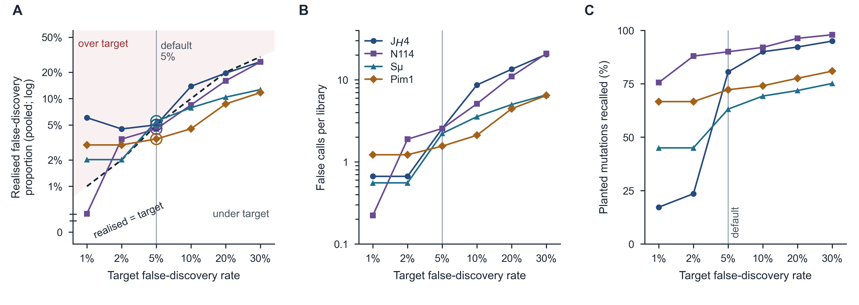
Figure S4. The control-based false-discovery threshold against planted truth, related to Figure 3. The spike-in libraries of Figure 3 (60 substitutions planted into 1–20 reads of each held-out AID-null control, three draws per control; 9 libraries per locus) were called at six target false-discovery rates, every other setting at its default and only the other controls serving as null and decoys. (A) Realised false-discovery proportion, false over all calls pooled across a locus's libraries, against the target; dashed line, realised = target; shading, over target; rings, the default 5%. The y axis is logarithmic; a pooled proportion of zero has no logarithm and is drawn on its own 0 row below an axis break. (B) False calls per library. (C) Recall of planted substitutions. Vertical lines, the default target of 5%. At the default, pooled proportions were 3.5–5.5% (1.6–2.6 false calls per library), and single libraries reached 10.6%. Below 5%, false calls levelled off at 0.2–1.2 per library while recall fell, consistent with library-specific errors that the other controls do not share and with decoy counts too coarse to resolve small targets (STAR Methods). The realised proportion depends on the number of true mutations per library (here 60) and is not a per-library guarantee. Analysis in crm/spikein.py (--tag _fdrcal) and crm/figs/figS4_fdr_calibration.py.
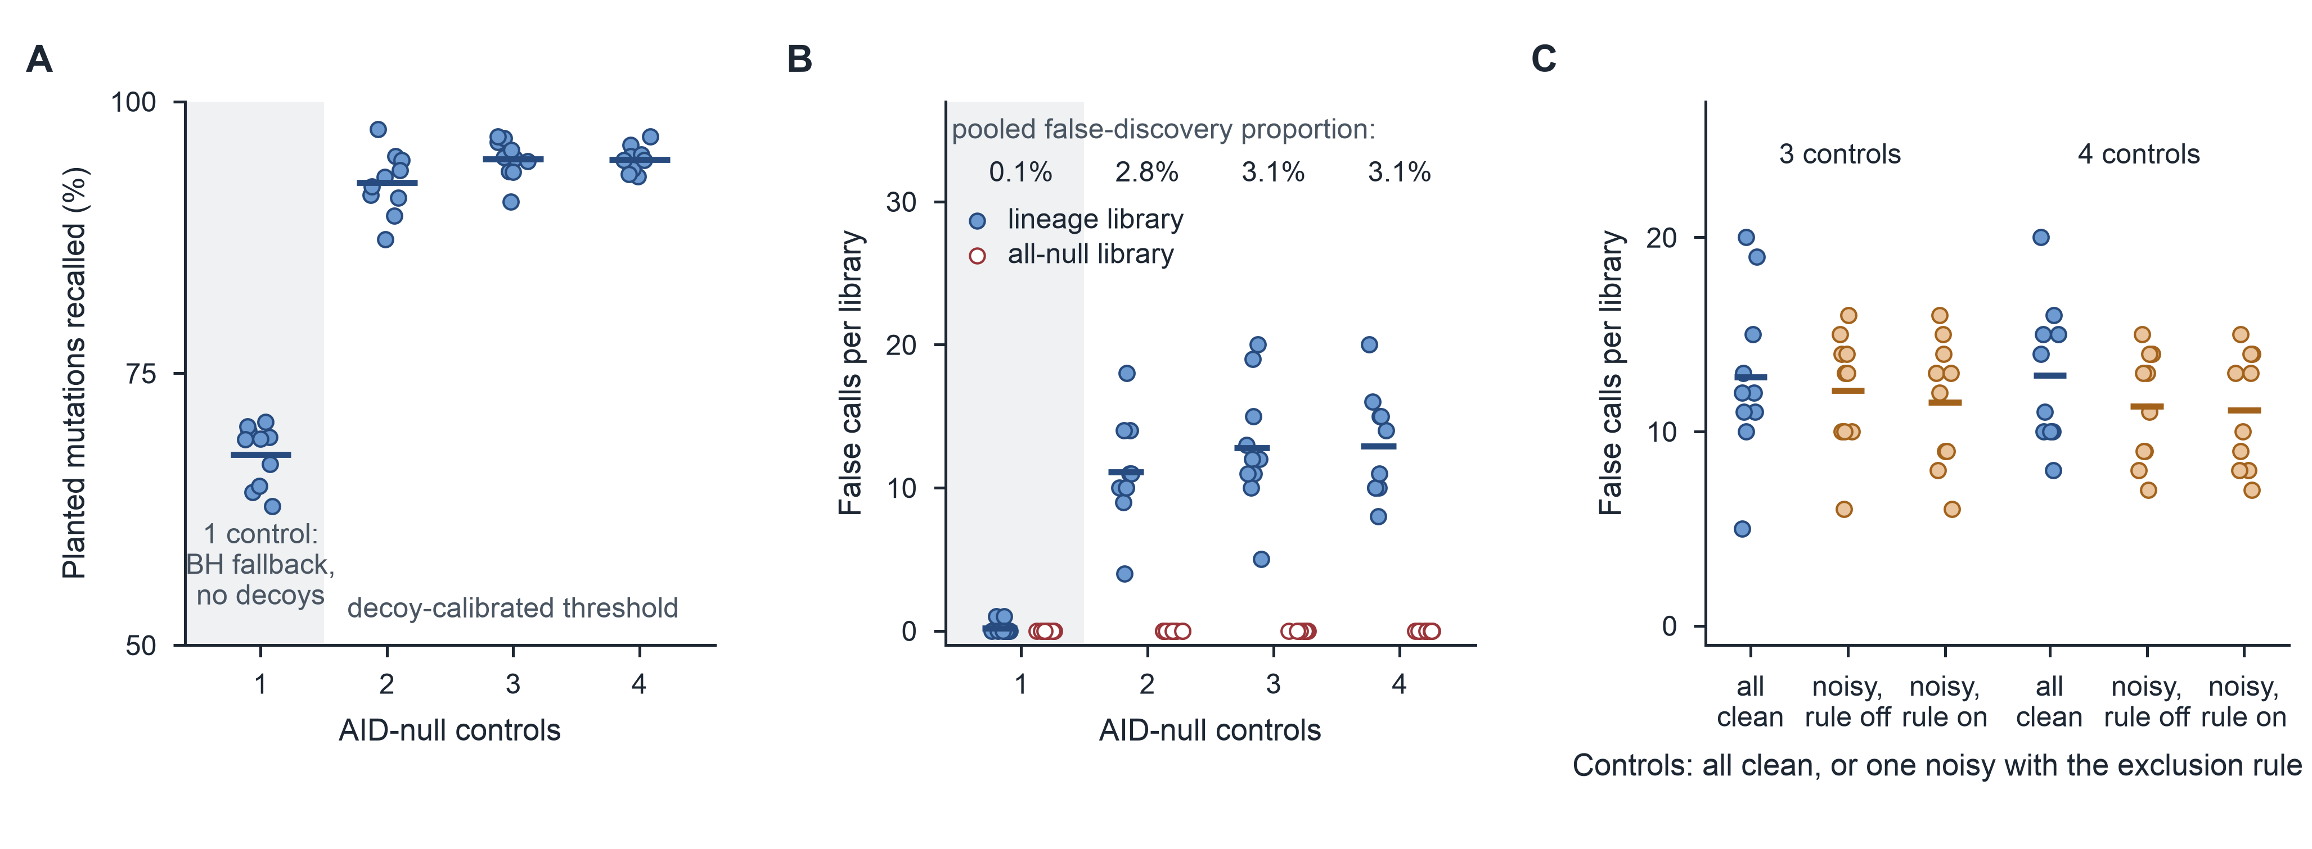
Figure S5. How many AID-null controls, and which, related to Figure 3. Everything the read-library route does rests on the controls, so their number and their provenance were varied through the whole run_project procedure. J_{H}4: the case is KO1 carrying planted polyclonal lineages, or none; the controls are halves of KO2 and KO3, so the third and fourth are technical partitions of the same two animals rather than new mice; 10 repeats per setting; points, repeats; bars, means. (A) Recall of planted mutations by number of controls; the shaded one-control condition uses a different procedure (below) and is set apart from the decoy-calibrated designs. With one control there are no decoys and the threshold falls back to Benjamini–Hochberg (BH), which is why recall drops: the empirical threshold needs a control to hold out. (B) False calls per library in lineage-bearing (filled) and all-null (open) libraries; above, the pooled false-discovery proportion of the lineage-bearing libraries. No all-null library produced a call at any number of controls. (C) All controls clean, or one control carrying recurrent artifacts at six positions in 6% of its reads, with the noisy-control rule off and on, beside the clean set. The rule set the noisy control aside in 10 of 10 runs and a clean control in 2–3; with four controls and the rule on, one of 10 all-null libraries produced a call. Two controls are the point at which the procedure works as intended, and a third adds little. Controls from a different experiment were also tested, on Sμ: each LPS AID-null library, carrying 60 planted substitutions in three draws, was called against its own experiment's other two AID-null controls, against two or three AID-null controls from the CH12 experiment of the same BioProject, or against all five. Recall was 63% with matched controls and 66–68% with CH12 controls, at false-discovery proportions of 5.5% and 5.4–5.6%; pooling all five lowered false calls from 2.2 to 0.8 per library. The SRA reads carry no run identifiers, so that comparison is between experiments rather than between verified sequencing runs. Analysis in crm/controls_design.py and crm/figs/figS5_controls.py.
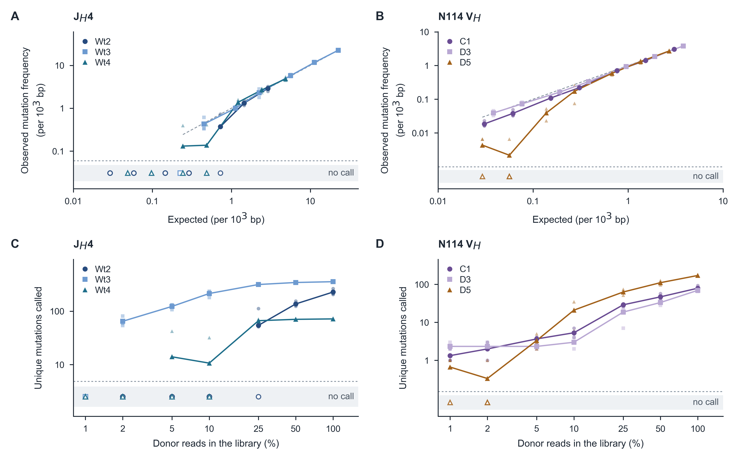
Figure S6. Real hypermutation diluted into AID-null reads, related to Figure 3. Each AID-active library (donor) was mixed with one AID-null library (diluent) at 1–100% donor reads in 500 usable reads, 3 draws per fraction, and called against the other two AID-null libraries (J_{H}4: donors Wt2–Wt4, diluent KO1, controls KO2 and KO3; N114 V_{H}: donors C1, D3 and D5, diluent D1, controls C3 and C4). Unlike the planted mutations of Figure 3, these are the mutations AID itself made, carrying their own clonality, hotspot clustering and multiple mutations per read. Small faint markers, the individual draws; large markers, their mean; lines join consecutive fractions that produced calls and stop where calling does. Draws that called nothing cannot be placed on a logarithmic axis and are drawn as open markers in the "no call" strip below the break. (A, B) Observed mutation frequency against the frequency expected from donor and diluent alone; dashed line, equality, spanning the called points it refers to. Frequency is read-weighted, so its expectation is linear in the donor fraction. On N114 V_{H} frequency was 0.87–0.97 of the expected value at 25–50% donor reads. (C, D) Unique mutations called against the share of donor reads. Calling is a step rather than a fade: on J_{H}4 it began at 2% donor reads for Wt3 and 50% for Wt2, tracking how many reads carry each mutation, which is mutation load crossed with clonal structure. A control-based threshold admits no call until enough candidates exceed the controls' background, so a donor whose mutations sit on few reads each loses them all at once. With 3 draws per fraction these thresholds are coarse. N114 V_{H} ran with ancestral_reference (STAR Methods); under the default ≥50% rule a mutation fixed within a subclone is removed at full strength but counted once diluted, and D3 then read 1.84 per 10³ bp at 50% donor reads against 0.63 at 100%. Analysis in crm/titration.py and crm/figs/figS6_titration.py.
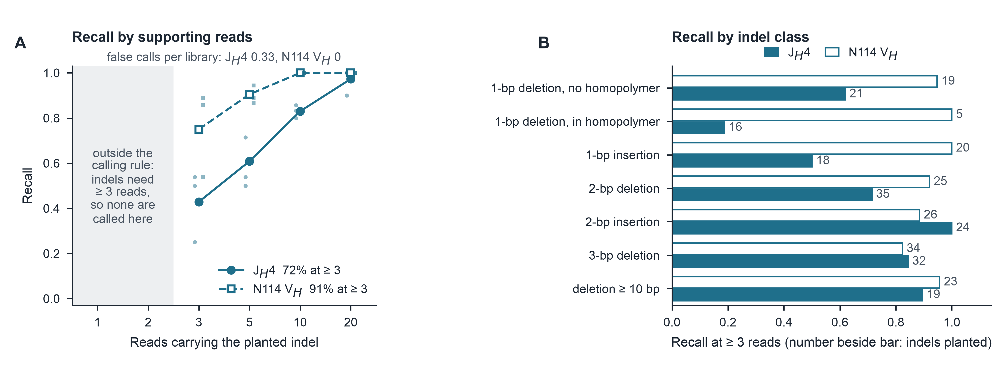
Figure S7. Indels planted into held-out AID-null libraries, related to Figure 3. The indel counterpart of Figures 3A and 3B. Ten insertions or deletions of 1–40 bp were planted into the reads of a held-out AID-null library, eight draws per control, 240 planted indels per amplicon, each carried by a set number of reads; error models were fitted to the other controls (STAR Methods). (A) Recall by the number of reads carrying the indel. Small faint markers, the three held-out controls in their own right. Below three reads the calling rule (indel_min_reads) calls no indel, so that region is shaded as outside the rule and no recall is drawn there: it is not a measured failure. Legend, recall of the indels carried by three or more reads; above the panel, the false calls each cost. (B) Recall by indel class among the events carried by three or more reads; beside each bar, the planted events of that class, several of which are few enough that the proportion is coarse. Single-base deletions inside a homopolymer are the class nanopore recovers least reliably, which is the error mode the indel model is fitted against. On J_{H}4 the false calls are not eight events but one: the same 28-bp deletion, in the same four reads of one control, in every draw. It carries 5-bp microhomology at its ends, so it is most likely a molecule the material already held rather than a calling error. Analysis in crm/indel_spike.py and crm/figs/figS7_indels.py.
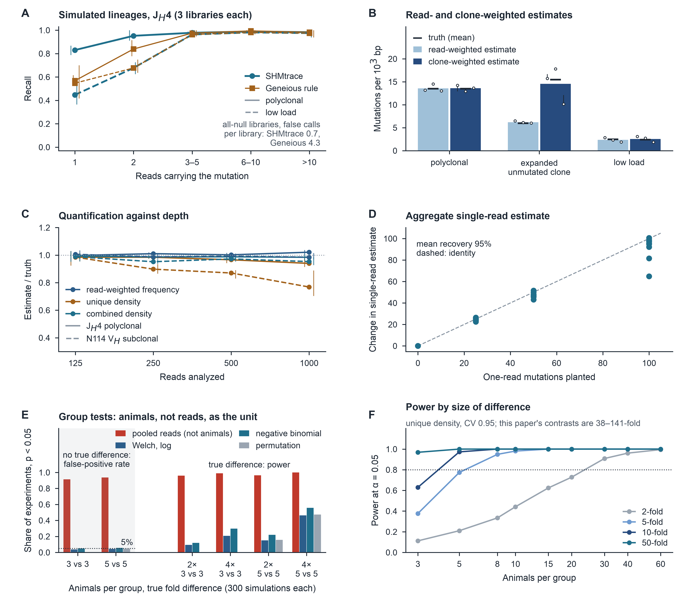
Figure S8. Downstream estimates and group tests in simulation, related to Figure 3 (page 1 of 2). What the read-library route's estimates and group comparisons deliver once calls are made. (A) Recall by read support in simulated J_{H}4 libraries of approximately 40 clones (power-law clone sizes; S5F-weighted mutations shared by a clone, a branch or one read), three libraries per scenario; vertical lines, range over the three libraries; text, false calls per library in all-null libraries. (B) Read- and clone-weighted estimates against their own truth; bars, mean estimates; black ticks, mean truth; stems join each library's truth to its estimate, because the truth differs between libraries. In the expanded scenario an unmutated clone contributes 60% of reads. (C) Estimate ÷ truth against depth, means and ranges over three held-out controls; solid, J_{H}4 polyclonal; dashed, N114 V_{H} subclonal. Combined density adds estimated uncalled single-read events. (D) Change in the aggregate single-read estimate against one-read mutations planted into held-out J_{H}4 control libraries (three controls; three replicates per amount); dashed line, identity. (E) Share of 300 simulated experiments per condition with p < 0.05, three or five animals per group, between-animal coefficient of variation 1. The two blocks answer different questions: with no true difference the rates are false-positive rates (dotted line, the nominal 5%); with a two- or four-fold difference they are power. Pooled-read tests treat reads rather than animals as the unit. Monte Carlo 95% half-width ≤ 5.6 points; the exact two-sided permutation test cannot fall below p = 0.10 at n = 3. (F) Power at α = 0.05, two-sided, from the Welch test on log rates, by animals per group and by the size of the difference sought, simulated from the J_{H}4 wild-type pilot (3 mice, 500 reads each; 1,000 experiments per point; negative-binomial counts with the pilot's clumping, animals log-normal with the pilot's between-animal coefficient of variation, CV 0.95). Dotted line, 80% power. How many animals are needed depends on the difference being sought, not on the method alone: a 2-fold difference between two AID-proficient groups needs about 24 per group at this CV, whereas at 10-fold three animals give 63% power and five give 97%, and at 50-fold three give 97%. The comparisons this paper makes are AID-competent against AID-null and run 38–141-fold, which is why they separate at three animals per group. The CV is itself estimated from three mice and so is the loosest term in the calculation.
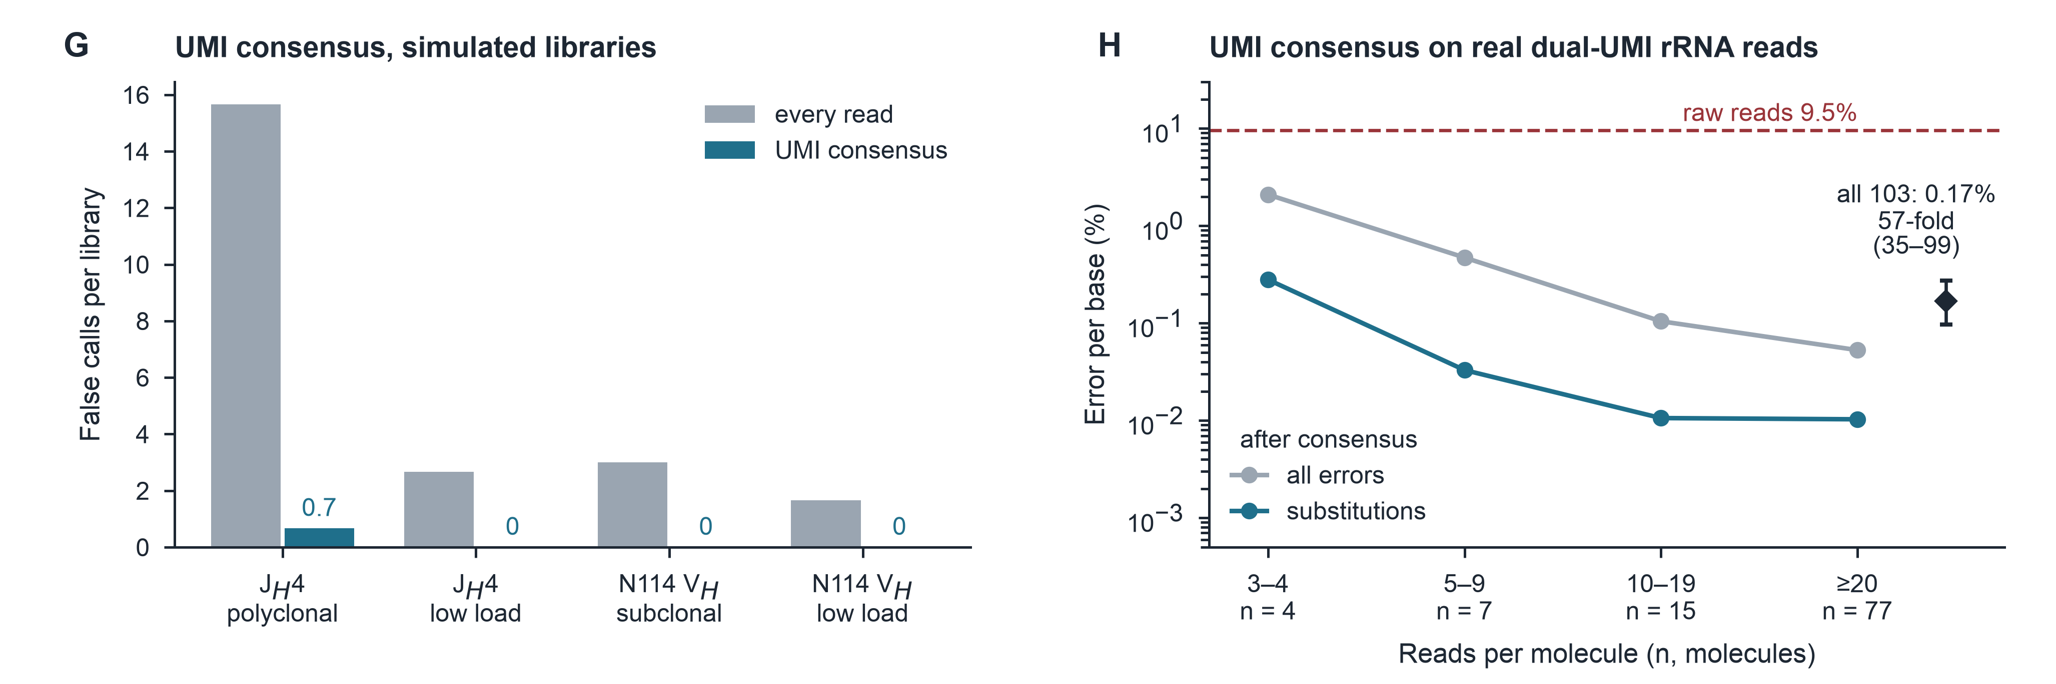
Figure S8. UMI consensus in simulation and on real reads, related to Figure 3 (page 2 of 2). (G) Simulated UMI libraries built from real control reads, three held-out controls each: false calls per library when every read is used and when reads are first collapsed to a consensus by tag. The four conditions are the two amplicons under two planted mutation loads: J_{H}4 polyclonal (about 40 clones) and J_{H}4 low load, and N114 V_{H} subclonal (one dominant clone) and N114 V_{H} low load, the same scenarios as Figure S8A. Consensus removes every false call in three of the four and leaves 0.67 in the fourth, annotated on the panel because a zero-height bar cannot be told from a missing one, while recall of the planted mutations rises from 90–96% to 99–100%. The two AID-null conditions are not plotted; their false calls fall from 0.67 and 2.67 per library to zero. Grouping reads by tag leaves 165 molecules from the 500 reads analysed, so the gain is bought with depth. (H) The same question on real data: error remaining after consensus in dual-UMI R10 reads of rRNA operons⁴⁴, by the number of reads per molecule; n, molecules; dashed line, the error of the raw reads; diamond, all 103 molecules of three or more reads pooled, with a bootstrap 95% interval from 2,000 resamples of molecules at fixed raw error. Consensus reduced error 57-fold, and at ten or more reads per molecule the residual substitution error approached one base in 10,000; what remains is mostly homopolymer indels. These are rRNA operons, not an SHM experiment: the panel measures what consensus does to sequencing error, which is why it sits beside the simulation in G rather than among the AID datasets of Figure 7.
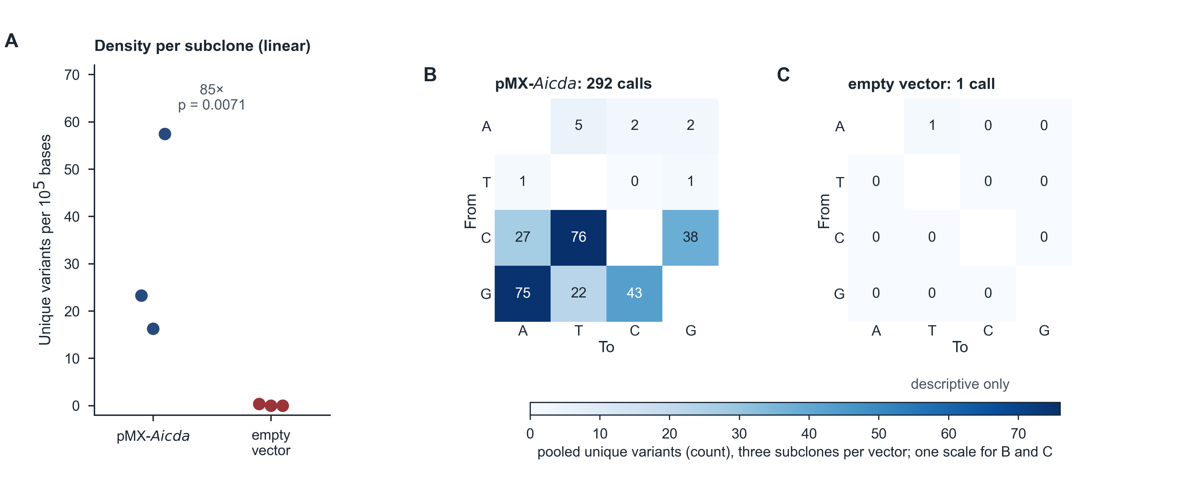
Figure S9. N114 V-region results, related to Figure 4 (page 1 of 2). AID expression drives mutation of the fixed immunoglobulin V-region substrate carried by N114 hybridoma cells. (A) Unique-variant density in each subclone (n = 3 per vector), on a linear axis so that a subclone with no call sits at zero. Fold change (geometric means) and p (Welch test on log density) enter zero-call subclones at one event, as in Figure 4. (B, C) Pooled From (rows) → To (columns) substitution matrices for the pMX-Aicda subclones (B) and the empty-vector subclones (C). Each cell gives the unique-variant count; both matrices share one colour scale. The single empty-vector call is shown, but a spectrum of one call is not interpreted. Because N114 cells carry a fixed V-region substrate, do not undergo ongoing V(D)J recombination and are not selected here for antigen binding, the excess in pMX-Aicda subclones reflects AID-dependent mutation rather than rearrangement or selection. That substrate carries an opal stop in CDR2, which silences antibody production, and whose reversion the original study scored as hypermutation⁴⁵; the calls here are made against the line's own sequence, stop included, and count mutation across the whole V region rather than reversion at that codon (STAR Methods). Experimental details: N114 cells were transduced with pMX-Aicda or matched empty vector, both encoding GFP and puromycin resistance; GFP-high cells were subcloned by limiting dilution and three puromycin-resistant subclones per vector were maintained for 1 month before DNA collection. The ~0.65 kb V region was amplified with Platinum SuperFi II high-fidelity polymerase and sequenced as individually barcoded R10.4.1/Kit 14 libraries, analysed at 500 reads per subclone. A unique variant is one substitution at one reference position, counted once per subclone however many reads carry it. Spectra of the individual libraries are shown on the following page.
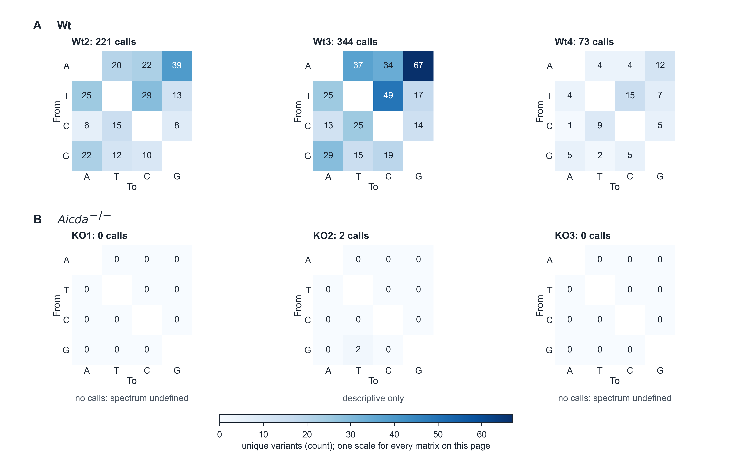
Figure S9. Per-library spectra, related to Figure 4 (page 2 of 2). The same spectra resolved to one matrix per library, so that the pooled patterns of Figure 4 and the preceding page can be seen to hold in each animal and subclone rather than in the pool alone. Top, J_{H}4 wild-type (Wt) and Aicda^{−/−} libraries; bottom, N114 V_{H} pMX-Aicda and empty-vector subclones. Within each component (A) denotes the AID-active libraries and (B) the AID-null libraries, and the panel letters restart in the lower component. Matrices are oriented From (rows) → To (columns), and each cell gives the unique-variant count, on one colour scale per page. A library with no call has no spectrum, and totals of one or two calls are descriptive only. Experimental details: the libraries are those of Figures 4 and 5, analysed at 500 reads each.
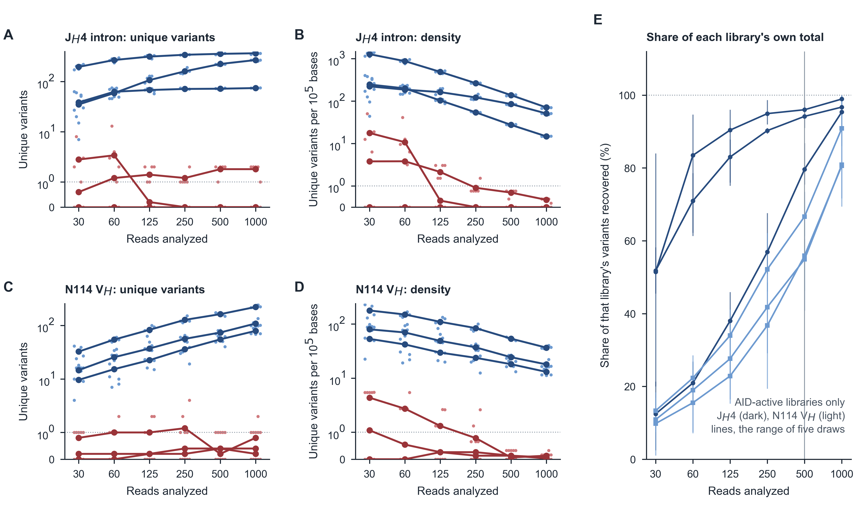
Figure S10. Sequencing depth and unique-variant discovery, related to Figure 4. Every library was analyzed at 30–1,000 reads, and the whole analysis was repeated five times at each depth with a different random draw of usable reads, the AID-null controls redrawn and recalibrated at that depth each time, so the spread shown is the spread a single run would have had. (A and B) J_{H}4 unique variants and unique-variant density against depth; (C and D) the same for N114 V_{H}. Points, the five draws of each library; lines, their mean; blue, AID-active libraries, red, AID-null. A library with no calls has a density of zero, which has no logarithm: those draws are drawn on the "0" row below the dotted break rather than floored to a small number, and they are common (J_{H}4 KO1 and KO3 called nothing at any depth in any draw). Density falls with depth because its numerator, distinct calls, saturates while its denominator keeps growing, so a density is only comparable at a stated depth. (E) How much of each AID-active library's own variant set each depth recovered. The denominator is the most that library ever yielded, over every depth and every draw, so a library is read against its own discovery rather than against its 1,000-read value alone; lines, the range of five draws; vertical line, the 500 reads used throughout. Discovery rises steeply and then flattens, as further reads re-sample positions already seen rather than revealing new ones, which is what saturation looks like for a finite set of truly mutated positions. The J_{H}4 libraries are near their own total by 500 reads (90% on average), whereas the N114 V_{H} libraries, which carry fewer mutations, are still climbing (59%). At 30 reads one draw is not informative: J_{H}4 Wt2 gave between 7 and 60 calls across its five draws, against 212 to 244 at 500 reads.
Figure S11. The background along the amplicon and in each read, related to Figure 4. (A and B) Mismatches at base quality ≥ 20 at every position of the analysis window, germline sites excluded, averaged over the AID-active libraries (blue, top track, its own scale) and in each AID-null library (red, one track each, one shared scale per locus, on which the small recurrent artifacts are visible); J_{H}4, 500 reads per library; Sμ (PRJNA1481264), 2,000. r, Spearman correlation between pairs of controls: the controls agree only weakly position by position (r = 0.12–0.20 over three pairs in J_{H}4 and 0.29–0.45 in Sμ). Recurrent artifacts are therefore a tendency of the chemistry and sequence context rather than a fixed per-position fingerprint, which is why the error model pools over substitution type, strand and base quality and shrinks each position towards that pooled rate instead of trusting its own count (STAR Methods). (C and D) Every mismatch at quality ≥ 20 (germline sites excluded) in each of the 500 reads of a wild-type (C) and an Aicda^{−/−} (D) J_{H}4 library; colored, at sites SHMtrace called; gray, other mismatches. Reads are sorted by clone (dotted lines between the largest clones) and by mutation load.
Figure S12. SHMtrace and the IgBLAST–SHazaM route on the same N114 V_{H} reads, related to Figure 4. The 500 reads SHMtrace analyzed from each N114 V_{H} library were assigned by IgBLAST (IGHV1-47-36*01; the parental line is 99.3% identical to it over 294 bp) and their substitutions over the V segment counted by SHazaM, with the IMGT germline, with the parental V segment as germline, and with the parental germline after masking bases below Q20; SHMtrace's calls over the same segment are shown for comparison. (A) Mutation frequency per library, the primary comparison; filled, pMX-Aicda; open, empty vector; libraries with no SHMtrace call sit in the 0 strip below the axis break; bars, geometric means with those zeros at one event. Beneath each route, its reference, the bases it keeps and what it counts. (B) Secondary: geometric-mean separation; a near-zero denominator inflates it. The SHazaM routes count every substitution in every read, including real single-read mutations that SHMtrace does not call, so their AID-library values are higher (2.8 against 1.6 per 10³ bp with masking); their empty-vector values (4.22 and 0.09 per 10³ bp without and with the parental germline and masking) are the background they cannot remove. MiXCR was not run. Analysis in crm/immcantation_compare.py and crm/figs/figS12_immcantation.py.
Figure S13. Sanger re-analysis, related to Figure 5 (page 1 of 2). Top, per-mouse counts of distinct Sanger substitutions at Q≥20, From (rows) → To (columns), on one colour scale; the AID-null totals of one or two are descriptive only. Bottom, fraction of Wt clones with a high-quality base at each J_{H}4 position and calls per 10³ observed bases; shading, the shared 529-bp window. Of 447 chromatograms in the eight archived sequencing orders, which cover that study’s wild-type, Mkln1-deficient and AID-null mice and also hold six traces of an unrelated amplicon, 184 were filed to the six mice used for nanopore sequencing; 2 of those were excluded in the sample sheet and not processed. Of the remaining 182, 48 failed analysis: 22 paralog amplicons, 12 without a contiguous 20-base Q≥20 segment, 11 unmapped and three too short. The 134 analyzed clones comprised 37, 40 and 26 Wt clones (103 total) and 11, 10 and 10 AID-null clones (31 total). Bookkeeping checks flag potential problems without automatically removing clones.
Figure S14. Reanalysis of published Maea Sanger data, related to Figure 5. J_{H}4 clones of germinal-center B cells from four wild-type (blue), four Maea^{fl/fl}Mb1^{cre} (purple) and Aicda^{−/−} (red) mice³³, each clone assigned to the mouse it was filed under in the original analysis. Filled circles and teal mean lines, SHMtrace from the chromatograms; open squares and brown mean lines, the published values, replotted from the paper's Source Data (Fig. 2g–i) and per-mouse tables (Supplementary Fig. 9b). The study reports three Aicda^{−/−} mice; four are filed in the original project and are all analyzed here (F). (A) Mutations per 10⁴ bp in each mouse; lines, means. (B) The same per mouse, SHMtrace against published; dashed line, identity. (C) Clones by mutations per clone, pooled by genotype, binned as published; the published bins come from the Fig. 2g Source Data, which count 96 and 183 clones, whereas the per-mouse tables behind Table S4 count 97 and 187. (D) G:C transitions and transversions as a share of each mouse's mutations. (E) Pooled 12-type substitution spectra, SHMtrace against published. (F) The published comparisons and SHMtrace's, with the one-tailed t-test used in the original study; "background explains" is the share of each group's calls that the Aicda^{−/−} clones' own error rate accounts for (STAR Methods), and the analysis time is for the whole project from one sample sheet, once that sheet had been built.
Figure S15. Reanalysis of published Mkln1 Sanger data, related to Figure 5. J_{H}4 clones of germinal-center B cells from three wild-type (blue), three Mkln1^{−/−} (purple) and three Aicda^{−/−} (red) mice³⁴, each clone assigned to the mouse folder it was filed under in the original analysis. Filled symbols, SHMtrace from the chromatograms; open squares, the published values, replotted from the paper's per-mouse tables (Supplementary Figure S2A). (A) Unique mutations per 10⁴ bases sequenced, per mouse; lines, means. (B) G:C transitions and transversions as a share of each mouse's mutations. (C) Pooled 12-type substitution spectra, SHMtrace against published, with r for each genotype. Of the three published Mkln1^{−/−} tables, only mouse #1's spectrum matches the clones of a folder (K2); tables #2 and #3 match no folder or set of clones in the original project, which limits the knockout's agreement. (D) The comparisons, published and SHMtrace's; the published P values are computed from the per-mouse tables as printed, and the values the paper's summary bars report (Supplementary Figure S2C) are listed separately. Paralog clones are J_{H}4-paralog amplicons, which SHMtrace analyzes apart from J_{H}4; "background explains" is as in Figure S14.
Figure S16. Reanalysis of published SW_{HEL} Sanger sequences, related to Figure 5. The 1,795 Sanger clones of Thientosapol et al. (2018), who hypermutated a SW_{HEL} V_{H}10 knock-in V region in germinal-center B cells and reported that inactivating Samhd1 raises transitions at C:G and lowers transversions at A:T and at C:G. SHMtrace was given only the deposited GenBank records: the germline is the iterated majority consensus of the clones themselves, each clone is assigned to the animal its own record names, and the arms are the genotypes its records state. (A) Mutations per sequence in each arm, SHMtrace against the paper's Table 1. (B) The 12 substitution types in each of the five arms, as a share of that arm's mutations. (C) The four classes the paper tests, one point per animal for SHMtrace and the published value as an open square; stars, two-tailed t-test across animals. (D) Published and reanalysed effects, side by side; for total mutation (a) the two columns use different tests, the paper's one-way ANOVA and SHMtrace's Welch test on per-animal log frequency, so they agree in direction but not in inference. Unlike Figures S14 and S15 this study deposits sequences rather than chromatograms, so the chromatogram reading and the bookkeeping checks are not exercised; it has no Aicda^{−/−} arm, so the Sanger error rate has to be carried over from the AID-null clones of those two studies (about 20 in 10⁵ bases at Q ≥ 20 in each), roughly 10-fold below the mutation frequency measured here.
Figure S17. Full-length spectra, related to Figure 6 (page 1 of 2). Extending the analysis from the Sanger window to the full amplicon increases the number of mutations sampled without altering the signature they carry. Pooled wild-type (Wt) substitution spectra across the shared 529-bp window and across the reliably covered 1,141-bp interval, with each cell giving the mutation count (A, B), and the two sets of shares plotted against each other (C; Pearson r = 0.989, r² = 0.977). The window lies inside the interval, so the comparison is descriptive and not an independent validation. Experimental details: the three Wt mice of Figure 5, analysed at 500 reads per mouse. Mutation trees from the same libraries are shown on the following page.
Figure S17. Mutation trees in each mouse, related to Figure 6 (page 2 of 2). The read-level reconstruction of Figure 6D, repeated in every mouse. Each tree is the most branched clone of one wild-type (Wt) mouse, built from the mutations its reads share. A tree summarises relationships among sequenced reads and not among cells: the reads of one clone may derive from the same molecule amplified more than once, so the corresponding cellular lineages were not independently established. Experimental details: the three Wt mice of Figure 5, analysed at 500 reads per mouse.
Figure S18. Engineered AID diversification, related to Figure 7. (A) One GFP substrate edited by a panel of deaminases delivered alike (SRP159221), three replicates per arm: the share of calls at WRC/GYW (circles) and the share that are C→T or G→A (squares), in wild-type and in UNG/MSH2-null 293T. Bars, group means. The motif share separates AID from APOBEC3A in both backgrounds; the transition share does so only in wild-type cells, because losing uracil excision drives transitions whichever enzyme made the uracil. This is the one engineered dataset with replicated no-editor controls, so its calls are control-calibrated. (B) An AID-diversified antibody V_{H} against the mutations its authors list for the same clusters⁴¹. Both columns come from that study's Additional file 1, which publishes, for each selected clone cluster, its nucleotide sequence and the authors' own list of the mutations they found in it: SHMtrace was given those sequences with the parental construct as reference, and its calls are compared with that list position by position, each cluster kept separate and nothing collapsed to a consensus. Each marker is one cluster entry, its area the number of entries sharing that pair of counts; dashed line, equality. SHMtrace recovers 150 of the 150 listed mutations and calls none the authors do not, over 42 entries across the study's two selection rounds. Those entries cover 38 distinct clusters, four of which recur between rounds, so the comparison is made against the deposit's own per-round listing rather than a deduplicated set. This is the only engineered analysis whose comparator is an independently curated list rather than another run of this software. Analyses in crm/liu_mutators.py and crm/devilder_clones.py.
Figure S19. Public Sμ mutation libraries under PI3Kδ blockade, related to Figure 7. Sμ amplicons from Wt and Aicda^{−/−} primary B cells treated with DMSO, idelalisib or duvelisib, three replicates per genotype and treatment (GSE77788). (A) Library coverage of the 651-bp reference, whose first half contains switch repeats. Six of nine Wt libraries are 300-bp single-end, whereas all Aicda^{−/−} libraries are paired-end, confounding genotype with library layout. Mates do not overlap. Window B is covered by one read from every library; window C covers repeats accessible only through the second mate. (B) Unique mutations per library in window B at 20,000 reads; bars, group means. Window B is the only stretch every library reads, and it lies outside the switch repeats where AID acts, so it cannot carry the drug comparison: Aicda^{−/−} libraries stay at background across treatments, and among wild-type libraries the variation between replicates of one treatment exceeds the differences between treatments. That is why the comparison that follows is restricted to the repeats and to the paired libraries that reach them. (C) Descriptive genotype comparison in window C using the twelve paired libraries (three Wt and nine Aicda^{−/−}). Each Wt treatment has only one replicate, so pooled treatment groups do not provide a balanced treatment comparison. Targeting index and C→T/G→A share refer to Wt calls.
Figure S20. Class-switch junctions in a public PacBio dataset, related to Figure 7. Sμ–Sγ1 products from Wt, Shld1^{−/−}, Xlf^{−/−} and Shld1^{−/−}Xlf^{−/−} primary B cells, three mice per genotype and one PacBio run per mouse (PRJNA831666). (A) Delivered reads, junction-bearing reads and unique junctions per library. Unique junctions group breakpoints within 3 bp on both sides. Reads per unique junction vary several-fold between samples; counts therefore measure long-range PCR-product recovery rather than switching efficiency. (B) Unique-junction microhomology classes in each mouse: blunt, 1–3 nt, ≥4 nt and junctions with inserted bases. (C) Mean microhomology per mouse; bars, genotype means; p, Welch tests against Wt, n = 3 per genotype. Permutation p values cannot fall below 0.1 at this sample size and are provided in crm/out/switch_pacbio/comparisons.csv. (D) Fraction of unique junctions with an alternative acceptor-segment placement within five matched bases of the best alignment, assessed by independent segment realignment. The module's internal ambiguity flag is 0% throughout because minimap2 reports no secondary alignments; breakpoints within repeats therefore remain approximate. Removing ambiguous junctions excludes 2–21% per sample and preserves the classification relative to p = 0.05 for 13 of 15 genotype–feature comparisons. Shld1^{−/−} ≥4-nt microhomology becomes stronger and Xlf^{−/−} insertions weaker (STAR Methods); not all 15 comparisons appear in panel C. The dataset lacks AID-null controls and does not evaluate substitution-test calibration.
Figure S21. What a read means on each of the four platforms, related to Figures 5–7. Top row, the two platforms applied to the same six mice, drawn on a common base-pair scale. A Sanger clone represents one PCR-derived molecule sequenced over the shared 529-bp window. The eight nanopore reads are experimental Wt3 reads from four clones spanning the 1,230-bp amplicon, with called mutations shown over positions 90–1,230. Error marks are simulated because uncalled mismatches cannot individually be classified as technical errors or true mutations. They were placed randomly at the AID-null mismatch rate after germline exclusion (0.14% of bases); 85% fall below Q20 (pale orange), with the remainder at Q≥20 (solid orange). Both are smaller than mutation markers. Individually unresolved single-read mutations are estimated in aggregate. Second row, the two platforms read from public deposits: overlapping Illumina pairs are merged before read preparation. Examples show median pairs among the first 20,000 pairs from a Wt J_{H}4 mouse (PRJNA973112; 95.5% merged) and 14,679 pairs from an AID-expressing CH12F3 replicate (PRJNA918596; 96.7% merged). Agreeing overlap bases have summed qualities capped at Q60; disagreements retain the higher-quality call or become N at tied qualities. Adapter read-through is removed, and pairs with <20-bp overlap are discarded. Overlap disagreements occurred at 0.13% and 0.55% of bases, respectively. Merged reads enter the Figure 1 workflow using the minimap2 sr preset, an expected-error limit of 0.02 per base and a minimum alignment requirement of no more than 100 bp. PRJNA973112 and PRJNA918596 contain uniformly Q30 bases, yielding one quality level in the error model; PRJNA820976 retains binned qualities (crm/scicanvas/s12_illumina.py). Beside it, one PacBio read across a class-switch junction: a HiFi read carries the Sμ donor, the join and the Sγ1 acceptor on one molecule, so the microhomology at the join and any inserted bases are read directly rather than inferred. The bar is the median junction-bearing read over that study’s 12 samples, 6,126 bases, and where the break falls varies between reads, so the donor and acceptor split drawn is schematic. Microhomology classes are that study’s own unique junctions, averaged over its samples. Reads per unique junction run 1.1–23.3 between samples, so junction counts measure long-range PCR recovery and not switching efficiency, and that deposit has no AID-null arm. Below both rows, coverage of each study locus by a single processed read, the PacBio switch junctions among them, whose bar is clipped because at scale it would reduce every other platform to a sliver. Bottom, a table setting the two in-house platforms side by side: the unit each counts, its span, its calling rule, what each gives alone, the Wt/AID-null separation and the main limits, then their agreement in the six matched mice. These comparisons are assay-specific: Sanger amplicons spanning V(D)J junctions can support lineage grouping, UMI consensus represents one molecule per family, and long-read coverage depends on amplicon design. Nanopore fold separation assigns zero-call controls one event. Sanger background is the Q≥20 mismatch rate in AID-null clones from Figures S14 and S15.
Figure S22. SHMtrace analysis workflow, related to STAR Methods. Sequence files are assigned to biological replicates through a sample sheet, filtered and aligned competitively against target, paralog and contaminant references. Matched AID-null libraries provide the background model for read-library substitution tests; held-out controls serve as decoys for threshold selection. Sanger substitutions are counted separately, with measured background reported alongside the counts (Figure 1C). Length limits are locus-specific (STAR Methods). The default ≥50% allele filter excludes likely germline differences but can also remove acquired mutations in dominant clones. Group comparisons use one value per animal. Illustrative panels show the error-rate grid by substitution and quality, expected versus observed candidate support, and calls versus decoys across thresholds. Outputs include density, mutation frequency, base-composition-corrected 12-type spectra, WRC/GYW and WA/TW targeting, positional profiles, clones, mutation trees and indels; Sanger outputs also report expected background counts. Bookkeeping flags do not automatically remove traces. A trace deliberately assigned to two animals is retained in both, and suspected accidental copies are flagged for review. Only rows explicitly marked as excluded in the sample sheet are omitted, with reasons recorded. Sample-sheet rows are illustrative. Figure S23 details the analytical rules and equations.
Figure S23. Rules underlying variant calling, related to STAR Methods. The four statistical stages of the read-library route, each with the rule and the equation the software implements, and each shown working on the J_{H}4 libraries rather than stated in the abstract. Read preparation and competitive alignment are routine preprocessing and are shown in Figure S1. (A) Reported base quality against the mismatch rate measured in Aicda^{−/−} libraries; the dashed line is the error probability the quality score nominally implies, and the gap between them is what the margin corrects. (B) Two candidates at equal depth in the same library, with their supporting reads in the wild-type and control libraries, and why one is called and the other is not. (C) Candidate counts and held-out-decoy counts across p-value cutoffs, with the threshold that selection returns; the threshold is an empirical estimate that depends on the controls representing the samples' background. (D) The per-animal unique-variant density that group comparisons are made on. Experimental details: panels are drawn from intuition_jh4.json and the bundled example library.
Figure S24. End-to-end stress tests using resampled control reads, related to STAR Methods. AID-null J_{H}4 reads were resampled and analyzed with run_project, including margin selection, decoy thresholding and noisy-control exclusion. Cases used KO1. Two-control analyses used one partition each from KO2 and KO3; three-control analyses used two KO2 partitions and one KO3 partition. Case and control read records did not overlap. These are conditional resampling experiments using existing libraries, rather than independent preparations or a new sequencing run. Unless stated otherwise, analyses used three controls and 500 reads. Teal, exclusion enabled; amber, exclusion disabled, paired on identical inputs. Two outcomes are distinguished: any discovery in an all-null resample (A), and the false-discovery proportion of each mutation-bearing resample, its false calls over all its calls (C). The shaded case-only artifact, absent from every control, marks the boundary of control-based calibration. (A) All-null resamples with any call and 95% Clopper–Pearson intervals; n = 25 per setting for unmodified background and one noisy control, and n = 5 for case-only and shared artifacts. Any discovery gives an all-null false-discovery proportion (FDP) of 1. (B) Mean false calls ± SEM. (C) Individual FDPs in mutation-bearing resamples, five per condition and setting; black bars, means; dashed line, nominal 5% target. (D) Exclusion rate under a heterogeneous null; n = 5 per setting with two controls at 250 or 1,000 reads, and n = 25 with three controls at 500 reads. Artifacts occupied six positions with nominal 6% support at each. Shared artifacts used identical alternate alleles and avoided planted biological mutations. Injection preserved read orientation and quality order. Shared all-null artifacts produced calls in 0/5 resamples with exclusion enabled and 0/5 disabled, versus 5/5 in both case-only settings. Small resample counts limit conclusions about error control (STAR Methods).
Table S2. Datasets used to develop and validate SHMtrace, related to STAR Methods
Dataset | Platform | Locus (window) | Design | AID-null controls | Unit of analysis | Used for
J_{H}4, this study | ONT R10.4.1 | J_{H}4 intron (529 bp; 1,141 bp) | GC B cells, 3 Wt mice | 3 Aicda^{−/−} mice, same run | mouse | Figures 2–6
N114, this study | ONT R10.4.1 | N114 V region (615 bp) | 3 pMX-Aicda subclones | 3 empty-vector subclones | subcloneᵃ | Figures 2–4
J_{H}4 Sanger, same mice | Sanger | J_{H}4 intron (529 bp) | 26–40 clones per Wt mouse | 10–11 clones per Aicda^{−/−} mouse | mouseᵇ | Figure 5
J_{H}4 Sanger, published study³³ | Sanger | J_{H}4 intron (529 bp) | 4 Wt, 4 Maea^{fl/fl}Mb1^{cre} mice; 20–57 clones each | 3 Aicda^{−/−} mice reported, 4 filed | mouse | Figure S14
J_{H}4 Sanger, published study³⁴ | Sanger | J_{H}4 intron (529 bp) | 3 Wt, 3 Mkln1^{−/−} mice; 24–93 clones each | 3 Aicda^{−/−} mice | mouse | Figure S15
PRJNA1481264, Sμ | ONT | Sμ (611 bp) | 3 LPS blasts; 4 CH12 | 3 Aicda^{−/−} each | culture | Figures 2 and 4
PRJNA1481264, Pim1 | ONT | Pim1 (862 bp) | 3 LPS blasts | 3 Aicda^{−/−} | culture | Figures 2 and 4
PRJNA1481264, CH12 off-targets 1 and 2 | ONT | AID off-targets (968 and 942 bp) | 3 CH12 wild type, 3 Mllt1/Mllt3 double knockout | 3 Aicda^{−/−} each | culture | Figure 4
PRJNA973112³⁶ | Illumina | J_{H}4 (70 bp) | 7 Wt, 7 Ldha-deleted mice | 4 AID-null mice | mouse | Figure 7
PRJNA918596³⁷ | Illumina | VDJ (229 bp) | AID, R50E, R174E/R178E (4 each) | 4 empty-vector replicates | replicateᶜ | Figure 7
PRJNA820976³⁸ | Illumina | IGH VDJ (421 bp) | 6 Wt, 6 HMCES-KO clones | 3 AID-KO clones | clone | Figure 7
Karst et al.⁴⁴ | ONT R10, dual UMI | rRNA operons (4.4 kb) | 103 molecules | known sequences | molecule | Figure S8H
SW_{HEL} Sanger, published study³⁵ | Sanger (GenBank) | SW_{HEL} V_{H}10 (558 bp) | Samhd1, Msh2 and double mutants, UGI arm; 1,795 clones | none | host animal | Figure S16
PRJNA170048³⁹ | Illumina (36 bp) | mOrange reporter (619 bp) | AID-ER in NIH-3T3 cells, 3 experiments x 3 repair contexts | catalytically dead AID-E58Q-ER | experiment | Figure 7
PRJNA831666⁴³ | PacBio | Sμ–Sγ1 switch junctions | 3 Wt, 3 Shld1, 3 Xlf, 3 double | none (repair genotypes, no AID-null arm) | mouse | Figure S20
GSE77788⁴² | Illumina | Sμ (216 bp shared; 221 bp repeats) | 9 Wt, 3 treatments | 9 Aicda^{−/−}, same treatments | culture | Figure S19
SRP159221⁴⁰ | Illumina | EGFP reporter (238 bp) | AID and APOBEC editors, 3 each | 3 no-editor libraries | culture | Figure S18A
Devilder et al.⁴¹ | Sanger (published sequences) | antibody V_{H} (423 bp) | 42 selected clusters, 2 rounds | parental construct as reference | cluster | Figure S18B
Simulations | – | J_{H}4, N114 V_{H} | planted sites, lineages, group tests, Sanger projects | held-out controls | simulated library | Figure 3; STAR Methods
GC, germinal-center; Wt, wild type; KO, knockout; ONT, Oxford Nanopore Technologies; UMI, unique molecular identifier. a, independent subclones from one transduction; b, the same mice as the nanopore comparison; c, deposit replicates whose experimental origin is unspecified. The table covers twelve AID-targeted loci from eleven laboratories, counting J_{H}4 once across the rows that share it: six somatic hypermutation targets, four AID-targeted loci that are not SHM (Sμ, Pim1 and the two CH12 off-targets), and two engineered substrates. The rRNA operons are excluded; the Sμ–Sγ1 junctions are class switching at Sμ and are not counted again. Lengths are analysis windows; the mOrange amplicon is 679 bp. Superscript numbers cite the main manuscript's reference list.
Table S3. Read preparation and calls per library, related to Figure 4
Assay | Library | Delivered | Over-length | High error | Unmapped / paralog | Chimeric / short | Paralog alleles | Usable | Analyzed
J_{H}4 | WT2 | 5,000 | 171 | 1,415 | 374 | 219 | 20 | 2,801 | 500
J_{H}4 | WT3 | 5,000 | 462 | 1,150 | 1,086 | 70 | 68 | 2,164 | 500
J_{H}4 | WT4 | 4,558 | 351 | 1,362 | 1,750 | 96 | 37 | 962 | 500
J_{H}4 | KO1 | 5,000 | 443 | 1,336 | 1,585 | 97 | 40 | 1,499 | 500
J_{H}4 | KO2 | 5,000 | 558 | 1,609 | 1,470 | 174 | 21 | 1,168 | 500
J_{H}4 | KO3 | 5,000 | 749 | 1,649 | 1,075 | 271 | 12 | 1,244 | 500
N114 V_{H} | C1 | 4,483 | 546 | 832 | 24 | 176 | 0 | 2,905 | 500
N114 V_{H} | D3 | 3,924 | 1,111 | 1,123 | 547 | 79 | 0 | 1,064 | 500
N114 V_{H} | D5 | 4,235 | 1,538 | 768 | 109 | 213 | 0 | 1,607 | 500
N114 V_{H} | C3 | 2,810 | 601 | 440 | 14 | 85 | 0 | 1,670 | 500
N114 V_{H} | C4 | 3,153 | 768 | 639 | 139 | 49 | 0 | 1,558 | 500
N114 V_{H} | D1 | 3,939 | 680 | 1,217 | 553 | 77 | 0 | 1,412 | 500
Calling results
Assay | Library | Candidates tested | Calls (FDR ≤ 0.05) | Unique density (×10⁻⁵) | Read-weighted frequency (×10⁻³) | Clone-weighted frequency (×10⁻³)
J_{H}4 | WT2 | 415 | 221 | 83.748 | 2.8242 | 16.3043
J_{H}4 | WT3 | 534 | 344 | 133.205 | 22.465 | 24.9184
J_{H}4 | WT4 | 306 | 73 | 27.826 | 4.9338 | 5.3166
J_{H}4 | KO1 | 214 | 0 | 0 | 0 | 0
J_{H}4 | KO2 | 256 | 2 | 0.76 | 0.1096 | 0.2363
J_{H}4 | KO3 | 254 | 0 | 0 | 0 | 0
N114 V_{H} | C1 | 279 | 70 | 23.264 | 1.3333 | –
N114 V_{H} | D3 | 299 | 49 | 16.246 | 0.5789 | –
N114 V_{H} | D5 | 402 | 173 | 57.456 | 2.8163 | –
N114 V_{H} | C3 | 187 | 1 | 0.327 | 0.0065 | –
N114 V_{H} | C4 | 216 | 0 | 0 | 0 | –
N114 V_{H} | D1 | 150 | 0 | 0 | 0 | –
Per-library read removal at each preparation step, starting from delivered FASTQ files. Five hundred usable reads were randomly selected (seed 0). All three mutation endpoints are reported (STAR Methods): unique-variant density counts each distinct call once per library over analyzed base observations; read-weighted frequency counts its support across reads; clone-weighted frequency gives each junction-defined clone equal weight. A dash indicates that no clone had an assignable junction. WT, wild type; KO, Aicda^{−/−}; C1, D3 and D5, pMX-Aicda subclones; C3, C4 and D1, empty-vector subclones.
Table S4. SHMtrace and two published Sanger analyses, metric by metric, related to Figures S14 and S15
Metric | Maea: SHMtrace | Maea: published | Mkln1: SHMtrace | Mkln1: published
Mutation frequency (×10⁻⁴) | 99 → 22 ↓*** | 100 → 23 ↓*** | 102 → 13 ↓** | 68 → 9 ↓**
Mutation frequency counted as published (×10⁻⁴) | 89 → 20 ↓*** | 100 → 23 ↓*** | 80 → 8 ↓** | 68 → 9 ↓**
Mutation frequency, evidence-based clone set (×10⁻⁴) | – | – | 92 → 12 ↓** | –
A:T mutations (% of all) | 66% → 69% ns | 65% → 69% ns | 63% → 47% ns | 61% → 45% ↓**
G:C transitions (% of all) | 19% → 11% ↓*** | 19% → 11% ↓** | 22% → 24% ns | 24% → 28% ns
G:C transversions (% of all) | 15% → 21% ↑* | 14% → 20% ↑* | 15% → 29% ↑** | 16% → 27% ↑**
G:C mutations at WRC/GYW (%) | 59% → 64% ns | N.R. | 59% → 66% ns | N.R.
A:T mutations at WA/TW (%) | 69% → 80% ns | N.R. | 71% → 75% ns | N.R.
Calls the background explains (%) | 2% → 7% | N.R. | 3% → 21% | N.R.
Mice (Wt / knockout) | 4 / 4 | 4 / 4 | 3 / 3 | 3 / 3
Clones (Wt / knockout) | 92 / 179 | 97 / 187 | 88 / 193 | 110 / 227
Cells report Wt → knockout values; arrows indicate the direction of significant changes. Stars denote two-sided tests across mice: Welch tests on log₁₀ frequency and Student t tests on per-mouse percentages; ***, p < 0.001; **, p < 0.01; *, p < 0.05; ns, not significant. Frequencies count unique mutations over clone number × fixed sequence length. SHMtrace uses analyzed clones and the shared 529-bp window, excluding paralog amplicons. The publications count all filed clones across their full consensus lengths, recovered from the tables as 577 bp for Maea and 556 bp for Mkln1. “Counted as published” applies those denominators to SHMtrace mutation counts; the paired rows therefore differ only in denominator. The evidence-based Mkln1 clone set reassigns or sets aside clones with sequence evidence contradicting their filing, using prespecified rules (STAR Methods). Published Maea frequency and G:C values are from Source Data; other Maea values and all Mkln1 values were computed from the printed per-mouse tables. Maea, Maea^{fl/fl}Mb1^{cre} (Barbulescu et al., 2024); Mkln1, Mkln1^{−/−} (Barbulescu et al., 2025). N.R., not reported.
Table S5. What "reproduced" means for each re-analyzed study, related to Figures S14–S16
Study (figure) | Same clones? | Same endpoint? | Same denominator? | Same test? | Published values are | Agreement
Maea^{fl/fl}Mb1^{cre}, Barbulescu et al. 2024 (Figure S14) | Yes, the deposited chromatograms, each clone kept with the mouse it was filed under. SHMtrace sets paralog amplicons aside, so it analyzes 92/179 of the 97/187 clones the per-mouse tables count | Yes for frequency and the G:C shares; the WRC/GYW and background columns are SHMtrace's only | No. The paper divides by every filed clone × 577 bp; SHMtrace by the clones it analyzes × the 529-bp window they read cleanly. Table S4's "counted as published" row applies the paper's denominator to SHMtrace's mutations | In the figure, yes: Figure S14F uses the one-tailed t the original study used. Table S4 reports two-tailed tests throughout, so its stars are the stricter of the two | Source Data for frequency and the G:C shares (Fig. 2g–i); per-mouse tables (Supplementary Fig. 9b) for the rest | Same direction and significance for frequency and both G:C classes. The Fig. 2g Source Data count 96/183 clones and the per-mouse tables 97/187, a discrepancy in the published record, not in the re-analysis
Mkln1^{−/−}, Barbulescu et al. 2025 (Figure S15) | Partly. Clones are kept with the mouse folder they were filed under, but of the three published knockout tables only mouse #1's spectrum matches a folder; #2 and #3 match no folder or set of clones in the project | Yes for frequency and the G:C shares; WRC/GYW and background are SHMtrace's only | No. The paper uses every filed clone × 556 bp; SHMtrace the clones it analyzes × 529 bp. An evidence-based clone set (Table S4) is reported as a sensitivity analysis | In the figure, yes: Figure S15D uses the one-tailed t the original study used. Table S4 reports two-tailed tests throughout | Computed from the per-mouse tables as printed (Supplementary Figure S2A). The paper's summary bars (Supplementary Figure S2C) give different values and are listed separately | Same direction and significance for frequency and G:C transversions. The knockout spectrum agrees less well, which the untraceable tables #2 and #3 are enough to explain
SW_{HEL} Samhd1, Thientosapol et al. 2018 (Figure S16) | Yes in number, 1,795 deposited GenBank records, but not in provenance: the deposit names 12 wild-type hosts where the paper reports 13, and one record carries about twice every other host's clones | Yes for the four substitution classes the paper tests; SHMtrace adds per-animal values the paper does not report | No. The paper collates in a 560-bp window and counts every sequence independently; SHMtrace uses the consensus of the clones themselves and counts unique mutations per animal | No for total mutation: the paper uses one-way ANOVA across its five arms, SHMtrace a Welch test on per-animal log frequency between two. The four class comparisons use a two-tailed t across animals | The paper's Table 1, transcribed from the PMC copy | All four substitution classes agree in direction and significance. Total mutation agrees in direction only, under two different tests, so it is not a like-for-like reproduction
No deposit supplies raw traces for the SW_{HEL} study, so its chromatogram reading and bookkeeping checks are not exercised; it also has no Aicda^{−/−} arm. "Same clones?" asks whether SHMtrace saw the same molecules, "same endpoint?" whether the quantity is the one the paper reported, "same denominator?" whether it is divided the same way, and "same test?" whether the comparison is the one the paper made. Where any answer is no, agreement in direction is not a like-for-like reproduction, and the figures say which is which.
Table S6. Statistical summary, related to Figures 3–7
Comparison | Test | Result
J_{H}4, Wt vs Aicda^{−/−} (nanopore, unique-variant density) | Welch t on log₁₀; n = 3 vs 3 | 141-fold; p = 0.0027
J_{H}4, Wt vs Aicda^{−/−} (Sanger, unique-variant density) | Welch t on log₁₀; n = 3 vs 3 | 38-fold; p = 8.8 × 10⁻⁴
N114 V_{H}, pMX-Aicda vs empty vector | geometric means; n = 3 vs 3 | 85-fold
J_{H}4, full length (positions 90–1,230) | geometric means | 40 vs 0.18 × 10⁻⁵; ~229-fold
Spectrum, Sanger vs nanopore (12 types, 3 Wt mice) | Pearson r (descriptive); slope | r = 0.92; slope 0.97
Spectrum, per type | repeated-measures interaction; paired t with Šídák | interaction p = 0.62; smallest adjusted p = 0.61
Position along the window, Sanger vs nanopore | Pearson r, 25-bp bins | r = 0.94
Targeting index, Wt calls (J_{H}4) | permutation, 2,000 position sets | 1.22–1.36; p ≤ 0.015
Targeting index, Aicda^{−/−} mismatch positions | permutation | 1.00; p = 0.50
Group tests without a true difference (simulated) | share with p < 0.05, 300 experiments | pooled reads 0.91–0.94; negative binomial 0.050–0.057; Welch 0.037–0.043
Leave-one-control-out margin | held-out control tests with p < 0.01 at the samples' depth | J_{H}4 5.4% at 1×, 1.0% at 5×; N114 V_{H} 9.6% at 1×, 0.5% at 10×
Sensitive mode (FDR 0.20) vs default (0.05), J_{H}4 spike-ins | single-read recall; overall recall; observed FDR; false calls per library | 72% vs 31%; 92% vs 81%; 0.18 vs 0.050; 11.9 vs 2.6
Sensitive mode (FDR 0.20) vs default (0.05), N114 V_{H} spike-ins | single-read recall; overall recall; observed FDR; false calls per library | 87% vs 58%; 96% vs 90%; 0.16 vs 0.045; 11.0 vs 2.6
Ldha-deleted vs Wt (Illumina J_{H}4, mutation frequency) | Welch interval on log₁₀; Mann–Whitney p; n = 7 vs 7 | 0.55-fold [95% CI 0.07–4.49]; p = 0.75
Repair context, transitions at C:G (NIH-3T3, SHMtrace calls) | one value per experiment; n = 3 per arm | 95% (Ugi) vs 4% (UNG); paired t, p = 0.0021
Spike-in FDR, control-based vs Benjamini–Hochberg | observed false/(true + false) calls | J_{H}4 0.050 vs 0.046; N114 V_{H} 0.045 vs 0.045 (other C3 library: 0.079 vs 0.105)
With three animals per group, p values and intervals should be interpreted descriptively. Fold separation depends on the one-event convention used for zero-call controls and does not represent a statistical lower confidence bound.
Table S7. The default calling threshold against two stricter settings, related to STAR Methods and Figure 3
Benchmark | Setting | False calls per library | FDR | Recall | Single-read recall
Spike-ins, J_{H}4 | Default | 2.6 | 0.050 | 81% | 31%
Spike-ins, J_{H}4 | α 0.01 | 0.7 | 0.061 | 17% | 0%
Spike-ins, J_{H}4 | Noisiest decoy | 1.0 | 0.029 | 55% | 7%
Spike-ins, N114 V_{H} | Default | 2.6 | 0.045 | 90% | 58%
Spike-ins, N114 V_{H} | α 0.01 | 0.2 | 0.005 | 76% | 0%
Spike-ins, N114 V_{H} | Noisiest decoy | 2.1 | 0.038 | 89% | 54%
Lineages, polyclonal | Default | 13.7 | 0.037 | – | 83%
Lineages, polyclonal | α 0.01 | 3.0 | 0.010 | – | 38%
Lineages, polyclonal | Noisiest decoy | 12.0 | 0.033 | – | 80%
Lineages, expanded clone | Default | 12.0 | 0.034 | – | 84%
Lineages, expanded clone | α 0.01 | 1.0 | 0.004 | – | 31%
Lineages, expanded clone | Noisiest decoy | 10.7 | 0.030 | – | 82%
Lineages, low load | Default | 2.3 | 0.029 | – | 45%
Lineages, low load | α 0.01 | 0.7 | 0.053 | – | 0%
Lineages, low load | Noisiest decoy | 0.7 | 0.013 | – | 23%
Lineages, null | Default | 0.7 | 1 (all false) | – | –
Lineages, null | α 0.01 | 0.7 | 1 (all false) | – | –
Lineages, null | Noisiest decoy | 0.7 | 1 (all false) | – | –
Project | Setting | Calls, mutation-bearing | Calls, controls | p (log-Welch) | Fold
J_{H}4 | Default | 221, 344, 73 | 0, 2, 0 | 0.0027 | 141
J_{H}4 | α 0.01 | 175, 337, 62 | 0, 2, 0 | 0.0039 | 123
J_{H}4 | Noisiest decoy | 206, 341, 73 | 0, 2, 0 | 0.0025 | 138
N114 V_{H} | Default | 70, 49, 173 | 1, 0, 0 | 0.0071 | 85
N114 V_{H} | α 0.01 | 59, 44, 129 | 1, 0, 0 | 0.0057 | 71
N114 V_{H} | Noisiest decoy | 66, 44, 163 | 1, 0, 0 | 0.0078 | 79
Default: control-based threshold at a false-discovery target of 0.05, expected false calls from the mean of the decoys. α 0.01: the same at 0.01 (mode strict). Noisiest decoy: target 0.05, expected false calls from the noisiest control's decoys (mode strict_max). Spike-ins: 60 planted mutations in each held-out AID-null library, 9 libraries per dataset. Lineages: simulated J_{H}4 libraries, 3 per scenario. FDR is the observed false-discovery proportion; in null libraries every call is false. Projects: the J_{H}4 and N114 V_{H} analyses of Figures 4 and 5 at 500 reads; calls per mutation-bearing and per control library, log-Welch p and geometric fold for unique density, Wt or pMX-Aicda against the AID-null controls. crm/strict_sensitivity.py.
References
1. Muramatsu, M., Kinoshita, K., Fagarasan, S., Yamada, S., Shinkai, Y., and Honjo, T. (2000). Class switch recombination and hypermutation require activation-induced cytidine deaminase (AID), a potential RNA editing enzyme. Cell 102, 553–563. 10.1016/s0092-8674(00)00078-7.
2. Di Noia, J.M., and Neuberger, M.S. (2007). Molecular mechanisms of antibody somatic hypermutation. Annu. Rev. Biochem. 76, 1–22. 10.1146/annurev.biochem.76.061705.090740.
3. Methot, S.P., and Di Noia, J.M. (2017). Molecular Mechanisms of Somatic Hypermutation and Class Switch Recombination. Adv. Immunol. 133, 37–87. 10.1016/bs.ai.2016.11.002.
4. Di Noia, J., and Neuberger, M.S. (2002). Altering the pathway of immunoglobulin hypermutation by inhibiting uracil-DNA glycosylase. Nature 419, 43–48. 10.1038/nature00981.
5. Rada, C., Di Noia, J.M., and Neuberger, M.S. (2004). Mismatch recognition and uracil excision provide complementary paths to both Ig switching and the A/T-focused phase of somatic mutation. Mol. Cell 16, 163–171. 10.1016/j.molcel.2004.10.011.
6. Rada, C., Williams, G.T., Nilsen, H., Barnes, D.E., Lindahl, T., and Neuberger, M.S. (2002). Immunoglobulin isotype switching is inhibited and somatic hypermutation perturbed in UNG-deficient mice. Curr. Biol. 12, 1748–1755. 10.1016/s0960-9822(02)01215-0.
7. Zeng, X., Winter, D.B., Kasmer, C., Kraemer, K.H., Lehmann, A.R., and Gearhart, P.J. (2001). DNA polymerase eta is an A-T mutator in somatic hypermutation of immunoglobulin variable genes. Nat. Immunol. 2, 537–541. 10.1038/88740.
8. Jolly, C.J., Klix, N., and Neuberger, M.S. (1997). Rapid methods for the analysis of immunoglobulin gene hypermutation: application to transgenic and gene targeted mice. Nucleic Acids Res. 25, 1913–1919. 10.1093/nar/25.10.1913.
9. Lebecque, S.G., and Gearhart, P.J. (1990). Boundaries of somatic mutation in rearranged immunoglobulin genes: 5' boundary is near the promoter, and 3' boundary is approximately 1 kb from V(D)J gene. J. Exp. Med. 172, 1717–1727. 10.1084/jem.172.6.1717.
10. Sible, E., Zheng, S., Choi, J.E., and Vuong, B.Q. (2021). Analysis of Somatic Hypermutation in the JH4 intron of Germinal Center B cells from Mouse Peyer's Patches. J. Vis. Exp. 170, e61551. 10.3791/61551.
11. Martin, O.A., Thomas, M., Marquet, M., Bruzeau, C., Garot, A., Brousse, M., Bender, S., Carrion, C., Choi, J.E., Vuong, B.Q., et al. (2023). The IgH Eµ-MAR regions promote UNG-dependent error-prone repair to optimize somatic hypermutation. Front. Immunol. 14, 1030813. 10.3389/fimmu.2023.1030813.
12. Zhang, T., Li, H., Ma, S., Cao, J., Liao, H., Huang, Q., and Chen, W. (2023). The newest Oxford Nanopore R10.4.1 full-length 16S rRNA sequencing enables the accurate resolution of species-level microbial community profiling. Appl. Environ. Microbiol. 89, e0060523. 10.1128/aem.00605-23.
13. Sereika, M., Kirkegaard, R.H., Karst, S.M., Michaelsen, T.Y., Sørensen, E.A., Wollenberg, R.D., and Albertsen, M. (2022). Oxford Nanopore R10.4 long-read sequencing enables the generation of near-finished bacterial genomes from pure cultures and metagenomes without short-read or reference polishing. Nat. Methods 19, 823–826. 10.1038/s41592-022-01539-7.
14. Sanderson, N.D., Hopkins, K.M.V., Colpus, M., Parker, M., Lipworth, S., Crook, D., and Stoesser, N. (2024). Evaluation of the accuracy of bacterial genome reconstruction with Oxford Nanopore R10.4.1 long-read-only sequencing. Microb. Genom. 10, 001246. 10.1099/mgen.0.001246.
15. Minervini, C.F., Cumbo, C., Redavid, I., Conserva, M.R., Orsini, P., Zagaria, A., Anelli, L., Coccaro, N., Tota, G., Impera, L., et al. (2021). Nanopore sequencing approach for immunoglobulin gene analysis in chronic lymphocytic leukemia. Sci. Rep. 11, 17668. 10.1038/s41598-021-97198-3.
16. Subas Satish, H.P., Zeglinski, K., Uren, R.T., Nutt, S.L., Ritchie, M.E., Gouil, Q., and Kluck, R.M. (2022). NAb-seq: an accurate, rapid, and cost-effective method for antibody long-read sequencing in hybridoma cell lines and single B cells. MAbs 14, 2106621. 10.1080/19420862.2022.2106621.
17. Delahaye, C., and Nicolas, J. (2021). Sequencing DNA with nanopores: Troubles and biases. PLoS One 16, e0257521. 10.1371/journal.pone.0257521.
18. Wilm, A., Aw, P.P., Bertrand, D., Yeo, G.H., Ong, S.H., Wong, C.H., Khor, C.C., Petric, R., Hibberd, M.L., and Nagarajan, N. (2012). LoFreq: a sequence-quality aware, ultra-sensitive variant caller for uncovering cell-population heterogeneity from high-throughput sequencing datasets. Nucleic Acids Res. 40, 11189–11201. 10.1093/nar/gks918.
19. Kearse, M., Moir, R., Wilson, A., Stones-Havas, S., Cheung, M., Sturrock, S., Buxton, S., Cooper, A., Markowitz, S., Duran, C., et al. (2012). Geneious Basic: an integrated and extendable desktop software platform for the organization and analysis of sequence data. Bioinformatics 28, 1647–1649. 10.1093/bioinformatics/bts199.
20. Lazic, S.E. (2010). The problem of pseudoreplication in neuroscientific studies: is it affecting your analysis?. BMC Neurosci. 11, 5. 10.1186/1471-2202-11-5.
21. Maccarthy, T., Roa, S., Scharff, M.D., and Bergman, A. (2009). SHMTool: a webserver for comparative analysis of somatic hypermutation datasets. DNA Repair (Amst) 8, 137–141. 10.1016/j.dnarep.2008.09.006.
22. Gupta, N.T., Vander Heiden, J.A., Uduman, M., Gadala-Maria, D., Yaari, G., and Kleinstein, S.H. (2015). Change-O: a toolkit for analyzing large-scale B cell immunoglobulin repertoire sequencing data. Bioinformatics 31, 3356–3358. 10.1093/bioinformatics/btv359.
23. Yaari, G., Vander Heiden, J.A., Uduman, M., Gadala-Maria, D., Gupta, N., Stern, J.N., O'Connor, K.C., Hafler, D.A., Laserson, U., Vigneault, F., et al. (2013). Models of somatic hypermutation targeting and substitution based on synonymous mutations from high-throughput immunoglobulin sequencing data. Front. Immunol. 4, 358. 10.3389/fimmu.2013.00358.
24. Zheng, Z., Chen, L., Su, J., Yu, X., He, M., Lee, Y.-L., Lam, T.-W., and Luo, R. (2026). ClairS: a deep-learning method for long-read tumor–normal pair somatic small variant calling. Nat. Methods 23, 1507–1520. 10.1038/s41592-026-03152-4.
25. Park, J., Cook, D.E., Chang, P.-C., Kolesnikov, A., Brambrink, L., Mier, J.C., Gardner, J., McNulty, B., Sacco, S., Keskus, A.G., et al. (2026). Accurate somatic small variant discovery for multiple sequencing technologies with DeepSomatic. Nat. Biotechnol. 44, 1569–1578. 10.1038/s41587-025-02839-x.
26. Zheng, Z., Li, S., Su, J., Leung, A.W.-S., Lam, T.-W., and Luo, R. (2022). Symphonizing pileup and full-alignment for deep learning-based long-read variant calling. Nat. Comput. Sci. 2, 797–803. 10.1038/s43588-022-00387-x.
27. Poplin, R., Chang, P.-C., Alexander, D., Schwartz, S., Colthurst, T., Ku, A., Newburger, D., Dijamco, J., Nguyen, N., Afshar, P.T., et al. (2018). A universal SNP and small-indel variant caller using deep neural networks. Nat. Biotechnol. 36, 983–987. 10.1038/nbt.4235.
28. Edgar, R.C., and Flyvbjerg, H. (2015). Error filtering, pair assembly and error correction for next-generation sequencing reads. Bioinformatics 31, 3476–3482. 10.1093/bioinformatics/btv401.
29. Li, H. (2018). Minimap2: pairwise alignment for nucleotide sequences. Bioinformatics 34, 3094–3100. 10.1093/bioinformatics/bty191.
30. Elias, J.E., and Gygi, S.P. (2007). Target-decoy search strategy for increased confidence in large-scale protein identifications by mass spectrometry. Nat. Methods 4, 207–214. 10.1038/nmeth1019.
31. Ye, J., Ma, N., Madden, T.L., and Ostell, J.M. (2013). IgBLAST: an immunoglobulin variable domain sequence analysis tool. Nucleic Acids Res. 41, W34–40. 10.1093/nar/gkt382.
32. Seija, N., Gannon, S., Häfner, K.A., Gemeinhardt, T.M., Ridani, J., Alvarez, D., Provencher, M., Subramani, P.G., Poitras, C., Piskor, E.-M., et al. (2026). Histone readers MLLT1 and MLLT3 concentrate AID to confer locus specificity. Nature. 10.1038/s41586-026-11087-1.
33. Barbulescu, P., Chana, C.K., Wong, M.K., Ben Makhlouf, I., Bruce, J.P., Feng, Y., Keszei, A.F.A., Wong, C., Mohamad-Ramshan, R., McGary, L.C., et al. (2024). FAM72A degrades UNG2 through the GID/CTLH complex to promote mutagenic repair during antibody maturation. Nat. Commun. 15, 7541. 10.1038/s41467-024-52009-x.
34. Barbulescu, P., Wong, M.K., Baronian, L., Wang, P., Aderinto, A., Kneussel, M., and Martin, A. (2025). MKLN1-dependent GID4/CTLH E3 ubiquitin ligase complex assemblies are required to support B-cell antibody diversification. J. Immunol. 214, 2564–2574. 10.1093/jimmun/vkaf201.
35. Thientosapol, E.S., Bosnjak, D., Durack, T., Stevanovski, I., van Geldermalsen, M., Holst, J., Jahan, Z., Shepard, C., Weninger, W., Kim, B., et al. (2018). SAMHD1 enhances immunoglobulin hypermutation by promoting transversion mutation. Proc. Natl. Acad. Sci. U. S. A. 115, 4921–4926. 10.1073/pnas.1719771115.
36. Sharma, R., Smolkin, R.M., Chowdhury, P., Fernandez, K.C., Kim, Y., Cols, M., Alread, W., Yen, W.F., Hu, W., Wang, Z.M., et al. (2023). Distinct metabolic requirements regulate B cell activation and germinal center responses. Nat. Immunol. 24, 1358–1369. 10.1038/s41590-023-01540-y.
37. Wang, Y., Zhang, S., Yang, X., Hwang, J.K., Zhan, C., Lian, C., Wang, C., Gui, T., Wang, B., Xie, X., et al. (2023). Mesoscale DNA feature in antibody-coding sequence facilitates somatic hypermutation. Cell 186, 2193–2207.e19. 10.1016/j.cell.2023.03.030.
38. Wu, L., Shukla, V., Yadavalli, A.D., Dinesh, R.K., Xu, D., Rao, A., and Schatz, D.G. (2022). HMCES protects immunoglobulin genes specifically from deletions during somatic hypermutation. Genes Dev. 36, 433–450. 10.1101/gad.349438.122.
39. Pérez-Durán, P., Belver, L., de Yébenes, V.G., Delgado, P., Pisano, D.G., and Ramiro, A.R. (2012). UNG shapes the specificity of AID-induced somatic hypermutation. J. Exp. Med. 209, 1379–1389. 10.1084/jem.20112253.
40. Liu, L.D., Huang, M., Dai, P., Liu, T., Fan, S., Cheng, X., Zhao, Y., Yeap, L.S., and Meng, F.L. (2018). Intrinsic Nucleotide Preference of Diversifying Base Editors Guides Antibody Ex Vivo Affinity Maturation. Cell Rep. 25, 884–892.e3. 10.1016/j.celrep.2018.09.090.
41. Devilder, M.C., Moyon, M., Gautreau-Rolland, L., Navet, B., Perroteau, J., Delbos, F., Gesnel, M.C., Breathnach, R., and Saulquin, X. (2019). Ex vivo evolution of human antibodies by CRISPR-X: from a naive B cell repertoire to affinity matured antibodies. BMC Biotechnol. 19, 14. 10.1186/s12896-019-0504-z.
42. Compagno, M., Wang, Q., Pighi, C., Cheong, T.C., Meng, F.L., Poggio, T., Yeap, L.S., Karaca, E., Blasco, R.B., Langellotto, F., et al. (2017). Phosphatidylinositol 3-kinase δ blockade increases genomic instability in B cells. Nature 542, 489–493. 10.1038/nature21406.
43. Vincendeau, E., Wei, W., Zhang, X., Planchais, C., Yu, W., Lenden-Hasse, H., Cokelaer, T., Pipoli da Fonseca, J., Mouquet, H., Adams, D.J., et al. (2022). SHLD1 is dispensable for 53BP1-dependent V(D)J recombination but critical for productive class switch recombination. Nat. Commun. 13, 3707. 10.1038/s41467-022-31287-3.
44. Karst, S.M., Ziels, R.M., Kirkegaard, R.H., Sørensen, E.A., McDonald, D., Zhu, Q., Knight, R., and Albertsen, M. (2021). High-accuracy long-read amplicon sequences using unique molecular identifiers with Nanopore or PacBio sequencing. Nat. Methods 18, 165–169. 10.1038/s41592-020-01041-y.
45. Martin, A., Bardwell, P.D., Woo, C.J., Fan, M., Shulman, M.J., and Scharff, M.D. (2002). Activation-induced cytidine deaminase turns on somatic hypermutation in hybridomas. Nature 415, 802–806. 10.1038/nature714.
46. Feng, Y., Li, C., Stewart, J.A., Barbulescu, P., Seija Desivo, N., Álvarez-Quilón, A., Pezo, R.C., Perera, M.L.W., Chan, K., Tong, A.H.Y., et al. (2021). FAM72A antagonizes UNG2 to promote mutagenic repair during antibody maturation. Nature 600, 324–328. 10.1038/s41586-021-04144-4.
47. Danecek, P., Bonfield, J.K., Liddle, J., Marshall, J., Ohan, V., Pollard, M.O., Whitwham, A., Keane, T., McCarthy, S.A., Davies, R.M., et al. (2021). Twelve years of SAMtools and BCFtools. Gigascience 10, giab008. 10.1093/gigascience/giab008.
48. Virtanen, P., Gommers, R., Oliphant, T.E., Haberland, M., Reddy, T., Cournapeau, D., Burovski, E., Peterson, P., Weckesser, W., Bright, J., et al. (2020). SciPy 1.0: fundamental algorithms for scientific computing in Python. Nat. Methods 17, 261–272. 10.1038/s41592-019-0686-2.
49. Martin, A., and Scharff, M.D. (2002). Somatic hypermutation of the AID transgene in B and non-B cells. Proc. Natl. Acad. Sci. U. S. A. 99, 12304–12308. 10.1073/pnas.192442899.
50. Benjamini, Y., and Hochberg, Y. (1995). Controlling the false discovery rate: a practical and powerful approach to multiple testing. J. R. Stat. Soc. Series B Stat. Methodol. 57, 289–300. 10.1111/j.2517-6161.1995.tb02031.x.
51. Hubert, L., and Arabie, P. (1985). Comparing partitions. J. Classif. 2, 193–218. 10.1007/BF01908075.

