Computer Architecture Lab
(EL-2012)
LABORATORY MANUAL

Fall 2026

(Lab#04)

Use of Venus Simulator for Register Level Execution of RISC-V Arithmetic and Memory Instructions

Student Name: _____Abdulmoeiz____ Roll No: _______24i-6510_________ Section: _A & B__

Date performed: _____________, 2026

MARKS AWARDED: ________ / 10

Signature and date of Instructor: _________________

____________________________________________________________________________________________________________________________________________________________

NATIONAL UNIVERSITY OF COMPUTER AND EMERGING SCIENCES, ISLAMABAD

 | Prepared by: | Fasih Ahmad | Version: 2.1
 | Verified by: | Dr. Nasir Ali Shah | Updated: Fall 2026
Learning Objectives:
- To use Venus simulator for simulation of RISC-V assembly language program
- To monitor the register contents after execution of RISC-V assembly instructions
- To execute load word, store word, loop and nested loops using Venus simulator
Tool Used:
Venus Simulator (available online)
- Assembly Language:
Instructions used by any processor are a mere sequence of bits. When we write a program for a processor, we must use those bit sequences. This approach is not only time taking but also prone to errors.
A useful alternative is to write programs for a processor in assembly language. Assembly language is different for each processor because it is representation of instruction set of the processor in terms of symbols.
Assembly language used to provide the advantage of exploiting the hardware more efficiently than high level languages (HLLs), but lately using smart, multiphase compilers, the gap has greatly reduced. Now, other than some niche embedded processing, HLLs usually compile into more efficient code than a human could otherwise produce.

RISC-V Registers:
- For the assembler/simulator used in this lab, each RISC-V register is 32-bits wide, not 64
- Groups of 32-bits called a word in RISC-V
- Registers are numbered from 0 to 31
Number references:
x0, x1, x2, … x30, x31

- By convention, each register also has a name to make it easier to code
- Therefore, each register can be referred to by number or name
- For example:
  - x18 - x27 s2 - s11 (correspond to C variables)
  - x28 – x31 t3 – t6 (correspond to temporary variables)

- In general, use names to make your code more readable

RISC-V Register File:
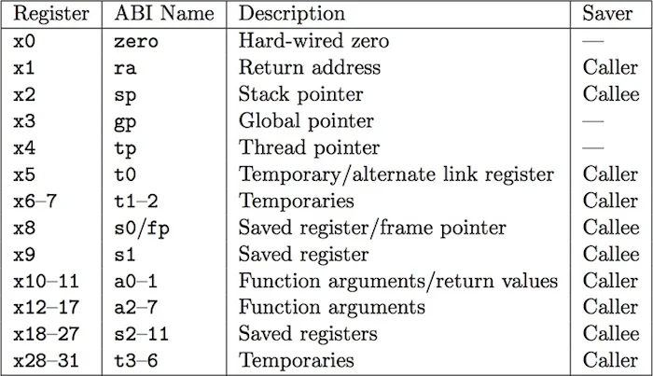

Introduction to RISC-V Assembly language instructions:
Assembly Instructions:
- In assembly language, each statement (called an instruction), executes exactly one of a brief list of simple commands.
- Unlike in C (and most other HLLs), each line of assembly code contains at most one instruction.
- Instructions are related to operations (=, +, -, *, /) in C or Java
Addition in Assembly
Example:
add s0, s1, s2 (in RISC-V)

where RISC-V registers s0, s1, s2 are associated with C variables a, b, c.

What is the C equivalent?
a = b + c (in C)

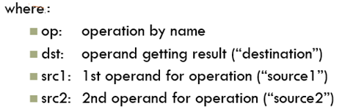
Syntax of RISC-V R-format instructions:

opt dst, src1, src2
Subtraction in Assembly
Example:
sub s3, s4, s5 (in RISC-V)
What is the C equivalent?
where RISC-V registers s3, s4, s5 are associated with C variables d, e, f.

Data Declarations
Format for declarations:
name: .storage_type value(s)
- create storage for variable of specified type (e.g. .word, .byte, etc.) and specified value(s)
- for storage type .space, gives number of spaces to be allocated
Note: labels are always followed by colon ‘:’
Examples:
var1: .word 3 # create a single integer variable with initial value 3
array1: .byte 'a', 'b' # create a 2-element character array with elements initialized
# to a and b

Load / Store Instructions
- In keeping with RISC philosophy, RAM access is only allowed with load and store
- all other instructions use register operands
- these instructions require setting up data in memory first

Load:
lw register_destination, RAM_source
#copy word (4 bytes) at source RAM location to destination register.
lh register_destination, RAM_source
#copy half-word (2 bytes) at source RAM location to destination register.
# and sign-extend to higher-order bytes (lhu does not sign extend)
lb register_destination, RAM_source
#copy byte at source RAM location to low-order byte of destination register,
# and sign-extend to higher-order bytes (lbu does not sign extend)

Store:
sw register_source, RAM_destination
#store word in source register into RAM destination
sb register_source, RAM_destination
#store byte (LSB) in source register into RAM destination (is there sbu?)

Based or indexed addressing:
The full format for the above load/store instructions is as below (with appropriate flavor):
lw t2, 4(t0)
#load word at RAM address ($t0 + 4) into register t2
#”4” gives offset from address in register t0
sw t2, 12($t0)
#store word in register t2 into RAM at address (t0 + 12)

Note: base addressing is especially useful for:
- arrays; access elements as offset from base address
- stacks; easy to access elements at offset from stack pointer or frame pointer

Pseudo Instructions

Load immediate:
li register_destination, value
#load immediate value into destination register
Load address:
la t0, var1
#copy RAM address of var1 (a label defined in the program) into register t0

Using Venus Simulator:

Where to Get Venus simulator?
This is an online simulator and may be accessed at: venus (thaumicmekanism.github.io)

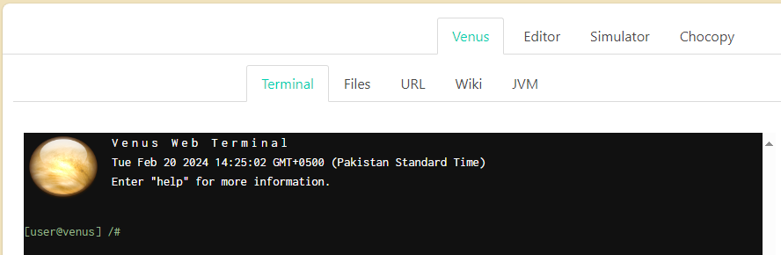

- If you wish to download a copy to run locally on your laptop, get it from here:
https://courses.missouristate.edu/KenVollmar/mars/download.htm
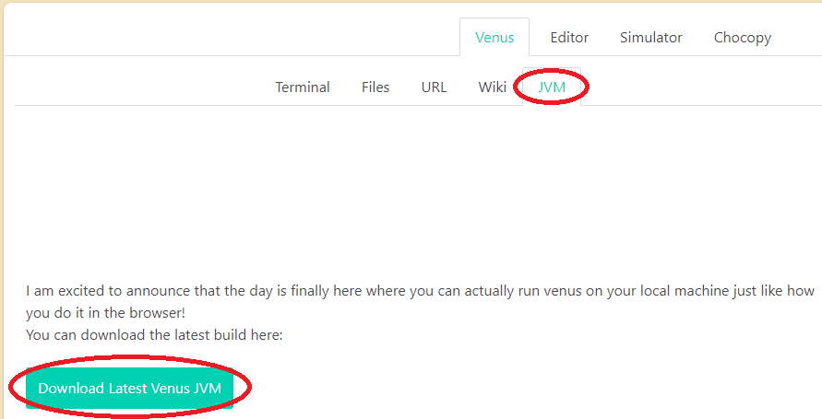

Procedure:
  - When the Venus simulator opens in your browser window you can either type or copy/paste your code in the Editor window.
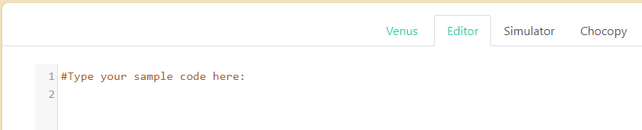
  - Once done (or anytime you want to) assemble and simulate your code by moving to the Simulator tab and clicking on the “Assemble & Simulate from Editor” button.
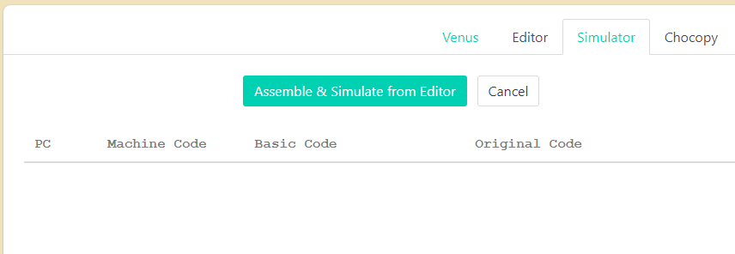
  - Once the code is assembled, you may Run, Debug or Trace execution of your code.
  - The Memory and Register or Cache state, will be seen in real time on the right side of the browser window.
  - There are a variety of options and features to explore in Venus online simulator, explore, experiment and exercise these on your own.
  - Try the three example codes below to learn about arithmetic, memory, and array manipulation in RISC-V.
  - When working through the code examples, you could print out or access this RISC-V reference sheet to help you: James Zhu’s RISC-V Refeence.

Example Codes:

Example 1: Adding two numbers
addi s0, x0, 4 #load 4 to s0
addi s1, s0, 0xa #add (hex) 10 to s0
add s2, s0, s1 #s2=s0+s1

Example 2: Immediates and memory manipulation

.data
var1: .word 23 # storage for var1; initial value is 23

.text
start: addi s1, zero,5
lw t1, var1 # load contents of RAM into
# reg t0: t0 = var1
la t0, var1 # load address
li t2, 10 # t2 =10 ("load immediate")
sw t2, (t0)
sw s1, 4(t0)
Example 3: Array manipulation

# Assume the base address for the array is in register a0
# The array contains 3 words (32-bit each)

.data
my_array: .word 10 # First word (element 0)
.word 0xf4f500 # Second word (element 1 – neg num)
.word 0x420050 # Third word (element 2)

.text
.globl main
main: la a0, my_array # Load base address of the array
# Access individual elements of the array
lw t0, 0(a0) # Load element 0 into t0
lh t1, 4(a0) # Load element 1 into t1
lhu t2, 4(a0) # Load element 1 into t2 too
lb t3, 8(a0) # Load element 2 into t3
sb t3, 12(a0) # Store element 2 into next mem loc

For more RISC-V assembly programs, please visit:
https://marz.utk.edu/my-courses/cosc230/book/example-risc-v-assembly-programs

Tasks:
- Complete following tasks in Lab.
- Copy your Venus Editor code, paste it into your submission copy and upload on GCR.
- Also translate to machine language representation (if required).
- Write RISC-V assembly code for given C program:
Consider A=5, B=4
- C = A+B
- D = A-B
- E = A*B
- F = A^2
- Separate the different fields of these RISC-V instructions according to their format and write decimal values. That is, write the machine language representation (expressed in decimal).

- Convert the following C code into RISC-V assembly language. Use appropriate registers for the variables.
m = (a - c) + (d + e) * f

- Write RISC-V assembly language program to perform AND, OR, XOR on the following numbers using Venus.
0x f f f
0x f 0 f

- The below RISC-V assembly code is supposedly an assembled version of the C code, also shown below. Use Venus to run and observe the registers values in Venus register view to verify the code is indeed running as expected. In case of syntax or logical errors, fix the assembly code until it works as intended.

#Assembly code
.section .text
.global arraysum
arraysum:
# a0 = int a[]
# a1 = int size
# t0 = ret
# t1 = i
li t0, 0 # ret = 0
li t1, 0 # i = 0
1: # For loop
bge t1, a1, 1f # if i >= size, break
slli t2, t1, 2 # Multiply i by 4 (1 << 2 = 4)
add t2, a0, t2 # Update memory address
lw t2, 0(t2) # Dereference address to get integer
add t0, t0, t2 # Add integer value to ret
addi t1, t1, 1 # Increment the iterator
j 1b # Jump back to start of loop (1 backwards)
1:
mv a0, t0 # Move t0 (ret) into a0
ret # Return via return address register

#HLL code (Sum of an Integer Array)
int arraysum(int a[], int size) {
int ret = 0;
int i;
for (i = 0; i < size; i++) {
ret = ret + a[i];
}
return ret;
}

- Write RISC-V assembly code to write table of two. You need to initialize table of two in the data section using .data in Venus. After this, load table values of two into different registers using lw command.

