Computer Architecture Lab
(EL-2012)
LABORATORY MANUAL

FALL 2026

(Lab#06)

Use of Venus Simulator for RISC-V Procedure Execution

Student Name: __________ Roll No: ________________ Section: _A__

Date performed: _____________, 2026

MARKS AWARDED: ________ / 10

Signature and date of Instructor: _________________

____________________________________________________________________________________________________________________________________________________________

NATIONAL UNIVERSITY OF COMPUTER AND EMERGING SCIENCES, ISLAMABAD

 | Prepared by: | Fasih Ahmad | Version: 2.1
 | Verified by: | Dr. Nasir Ali Shah | Updated: Spring 2026

Learning Objectives:
- To use Venus simulator for simulation of RISC-V assembly language program
- To monitor the register contents after execution of RISC-V assembly instructions
- To execute procedures and nested functions using Venus simulator.

Tool Used:
Venus Simulator

Assembly Language:
Refer to earlier Labs #06 “Venus Simulator for Register Level Execution of Arithmetic and Memory Instructions” and #07 “Venus Simulator for Register Level Execution of Control Instructions” for background information on Venus simulator and its usage, specially:
- RISC-V Registers
- Assembly Instructions
- Data Declarations
- Load / Store Instructions
- Indirect and Based Addressing

Procedures:
- Procedures help decompose applications into smaller modules
- Assembly language procedures require
  - Storage for local variables
  - Arguments must be passed in and return values passed out
  - Execution must continue after the call

Procedure Steps
  - Place parameters where procedure can access them
  - Transfer control to the procedure
  - Save any needed context of calling program
  - Obtain storage needed for the procedure
  - Execute the desired task
  - Make results available to the calling program
  - Restore any needed context of calling program
  - Return control to the point of origin

Supporting Procedures
RISC-V registers:
- Registers are the fastest place to hold data in a computer
- Dedicated RISC-V registers to support procedure calls
  - a0 – a7 (Argument registers to pass parameters. At most eight function arguments can be passed)
  - a0 – a1 (Value registers to return values. At most two values can be returned)
  - ra (Return address register to return execution to the point of origin)

RISC-V instructions:
- jal (jump-and-link)
  - saves the address of the following instruction in register ra (why not current instruction?)
  - Jumps to an address to service the procedure call
  - The link stored in register ra is called the return address (what is it?)

- jalr (jump-and-link register)
  - jumps to the address stored in the register ra (why not a label as in jump?)
  - Used by called procedure to return control to calling program

- Procedure Call
  - The calling program (caller) puts the parameter values in a0 - a7 and uses jal X to jump to procedure X (callee). Note the correct syntax in the RISC-V reference card.
  - The callee then
    - performs the calculations
    - places the results in a0 - a1, and
    - returns control to the caller using jalr ra. Note the correct syntax in the RISC-V reference card.

Stack:
- Stack is a LIFO data structure. A natural way of temporarily store data for procedures as well as call/return information
- Stacks historically grow down in memory
- Stack operations: push, pop
- RISC-V stack
  - The sp register should always point to the top of the stack
  - Stack grows from higher addr to lower address
  - RISC-V does not provide push and pop instructions. They must be implemented by the programmer.

Stack Push operation:
- To push data onto the stack
  - make room for the data by moving sp down - allocate storage.
  - place data into the allocated storage.
  - example: push registers s0, t0 and t1 onto the stack.
RISC-V Code:
addi sp, sp, -4 # decrement stack pointer to allocate stack space
sw s0, 0(sp) # saved (preserved) registers need to be saved by callee
# t0/t1 are temp (non-preserved) registers and need not be saved.
# If caller needs their contents after a procedure call, they should # be saved by caller itself.
Stack Pop operation:
- To pop data from the stack
  - any stored data may be accessed by its position relative to sp
  - example: retrieve contents of registers s0, t0 and t1 from stack
RISC-V Code:
lw s0, 0(sp) # saved (preserved) registers need to be saved
# t0/t1 are temp (non-preserved) registers and need not be restored
addi sp, sp, +4 # increment stack pointer to free up stack
  - As you can see it is possible to access any data that has been placed on the stack through the sp register.

Remember that preserving registers on stack is a shared responsibility between caller and callee, as shown in the figure below:

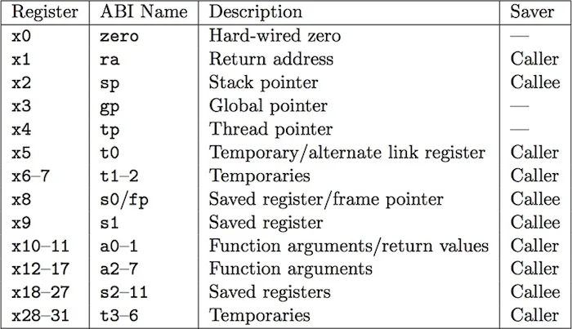

Tasks:
Complete following tasks in Lab.
- Examine why the below procedure is not displaying correct value in t1 register. Fix it.
.text
main:
li a0, 1
li s0, 2500
jal ra, procedure # call procedure
add t1, s0, a0 # result should be 1003+2500

li a0,1 # setup system call for display (command in a0)
mv a1, t1 # data to display in a1
ecall # displays result on console

procedure:
li s0, 3
li t0, 1000
add a0, s0, t0
jalr zero, ra, 0 # return

- Run given example on Venus Simulator and explain the code.
addi s0, zero, 5
addi t1, zero, 10
addi t0, zero,15
addi sp, sp, -12
sw s0, 0(sp)
sw t0, 4(sp)
sw t1, 8(sp)
lw t4, 8(sp)
lw t2, 4(sp)
lw t3, 0(sp)
addi sp, sp, 12

- Write RISC-V assembly code for given C code:
int main(){
x=EqSolver(a,b);
}
int EqSolver (int a, int b){
return (a+b)(a-b);
}

- Write RISC-V assembly code to find the area and perimeter of square. You need to write two procedures (i.e. AreaFinder and PerimeterFinder ) and call both functions in main module.

- Write RISC-V assembly code for given C code:
int main(){
y=EqSolver(x);
}
int EqSolver (int x){
return (x^3+5x^2+6x);
}

- Implement the following C code in RISC-V assembly using Venus.
int main(int n, int k){
if (k == 1)
y=F1(n,k);
else if (n > k)
y= F2(n);
else
y= F3(n);
}
int F1 (int x,int z){
return (x² + z²);
}
int F2 (int z){
return (z³);
}
int F3 (int w){
return (w+5);
}
- Implement the following C code in RISC-V assembly using Venus.
int main(int n, int k){
if (k == 0)
y=fun1(n);
else if (n == k)
y= fun2(n);
else
y= fun3(n);
}
int fun1 (int x){
return (x²);
}
int fun2 (int z){
return (z³);
}
int fun3 (int w){
return (w+1);
}

- Implement the following C code in RISC-V assembly using Venus.
Without Recursion:
int main(){
y=fib(n);
}
int fib(int n)
{
int a=0,b=1,c=i;
if(n==0)
return a;
else {
for(i=2;i<=n;i++)
{
c=a+b;
a=b;
b=c;
}
return b;
}}

With Recursion:
int main(){
y=fib(n);
}
int fib(int n)
{
if (n==0)
return 0;
else if (n == 1)
return 1;
else
return fib(n−1) + fib(n−2);
}

