Computer Architecture Lab
(EL-2012)
LABORATORY REPORT

Fall 2026

(Lab#_03__)
Write Lab Title Here

Student Name: ___Abdulmoeiz_______ Roll No: _______24i-6510_________ Section: __CE A_

Date performed: ____1 Sep____, 2026

MARKS AWARDED: ________ / 10

Signature and date of Instructor: _________________
Lab Instructors: Dr. Nasir Ali Shah, Engr. Fasih Ahmad

______________________________________________________________________________________________________________________________________________________

NATIONAL UNIVERSITY OF COMPUTER AND EMERGING SCIENCES, ISLAMABAD
Prepared by: | Fasih Ahmad |  | Version: 1.0
Verified by: | Dr. Nasir Ali Shah |  | Updated: Fall 2026

Task 1:

Description:
This lab task was about writing behavioural level Verilog code for adder and subtractor . Control flow statements were used to perform addition/subtraction. Later to test, its test bench coce was written and simulation was run to check the behaviour of wave form which matches the expected result

Code:
module addsub (a, b, sub, result);
input [3:0] a, b;
input sub;
output reg [4:0] result;
always @(*)
begin
if (sub == 0)
result <= a + b;
else
result <= a - b;
end
endmodule

module addsub_testbench;
reg [3:0] a, b;
reg sub;
wire [4:0] result;

addsub uut (.a(a), .b(b), .sub(sub), .result(result));

initial
begin
a = 4'd5; b = 4'd3; sub = 0; #20;
a = 4'd5; b = 4'd3; sub = 1; #20;
end
endmodule

Output:
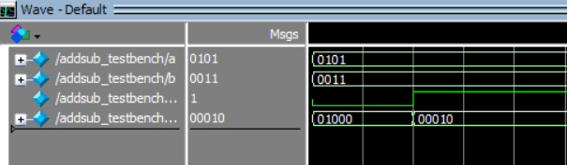

Task 2:

Description:
In this task , behavioural level Verilog code for 2x1 multiplexer was written. In order to make2x1 multiplexer use control flow statements. Later to test the Verilog code, its test bench was written and simulation of code was run and check the behaviour of wave form which matches the expected result
Code:
module MUX2x1(a,b,c,s);
input a,b,s;
output reg c;

always @*
begin
if(s==0)
c=a&b;
else
c=a|b;
end
endmodule

module MUX2x1_testbench;
reg a,b,s;
wire c;

MUX2x1 uut(
.a(a),.b(b),.s(s),.c(c)
);

initial
begin
a=0;b=1;s=0;
#50;
a=0;b=1;s=1;
#50;
a=1;b=1;s=0;
#50;
a=1;b=1;s=1;
#50;
a=0;b=0;s=0;
#50;
a=0;b=0;s=1;
#50;
end
endmodule

Output:
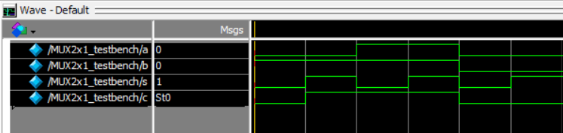

Task 3:

Description:
In this task , I wrote behavioral level Verilog code to implement 2 bit comparator. It works by checking whether the 2 numbers are equal, lesser than, or greater than one another. Control flow statements were used again to write the logic of the comparator. Later write its test bench was written and simulation was run to check the behavior of wave form which matches my expected result

Code:
module comparator(a,b,g,e,l);
input [1:0]a;
input [1:0]b;
output reg g;
output reg e;
output reg l;

always @*
begin
g=2'b00;
l=2'b00;
e=2'b00;
if(a>b)
g=1;
else if(a==b)
e=1;
else
l=1;
end
endmodule;

module comparator_testbench;
reg [1:0]a;
reg [1:0]b;
wire g,e,l;

comparator uut(
.a(a),.b(b),.g(g),.l(l),.e(e)
);

initial
begin
a=2'b00;b=2'b01;
#50;
a=2'b11;b=2'b01;
#50;
a=2'b01;b=2'b01;
#50;
a=2'b10;b=2'b01;
#50;
end
endmodule

Output:
