Computer Architecture Lab
(EL-2012)
LABORATORY REPORT

Fall 2026

(Lab#_05__)
Write Lab Title Here

Student Name: ___Abdulmoeiz_______ Roll No: _______24i-6510_________ Section: __CE A_

Date performed: ____15 Sept____, 2026

MARKS AWARDED: ________ / 10

Signature and date of Instructor: _________________
Lab Instructors: Dr. Nasir Ali Shah, Engr. Fasih Ahmad

______________________________________________________________________________________________________________________________________________________

NATIONAL UNIVERSITY OF COMPUTER AND EMERGING SCIENCES, ISLAMABAD
Prepared by: | Fasih Ahmad |  | Version: 1.0
Verified by: | Dr. Nasir Ali Shah |  | Updated: Fall 2026

Task 1:

Description:
An actual instruction has its own binary encoding that the hardware understands. A pseudo instruction is a convenience name for user and assembler, which rewrites it into one or more actual instructions before producing machine code. Instruction like beq, bne, blt, bge are Actual. Jal and jalr are also Actual instructions. Rest are Pusedo Instructions which are then translated into actual instructions

Code:
Non Code based task
Output:

Task 2
Description:
This task was about how to design a wotking code which tells the difference between conditional branch and jump functionality and how its working principle is different from each other. This is done aby the code below which shows how L2 is always executed due to jump statement while L1 is only takem when s0 and s1 are equal

Code:
addi s0, x0, 5 # s0 = 5
addi s1, x0, 5 # s1 = 5
beq s0, s1, L1 # taken only if s0 == s1
addi t0, x0, 1 # skipped if beq is taken
L1:
j L2 # always taken
addi t1, x0, 2 # never executes
L2:
addi t2, x0, 3 # always executes

Output:
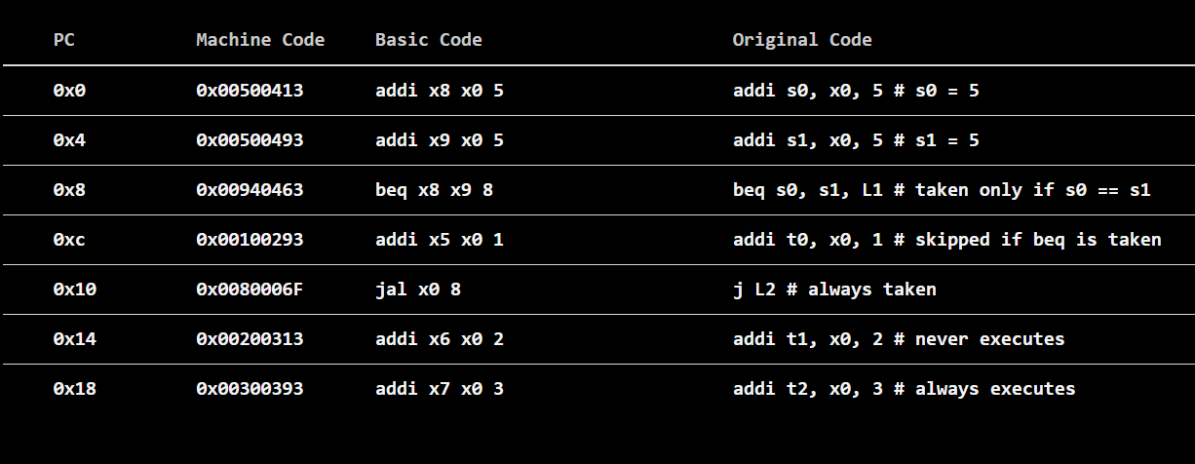

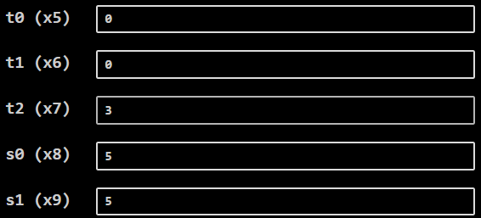

Task 3:

Description:
This task gave us pre written assembly codes and we had to analuyse their working by looking how the registers change their contents after each line. This task made sure that we see the affet of each opcode in assembly and how conditional statements are simulated in assembly

Code:
Code 1:

addi s0, s0, 4
addi s1, s1, 6
beq s0, s1, Fin
True:
add s2, s1, s0
j end
Fin:
sub s2, s1, s0
end:

Code 2:

addi s0, s0, 4
addi s1, s1, 4
beq s0, s1, Fin
True:
add s2, s1, s0
j End
Fin:
sub s2, s1, s0
End:

Output:
Code 1:

addi s0,s0, 4 #this performs add immediate value of 4 to s0
addi s1,s1, 6 #this performs add immediate value of 6 to s1
beq s0, s1, Fin #if s0 == s1 then branch to Fin label
True: #this code will occur if upper condition fails
add s2, s1, s0 #perform addition of s0 and s1 register and store in s2
j end #unconditional jump to end
Fin:
sub s2, s1, s0 #this statement is not executed since beq condition fails
end:

Code 2:

addi s0,s0, 4 #add immediate value of 4 to s0
addi s1,s1, 4 #add immediate value of 4 to s1
beq s0, s1, Fin #If s0 == s1 then jump to Fin Label
True:
add s2, s1, s0 #these statements are not implemented since the code jumps to Fin
j End
Fin: #this statement is implemented and the subtraction result is stored in s2
sub s2, s1, s0
End:

OUTPUT SCREENSHOTS:
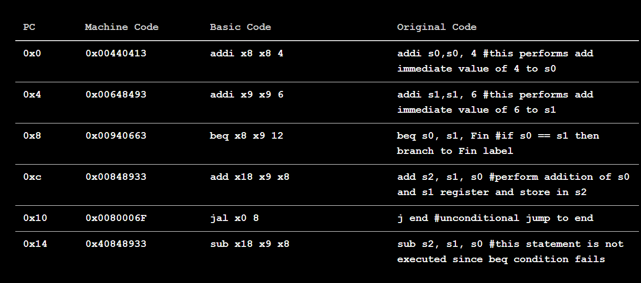
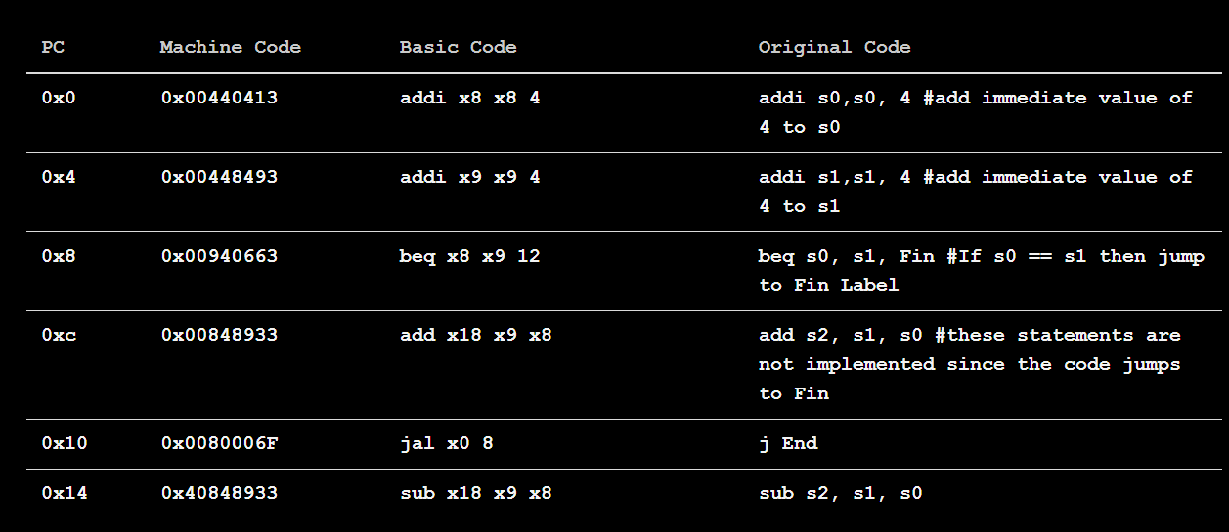

Task 4:

Description:
This task was about converting a C++ code in assembly language and then simulate it over venus. This task was entirely based on conditionals and tested our knowledge about conditional jumping in assembly. We were given register values which we had to use in our code. The code was fairly easy and we learnt the application of conditional jump statements

Code:
addi s2, x0, 5
addi s3, x0, 10
addi s4, x0, 4
addi s5, x0, 3
beq s2, s3, B1
True:
add t2,s4,s5
j End
B1:
sub t1,s4,s5
j End
End:

Output:
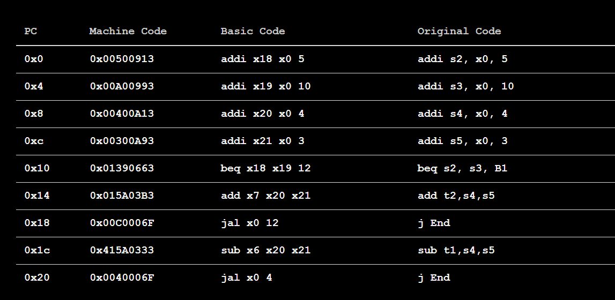

Task 5:

Description:
This task was about how to how to shift a binary number to the left twice inside the register. This task tested on our knowledge of RIUSC V opcodes and if we can implement them practically inside the simulator. The assembly code was simple and to the point

Code:
addi s0,x0,10
slli s1, s0, 2

Output:
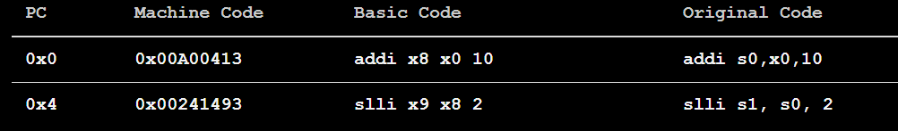

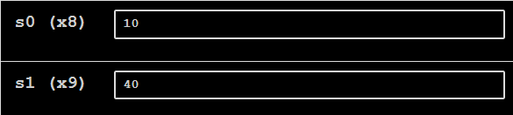

Task 6:

Description:
This task was about a given C++ code and had to convert it into assembly code. It was a fairly simple for loop in which we had to explicitly show the counter increment. It was done via conditional statements in assembly language

Code:
addi s0,x0,0
addi s2,x0,5
Loop:
addi s0,s0,1
bne s0,s2,Loop
True:
j end
end:

Output:
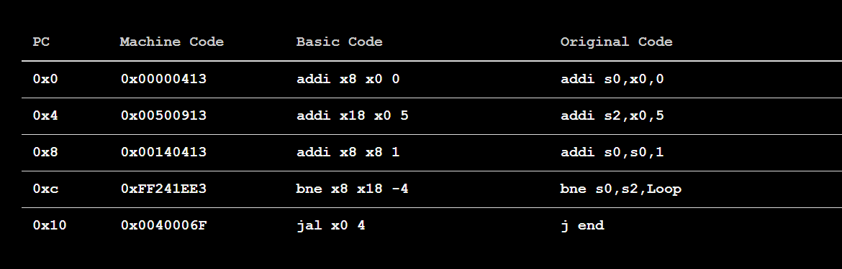

Task 7:

Description:
This task was writing an assembly language for given loop in C++. It was a full working ocde in which there was a 10 integer array alongside a while loop which only worked until i<5. This meant that conditional jump statements were required in the task
Code:
.data
num: .word 0,0,0,0,0,0,0,0,0,0 # int num[10] (40 bytes)

.text
la s0, num # s0 = base address of num
addi s1, x0, 0 # i = 0
addi s2, x0, 5 # limit = 5
loop:
bge s1, s2, end # exit if i >= 5
addi t0, s1, 5 # t0 = i + 5
slli t1, s1, 2 # t1 = 4i
add t2, s0, t1 # t2 = &num[i]
sw t0, 0(t2) # num[i] = i + 5
addi s1, s1, 1 # i++
j loop
end:
addi a0, x0, 10 # exit ecall
ecall

Output:
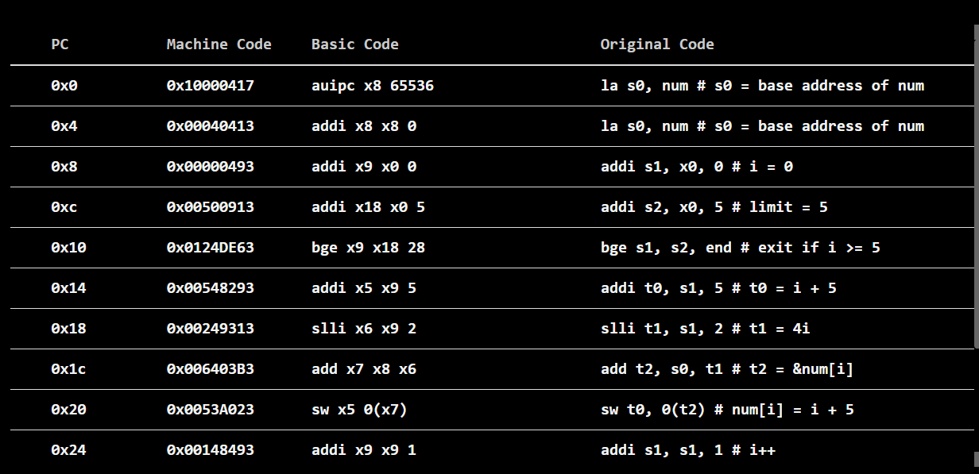

Task 8:

Description:
This task was again about converting a C++ code into an assembly code and then running on venus. This code had nested loops. It was difficult to simulate the loops in venus , as it was getting difficult to control the register values which dictated the loop. This task required online resources to understand the structure of a general nested loop in assembly

Code:
addi s0, x0, 0 # Counter = 0
addi s1, x0, 0 # x = 0
addi s3, x0, 3 # outer limit
addi s4, x0, 2 # inner limit
outer:
bge s1, s3, done # exit if x >= 3
addi s2, x0, 0 # y = 0 (reset every outer pass)
inner:
bge s2, s4, inner_done # exit inner if y >= 2
add s0, s1, s2 # Counter = x + y
addi s2, s2, 1 # y++
j inner
inner_done:
addi s1, s1, 1 # x++
j outer
done:
addi a0, x0, 10
ecall

Output:
