Computer Architecture Lab
(EL-2012)
LABORATORY MANUAL

Fall 2026

(Lab#05)

Use of Venus Simulator for Register Level Execution of RISC-V Control Instructions

Student Name: __________ Roll No: ________________ Section: _A__

Date performed: _____________, 2026

MARKS AWARDED: ________ / 10

Signature and date of Instructor: _________________

____________________________________________________________________________________________________________________________________________________________

NATIONAL UNIVERSITY OF COMPUTER AND EMERGING SCIENCES, ISLAMABAD

 | Prepared by: | Fasih Ahmad | Version: 2.0
 | Verified by: | Dr. Nasir Ali Shah | Updated: Fall 2026
Learning Objectives:
- To use Venus simulator for simulation of RISC-V assembly language program
- To monitor the register contents after execution of RISC-V assembly instructions
- To execute load word, store word, loop and nested loops using Venus simulator
Tool Used:
Venus Simulator (available online)

Assembly Language:
Refer to earlier Lab#01 “Use of Venus Simulator for Register Level Execution of RISC-V Instructions” for background information on Venus simulator and its usage, specially:
- RISC-V Registers
- Assembly Instructions
- Data Declarations
- Load / Store Instructions
- Indirect and Based Addressing
RISC-V Register File:
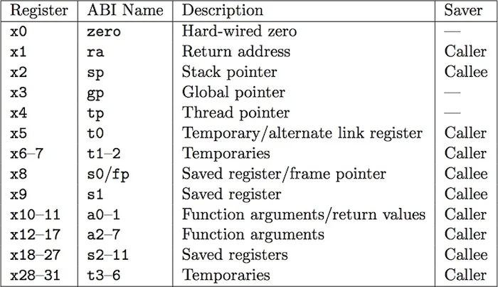

Control Instructions

Comparison for conditional branches is built into the instructions themselves.

Branches
type target # conditional branch to program label target
beq t0, t1, target # branch to target if t0 = t1
blt t0, t1, target # branch to target if t0 < t1
ble t0, t1, target # branch to target if t0 <= t1
bgt t0, t1, target # branch to target if t0 > t1
bge t0, t1, target # branch to target if t0 >= t1
bne t0, t1, target # branch to target if t0 <> t1
Table 1
Jumps
j target # unconditional jump to target
jal ra, target # unconditional jump to PC+target and save PC in ra
jalr zero, const(ra) # unconditional jump to ra+const and save PC in zero
Table 2

Using Venus Simulator:

Where to Get Venus simulator?
This is an online simulator and may be accessed at: venus (thaumicmekanism.github.io)

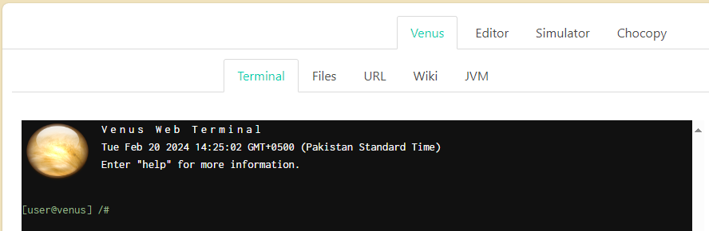

- If you wish to download a copy to run locally on your laptop, get it from here:
https://courses.missouristate.edu/KenVollmar/mars/download.htm
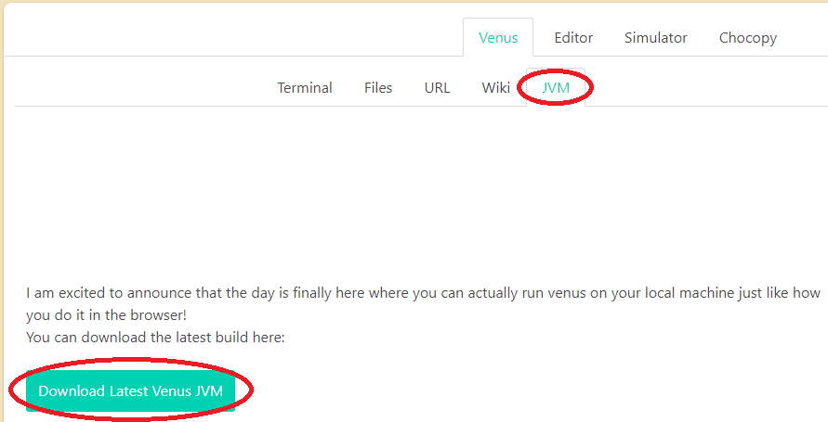

Procedure:
  - When the Venus simulator opens in your browser window you can either type or copy/paste your code in the Editor window.
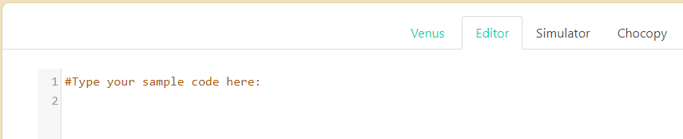
  - Once done (or anytime you want to) assemble and simulate your code by moving to the Simulator tab and clicking on the “Assemble & Simulate from Editor” button.
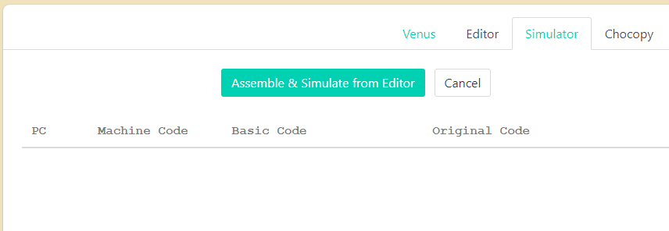
  - Once the code is assembled, you may Run, Debug or Trace execution of your code.
  - The Memory and Register or Cache state, will be seen in real time on the right side of the browser window.
  - There are a variety of options and features to explore in Venus online simulator, explore, experiment and exercise these on your own.
  - Try the three example codes below to learn about arithmetic, memory, and array manipulation in RISC-V.
  - When working through the code examples, you could print out or access this RISC-V reference sheet to help you: James Zhu’s RISC-V Reference.

Example Codes:

Example 1: Decide outcome based on two numbers
blt s0, s1, label #jump to label if s0 < s1
label: #execute code if s0 < s1 #true clause
#execute code if s0 >= s1 #false clause
For more RISC-V assembly programs, please visit:
https://marz.utk.edu/my-courses/cosc230/book/example-risc-v-assembly-programs

Tasks:
- Indicate which of the assembly instructions listed in Table 1 and Table 2 above are actual instructions and which are pseudo-instructions? How do you know?
- Write a code snippet with just two instructions beq and j (conditional branch and jump). Simulate to understand the difference between them. Explain.
- Run the codes given below, comment each code line by line, and explain what it does:
Code 1:
addi s0, s0, 4
addi s1, s1, 6
beq s0, s1, Fin
True:
add s2, s1, s0
j end
Fin:
sub s2, s1, s0
end:

Explanation:

Code 2:
addi s0, s0, 4
addi s1, s1, 4
beq s0, s1, Fin
True:
add s2, s1, s0
j end
Fin:
sub s2, s1, s0
End:

Explanation:

- Convert given C code into RISC-V assembly and simulate using Venus simulator. Consider a=5, b=10, d=4, e=3.
if (a = = b)
c = d – e ;
else
c = d + e ;
- Write RISC-V assembly code to shift a number (e.g. 2) to the left twice and simulate using Venus simulator.
- Write RISC-V assembly language for given loop and simulate it using Venus.
Initialize counter = 0;
for i = 1 to 5
increment counter;
end
- Write RISC-V assembly language for given loop and simulate it using Venus.
int num[10];
void main(){
i=0;
while (i<5)
num[i] = i+5;
}
- Write RISC-V assembly code for nested loops and simulate it using Venus.
Counter=0;
for (int x=0; x<3; x++) {
for (int y=0; y<2; y++) {
Counter=x+y;
}
}

