NeatAgent

Overview
A new open-source model that just came out last night by Google is called gemma4, the performance is surpassing very large models in performance, I plan on leveraging local models to build safe to use agents that does not send any information to random APIs. I am building an agentic application that solves a problem I personally face and assume many others share. After a work session I find my desktop and download folders filled with scattered files, unorganized with weird names. The AI agent will have access to a specified folder to start reorganizing and creating relevant folders. The agent will be able to read a variety of file types ranging from txt, pdf, or images to understand their context and store them accordingly. Claude by anthropic have just release a similar idea “Claude Cowork”, where Claude can interact with your desktop and read through the files.
So what makes my Agent Organizer novel? I am building it completely using local models. I do not want to share personal files on my desktop with Anthropic or OpenAI, so I am using smaller models that can run on a new MacBook machine with newer chips. The goals is to create a free to use fully local agentic application that can run in your command line. The features of the applications are still not ironed out.
To evaluate the effectiveness of the Agentic File System Organizer, I will benchmark the system across three dimensions: organization accuracy, efficiency, and usability. The goal is to compare the agent’s performance against baseline alternatives and measure whether a local agentic approach can reliably organize unstructured personal files. I will also run user studies, on participants machines and get their review.
Experiments
As suggested by Professor Kaiser, I will be running multiple experiments to validate agents accuracy. I plan on curating a simple dataset that have multiple files with ground truth labels. Then to test the accuracy of the agent, I will be using an LLM as judge approach. The curation of this dataset is important in collecting metrics to properly evaluate the agent.

Research Questions
RQ1: Organization Accuracy by File Type
How does the semantic accuracy of file organization vary across file types (text, PDF, CSV, and image) when using a local LLM-based plan-and-act agent?
RQ2: Content vs. Filename Classification
To what extent does file content improve organization accuracy over filename alone for ambiguously named files?
RQ3: Local Model Size vs. Quality Trade-off
How does model size affect plan quality and organization accuracy in a fully local agentic file organizer?
RQ4: User Acceptance of AI-Generated Organization
Do users agree with the organizational structure proposed by a local LLM agent, and does human plan approval (human-in-the-loop) increase trust in the outcome?

Value to User Community
The prospect users of my agent is anyone with a messy folder that wants to automate the task of cleaning and organizing certain folders. Upon asking friends, they all seem to share this common problem of having a ton of files scattered in their desktop that they have accumulated overtime. NeatAgent should be able to solve their problem and organize their folders “neatly”. A common fear is data privacy, people do not want to allow large coompanies such as “Claude” or “OpenAI” have access to their personal files. NeatAgent will run 100% locally and users’ data will not be sent off to an API.

Demo
I plan to show the class a simple usage of NeatAgent where I will be using my curated dataset with scattered folders and files, then look at the organized folders from NeatAgent. I might not be able to show the full run down of the agent live; as LLMs and this task in particular takes some time to complete ~6 minutes, so instead of I will pre-run the agent and show the before and after folders and the logs/manifest of that run, what the agent was thinking and how they were going through files and reading them.

Delivery
I will be hosting all of my work on github and I am aslo experimenting with using Linear to track and plan NeatAgent. The agent will run in the command line so it is a CLI app. There are certain requirements for using the agent in terms of machine capabilities.

A flowchart illustrating the agent's task planning and execution process.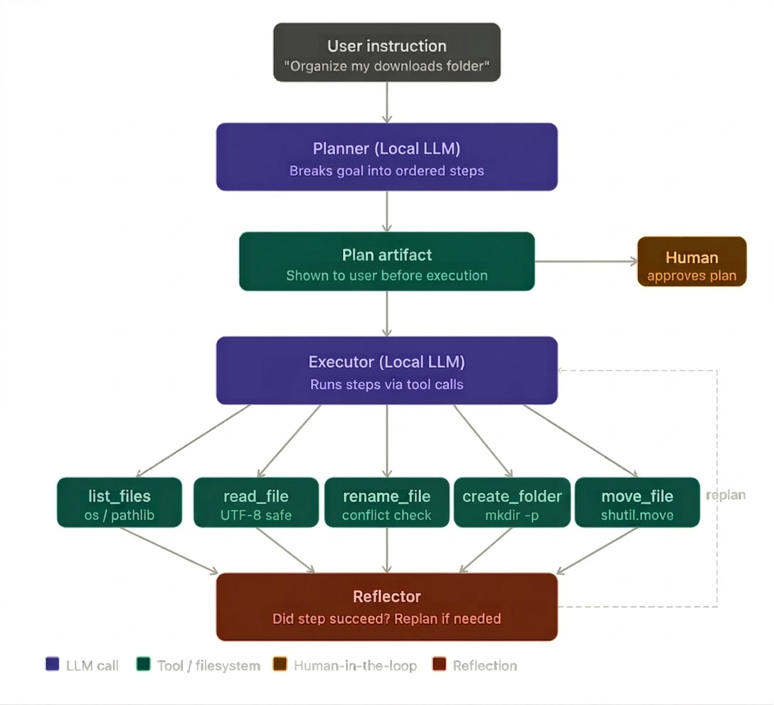
Figure 1. Agent Planning and Execution Flowchart (Generated using Nonbanana)

