OptiCrop
Smart Crop Recommendation System
Project Documentation

Team Member | Role
Bala Sai Venkat Ramisetty | Team Lead
Eede Veda Srivalli | Member
Marneni Pranathi | Member
M Anunay | Member
Kadingu Uday Kumar | Member

1. Introduction

Project Title
OptiCrop – Smart Crop Recommendation System

Team Members
Bala Sai Venkat Ramisetty — Team Lead
Eede Veda Srivalli — Member
Marneni Pranathi — Member
M Anunay — Member
Kadingu Uday Kumar — Member

2. Project Overview

Purpose
OptiCrop is a web-based smart agriculture application that recommends a suitable crop from soil nutrient values and environmental conditions. The goal is to convert seven simple inputs—Nitrogen, Phosphorus, Potassium, Temperature, Humidity, Soil pH and Rainfall—into an understandable crop recommendation supported by crop details, ideal conditions and growing guidance.

Features
- Seven-parameter crop recommendation form
- Machine-learning-based crop prediction
- Recommended crop result card
- Crop season, harvest time, soil type and water requirement information
- Fertilizer, market demand, suitable region and common-use guidance
- Ideal environmental condition display
- Growing tips
- “How OptiCrop Works” workflow explanation
- Model information: 2200+ training records, 22 crop classes, 7 input features and Random Forest algorithm
- Responsive, section-based web interface

3. Architecture

Frontend
The user interface is a responsive single-page style website built with HTML, CSS and JavaScript. Navigation sections include Home, Predict, Crop Details, How It Works and Dataset/Model information. JavaScript handles user interaction and submission of prediction values.

Backend
The application uses a Python Flask backend. The server receives the seven crop parameters, validates and preprocesses them, sends them to the trained machine-learning model, and returns the predicted crop for display.

Machine Learning Layer
A Random Forest classification model is used for crop recommendation. The model uses seven features: N, P, K, temperature, humidity, pH and rainfall. The website reports 2200+ training records and 22 crop classes.

Database / Data Layer
The demonstrated version is prediction-oriented and does not show user-account persistence. The crop dataset is used for model training, while crop descriptive information is served to the result interface. A conventional database can be added later for users, prediction history, feedback and analytics.

4. Setup Instructions

Prerequisites
Python 3.x, pip, Flask, pandas, NumPy, scikit-learn, joblib or pickle, and a modern web browser.

Installation
1. Copy or clone the project source code.
2. Create and activate a Python virtual environment.
3. Install dependencies using the project requirements file.
4. Place the trained model and required dataset/resources in their configured folders.
5. Configure Flask environment settings if required.
6. Run the Flask application and open the local address shown in the terminal.

5. Folder Structure

Suggested Organization
OptiCrop/
├── app.py
├── model/
│ └── crop_recommendation_model.pkl
├── templates/
│ └── index.html
├── static/
│ ├── css/
│ ├── js/
│ └── images/
├── data/
│ └── crop_recommendation.csv
└── requirements.txt

6. Running the Application

Local Run
Activate the virtual environment, install dependencies, then run the Flask entry point (for example, python app.py or flask run depending on project configuration). Open the local URL displayed by Flask in a browser and use the Crop Recommendation form.

7. API Documentation

Prediction Endpoint
Typical application flow: POST /predict. Request fields: nitrogen, phosphorus, potassium, temperature, humidity, ph and rainfall. The backend converts values to the model input format and returns the recommended crop. Example logical response: {"recommended_crop": "rice"}. Exact route naming may vary with the source implementation.

Page Endpoint
GET / returns the main OptiCrop interface.

8. Authentication

Current Scope
The demonstrated application does not show login, registration, token or session-based authorization. The crop recommendation feature is publicly accessible. If user profiles and saved prediction history are added, secure password hashing, session management and role-based authorization should be implemented.

9. User Interface

UI Description
The interface uses a clean green agricultural theme. The home area introduces smart farming, the prediction form collects seven values, the result area shows the recommended crop, and later sections present crop details, environmental conditions, growing tips, workflow and model information.
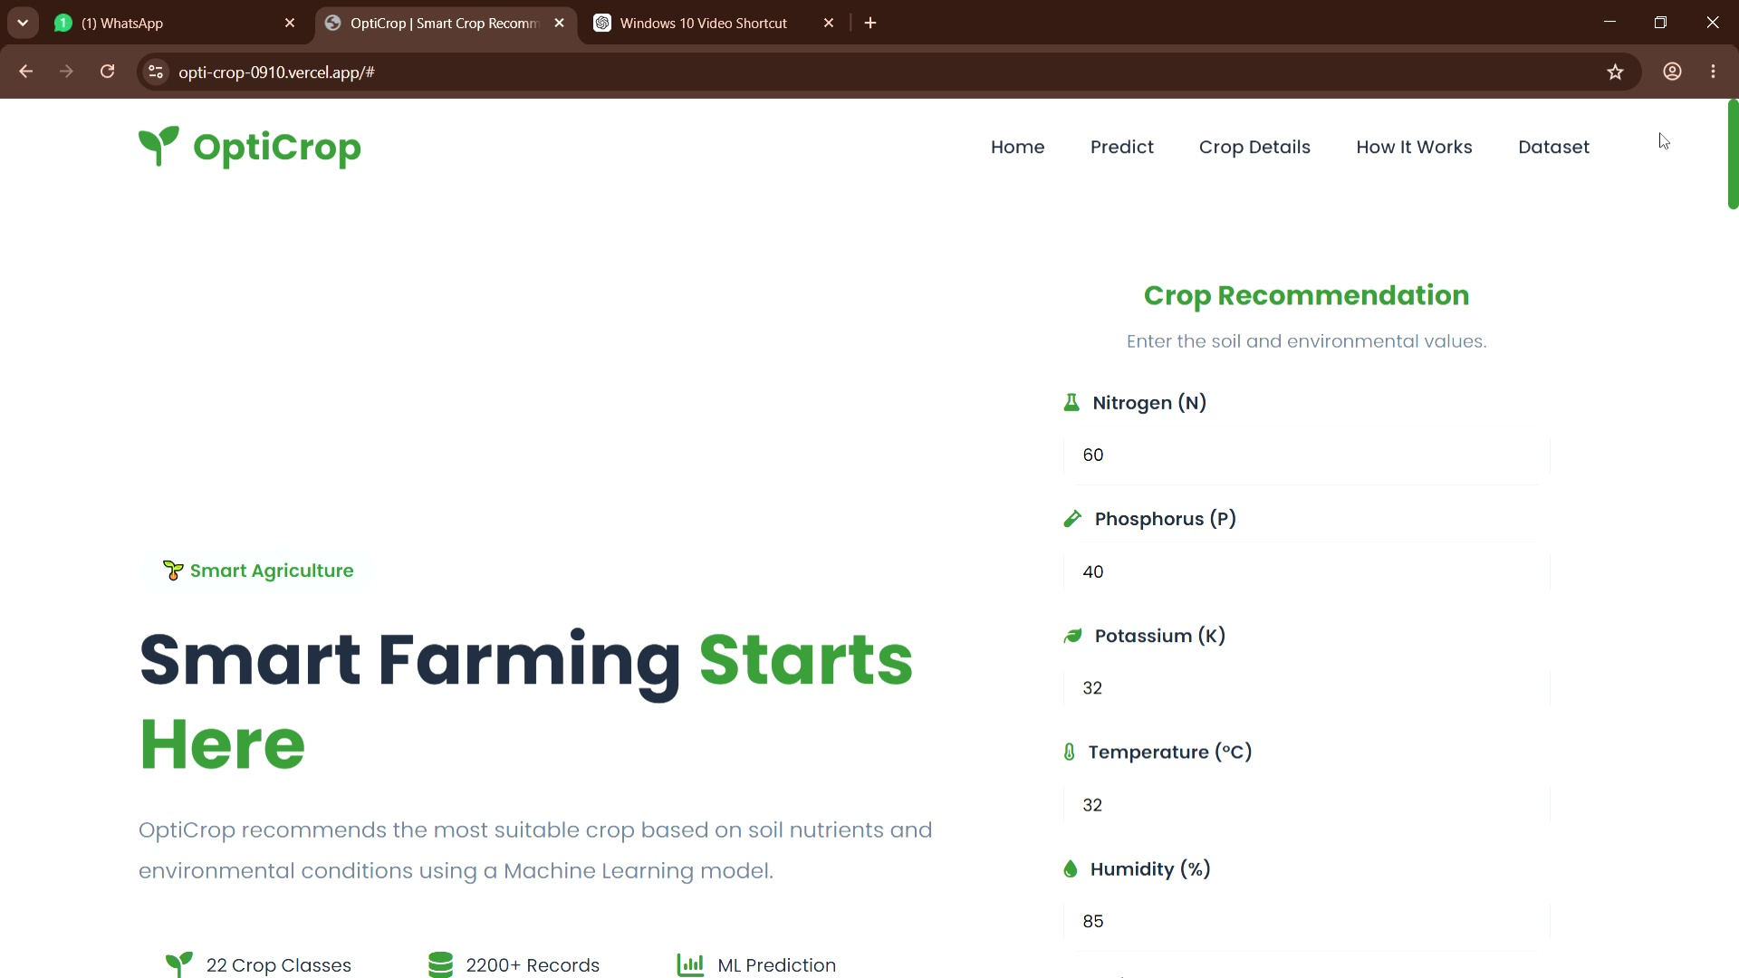
Home and crop input interface
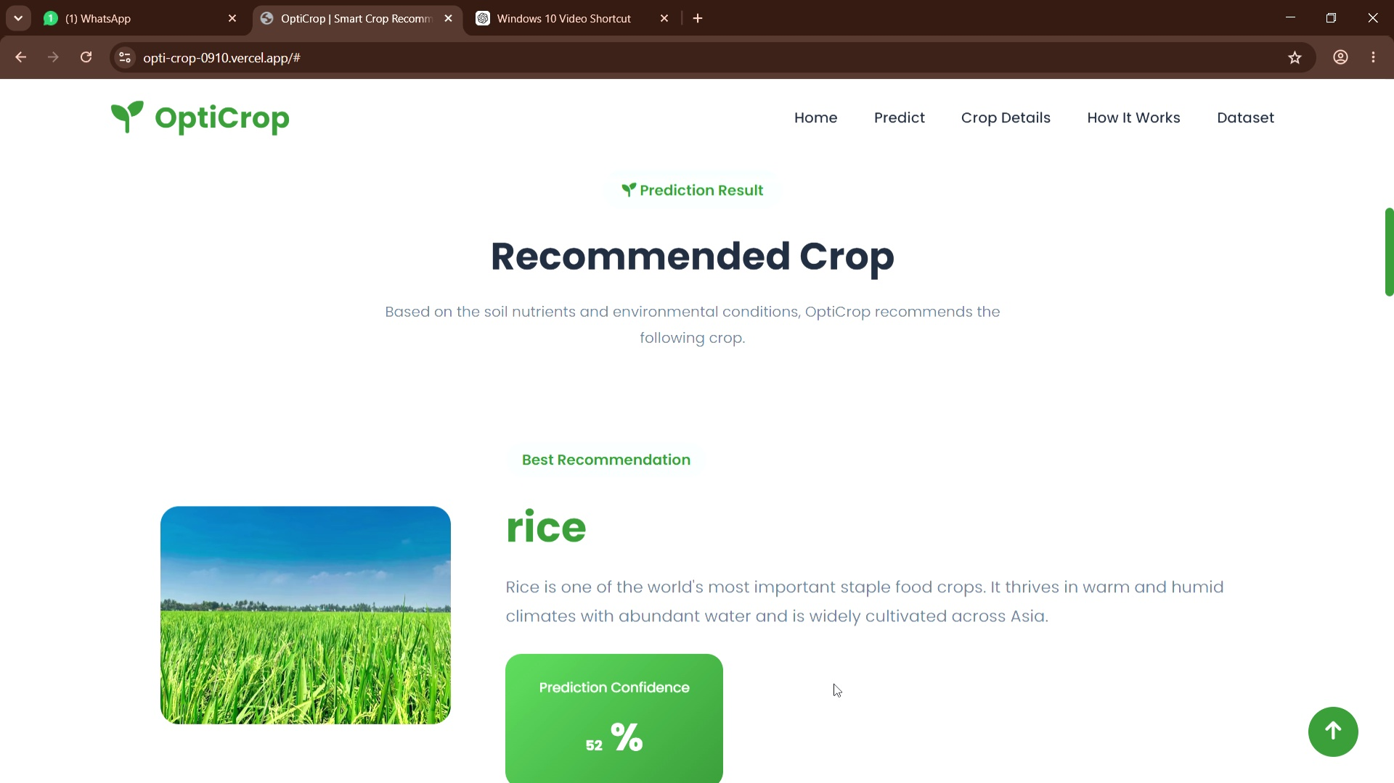
Recommended crop result
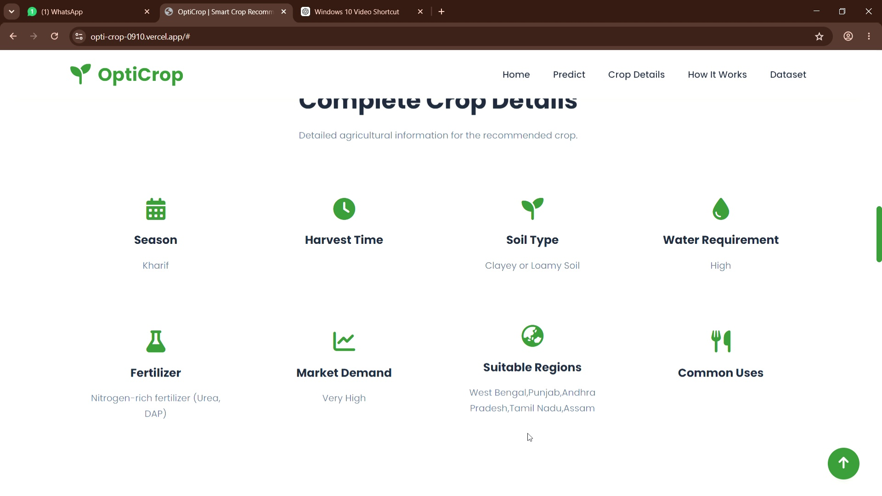
Crop details
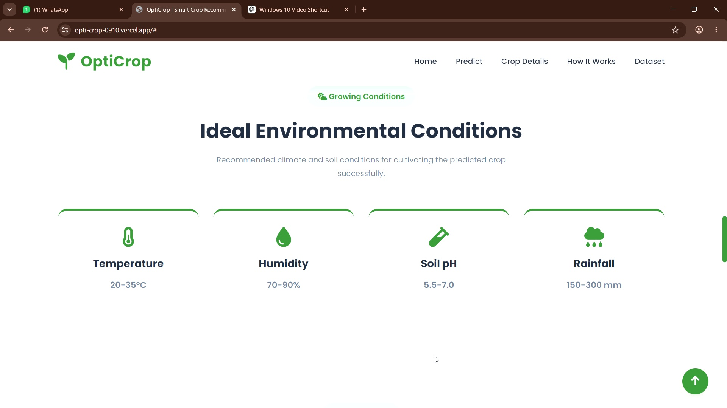
Ideal environmental conditions
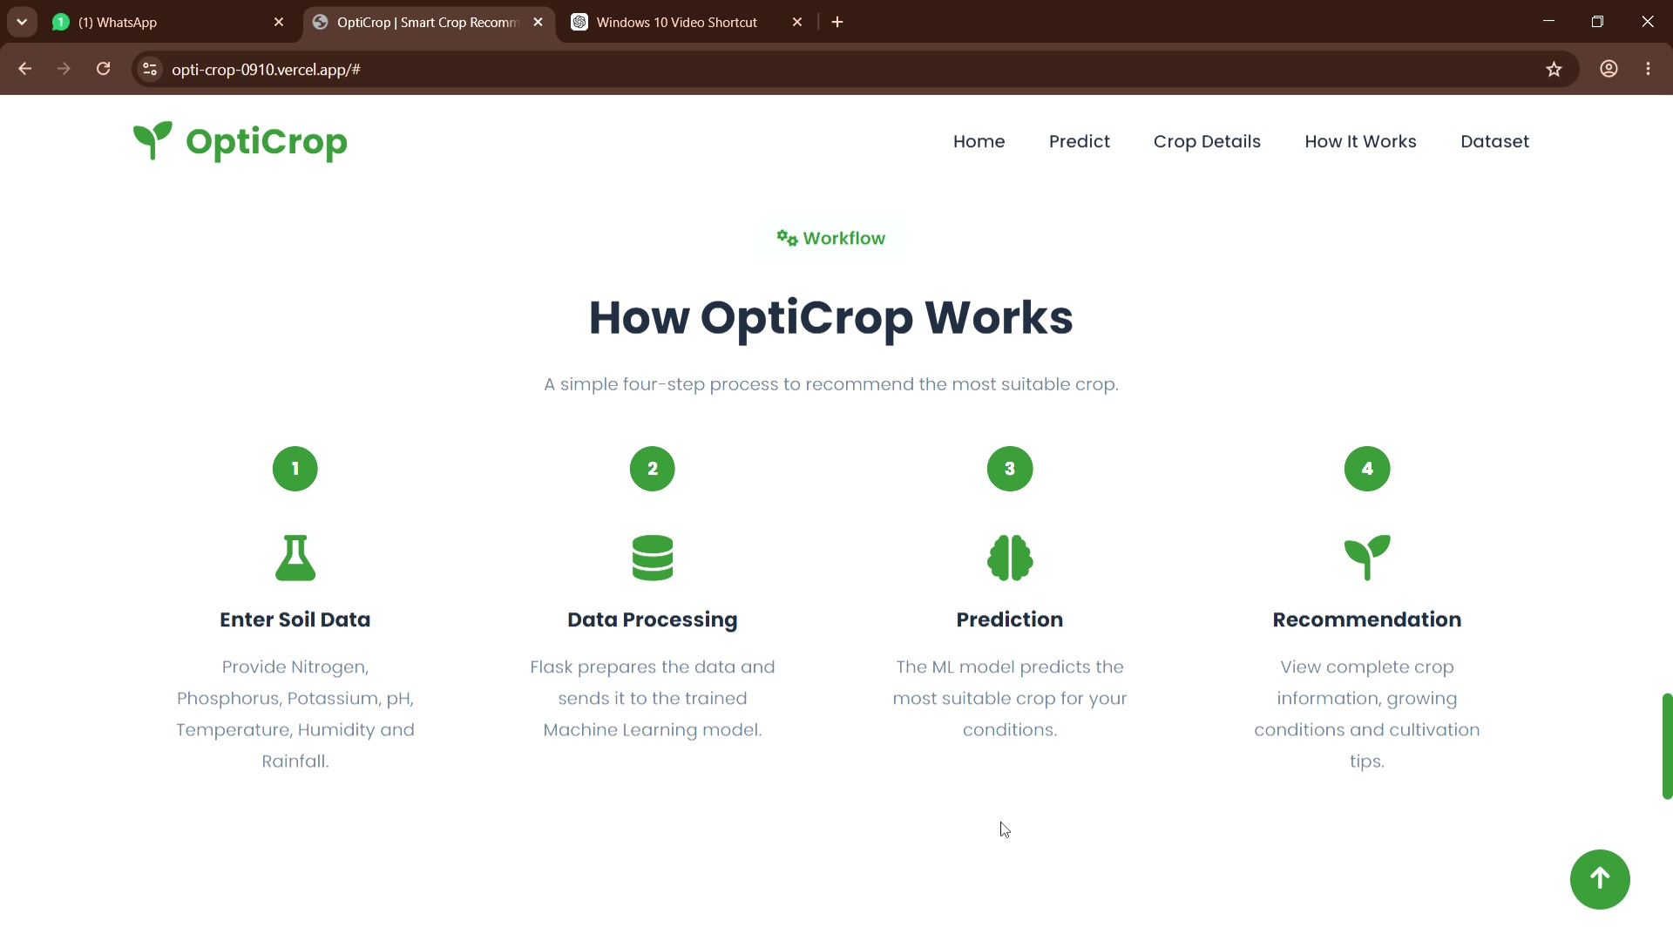
How OptiCrop Works
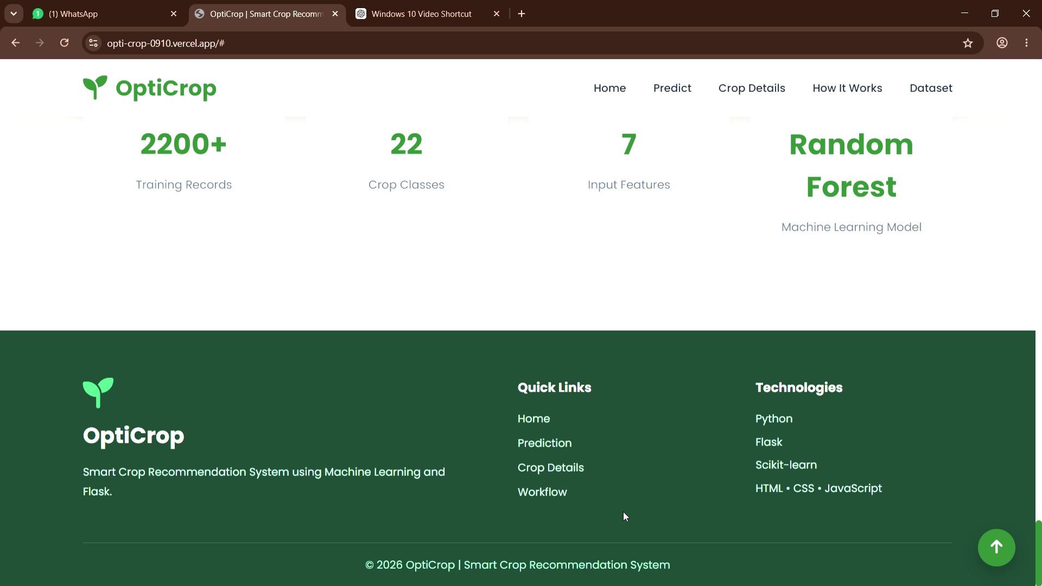
Model information

10. Testing

Strategy
Testing should cover input validation, prediction response, route handling, model loading, invalid or missing values, boundary values and browser responsiveness. Functional tests verify that all seven fields can be submitted and a crop result is displayed. Model tests compare predictions with held-out labelled data. UI tests verify navigation, layout and readability on common screen sizes.

11. Screenshots or Demo

Demo Coverage
The uploaded project demo shows the home and prediction interface, a rice recommendation result, crop details, ideal environmental conditions, growing tips, the four-step OptiCrop workflow and model information.

12. Known Issues

Limitations
- Recommendation quality depends on the representativeness and correctness of training data.
- Incorrect sensor or manually entered values can produce unsuitable recommendations.
- The current demo does not show location-aware weather integration, live market prices or user history.
- The model output should support—not replace—local agronomic expertise, soil testing and regional agricultural advisories.

13. Future Enhancements

Planned Improvements
Integrate live weather APIs, GPS/location-aware recommendations, soil sensor or IoT input, multilingual support, fertilizer recommendation, pest and disease alerts, crop yield estimation, market-price forecasting, user accounts with prediction history, explainable-AI confidence information and mobile/PWA support.

