**CHAPTER FOUR**

**SYSTEM IMPLEMENTATION AND TESTING**

**4.1 Introduction**

This chapter presents the development, implementation, and testing phases of the Online Assignment Submission Platform. It outlines the process of transforming the system design into a functional application, testing individual modules, and ensuring seamless integration of all components. The ultimate objective is to deliver a robust, user-friendly, and efficient system that meets the requirements specified earlier. Testing ensures that the platform is reliable, performs optimally, and provides an excellent user experience in practical scenarios.

**4.2 System Implementation**

The implementation phase converts the proposed design into a working system using HTML, CSS, JavaScript, Node.js, and MongoDB Compass. The system is hosted locally during development using the Express framework, facilitating seamless interaction between the frontend, backend, and database. This section focuses on integrating the platform's user-friendly interface with backend services and implementing unique features such as plagiarism detection and notifications.

**4.3 System Architecture**

The Online Assignment Submission Platform is developed using a three-tier architecture:

**Presentation Layer:** Provides an intuitive and responsive user interface for lecturers and students. It is implemented using HTML, CSS, and JavaScript.

**Application Layer:** This layer manages the core functionalities, including user authentication, assignment creation, plagiarism detection, submission management, notification delivery and grading. It is developed using Node.js and the Express framework.

**Data Layer:** Stores all platform data, such as user profiles, assignments, submissions, and feedback, plagiarism reports, and notification. in a MongoDB database.

**4.4 System Interface**

The System Interface of the Online Assignment Submission Platform is designed to provide an efficient and intuitive experience for all users, including students, lecturers, and administrators. It bridges the interaction between users and the platform’s functionalities, ensuring smooth navigation and responsiveness across all devices. With role-specific dashboards, the interface ensures that students can easily view assignments, submit their work, and receive feedback, while lecturers can efficiently manage assignments, review submissions, and provide grades. Administrators are provided with tools for managing user accounts and monitoring system activities. The interface's design emphasizes clarity, usability, and accessibility to meet the diverse needs of its users.

**Welcome Page**

The Welcome Page serves as the entry point to the Online Assignment Submission Platform, offering users an overview of the platform's purpose and functionalities while guiding them toward the next steps.

**Features:**

* A concise introduction to the platform, emphasizing its role in simplifying assignment submission and management.
* Buttons directing users to register or log in.
* Navigation links to key sections, including "Home," "About," and "Contact Us."

**Purpose:**

To provide users with a clear understanding of the platform’s capabilities and direct them to the appropriate starting point based on their role, whether signing up as a new user or logging in as an existing one.

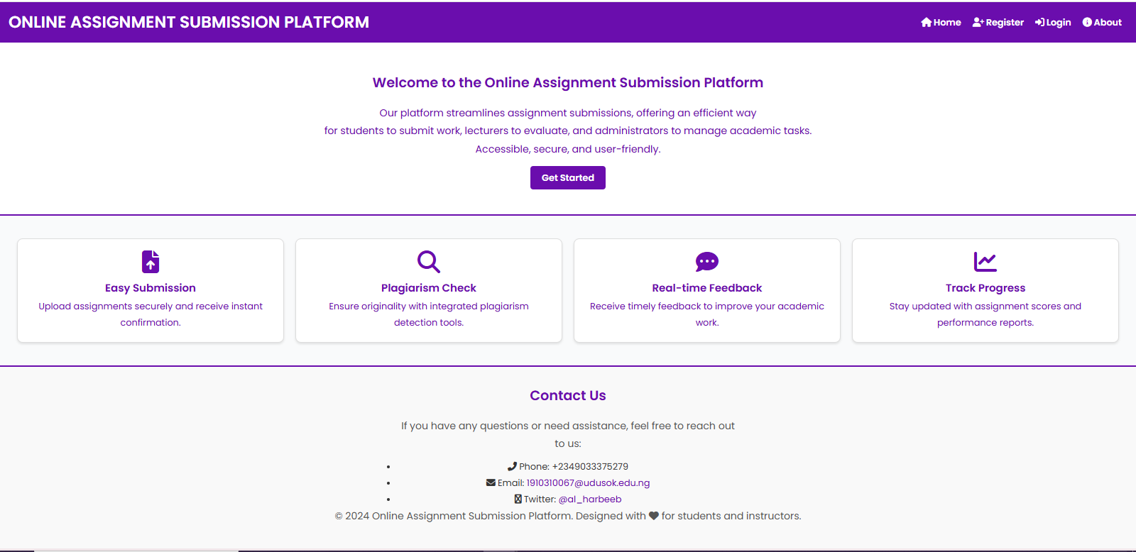

**User Registration Page**

The User Registration Page facilitates the creation of accounts for users, ensuring a seamless onboarding process tailored to their roles.

**Features:**

Dropdown menu to select a role as either Student or Lecturer

Input fields for full name, email address, password, student admission number and lecturer ID

A secure password entry with a visibility toggle for user convenience.

A clear and accessible "Register" button for completing the sign-up process.

**Purpose:**

To enable users to create accounts aligned with their roles, ensuring they are directed to the appropriate dashboard and provided with access to role-specific functionalities.

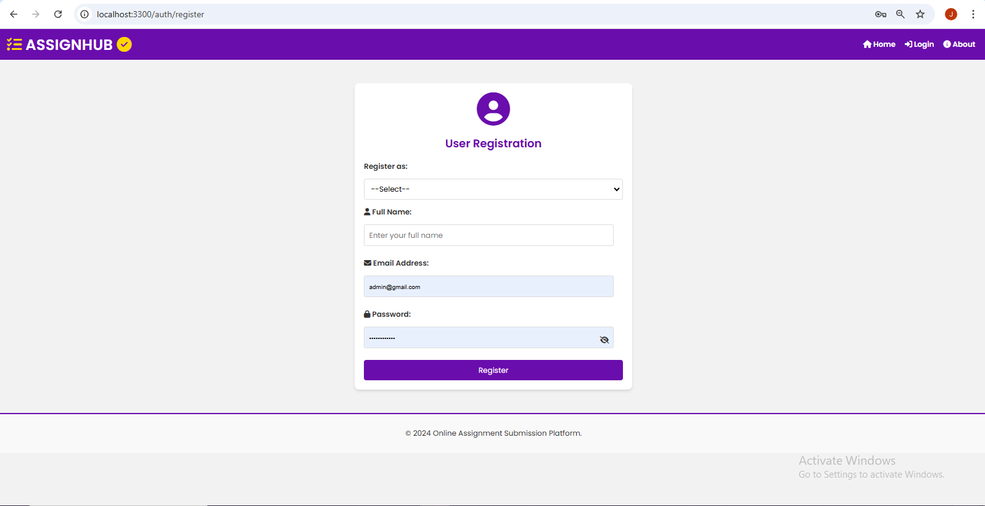

**Sign-in Page**

The Login Interface serves as the secure gateway to the assignment submission platform, enabling authenticated access for students, instructors and administrators

**Features :**

* User authentication form with email address and password fields, ensuring secure access to individual accounts
* Role selection dropdown menu to differentiate between different types of users (likely students, instructors, and administrators)
* Registration link for new users who don't have an account yet

**Purpose:**

To authenticate users and direct them to their appropriate dashboards while maintaining platform security and providing clear paths for both existing and new users.

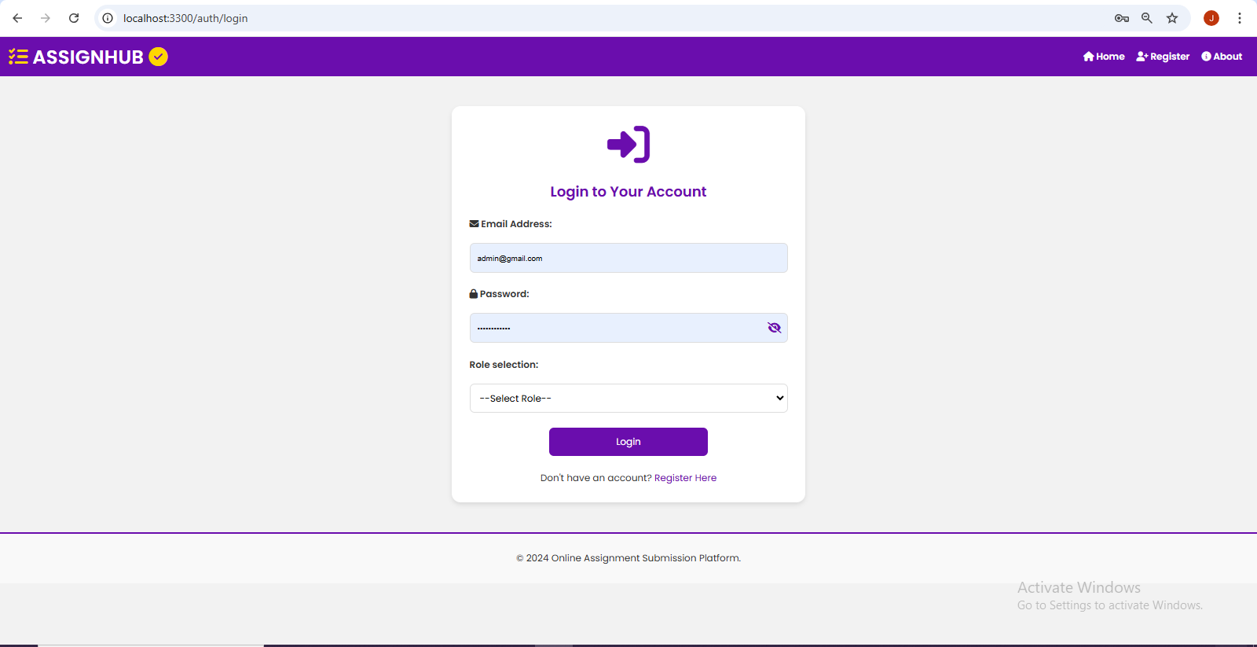

**Role-Specific Dashboards:**

**Admin Dashboard**:

The Admin Dashboard is the central hub of the Online Assignment Submission Platform, offering a full range of tools and features to efficiently manage and oversee the system.

**Features:**

* Manage Users for comprehensive user account control
* Platform Analytics for system performance tracking
* Generate Lecturer ID for lecturer account creation
* Manage Course for course administration
* Left sidebar navigation menu for quick access
* Secure logout and navigation options

**Purpose:**

To provide administrators with a centralized interface for managing the entire platform infrastructure, including user management, analytics tracking, lecturer credentialing, and course oversight, while maintaining platform security and operational efficiency through an organized and intuitive dashboard environment.

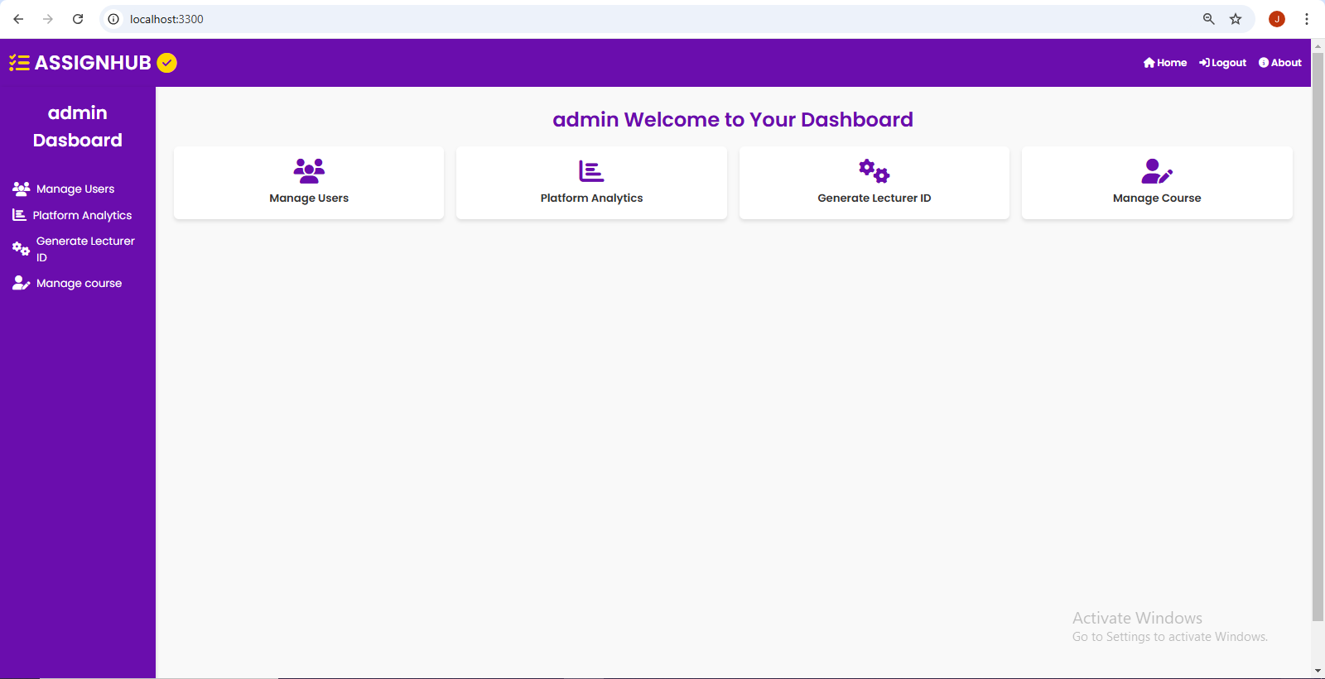

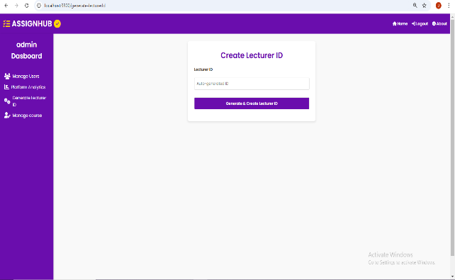 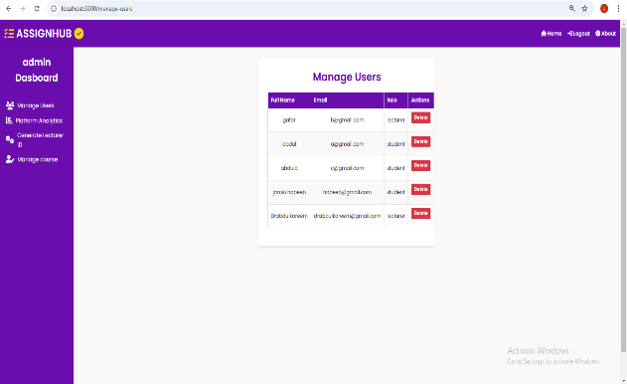

**Lecturer Dashboard:**

The Lecturer Dashboard serves as the centralized hub for lecturers, offering a streamlined way to manage courses, assignments, and student performance.

**Features:**

* Easy navigation with sidebar options to create assignments, view submissions, and analyze assignment performance.
* Access to course management tools, enabling lecturers to organize course content effectively.
* Integrated plagiarism management functionality to maintain academic integrity.

**Purpose:**

To provide lecturers with a user-friendly interface for creating and managing academic tasks, tracking student submissions, and ensuring the quality of academic work.

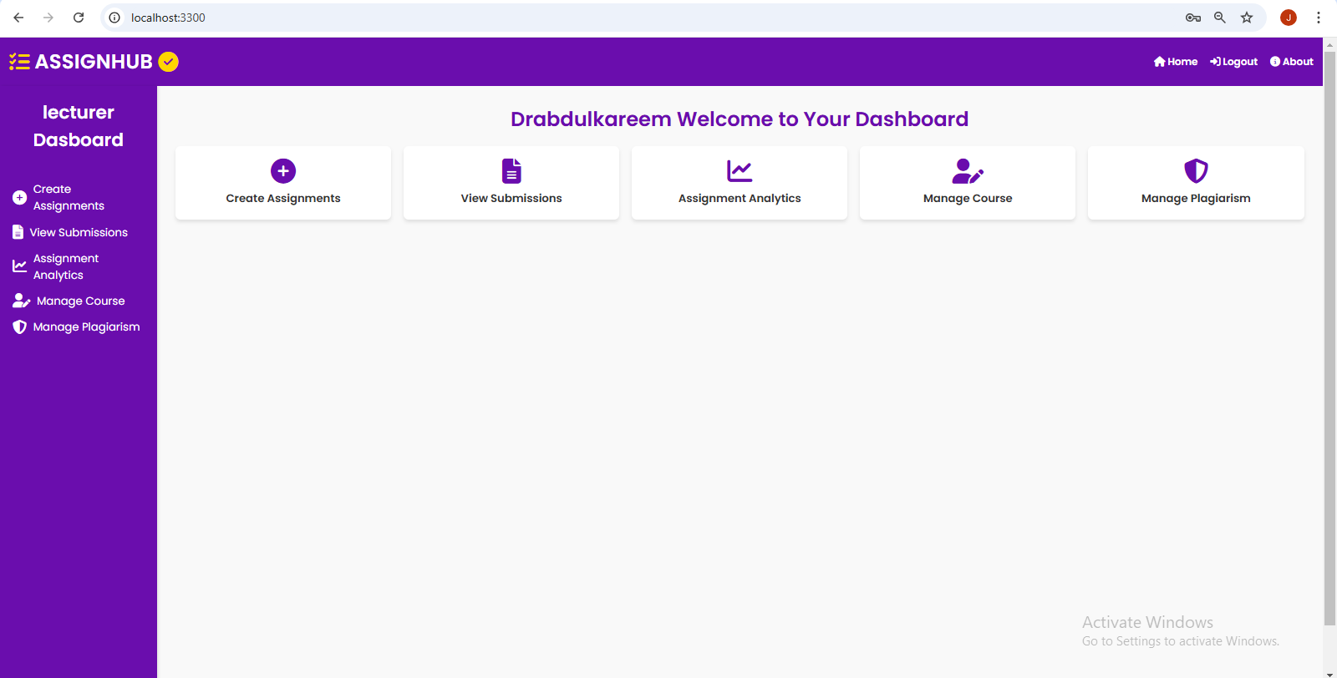

**Student Dashboard:**

The Student Dashboard provides a personalized interface for students to access and manage their academic activities effortlessly.

**Features:**

* View assignments and access all tasks for registered courses, including deadlines and detailed instructions.
* Submit assignments by uploading completed work directly through the platform for lecturer evaluation.
* View feedback and review detailed comments, scores, and suggestions provided by lecturers.
* Monitor submission history to track the status of past submissions, including dates and grades received.
* Register for courses to gain access to assignments pertaining to registered courses.

**Purpose:**

To empower students with a user-friendly platform that enables efficient management of assignments, tracking submissions, and engaging with feedback to enhance academic performance.

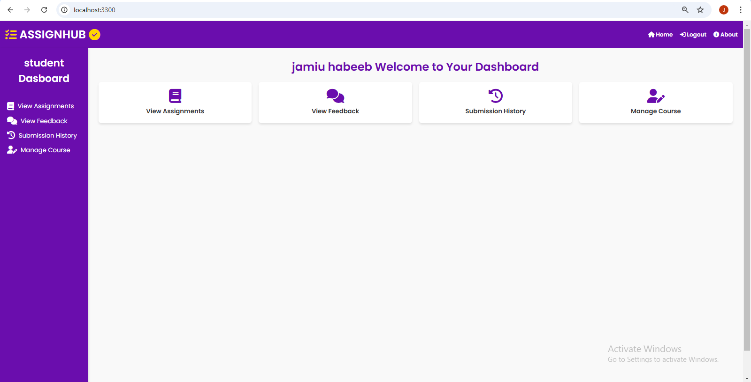

**4.5 System Testing**

Testing ensures the Online Assignment Submission Platform is free from defects, meets all specified requirements, and delivers intended functionality effectively. The testing phase employed two primary methodologies: Unit Testing and Integration Testing.

**4.5.1 Unit Testing**

Unit testing focused on validating individual components and modules of the system independently. Each function and feature was tested thoroughly to ensure proper operation.

**Components Tested:**

1. **User Authentication:**
   * Verification of login and registration modules for all user roles (Admin, Lecturer, and Student)
   * Testing of invalid login attempts and session management
   * Password encryption and security validation
   * Role-based access control implementation
2. **Course Management:**
   * Course creation and registration functionality
   * Student enrollment processes
   * Course information updates and modifications
   * Course deletion and archiving capabilities
3. **Assignment Management:**
   * Creation and modification of assignments
   * Setting and updating submission deadlines
   * File upload functionality and format restrictions
   * Assignment visibility controls
4. **Plagiarism Detection:**
   * Accuracy of plagiarism detection algorithms
   * Processing of various file formats
   * Generation of plagiarism reports
   * Threshold settings for plagiarism detection
5. **Notification System:**
   * Delivery of assignment submission confirmations
   * Deadline reminder notifications
   * Feedback and grading notifications
   * System update notifications

**Results:** All tested components passed with expected outputs. Minor issues were identified and resolved, including:

* File size validation improvements
* Enhanced error messaging for invalid file formats
* Optimization of plagiarism detection processing time
* Refined notification delivery timing

**4.5.2 Integration Testing**

Integration testing evaluated the seamless interaction between different modules and ensured system components work together effectively.

**Tests Conducted:**

1. **Assignment Workflow:**
   * Complete cycle from assignment creation by lecturer to student submission
   * Plagiarism check integration with submission process
   * Notification delivery at each stage
   * Feedback and grading workflow
2. **Course Management Workflow:**
   * Course creation and student registration process
   * Assignment association with specific courses
   * Student access to course-specific assignments
   * Grade management within courses
3. **Administrative Functions:**
   * User management across all roles
   * System-wide notifications and announcements
   * Platform analytics and reporting
   * Course and assignment oversight
4. **Database Operations:**
   * Data consistency across all operations
   * Proper storage and retrieval of assignments
   * File storage and management
   * User data integrity

**Results:**

* Successful integration of all modules with smooth data flow between frontend, backend, and database
* Resolved minor issues in:
  + Notification delivery timing
  + File upload synchronization
  + Plagiarism report generation
  + Course registration validation

**4.5.3 Performance Testing**

Performance testing evaluated the system's responsiveness, stability, and scalability under various conditions.

**Key Metrics Tested:**

* Response time for file uploads and downloads
* Plagiarism detection processing speed
* Concurrent user handling
* Database query performance
* System resource utilization

**Results:**

* Average response time: < 2 seconds for standard operations
* File upload capacity: Up to 25MB per file
* Concurrent users supported: 100+ without performance degradation
* Plagiarism detection processing: < 60 seconds per document
* Database query response: < 1 second for standard queries

**4.5.4 Security Testing**

Security testing ensured the protection of user data and system integrity.

**Areas Tested:**

* User authentication and authorization
* Data encryption
* Session management
* File upload security
* Database security

**Results:**

* Successful implementation of role-based access control
* Secure file storage and transmission
* Encrypted user credentials
* Protected against common web vulnerabilities
* Secure session handling and timeout mechanisms

The testing phase demonstrated that the Online Assignment Submission Platform meets its intended requirements and performs reliably under various conditions. Minor issues identified during testing were addressed, resulting in a robust and secure system ready for deployment.