SOFTWARE REQUIREMENTS SPECIFICATION
Carvix
Smart Vehicle Maintenance & Monitoring Platform
Document Item | Value
Version | 0.1 – Diagrams inserted; role names aligned to ERD
Status | Proposed / Under Team Review
Stack | Python 3.12+, Django MVT, PostgreSQL, HTML5, CSS3, JavaScript ES6+
AI | Agentic AI with LLM Tool Calling / Function Calling
Program | Full-Stack Python Graduation Project 2026
Deadline in official specification | 29 September 2026

1. Introduction

1.1 Purpose
This SRS defines the functional, non-functional, security, database, interface, and Agentic AI requirements of Carvix. It creates a shared baseline for implementation, testing, documentation, and project defense.

1.2 Problem Statement
Vehicle owners may store maintenance information in scattered records and messages. This makes it difficult to track service history, detect overdue maintenance, locate suitable service slots, and coordinate maintenance activities. Service teams also need a structured way to manage appointments, technicians, and spare parts.

1.3 Objectives
- Centralize vehicle and maintenance information.
- Allow users to manage vehicles and service appointments.
- Support maintenance history, technicians, and spare parts.
- Provide secure authentication and role-based access control.
- Embed a context-aware Agentic AI assistant in the dashboard.
- Allow AI tools to perform validated backend actions without bypassing permissions.
- Use a normalized PostgreSQL database and clean Django architecture.
- Maintain professional GitHub branches, issues, pull requests, and continuous commits.

1.4 Scope
In scope:
- Authentication and profiles
- Vehicle management
- Maintenance records
- Service appointments
- Technician management
- Spare-part management
- Context-aware AI assistant
- Validated AI tool calling
- RBAC, auditability, testing, ERD, architecture diagram, and README
Out of scope for the initial release:
- Direct OBD/hardware integration
- Online payments
- Insurance processing
- Full predictive ML forecasting
- RAG, vector databases, embeddings, and complex cloud orchestration
- Raw SQL access by the AI agent

1.5 Assumptions
- The first release is intended for local or controlled demonstration.
- The final LLM provider, exact roles, branding, and deployment target are subject to team approval.
- All committed code must be understood and defendable by the team.
- The AI agent may request actions, but Django remains responsible for validation and execution.

2. Stakeholders and Roles
Role | Description | Main Permissions
Visitor | Unauthenticated visitor | View public pages; register; log in
Client | User managing vehicles | Manage own vehicles, view own records, request appointments, use AI
Technician | Staff member performing assigned work | View assigned jobs and update permitted statuses
Manager | Staff managing operations | Manage appointments, technicians, maintenance, and parts
Admin | System operator | Manage users, roles, reference data, and system configuration

3. Functional Requirements
ID | Priority | Requirement
FR-AUTH-01 | Must | The system shall support registration with validated data.
FR-AUTH-02 | Must | The system shall hash passwords using Django authentication mechanisms.
FR-AUTH-03 | Must | The system shall provide login, logout, and profile management.
FR-AUTH-04 | Must | The system shall enforce role-based access control on protected pages and endpoints.
FR-AUTH-05 | Must | The system shall prevent horizontal and vertical privilege escalation.
FR-VEH-01 | Must | The system shall allow clients to create, view, update, and deactivate (soft-delete via is_active=False) their own vehicles.
FR-VEH-02 | Must | The system shall store vehicle make, model, year, registration identifier, mileage, and an active/inactive flag.
FR-MNT-01 | Must | The system shall store maintenance records linked to a vehicle.
FR-MNT-02 | Must | A maintenance record shall support service type, date, mileage, description, cost, and responsible technician where applicable.
FR-MNT-03 | Must | The system shall display maintenance history chronologically.
FR-MNT-04 | Should | The system should identify upcoming and overdue maintenance using configured rules.
FR-APT-01 | Must | The system shall allow authorized users to create appointment requests.
FR-APT-02 | Must | The system shall display appointment date, time, vehicle, service type, and status.
FR-APT-03 | Must | Authorized staff shall confirm, reschedule, reject, or complete appointments.
FR-APT-04 | Must | The system shall prevent double-booking according to configured scheduling rules.
FR-TECH-01 | Must | Managers shall manage technician records and assignments.
FR-SP-01 | Should | Authorized staff should manage spare parts, stock quantities, and usage.
FR-AI-01 | Must | The system shall provide an AI assistant embedded in the authenticated dashboard.
FR-AI-02 | Must | The AI assistant shall use only application context allowed for the logged-in user.
FR-AI-03 | Must | The agent shall select registered tools through structured function calling.
FR-AI-04 | Must | Each tool call shall receive the authenticated user context.
FR-AI-05 | Must | Each tool call shall validate parameters, ownership, and permissions.
FR-AI-06 | Must | The AI shall not have raw SQL or unrestricted database privileges.
FR-AI-07 | Must | Sensitive write actions shall require explicit confirmation where applicable.
FR-AI-08 | Should | The agent should support history review, overdue checks, slot lookup, and appointment booking.
FR-DOC-01 | Must | The team shall maintain an SRS, ERD, architecture diagram, and professional README.

4. Non-Functional Requirements
ID | Category | Requirement
NFR-PERF-01 | Performance | Common local CRUD requests should normally respond within approximately 2 seconds, excluding external AI latency.
NFR-SEC-01 | Security | The system shall apply CSRF protection, authentication, server-side authorization, and secure password handling.
NFR-SEC-02 | Security | API keys and secrets shall be stored in environment variables and excluded from Git.
NFR-SEC-03 | Security | AI tools shall validate schemas, ownership, permissions, and allowed state transitions.
NFR-REL-01 | Reliability | Invalid input and failed tool execution shall produce controlled errors instead of application crashes.
NFR-REL-02 | Reliability | Critical multi-step database operations shall use transactions where required.
NFR-USE-01 | Usability | The interface shall provide consistent navigation, readable forms, and clear validation messages.
NFR-MAINT-01 | Maintainability | Business logic shall be separated from views using services or reusable functions.
NFR-DATA-01 | Integrity | The database shall use primary keys, foreign keys, constraints, indexes, and explicit deletion behavior.

5. RBAC Matrix
Capability | Client | Technician | Manager | Admin
Own profile | CRUD own | CRUD own | CRUD own | Manage if authorized
Own vehicles | CRUD own | View assigned context | View authorized | All
Maintenance history | Own vehicles | Assigned jobs | Authorized records | All
Create appointment | Yes | If permitted | Yes | Yes
Confirm/reschedule | Request only | Assigned scope | Yes | Yes
Manage technicians | No | No | Yes | Yes
Manage spare parts | No | Limited use | Yes | Yes
Use AI | Yes | Yes | Yes | Yes
Manage users/roles | No | No | Limited | Yes

6. Agentic AI Design

6.1 Agent Loop
- Goal Perception: receive the user's natural-language request.
- Context Preparation: load only permitted application context.
- Tool Selection: choose a registered tool using its structured schema.
- Validation: check tool name, arguments, identity, ownership, and permissions.
- Execution: call a controlled Django service function.
- Observation: return structured success or failure data.
- Completion: explain the result without claiming success when execution failed.

6.2 Proposed Tools
Tool | Arguments | Purpose | Controls
get_vehicle_history | vehicle_id, optional dates | Return permitted maintenance history | Read-only; ownership check
check_maintenance_due | vehicle_id | Identify upcoming or overdue service | Read-only; ownership check
get_available_slots | service_type, preferred date | Return available appointment slots | Validate date and resources
book_maintenance_appointment | vehicle_id, slot_id, service_type, confirmation | Create an appointment | Recheck availability; permission and confirmation
list_my_vehicles | (none) | List vehicles visible to the current user | Read-only; login required
cancel_appointment | appointment_id | Cancel an appointment owned by the user | Write; ownership check; explicit confirmation required

6.2.1 Planned Tool Argument Schemas
The following JSON schemas define the intended contract between the agent and the Django backend. They are the planned interface and will be verified against the implementation during Day 2–3. Any mismatch between these schemas and the delivered code will be corrected in this SRS before final submission.

list_my_vehicles
{
"name": "list_my_vehicles",
"description": "Return the vehicles the current user is allowed to see.",
"parameters": {"type": "object", "properties": {}, "required": []}
}

get_vehicle_history
{
"name": "get_vehicle_history",
"description": "Return past maintenance records for a vehicle the user can see.",
"parameters": {
"type": "object",
"properties": {
"vehicle_id": {"type": "integer"},
"date_from": {"type": "string", "description": "Optional ISO date."},
"date_to": {"type": "string", "description": "Optional ISO date."}
},
"required": ["vehicle_id"]
}
}

check_maintenance_due
{
"name": "check_maintenance_due",
"description": "Identify upcoming or overdue maintenance for a vehicle.",
"parameters": {
"type": "object",
"properties": {"vehicle_id": {"type": "integer"}},
"required": ["vehicle_id"]
}
}

get_available_slots
{
"name": "get_available_slots",
"description": "Return available appointment slots.",
"parameters": {
"type": "object",
"properties": {
"maintenance_type_id": {"type": "integer"},
"date_from": {"type": "string"},
"date_to": {"type": "string"}
},
"required": ["maintenance_type_id", "date_from", "date_to"]
}
}

book_maintenance_appointment
{
"name": "book_maintenance_appointment",
"description": "Create a service appointment after revalidating availability and ownership.",
"parameters": {
"type": "object",
"properties": {
"vehicle_id": {"type": "integer"},
"maintenance_type_id": {"type": "integer"},
"scheduled_at": {"type": "string", "description": "ISO-8601 future datetime."},
"notes": {"type": "string"}
},
"required": ["vehicle_id", "maintenance_type_id", "scheduled_at"]
}
}

cancel_appointment
{
"name": "cancel_appointment",
"description": "Cancel an appointment. Only call after explicit user confirmation.",
"parameters": {
"type": "object",
"properties": {"appointment_id": {"type": "integer"}},
"required": ["appointment_id"]
}
}

6.3 AI Governance
- Never allow raw SQL access.
- Bind every tool call to request.user.
- Validate all arguments before execution.
- Do not expose another user's records.
- Recheck availability immediately before booking.
- Require explicit confirmation for sensitive write actions.
- Return structured results such as success, error_code, message, and data.
- Log important actions where practical.

6.4 Sample Agent Traces
This section is reserved for traces captured from real runs of the agent after it is implemented. Each trace will include:
- The user’s natural-language input.
- Every tool call with its arguments.
- Every backend response.
- The final assistant reply.
Traces will be captured during Day 3–4 and added here before final submission.

7. Database Requirements
Entity | Core Attributes
User | id, username, email, password hash, role (ADMIN/MANAGER/TECHNICIAN/CLIENT), phone, avatar, is_active, created_at
Vehicle | id, owner_id (FK User), make, model, year, license_plate, vin, mileage, fuel_type, is_active, created_at, updated_at
MaintenanceType | id, name, description, interval_km, interval_days, base_cost, is_active, created_at
ServiceAppointment | id, client_id (FK User), vehicle_id (FK Vehicle), maintenance_type_id (FK MaintenanceType), technician_id (FK User, nullable), scheduled_at, status, notes, created_at, updated_at
MaintenanceRecord | id, vehicle_id (FK), maintenance_type_id (FK), appointment_id (FK ServiceAppointment, unique, nullable), technician_id (FK User, nullable), performed_at, mileage_at_service, labor_cost, notes, created_at
SparePart | id, name, part_number, unit_price, stock_quantity, reorder_level, created_at
PartUsage | id, maintenance_record_id (FK), spare_part_id (FK), quantity, unit_price (historical snapshot)
ChatSession | id, user_id (FK), title, started_at, created_at, updated_at
ChatMessage | id, session_id (FK), role, content, tool_name, tool_payload, tool_result, context, created_at

- Every entity shall have a primary key.
- Relationships shall use foreign keys.
- Unique constraints shall be applied to identifiers that must be unique.
- The schema should follow 3NF where appropriate.
- Appointment overlap, ownership, and stock rules shall be validated in the backend and protected by safe transactions where required.

7.1 Entity Relationship Diagram
Figure 1 — Carvix Entity Relationship Diagram (v0.1). Nine entities: User, Vehicle, MaintenanceType, ServiceAppointment, MaintenanceRecord, SparePart, PartUsage, ChatSession, ChatMessage.

7.2 Design Rationale
The schema reaches 3NF by keeping every non-key attribute dependent on the whole primary key only. Key decisions:
- 1. MaintenanceType is a separate table — it stores interval_km and interval_days, the rules behind overdue detection (FR-MNT-04).
- 2. PartUsage is a through table — the M:N relationship between MaintenanceRecord and SparePart carries quantity and a historical unit_price, which a plain many-to-many field cannot hold.
- 3. ServiceAppointment is not the same entity as MaintenanceRecord — an appointment is a plan (it may be cancelled or a no-show); a record is a fact. Merging them would require many nullable columns.
- 4. A partial unique index on (technician_id, scheduled_at) where status != 'CANCELLED' enforces FR-APT-04 without blocking reused slots.
- 5. All foreign keys declare explicit on_delete behavior: CASCADE for owned data, PROTECT for reference data, and SET_NULL for optional assignments.

8. Architecture
- Presentation: Django Templates, HTML5, CSS3, ES6+ JavaScript, Fetch API.
- Application: URLs, views, forms, authentication, and permissions.
- Business Services: vehicle, maintenance, appointment, technician, and spare-part services.
- AI Layer: agent service, prompts, tool registry, schemas, and chat endpoint.
- Data Layer: Django ORM and PostgreSQL.
- External LLM Service: server-side API integration using environment variables.
The AI layer may request an action, but the Django business layer is the final authority for authorization, validation, and database changes.
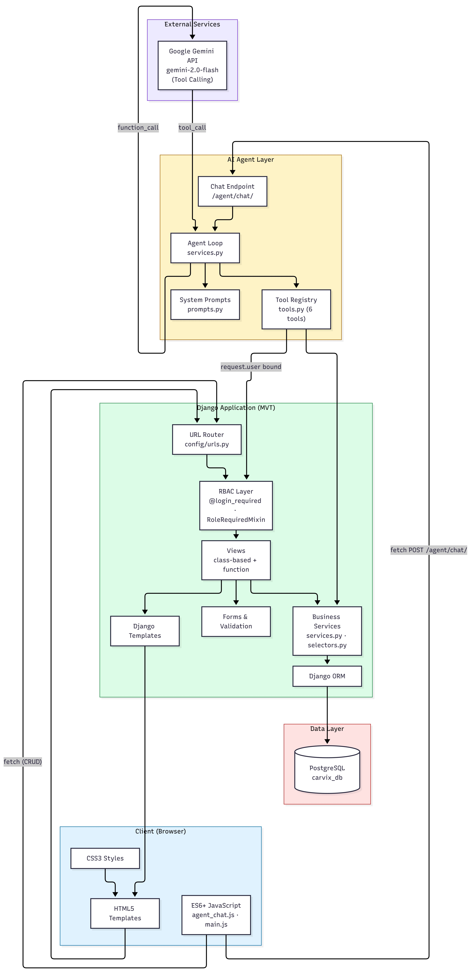
Figure 2 — Carvix system architecture. Django is the sole authority for authorization, validation, and database changes. The AI agent requests actions through the tool registry; it never touches the database directly.

9. Key User Journeys
Journey | Steps
Register | Open registration → submit data → validate → create account → log in → dashboard
Add vehicle | Open vehicles → enter data → validate → save vehicle → show confirmation
Book appointment | Select vehicle/service → show slots → select slot → validate → create appointment
AI maintenance check | Ask AI → select permitted vehicle → call tool → validate → return overdue/upcoming results
AI booking | Check maintenance → find slots → ask for confirmation → validate again → create appointment → show result

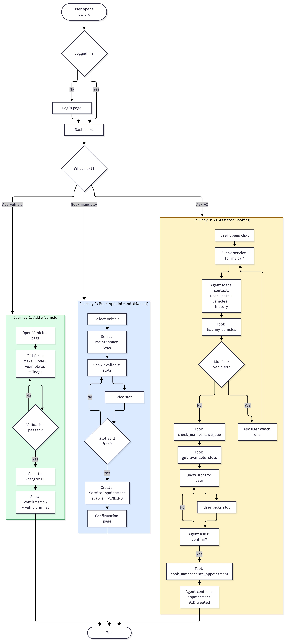
Figure 3 — Three key user journeys: manual vehicle creation, manual booking, and AI-assisted booking. The AI journey shows multi-step tool calling with confirmation before the write action.

10. UI Requirements
- Provide a consistent navigation bar and dashboard.
- Show field-level validation errors.
- Use clear tables/cards for vehicles, history, and appointments.
- AI chat shall show messages, loading state, errors, and action results.
- Sensitive actions shall have explicit confirmation controls.
- The interface should be usable on desktop and mobile screens.

11. Testing and Acceptance Criteria
Area | Acceptance Criteria
Authentication | Registration, login, logout, invalid credentials, and session behavior work.
Authorization | A client cannot access another client's vehicle or maintenance records.
Vehicles | Create, view, update, and deactivate operations validate correctly.
Appointments | Invalid or occupied slots are rejected; status transitions follow rules.
AI read tool | The agent can call a read-only tool and receive structured data.
AI write tool | Booking checks identity, ownership, permission, availability, and confirmation.
Validation | Malformed tool arguments never create unauthorized database changes.
Database | Migrations run successfully and relationships remain valid.
Documentation | README, SRS, ERD, and architecture diagram match the implemented system.

12. GitHub Development Strategy
- Keep main stable and reviewed.
- Use feature branches for individual tasks.
- Use pull requests for meaningful changes.
- Track work through Issues and a project board.
- Use Conventional Commits such as feat:, fix:, docs:, refactor:, and test:.
- Commit continuously; do not upload the complete codebase immediately before the deadline.
- Every team member must understand and defend their committed code.
Branch | Purpose
main | Stable reviewed version
feature/authentication | Authentication and profiles
feature/vehicles | Vehicle module
feature/appointments | Appointment workflow
feature/ai-tools | Agent service and tools
docs/srs-erd | Documentation and diagrams

13. Proposed Django Structure
- config/ – settings and URLs
- apps/authentication/ – users, roles, profiles
- apps/core/ – landing pages and shared components
- apps/vehicle_management/ – vehicles, maintenance, appointments, technicians, parts
- apps/ai_agent/ – services.py, tools.py, prompts.py, tool registry
- templates/ – HTML templates
- static/css/ – styles
- static/js/ – ES6 modules and agent_chat.js
- docs/ – SRS, ERD, architecture diagram
- requirements.txt and .env.example

14. Risks and Mitigation
Risk | Mitigation
Unauthorized AI action | Identity binding, permission checks, validation, confirmation
Hallucinated arguments | Explicit schemas, tool descriptions, structured errors
Double booking | Recheck slot and use transactional logic
Scope expansion | Prioritize Must requirements and document future scope
Merge conflicts | Feature branches, pull requests, small commits
AI-generated code not understood | Code review, explanation sessions, individual defense preparation

15. Open Decisions
- Confirm final roles and whether Technician and Manager are separate.
- Confirm whether the platform serves individual owners, service centers, or both.
- Confirm exact vehicle fields such as VIN, plate, fuel type, and mileage.
- Confirm service categories and maintenance rules.
- Confirm notification method: in-app only or email.
- Confirm how appointment slots are created and managed.
- Confirm final branding, language, and deployment environment.

16. Definition of Done
- Feature implemented and reviewed.
- Server-side validation and permissions are present.
- Relevant tests or manual test cases are completed.
- Migrations are created and tested.
- Frontend loading, success, and error states are handled.
- Documentation is updated.
- Change is committed using a clear message and merged through the agreed workflow.

17. Traceability to Official Specification
Official Requirement | Carvix Implementation
Django MVT, PostgreSQL, HTML/CSS/ES6+ | Architecture and proposed project structure
Authentication and RBAC | FR-AUTH requirements and RBAC matrix
Context-aware chatbot | Embedded dashboard assistant with application context
Agentic Tool Calling | Agent loop, registered tools, validation, and execution
Permission and parameter validation | AI governance rules and acceptance tests
ERD and normalization | Proposed entities and database requirements
GitHub workflow | Branches, issues, pull requests, and commit conventions
SRS and README | This document and documentation Definition of Done

18. Approval
Role | Name | Date / Signature
Project Supervisor | TBD | TBD
Team Lead | TBD | TBD
Team Member | TBD | TBD
Team Member | TBD | TBD
Team Member | TBD | TBD

End of Document – Carvix SRS Draft 0.1

