**KINGDOM OF SAUDI ARABIA**

|  |  |  |
| --- | --- | --- |
| **المملكة العربية السعودية**  **وزارة التعليم العالي**  **جامعة الإمام محمد بن سعود الإسلامية**  **كلية علوم الحاسب والمعلومات** | A description...  **Second term 1441/2020** | **KINGDOM OF SAUDI ARABIA**  **Ministry of Higher Education**  **Al-Imam Mohammad University**  **College of Computer & Information Sciences** |

**Software Engineering (CS- 310)**

**BSCS- Section: 171**

**Project-Phase No: 01**

**MADA verification**

**(SRS)**

**Submitted By**

**Abdulrahman Alghaligah (439015052) – Coordinator**

**Omair Aljabri (439012472)**

**Sulaiman Almohsen (439012196)**

**Omar Musayri (439011747)**

**Supervisor**

**Dr.Sultan S. Alqahtani**

**Date: 27, February.**

Table of **Contents**

1 Introduction: 3

1.1 Purpose 3

1.2 Scope 3

1.3 Definitions, Acronyms, and Abbreviations 3

1.4 References 4

1.5 Overview 4

2 General description: 5

2.1 Product perspective 5

2.2 Product functions 5

2.3 User characteristics 6

2.4 General constraints: 6

3 Functional requirements: 6

3.1 Adding new bank card: 6

3.2 Removing bank card: 7

3.3 Adding fingerprint: 7

3.4 Adding Face ID: 7

3.5 Show bank card details: 8

3.6 Show latest operation: 8

# 1 Introduction:

This document gives a complete description of the SRS documents.

also, provide purpose, list of definition, abbreviations and scope described clearly.

# Purpose

purpose of this SRS documents is to cover all requirements for the "MADA Verifications" software, it will give also an explanation of the development of the system, interfaces, interactions etc.

In the first place of this document is to give the customer a clear image for this SRS document and his approval.

# Scope

"MADA Verifications" is software system products will be a mobile application of mobile Banking verification operations, which helps people to verify his bank operations easier and faster, currently can run on Android platform, in the future will be able also on IOS platform and another OS.

# Definitions, Acronyms, and Abbreviations

|  |  |
| --- | --- |
| Term | Definitions |
| MV | Stands for MADA Verification application, which is a system to verify bank operations through mobile phones. |
| User | A client who's using the MV application. |
| Application store | the platform already installed on a mobile phone as a store of applications can be downloaded either free or at a cost. |
| Stakeholder | Any person who benefits from the system and who is not a developer. |
| SRS | Stands for software requirements specification. |
| Face ID | Is a technology capable of identifying or verifying a person from a digital image. |
| Fingerprint | Is a technology capable of identifying or verifying a person from a human finger. |
| OS | Stands for operating system. |

# References

* Wikipedia: <https://en.wikipedia.org/wiki/Google_Play>
* Wikipedia: <https://en.wikipedia.org/wiki/Face_ID>
* Ian Sommerville, Software Engineering 9th edition, Addison Wesley, 2010

# Overview

The 2nd chapter of this SRS document gives an overview of the functionality of the product and describe the main functions that the system will do.

The 3rd chapter shows the Functional requirements in more details. It describes the services that the system should offer.

# 2 General description:

This section describes the general concept of our product and its requirements without going into details. The system will be explained how the product will communicate with other systems. It should be made those requirements easier to understand.

# Product perspective

MV is a mobile application based. The application will be linked with banks systems. MV app will be used to verify banks operations while banks will make those operations, the bank will send a request to the app for verifying the operation. (see figure 1)

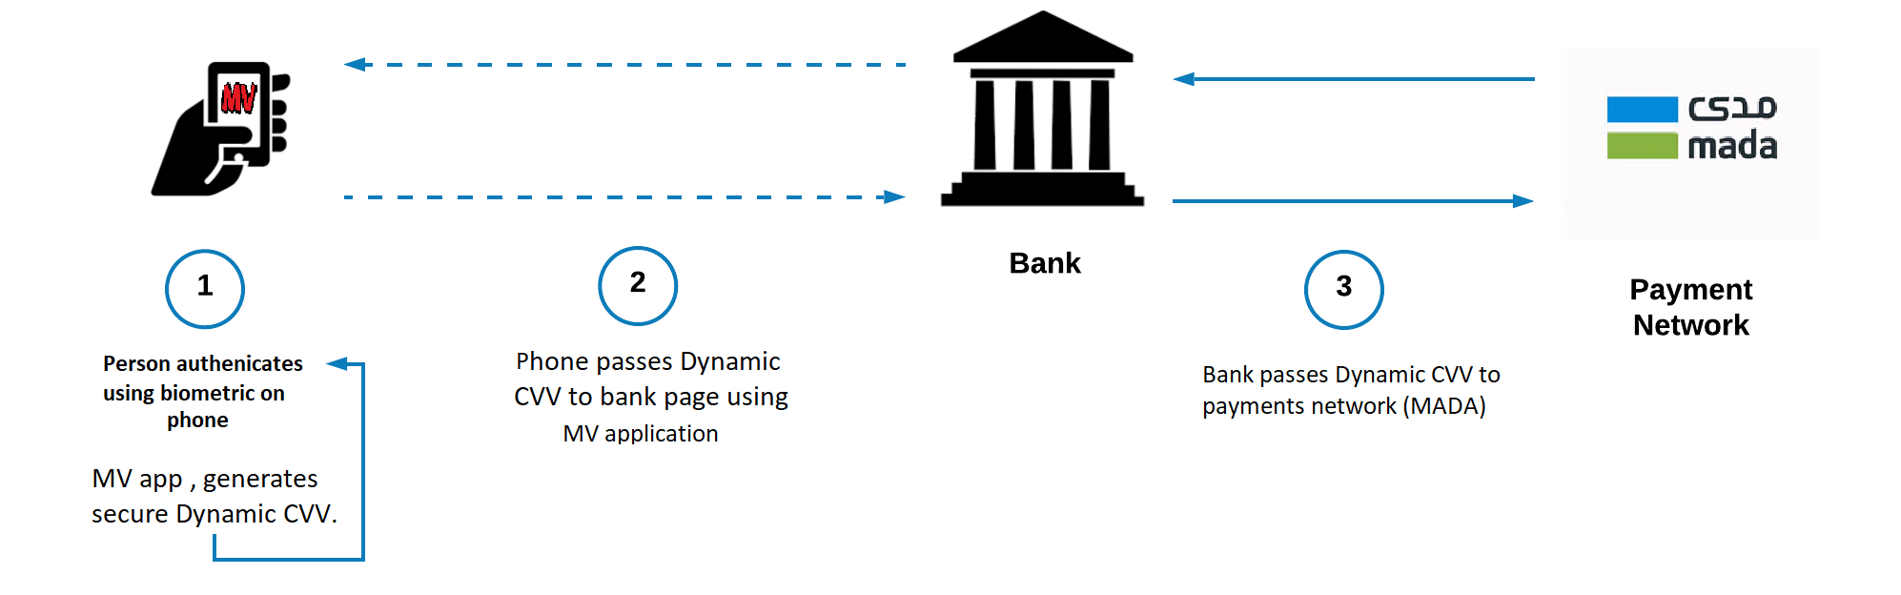

Figure 1: system overview

This figure shows the communication between these systems, our application will need somewhere to store the data, for that case we made MV database will only use to get data and modify data. All the databases communicate will go through the internet.

# Product functions

The MV user can either add or remove banks cards to the application then he should link the card with his face ID or fingerprint using them for verify operations also the app will provide the flexibility of adding or removing either fingerprint or face ID, also user can add his email for following his operations. The application will be able to show card details and latest operations were execute also the app will provide complete privacy for these operations, and there are more and more settings can provide such as changing languages, allow notifications etc.

# User characteristics

The only user of the MV application is banks customer, a customer is anyone who has a bank account, the only skill needed by him is the ability to use smartphones further, he does not need to have wide knowledge about technology. That means he should have simple knowledge.

# General constraints:

At the beginning we decide to run our application on Android smartphones, so one of the constraints is our product only works on Android OS. The App is run only on Google play platform which means there are other constraints which are the app not able to run on IOS platform or Windows platform for now. The system is designed especially for those who have local bank account further, the app must have internet access. The smartphones should support either face ID or fingerprint.

# Functional requirements:

# 3.1 Adding new bank card:

|  |  |
| --- | --- |
| Function | Adding a new bank card to the application. |
| Description | A user could be able to add his bank card. |
| Inputs | Bank card information. |
| Source | MV application. |
| Outputs | An email sent from MV to the user, the card successfully added |
| Destination | MV application. |
| Action | User should add his bank card to the application by open the app and go with add new bank card button. |
| Requirements | User should be downloaded MV application. |
| Pre-Condition | None. |
| Post-Condition | None. |
| Side effects | None. |

# 3.2 Removing bank card:

|  |  |
| --- | --- |
| Function | Removing a bank card from the application. |
| Description | A user could be able to remove his bank card from the application. |
| Inputs | None. |
| Source | MV application. |
| Outputs | An email sent from MV to the user, the card removed. |
| Destination | MV application. |
| Action | User should remove his bank card from the application by open the app and press remove bank card button. |
| Requirements | User should be downloaded MV application. |
| Pre-Condition | None. |
| Post-Condition | None. |
| Side effects | None. |

# 3.3 Adding fingerprint:

|  |  |
| --- | --- |
| Function | Adding fingerprint to MV application |
| Description | A user could be able to add his fingerprint to the application. |
| Inputs | A human finger will be scanned as input. |
| Source | MV application. |
| Outputs | None. |
| Destination | MV application. |
| Action | User should add his fingerprint to the application by open the app and press add fingerprint button. |
| Requirements | User should be downloaded MV application. |
| Pre-Condition | None. |
| Post-Condition | None. |
| Side effects | None. |

# 3.4 Adding Face ID:

|  |  |
| --- | --- |
| Function | Adding Face ID to MV application. |
| Description | A user could be able to add his Face ID to the application. |
| Inputs | Human Face will be scanned as input. |
| Source | MV application. |
| Outputs | None. |
| Destination | MV application. |
| Action | User should add his Face ID to the application by open the app and press add Face ID button. |
| Requirements | User should be downloaded MV application. |
| Pre-Condition | None. |
| Post-Condition | None. |
| Side effects | None. |

# 3.5 Show bank card details:

|  |  |
| --- | --- |
| Function | Show bank card details from the application. |
| Description | A user could be able to see his bank card details by the application. |
| Inputs | None. |
| Source | MV application. |
| Outputs | None. |
| Destination | MV application. |
| Action | User should see his bank card details from the application by open the app and press card details button. |
| Requirements | User should be downloaded MV application. |
| Pre-Condition | None. |
| Post-Condition | None. |
| Side effects | None. |

# 3.6 Show latest operations:

|  |  |
| --- | --- |
| Function | Show the latest operations from the application. |
| Description | A user could be able to see the latest operations from the application. |
| Inputs | None. |
| Source | MV application. |
| Outputs | None. |
| Destination | MV application. |
| Action | User should see the latest bank operations was verifying by MV application from opening the app and go to the latest operations option. |
| Requirements | User should be downloaded MV application. |
| Pre-Condition | None. |
| Post-Condition | None. |
| Side effects | None. |

**Github**