**KINGDOM OF SAUDI ARABIA**

|  |  |  |
| --- | --- | --- |
| **المملكة العربية السعودية**  **وزارة التعليم العالي**  **جامعة الإمام محمد بن سعود الإسلامية**  **كلية علوم الحاسب والمعلومات** | A description...  **Second term 1441/2020** | **KINGDOM OF SAUDI ARABIA**  **Ministry of Higher Education**  **Al-Imam Mohammad University**  **College of Computer & Information Sciences** |

**Software Engineering (CS- 310)**

**BSCS- Section: 171**

**Project-Phase No: 02**

**MADA verification**

**(DD)**

**Submitted By**

**Abdulrahman Alghaligah (439015052) – Coordinator**

**Omair Aljabri (439012472)**

**Sulaiman Almohsen (439012196)**

**Omar Musayri (439011747)**

**Supervisor**

**Dr.Sultan S. Alqahtani**

**Date: 19, March.**

Table of Contents

1 Introduction: 3

1.1 Purpose 3

1.2 Scope 3

1.3 Definitions, Acronyms, and Abbreviations 3

1.4 References 4

1.5 Overview 4

2 General description: 5

2.1 Product perspective 5

2.2 Product functions 5

2.3 User characteristics 6

2.4 General constraints: 6

3 Specific requirements 6

3.1 Functional requirements 6

3.1.1 Adding new bank card: 6

3.1.2 Removing bank card: 7

3.1.3 Adding fingerprint: 7

3.1.4 Adding Face ID: 7

3.1.5 Show bank card details: 8

3.1.6 Show latest operations: 8

3.2 Non-Functional requirements 9

4 Conclusion 9

|  |
| --- |
| **0 Cover page (same as Phase #0 and #1)** |
| **1 Table of content (use the same template provided in Phase #1)** |
| **2 Abstract: revised version of your project’s abstract.** |
| **3 Introduction: use the same introduction you have in Phase #1 with slight modifications which re-state the goals of your project and gives a concise account of progress made since the previous report (specification – SRS).** |
| **4 Design: There is a significant flexibility here. In any case, you should include with accompanying textual descriptions, the following:** |
| **- At least two system-level diagram, e.g., your system’s interaction model (use Use-case diagram - see Chapter 5 slide 9) and your system’s architectural pattern (choose only one - see Chapter 6).** |
| **- Class diagram: in the case of object-oriented solutions, the classes are example of such program units, hence a design class diagram with details of attributes, operations, relationships, and multiplicity constraints should be provided (at least 5 classes are expected). Briefly describe the role of each class as well as the methods included (in total, at least 10 to 18 methods should be described).** |
| **- At least one or two of state charts, flowcharts and/or sequence diagrams describing in details non-trivial components of your system’s behaviour (operations/functions).** |

**2 Abstract**

This document gives a complete description of the SRS documents.

also, provide purpose, list of definition, abbreviations and scope described clearly.

**3 Introduction**

This document gives a complete description of the SRS documents.

also, provide purpose, list of definition, abbreviations and scope described clearly.

**4 Design**

**4.1 High level and low level design**

**(System Main architecture and subsystems)**

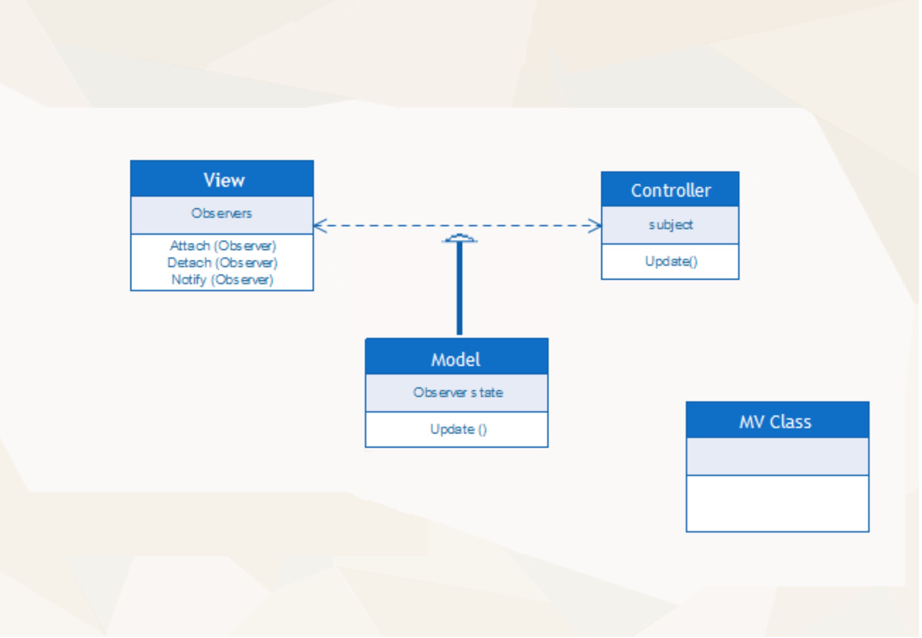**4.2 Class diagram**

**4.3 Class method description**

**MV Class :**

|  |  |
| --- | --- |
| Class | MV |
| Method | **Add Bank card** |
| Visibility | **Private** |
| Return type | **Void** |
| Parameters, types | **Card information: (String,int).** |
| Description | **In this method allow to user to add his card .** |